SOFTWARE TESTING LAB
PRACTICAL 5
Defect Identification and Professional Bug Reports
Sample practical record | Screenshot-style outputs are illustrative

Aim
To identify defects and prepare professional bug reports including severity, priority, screenshots and reproduction steps.

Procedure
- Execute a test case and compare actual behaviour with expected behaviour.
- Write a concise bug title, environment, preconditions and reproducible steps.
- Record expected result, actual result, severity, priority and evidence.
- Assign a status and retest after a fix is provided.

Sample Outputs / Screenshots
The following are original, illustrative screenshot-style outputs prepared for the practical topic. They are not captures from a live application. Replace or supplement them with screenshots from your actual lab execution if your instructor requires real execution evidence.

Output 1: Defect Found
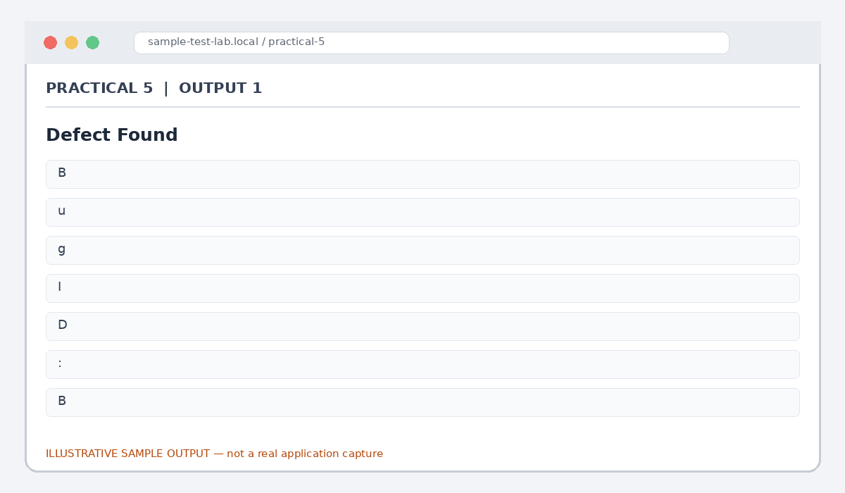
Figure 5.1: Defect Found (illustrative sample)

Output 2: Reproduction Steps
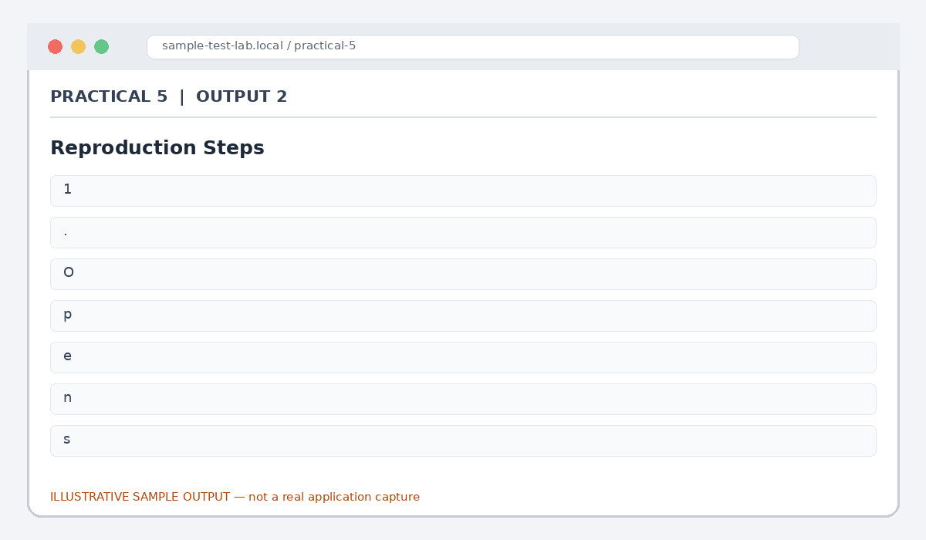
Figure 5.2: Reproduction Steps (illustrative sample)

Output 3: Expected vs Actual
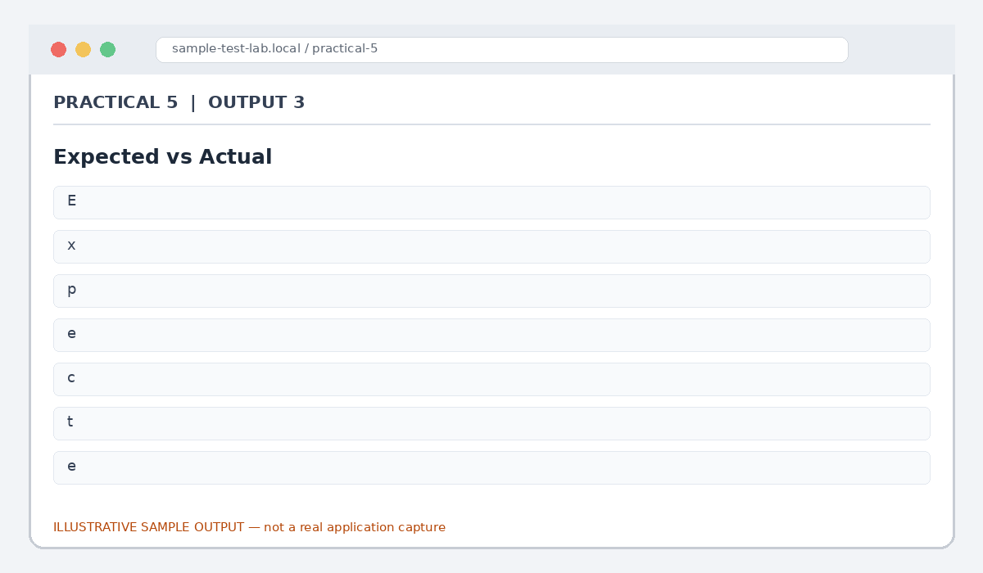
Figure 5.3: Expected vs Actual (illustrative sample)

Output 4: Severity and Priority
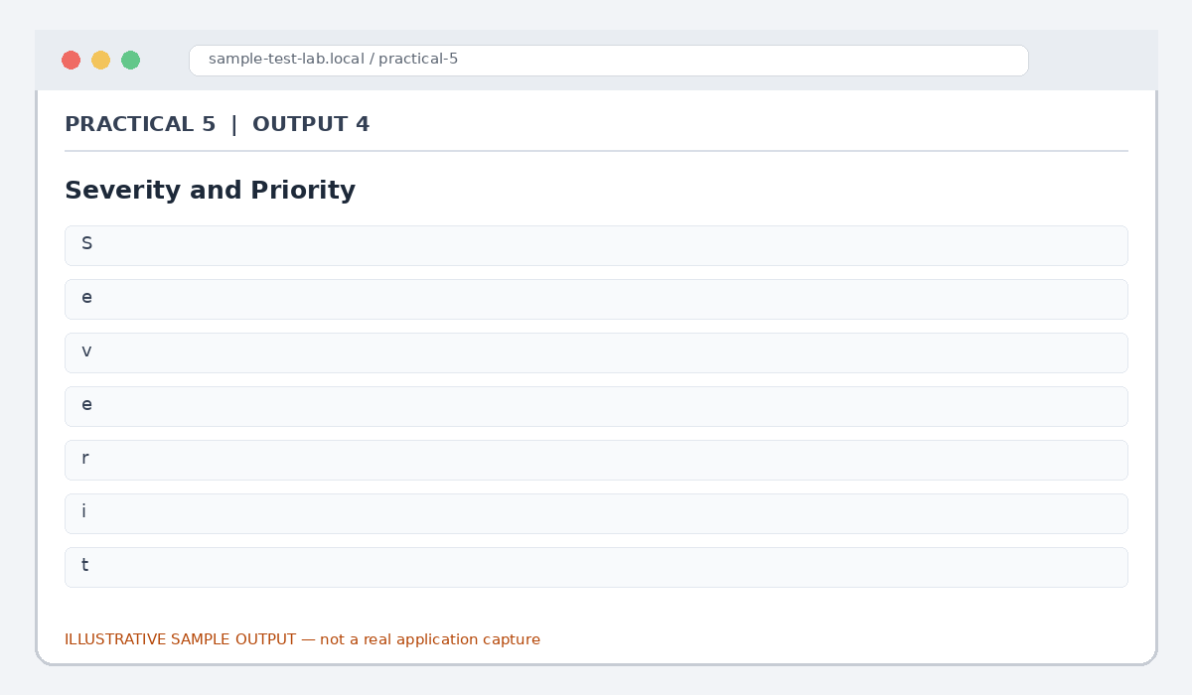
Figure 5.4: Severity and Priority (illustrative sample)

Output 5: Bug Lifecycle
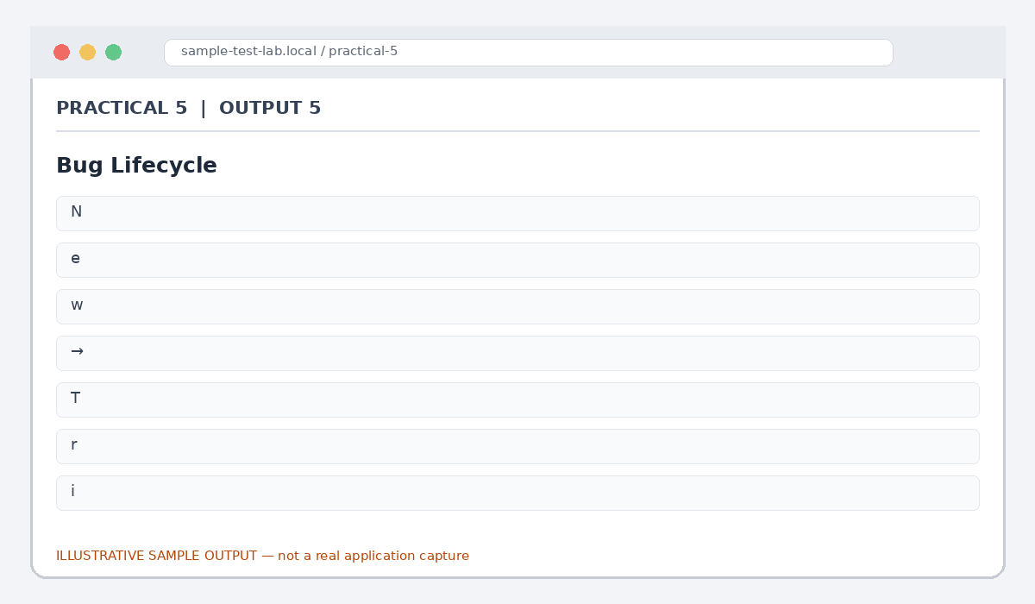
Figure 5.5: Bug Lifecycle (illustrative sample)

Result
A sample defect report was prepared with reproduction steps, expected/actual results, severity, priority and lifecycle status.

Note for Final Submission
Check the exact rules, requirements, and results from your assigned application/manual before submitting. Any sample status, test data, limits, counts, or defect priorities in this document are examples and should be replaced with actual lab observations where required.

