SOFTWARE TESTING LAB
PRACTICAL 6
Manual Test Cases, Execution and Summary Reports
Sample practical record | Screenshot-style outputs are illustrative

Aim
To apply manual test cases using multiple input conditions and prepare detailed test execution and summary reports.

Procedure
- Prepare test cases for valid, invalid, empty and boundary input conditions.
- Execute each test case manually in the test environment.
- Record actual results and mark each case Pass, Fail or Blocked.
- Summarize execution totals, defect counts, pass rate and unresolved risks.

Sample Outputs / Screenshots
The following are original, illustrative screenshot-style outputs prepared for the practical topic. They are not captures from a live application. Replace or supplement them with screenshots from your actual lab execution if your instructor requires real execution evidence.

Output 1: Test Execution Sheet
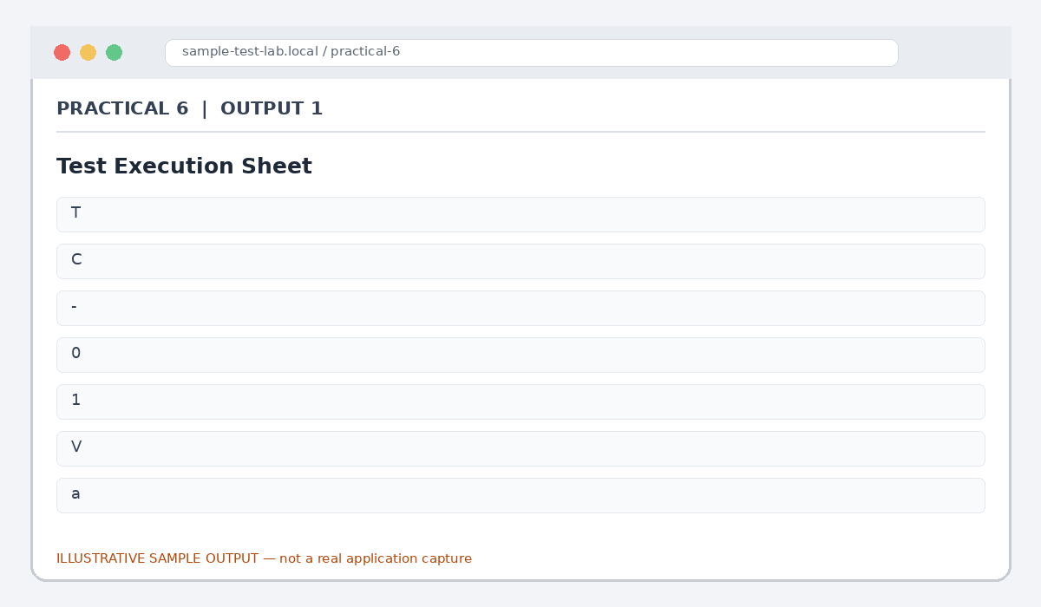
Figure 6.1: Test Execution Sheet (illustrative sample)

Output 2: Input Conditions
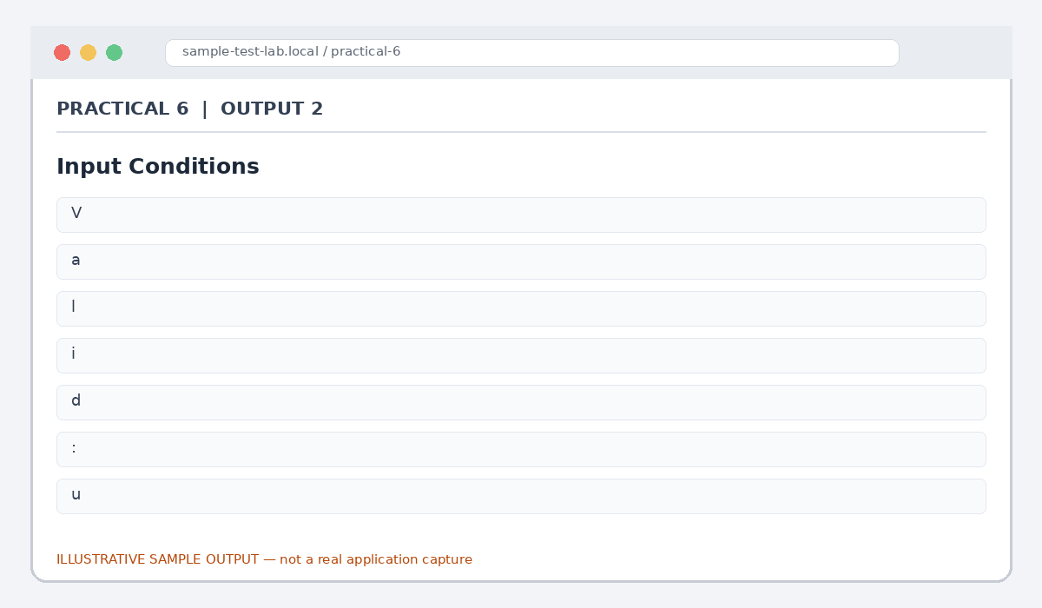
Figure 6.2: Input Conditions (illustrative sample)

Output 3: Execution Evidence
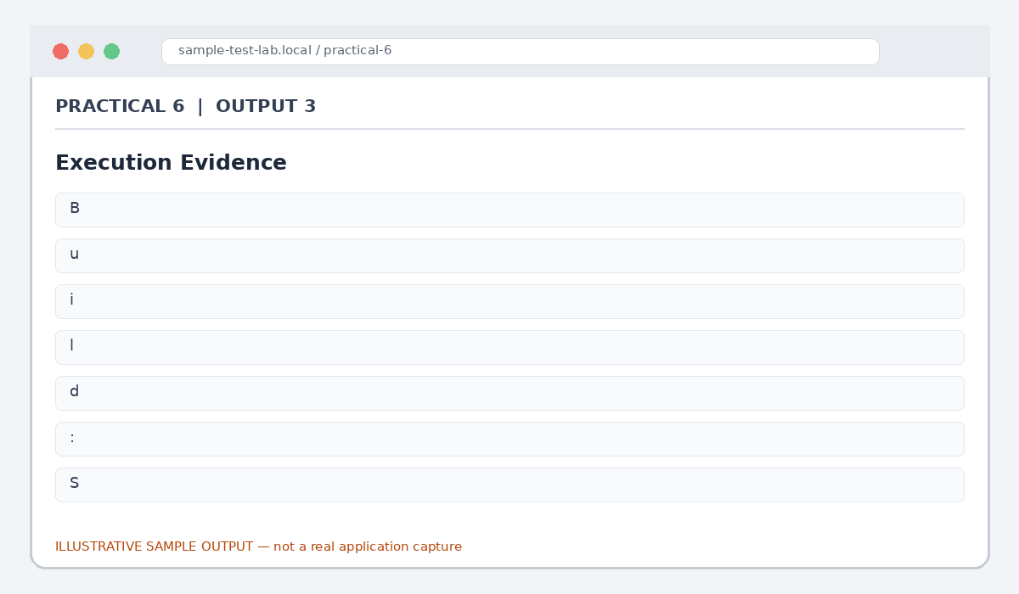
Figure 6.3: Execution Evidence (illustrative sample)

Output 4: Execution Summary
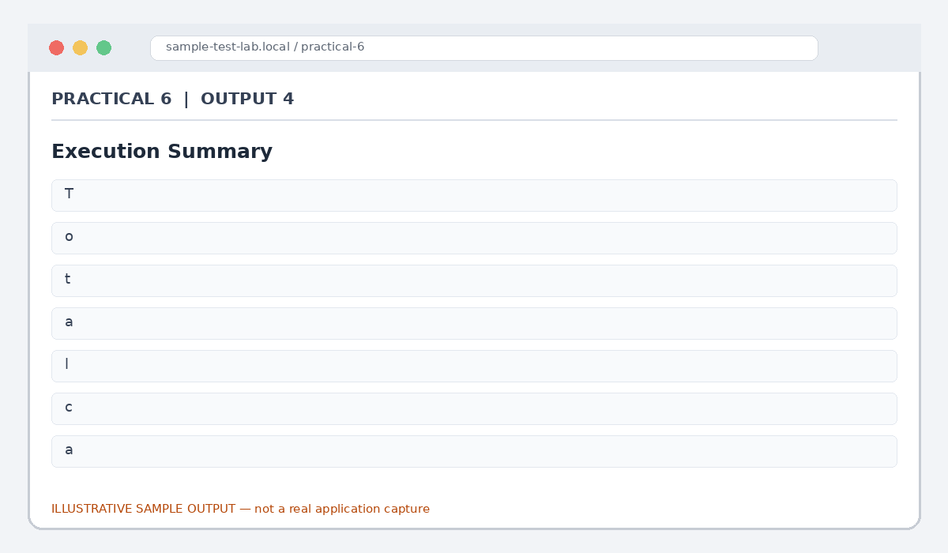
Figure 6.4: Execution Summary (illustrative sample)

Output 5: Final Test Summary
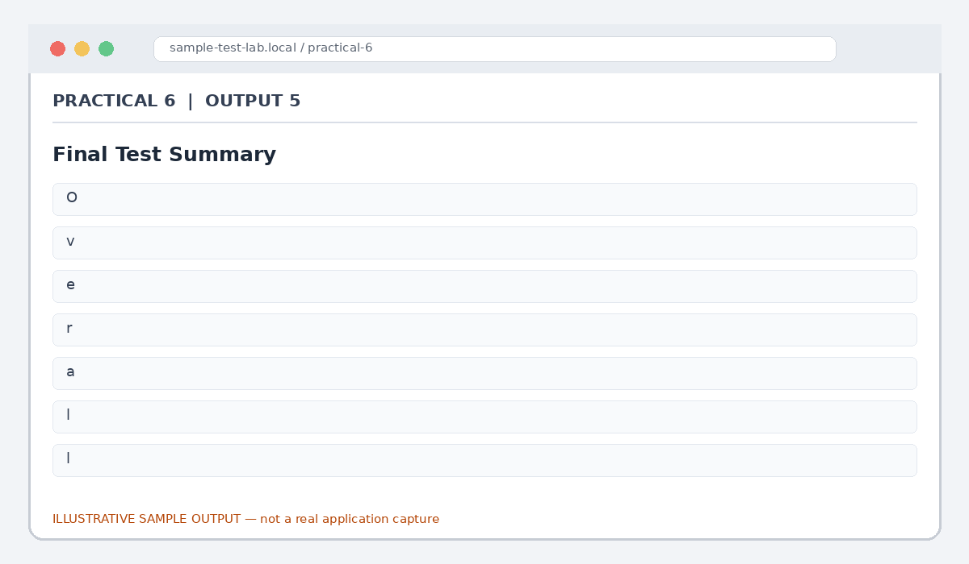
Figure 6.5: Final Test Summary (illustrative sample)

Result
Manual test execution and summary reporting were demonstrated using multiple input conditions and illustrative sample results.

Note for Final Submission
Check the exact rules, requirements, and results from your assigned application/manual before submitting. Any sample status, test data, limits, counts, or defect priorities in this document are examples and should be replaced with actual lab observations where required.

