SOFTWARE TESTING LAB
PRACTICAL 7
Boundary Value Analysis (BVA) and Equivalence Partitioning
Sample practical record | Screenshot-style outputs are illustrative

Aim
To apply BVA and Equivalence Partitioning for validation testing of forms and authentication modules.

Procedure
- Identify input fields and their allowed minimum and maximum values.
- Divide inputs into valid and invalid equivalence classes.
- Select representative values from each class.
- Test boundary values immediately below, at and above the limits, and record expected results.

Sample Outputs / Screenshots
The following are original, illustrative screenshot-style outputs prepared for the practical topic. They are not captures from a live application. Replace or supplement them with screenshots from your actual lab execution if your instructor requires real execution evidence.

Output 1: Validation Rule
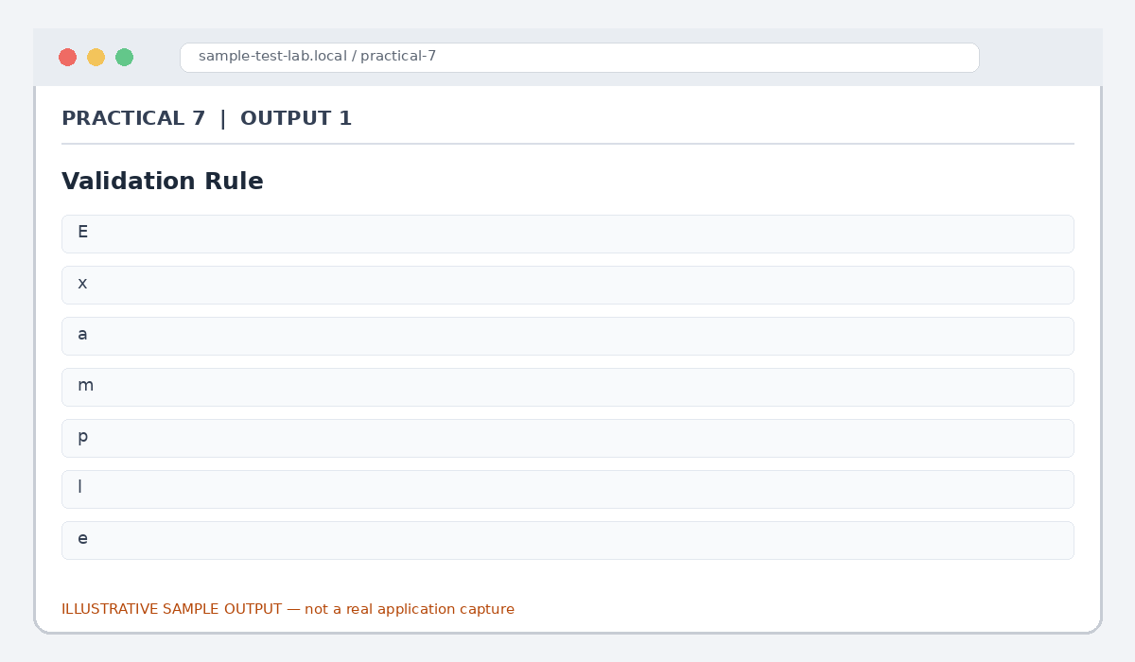
Figure 7.1: Validation Rule (illustrative sample)

Output 2: Equivalence Partitions
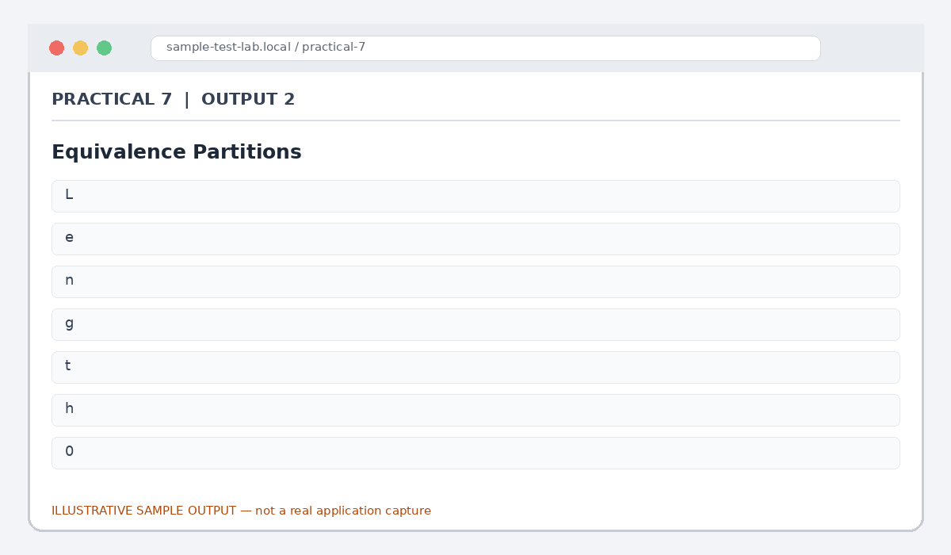
Figure 7.2: Equivalence Partitions (illustrative sample)

Output 3: BVA Test Values
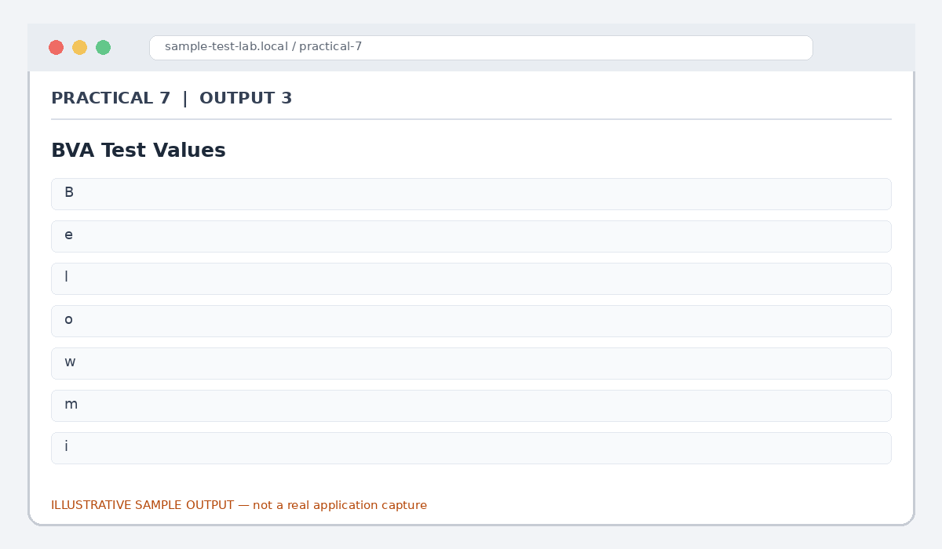
Figure 7.3: BVA Test Values (illustrative sample)

Output 4: Email Field Partitions
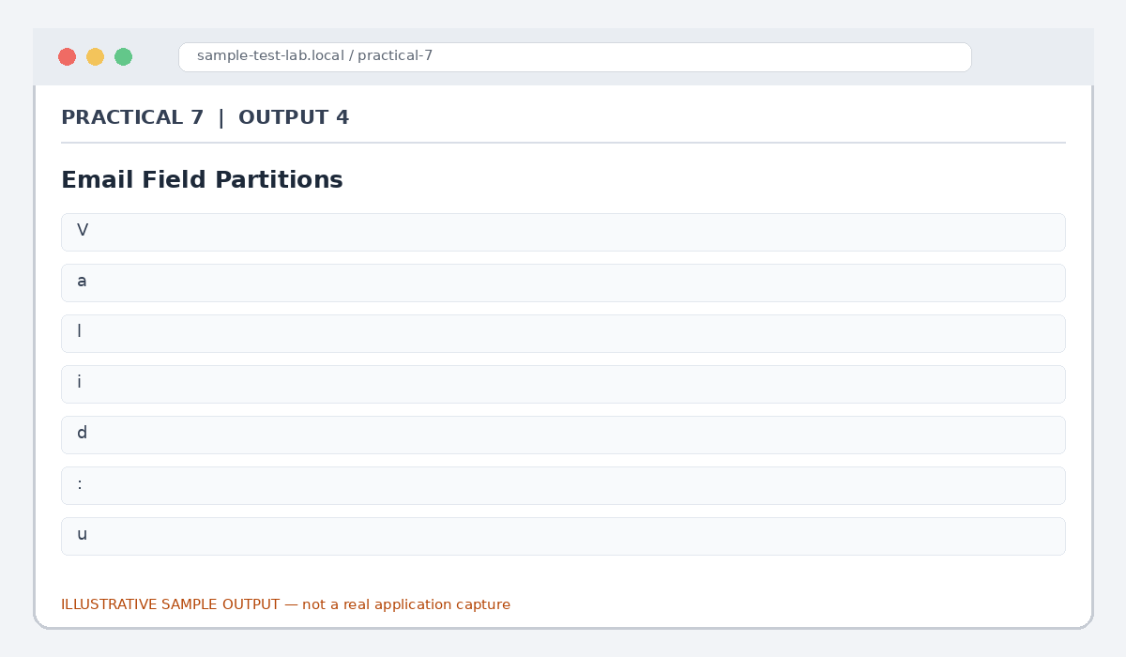
Figure 7.4: Email Field Partitions (illustrative sample)

Output 5: Sample BVA Results
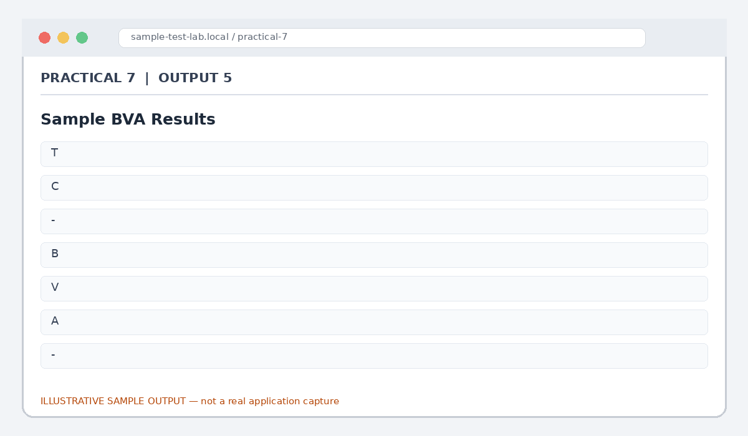
Figure 7.5: Sample BVA Results (illustrative sample)

Result
Equivalence classes and boundary values were identified for sample form validation. Actual limits must be confirmed from the application requirements.

Note for Final Submission
Check the exact rules, requirements, and results from your assigned application/manual before submitting. Any sample status, test data, limits, counts, or defect priorities in this document are examples and should be replaced with actual lab observations where required.

