SOFTWARE TESTING LAB
PRACTICAL 8
Defect Management, Test Case Management and Execution Reports using Bugzilla and TestLink
Sample practical record | Illustrative screenshot-style outputs

Aim
To apply defect management, test case management and execution report generation using Bugzilla and TestLink workflows.

Procedure
- Create a sample project and define test cases in a test management workflow.
- Record a sample defect with summary, steps, expected result, actual result, severity and priority.
- Link the defect to the related test case where the tool supports linking.
- Review the defect lifecycle and test execution summary.

Outputs / Screenshots
These are original screenshot-style illustrations prepared for the listed practical. They are not screenshots captured from Bugzilla, TestLink, a live website, or a running Selenium session. Replace or supplement them with actual lab screenshots if required.

Output 1: Project Dashboard
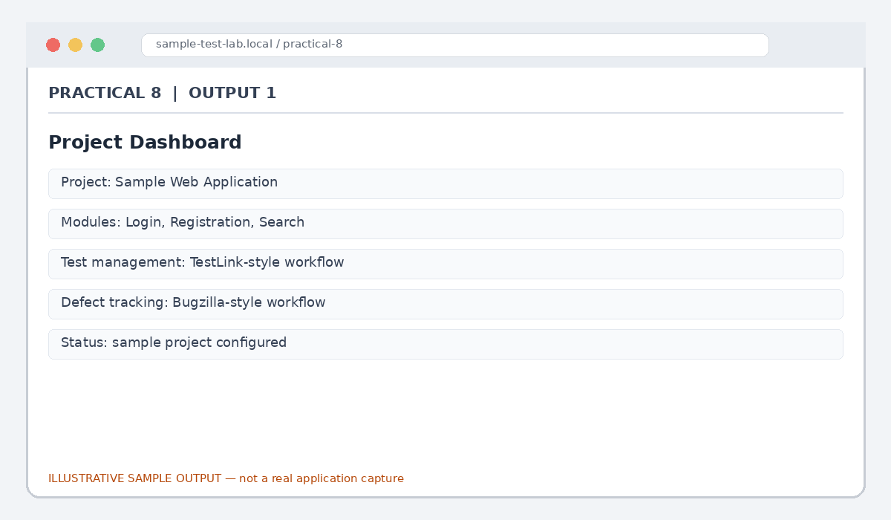
Figure 8.1: Project Dashboard (illustrative sample)

Output 2: Test Case Record
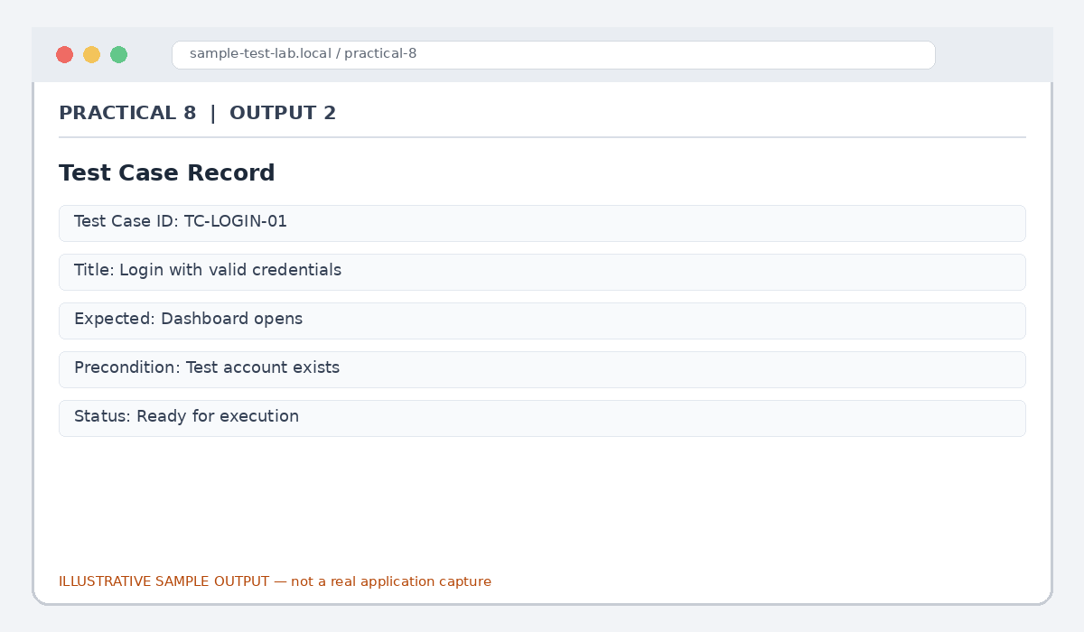
Figure 8.2: Test Case Record (illustrative sample)

Output 3: Defect Entry
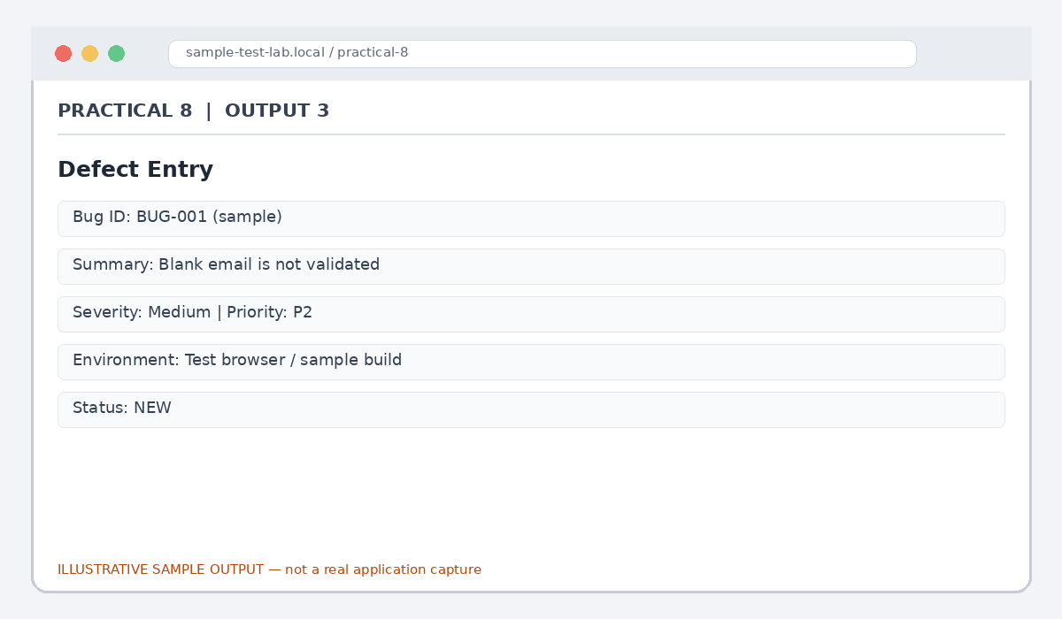
Figure 8.3: Defect Entry (illustrative sample)

Output 4: Defect Workflow
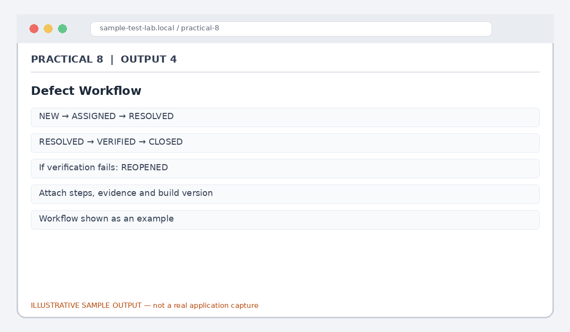
Figure 8.4: Defect Workflow (illustrative sample)

Output 5: Execution Report
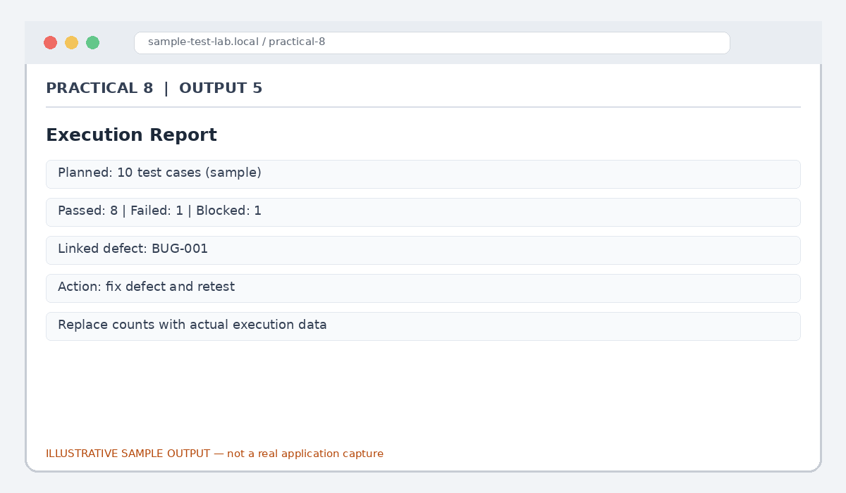
Figure 8.5: Execution Report (illustrative sample)

Result
A sample workflow was documented for test case management, defect tracking and execution reporting.

Submission Note
Confirm tool versions, application rules and test outcomes from your own lab setup. Sample statuses, data and counts must be replaced with actual observations where required.

