SOFTWARE TESTING LAB
PRACTICAL 9
Black-box, White-box, Integration and System Testing
Sample practical record | Illustrative screenshot-style outputs

Aim
To analyze black-box testing, white-box testing, integration testing and system testing on a sample web application.

Procedure
- Select a sample web application with login and search modules.
- Design black-box tests from inputs and expected outputs.
- Review white-box testing as logic/path-oriented testing of code.
- Test interactions between modules, then test the complete application.

Outputs / Screenshots
These are original screenshot-style illustrations prepared for the listed practical. They are not screenshots captured from Bugzilla, TestLink, a live website, or a running Selenium session. Replace or supplement them with actual lab screenshots if required.

Output 1: Sample Web Application
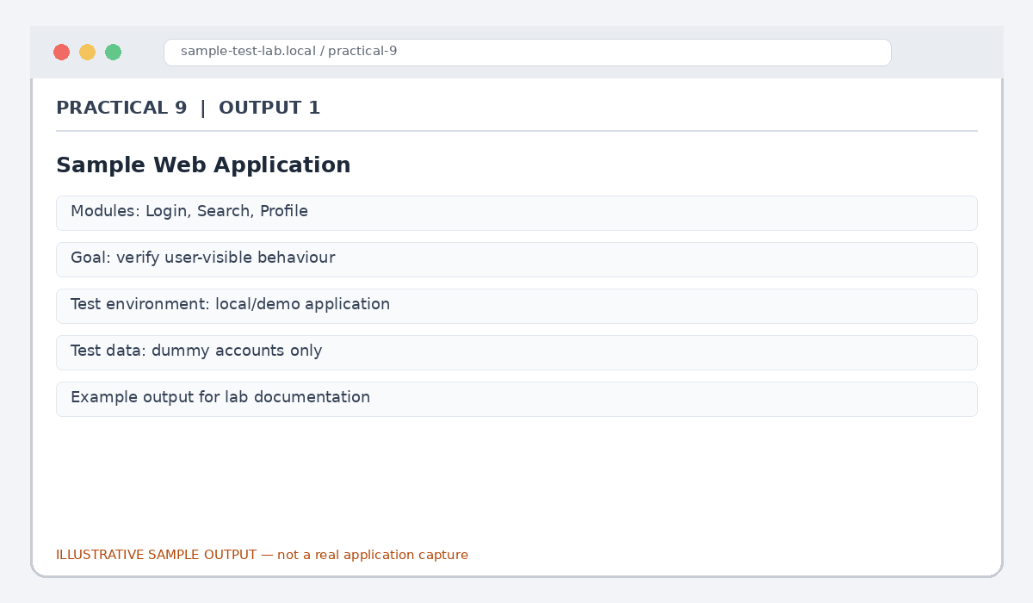
Figure 9.1: Sample Web Application (illustrative sample)

Output 2: Black-box Test
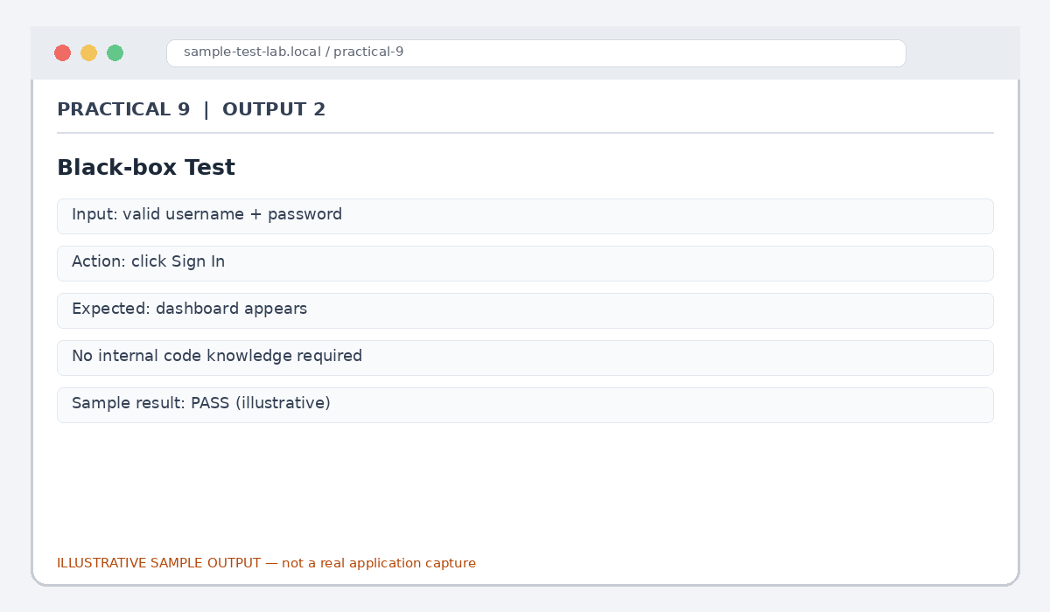
Figure 9.2: Black-box Test (illustrative sample)

Output 3: White-box Test
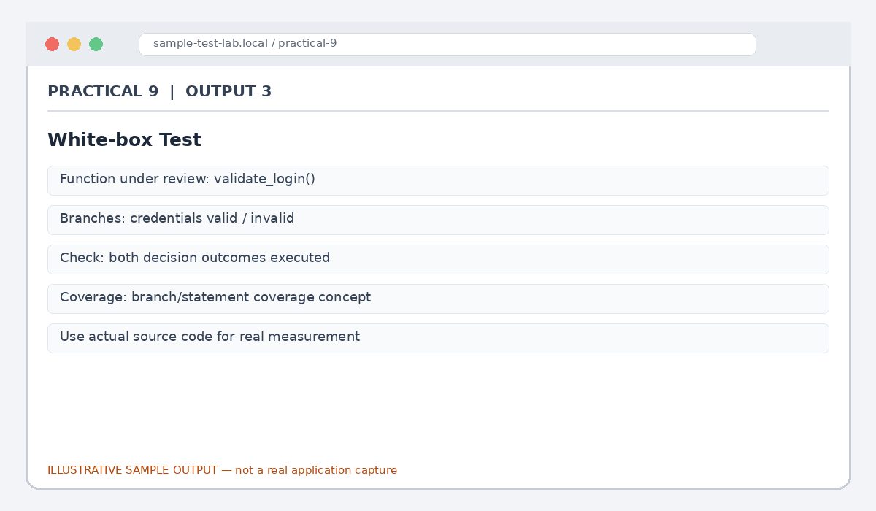
Figure 9.3: White-box Test (illustrative sample)

Output 4: Integration Test
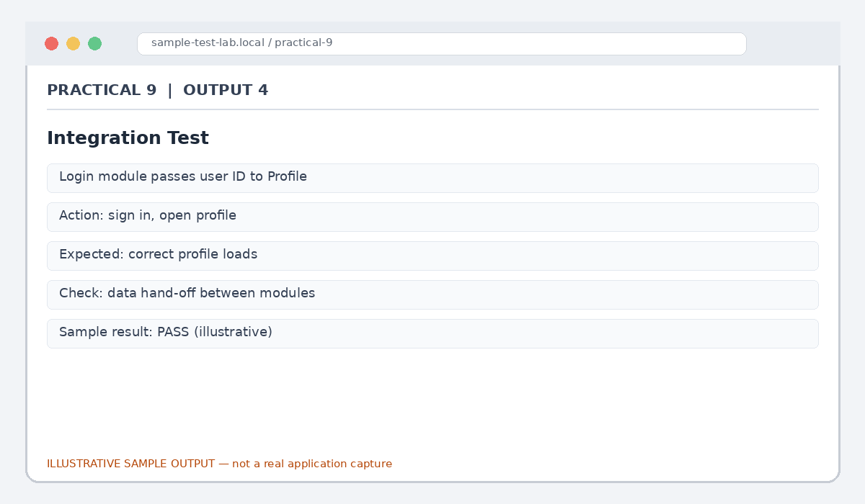
Figure 9.4: Integration Test (illustrative sample)

Output 5: System Test
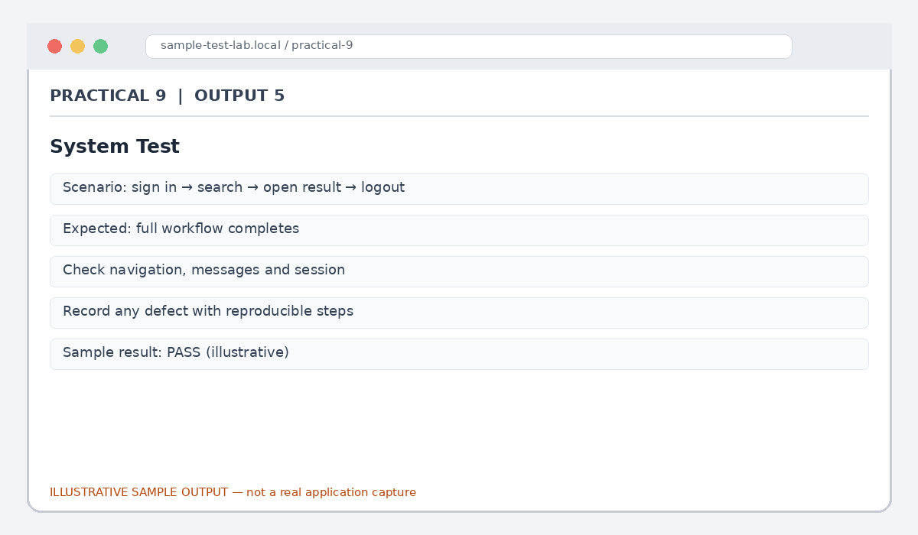
Figure 9.5: System Test (illustrative sample)

Result
The four testing approaches were demonstrated using a sample web-application workflow.

Submission Note
Confirm tool versions, application rules and test outcomes from your own lab setup. Sample statuses, data and counts must be replaced with actual observations where required.

