SOFTWARE TESTING REPORT
Minimalist E-commerce Website
Evidence-based test report | 28 October 2026
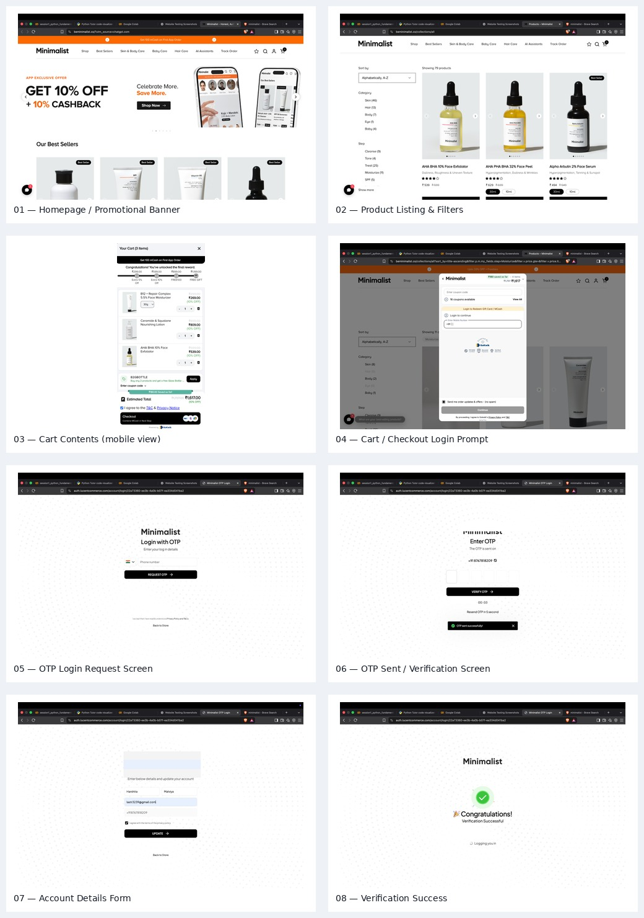

1. Executive Summary
This report documents a screenshot-based review of the Minimalist e-commerce website. The supplied evidence covers the homepage, product listing and filters, cart contents, checkout login prompt, OTP request/entry flow, account-details form, and a verification-success screen. The report records observed evidence separately from expected behaviour so that unverified actions are not incorrectly reported as passed.

2. Application and Scope
Application | Minimalist e-commerce website
Website | https://beminimalist.co/
Application type | Retail / skincare e-commerce
Evidence provided | 8 screenshots supplied by the user
Review date | 28 October 2026 (based on supplied screenshot context)
In scope | Homepage, product listing/filter UI, cart UI, checkout login prompt, OTP screens, account details form
Out of scope / not verified | Source-code inspection, payment processing, actual order placement, backend logs, cross-browser compatibility, performance/security scans

3. Test Objectives
- Review visible application screens and identify the user-facing modules.
- Map the observed screens to black-box, integration, and end-to-end testing opportunities.
- Record expected and actual results in a consistent test-execution format.
- Identify tests that need further execution before they can be marked Pass or Fail.
- Protect personal authentication details in evidence prepared for sharing.

4. Test Environment
Application under test | https://beminimalist.co/
Browser visible in evidence | Brave browser on macOS (based on screenshots)
Test data | Products/cart and authentication screens shown in supplied screenshots
Test method | Manual, screenshot-based review
Automation | Not evidenced in the supplied screenshots
Source-code access | Not provided

5. Test Execution Summary
Status definitions: “Pass (visual check)” means the expected screen elements are visible in the supplied evidence. “Pass (visible response)” means a response message or screen is visible. “Not Executed” means the screenshots do not demonstrate the test action/result. “Partial evidence” means the screens cover parts of a workflow but do not prove every transition.
Test Case ID | Section | Test Step | Status
ST-01 | Homepage | Open the Minimalist website homepage | Pass (visual check)
ST-02 | Product Listing | Open all products and inspect product grid | Pass (visual check)
ST-03 | Product Listing | Check category/filter controls are present | Not Executed
ST-04 | Cart | Inspect cart item details and quantities | Pass (visual check)
ST-05 | Cart | Check quantity increase/decrease controls | Not Executed
ST-06 | Cart / Login | Proceed from cart to checkout | Pass (visual check)
ST-07 | Authentication | Submit login form without a phone number | Not Executed
ST-08 | Authentication | Request OTP with an authorized test number | Pass (visible response)
ST-09 | Authentication | Verify OTP using valid code | Pass (visible response)
ST-10 | Account Details | Inspect required account detail fields | Pass (visual check)
ST-11 | Account Details | Submit incomplete account details | Not Executed
ST-12 | System / End-to-End | Review the visible journey from product discovery to login verification | Partial evidence
ST-13 | Security / Privacy | Check that sensitive authentication details are excluded from report | Pass (report preparation)
ST-14 | White-box testing | Inspect internal application logic | Not Executed
ST-15 | Regression | Repeat key product/cart/login checks after a change | Not Executed

6. Detailed Test Cases

ST-01 — Open the Minimalist website homepage
Section | Homepage
Test Input | Navigate to https://beminimalist.co/
Expected Result | Homepage loads and displays brand navigation, promotional banner, and product section
Actual Result | Homepage and promotional banner are visible in screenshot 01
Status | Pass (visual check)
Personal Comments & Suggestions | Screenshot confirms visible homepage content; repeat after refresh to check consistency.

ST-02 — Open all products and inspect product grid
Section | Product Listing
Test Input | Open Shop / All Products collection
Expected Result | Product listing, product names, prices, categories, and sort controls are displayed
Actual Result | Product grid, category filters, sort dropdown, and prices are visible in screenshot 02
Status | Pass (visual check)
Personal Comments & Suggestions | Test each filter and sort option separately; record actual behaviour before marking functional tests passed.

ST-03 — Check category/filter controls are present
Section | Product Listing
Test Input | Inspect Category and Step filters
Expected Result | Filter controls are visible and usable; results update when a filter is selected
Actual Result | Filter options are visible in screenshot 02; selection behaviour is not evidenced
Status | Not Executed
Personal Comments & Suggestions | Capture a second screenshot after applying a filter and compare product count/results.

ST-04 — Inspect cart item details and quantities
Section | Cart
Test Input | Open cart with items added
Expected Result | Cart shows item names, quantity controls, item prices, discounts, and estimated total
Actual Result | Cart with three items, quantities, discounts, and estimated total is visible in screenshot 03
Status | Pass (visual check)
Personal Comments & Suggestions | Cart screenshot contains four-item summary in header but three visible product rows; verify total/count consistency with a full cart capture.

ST-05 — Check quantity increase/decrease controls
Section | Cart
Test Input | Use + and − on a cart item
Expected Result | Quantity and subtotal update correctly
Actual Result | Quantity controls are visible in screenshot 03; no before/after evidence
Status | Not Executed
Personal Comments & Suggestions | Capture quantity before and after changing it, then verify subtotal and cart count.

ST-06 — Proceed from cart to checkout
Section | Cart / Login
Test Input | Click Checkout
Expected Result | Checkout flow starts and requests login if authentication is required
Actual Result | Login prompt asking for mobile number is visible in screenshot 04
Status | Pass (visual check)
Personal Comments & Suggestions | This confirms the login prompt appeared; it does not prove the complete checkout flow.

ST-07 — Submit login form without a phone number
Section | Authentication
Test Input | Leave phone field blank and click Continue / Request OTP
Expected Result | Validation message appears and OTP is not sent
Actual Result | No blank-field validation result captured
Status | Not Executed
Personal Comments & Suggestions | Perform only if appropriate; capture the validation message without entering personal data.

ST-08 — Request OTP with an authorized test number
Section | Authentication
Test Input | Enter a number you control and request OTP
Expected Result | OTP request is accepted and the OTP-entry screen appears
Actual Result | OTP-entry screen and 'OTP sent successfully' notification are visible in screenshot 06
Status | Pass (visible response)
Personal Comments & Suggestions | Screenshot demonstrates the site's visible response, not delivery or correctness of the OTP.

ST-09 — Verify OTP using valid code
Section | Authentication
Test Input | Enter the OTP received on your own device
Expected Result | OTP is accepted and the account flow continues
Actual Result | Verification-success screen is visible in screenshot 08
Status | Pass (visible response)
Personal Comments & Suggestions | Use only your own number and OTP. Do not include OTP values in the report.

ST-10 — Inspect required account detail fields
Section | Account Details
Test Input | Review first name, last name, email, phone, and consent checkbox
Expected Result | Fields and consent control are displayed before updating account
Actual Result | Account details form is visible in screenshot 07
Status | Pass (visual check)
Personal Comments & Suggestions | Avoid including real personal details in the submitted report; redact screenshots where needed.

ST-11 — Submit incomplete account details
Section | Account Details
Test Input | Leave a required field blank and click Update
Expected Result | Required-field validation is shown and update is blocked
Actual Result | No incomplete-submission result captured
Status | Not Executed
Personal Comments & Suggestions | Test one missing field at a time and record the exact validation message.

ST-12 — Review the visible journey from product discovery to login verification
Section | System / End-to-End
Test Input | Homepage → product listing → cart → login/OTP → account details
Expected Result | Each accessible screen transitions to the next expected stage
Actual Result | Screenshots 01–08 document these stages, but not every transition is recorded
Status | Partial evidence
Personal Comments & Suggestions | Add timestamped screenshots or screen recording for each transition; do not claim order completion because no order confirmation is shown.

ST-13 — Check that sensitive authentication details are excluded from report
Section | Security / Privacy
Test Input | Review evidence before sharing
Expected Result | Phone number, email, and OTP values are not exposed unnecessarily
Actual Result | Some source screenshots contain personal details; collage redacts visible details in screenshots 06–07
Status | Pass (report preparation)
Personal Comments & Suggestions | Keep original screenshots private and submit only redacted evidence where allowed.

ST-14 — Inspect internal application logic
Section | White-box testing
Test Input | Review source code or authorized test instrumentation
Expected Result | Code paths, conditions, and internal logic can be verified
Actual Result | Public website screenshots do not expose source code
Status | Not Executed
Personal Comments & Suggestions | White-box testing requires authorized source-code access; screenshots alone cannot establish it.

ST-15 — Repeat key product/cart/login checks after a change
Section | Regression
Test Input | Repeat previously executed tests
Expected Result | Previously working behaviour remains unchanged
Actual Result | No baseline-versus-after-change evidence supplied
Status | Not Executed
Personal Comments & Suggestions | Regression testing requires a change/build comparison and recorded rerun results.

7. Testing Technique Mapping
Technique | Relevant example | Evidence limitation
Black-box testing | Search/listing UI, cart UI, required fields, login validation | Inputs and resulting messages/screens must be captured for each test; only some responses are shown.
Integration testing | Product listing → cart → checkout/login flow | Screenshots show related stages but do not prove all transitions or backend integration.
System testing | End-to-end shopping journey | No completed order confirmation is included; full end-to-end pass cannot be claimed.
White-box testing | Internal conditions, branches, and source logic | Not possible to establish from public website screenshots alone; authorized source code is required.
Regression testing | Repeat key product, cart, and login tests after a release/change | No baseline-versus-new-version comparison was supplied.

8. Findings and Recommendations
- Capture separate before-and-after screenshots for quantity controls, sort options, and each product filter.
- Run negative tests for blank and invalid form inputs, and record the exact validation messages.
- Verify the cart item count, visible line items, discounts, and estimated total for consistency.
- Do not claim a successful order unless the final order confirmation is captured; avoid making a real purchase for coursework.
- For white-box testing, use an authorized source-code project or clearly state that source-level testing was outside the available scope.
- Before submission, use redacted screenshots for phone numbers, email addresses, and authentication details.

9. Overall Conclusion
The screenshots provide useful visual evidence for several Minimalist website modules and show a partial journey from product discovery through cart and account verification. They support a preliminary manual test report, but they do not independently prove all functional, integration, system, white-box, or regression behaviours. Tests marked Not Executed should be performed and documented before a final pass/fail sign-off.

Appendix A — Screenshot Evidence
The following evidence collage is redacted where visible personal authentication details appeared.

01 — Homepage / Promotional Banner
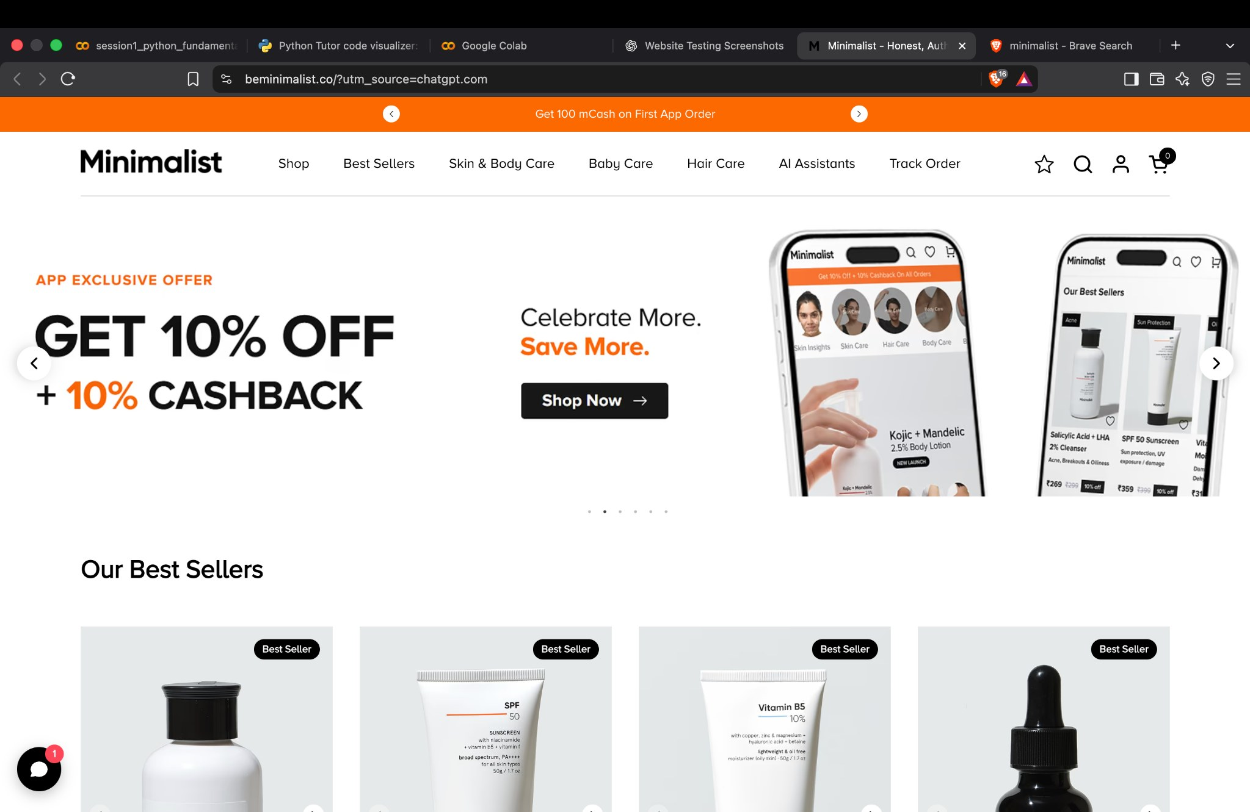
Evidence reference: 01 — Homepage / Promotional Banner. Use this image only as evidence of the visible screen; it does not by itself prove backend behaviour.

02 — Product Listing & Filters
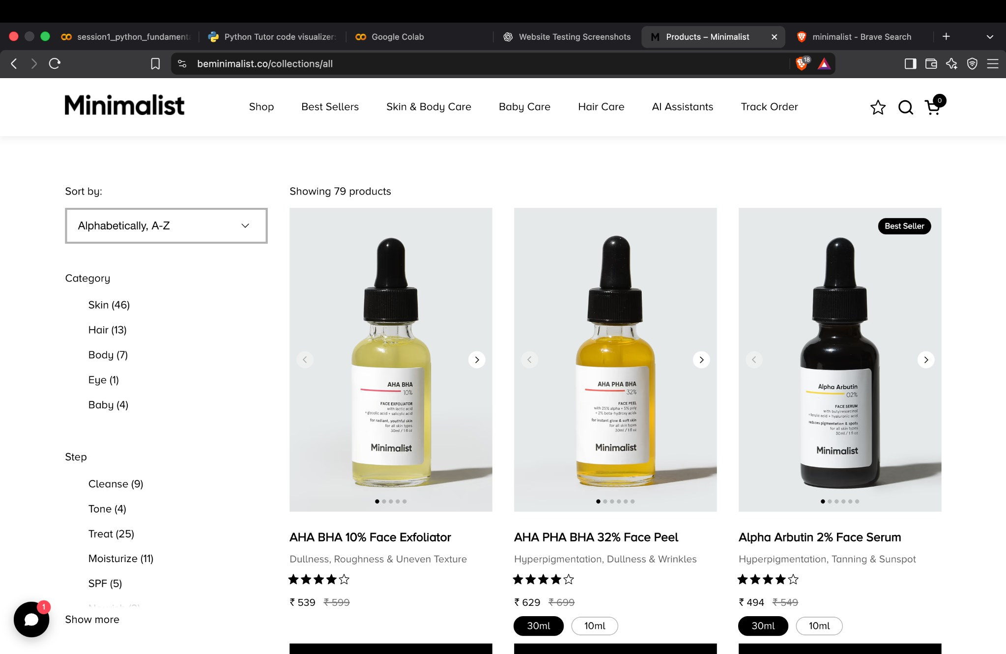
Evidence reference: 02 — Product Listing & Filters. Use this image only as evidence of the visible screen; it does not by itself prove backend behaviour.

03 — Cart Contents (mobile view)
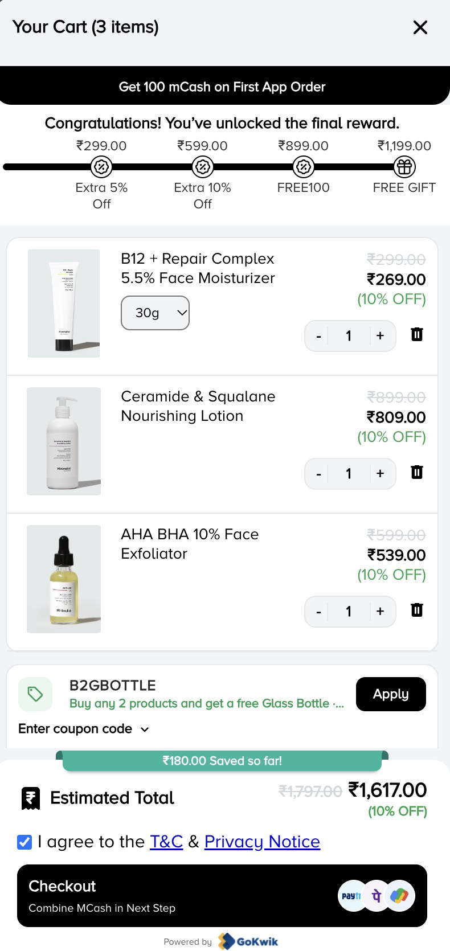
Evidence reference: 03 — Cart Contents (mobile view). Use this image only as evidence of the visible screen; it does not by itself prove backend behaviour.

04 — Cart / Checkout Login Prompt
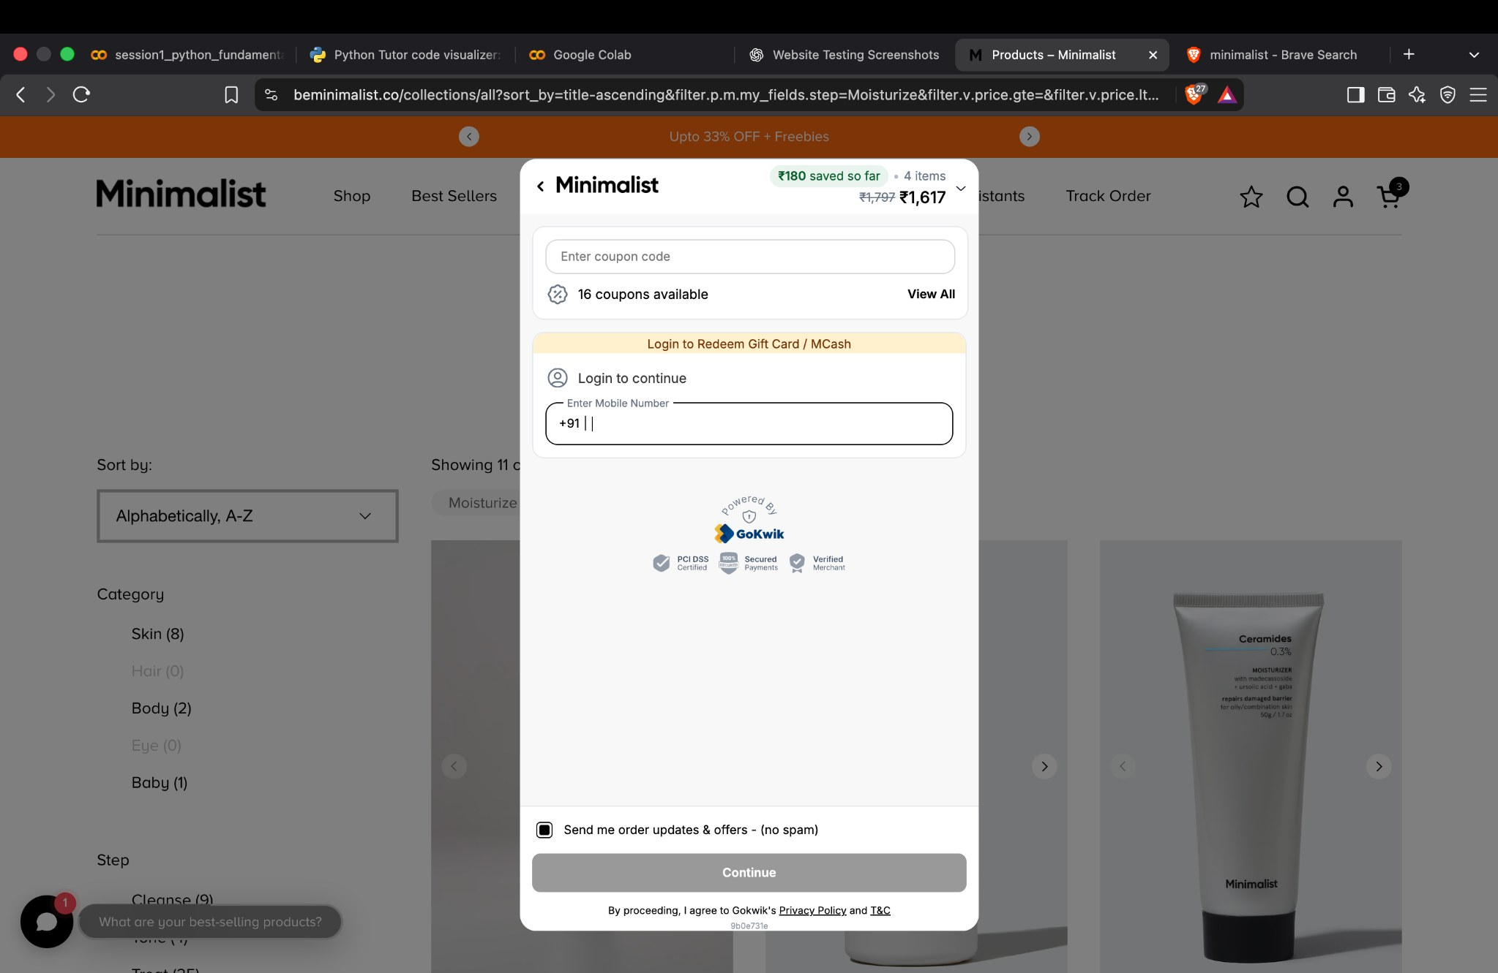
Evidence reference: 04 — Cart / Checkout Login Prompt. Use this image only as evidence of the visible screen; it does not by itself prove backend behaviour.

05 — OTP Login Request Screen
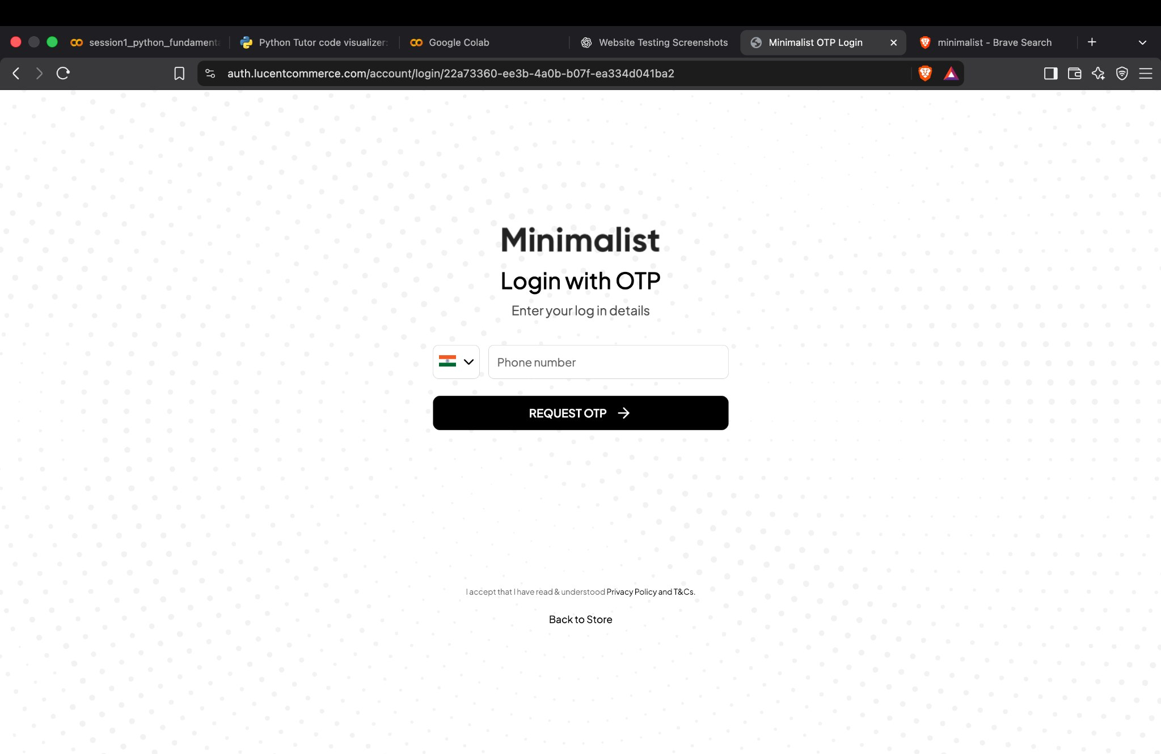
Evidence reference: 05 — OTP Login Request Screen. Use this image only as evidence of the visible screen; it does not by itself prove backend behaviour.

06 — OTP Sent / Verification Screen
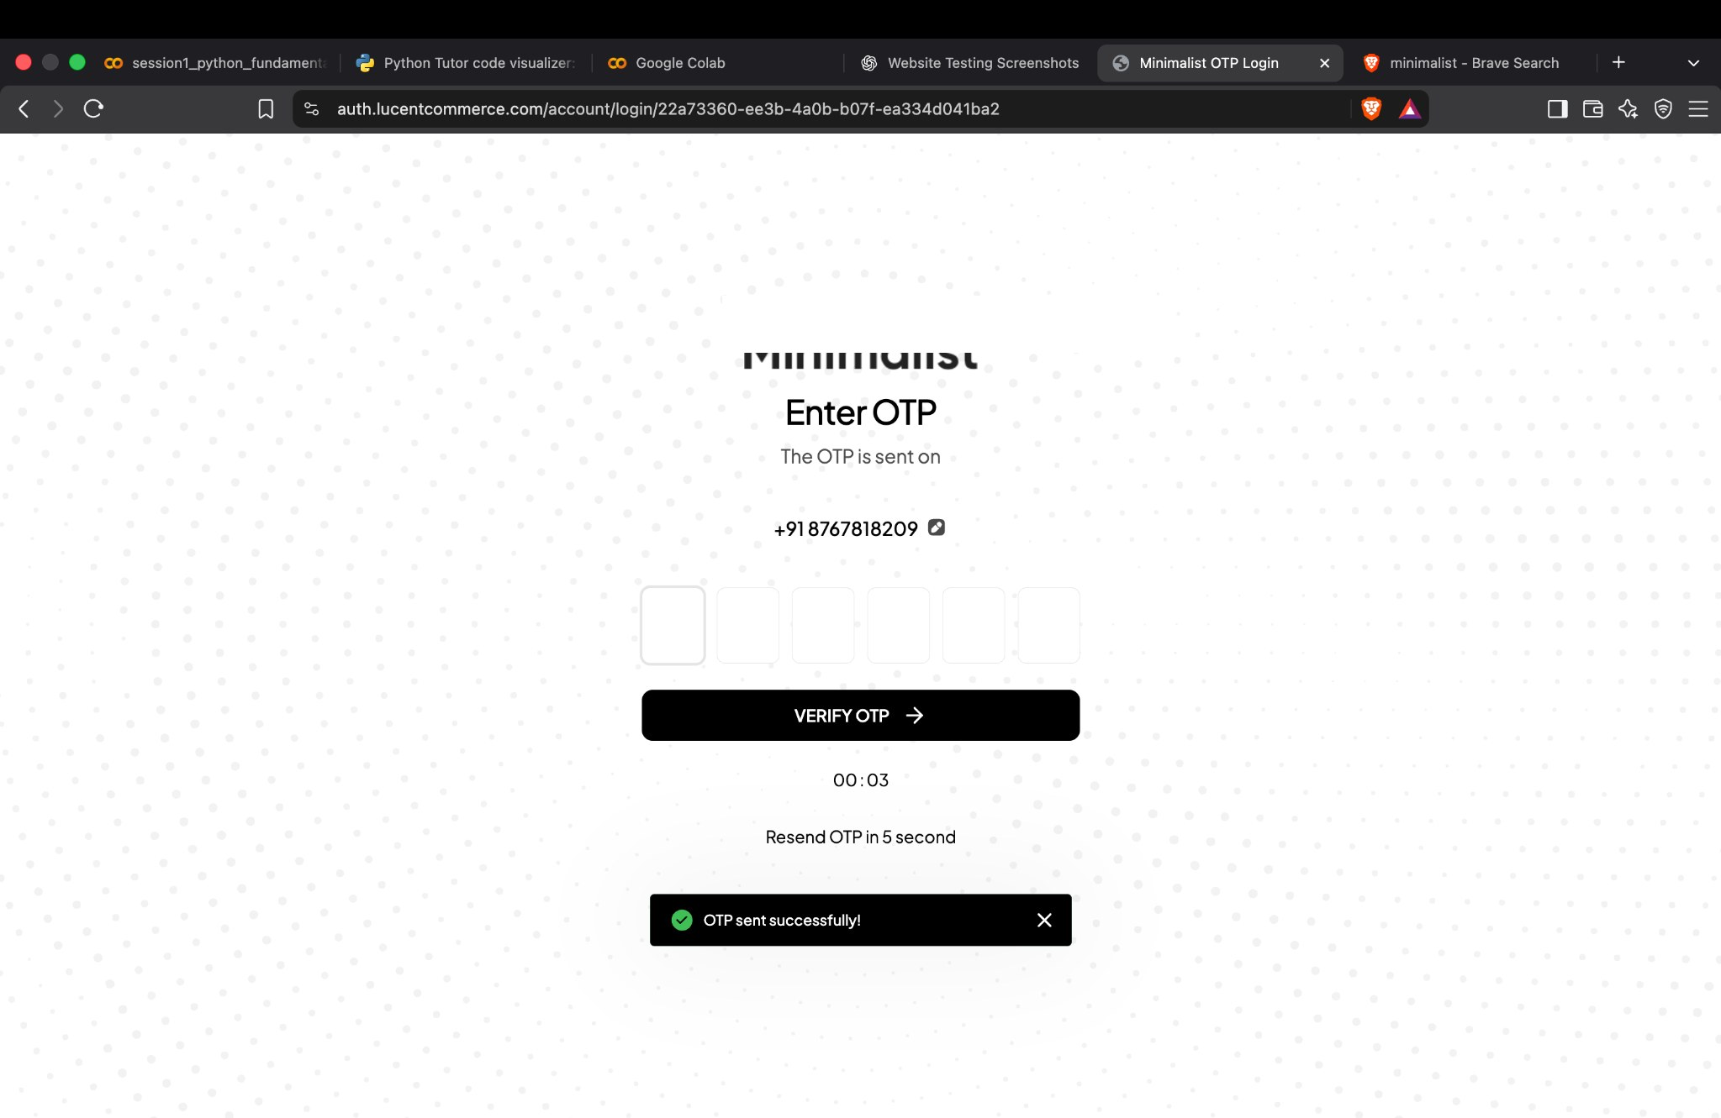
Evidence reference: 06 — OTP Sent / Verification Screen. Use this image only as evidence of the visible screen; it does not by itself prove backend behaviour.

07 — Account Details Form
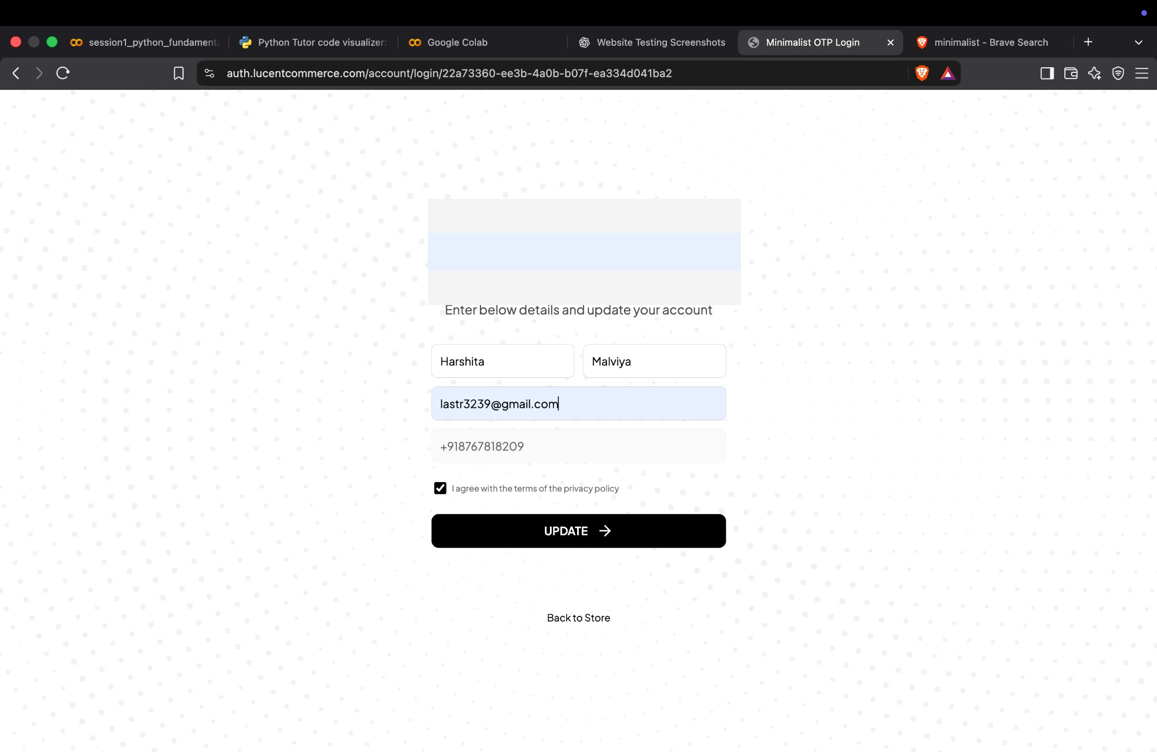
Evidence reference: 07 — Account Details Form. Use this image only as evidence of the visible screen; it does not by itself prove backend behaviour.

08 — Verification Success
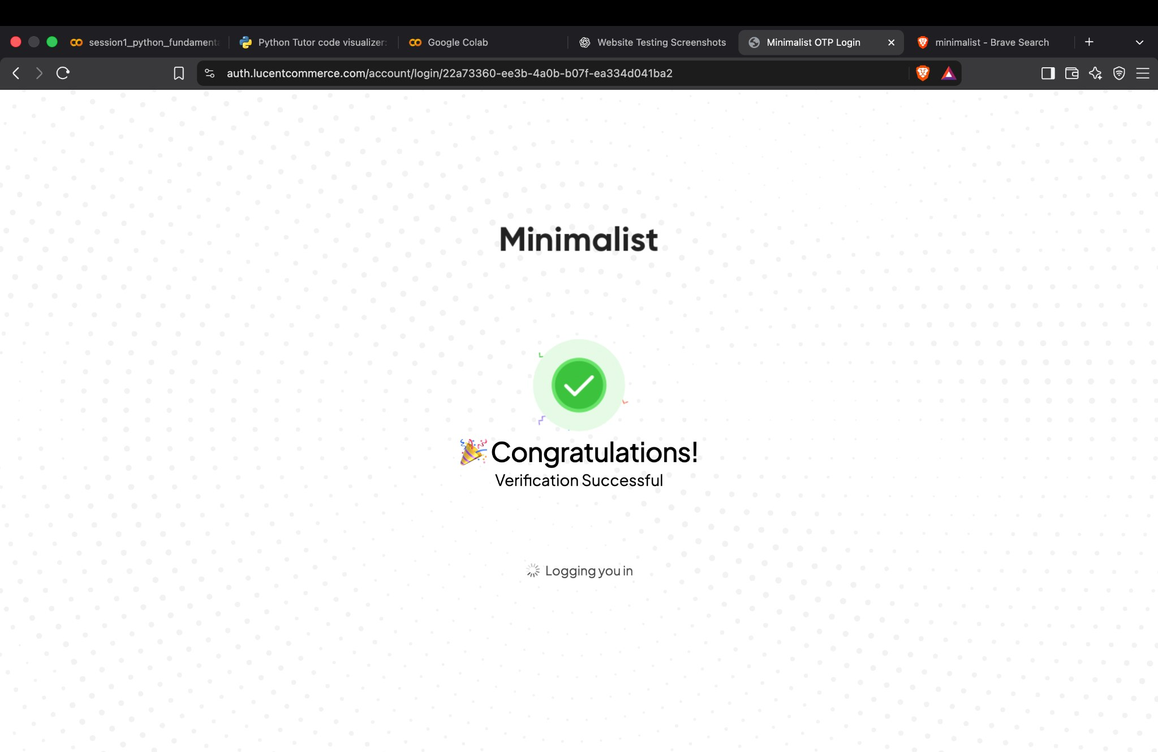
Evidence reference: 08 — Verification Success. Use this image only as evidence of the visible screen; it does not by itself prove backend behaviour.

