Module Name:Automation & Regression Testing
Website: https://demowebshop.tricentis.com/login
Test Case ID: REG01
Scenario :register
Steps:1. Open demowebshop website.
2. Enter valid email and passwords.
3. Click login.
Screenshot:
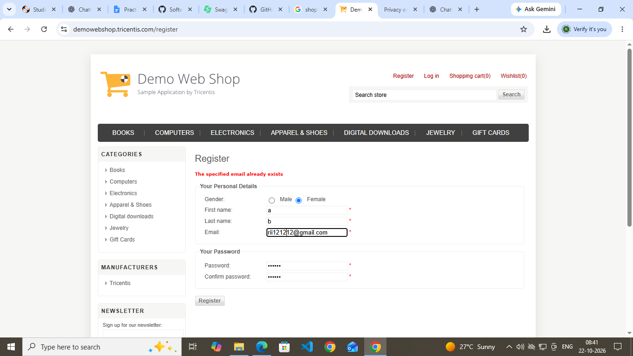

Test Case ID: REG02
Scenario: Product display
Steps:
1. Open demowebshop website.
2. Login with valid credential.
3. Verify product visibility.
Screenshot: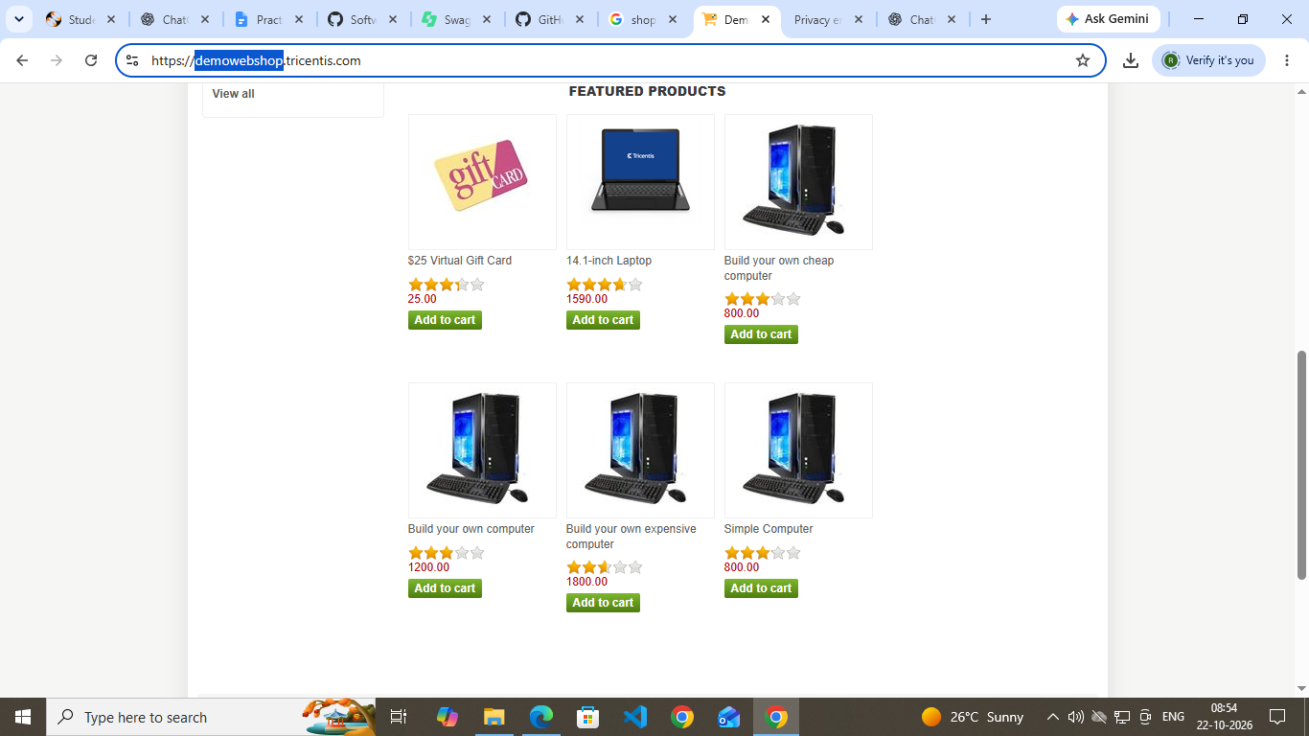

Test Case ID: REG03
Scenario: Add to cart
Steps:
1. Open demowebshop website.
2. Login with valid credential.
3. Add a product to the cart.
3. Open the Shopping Cart page.
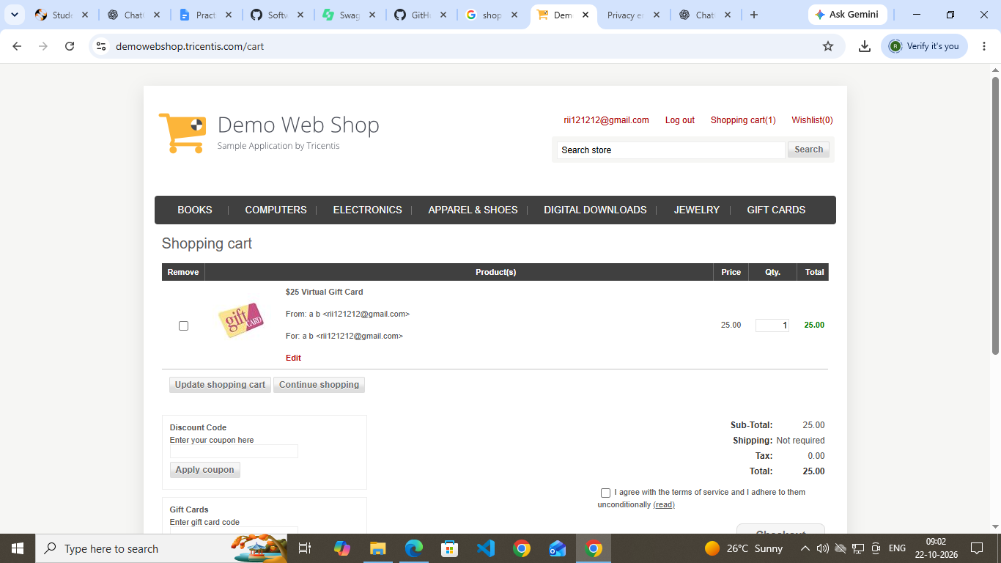

Test Case ID: REG04
Scenario:Remove from cart
Steps:
1. Open demowebshop website.
2. Add a product to the cart.
3. Remove product from cart.
Screenshot:
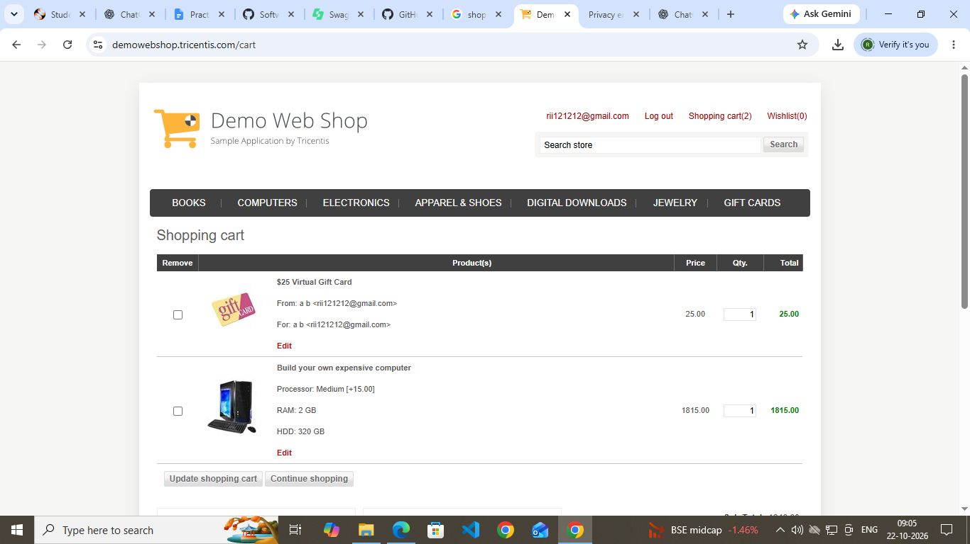
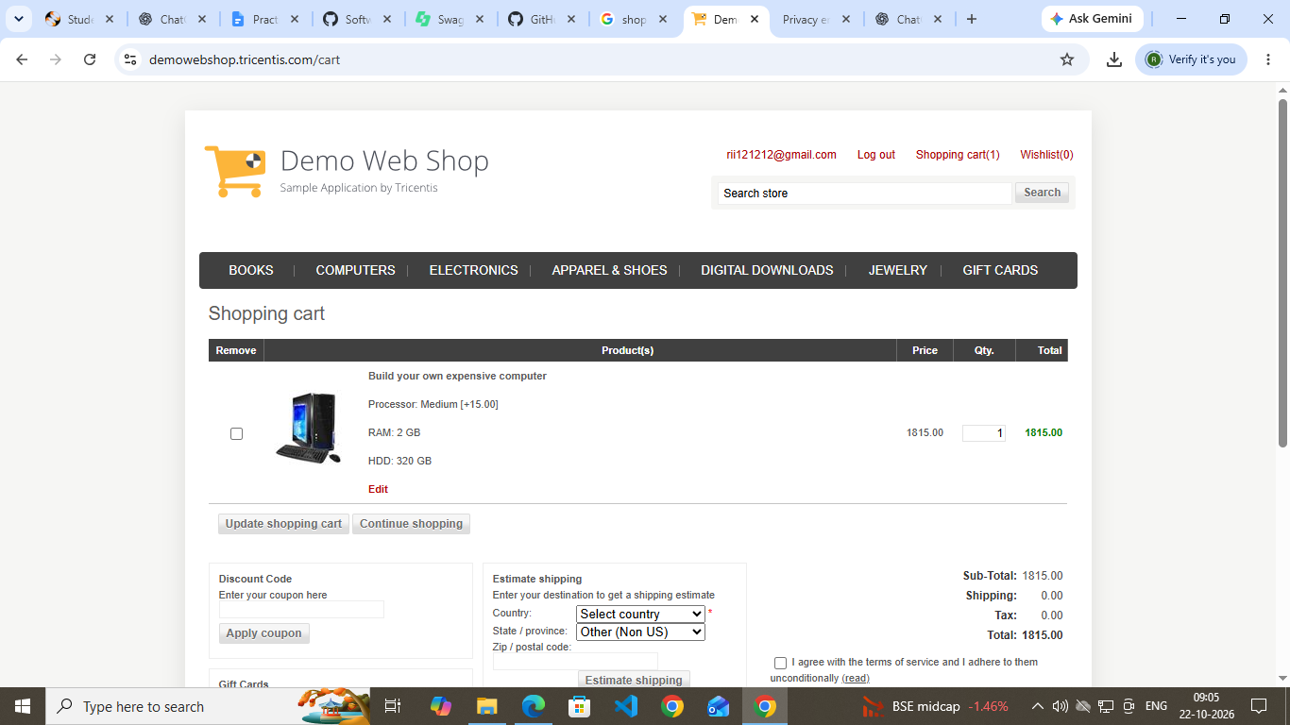

Test Case ID:REG05
Scenario: Checkout
Steps:
1. Open demowebshop website.
2. Add a product to the cart.
3. Proceed to checkout.
4. Observe the payment method section.
Screenshot: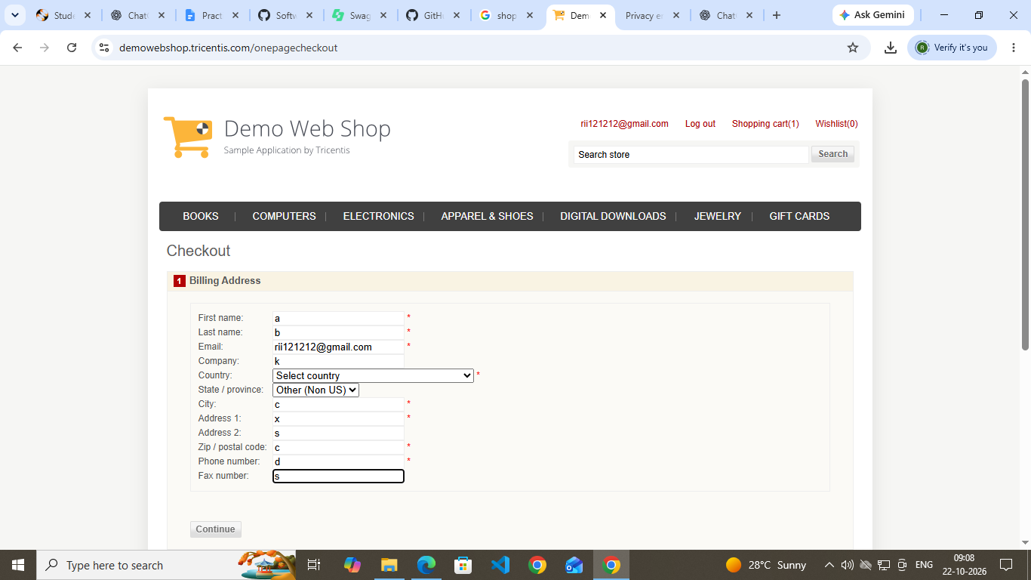
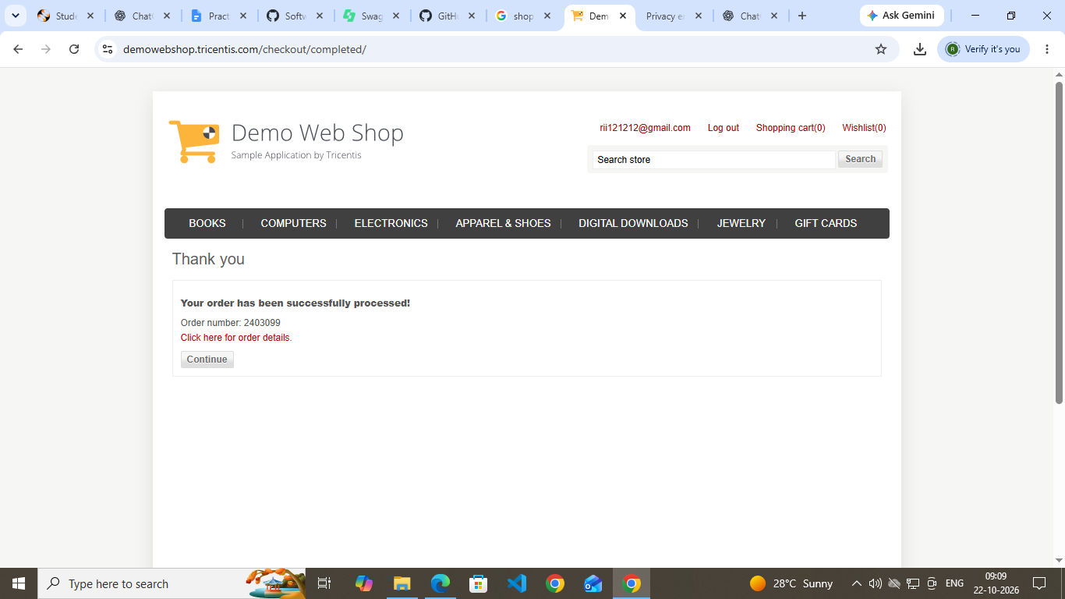

Test Case ID:REG06
Scenario:logout
Steps:
1. Open demowebshop website.
2. Login into website
3. Click logout.
Screenshot: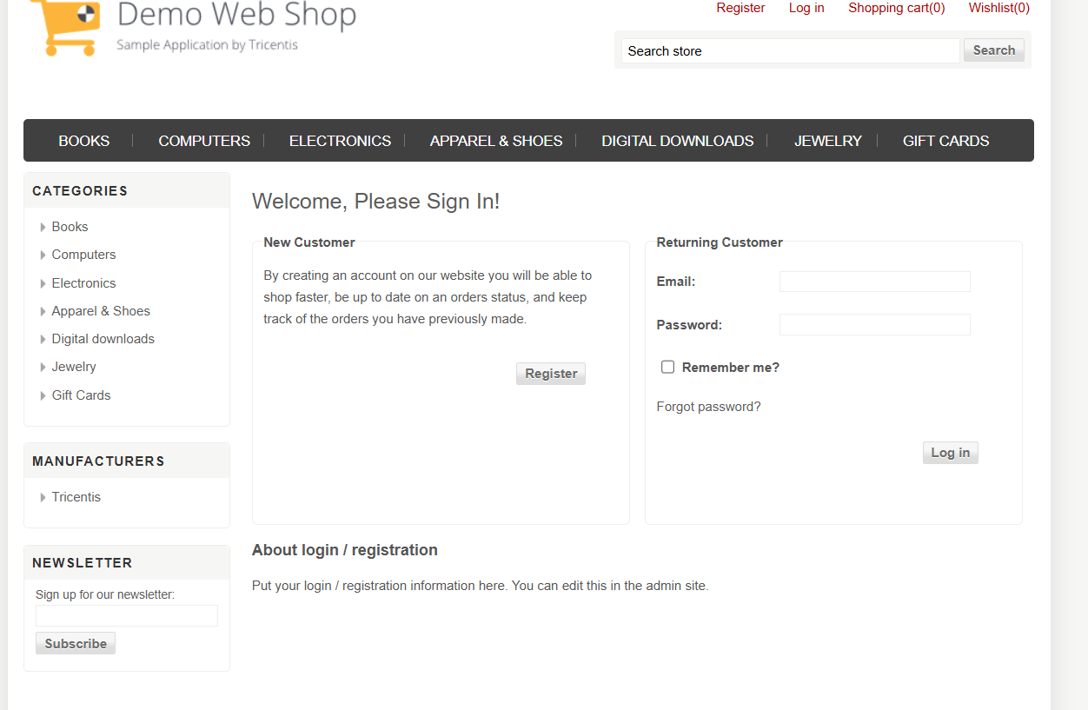

Conclusion and Recommendations
Application Status: Application functioned successfully for all executed test cases.
Pass Rate: 100% – All test cases passed.

