Module Name: Login / Registration
Webpage URL: https://demo.nopcommerce.com/
Test Case ID: TC01
Scenario: Verify valid user registration
Steps:
1. Open nopCommerce website.
2. Click 'Register'.
3. Enter valid registration details.
4. Click 'Register'.
Screenshot: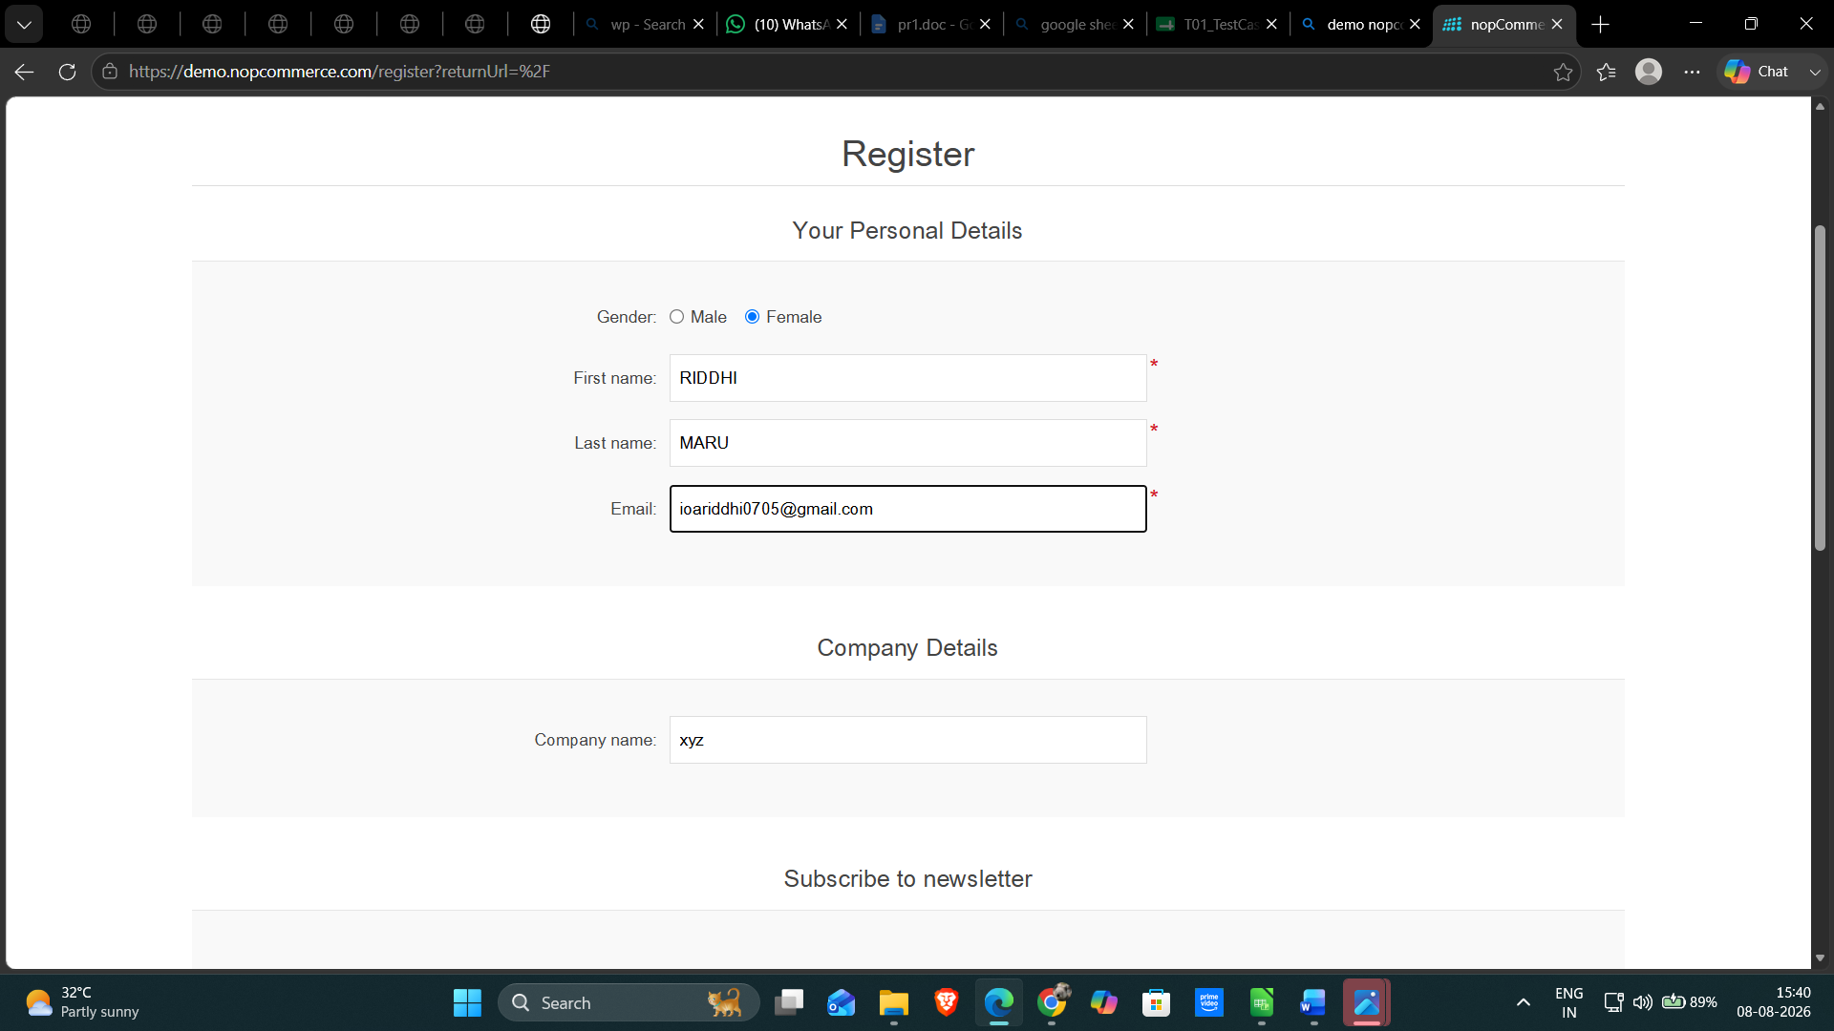
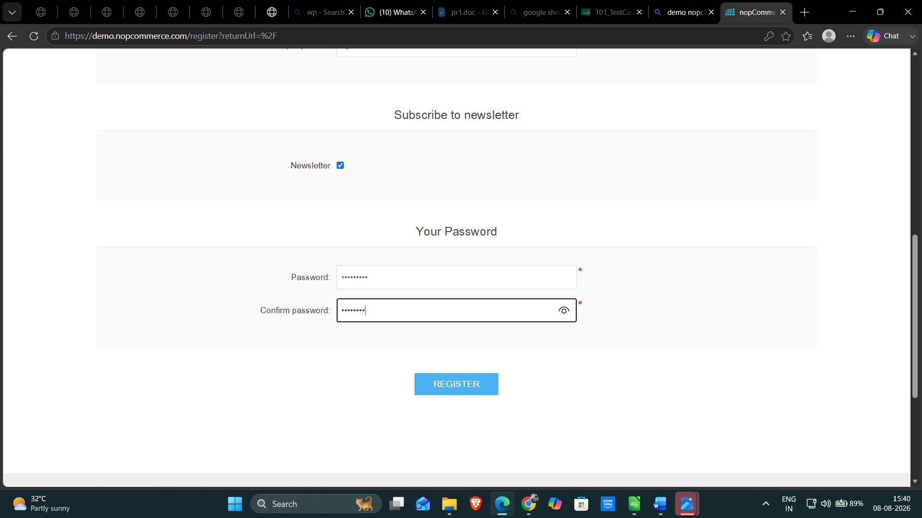

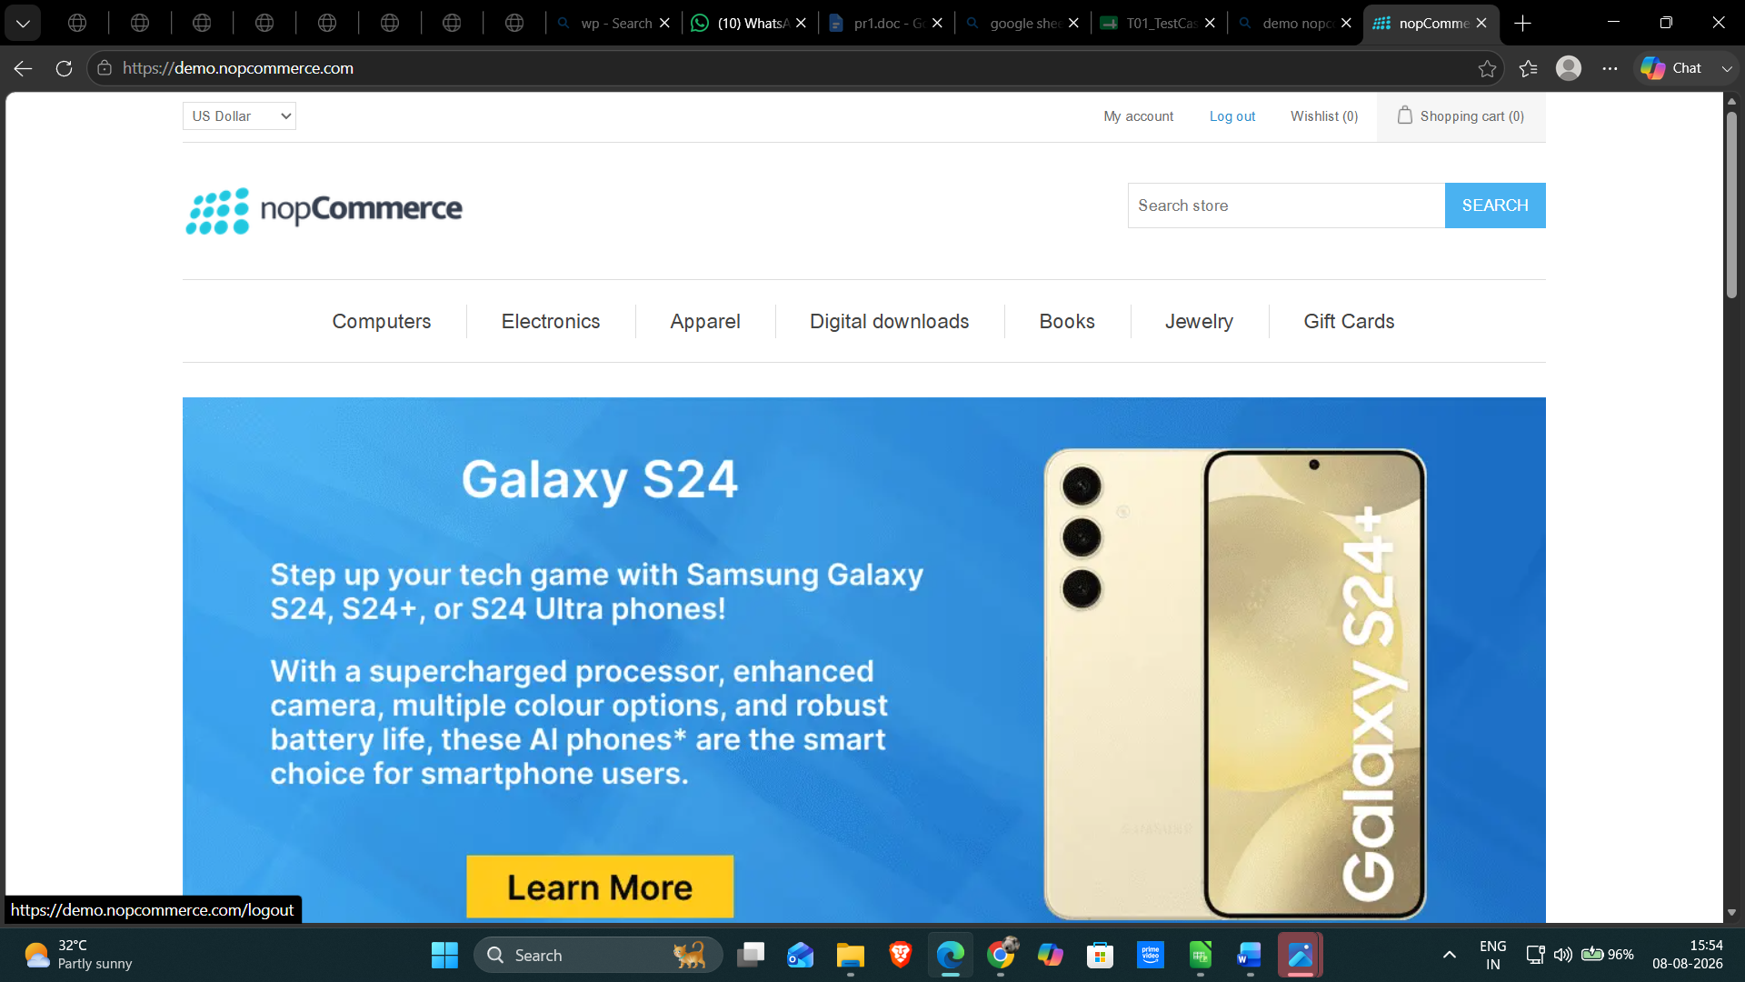
Test Case ID: TC02
Scenario: Verify invalid user registration
Steps:
1. Open nopCommerce website.
2. Click 'Register'.
3. Enter invalid registration details.
4. Click 'Register'.
Screenshot:
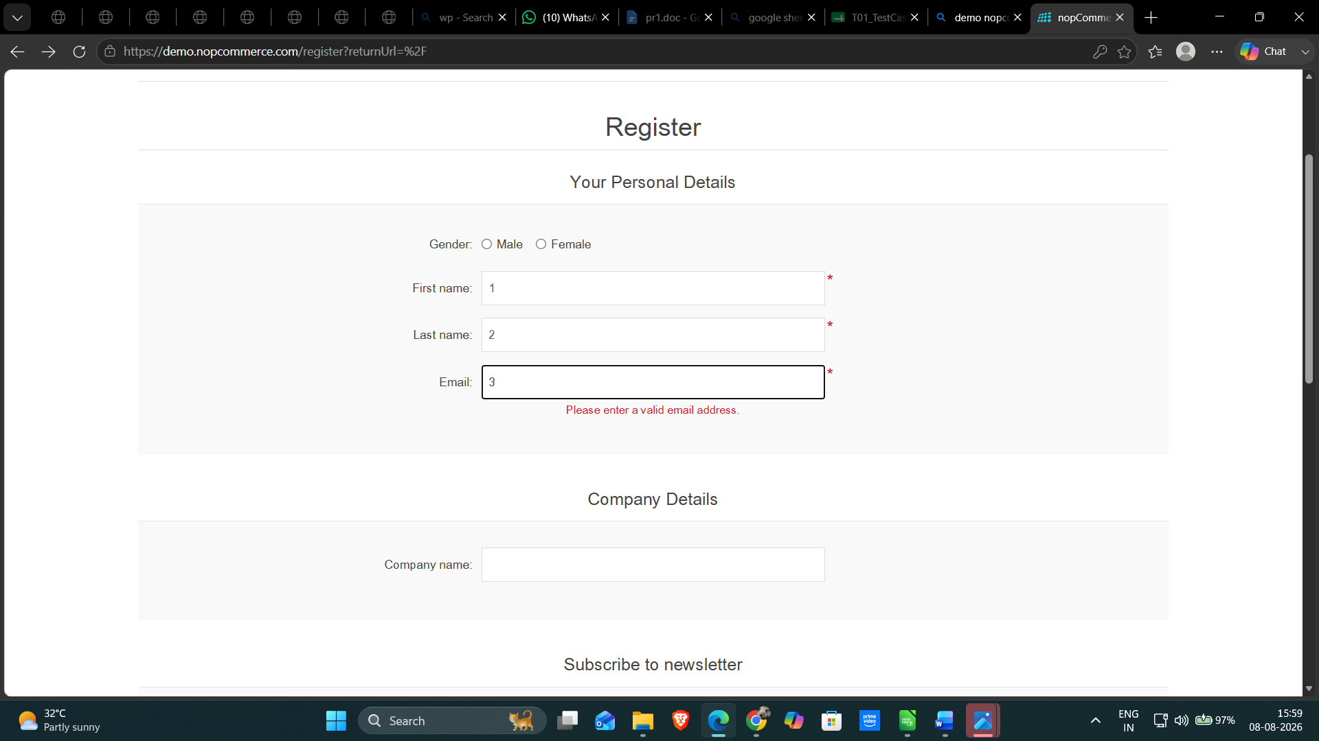

Test Case ID: TC03
Scenario: Verify registration with existing email
Steps:
1. Open nopCommerce website.
2. Click 'Register'.
3. Enter an already registered email.
4. Click 'Register'.
Screenshot:
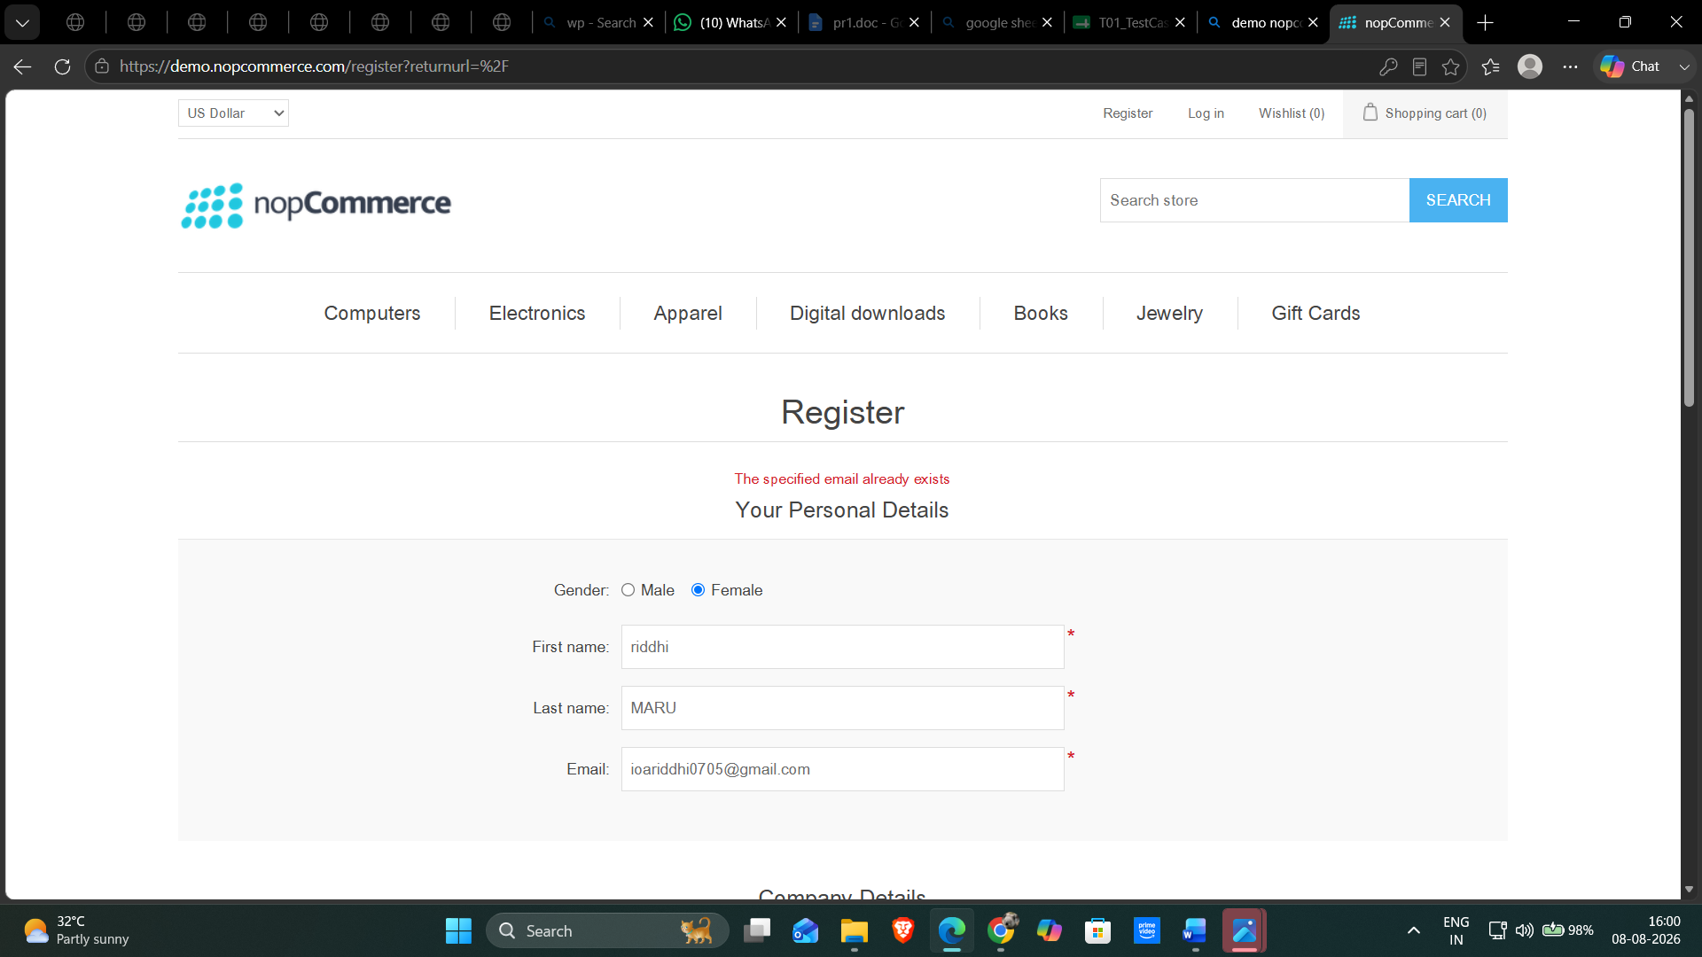

Test Case ID: TC04
Scenario: Verify login with valid credentials
Steps:
1. Open nopCommerce website.
2. Click 'Log in'.
3. Enter valid email and password.
4. Click 'Log in'.
Screenshot:
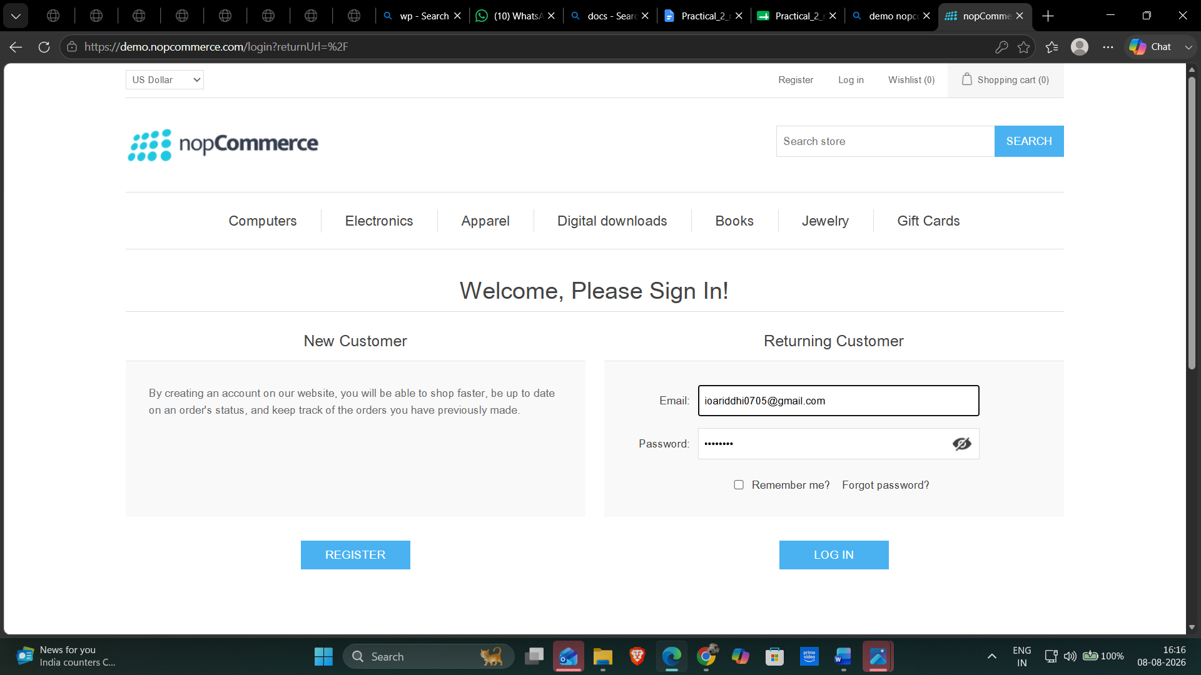

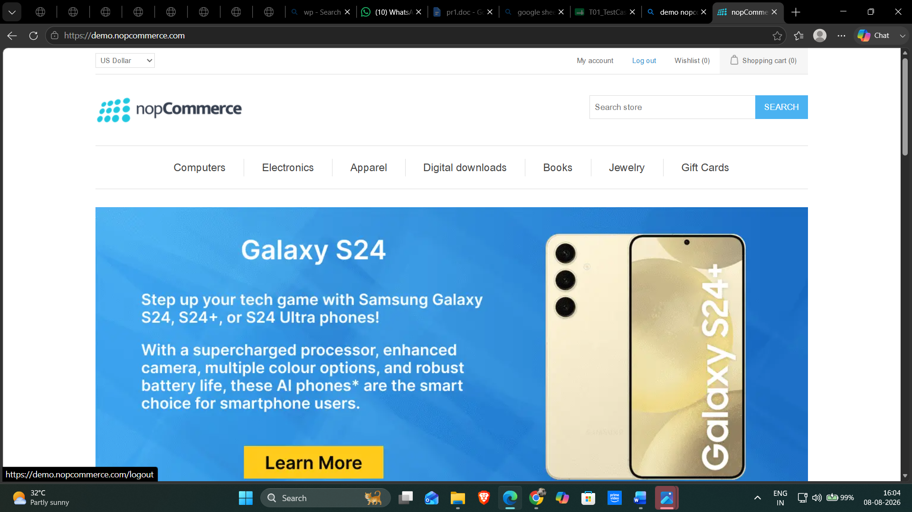

Test Case ID: TC05
Scenario: Verify login with invalid email
Steps:
1. Open nopCommerce website.
2. Click 'Log in'.
3. Enter an invalid email.
4. Click 'Log in'.
Screenshot: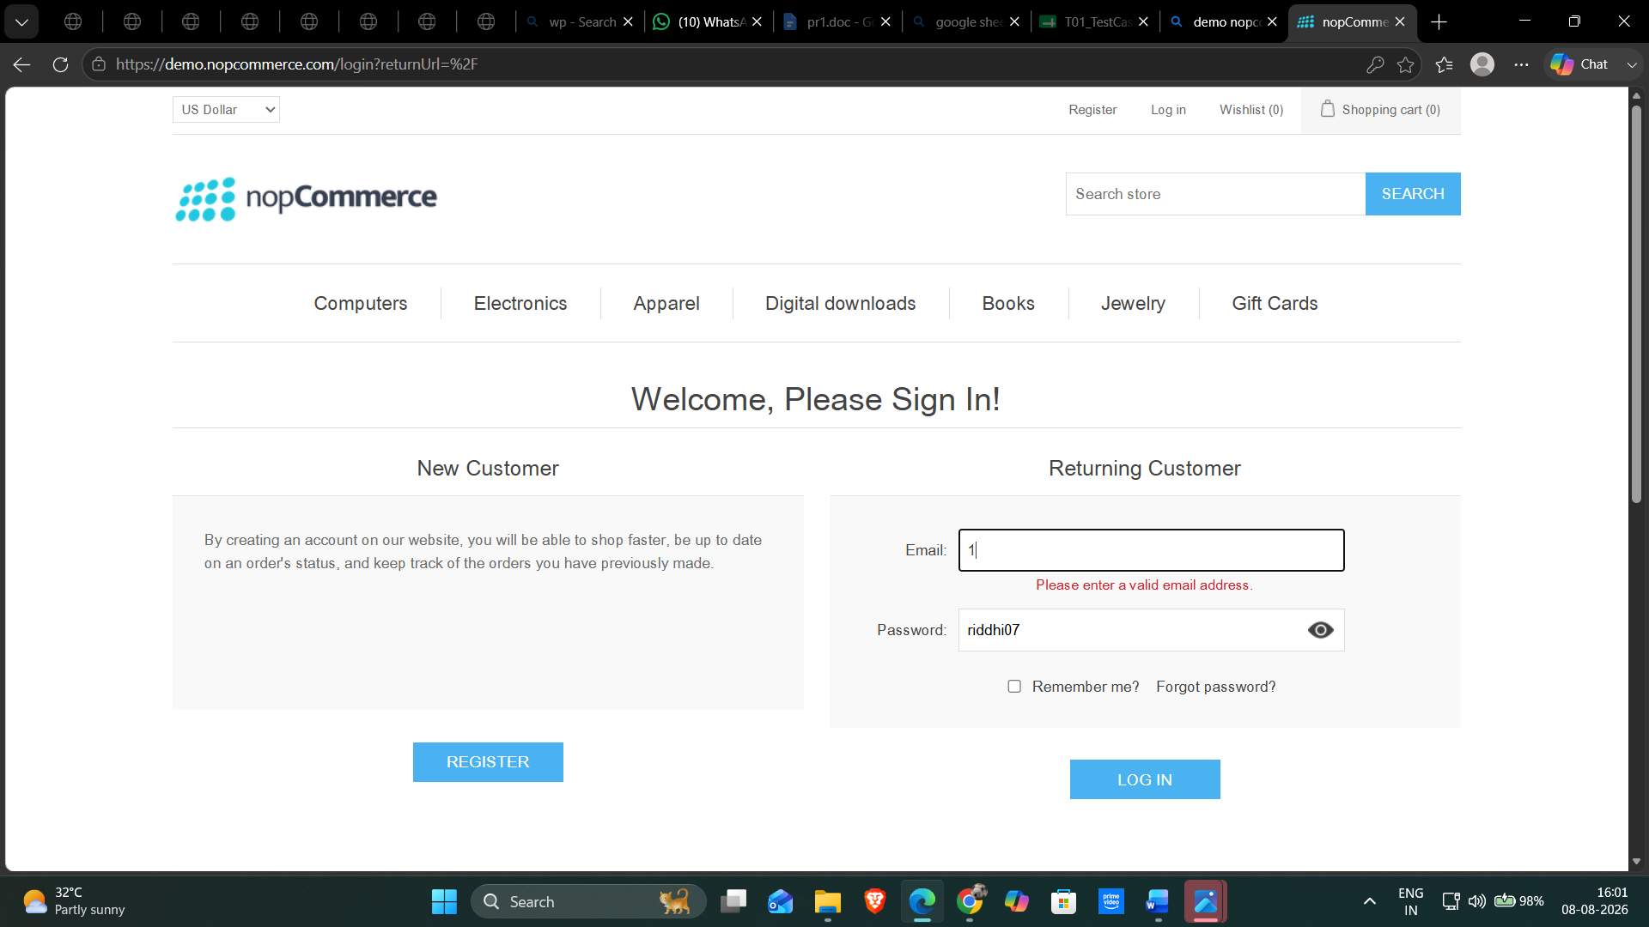
Test Case ID: TC06
Scenario: Verify login with invalid password
Steps:
1. Open nopCommerce website.
2. Click 'Log in'.
3. Enter a registered email and incorrect password.
4. Click 'Log in'.
Screenshot: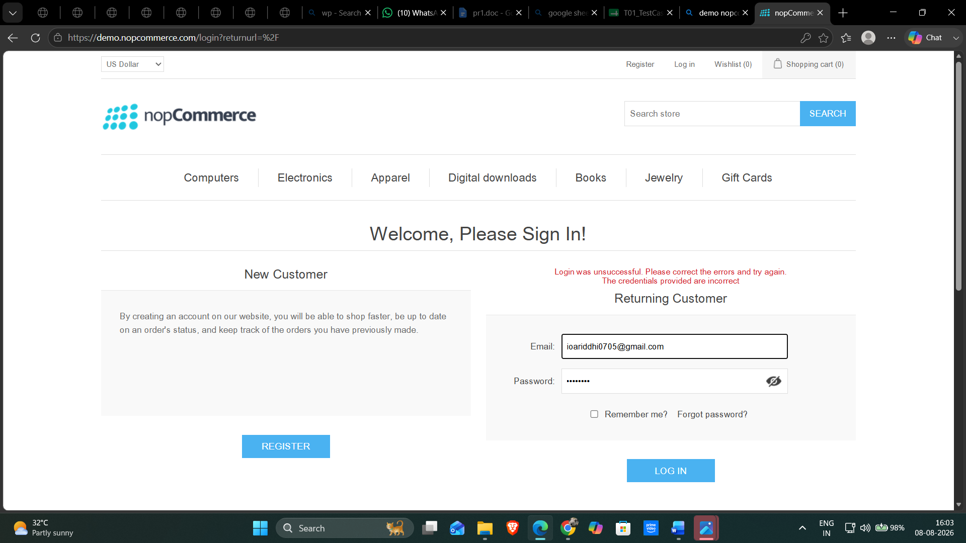
Test Case ID: TC07
Scenario: Verify login with blank email
Steps:
1. Open nopCommerce website.
2. Click 'Log in'.
3. Leave the email field blank.
4. Click 'Log in'.
Screenshot:
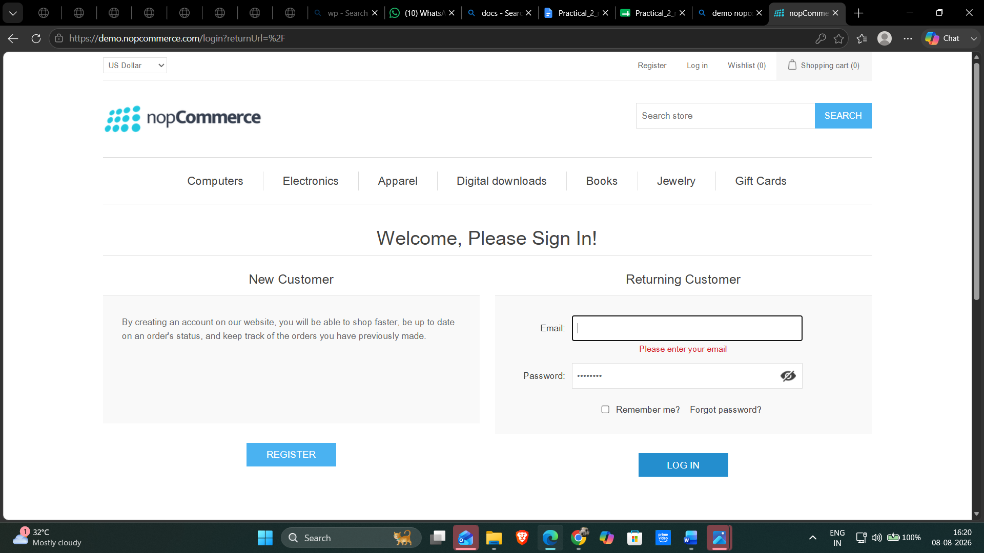

Test Case ID: TC08
Scenario: Verify user logout functionality
Steps:
1. Open nopCommerce website.
2. Click 'Log in'.
3. Enter valid email and password.
4. Click 'Log in'.
5. Click 'Log out'.
Screenshot:

Conclusion and Recommendations
Pass Rate:
100% – Application Working Successfully
Application Status:
All 8 test cases passed successfully.
Issues Found
TC08: The provided screenshot still shows the user logged in (My account / Log out), so the logout result is not verified.
TC08: The provided screenshot still shows the user logged in (My account / Log out), so the logout result is not verified.
Recommendations
1. Continue regression testing after application updates.
2. Perform cross-browser testing (Chrome, Edge, Firefox).
3. Conduct security testing for authentication features.
4. Perform performance testing with multiple users.
5. Regularly review login and session management.
Bug Report
All planned scenarios were executed successfully.
Field | Description
Bug ID | -
Title | No Critical Bug Found
Description | No functional issues were observed during testing.
Module | Login / Registration
Severity | -
Steps to Reproduce | -
Expected Result | Application should function correctly.
Actual Result | Application functioned as expected.

