Module Name: Product / Cart
Webpage URL: https://demo.nopcommerce.com/
Test Case ID: TC01
Scenario: Verify products are displayed
Steps:
1. Open nopCommerce website.
2. Observe the product listing.
3. Verify products are displayed.
Screenshot: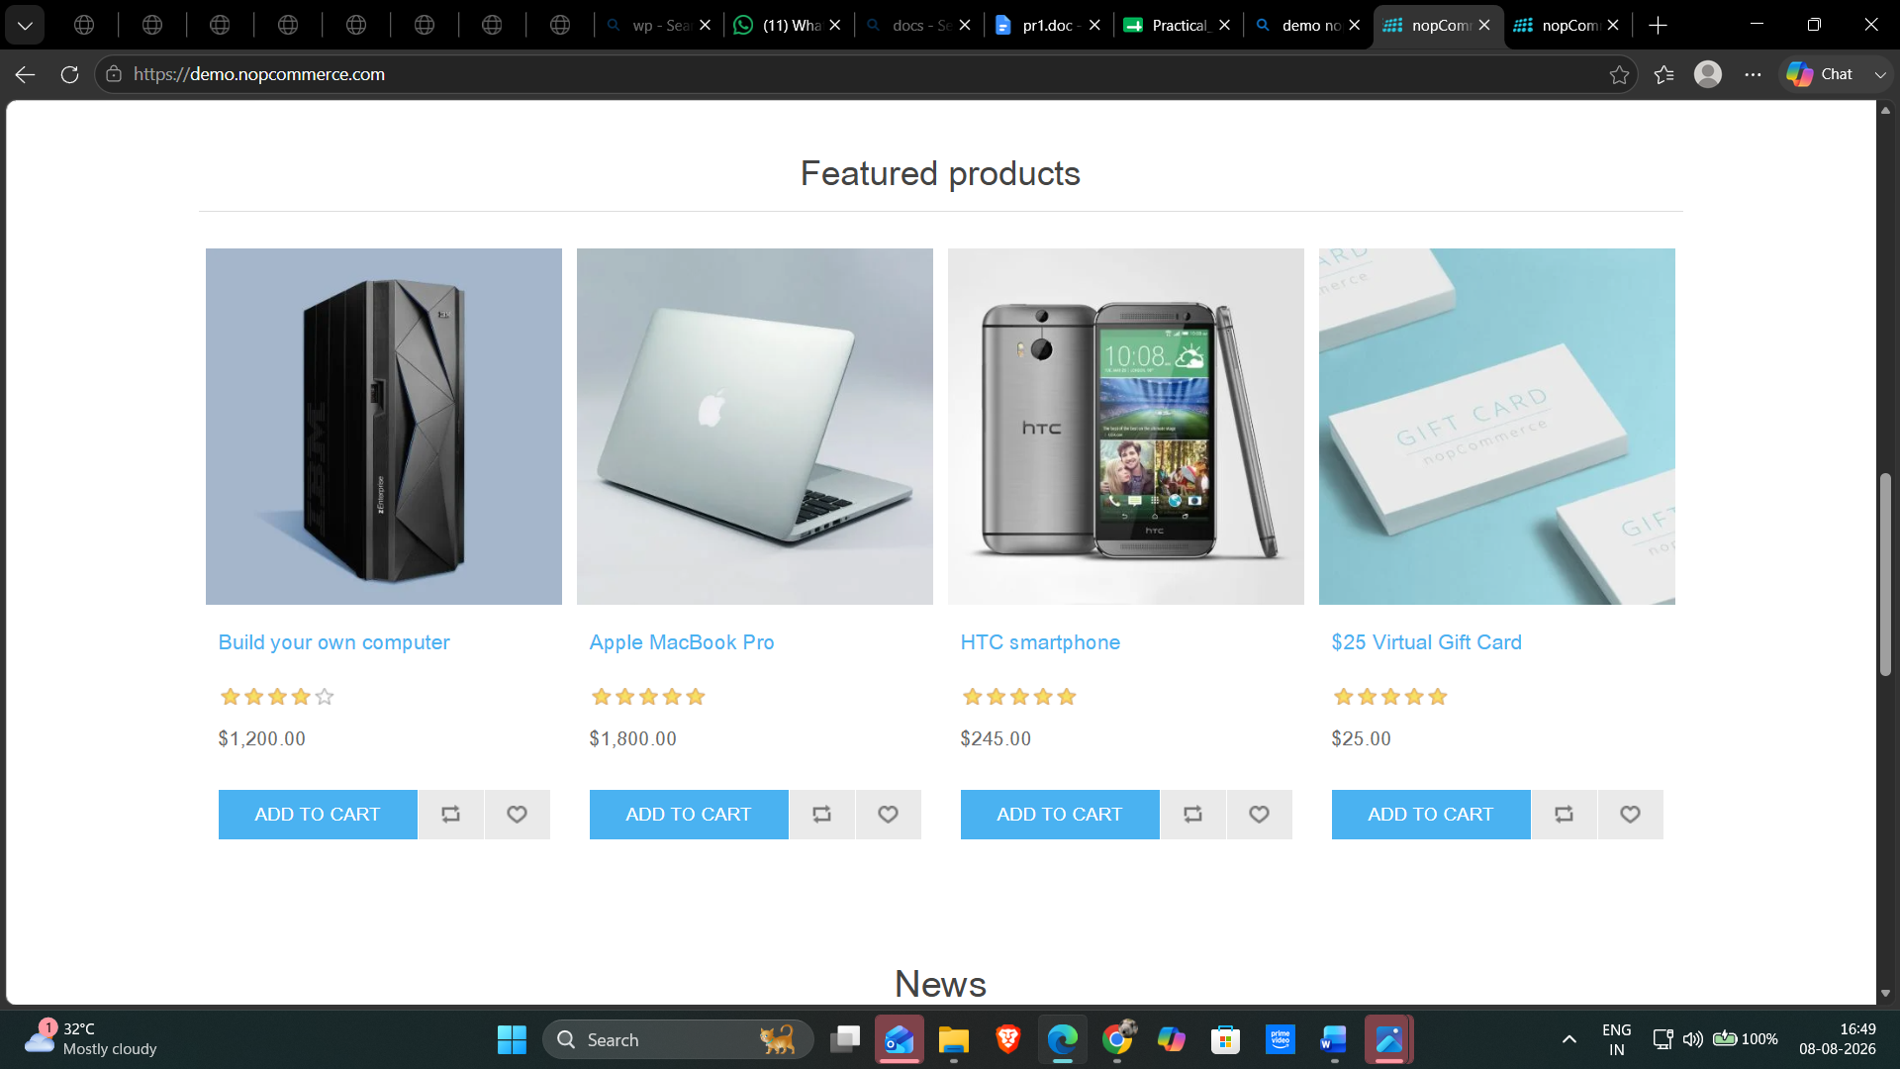
Test Case ID: TC02
Scenario: Verify product can be selected
Steps:
1. Open nopCommerce website.
2. Select a product.
3. Verify the product page opens.
Screenshot:

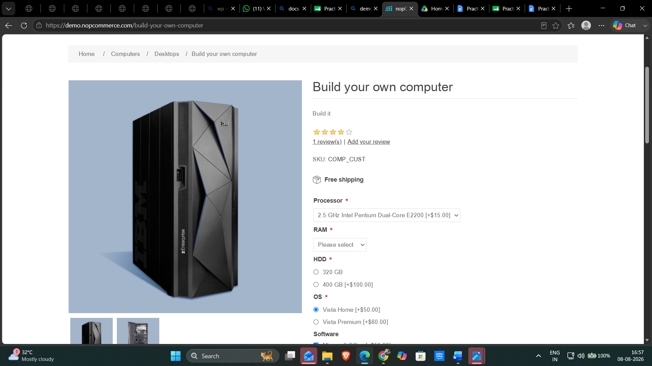
Test Case ID: TC03
Scenario: Verify product details
Steps:
1. Open nopCommerce website.
2. Select a product.
3. Verify the product details.
Screenshot: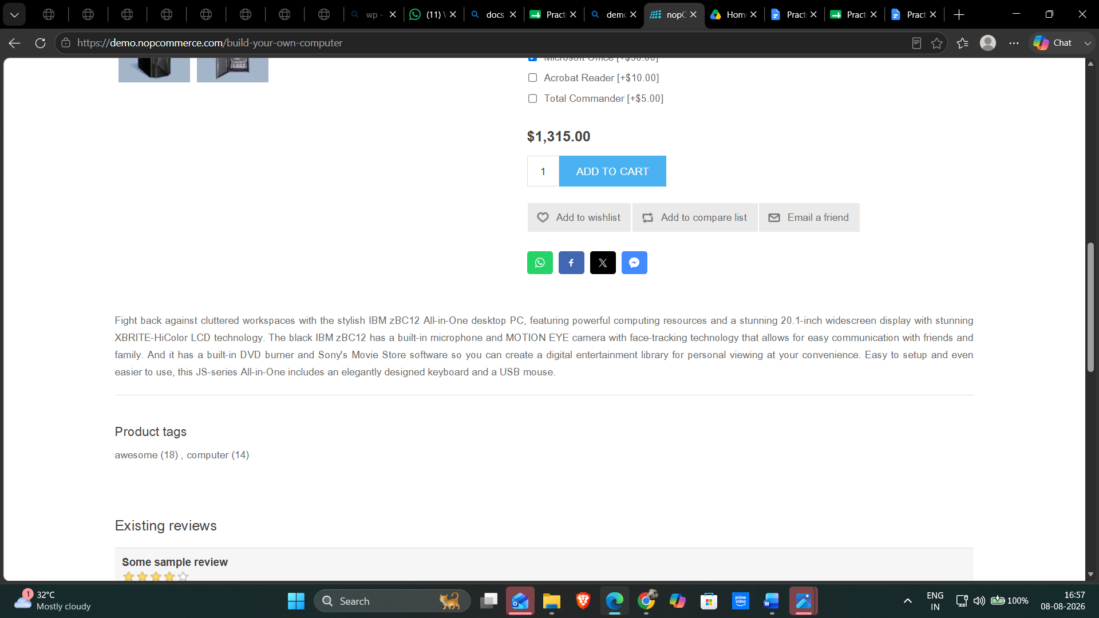

Test Case ID: TC04
Scenario: Verify product can be added to cart
Steps:
1. Open nopCommerce website.
2. Select a product.
3. Click 'Add to cart'.
Screenshot: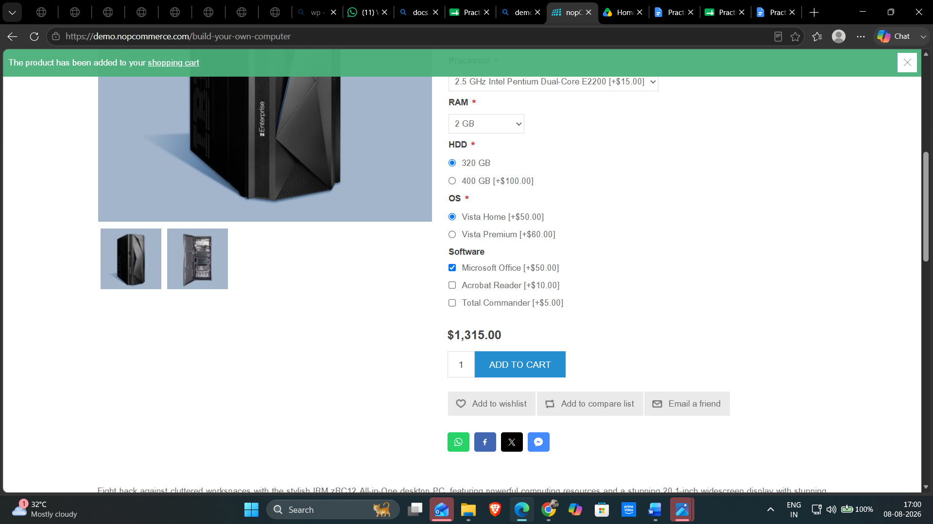

Test Case ID: TC05
Scenario: Verify cart can be opened
Steps:
1. Open nopCommerce website.
2. Add a product to the cart.
3. Click 'Shopping cart'.
Screenshot:
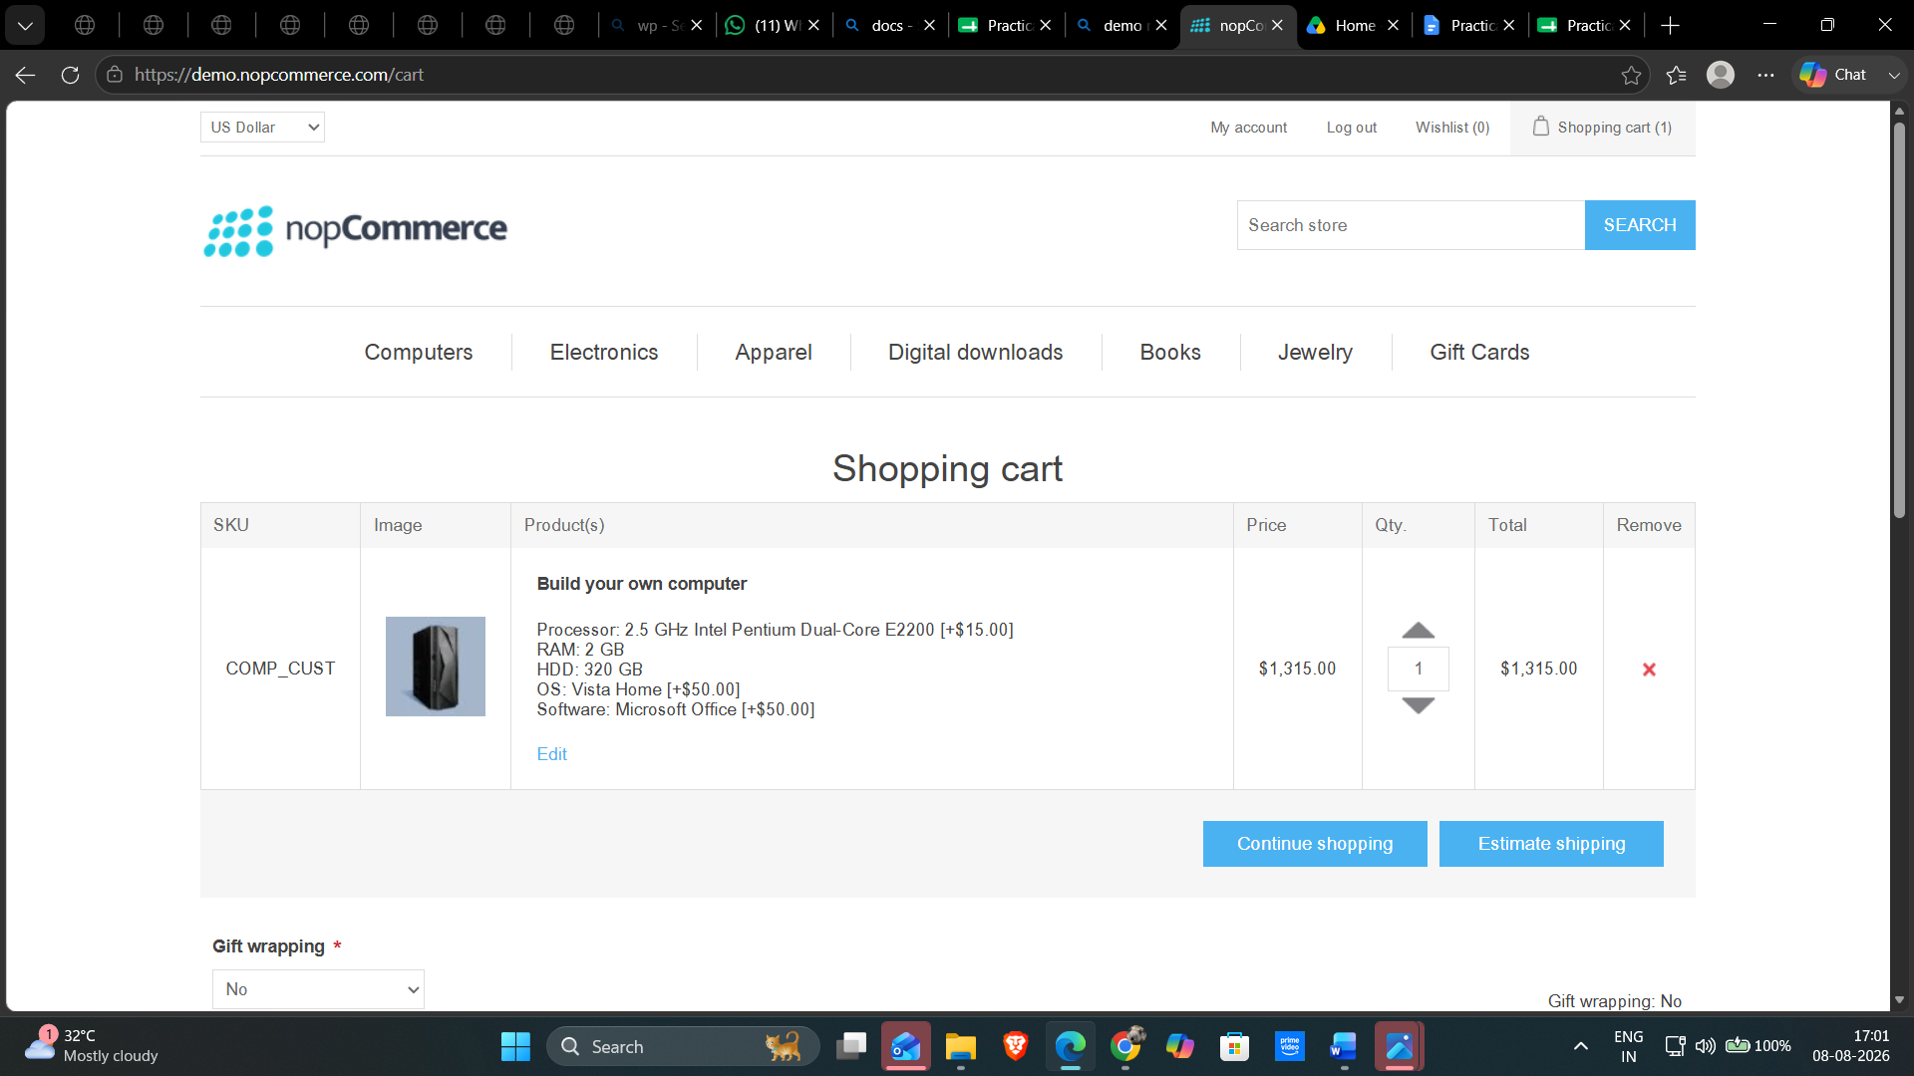

Test Case ID: TC06
Scenario: Verify product appears in cart
Steps:
1. Open nopCommerce website.
2. Add a product to the cart.
3. Open the Shopping Cart page.
4. Verify the added product.
Screenshot: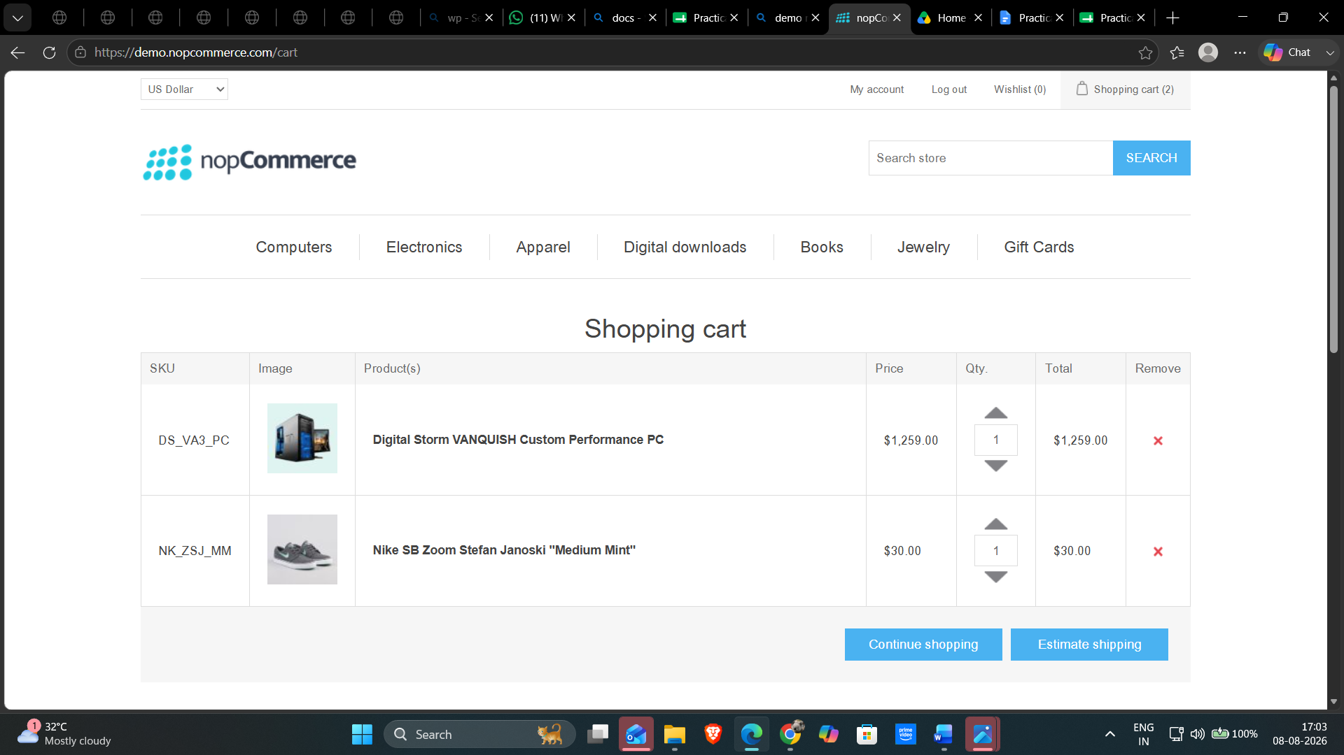

Test Case ID: TC07
Scenario: Verify product can be removed from cart
Steps:
1. Open nopCommerce website.
2. Add a product to the cart.
3. Open the Shopping Cart page.
4. Remove the product.
Screenshot: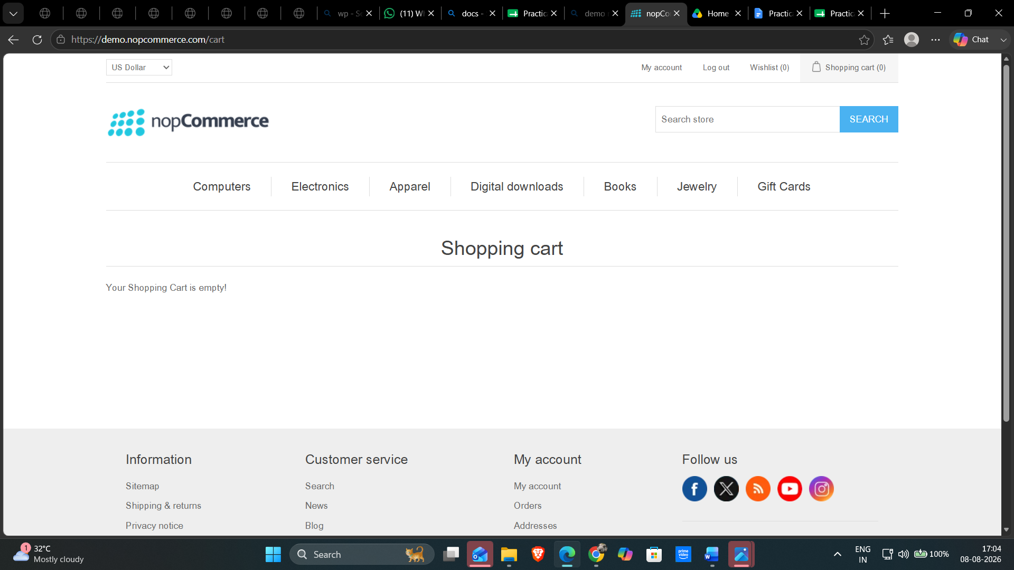

Requirement Review
Review the Product and Cart module requirements after execution.
Requirement | Clear / Unclear | Reason
User can view products | Clear | Products were visible on the homepage.
User can select a product | Clear | Selecting a product opened its product page.
User can view product details | Clear | Product name, price, options and description were displayed.
User can add product to cart | Clear | Add to cart showed a successful confirmation message.
User can open shopping cart | Clear | Shopping Cart page opened successfully.
User can verify product in cart | Clear | The selected product was listed in the cart.
User can remove product from cart | Clear | After removal, the cart displayed as empty.
Conclusion and Recommendations
Pass Rate: 100% – Application Working Successfully
Application Status: All 7 test cases passed successfully.
Issues Found
No functional issues were observed during testing.
No functional issues were observed during testing.
Recommendations
1. Continue regression testing after application updates.
2. Perform cross-browser testing (Chrome, Edge, Firefox).
3. Verify product and cart functionality after changes.
4. Perform usability testing for the Product and Cart module.
Bug Report
All planned Product / Cart scenarios were executed successfully. No functional issues were observed.
Field | Description
Bug ID | N/A
Title | No Critical Bug Found
Description | No functional issues were observed during testing.
Module | Product / Cart
Severity | N/A
Steps to Reproduce | N/A
Expected Result | Application should function correctly.
Actual Result | Application functioned as expected.

