Module Name: Search / Category / Checkout / Payment / UI
Webpage URL: https://demo.nopcommerce.com/
Test Case ID: TC01
Scenario: Verify product search with valid keyword
Steps:
1. Open nopCommerce website.
2. Enter a valid product keyword in the search box.
3. Click Search.
Screenshot: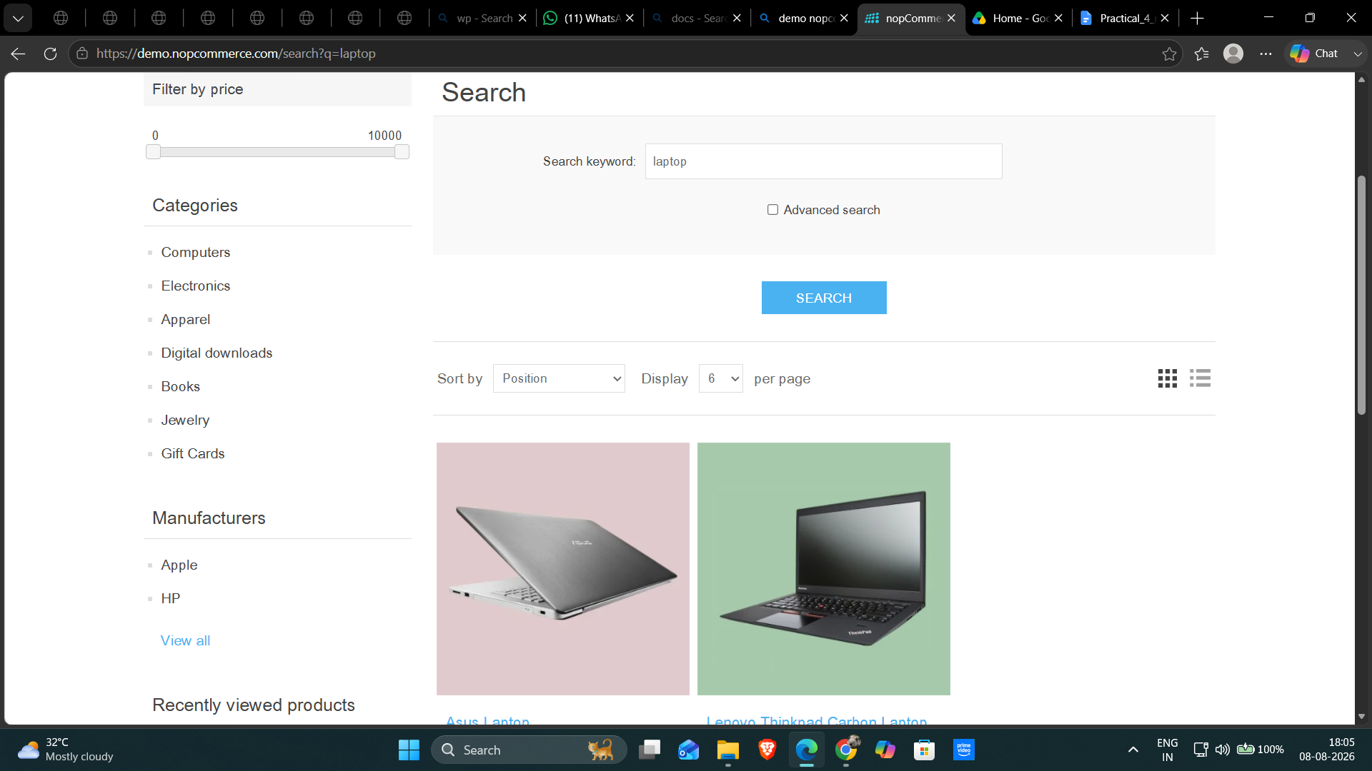

Test Case ID: TC02
Scenario: Verify product search with invalid keyword
Steps:
1. Open nopCommerce website.
2. Enter an invalid product keyword in the search box.
3. Click Search.
Screenshot:
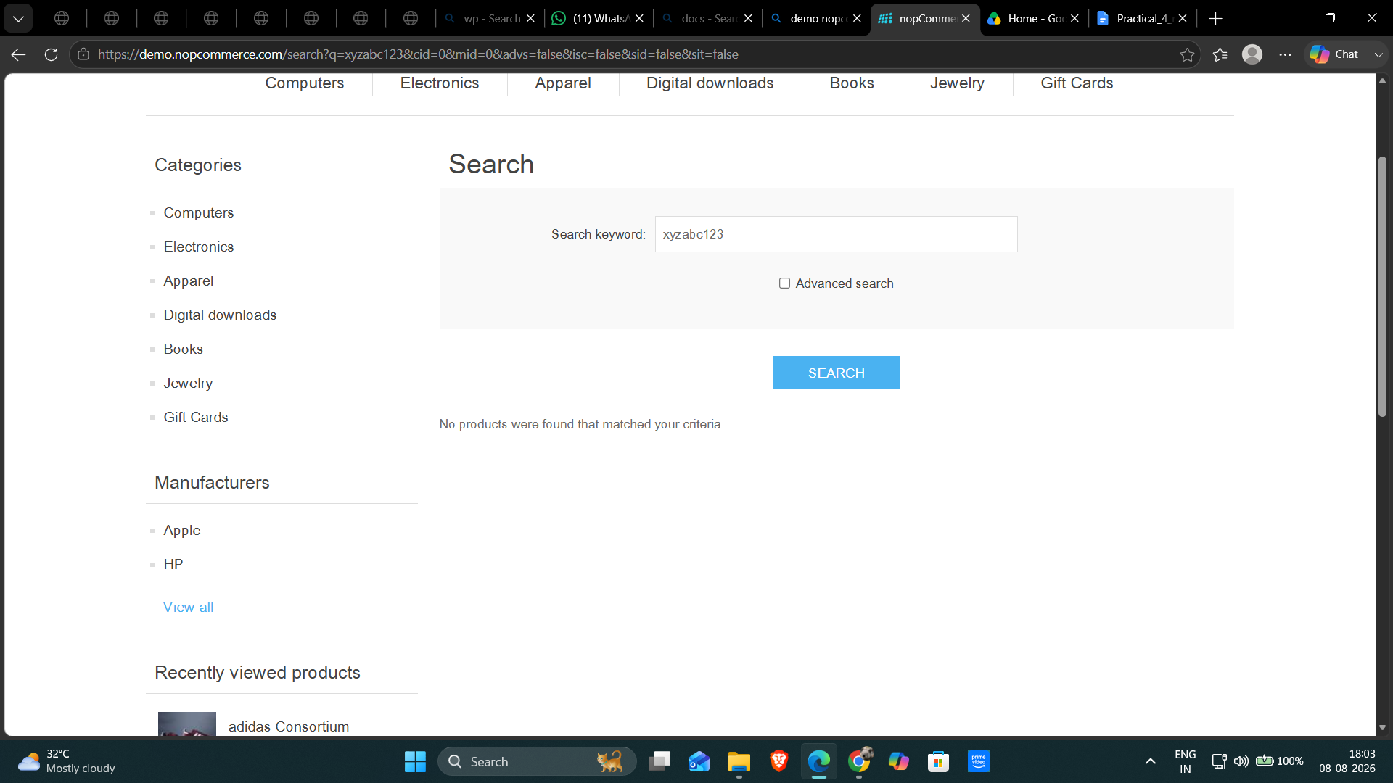

Test Case ID: TC03
Scenario: Verify category navigation
Steps:
1. Open nopCommerce website.
2. Select a product category.
3. Verify the category page.
Screenshot: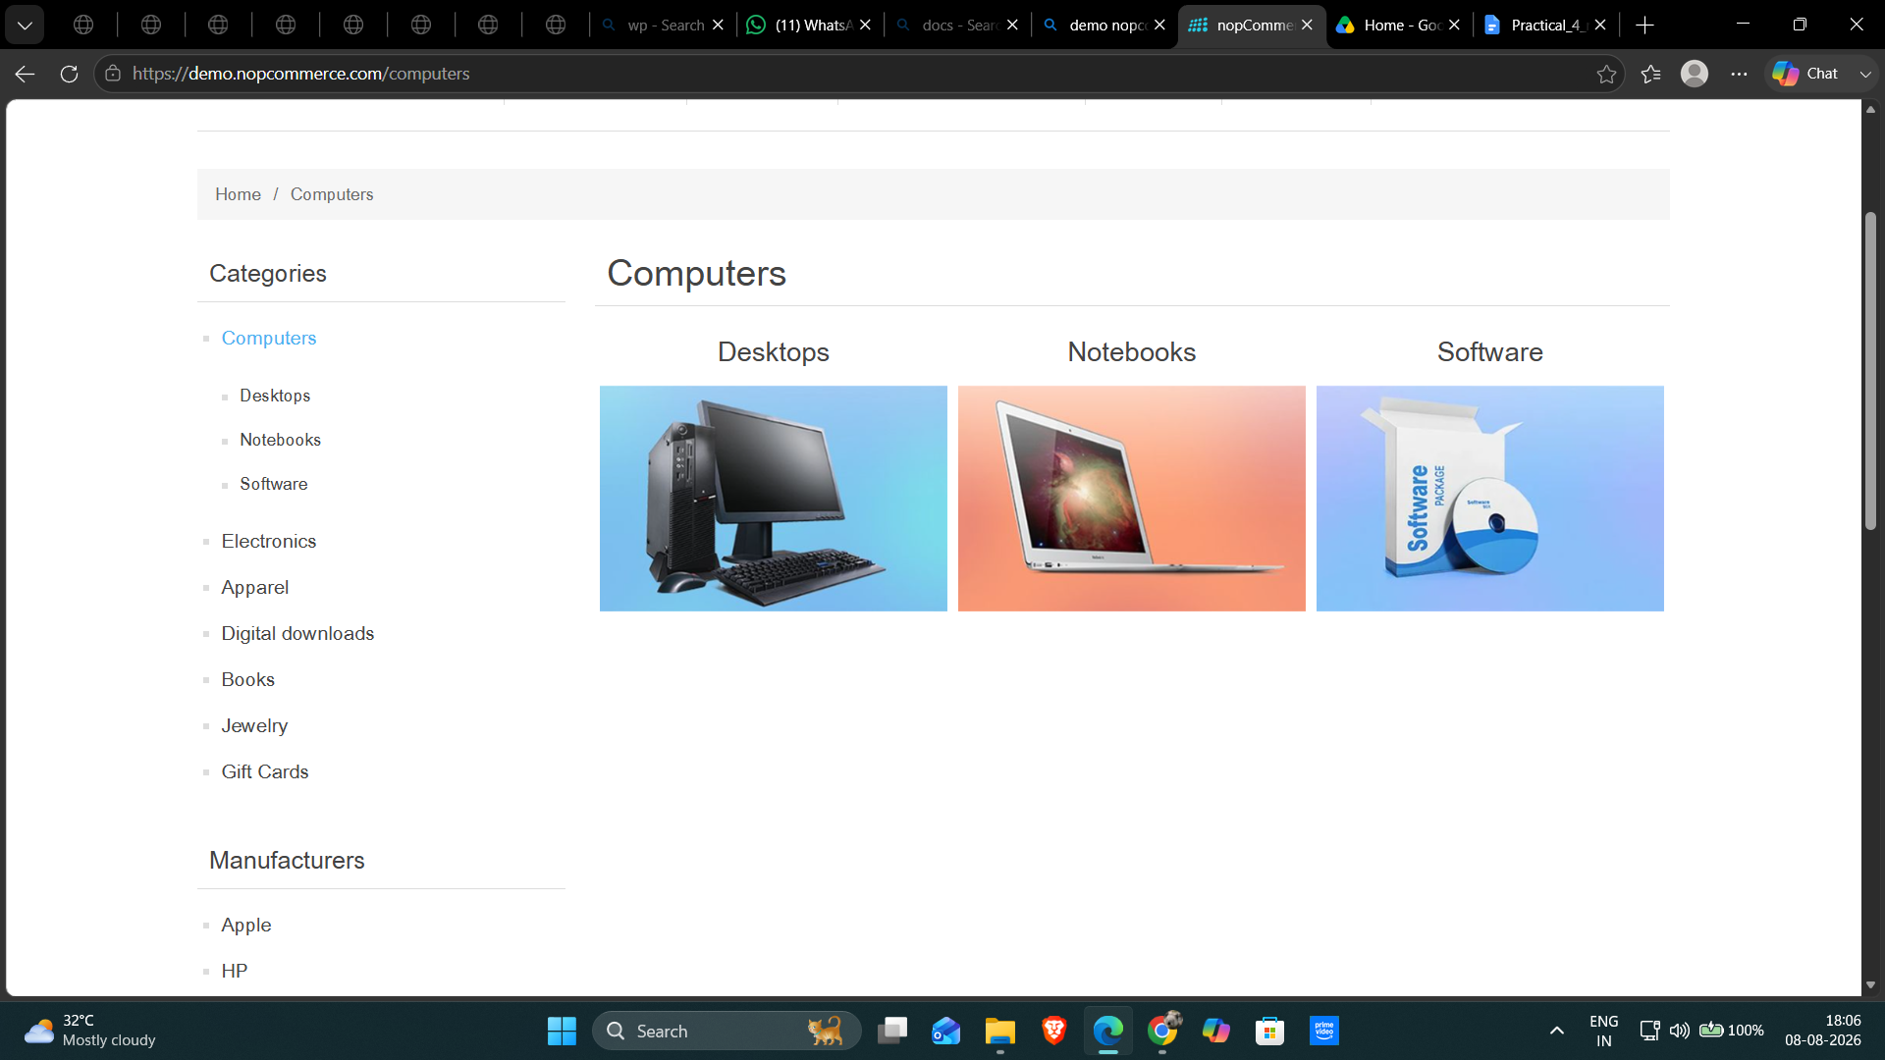

Test Case ID: TC04
Scenario: Verify checkout with valid details
Steps:
1. Open nopCommerce website.
2. Add a product to the cart.
3. Open the Shopping Cart page.
4. Click Checkout.
5. Enter valid checkout details.
Screenshot: 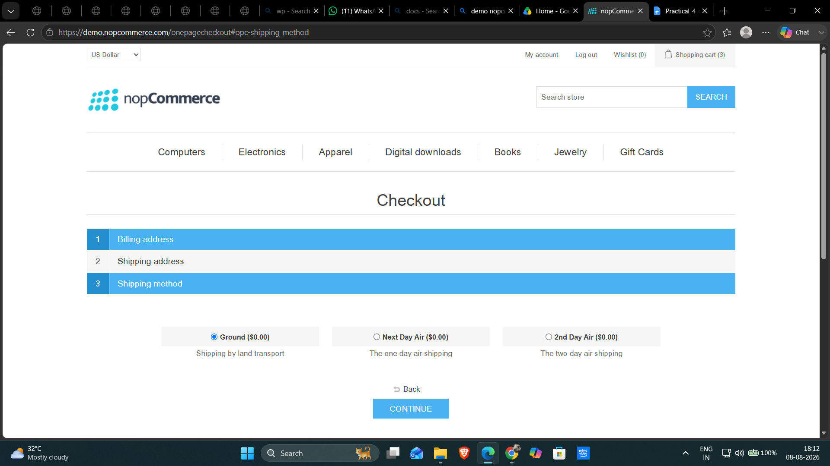

Test Case ID: TC05
Scenario: Verify checkout validation with missing required details
Steps:
1. Open nopCommerce website.
2. Add a product to the cart.
3. Open the Shopping Cart page.
4. Click Checkout.
5. Leave required details blank.
Screenshot:
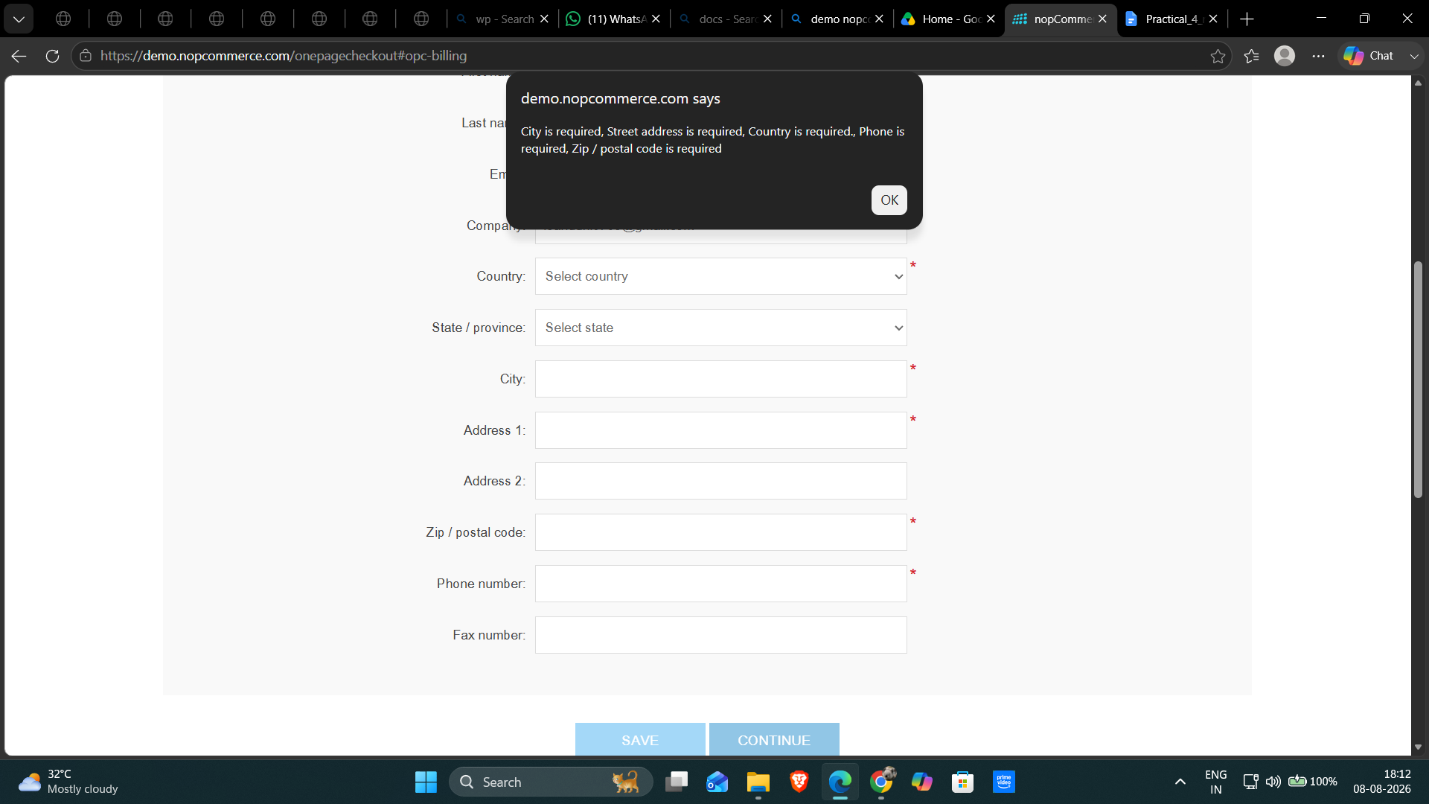

Test Case ID: TC06
Scenario: Verify payment method is displayed during checkout
Steps:
1. Open nopCommerce website.
2. Add a product to the cart.
3. Proceed to checkout.
4. Observe the payment method section.
Screenshot:
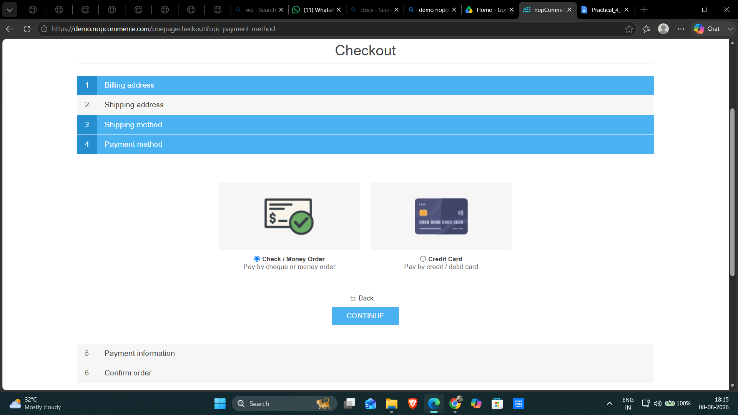

Test Case ID: TC07
Scenario: Verify checkout page loading performance
Steps:
1. Open nopCommerce website.
2. Add a product to the cart.
3. Open the Shopping Cart page.
4. Click Checkout.
5. Observe the checkout page loading.
Screenshot:
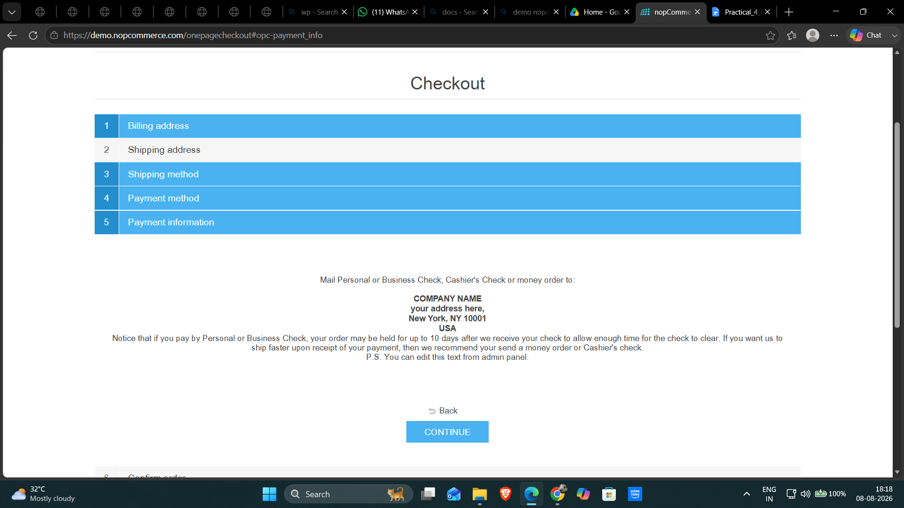
Test Case ID: TC08
Scenario: Verify cart total updates correctly after product quantity change
Steps:
1. Open nopCommerce website.
2. Add a product to the cart.
3. Open the Shopping Cart page.
4. Change the product quantity.
Screenshot: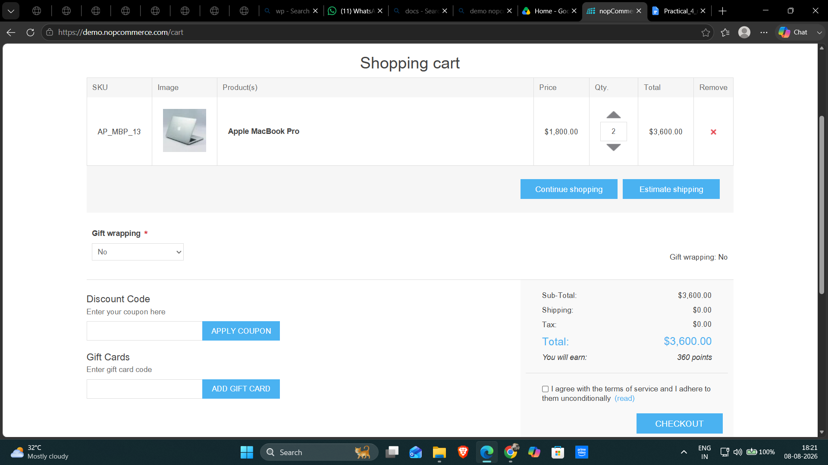
Test Case ID: TC09
Scenario: Verify checkout page layout and usability
Steps:
1. Open nopCommerce website.
2. Add a product to the cart.
3. Proceed to checkout.
4. Observe the checkout page layout and controls.
Screenshot:
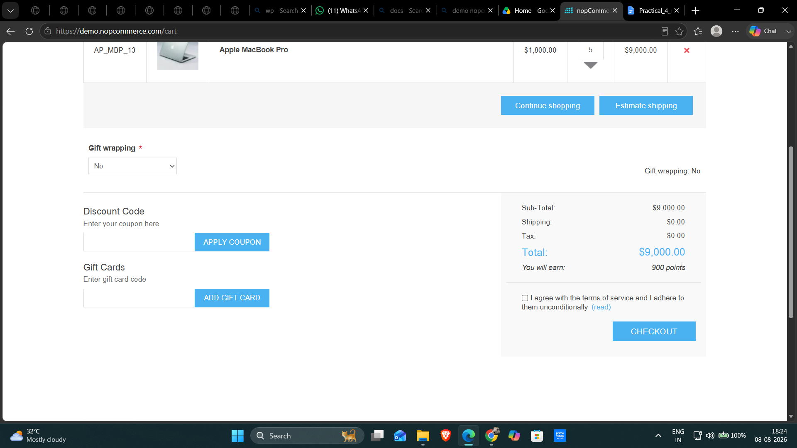

Test Case ID: TC10
Scenario: Verify website compatibility in different browsers
Steps:
1. Open nopCommerce website in Chrome.
2. Open nopCommerce website in Edge.
3. Open nopCommerce website in Firefox.
4. Compare the main checkout flow.
Screenshot:
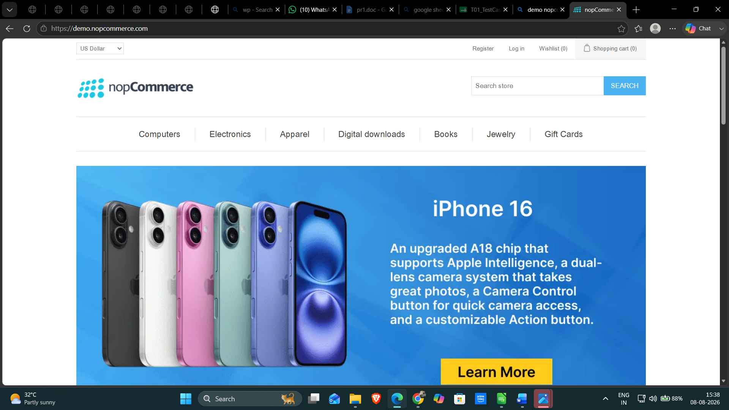
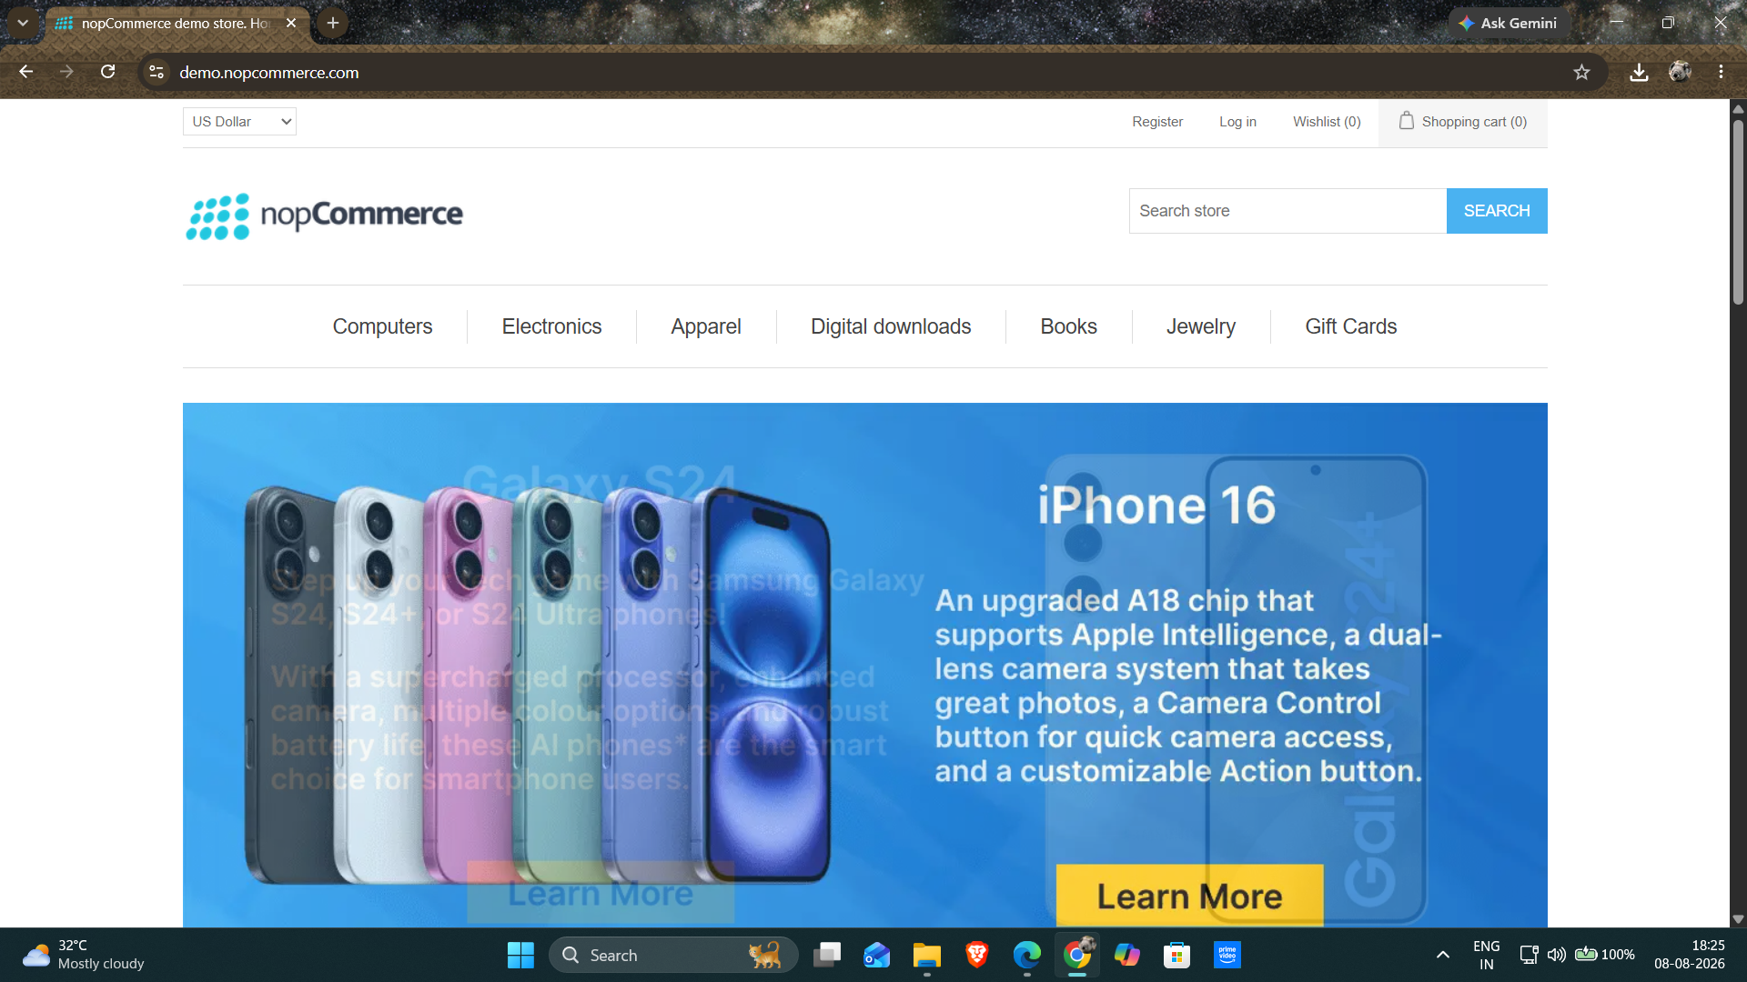
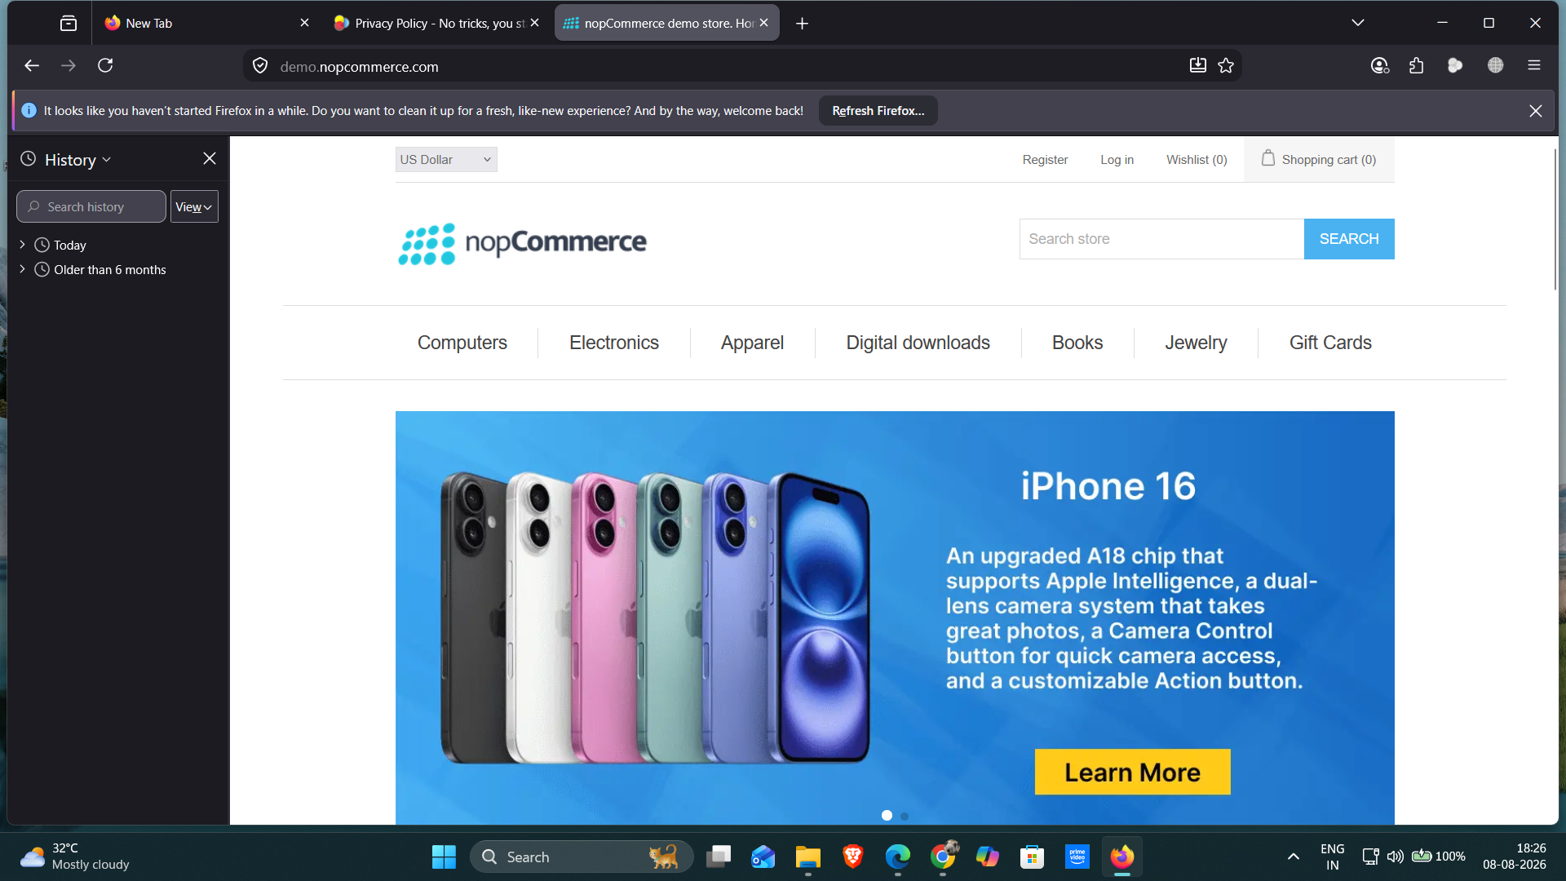

Conclusion and Recommendations
Pass Rate: 80% – 8 of 10 test cases verified as Passed.
Application functioned correctly for all verified scenarios.
Issues Found
No functional issues were observed in the verified scenarios.
Test Classification Summary
TCID | Test Case | Classification
TC01 | Verify product search with valid keyword | Functional / Positive
TC02 | Verify product search with invalid keyword | Functional / Negative
TC03 | Verify category navigation | Functional
TC04 | Verify checkout with valid details | Functional / Positive
TC05 | Verify checkout validation with missing required details | Functional / Negative
TC06 | Verify payment method is displayed during checkout | Functional / Positive
TC07 | Verify checkout page loading performance | Non-Functional
TC08 | Verify cart total updates correctly after product quantity change | Functional
TC09 | Verify checkout page layout and usability | Non-Functional / UI
TC10 | Verify website compatibility in different browsers | Non-Functional

Execution Result Summary
TCID | Actual Result | Status | Comment
TC01 | Matching products were displayed for the valid search keyword. | Pass | Valid search worked successfully.
TC02 | No matching products were displayed for the invalid search keyword. | Pass | Invalid keyword search behaved as expected.
TC03 | The Computers category page and category options were displayed. | Pass | Category navigation worked successfully.
TC04 | Checkout progressed to the checkout/shipping stage after valid details. | Pass | Valid checkout flow progressed successfully.
TC05 | Required-field validation was displayed when required checkout details were left blank. | Pass | Missing required details were validated.
TC06 | Payment methods were displayed during checkout. | Pass | Payment method section was displayed.
TC07 | Checkout page loaded successfully; exact loading time was not recorded in the screenshot evidence. | Not Verified | Performance cannot be fully verified without a measured loading time.
TC08 | Cart quantity and total updated from 2/$3,600 to 5/$9,000. | Pass | Cart total updated correctly with quantity change.
TC09 | No screenshot/evidence for the checkout layout and usability test is present in the uploaded document. | Not Verified | Needs execution evidence before marking Pass.
TC10 | nopCommerce was shown in Chrome, Edge, and Firefox screenshots. | Pass | Basic cross-browser appearance was verified.

