Module Name: Defect Identification and Bug Reports
Webpage URL: https://demo.nopcommerce.com/
Test Case ID: TC01
Scenario: Verify invalid product search handling
Steps:
1. Open nopCommerce website.
2. Enter an invalid keyword such as xyzabc123 in the search box.
3. Click Search.
4. Observe the search result.
Screenshot:
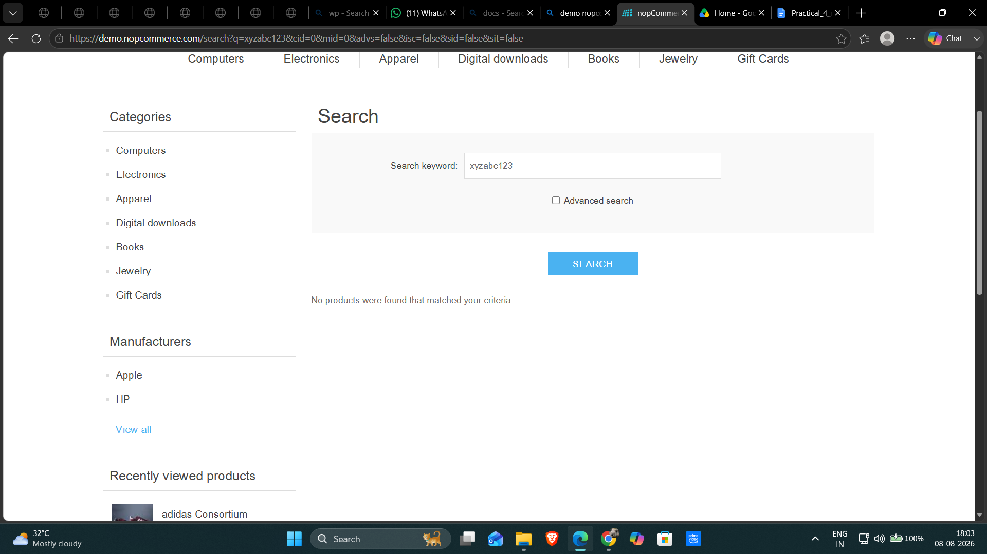

Test Case ID: TC02
Scenario: Verify required checkout field validation
Steps:
1. Open nopCommerce website.
2. Add a product to the cart.
3. Open the Shopping Cart page.
4. Click Checkout.
5. Leave a required checkout field blank.
6. Continue checkout.
Screenshot: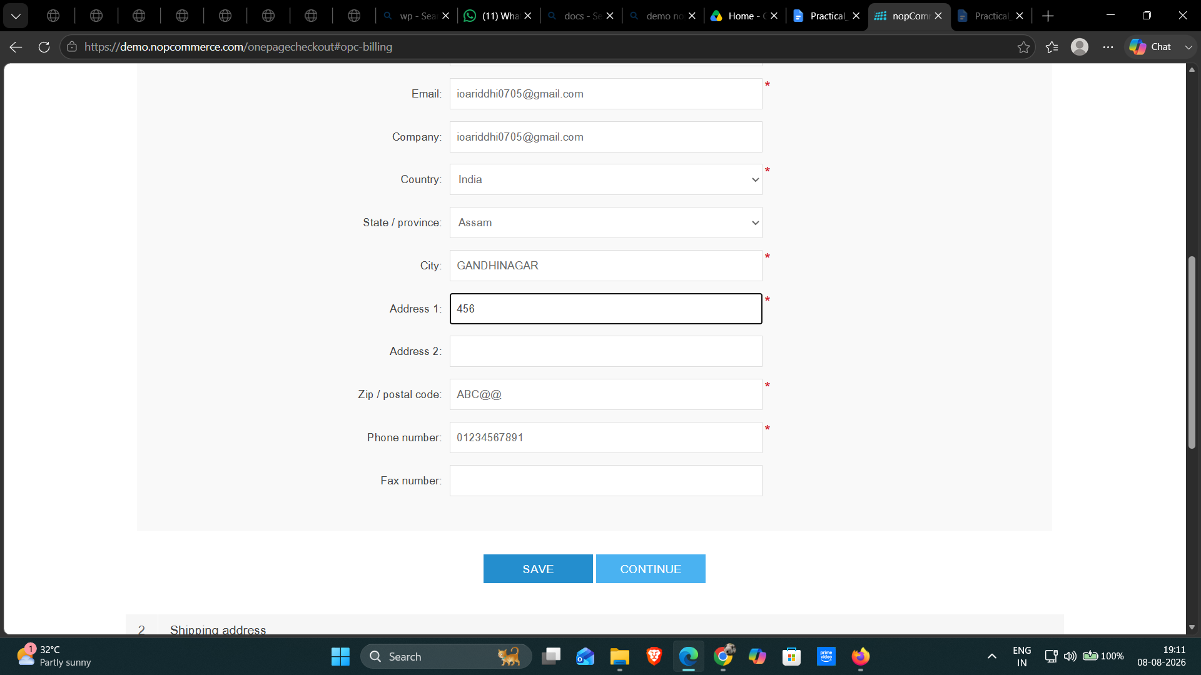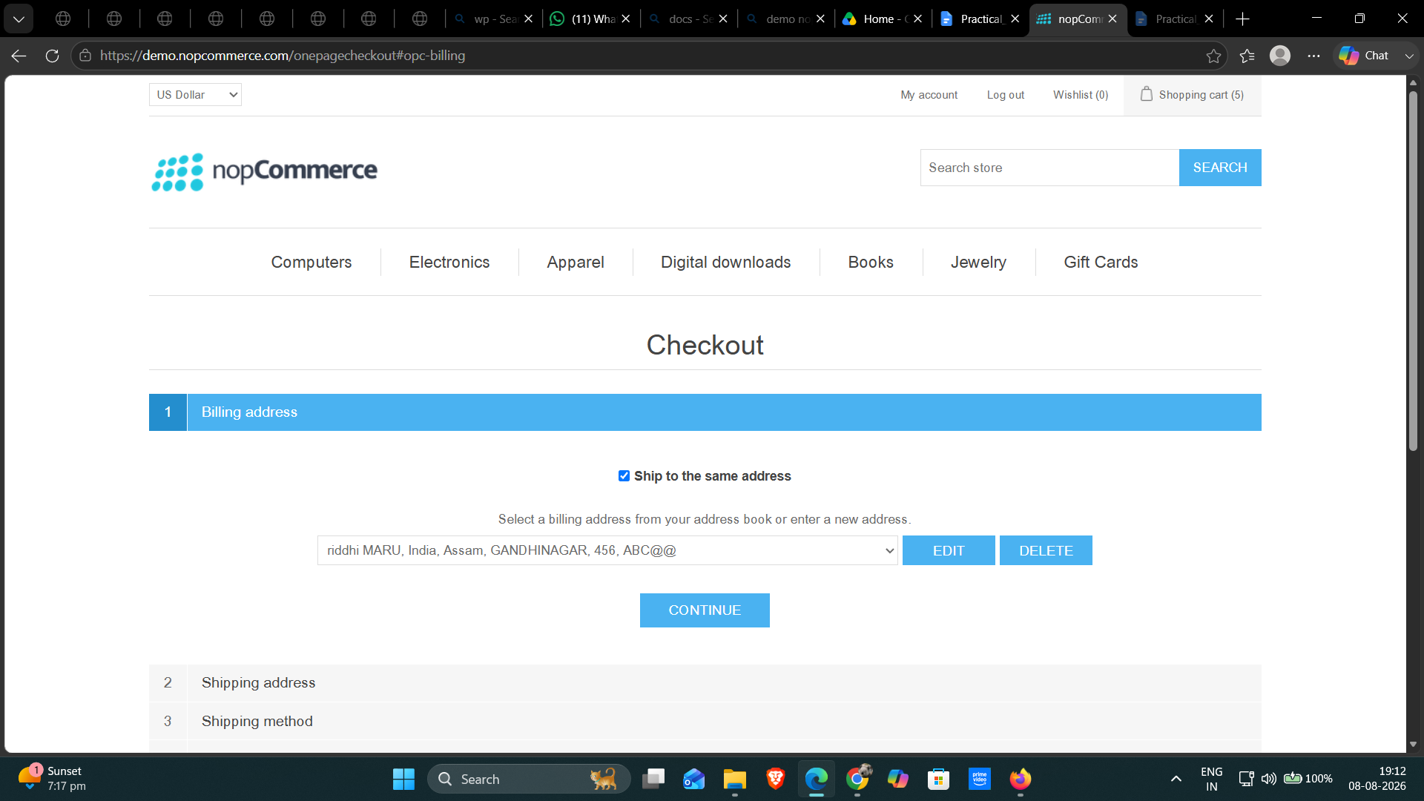

Test Case ID: TC03
Scenario: Verify cart total after quantity change
Steps:
1. Open nopCommerce website.
2. Add a product to the cart.
3. Open the Shopping Cart page.
4. Change the product quantity.
5. Observe the cart total.
Screenshot:
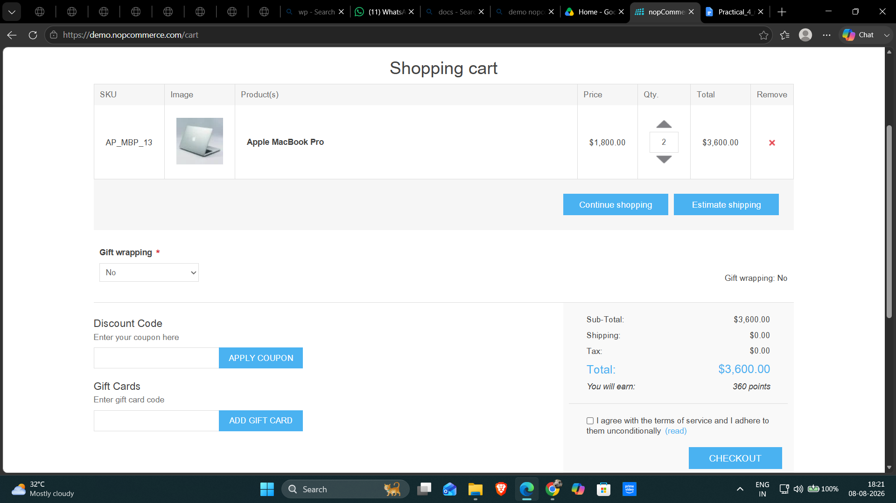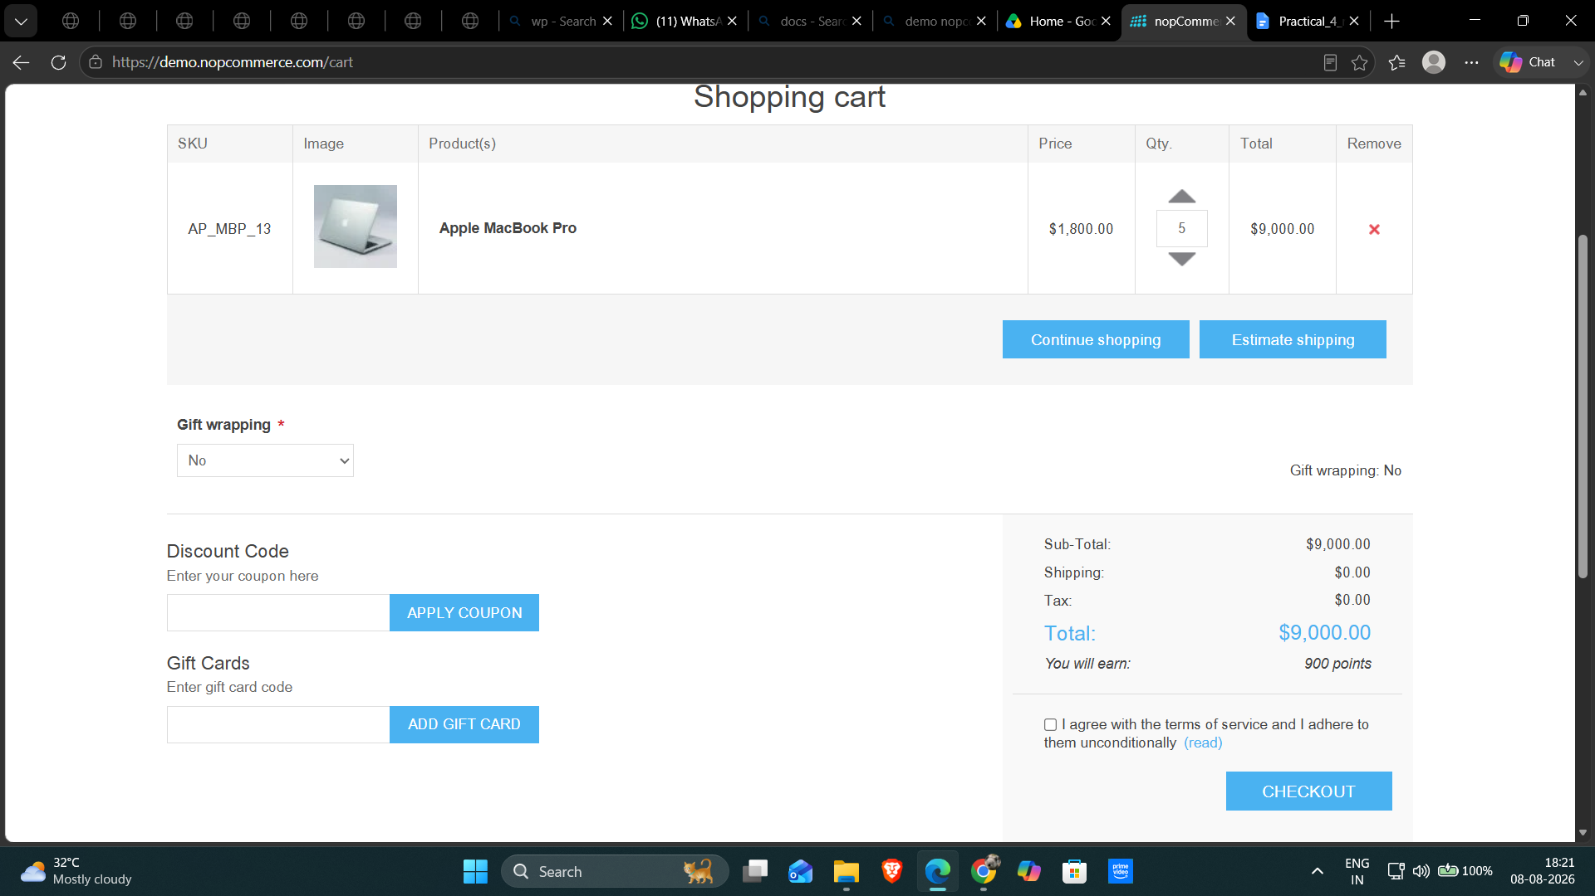

Test Case ID: TC04
Scenario: Verify checkout layout on smaller screen
Steps:
1. Open nopCommerce website.
2. Add a product to the cart.
3. Proceed to checkout.
4. Resize the browser to a smaller viewport.
5. Observe the checkout fields and controls.
Screenshot:
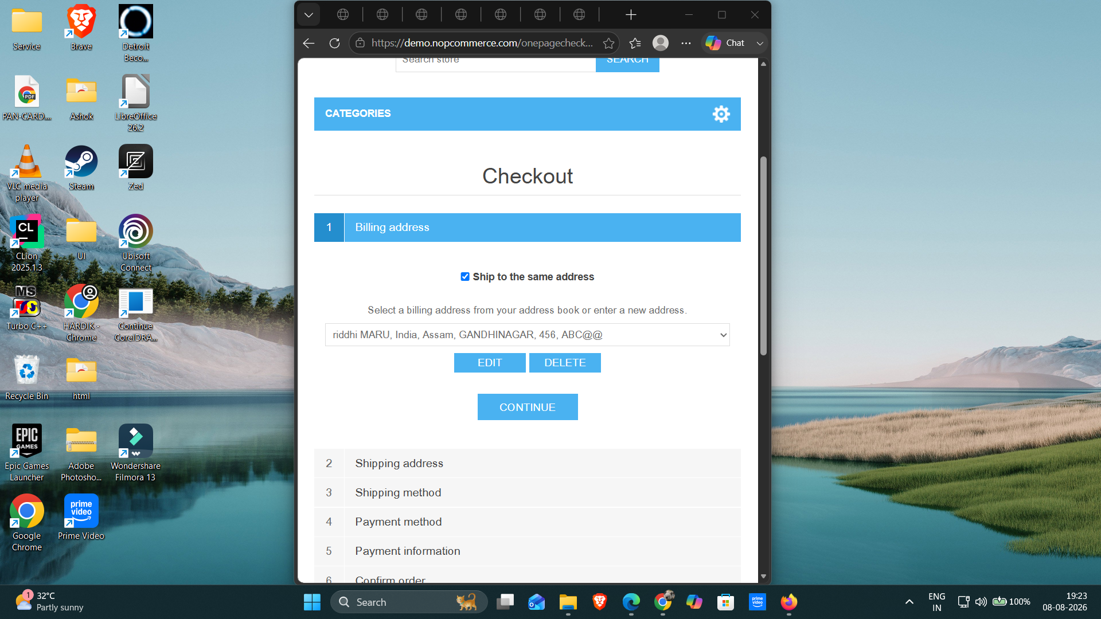

Test Case ID: TC05
Scenario: Verify payment option handling
Steps:
1. Open nopCommerce website.
2. Add a product to the cart.
3. Proceed to checkout.
4. Observe the payment method section.
5. Continue with the available payment option.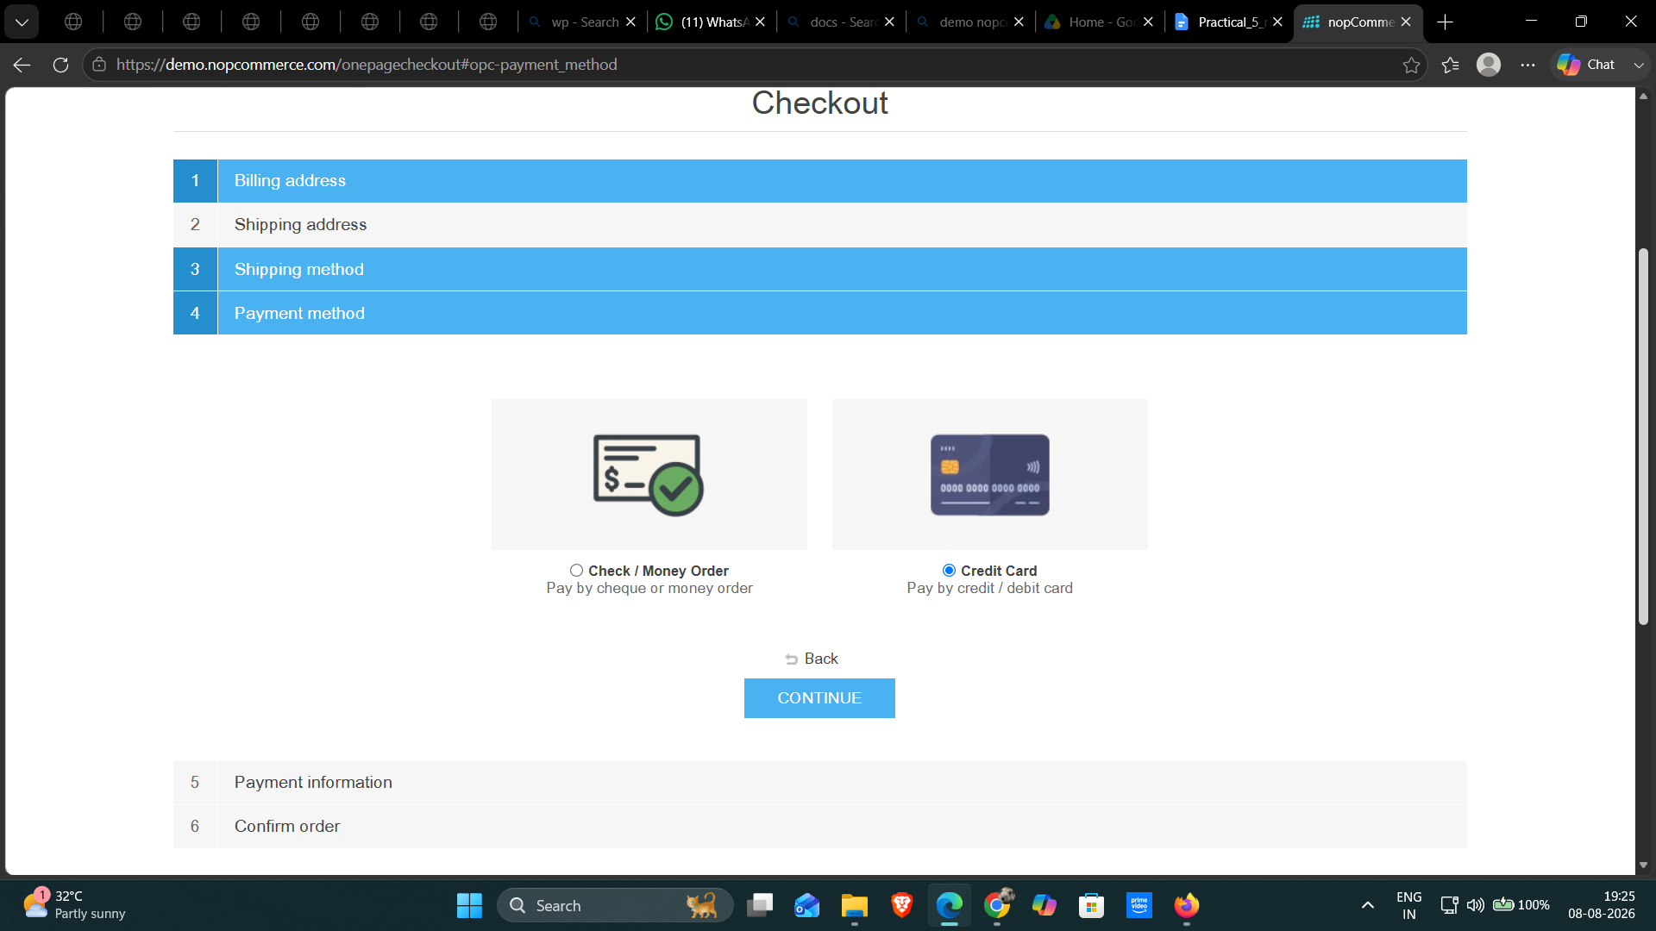
Screenshot: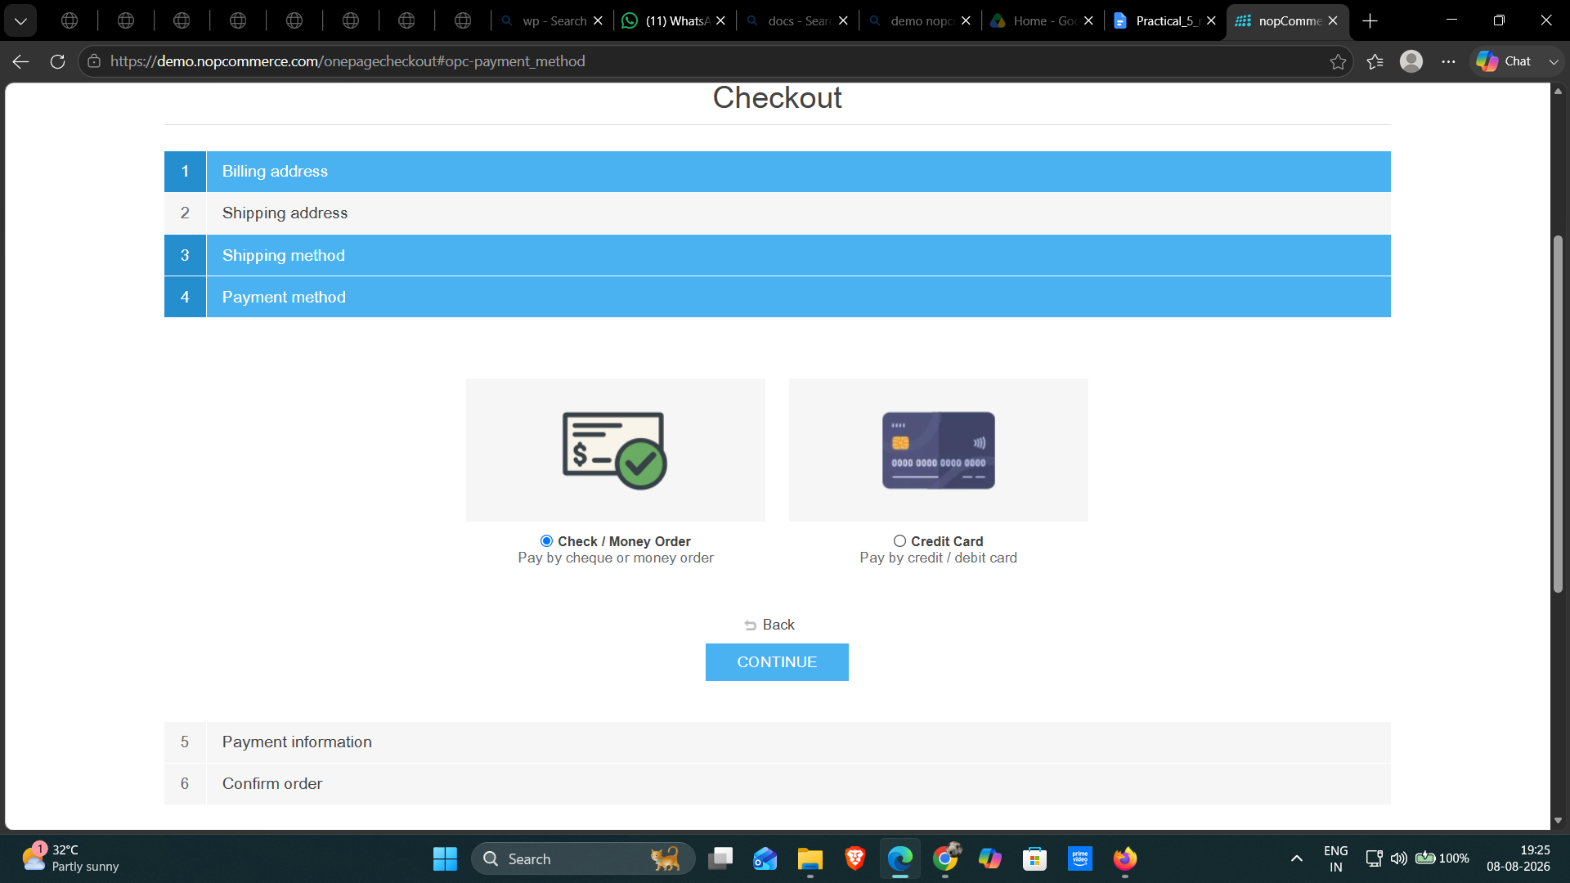
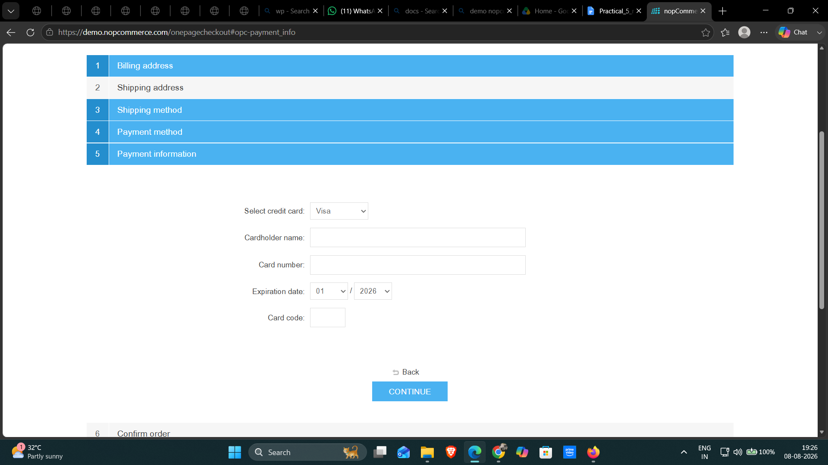

Bug Report
Field | Description
Bug ID | BUG-001
Title | Invalid characters accepted in ZIP / Postal Code field
Module | Checkout / Billing Address
Severity | Medium
Priority | High
Steps to Reproduce | 1. Open nopCommerce website.  2. Add a product to the cart.  3. Proceed to Checkout.  4. Enter ABC@@ in the ZIP / Postal Code field.  5. Enter the remaining required billing details.  6. Click Save.  7. Continue checkout.
Expected Result | The system should reject the invalid ZIP / Postal Code and display a validation message.
Actual Result | The system accepted ABC@@ as the ZIP / Postal Code and saved it in the billing address.
Screenshot | See attached screenshots below.
Status | Open
Bug Evidence Screenshots
Screenshot 1 – Invalid ZIP / Postal Code entered as ABC@@
Screenshot 2 – Invalid ZIP / Postal Code saved in billing address
Conclusion and Recommendations
Application Status: Application functioned successfully for all executed test cases.
Pass Rate: 100% – All test cases passed.
Issues Found
BUG-001: Invalid characters accepted in ZIP / Postal Code field.
Severity: Medium | Priority: High | Status: Open

Recommendations
1. Validate ZIP / Postal Code according to the selected country.
2. Reject invalid characters where a numeric postal code is required.
3. Display a clear validation message for invalid postal codes.
4. Retest the defect after the fix.
5. Perform regression testing on checkout and billing address fields.

