Module Name: Product Review Module
Webpage URL: https://demo.nopcommerce.com/
Test Case ID: TC01
Scenario: Verify product review submission with valid input
Steps:
1. Open nopCommerce website.
2. Open a product page.
3. Open the product review section.
4. Enter/select the test condition: Valid review text + valid rating.
5. Submit the review.
6. Observe the result.

Screenshot:

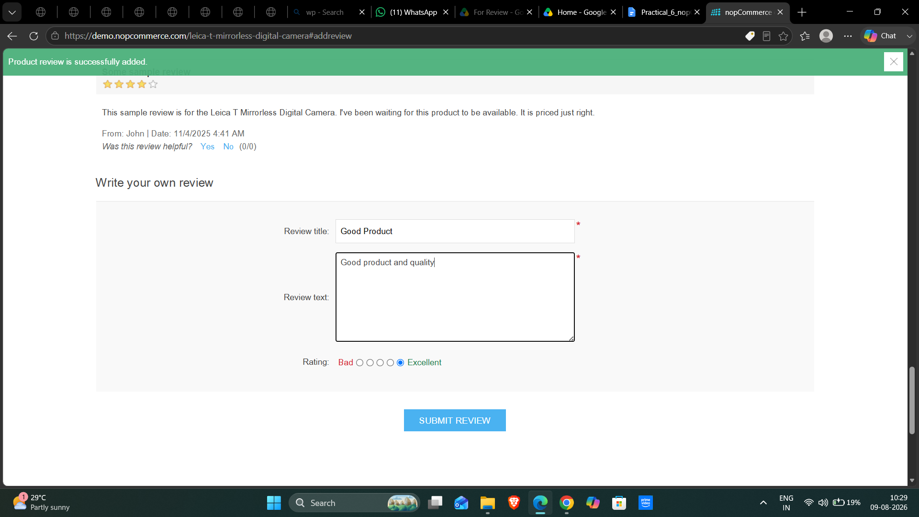

Test Case ID: TC02
Scenario: Verify product review with blank review title
Steps:
1. Open nopCommerce website.
2. Open a product page.
3. Open the product review section.
4. Leave the Review Title blank, enter valid Review Text, and select Excellent rating.
5. Submit the review.
6. Observe the result.
Screenshot:
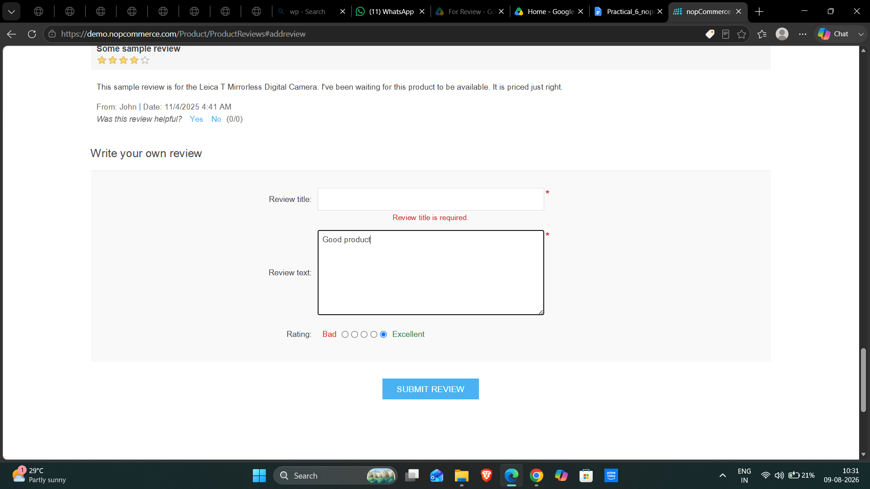

Test Case ID: TC03
Scenario: Verify product review with blank review text
Steps:
1. Open nopCommerce website.
2. Open a product page.
3. Open the product review section.
4. Enter a valid Review Title, leave Review Text blank, and select Excellent rating.
5. Submit the review.
6. Observe the result.

Screenshot: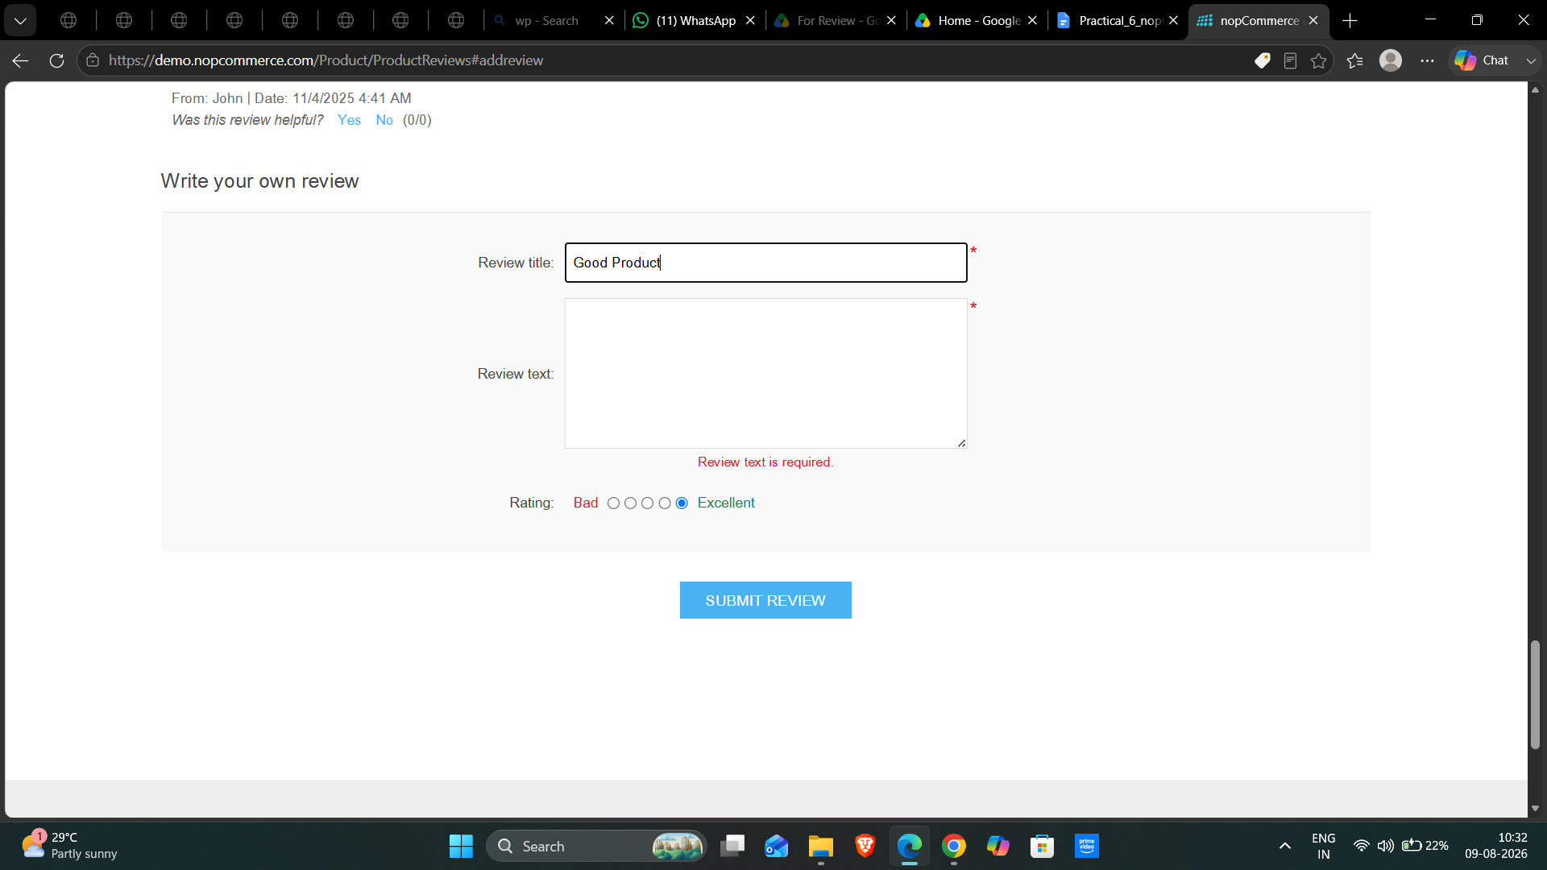

Test Case ID: TC04
Scenario: Verify product review with blank review and rating
Steps:
1. Open nopCommerce website.
2. Open a product page.
3. Open the product review section.
4. Enter/select the test condition: Blank review + blank rating.
5. Submit the review.
6. Observe the result.

Screenshot: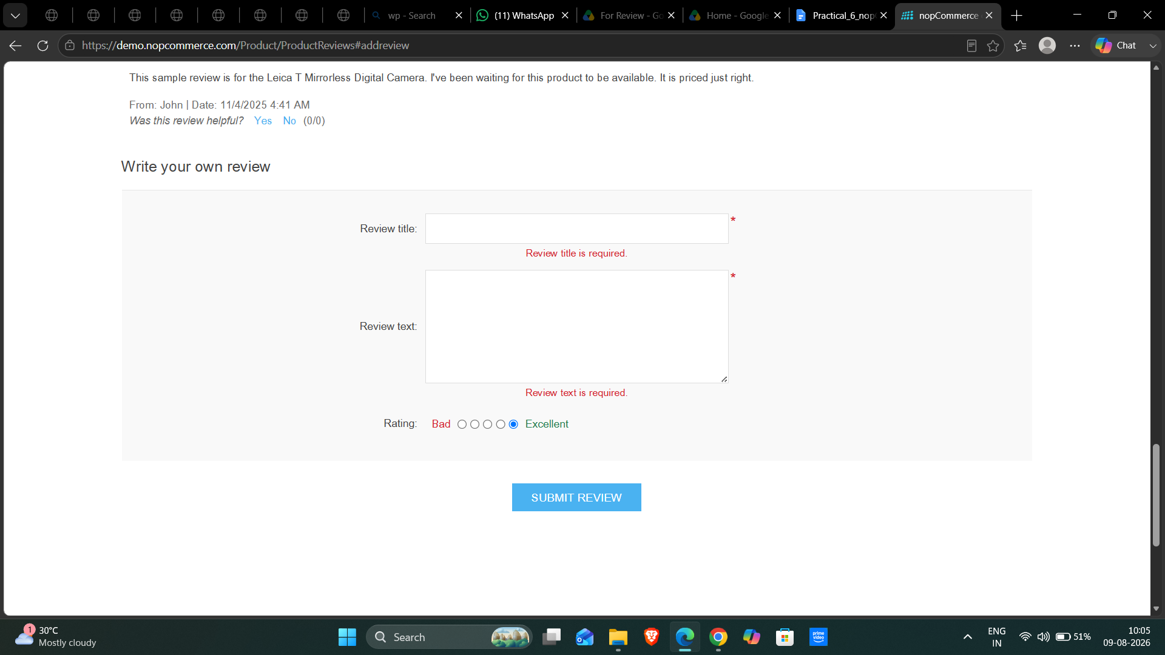
Test Case ID: TC05
Scenario: Verify product review with special characters
Steps:
1. Open nopCommerce website.
2. Open a product page.
3. Open the product review section.
4. Enter/select the test condition: @@@###$$$.
5. Submit the review.
6. Observe the result.

Screenshot: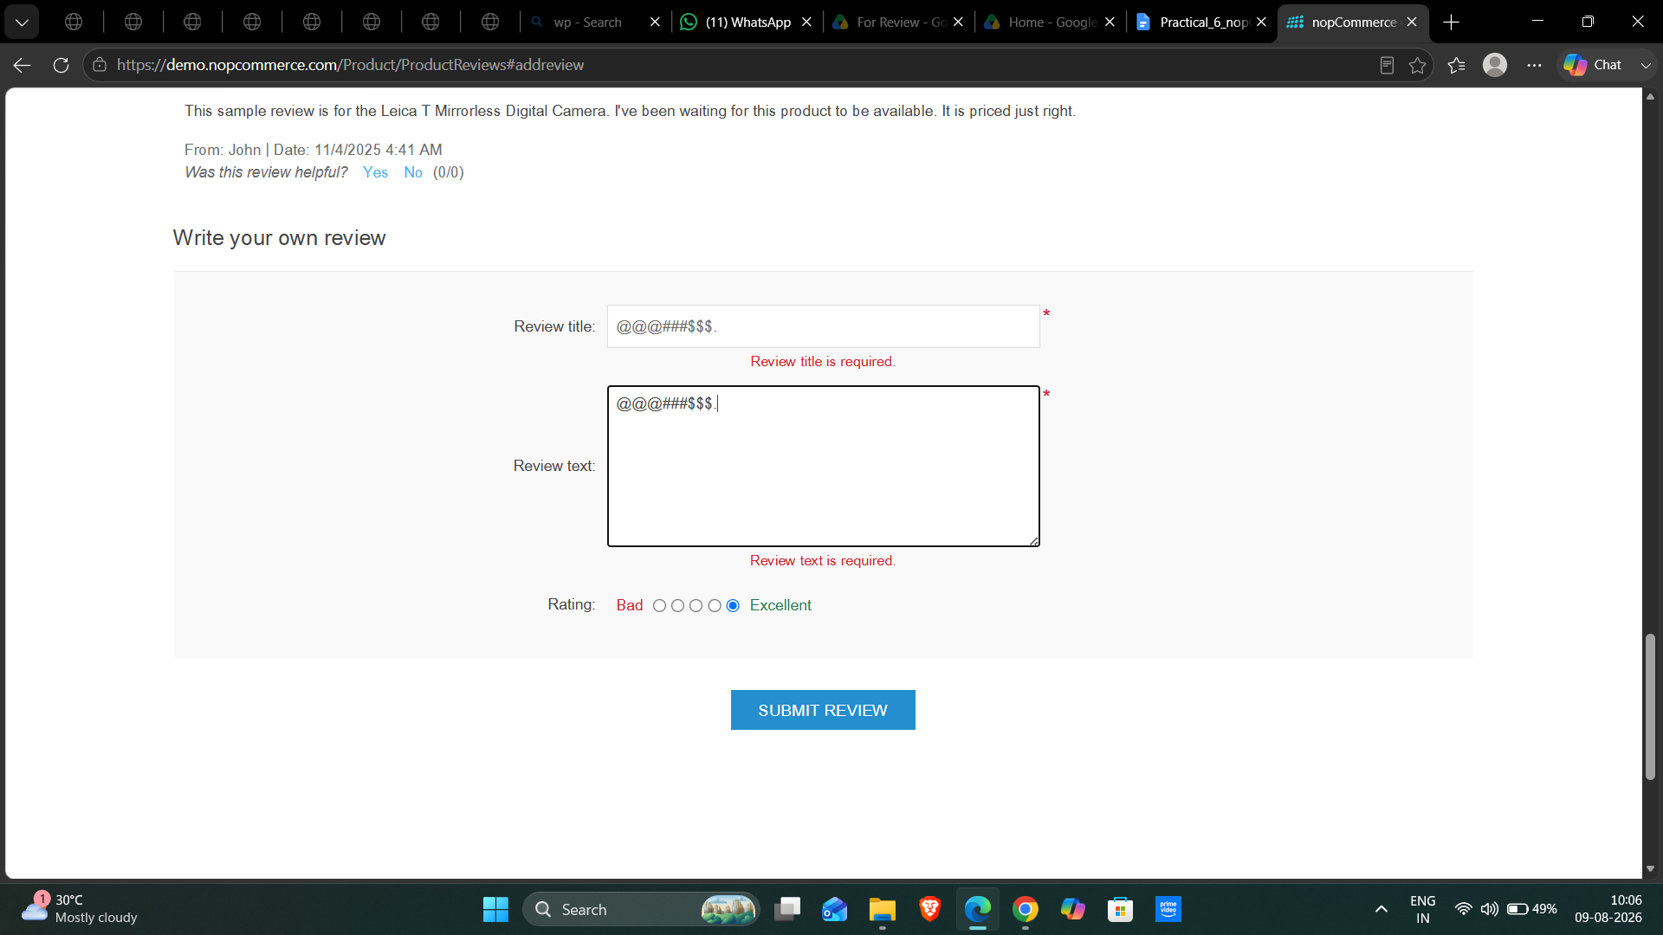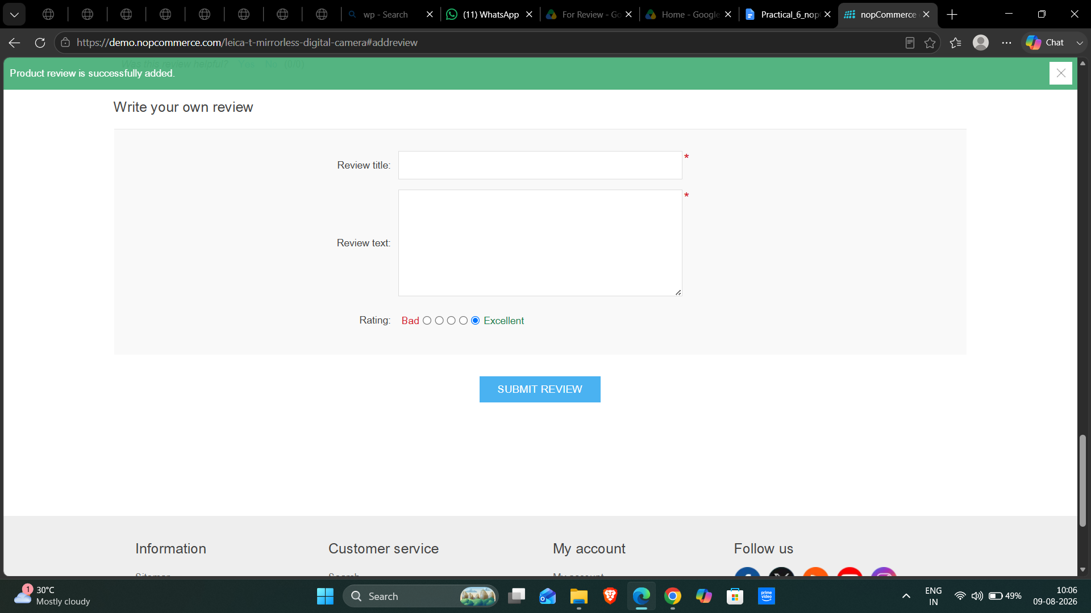

Test Case ID: TC06
Scenario: Verify product review with numeric input
Steps:
1. Open nopCommerce website.
2. Open a product page.
3. Open the product review section.
4. Enter/select the test condition: 123456789.
5. Submit the review.
6. Observe the result.

Screenshot:
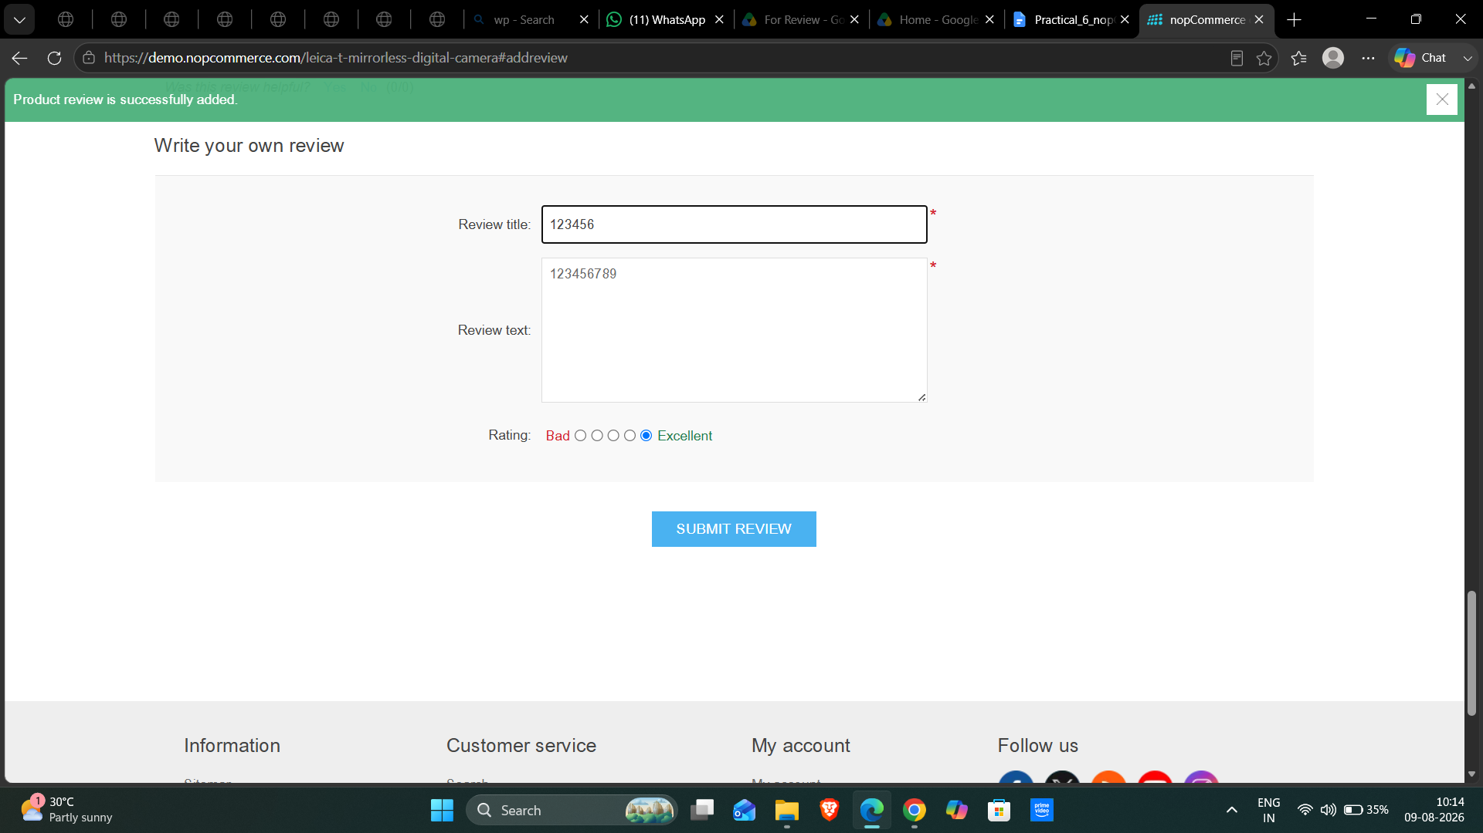

Test Case ID: TC07
Scenario: Verify product review with valid text and invalid rating condition
Steps:
1. Open nopCommerce website.
2. Open a product page.
3. Open the product review section.
4. Enter/select the test condition: Valid review + invalid rating.
5. Submit the review.
6. Observe the result.
Expected Result: System should validate the rating and prevent submission if the rating is invalid.
Screenshot:
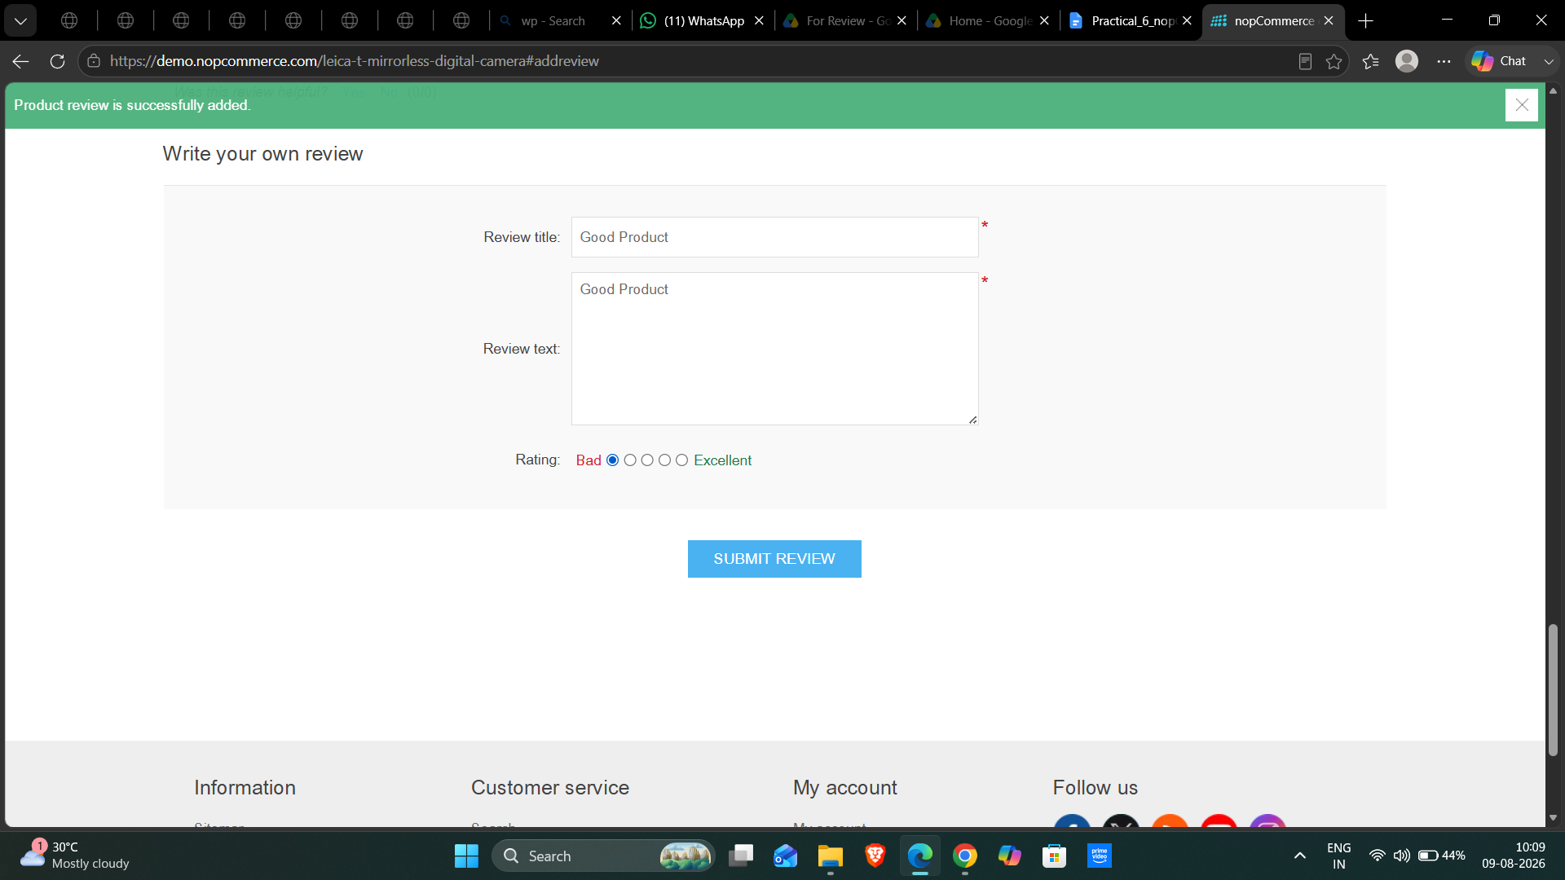

Test Case ID: TC08
Scenario: Verify product review with alphabetic valid input
Steps:
1. Open nopCommerce website.
2. Open a product page.
3. Open the product review section.
4. Enter/select the test condition: Good product.
5. Submit the review.
6. Observe the result.
Expected Result: Review should be accepted and processed correctly.
Screenshot:
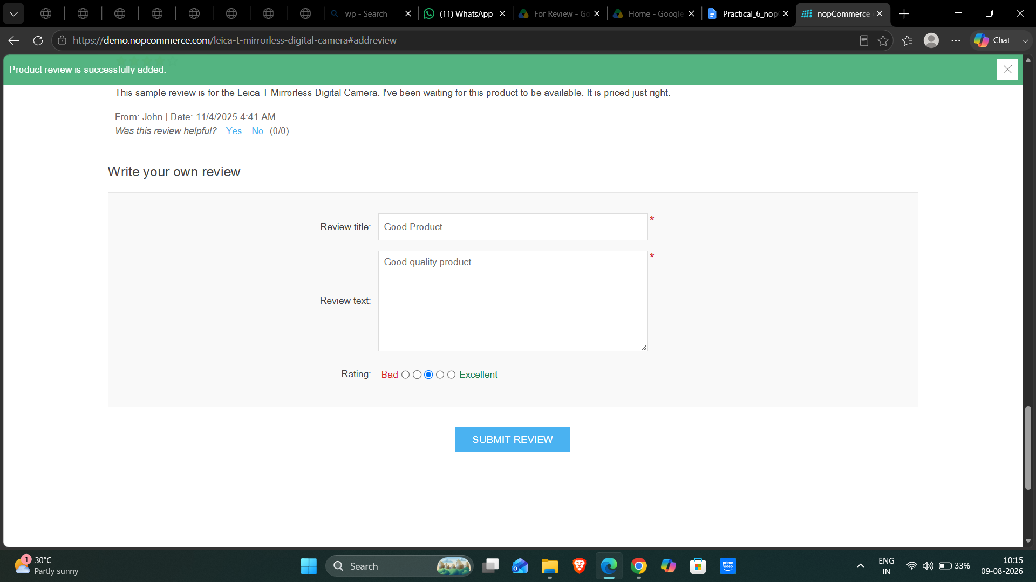

Test Case ID: TC09
Scenario: Verify product review with mixed valid text and numbers
Steps:
1. Open nopCommerce website.
2. Open a product page.
3. Open the product review section.
4. Enter/select the test condition: Good product 123.
5. Submit the review.
6. Observe the result.
Expected Result: System should process the review according to the field validation rules.
Screenshot:
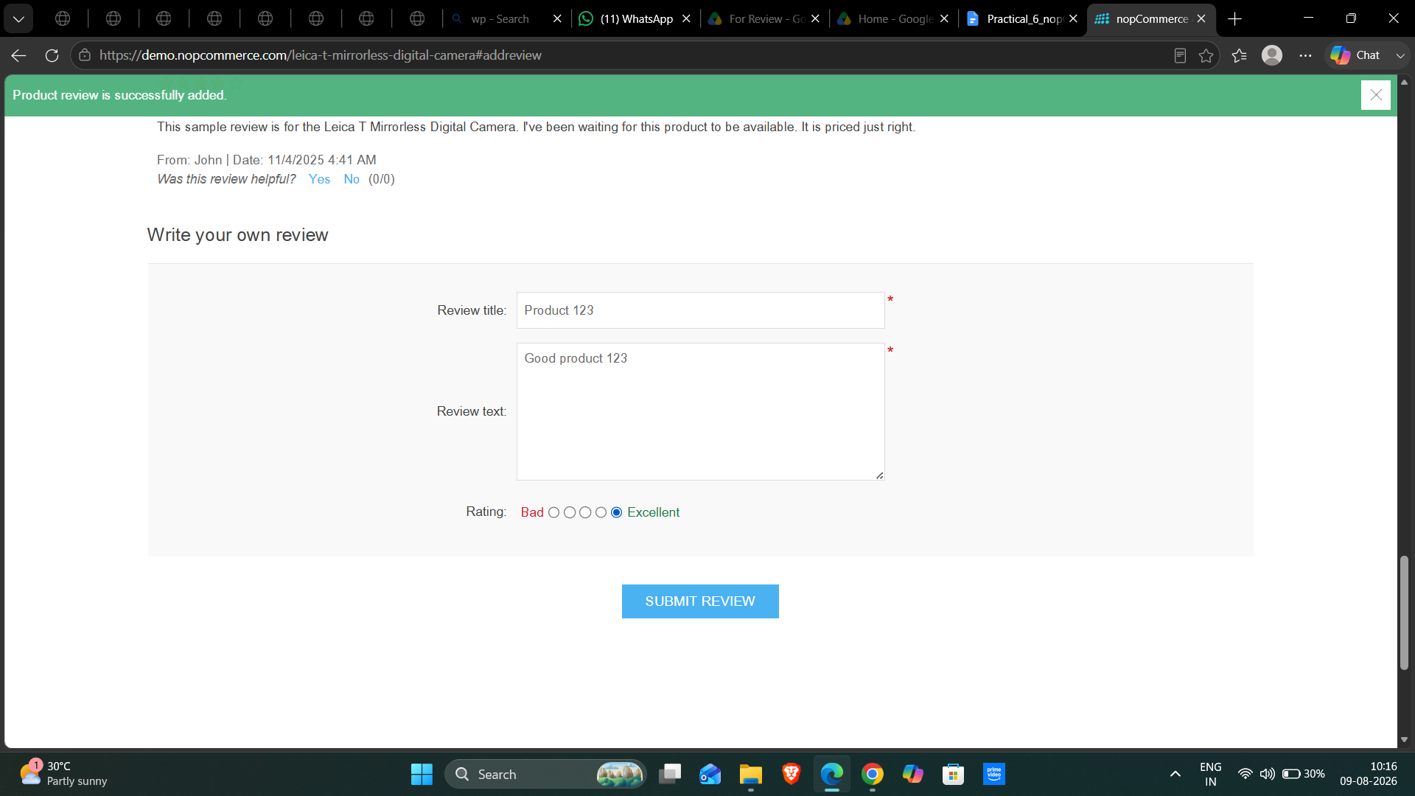

Test Case ID: TC10
Scenario: Verify product review with blank/space input
Steps:
1. Open nopCommerce website.
2. Open a product page.
3. Open the product review section.
4. Enter/select the test condition: Spaces only.
5. Submit the review.
6. Observe the result.

Screenshot: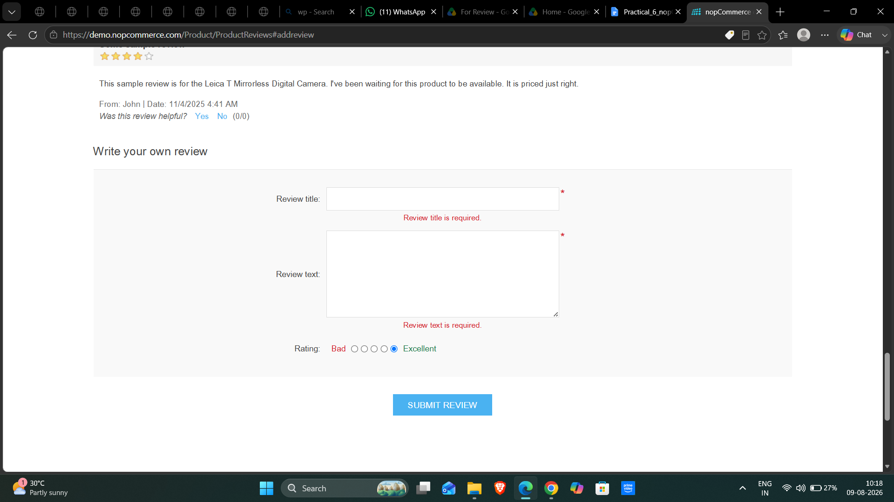
Manual Test Execution
Test Case ID | Input | Expected Result | Actual Result | Status
TC01 | Valid review text + valid rating | Review should be accepted and submitted successfully. | Valid Review Title and Review Text were entered, Excellent rating was selected, and the message 'Product review was successfully added' was displayed. | Pass
TC02 | Blank review text | System should display an appropriate validation message. | Review Title was left blank while Review Text was entered. The page displayed 'Review title is required' and the review was not submitted. | Pass
TC03 | Valid review + blank rating | System should display an appropriate validation message. | Review Title was entered while Review Text was left blank. The page displayed 'Review text is required' and the review was not submitted. | Pass
TC04 | Blank review + blank rating | System should display validation messages and should not submit the review. | The required-field validation was displayed and the review was not submitted. | Pass
TC05 | @@@###$$$ | System should handle the input correctly and display an appropriate validation/result message. | Special-character input was accepted and the product review was submitted successfully. | Pass
TC06 | 123456789 | System should validate the input according to the review field rules. | Numeric input was accepted and the product review was submitted successfully. | Pass
TC07 | Valid review + invalid rating | System should validate the rating and prevent submission if the rating is invalid. | The selected Bad rating was accepted with valid review information and no validation error was displayed. | Pass
TC08 | Good product | Review should be accepted and processed correctly. | The review with Good rating was submitted successfully. | Pass
TC09 | Good product 123 | System should process the review according to the field validation rules. | Mixed text and numeric review input was accepted and submitted successfully. | Pass
TC10 | Spaces only | System should validate the input and should not accept whitespace-only review text. | Blank/whitespace validation prevented an invalid review submission. | Pass
Test Summary Report
Total Test Cases | 10
Passed | 10
Failed | 0
Defects Found | 0
Pass Percentage | 100%
Observation
Multiple input conditions were used for manual test execution, including valid, blank, special-character, numeric, mixed and rating conditions.
All 10 executed test cases passed based on the recorded execution results and the updated screenshots for TC01, TC02 and TC03.
Boundary Value Analysis is not included in Practical 6.
Conclusion / Outcome
Manual test execution was completed by comparing Expected Result with Actual Result and recording the Pass/Fail status.
No defects were identified in the final execution results. Boundary Value Analysis is reserved for Practical 7.

