Module Name: Product Quantity / Cart Quantity
Webpage URL: https://demo.nopcommerce.com/
Test Case ID: TC01
Test Case: Verify minimum valid quantity
Steps:
1. Open nopCommerce website.
2. Open a product page.
3. Add the product to the cart.
4. Enter quantity: 1.
5. Update the cart.
6. Observe the result.
Test Input: 1
Actual Result: Quantity 1 was accepted and the product was added to the shopping cart.
Status: Pass
Comment: Minimum valid quantity worked as expected.

Screenshot: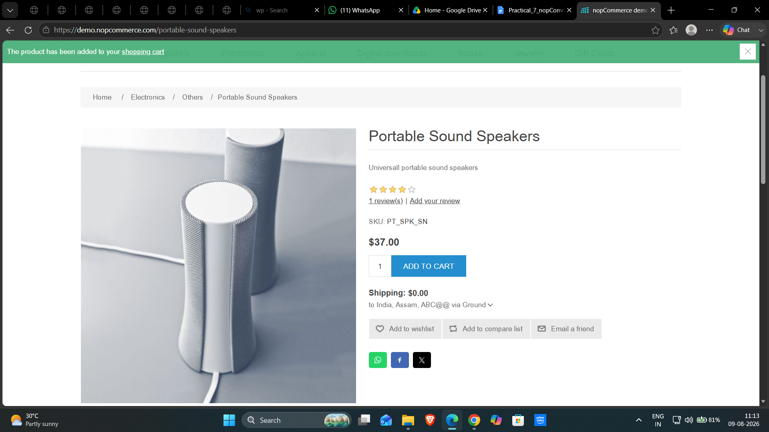

Test Case ID: TC02
Test Case: Verify quantity below minimum
Steps:
1. Open nopCommerce website.
2. Open a product page.
3. Add the product to the cart.
4. Enter quantity: 0.
5. Update the cart.
6. Observe the result.
Test Input: 0
Actual Result: The system displayed a quantity validation message and did not accept quantity 0.
Status: Pass
Comment: Below-minimum validation worked as expected.
Screenshot:
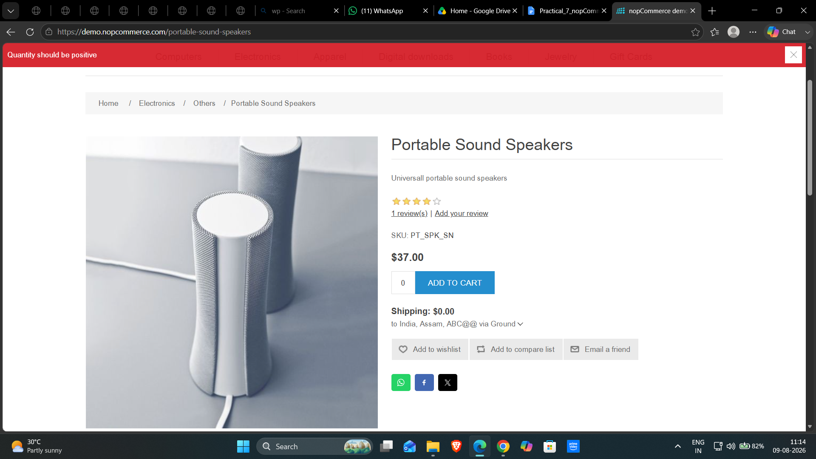
Test Case ID: TC03
Test Case: Verify just above minimum quantity
Steps:
1. Open nopCommerce website.
2. Open a product page.
3. Add the product to the cart.
4. Enter quantity: 2.
5. Update the cart.
6. Observe the result.
Test Input: 2
Actual Result: Quantity 2 was accepted and the product was added to the shopping cart.
Status: Pass
Comment: Just-above-minimum value worked as expected.
Screenshot: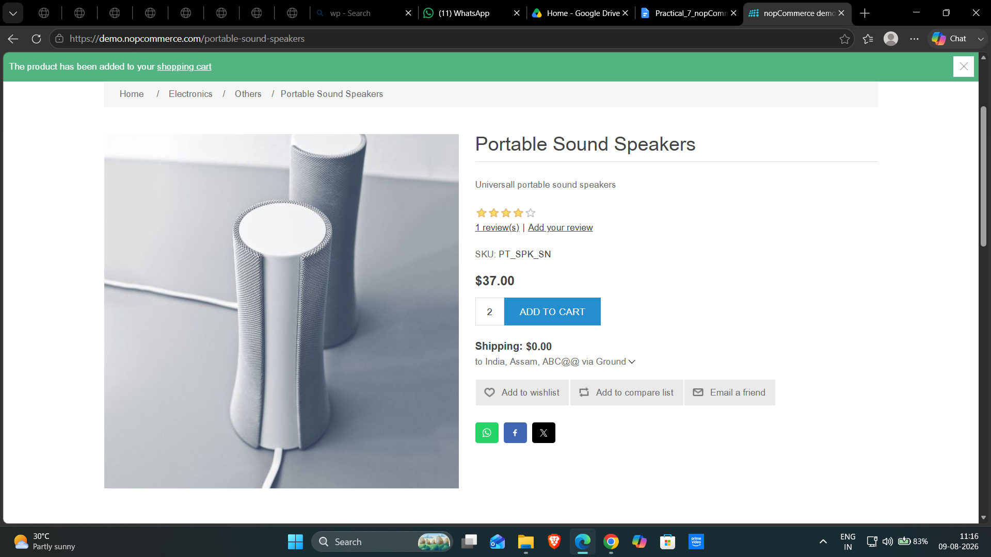

Test Case ID: TC04
Test Case: Verify quantity with leading zero
Steps:
1. Open nopCommerce website.
2. Open a product page.
3. Add the product to the cart.
4. Enter quantity: 01.
5. Update the cart.
6. Observe the result.
Test Input: 01
Actual Result: The leading-zero quantity was accepted and processed as a valid quantity.
Status: Pass
Comment: Leading-zero input was handled successfully.
Screenshot:
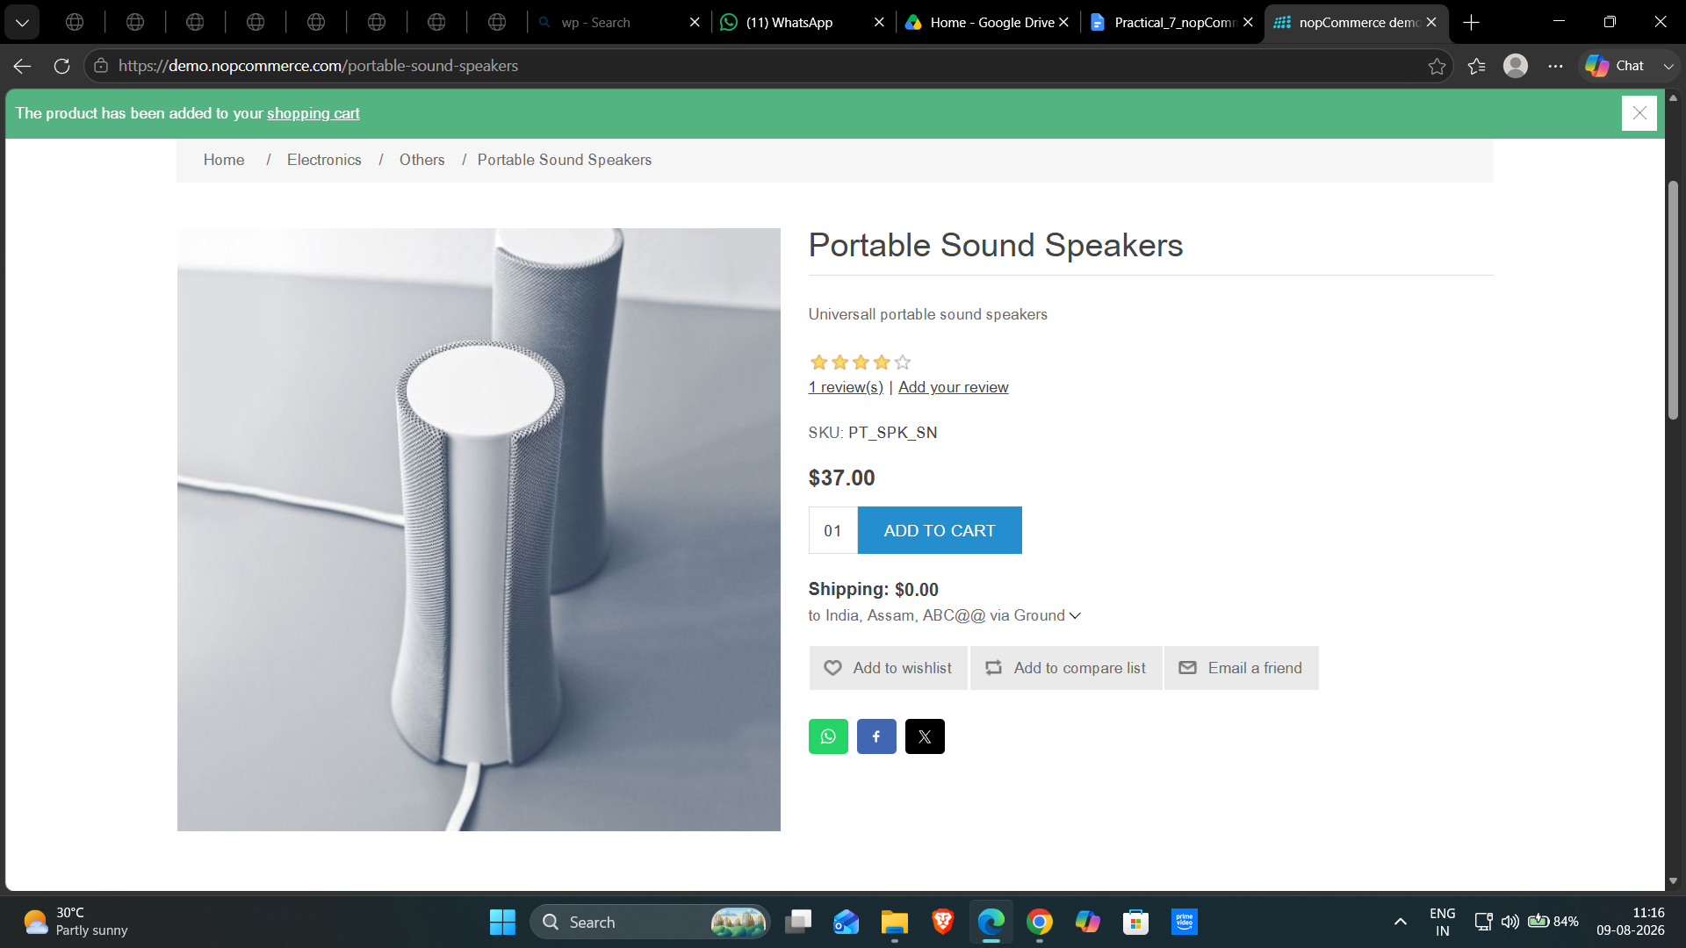

Test Case ID: TC05
Test Case: Verify just before maximum quantity
Steps:
1. Open nopCommerce website.
2. Open a product page.
3. Add the product to the cart.
4. Enter quantity: 9999.
5. Update the cart.
6. Observe the result.
Test Input: 9999
Actual Result: Quantity 9999 was accepted as a valid quantity.
Status: Pass
Comment: Value just below the maximum was accepted.
Screenshot:
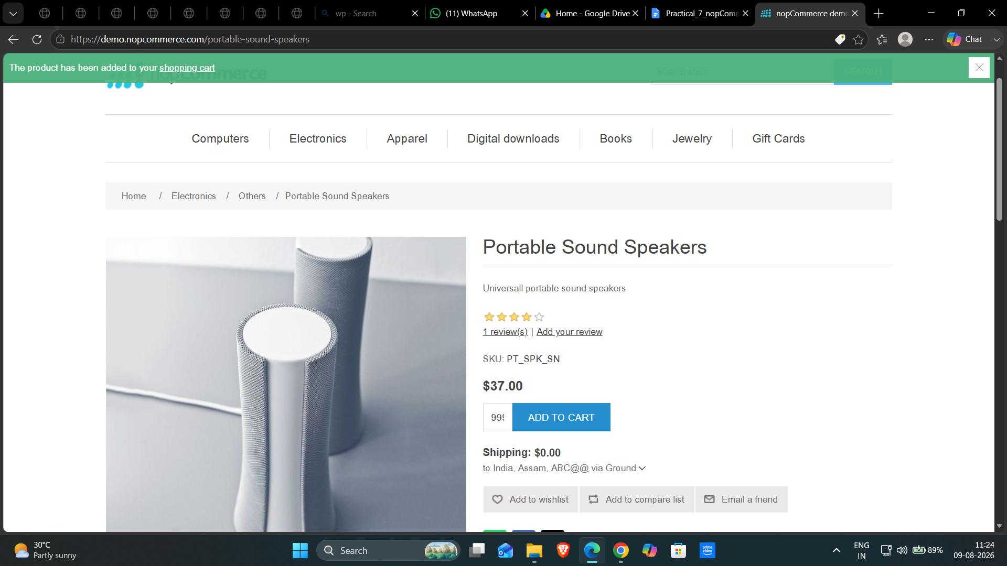
Test Case ID: TC06
Test Case: Verify maximum quantity
Steps:
1. Open nopCommerce website.
2. Open a product page.
3. Add the product to the cart.
4. Enter quantity: 10000.
5. Update the cart.
6. Observe the result.
Test Input: 10000
Actual Result: Quantity 10000 was accepted by the system.
Status: Pass
Comment: 10000 is the observed maximum valid quantity.
Screenshot:

Test Case ID: TC07
Test Case: Verify quantity above maximum
- Steps:Open nopCommerce website.
- Open any product page.
- Add the product to the cart.
- Open the Shopping Cart.
- Enter 10001 in the Quantity field.
- Click Update Shopping Cart.
- Observe the result.
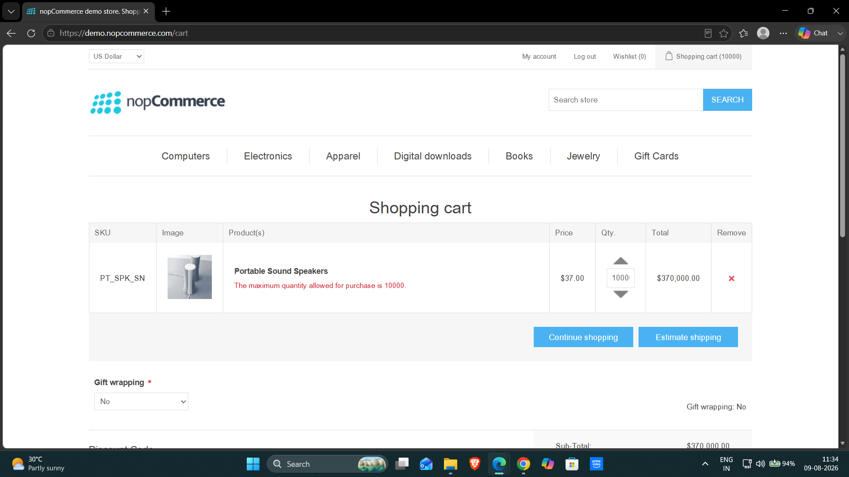

Test Input: 10001
Actual Result: The system rejected 10001 and displayed a message indicating that the maximum quantity allowed is 10000.
Status: Pass
Comment: Above-maximum validation worked as expected.
Test Case ID: TC08
Test Case: Verify negative quantity
Steps:
1. Open nopCommerce website.
2. Open a product page.
3. Add the product to the cart.
4. Enter quantity: -1.
5. Update the cart.
6. Observe the result.
Test Input: -1
Actual Result: The system displayed 'Quantity should be positive' and did not accept the negative quantity.
Status: Pass
Comment: Negative quantity validation worked as expected.
Screenshot:

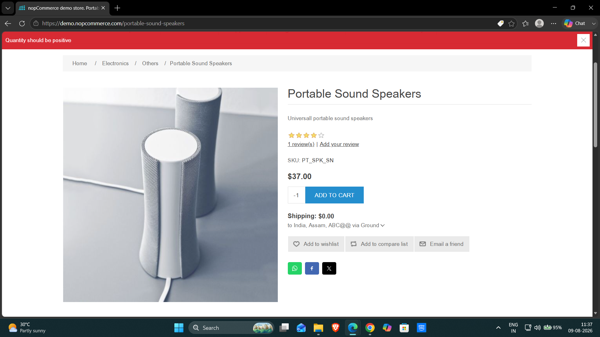

Test Case ID: TC09
Test Case: Verify negative decimal quantity
Steps:
1. Open nopCommerce website.
2. Open a product page.
3. Add the product to the cart.
4. Enter quantity: -1.5.
5. Update the cart.
6. Observe the result.
Test Input: -1.5
Actual Result: The system displayed 'Quantity should be positive' and did not accept the negative decimal quantity.
Status: Pass
Comment: Negative decimal validation worked as expected.
Screenshot: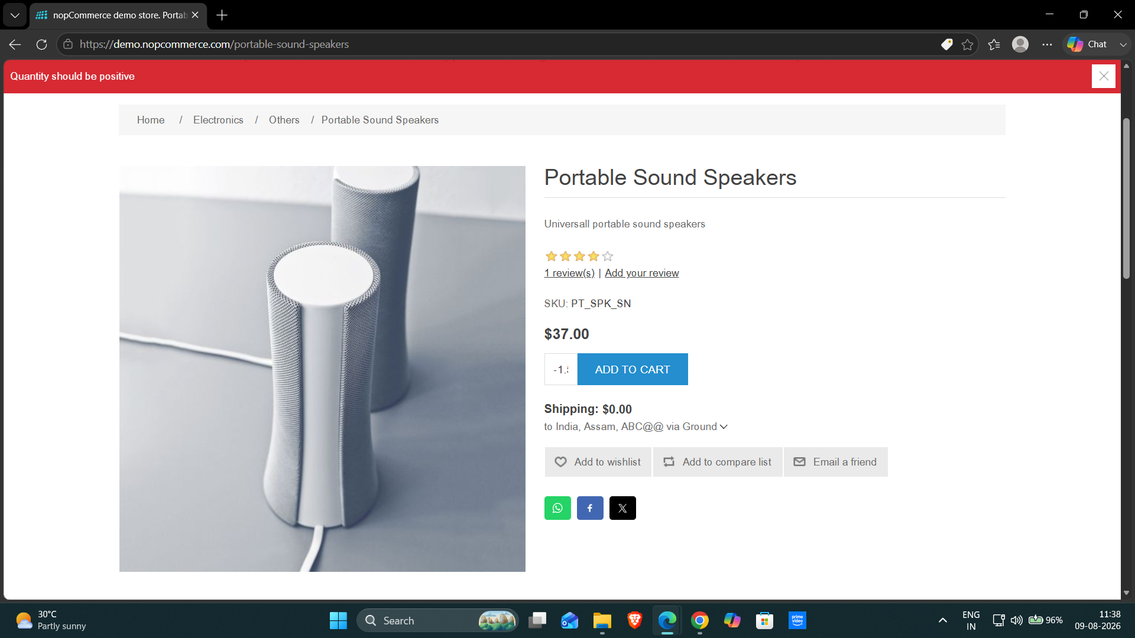

Test Case ID: TC10
Test Case: Verify positive decimal quantity
Steps:
1. Open nopCommerce website.
2. Open a product page.
3. Add the product to the cart.
4. Enter quantity: 1.5.
5. Update the cart.
6. Observe the result.
Test Input: 1.5
Actual Result: The system displayed 'Quantity should be positive' and did not accept the decimal quantity.
Status: Pass
Comment: Decimal quantity validation worked as expected.
Screenshot: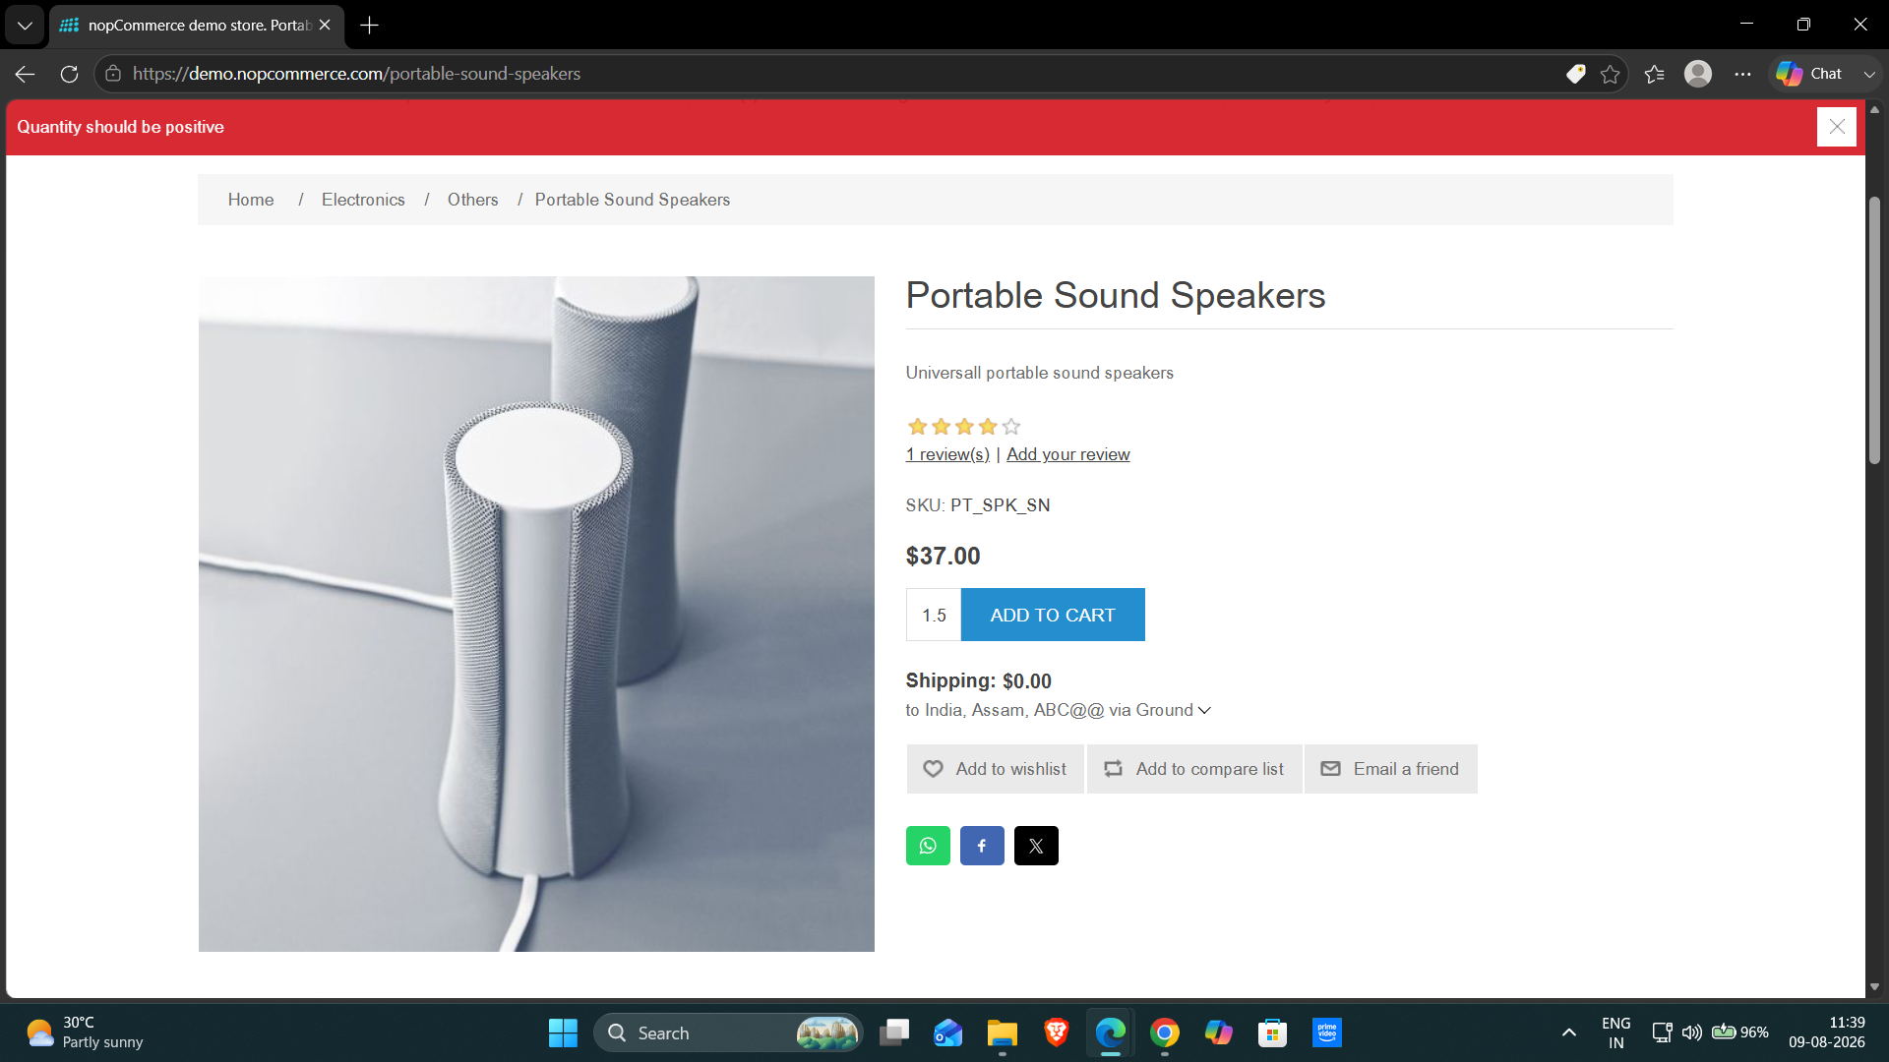

Test Summary Report
Total Test Cases | 10
Passed | 10
Failed | 0
Defects Found | 0
Pass Percentage | 100%
Conclusion and Recommendations
Pass Rate: 100% – Application Working Successfully
Issues Found
No functional issues were observed during testing.
____________________________________________________________

Verify quantity validation after future changes.
Continue regression testing after application updates.
Recommendations
Boundary Value Analysis (BVA) Rules
Rule | Value / Condition | Example
Minimum Value | Lowest valid quantity | 1
Maximum Value | Highest valid quantity | 10000
Invalid Values | Values below minimum, above maximum, or invalid format | 0, 10001, -1, -1.5, 1.5

