Assignment-6
AI Assisted Problem Solving Using Python –AIAP

Student Name:- Guguloth Sai Priya
Hall ticket No:- 2505B04204
Branch :- Embedded System (ES)

Lab 6: AI-Based Code Completion – Classes, Loops, and Conditionals
Lab Objectives
- Explore AI-powered auto-completion features for core Python constructs.
- Analyze how AI suggests logic for class definitions, loops, and conditionals.
- Evaluate the completeness and correctness of code generated by AI assistants.
Lab Outcomes
Upon successful completion of this lab, students will be able to:
- Use AI tools to generate and complete class definitions and methods.
- Understand and assess AI-suggested loops for iterative tasks.
- Generate conditional statements through prompt-driven suggestions.
- Critically evaluate AI-assisted code for correctness and clarity.
Task Description #1: Classes
Instructions:
- Use an AI assistant to complete a Student class with attributes and a method.
- Verify the output.
- Analyze the generated code for structure, clarity, and correctness.
Expected Output:
- A Python class with a constructor (__init__) and a display_details() method.

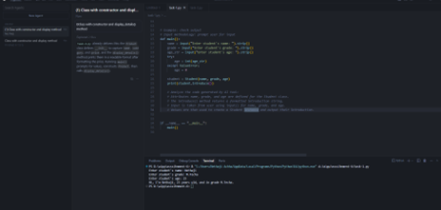

Task Description #2: Loops
Instructions:
- Prompt the AI to complete a function that prints the first 10 multiples of a given number using a loop.
- Analyze the generated code.
- Request alternative implementations using different loop constructs.
Expected Output:
- A correct loop-based implementation using for or while.
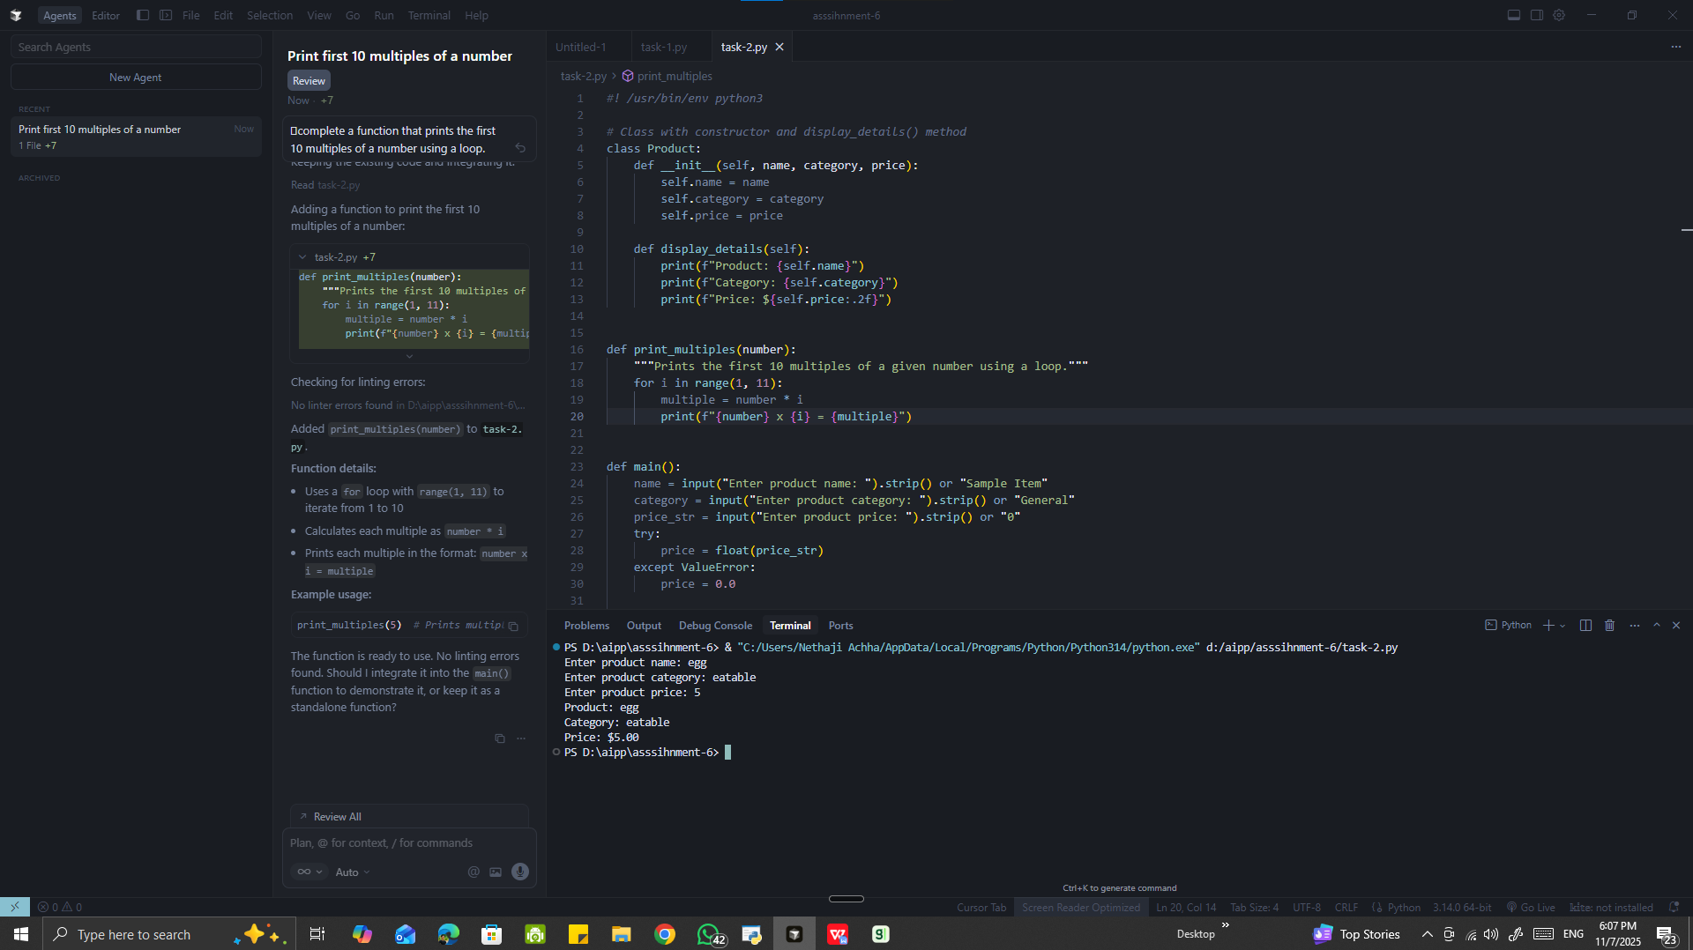
Task Description #3: Conditional Statements
Instructions:
- Ask the AI to write nested if-elif-else statements to classify age groups (e.g., child, teenager, adult, senior).
- Analyze the generated code for logical accuracy and readability.
- Request alternative implementations using other conditional structures.
Expected Output:
- A function that classifies age groups with appropriate conditions and a brief explanation of the logic.

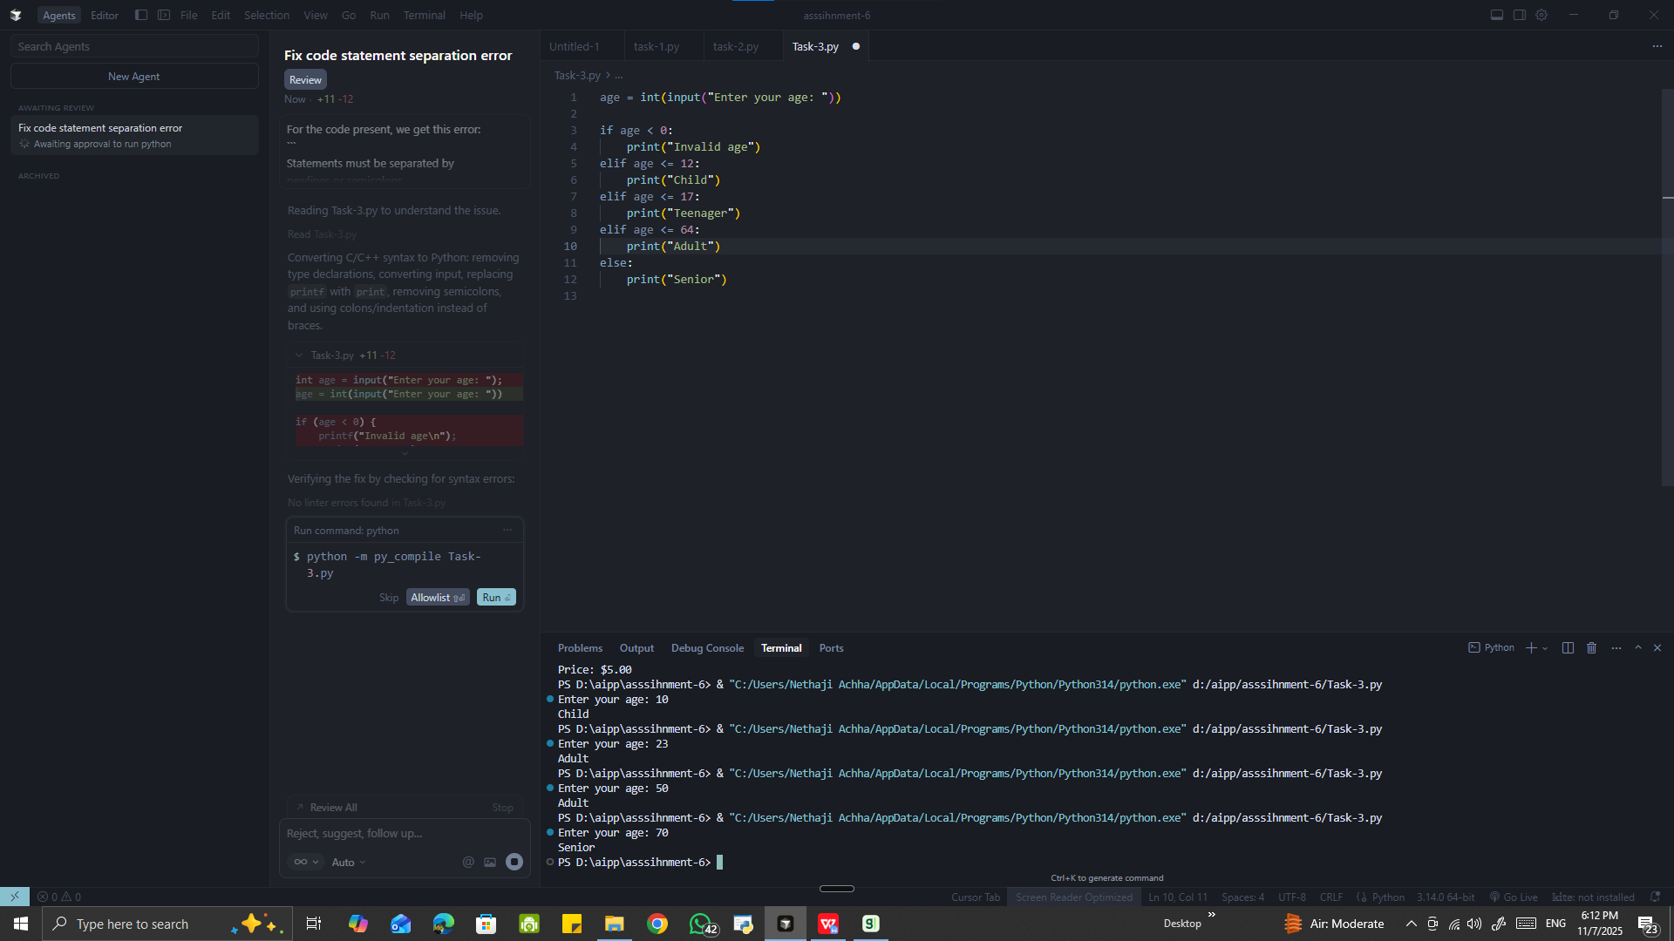

Task Description #4: For and While Loops
Instructions:
- Generate a sum_to_n() function using AI to calculate the sum of the first n natural numbers.
- Analyze the generated code.
- Request suggestions for alternative loop-based implementations.
Expected Output:
- Python code using for or while loops with a clear explanation of the logic.
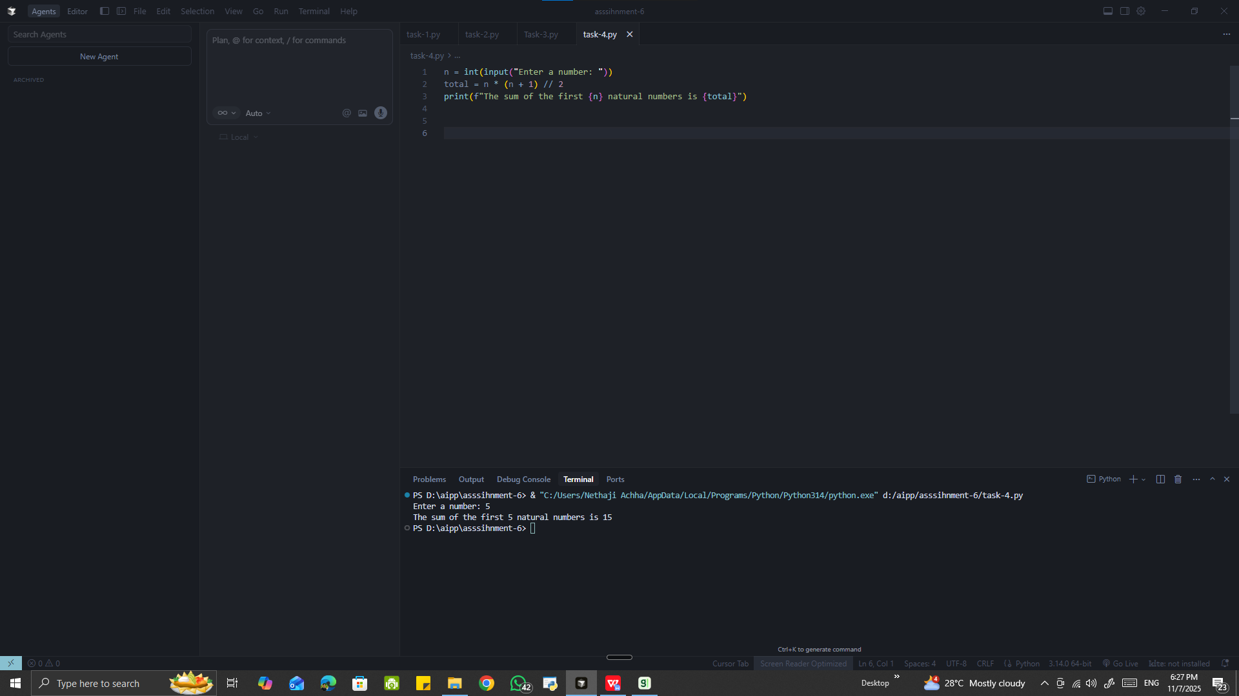

Task Description #5: Class – BankAccount
Instructions:
- Build a BankAccount class using AI with the following methods and attributes:
  - deposit()
  - withdraw()
  - get_balance()
  - amount (as a parameter)
- Add comments to explain each part of the code.
- Expand the code to include error handling and transaction history if possible.
Expected Output:
- A complete Python class with method definitions, comments, and a brief explanation of the code structure.
