Assignment-7
AI Assisted Problem Solving Using Python –AIAP

Student Name:- Guguloth Sai Priya
Hall ticket No:- 2505B04204
Branch :- Embedded System (ES)

Lab 7: AI-Error Debugging with AI – Systematic Approaches to Finding and Fixing Bugs
Lab Objectives
- Identify and correct syntax, logic, and runtime errors in Python programs using AI tools.
- Understand common programming bugs and AI-assisted debugging suggestions.
- Evaluate how AI explains, detects, and fixes different types of coding errors.
- Build confidence in using AI to perform structured debugging practices.
Lab Outcomes
After completing this lab, students will be able to:
- Use AI tools to detect and correct syntax, logic, and runtime errors.
- Interpret AI-suggested bug fixes and explanations.
- Apply systematic debugging strategies supported by AI-generated insights.
- Refactor buggy code using responsible and reliable programming patterns.

Task Descriptions and Expected Outputs
Task #1: Syntax Error – Missing Colon
def add(a, b):
return a + b
Expected Output#1
- Corrected function with syntax fix
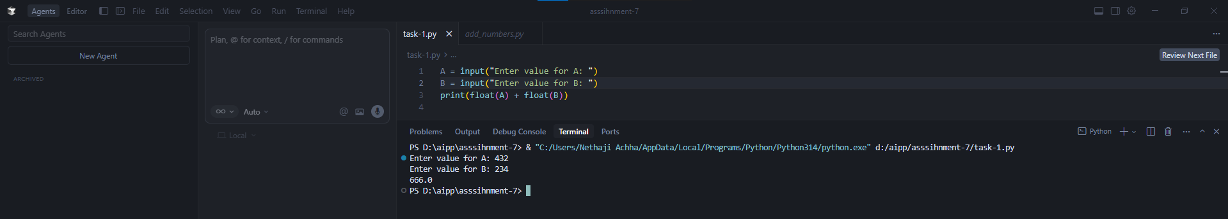

Task Description#2 (Loops)
- Identify and fix a logic error in a loop that causes infinite iteration.


Expected Output#2
- AI fixes increment/decrement error
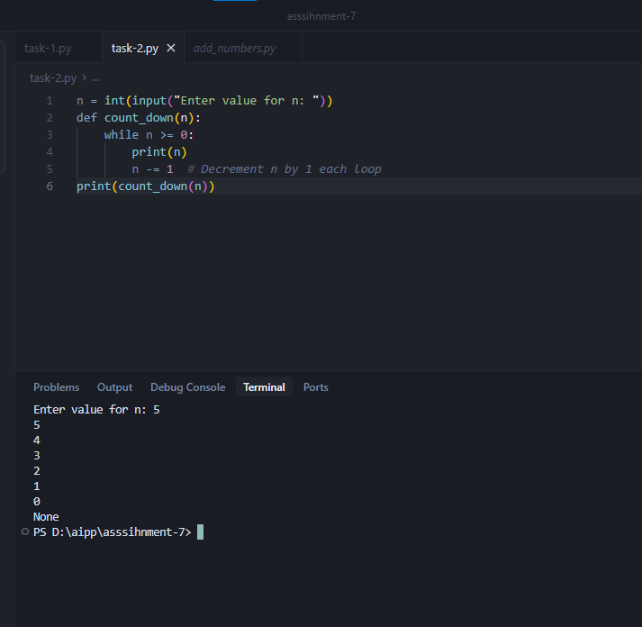

Task Description#3
Debug a runtime error caused by division by zero. Let AI insert try-except.



Expected Output#3
- Corrected function with safe error handling
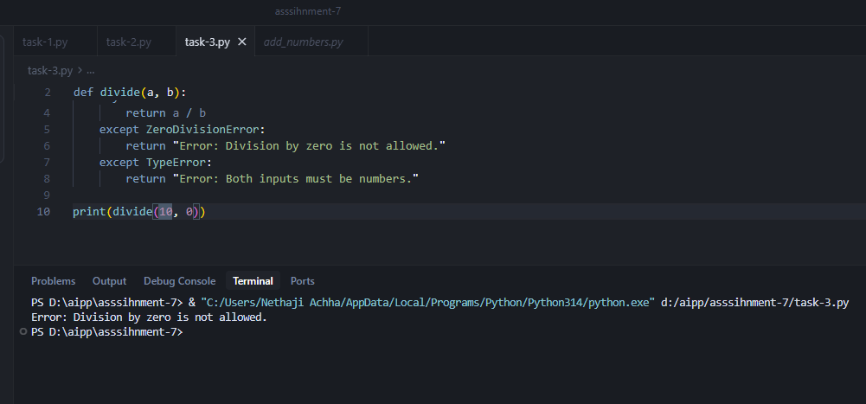

Task Description#4
- Provide a faulty class definition (missing self in parameters). Let AI fix it


Expected Output#4
- Correct __init__() method and explanation
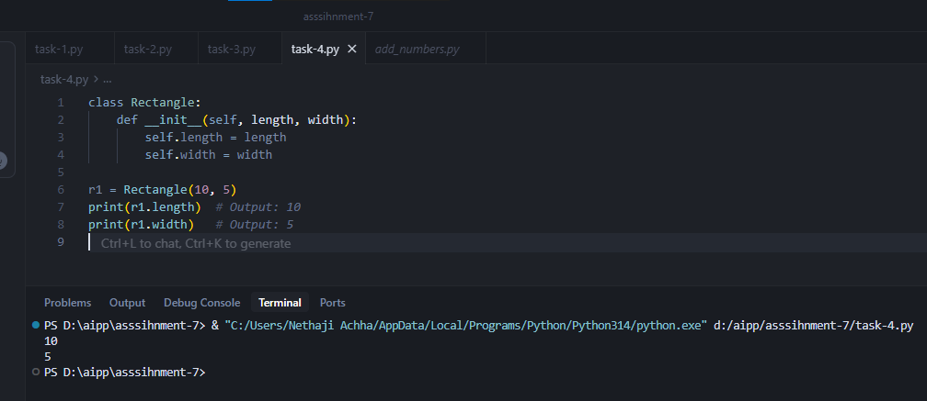

Explanation:
The first parameter of every instance method (including __init__) must be self.
self refers to the current instance of the class, allowing access to its attributes and methods.
Task Description#5
- Access an invalid list index and use AI to resolve the Index Error.


Expected Output#5
- AI suggests checking length or using safe access logic
