Assignment :- 1
AI Assisted Problem Solving Using Python –AIAP

Student Name:- Guguloth Sai Priya
Hall ticket No:- 2505B04204
Branch :- Embedded System (ES)

Lab 1 :- Environment Setup – GitHub Copilot and VS Code Integration

Lab Objectives :-
- To install and configure GitHub Copilot in Visual Studio Code.
- To explore AI-assisted code generation using GitHub Copilot.
- To analyze the accuracy and effectiveness of Copilot’s code suggestions.
- To understand prompt-based programming using comments and code context.
Lab Outcomes (LOs)
After completing this lab, students will be able to:
- Set up GitHub Copilot in VS Code successfully.
- Use inline comments and context to generate code with Copilot.
- Evaluate AI-generated code for correctness and readability.
- Compare code suggestions based on different prompts and programming styles.
Procedure:-
Task :-1 . Open “Visual Studio Code”.
2. Go to Extensions (Ctrl + Shift + X). 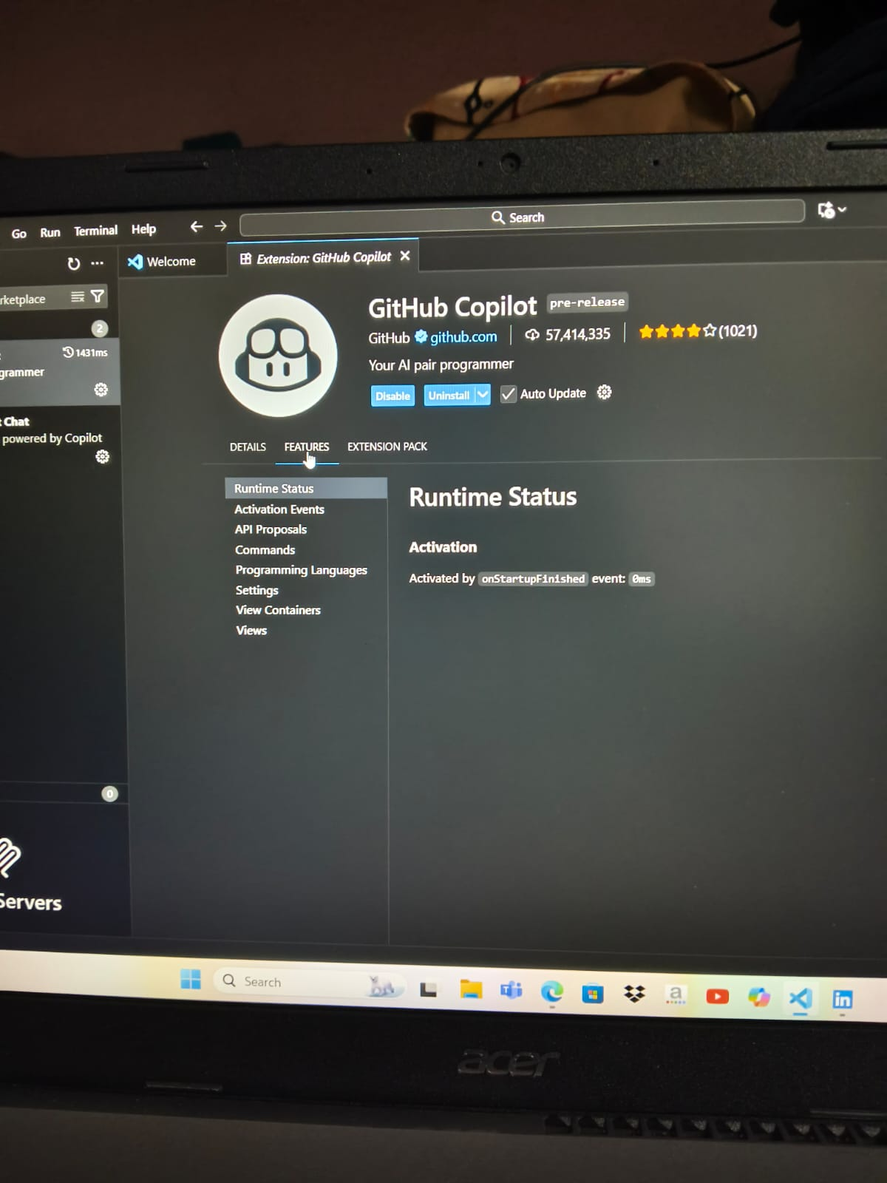
3. Search for “GitHub Copilot”.
4. Click “Install”.
5. Sign in with your “GitHub account” when prompted.
6. After installation, go to “Settings → Extensions → GitHub Copilot” and ensure it is “enabled”.

7. Test by creating a new Python file and typing a comment like” # function to add two numbers “ to see Copilot suggestions.

Task 2: Generate is_prime() Function*

Steps
- Create a new Python file named prime_check.py.
- Type this comment: # Function to check if a number is prime


- Wait for Copilot’s suggestion and accept it.
Sample Copilot Output
def is_prime(n):
if n <= 1:
return False
for i in range(2, int(n ** 0.5) + 1):
if n % i == 0:
return False
return True
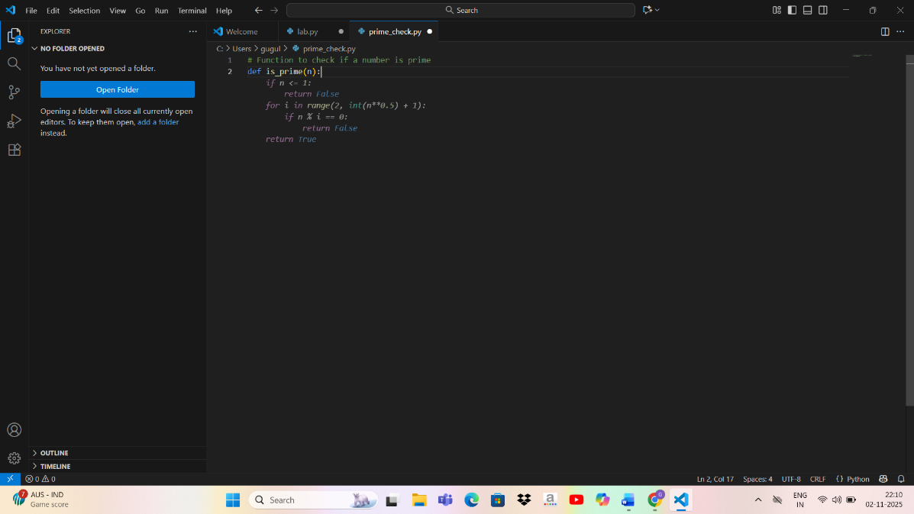

Testing:-
print(is_prime(12)) # True
print(is_prime(13)) # False
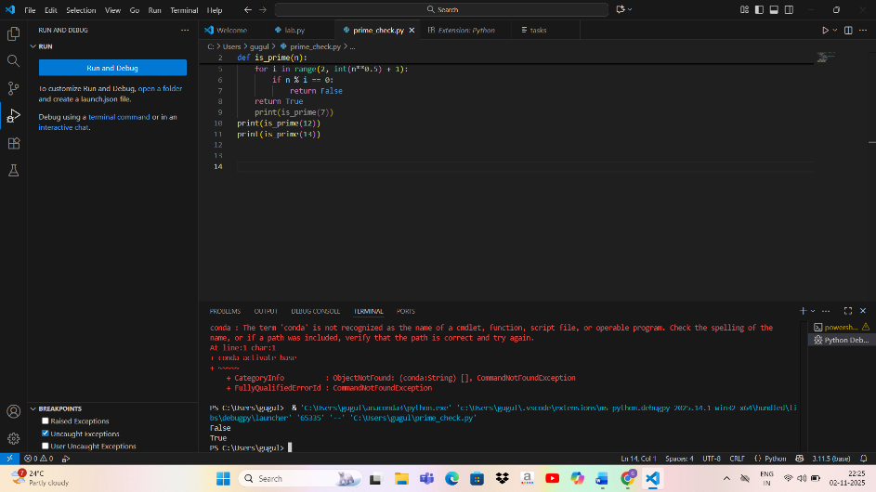

Output:-

True
False
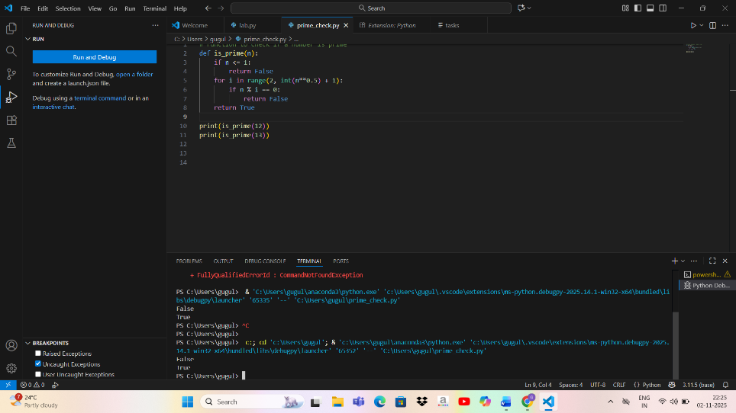

Analysis
- Accuracy: Correctly identifies prime numbers.
- Efficiency: Uses √n optimization for loop range.
- Readability: Clear and well-structured function.

Task 3: Generate Reverse String Function
Steps
- In the same or a new file, type:
# Function to reverse a string
- Accept Copilot’s suggestion.

Sample Copilot Output:-


def reverse_string(s):
return s[::-1]

Testing:-

print(reverse_string("Hello")) # olleH

Output :-
olleH

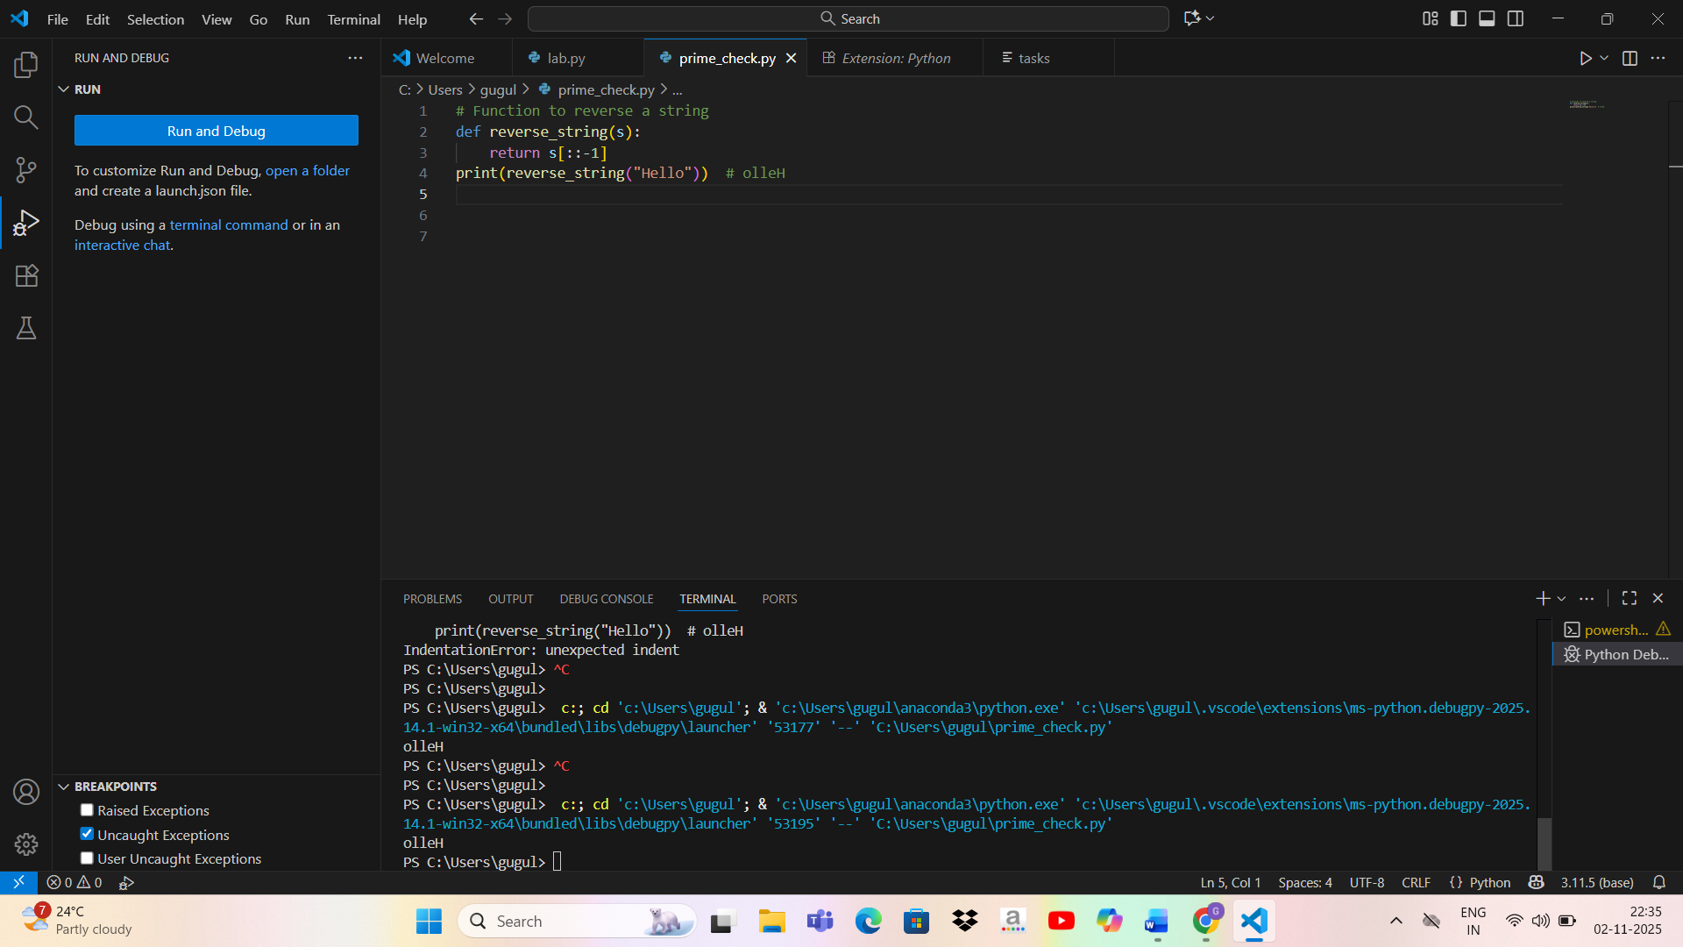

Analysis
- Simplicity: Very concise and pythonic.
- Accuracy: Reverses string correctly.
- Efficiency: Uses slicing — optimal for small strings.

Task 4: Generate Factorial Functions
Steps
(a) Recursive Factorial
Comment:
# Recursive factorial function

Copilot Output:
def factorial_recursive(n):
if n == 0 or n == 1:
return 1
return n * factorial_recursive(n - 1)

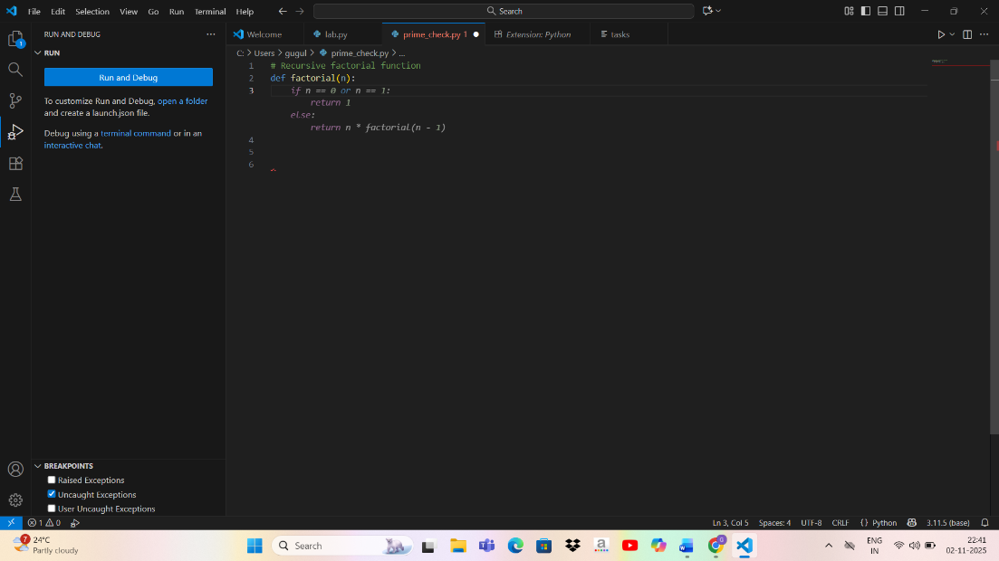

(b) Iterative Factorial
Comment:
# Iterative factorial function
Copilot Output:
def factorial_iterative(n):
result = 1
for i in range(1, n + 1):
result *= i
return result
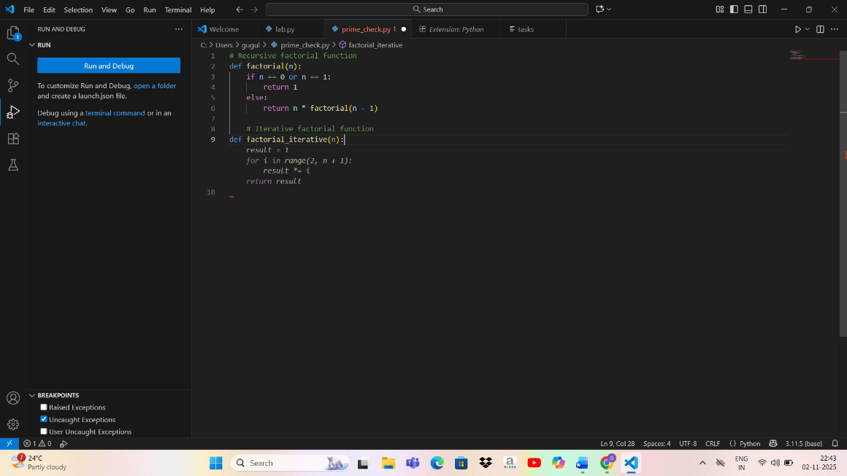

Testing
print(factorial_recursive(5)) # 120
print(factorial_iterative(5)) # 120
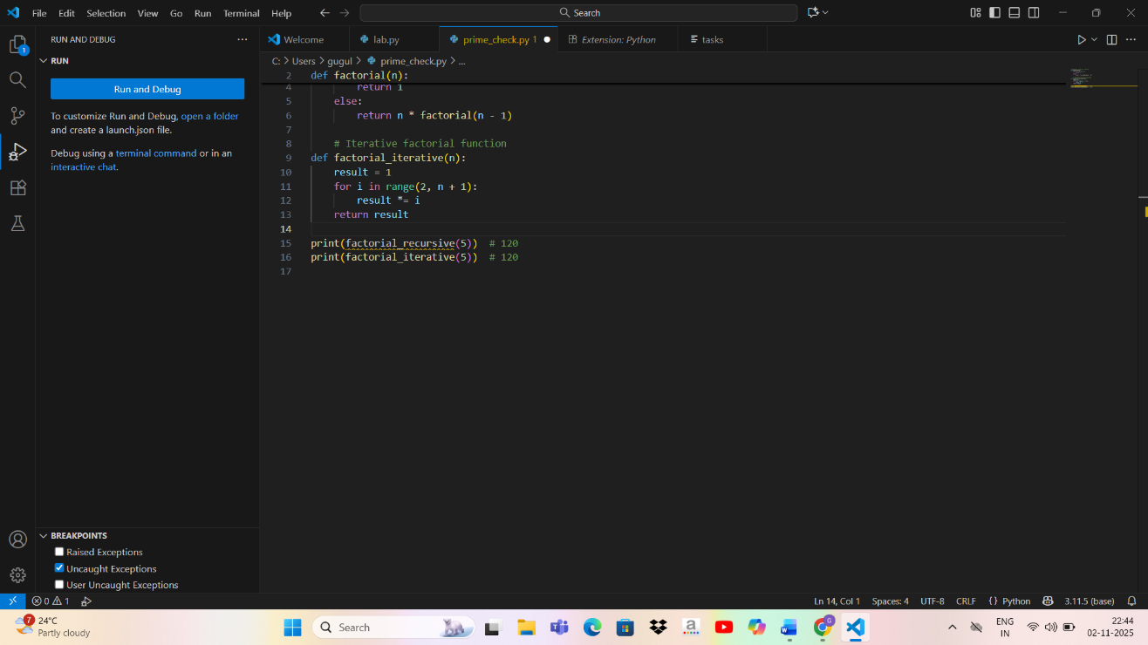

Output:
120
120
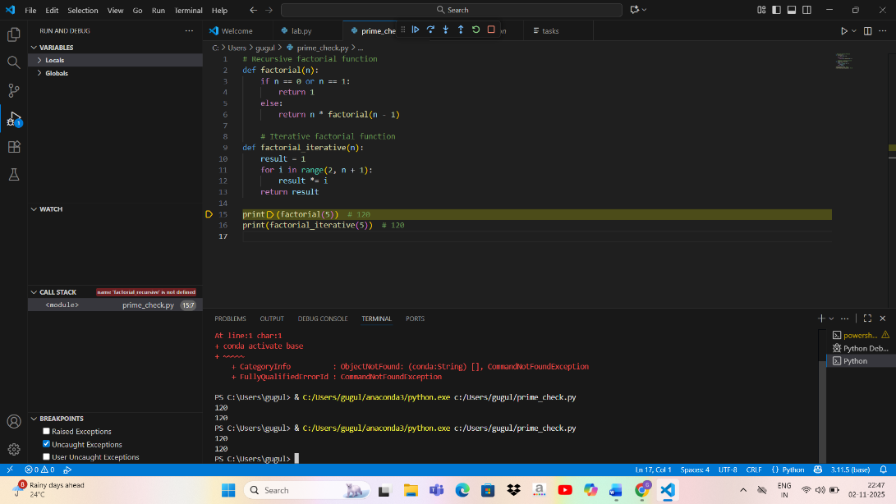

Comparison
Type | Method | Pros | Cons
Recursive | Uses recursion | Elegant, concise | Risk of recursion limit for large n
Iterative | Uses loop | Memory efficient | Slightly longer code

Task 5: Find the Largest Number in a List
Steps
Type: # Function to find the largest number in a list
Copilot Output:
def find_largest(numbers):
largest = numbers[0]
for num in numbers:
if num > largest:
largest = num
return largest

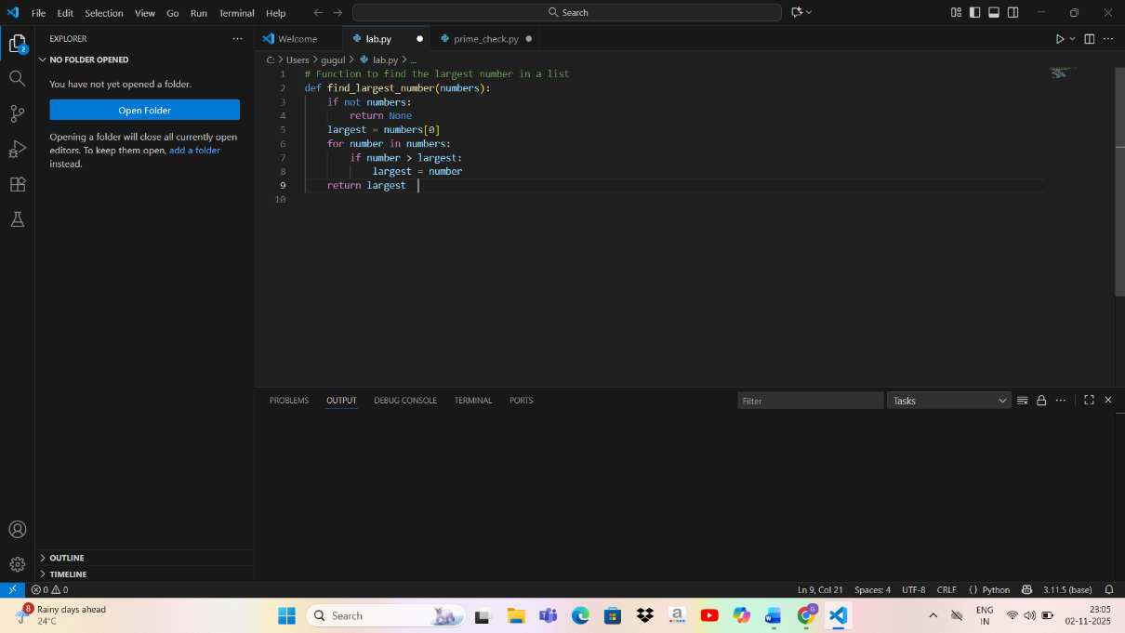

Testing
print(find_largest([2, 45, 1, 67, 34])) # 67
✅ Output:
67
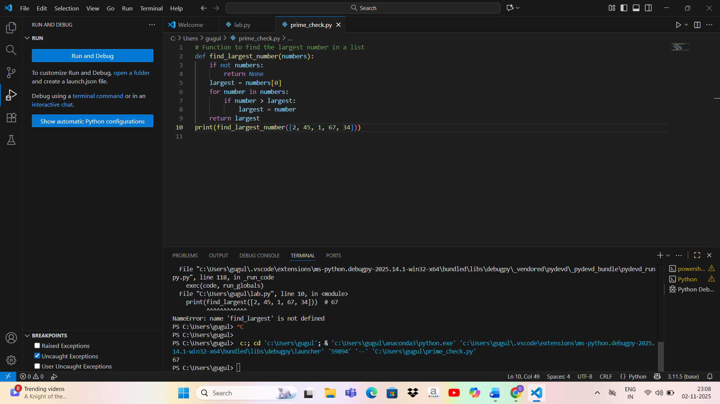

Analysis
- Accuracy: Correctly finds max value.
- Efficiency: Linear O(n) — acceptable for this problem.
- Readability: Simple and easy to follow.

📊 Summary & Observations
Task | Function | Copilot Accuracy | Readability | Efficiency
1 | Setup | ✅ | N/A | N/A
2 | is_prime() | ✅ Accurate | ✅ Clear | ✅ Efficient
3 | reverse_string() | ✅ | ✅ | ✅
4 | factorial_recursive() | ✅ | ✅ | ⚠️ Risk for large n
4 | factorial_iterative() | ✅ | ✅ | ✅
5 | find_largest() | ✅ | ✅ | ✅

Conclusion:-
GitHub Copilot provides intelligent, context-aware code suggestions that significantly speed up development and reduce syntax errors.
By leveraging prompt-based programming through comments, developers can quickly generate functional, readable, and efficient code. However, human review remains crucial to ensure logical correctness and efficiency for complex problems.

