Set 5
Guguloth Sai Priya
HtNo:- 2505B04204
Subject:- AI Assisted Problem Solving Using Python
Lab Test 1: Generate Python code for the Fibonacci sequence with Cursor AI. Refine your prompts to handle only positive integers and record the changes and outcomes.
Title: Fibonacci Sequence with Cursor AI
Objective: To generate Python code for the Fibonacci sequence using Cursor AI, refine prompts to handle only positive integers, and record the changes and outcomes

Step 1: Initial Prompt
Prompt:
Generate Python code to print the Fibonacci sequence up to n terms.
Outcome:
def fibonacci(n):
sequence = [0, 1]
for i in range(2, n):
sequence.append(sequence[i-1] + sequence[i-2])
return sequence[:n]

n = int(input("Enter number of terms: "))
print(fibonacci(n))
Works for positive integers, but fails or produces incorrect results for 0 or negative inputs.
Step2:-
Refined Prompt
Prompt:
Generate Python code for the Fibonacci sequence that only accepts positive integers.
Output:-
def fibonacci(n):
if n <= 0:
raise ValueError("Number of terms must be a positive integer.")
sequence = [0, 1]
for i in range(2, n):
sequence.append(sequence[i-1] + sequence[i-2])
return sequence[:n]

try:
n = int(input("Enter number of terms: "))
print(fibonacci(n))
except ValueError as e:
print(e)
Now raises an error for invalid input, but still not user-friendly.
Step3:
Final Refined Prompt
Prompt:
Generate Python code for the Fibonacci sequence that validates input, only accepts positive integers, and asks again if the user enters invalid input.
Output:-
def fibonacci(n):
sequence = [0, 1]
for i in range(2, n):
sequence.append(sequence[i-1] + sequence[i-2])
return sequence[:n]

while True:
try:
n = int(input("Enter number of terms (positive integer): "))
if n <= 0:
print("Please enter a positive integer.")
continue
print(fibonacci(n))
break
except ValueError:
print("Invalid input. Please enter a positive integer.")
Total code of Fibonacci Sequence with Cursor AI
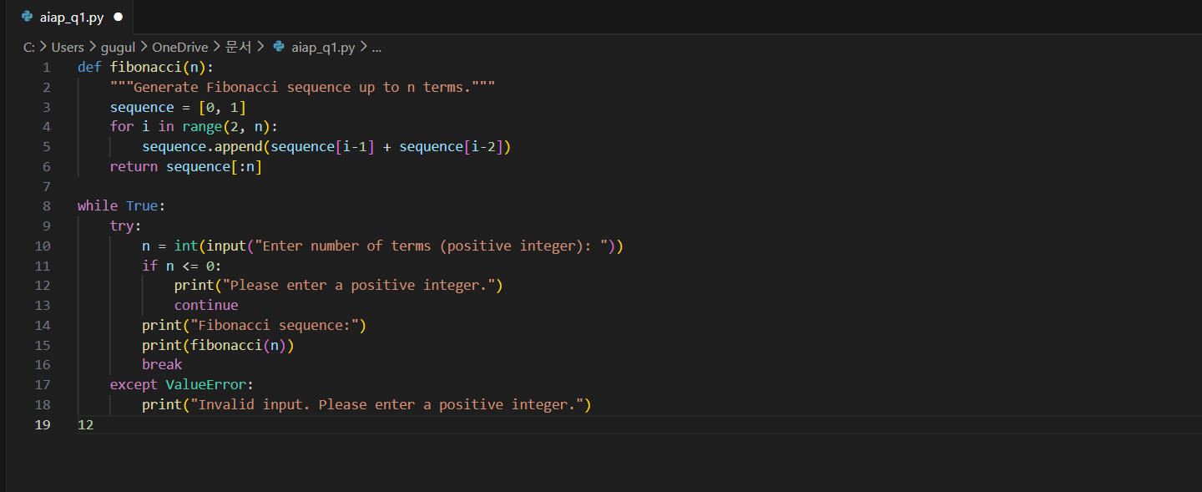

Output:-
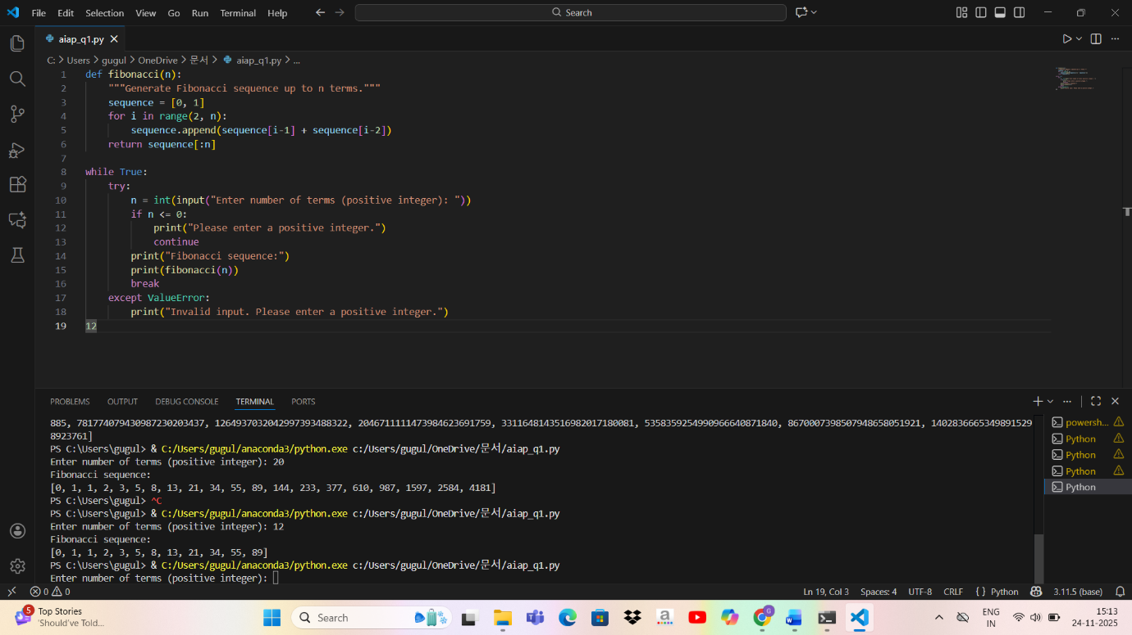

Conclusion:- Cursor AI generated a working Fibonacci program. Through iterative refinement of prompts, the code evolved from a basic implementation to a robust version that validates input and handles edge cases. This demonstrates the importance of prompt engineering in guiding AI to produce reliable and user-friendly code.

