Lab Test – 1
Set - 1
Question 1:
Write a Python function to calculate the factorial of a number. Use a coding assistant and document how you refine your prompt to ensure the function handles negative input and zeros.
Prompt:
Write a Python function to calculate the factorial of a number, making sure it works for zero.

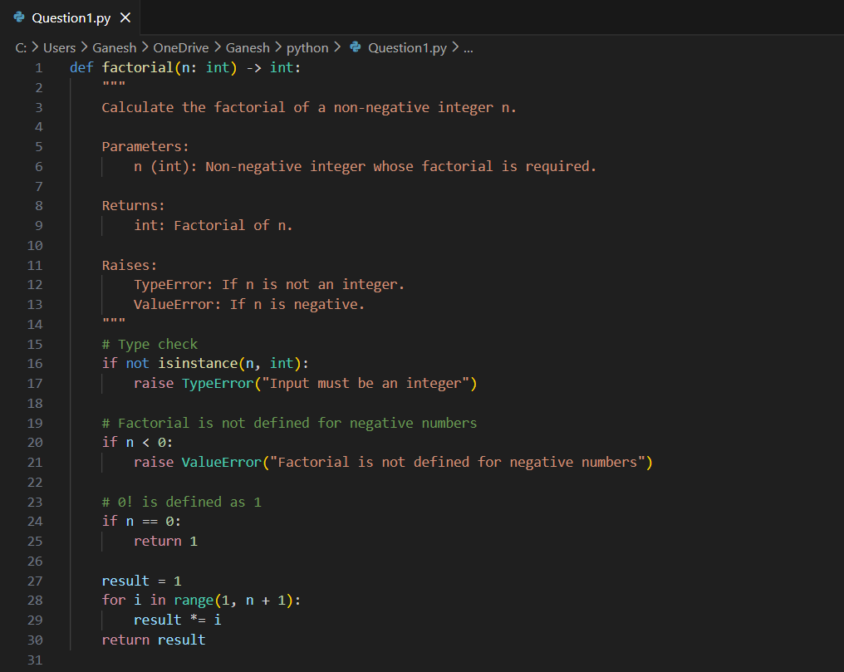
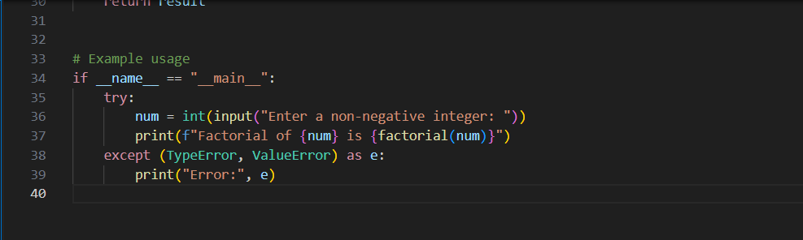

Practical Output:
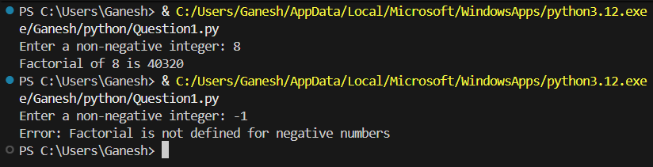

Question 2:
Given a list of student marks, compute the mean and list all students above the
mean. Demonstrate zero-shot, one-shot, and few-shot prompts to guide an AI tool to solve this. Summarize the differences in approach
Prompt:
Given a dictionary of student names and marks, write Python code to compute the mean of the marks and print the names of students whose marks are above the mean.
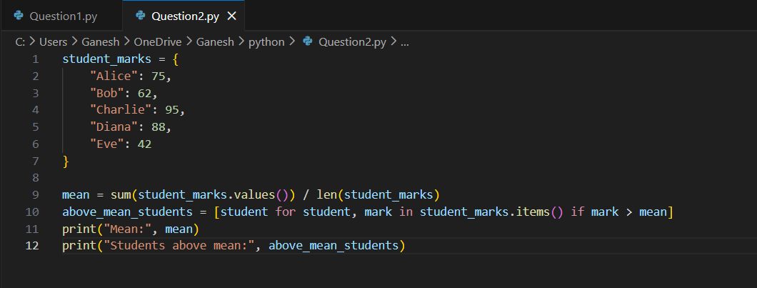

Practical Output:

