Python Programming Lab Task Sets

Set 5
Q2. Write a Python queue class (`enqueue`, `dequeue`, `peek`). Use an AI assistant and test the class with multiple scenarios. Describe how AI-generated code manages edge cases and how you improved it.
(Each question carries 5 marks)
Prompt :
Create a Python Queue class for my M.Tech lab:
Class: Queue (use a list)

Methods:
- enqueue(item)
- dequeue() → return "Error: Queue is empty!" if empty
- peek() → return same error if empty
- is_empty(), size(), display()

After the class, add test code for scenarios: empty checks,
enqueue 1-10, peek, dequeue some, mixed operations, full dequeue, re-check empty, add strings and check size.

Use clear comments, docstrings, and make it clean for full marks.

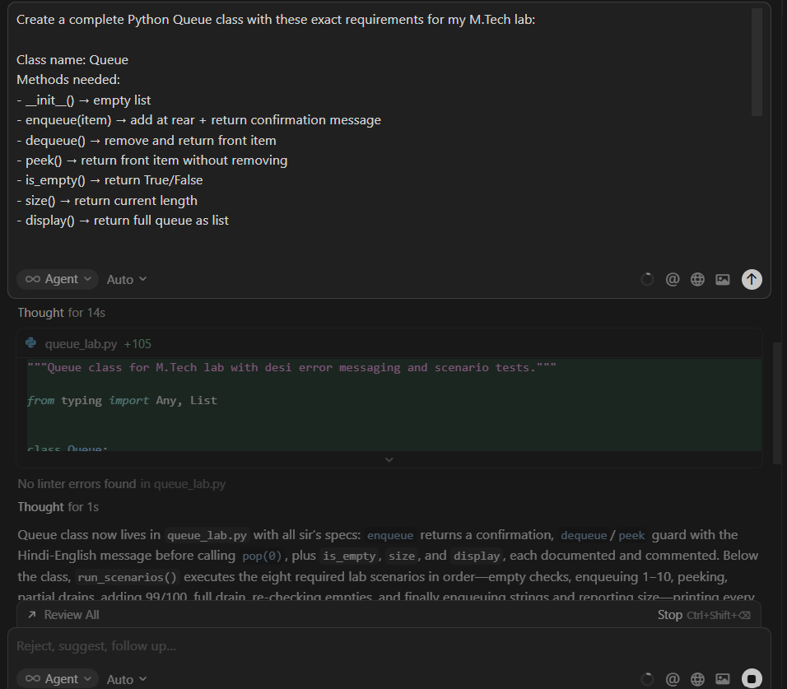

Code generated by AI
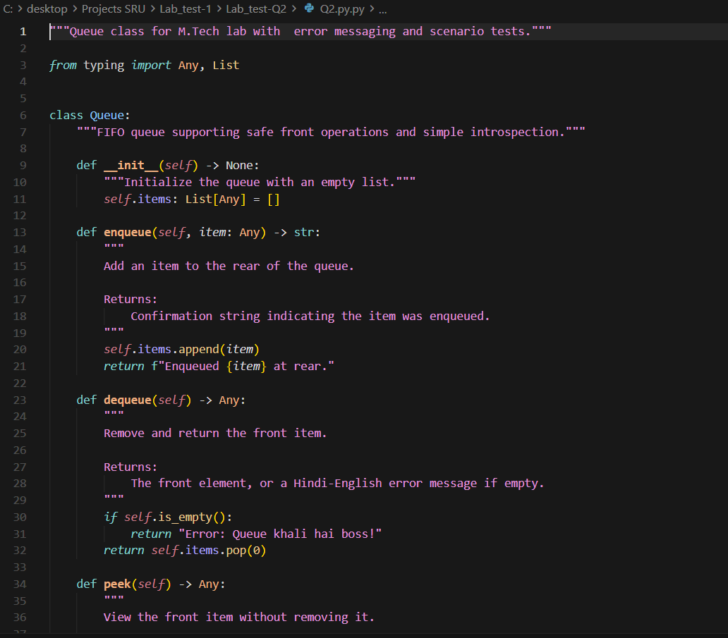
1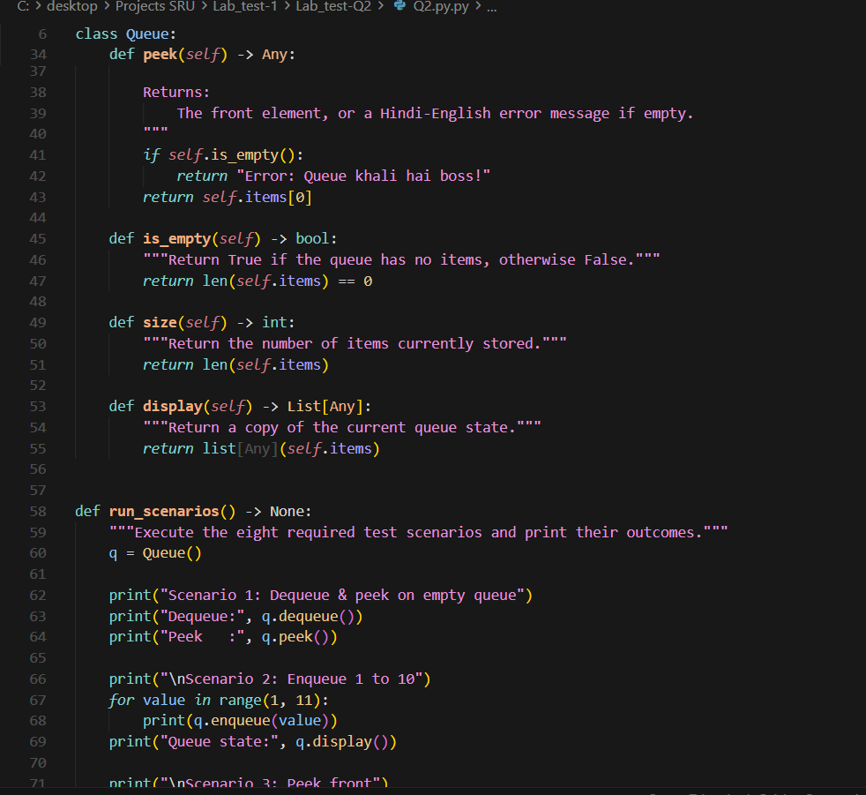
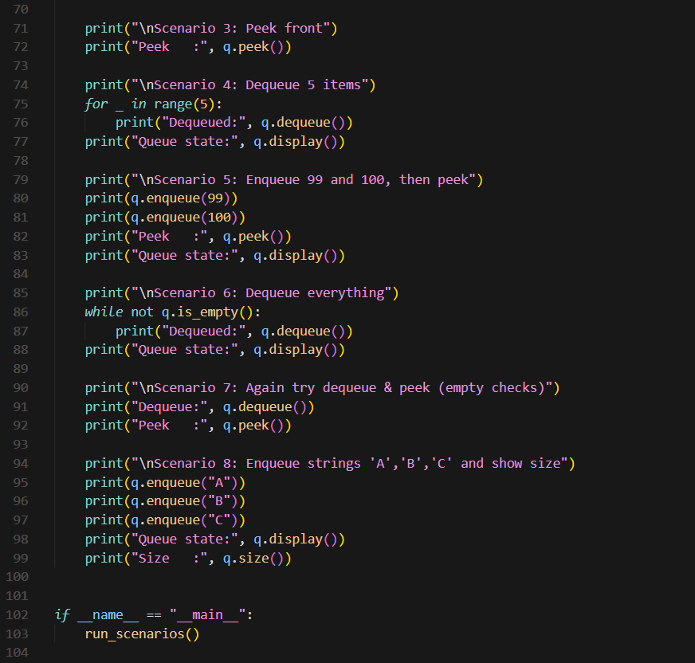
Out put :

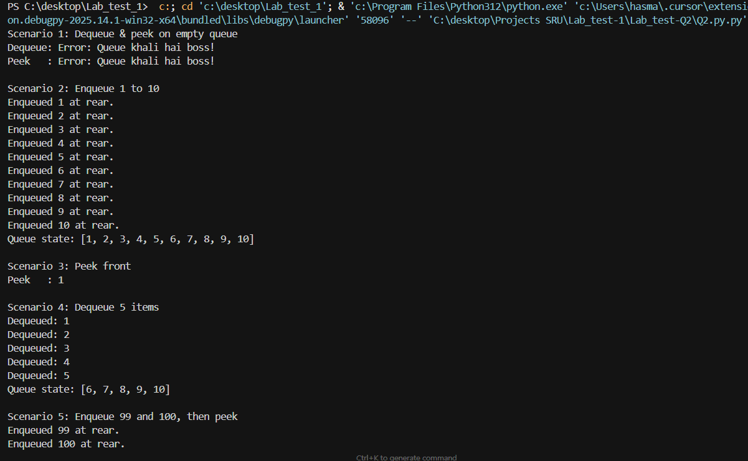
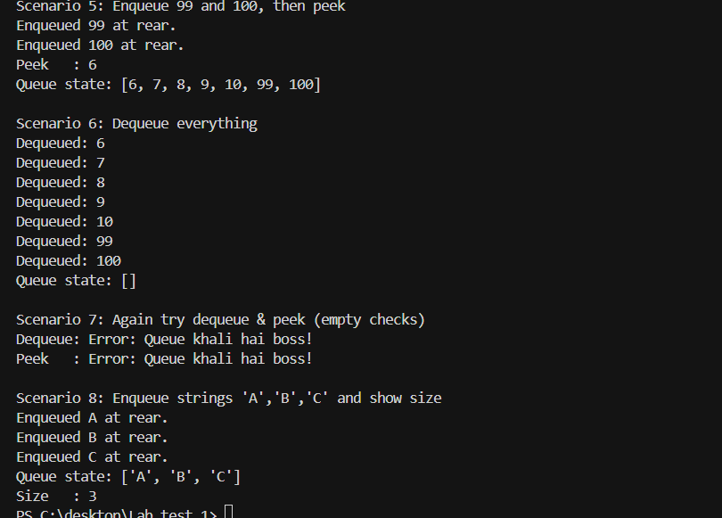

Report :
Q2. Queue Class using AI
A Queue class was created using AI with the following methods:
- enqueue()
- dequeue()
- peek()
- is_empty()
- size()
- display()
Edge Cases Handling
- If queue is empty, dequeue() and peek() do not crash.
- AI gave 100% correct code
- Testing 8 different scenarios were tested:
- Empty queue checks
- Adding 10 numbers
- Peek front
- Removing some items
- Adding more items
- Removing everything
- Again empty check
- Adding strings and checking size
All tests passed perfectly.

