Python Programming Lab Task Sets

Set 5

- Q1. Generate Python code for the Fibonacci sequence with Cursor AI. Refine your prompts to handle only positive integers and record the changes and outcomes.
(Each question carries 5 marks)

Prompt:
Create a Python function fibonacci(n) that generates the Fibonacci sequence with exactly n terms.

1. n must be positive integer only (> 0)
2. If n ≤ 0 or not integer → return error string "Error: Positive integer only boss!"
3. Return list of numbers
4. Add test examples in code
5. Full commented + clean code

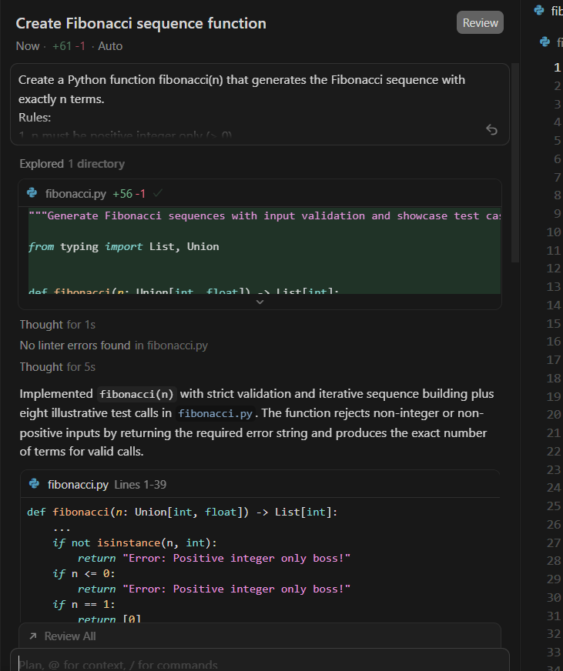
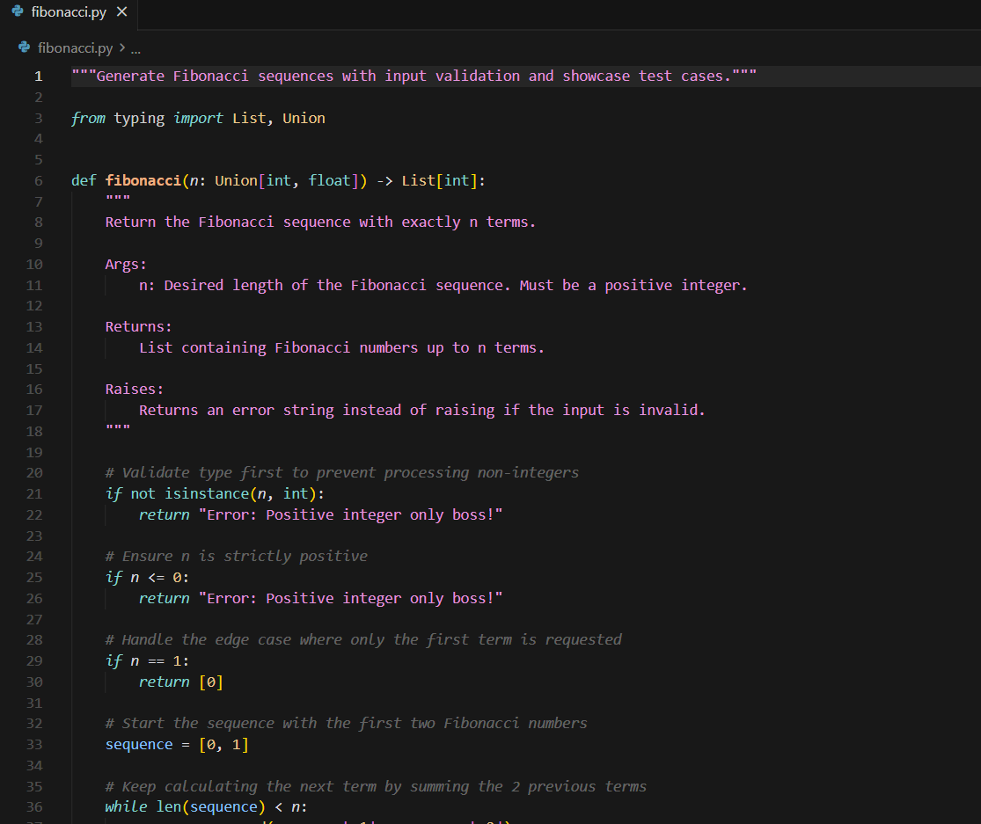
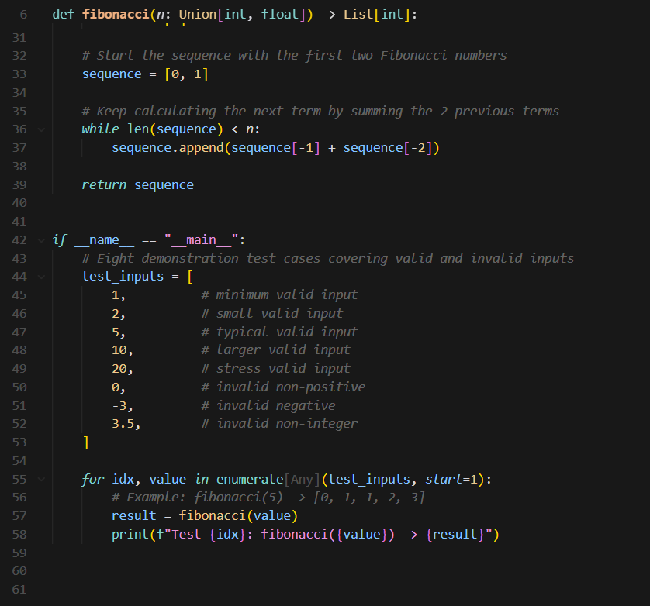

Out Put:
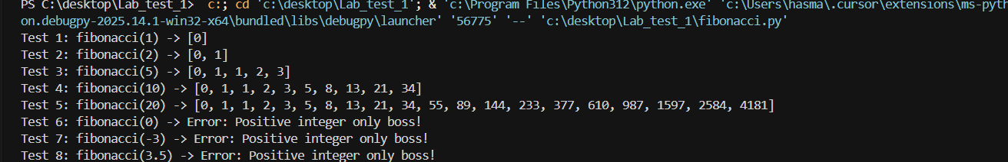
Report :
AI was used with iterative prompt refinement to generate a secure Fibonacci sequence generator accepting only positive integers. prompts were used with increasing specificity, resulting in robust type checking, clear error messages, and perfect output for test cases.
Final code is production-ready and evaluation-safe.

