Topics

窗体顶端

窗体底端
PremiumShopForums
- HTML & CSS
- JavaScript
- PHP
- Ruby
- Mobile
- Design & UX
- Entrepreneur
- Web
- WordPress
- Web Dev @ Microsoft

窗体顶端

Wondering how your team compares to other software teams? We did the work for you.Compare Nowx 想知道把你的软件团队是如何比作其它的软件团队的？我们为你做工作。 比较现在！

Introducing the CSS clip-path Property
介绍css修剪路径属性

Nitish Kumar 联邦铁道部长和农业部长的库马尔
June 02, 2016 2016年6月2号
+19 19个赞
窗体顶端
Want cutting–edge content？
想裁剪内容吗？
Get the best of Front-end plus exclusive（独有的）deals and freebies（免费赠品） in your inbox!
在你的收件箱里获得前端附加的独有的交易和免费赠品
Subscribe订阅
窗体底端
Success! Subscribed.成功定购
Claim your free ebook!认领你的免费的电子书
Get HTML5 and CSS3 for The Real World, 2nd edition when you start a free

14–day SitePoint Premium trial
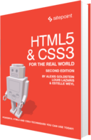Get this deal!
Was this helpful?
The web is predominantly主要地；显著地 rectangular矩形的. On the other hand, print 印刷业media 媒体tends to be more varied多变的 in shape. Among the many reasons for this difference is a lack of缺乏 appropriate适当的 tools to achieve what we have in print media.织物是很明显的矩形。另一方面，印刷业在形状上媒介趋向于更加的多变。在许多原因中对于这点不同之处是缺乏适当的工具去实现我们在印刷媒介已经有的东西。
This tutorial个别指导 will introduce you to clip-path, a property性质，性能 which allows you to prevent a portion部分 of an element元素；要素 from being displayed显示. The region范围；部位 that is visible明显的；看得见的 is governed管理；支配 by the values you provide. We will begin with the basics, then cover the syntax语法；句法；有秩序的排列 and later on后来；稍后；过些时候 move to more advanced先进的；高级的 concepts概念，观念；思想.个别指导将给你介绍修剪路径，一个允许你阻止一部分一个显示的元素的性能。部位是很明显的，它你提供的价值管理着。我们将开始基础，然后覆盖语法，后来再植入更多先进的概念。

The Basics基础
- Clipping is when we trim修剪 a piece from something. In our case, it is an operation which allows us to completely or partially部分地；偏袒地 hide elements on a web page. Two other concepts概念 that relate to涉及，有关 clipping which we will use in this article are clipping path and clipping region地区；范围；部位.剪是在我们修剪一些东西的一块时用到。对我们而言，允许我们在网页上完全地或者部分地隐藏元素是一个操作。两个另外的有关将在文章使用的剪切的概念，是修剪路径和修剪部位。
- Clipping path is the path we use to clip an element, it marks out规划，制定 our clipping region. It can be a basic shape or a complex polygonal[数] 多边形的；[数] 多角形的 path. The clipping region then includes all the area enclosed被附上的 within the clipping path.修剪路径是我们使用剪切元素的路径，它规定了我们的修剪部位 。它可以是一个基础的形状或者一个复杂的多边形路径。修剪部位包括所有在修剪路径被附上的地方。
Anything outside the clipping region is clipped by the browsers浏览器. This not only includes backgrounds and other such content but also borders, text-shadows and so on. Moreover, browsers won’t capture俘获；夺得；捕捉，拍摄,录制 any events like hover or click outside an element’s clipping region.任何外部的修剪部分是被浏览器修剪的这不但包括背景和其它的一些内容，而且包括边框，文档阴影等等。此外，浏览器不会捕捉任何像hover或者click外面的一个元素事件修剪部位。
Even though our specific element is now non-rectangular, the content around the elements flows exactly the way it would have if the element had its original shape. To make the surrounding elements flow according to the shape of the clipped element, you will have to use the shape-outside property性质. This has been covered in detail in this SitePoint tutorial.
Also, keep in mind that you do not want to confuse this property with the deprecated clip property which was very restrictive and only supported rectangular clipping.

Syntax语法；句法 and Usage语法和使用
The correct syntax for using this property is:
clip-path: <clip-source> | [ <basic-shape> || <geometry-box> ] | none
The syntax values above include:
- clip-source will be a URL referencing an internal or external SVG <clipPath> element.
- basic-shape accepts the basic shape function defined in the CSS Shapes specification.
- geometry-box is optional. When you provide it along with the basic-shape function, it acts like a reference box for the clipping done by basic-shape. If geometry-box is specified by itself, then it uses the shape of specified box, including any corner shaping (provided by the border-radiusproperty) as the clipping path. We will explore this further soon.
Now, consider the following CSS code which uses the basic shape function:
img {
clip-path: polygon(50% 0%, 100% 50%, 50% 100%, 0% 50%);}
It will clip all the images in the shape of a rhombus. But why are the images being clipped in shape of a rhombus and not a trapezium or parallelogram? It all depends on the value of your vertices. The following diagram illustrates the conventions to be used when you are creating your own polygon shapes for clipping:
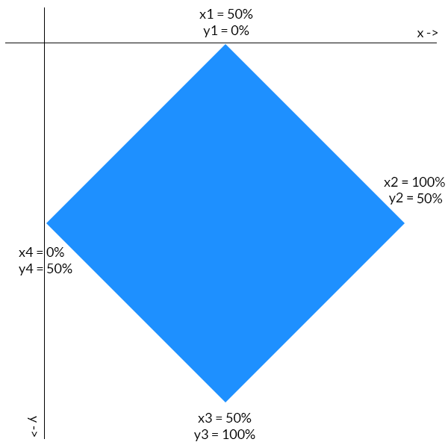
The first coordinate坐标；同等的人或物 of each point determines its location on the x-axis. Similarly, the second point specifies指定 its location on the y-axis. The points are all plotted 标绘的 in a clockwise顺时针方向的 direction. Consider the rightmost最右边的 point of our rhombus 菱形. It is located half way方向 down the y-axis, so its y coordinate 坐标 is 50%. It is also located at the extreme right position on the x-axis, so its x coordinate is 100%. Values of all other points can be deduced similarly.

Clipping Elements With geometry-box Values
When you are clipping a HTML element the geometry-box (or reference box) can be any one of the following — margin-box, border-box, padding-box or content-box. The geometry-box value should be used in following manner:
.clip-me {
clip-path: polygon(10% 20%, 20% 30%, 50% 80%) margin-box;
margin: 10%;}
In the case above, the margin-box of our element will be used as a reference to determine the exact location of clipping points. The point (10%, 10%) is the top-left corner of our margin-box and thus ourclip-path would be positioned in relation to that point.
In case of SVG elements, it can be fill-box, stroke-box and view-box. The value view-box will use the nearest SVG viewport as a reference box if no view-box is specified.

Uses of clip-path
This property has a lot of interesting uses. Firstly, it can improve our text content. Take a look at the image below. The background behind the headline and the second paragraph was created using clip-pathproperty:
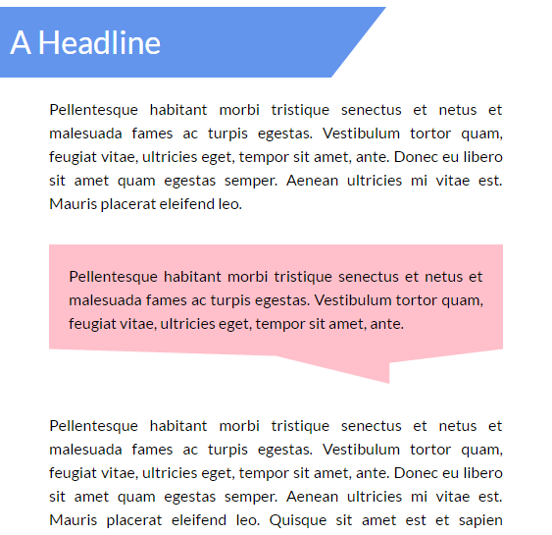
You can easily create the first background using gradients and other such techniques. However, it would be a lot harder to create the second one without the help of clip-path. Note that the line at the bottom of that message-like background is not perfectly horizontal, it is a bit oblique. To achieve this result withclip-path you need only a single line of CSS:
.p-msg {
clip-path: polygon(0% 0%, 100% 0%, 100% 75%, 75% 85%, 75% 100%, 50% 80%, 0% 75%);}
The background has seven vertices and it is reflected in our polygon’s clip-path. How did I come up with those co-ordinates you ask? I’ll leave that to the reader to figure out — doing so will help you have a better understanding of the concepts. Play around with the CodePen below to get the hang of it:
You can also clip images into different shapes with this property and arrange them together in cool ways with the help of a little CSS. The image thumbnails in your galleries no longer need to be rectangular and the user avatars can have any shape that you wish. In this tutorial, we will arrange images in the shape of a rhombus. Since all images have the same basic rhomboid shape they will use the same clip-pathvalue. Here is the CSS for rightmost image:
.right {
clip-path: polygon(50% 0%, 100% 50%, 50% 100%, 0% 50%);
position: relative;
top: -352px;
left: 256px;}
Here is an example of clip-path images in action:
There is a lot more that you can do with clip-path — you can create buttons with fancy shapes or add nice hover effects to your navigation menu. You are limited only by your own creativity!

Adding Animation
This property is also able to be animated. The only thing that you have to keep in mind is that the number of vertices in the final and initial shape must be the same. This makes sense because otherwise the browser won’t know where to add that extra vertex (or where to remove it from). Here is some CSS to animate a trapezium:
@keyframes polygons {
25% {
clip-path: polygon(20% 0%, 100% 38%, 70% 90%, 0% 100%);
}
50% {
clip-path: polygon(0 46%, 100% 15%, 55% 74%, 0 100%);
}
70% {
clip-path: polygon(100% 38%, 100% 38%, 66% 100%, 0 53%);
}}
In the final phase of the animation, the trapezium changes into a triangle. As I mentioned earlier, we can’t change the number of vertices and expect the animation to be smooth. Changing the number of vertices will make the transition abrupt. To resolve this issue, I have set the first two vertices in the last polygon in such a way that they coincide. This way our quadrilateral transforms nicely into a triangle.

Browser Support
This property is not supported by IE and Edge. Firefox only supports clip-path partially (it only supports the url() syntax). However, from version 47 onward, Firefox supports this property with thelayout.css.clip-path-shapes.enabled flag enabled.
Chrome, Safari and Opera require the prefix -webkit- in order to work properly. Unfortunately, even they don’t support shapes in external SVGs. You can read more about browser support on Can I Use.

Conclusion

More from this author
- Introducing the CSS Grid Layout
- How to Use PostCSS with Gulp
This tutorial covered the basics of clip-path to help you get started. While it did not take much time to learn how to use this property, using it creatively will take a little practice. By the time browser support is decent enough, you will be ready to create stunning effects with clip-path.
I would also like to mention two tools — clippy by Bennett Feely and clip path generator by CSS Plant — to make it easier for you to create complex polygonal paths.
Have you created something awesome with clip-path? Please provide a link to it in the comments.
Tags: clip-path, css shapes, css shapes spec
Was this helpful?
窗体顶端
Get our latest front-end articles in your inbox, once a week, for free.
Get Updates
窗体底端
Nitish Kumar

I am a front-end developer who has a keen interest in working with various libraries and reading about latest developments in my field. I also publish a list of most popular web development articles of the week every Tuesday on the website Freadio.

COURSES >

3:07:36
JavaScript: Next Steps
M. David Green

1:11:20
React The ES6 Way
Darin Haener

1:49:07
Your First Meteor 1.2 Application
David Turnbull

BOOKS >


Jump Start Sass
Hugo Giraudel

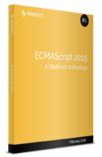
ECMAScript 2015: A SitePoint Anthology
James Hibbard

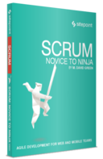
Scrum: Novice to Ninja
M. David Green

SCREENCASTS >

Finding Bugs in Your Commits with Git Bisect
Shaumik Daityari

Exploring and Working with Photos in Canva
Lisa Larson-Kelley

Creating Custom Sass Functions
Guilherme Muller

Recommended for you
- A Basic HTML5 Template For Any Project
- Boxy SVG: A Fast, Simple, Insanely Useful, FREE SVG Editor
- Quick Tip: 4 Really Useful, Re-Useable Code Snippets from Codepen
- Make Your Own Responsive SVG Graphs & Infographics
- Front End Development after Internet Explorer
LAST CHANCE
Learn Web Development
Get one free year of unlimited book and course downloads on SitePoint Premium and start learning web development now!
Get Your Free Year Now






Close
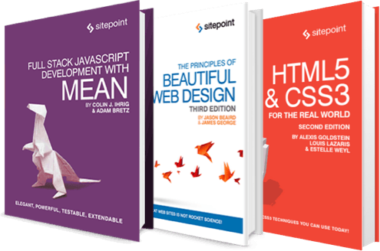
窗体顶端
Get 10 free ebooks
from SitePoint Premium today.

窗体底端

About

- Our Story
- Advertise
- Press Room
- Reference
- Terms of Use
- Privacy Policy
- FAQ
- Contact Us
- Contribute

Visit

- SitePoint Home
- Forums
- Newsletters
- Premium
- References
- Shop
- Versioning

Connect

© 2000 – 2016 SitePoint Pty. Ltd.

