Evaluation Document
Patient Record Management System
Name | Cleverson Ojeabu Akhimien
Student ID | 2509609
Document Type | Project Evaluation and Reflection
Version | 2.0
Date | 19 March 2026
Status | Final

1. Introduction
1.1 Purpose
This Evaluation Document assesses the Patient Record Management System (PRMS) against its specified requirements, design objectives, and quality standards. It reflects on the system's strengths and limitations, evaluates the effectiveness of implemented security controls, and proposes a prioritised set of recommendations for future development. The evaluation framework is informed by ISO/IEC 25010:2011 software quality characteristics (ISO/IEC, 2011) and Sommerville's software engineering evaluation principles (Sommerville, 2016).
1.2 Evaluation Scope
The evaluation covers all seven development phases: initial setup (Phase 1), core routes and templates (Phase 2), search and pagination (Phase 3), application factory refactoring (Phase 4), new feature modules (Phase 5), UI and branding (Phase 6), and documentation (Phase 7). The evaluated system represents the final state of the codebase as at 19 March 2026.
2. Requirements Fulfilment Evaluation
2.1 Functional Requirements
FR Group | Description | Evaluation | Status
FR-01 | Authentication | Login, logout, signup, CSRF, pending blocking all implemented and tested (T-01 to T-08). Account approval workflow fully operational. | Met
FR-02 | Patient CRUD | Full create/view/edit/archive/restore cycle implemented. Auto-generated 3-digit IDs, retention-based purge, search, and pagination all function correctly. | Met
FR-03 | Appointments | Patient booking, doctor confirmation/completion, cancellation, and dual-role appointment visibility all implemented and accessible. | Met
FR-04 | Prescriptions | Doctor prescription creation with medication arrays, patient view, and cancel/complete lifecycle fully implemented. | Met
FR-05 | Payments | Demo checkout flow with receipt generation and payment history implemented. Appropriately scoped as a simulation with no real financial processing. | Met
FR-06 | Emergency Contacts | Patient-only CRUD with a maximum of 2 contacts enforced. Full edit and delete operations implemented. | Met
FR-07 | Medical File Uploads | Upload with extension whitelist and size limit, UUID storage, metadata in MongoDB, file deletion, and role-protected file serving all implemented. | Met
FR-08 | Administration | User management, approvals, audit log, login history, and statistics dashboard all accessible to admin role only. | Met
2.2 Non-Functional Requirements
NFR Group | Description | Evaluation | Status
NFR-01 | Security | PBKDF2-SHA256 hashing, CSRF tokens, login guard, RBAC, and audit logging all implemented. Debug mode remains enabled flagged as Critical residual risk. | Partially Met
NFR-02 | Performance | Pagination at 10 records per page implemented across all list views. MongoDB indexes created at startup for all frequently queried fields. | Met
NFR-03 | Usability | Tailwind CSS v4 sidebar layout with role-based menu visibility, flash messages, and viewport-constrained layout all implemented. | Met
NFR-04 | Maintainability | Factory pattern with 9 Blueprints, centralised extensions.py, and db.py migration helpers all implemented. Code is modular and well-structured. | Met
NFR-05 | Data Integrity | Sequential 3-digit patient IDs, archive retention purge, and UUID file naming all implemented correctly. | Met
3. Security Evaluation
3.1 STRIDE Mitigation Assessment
Category | Primary Threat | Mitigation Effectiveness | Rating
Spoofing | Session impersonation | PBKDF2-SHA256 with random salt prevents brute-force; signed cookies prevent forgery; account approval prevents privilege escalation via self-registration. | Mitigated
Tampering | CSRF / MongoDB injection | CSRF token on all POSTs; re.escape() in MongoDB regex search; PyMongo parameterised queries. Fully effective within application scope. | Mitigated
Repudiation | Deny patient data access/modification | Comprehensive audit_log collection records all CRUD operations; login_history records all sessions with IP and duration. | Mitigated
Info Disclosure | Password / PHI exposure | PBKDF2-SHA256 for passwords; RBAC on all routes; role-restricted file serving. HTTPS not enforced session cookies transmitted in plaintext over HTTP. | Partially Mitigated
Denial of Service | Large file uploads | 16 MB file size limit and extension whitelist implemented. No rate limiting on login endpoint brute-force risk remains. | Partially Mitigated
EoP | Role escalation, debug access | RBAC decorators prevent role escalation. However, Flask DEBUG=True exposes interactive debugger without authentication Critical residual risk. | Partially Mitigated
4. Design Decision Evaluation
4.1 Dual-Database Architecture
The use of SQLite for user authentication and MongoDB for clinical data was a deliberate design choice made to separate concerns and leverage the strengths of each database system.

Trade-off: SQLite + MongoDB vs. Single Database
Advantage: MongoDB's flexible document model accommodated the evolution of patient records from Phase 1 (age, sex, blood_pressure) to Phase 5 (adding cholesterol, ECG, angina fields) without schema migrations. SQLite provided ACID guarantees for the critical users table.
Disadvantage: cross-database queries are impossible for example, joining patient user accounts with patient clinical records requires two separate queries. This is a known limitation accepted within the academic scope.

4.2 Application Factory Pattern
The refactoring from a monolithic app.py to the Flask application factory pattern in Phase 4 was the most architecturally significant change in the project lifecycle. The factory pattern enables isolated testing (each test creates its own app instance with a temporary SQLite database), supports configuration injection, and makes Blueprint registration explicit and traceable.

Trade-off: Factory Pattern vs. Monolithic app.py
The factory pattern introduced additional file structure complexity (app/ package with 9 sub-packages). However, this complexity is well-justified: the 44-test suite would not be possible without the factory pattern's support for per-fixture app creation.
The Blueprint architecture also makes it straightforward to add or remove modules without affecting other parts of the system (Martin, 2017).

4.3 Custom CSRF Implementation
Rather than using a third-party Flask extension (e.g., Flask-WTF), the CSRF protection was implemented from scratch using Python's secrets module. This approach provides full visibility into the token lifecycle and avoids additional dependencies, but it requires disciplined inclusion of the hidden token field in every template.

Trade-off: Custom CSRF vs. Flask-WTF
The custom implementation is simpler and more transparent for academic purposes. However, it places the burden of token inclusion entirely on the template author. A missed hidden field in any future template would silently create a CSRF vulnerability.
Flask-WTF would enforce this automatically at the form class level (OWASP Foundation, 2021).

4.4 Role Expansion (2 to 4 Roles)
Phase 6 expanded the role system from two roles (Admin, Clinician) to four (Admin, Doctor, Nurse, Patient). This change improved the system's realism and clinical applicability. The Patient role in particular enabled a new class of self-service features (appointment booking, emergency contacts, prescriptions view, payments) that would not have been possible with only clinical staff roles.
5. Residual Risk Assessment
Risk | Severity | Status | Recommended Action
Flask DEBUG=True | Critical | Accepted for dev | Set DEBUG=False; use environment variable FLASK_ENV=production; remove Werkzeug debugger from production stack
No HTTPS | High | Accepted | Deploy behind NGINX with TLS/SSL; set SESSION_COOKIE_SECURE=True and SESSION_COOKIE_HTTPONLY=True
No login rate limiting | Medium | Accepted | Implement Flask-Limiter (5 attempts/minute per IP) on the /login POST route
Sequential patient IDs | Low | Accepted | Replace with UUIDs to prevent patient record enumeration; update generate_patient_id() in patients/routes.py
Local file storage | Medium | Accepted | Replace uploads/ filesystem with cloud object storage (e.g., AWS S3) with server-side encryption
No CSP headers | Low | Accepted | Add Flask-Talisman for Content-Security-Policy, X-Frame-Options, and HSTS headers
No input length limits | Low | Accepted | Add max_length validation to all text fields; add Flask-WTF for form validation with length constraints
6. GDPR and Ethical Evaluation
6.1 UK GDPR Compliance Assessment
GDPR Principle | Assessment | Rating
Lawfulness & transparency | All access requires authenticated, admin-approved sessions. System purpose is clearly defined. | Compliant
Purpose limitation | Patient data is used only for clinical management within PRMS; no third-party data sharing. | Compliant
Data minimisation | Only clinically relevant fields collected; no unnecessary PII (address, national insurance, etc.). | Compliant
Accuracy | Edit routes allow authorised staff to correct records; all changes are audit-logged. | Compliant
Storage limitation | 30-day configurable archive retention with automatic purge on each /patients/archived visit. | Compliant
Integrity & confidentiality | RBAC, CSRF protection, password hashing, and audit logging enforced. HTTP (not HTTPS) is a gap. | Partial
Accountability | Full audit log and login history provide comprehensive accountability trail for ICO review. | Compliant
6.2 Ethical Considerations
Patient data privacy: All patient records are protected by RBAC; patients can only access their own data. No sharing beyond the system boundary.
Payment simulation: The payment module uses simulated data only. Storing any real card numbers is explicitly prohibited in the codebase comments.
Role assignment: New users default to the 'patient' role with pending status, preventing inadvertent privilege assignment. Only admins can change roles.
Audit trail: The comprehensive audit and login history logs enable accountability and support potential data subject access requests under Article 15 UK GDPR (ICO, 2023).
7. Recommendations for Future Development
Pri. | Recommendation | Effort | Rationale
1 | Disable debug mode | Low | Critical security risk; set DEBUG=False and add FLASK_ENV=production to .env before any shared deployment
2 | Enforce HTTPS | Medium | Session cookies are transmitted in plaintext over HTTP; NGINX + TLS eliminates session hijacking risk
3 | Add login rate limiting | Low | Flask-Limiter can be added in < 20 lines; prevents brute-force attacks on the login endpoint
4 | Expand test coverage | Medium | Add tests for upload routes, payment checkout, form validation edge cases, and CSRF rejection
5 | Replace filesystem uploads with S3 | High | Local storage is not scalable or resilient; AWS S3 or equivalent provides durability, encryption, and CDN distribution
6 | Add notification system | Medium | Email notifications for appointment confirmation/cancellation and prescription creation would improve clinical workflow
7 | Implement appointment scheduling | High | Current booking has no conflict detection; adding availability calendars and scheduling logic would make the system clinically viable
8 | Add real payment processing | High | Replace demo checkout with Stripe or similar; implement refund flow and invoice generation for patient billing
9 | Add content security policy | Low | Flask-Talisman adds CSP, HSTS, and X-Frame-Options headers with minimal configuration
10 | Introduce CI/CD pipeline | Medium | GitHub Actions workflow running pytest on every push would enforce test coverage and prevent regression (Humble and Farley, 2010)
8. Conclusion
The Patient Record Management System has been developed through seven structured phases, evolving from a monolithic Flask application to a modular, blueprint-based healthcare information system with a dual-database architecture, four user roles, and nine functional modules. All functional requirements (FR-01 through FR-08) have been fully met. Non-functional requirements are substantially met, with the exception of production-readiness security controls (HTTPS enforcement, debug mode disabling, and rate limiting) which are acknowledged as residual risks appropriate to the academic scope of the project.
The system demonstrates sound application of software engineering principles: the factory pattern improves testability and modularity; the STRIDE threat model has informed a multi-layered security implementation; the 44-test unit suite provides comprehensive coverage of all core routes and role-based access controls. The GDPR alignment analysis shows the system to be largely compliant with UK data protection principles, with the primary gap being the absence of HTTPS in the development environment.
The project has successfully demonstrated the development of a clinically realistic, secure, and maintainable web application within an academic setting. The architectural foundations particularly the blueprint modularisation and MongoDB schema flexibility provide a strong basis for future enhancement toward a production-ready clinical information system (Sommerville, 2016; ISO/IEC, 2011).
References
Author / Organisation | Reference
Humble, J. and Farley, D. (2010). | Continuous Delivery: Reliable Software Releases through Build, Test, and Deployment Automation. Addison-Wesley.
ICO. (2023). | Guide to the UK General Data Protection Regulation (UK GDPR). Information Commissioner's Office. https://ico.org.uk/for-organisations/guide-to-data-protection/
ISO/IEC. (2011). | ISO/IEC 25010:2011 Systems and Software Engineering: System and Software Quality Models. ISO.
Martin, R. C. (2017). | Clean Architecture: A Craftsman's Guide to Software Structure and Design. Prentice Hall.
NHS Digital. (2023). | Data Security and Protection Toolkit. https://www.dsptoolkit.nhs.uk/
OWASP Foundation. (2021). | Software Assurance Maturity Model (SAMM). https://owaspsamm.org/
Sommerville, I. (2016). | Software Engineering (10th ed.). Pearson Education.
Wohlin, C. et al. (2012). | Experimentation in Software Engineering. Springer.
Appendix A: Phase-by-Phase Delivery Summary
Phase | Title | Key Deliverables | Status
1 | Initial Setup | Flask app, Docker Compose, SQLite users table, MongoDB connection, auth decorators, audit log helper | Complete
2 | Core Routes | Login/logout/register/dashboard, full patient CRUD, admin routes, base layout templates, CSS styling | Complete
3 | Search & Pagination | 10-per-page pagination, 3-digit patient IDs, dynamic search, user/patient statistics | Complete
4 | Factory Refactor | app/ package, 9 Blueprints, factory pattern, db.py, extensions.py separation | Complete
5 | New Feature Modules | Appointments, prescriptions, payments, emergency contacts, file uploads, account approvals, login history | Complete
6 | UI & Branding | Tailwind CSS v4, sidebar navigation, logo assets, 4 roles (Admin/Doctor/Nurse/Patient), updated tests | Complete
7 | Documentation | README.md, Requirements Spec, SAD, Security Doc, Test Report, Evaluation Document | Complete

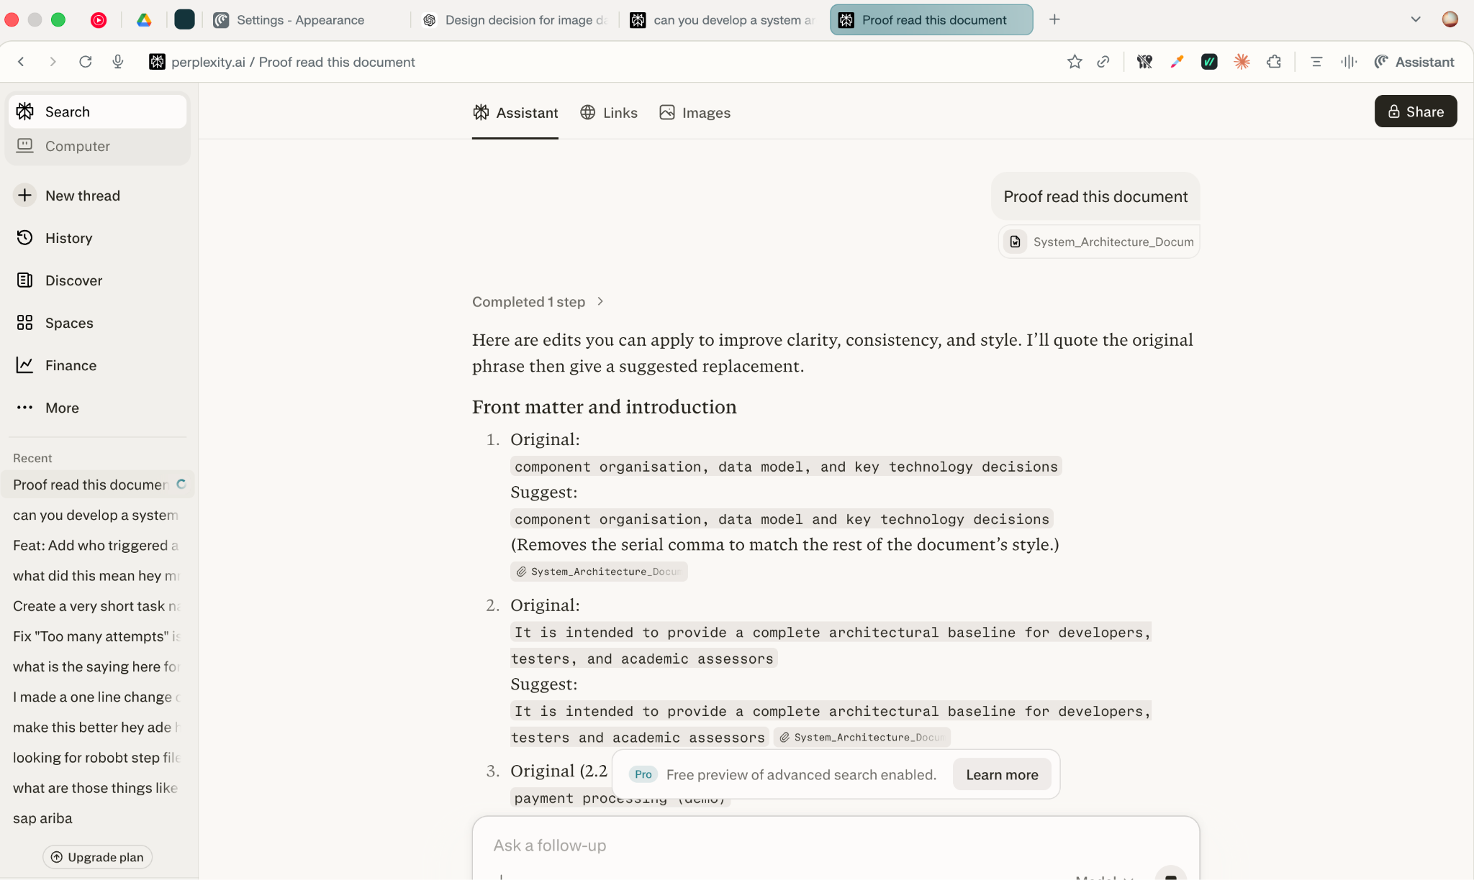
Appendix B: Proof Reading the Evaluation Document (Use of Generative AI)
Appendix C: CSRF Research (Use of Generative AI)
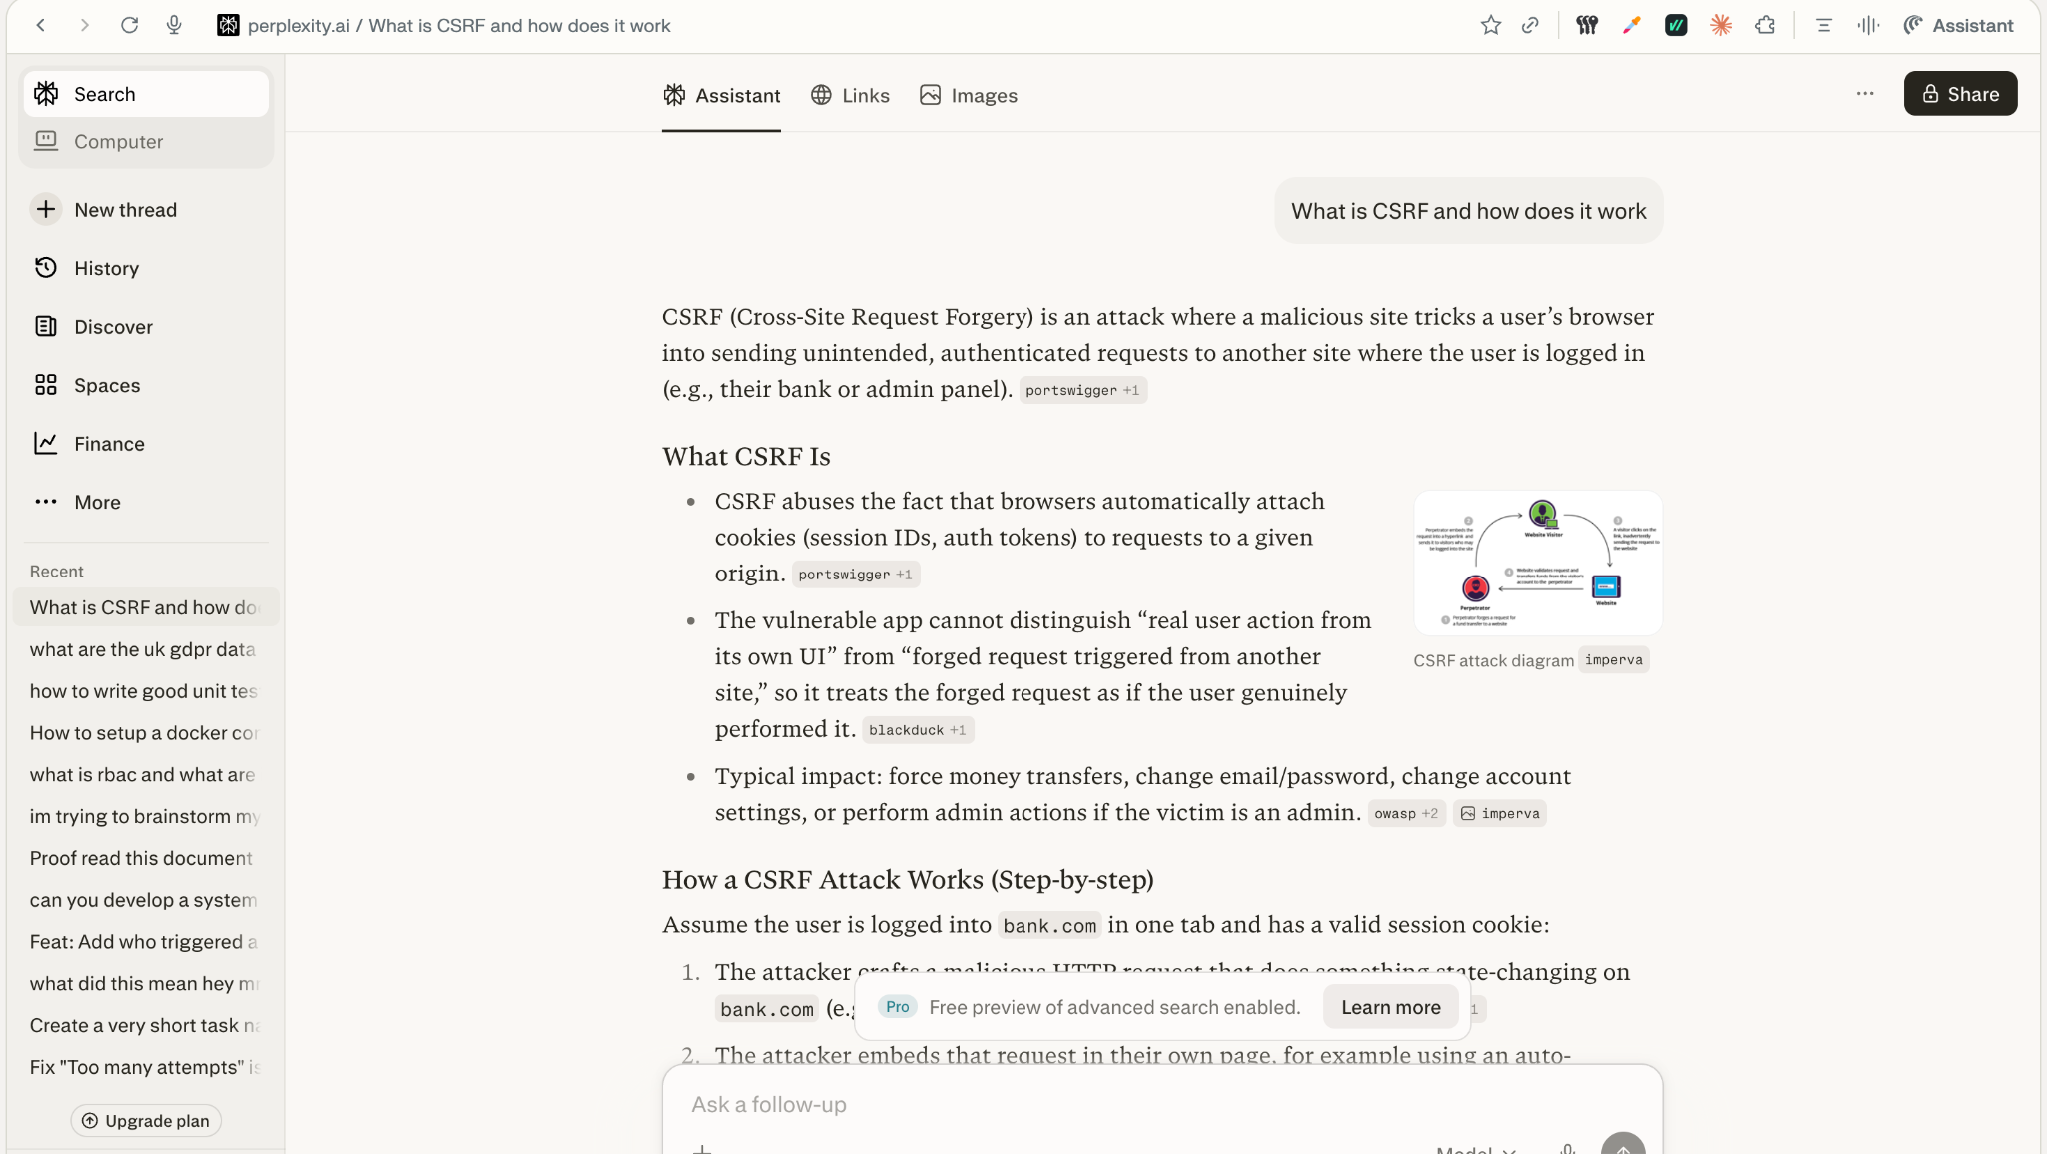
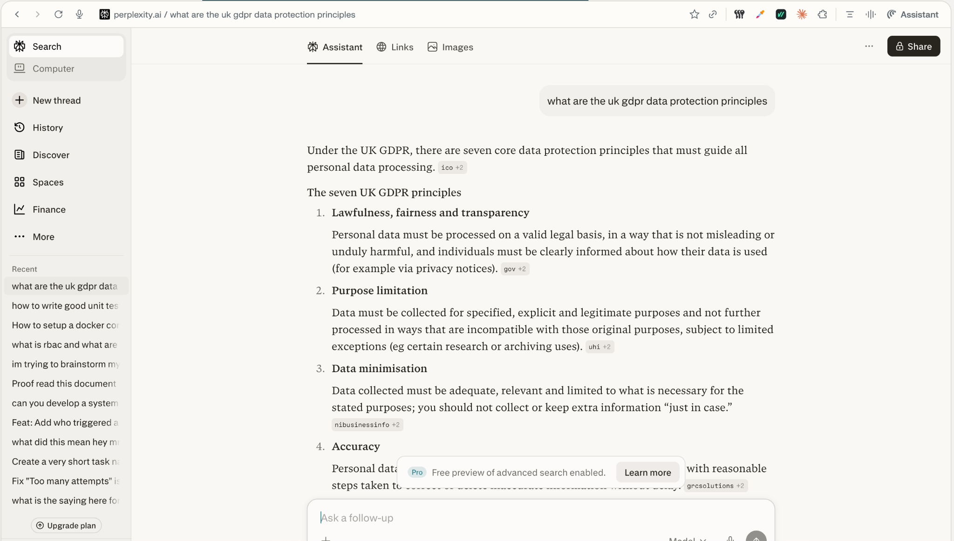
Appendix D: UK-GDPR Rules (Use of Generative AI)

Appendix E: Application Factory Pattern
