Security Documentation
Patient Record Management System

Name | Cleverson Ojeabu Akhimien
Student ID | 2509609
Document Type | Security Analysis and Controls Documentation
Version | 2.0
Date | 19 March 2026

1. Introduction
1.1 Purpose
This Security Documentation presents the threat model, security controls, and risk assessment for the Patient Record Management System (PRMS). It applies the STRIDE framework (Spoofing, Tampering, Repudiation, Information Disclosure, Denial of Service, Elevation of Privilege) to identify and evaluate security threats and documents the countermeasures implemented in the application (Shostack, 2014; Microsoft Corporation, 2009).
1.2 Scope
The scope covers the entire PRMS application stack: Flask web application, MongoDB clinical database, SQLite authentication database, user session management, file upload subsystem, and all HTTP routes. It does not cover infrastructure-level security (firewalls, TLS configuration, server hardening) beyond the application boundary.
1.3 Security Context
The PRMS processes personal health information (PHI) including patient records, prescriptions, appointments, and medical files. As a healthcare system, it is subject to the UK General Data Protection Regulation (UK GDPR) and NHS Data Security and Protection Toolkit requirements (ICO, 2023; NHS Digital, 2023). All security controls documented here are implemented at the application layer.
2. STRIDE Threat Model
2.1 Methodology
STRIDE is a threat modelling framework developed by Microsoft that categorises threats into six types (Shostack, 2014). For each STRIDE category, the relevant threats to the PRMS are identified, the impact is assessed, and the implemented countermeasure is described.
2.2 STRIDE Analysis Table
Category | Threat | Risk | Countermeasure
Spoofing | Attacker impersonates a legitimate user by replaying stolen session cookies | High | Flask signed-cookie sessions with server-side secret key; session is cleared on logout; login attempts checked against PBKDF2-SHA256 hashed passwords
Spoofing | Attacker registers as a privileged user (doctor/admin) via the signup form | High | All signups default to role='patient' and status='pending'; admin must explicitly approve and may change the role before account activation
Tampering | Attacker submits forged POST requests to modify patient or user data | High | CSRF token (secrets.token_hex(16)) injected into all forms; app.before_request validates form token against session token on every POST
Tampering | Attacker modifies MongoDB documents directly by injecting unsanitised input | Medium | PyMongo uses parameterised queries; no string interpolation into MongoDB filter documents; regex input in search is escaped with re.escape()
Repudiation | Clinician denies having created, modified, or viewed a patient record | High | log_action() records all patient CRUD, archive, and restore operations to the audit_log collection with user_id, username, action, and timestamp
Repudiation | User denies having logged in from a specific IP or at a specific time | Medium | Login history collection records user_id, username, role, login_at, logout_at, duration_seconds, ip_address for every session
Information Disclosure | Password hashes exposed via database breach | High | All passwords stored as PBKDF2-SHA256 hashes via Werkzeug; plaintext passwords never stored or logged
Information Disclosure | Sensitive patient data accessed by unauthorised role | High | @role_required(*roles) decorator on all sensitive routes; patients can only access their own records, appointments, and prescriptions
Information Disclosure | Medical file served to unauthorised user | High | File serve route (/uploads/<file>) protected by @login_required and @role_required(admin, doctor, nurse); patients cannot directly access files
Denial of Service | Large file upload exhausts server disk space or memory | Medium | File size limit enforced at 16 MB; file extension whitelist limits accepted types
Denial of Service | Repeated failed login attempts lock legitimate users out | Low | No rate limiting currently implemented; accepted as residual risk for academic scope; recommended as future enhancement
Elevation of Privilege | Authenticated nurse or patient accesses admin-only or doctor-only routes | High | @role_required('admin') or @role_required('admin','doctor') applied to all privileged routes; unauthorised access redirects to dashboard with error flash
Elevation of Privilege | User exploits debug mode to access interactive debugger | Critical | Flask debug=True in development; interactive debugger is accessible without authentication when DEBUG is enabled; flagged as Critical residual risk
3. Authentication Security
3.1 Password Hashing
NFR-01.1 PBKDF2-SHA256 Password Hashing
All user passwords are stored as cryptographic hashes using Werkzeug's generate_password_hash (PBKDF2-SHA256 + random salt). Plaintext passwords are never stored or logged.

All user passwords are hashed before storage using Werkzeug's generate_password_hash function, which applies the PBKDF2-SHA256 algorithm with a random salt. This follows NIST SP 800-63B guidance for memorised secret verifiers (NIST, 2020) and ensures that even if the users.db file is compromised, plaintext passwords cannot be recovered.
# Registration app/auth/routes.py
from werkzeug.security import generate_password_hash, check_password_hash

# Hash on signup
hashed = generate_password_hash(password) # PBKDF2-SHA256 + random salt
db.execute('INSERT INTO users (..., password) VALUES (?)', (hashed,))

# Verify on login
if user and check_password_hash(user['password'], password):
session['user_id'] = user['id']
session['role'] = user['role']
3.2 Account Approval Workflow
FR-01.3 Pending/Rejected Account Blocking
New user registrations are created with status='pending'. Admin must explicitly approve before login is permitted.

New user registrations are created with status='pending'. The login route checks the account status and rejects login attempts from pending or rejected accounts. Admins approve accounts via the /admin/approvals route, transitioning status to 'approved'. This prevents unauthorised access from self-registered users until vetted.
3.3 Session Management
Flask signed-cookie sessions store user_id, username, role, and a CSRF token. The session is signed with the SECRET_KEY environment variable. On logout, session.clear() removes all session data. Login history is recorded (login_at, logout_at, duration_seconds, ip_address) in the login_history MongoDB collection for audit purposes.
4. CSRF Protection
NFR-01.2 CSRF Token Validation
Every state-mutating POST request is validated against a session-stored 32-char hex token generated by secrets.token_hex(16).

The PRMS implements a custom Synchronizer Token Pattern (OWASP, 2021) to prevent Cross-Site Request Forgery attacks. A 32-character hexadecimal token is generated using Python's cryptographically secure secrets.token_hex(16) function and stored in the user's session. The token is injected into every rendered template via a context processor and included as a hidden form field.
# app/__init__.py
import secrets

def generate_csrf_token():
if 'csrf_token' not in session:
session['csrf_token'] = secrets.token_hex(16) # 32 hex chars
return session['csrf_token']

@app.context_processor
def inject_csrf_token():
return dict(csrf_token=generate_csrf_token())

@app.before_request
def check_csrf():
if request.method == 'POST':
token = session.get('csrf_token')
form_token = request.form.get('csrf_token')
if not token or token != form_token:
flash('Invalid form submission. Please try again.', 'error')
return redirect(request.url)
Every Jinja2 form template includes the hidden field:
<input type="hidden" name="csrf_token" value="{{ csrf_token }}">
5. Role-Based Access Control
5.1 Decorator Implementation
NFR-01.3 / NFR-01.4 @login_required and @role_required
Two decorators enforce access control at the route level; all restricted routes redirect rather than returning HTTP 403.

Access control is enforced through two custom decorators in app/auth/decorators.py. @login_required verifies that user_id exists in the session. @role_required(*roles) verifies that the session role is within the permitted set. Both decorators redirect unauthorised requests rather than returning HTTP 403, to avoid leaking endpoint existence (Anderson, 2020).
# app/auth/decorators.py
from functools import wraps
from flask import session, flash, redirect, url_for

def login_required(f):
@wraps(f)
def decorated(*args, **kwargs):
if 'user_id' not in session:
flash('Please log in to access this page.', 'error')
return redirect(url_for('auth.login'))
return f(*args, **kwargs)
return decorated

def role_required(*roles):
def decorator(f):
@wraps(f)
def decorated(*args, **kwargs):
if session.get('role') not in roles:
flash('You do not have permission.', 'error')
return redirect(url_for('main.dashboard'))
return f(*args, **kwargs)
return decorated
return decorator
5.2 Role Permission Matrix
Route / Action | Admin | Doctor | Nurse | Patient | Decorator
View patient list | Y | Y | Y | N | @role_required(admin, doctor, nurse)
Create / edit patient | Y | Y | N | N | @role_required(admin, doctor)
Archive / restore patient | Y | N | N | N | @role_required(admin)
Book appointment | N | N | N | Y | @role_required(patient)
Confirm / complete appt | Y | Y | N | N | @role_required(admin, doctor)
Create prescription | N | Y | N | N | @role_required(doctor)
Upload / delete file | Y | Y | N | N | @role_required(admin, doctor)
Emergency contacts | N | N | N | Y | @role_required(patient)
Payments | N | N | N | Y | @role_required(patient)
Admin users / approvals | Y | N | N | N | @role_required(admin)
Audit log / login history | Y | N | N | N | @role_required(admin)

6. Audit Logging
NFR-01.5 Audit Log and Login History
Two levels of audit logging support non-repudiation: a patient audit log and a login history record per session.

The PRMS implements two levels of audit logging to support non-repudiation (STRIDE Repudiation) and accountability requirements under UK GDPR Article 5(1)(f) (ICO, 2023):
Patient audit log log_action() records every patient data access and mutation event in the audit_log MongoDB collection with fields: user_id, username, action (create / view / edit / archive / restore), patient_id, timestamp.
Login history each login event inserts a record into login_history with user_id, username, role, login_at, ip_address; logout updates the record with logout_at and duration_seconds.
# app/extensions.py
def log_action(user_id, username, action, patient_id=None):
audit_collection.insert_one({
'user_id': user_id,
'username': username,
'action': action, # 'create' | 'view' | 'edit' | 'archive' | 'restore'
'patient_id': str(patient_id) if patient_id else None,
'timestamp': datetime.now().isoformat(),
})

7. Medical File Upload Security
File uploads pose specific security risks including unrestricted file type attacks and denial-of-service via large payloads (OWASP, 2021). The PRMS mitigates these risks as follows:
Control | Implementation
Extension whitelist | Only .jpg, .jpeg, .png, .gif, .pdf, .doc, .docx are accepted; checked via os.path.splitext
File size limit | Files larger than 16 MB (16 * 1024 * 1024 bytes) are rejected before storage
UUID filename | Original filename replaced with uuid4().hex + extension to prevent path traversal and filename collisions
Access control | File serve route protected by @role_required(admin, doctor, nurse); patients cannot access uploaded files
Metadata separation | File metadata stored in MongoDB; binary stored on filesystem under /uploads/
Deletion | Delete route removes both the filesystem file (os.remove) and the MongoDB record in a single operation

8. Residual Risks
The following security risks are accepted within the academic scope of this project. They would require remediation before any production deployment.
Risk | Severity | Current State | Recommended Mitigation
Debug mode enabled | Critical | Flask debug=True exposes interactive debugger without auth | Set DEBUG=False and FLASK_ENV=production via environment variables before any public deployment
No rate limiting | Medium | Login endpoint has no brute-force protection | Implement Flask-Limiter or NGINX rate limiting on /login (e.g., 5 attempts / minute per IP)
No HTTPS enforcement | High | Application served over HTTP; sessions vulnerable to intercept | Deploy behind NGINX with TLS; set SESSION_COOKIE_SECURE=True
No input length limits | Low | Form fields have no maximum length validation beyond type check | Add max length validation to all text fields in the server-side form validator
Sequential patient IDs | Low | Patient IDs are predictable integers (001, 002, ...) | Use UUIDs or random identifiers to prevent enumeration attacks
Local file storage | Medium | Uploaded files stored on the Flask container filesystem | Use cloud object storage (e.g., AWS S3) with server-side encryption for production
No content security policy | Low | No CSP headers set; XSS mitigation relies solely on Jinja2 autoescaping | Add Flask-Talisman or manual CSP headers to restrict script sources
References
Author / Organisation | Reference
Anderson, R. (2020). | Security Engineering: A Guide to Building Dependable Distributed Systems (3rd ed.). Wiley.
ICO. (2023). | Guide to the UK General Data Protection Regulation (UK GDPR). Information Commissioner's Office. https://ico.org.uk/for-organisations/guide-to-data-protection/
IEEE. (2008). | IEEE Std 829-2008: IEEE Standard for Software and System Test Documentation. IEEE.
IEEE. (2018). | IEEE Std 830-1998 (Reaffirmed 2009): IEEE Recommended Practice for Software Requirements Specifications. IEEE.
Khorikov, V. (2020). | Unit Testing: Principles, Practices, and Patterns. Manning Publications.
Microsoft Corporation. (2009). | The STRIDE Threat Model. Microsoft Developer Network.
NHS Digital. (2023). | Data Security and Protection Toolkit. https://www.dsptoolkit.nhs.uk/
NIST. (2020). | NIST Special Publication 800-63B: Digital Identity Guidelines Authentication and Lifecycle Management. National Institute of Standards and Technology.
OWASP. (2021). | OWASP Top Ten: A10:2021 Server-Side Request Forgery (SSRF); A05:2021 Security Misconfiguration. https://owasp.org/Top10/
Pallets Projects. (2024). | Flask Documentation (3.x). https://flask.palletsprojects.com/
Shostack, A. (2014). | Threat Modeling: Designing for Security. Wiley.
Sommerville, I. (2016). | Software Engineering (10th ed.). Pearson Education.

Use of Generative AI
Use of Generative Artificial Intelligence

This assignment used generative artificial intelligence tools to support the development of this work. AI tools were used for brainstorming ideas, structuring content, refining explanations, and improving clarity of writing.

All content has been reviewed, edited, and validated to ensure accuracy, relevance, and alignment with the requirements of the assignment. Any AI-generated outputs, including written suggestions and visual elements such as system diagrams or logos, were adapted and integrated. Evidence of AI use, including interaction logs and prompts, is provided in the appendix.

Appendix A: UK GDPR Alignment
The following table summarises how the PRMS addresses key UK GDPR principles (ICO, 2023):
GDPR Principle | PRMS Implementation
Lawfulness, fairness, transparency | System is used in an academic/clinical context; all access requires explicit authentication and approval by an administrator
Purpose limitation | Patient data is used only for clinical management purposes within the PRMS; no data is shared with third parties
Data minimisation | Only clinically relevant fields (age, sex, blood pressure, cholesterol, ECG, etc.) are collected; no unnecessary personal data
Accuracy | Authorised staff (admin/doctor) may edit patient records; audit log records all changes with user attribution
Storage limitation | Archived records are automatically purged after ARCHIVE_RETENTION_DAYS (default 30 days)
Integrity and confidentiality | RBAC, CSRF protection, password hashing, and audit logging enforce data integrity and confidentiality at the application layer
Accountability | Comprehensive audit log and login history provide a complete record of all data access and modification events

Appendix B: RBAC
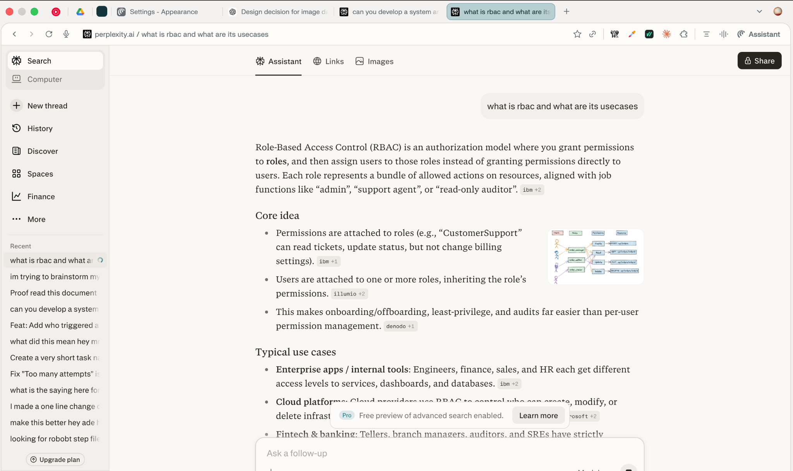

Appendix B: CSRF
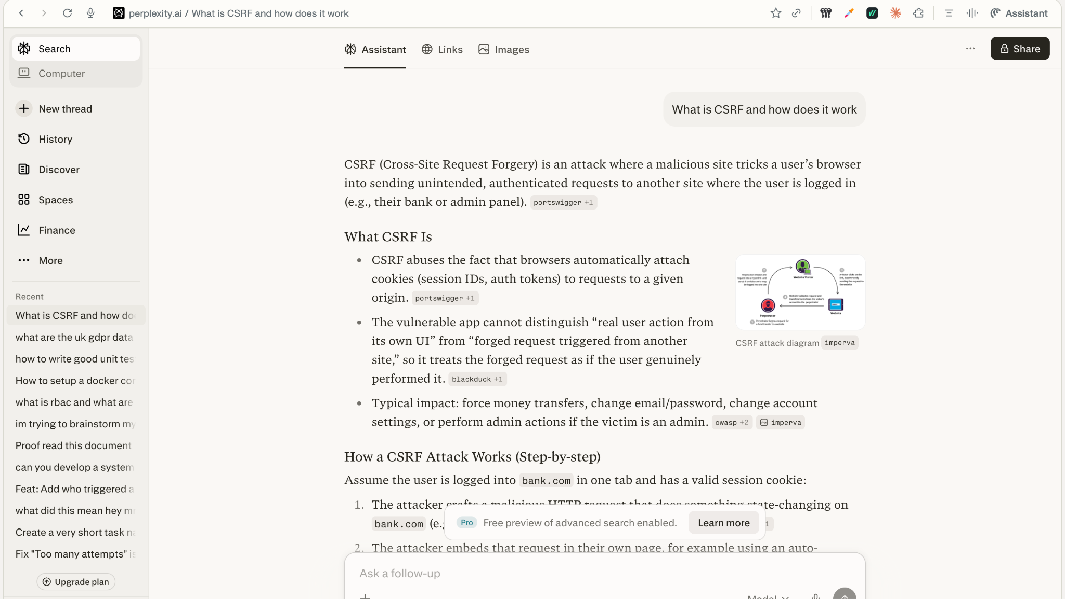
Appendix B: RBAC
