System Architecture Document
Patient Record Management System

Name | Cleverson Ojeabu Akhimien
Student ID | 2509609
Document Type | System Architecture Document
Version | 3.0
Date | 19 March 2026

2. Introduction
2.1 Purpose
This System Architecture Document (SAD) describes the software architecture, component organisation, data model, and key technology decisions for the Patient Record Management System (PRMS). It is intended to provide a complete architectural baseline for developers, testers, and academic assessors (Bass, Clements and Kazman, 2012).
2.2 Scope
The PRMS provides a browser-based interface for clinical staff (Admins, Doctors, Nurses) and patients to manage healthcare records. The system encompasses user authentication, patient CRUD, appointment booking, prescription management, payment processing (demo), emergency contacts, medical file uploads, and administrative tooling. It is deployed as a Docker Compose stack consisting of a Python Flask container and a MongoDB container.
2.3 Architectural Goals
Modularity each functional domain is isolated in its own Flask Blueprint to enable independent development and testing.
Security role-based access control and CSRF protection are enforced consistently across all routes.
Maintainability of the application factory pattern and centralised database helpers reduce coupling.
Separation of concerns SQLite manages authentication data; MongoDB manages all clinical and operational data.

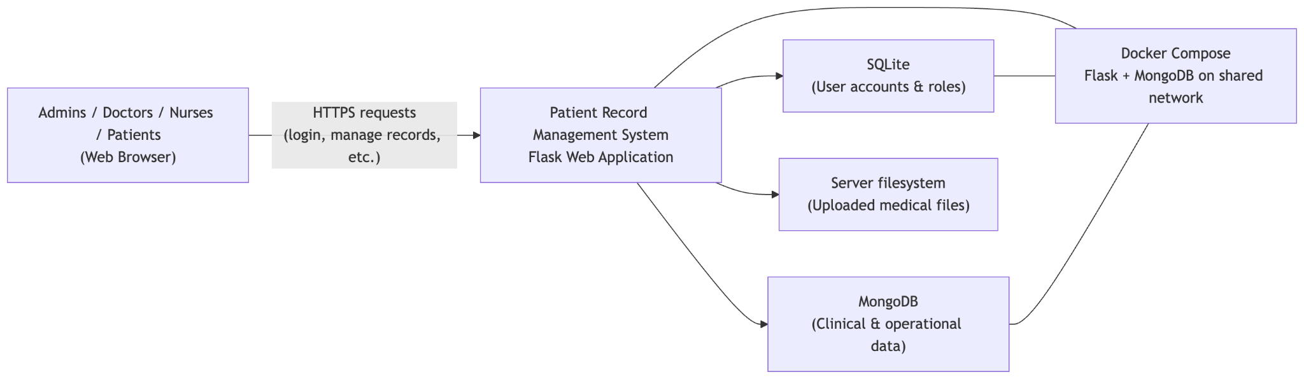
Fig. 1: System Architecture Diagram
3. Architectural Overview
3.1 Architectural Style
The PRMS follows a layered, server-side MVC (Model-View-Controller) architecture, implemented with Flask. The presentation layer consists of Jinja2 HTML templates styled with Tailwind CSS v4. The controller layer is implemented as Flask Blueprint route handlers. The model layer is split across two databases: SQLite for identity/auth and MongoDB for clinical data.
The application uses an Application Factory pattern (Pallets Projects, 2024): a create_app() function in app/__init__.py instantiates the Flask application, registers all nine Blueprints, configures CSRF protection, initialises both databases, and seeds the default admin account. This pattern enables isolated testing and flexible configuration.
3.2 High-Level Architecture
System Architecture Overview
Browser (Jinja2 + Tailwind CSS v4)
--> Flask Application (app factory, 9 Blueprints, CSRF guard)
--> SQLite (users.db) : User identity, roles, status
--> MongoDB (patient_records) : Clinical data, audit logs, sessions
--> Filesystem (uploads/) : Medical file binaries
--> Docker Compose network (Flask + MongoDB containers)
3.3 Deployment Topology
The application is deployed using Docker Compose with two services: (1) a Flask Python 3.x web container serving the application on port 5000, and (2) a MongoDB 7.x container on the default port 27017. Both containers share a private bridge network. The SQLite database (users.db) resides on the Flask container's filesystem. Environment variables (SECRET_KEY, MONGO_URI, MONGO_DB_NAME, DATABASE, ARCHIVE_RETENTION_DAYS) are loaded from a .env file via python-dotenv.
4. Component Architecture
4.1 Application Factory app/__init__.py
The entry point creates the Flask application, configures the Jinja2 datetimeformat filter, sets up the CSRF protection hook (app.before_request), injects the CSRF token and pending approval count into all templates via context processors, registers all nine Blueprints, and initialises the databases.
4.2 Blueprint Modules
Blueprint | URL Prefix | Responsibilities
auth | /login, /logout, /signup | User authentication, registration, CSRF session; records login history
main | /, /dashboard | Index redirect; role-specific dashboard with statistics
patients | /patients, /patient/* | Patient CRUD, archive/restore, pagination, search, medical file links
admin | /admin/* | User management, account approvals, audit log, login history
appointments | /appointments, /appointment/* | Appointment booking (patient), confirmation/completion (doctor/admin), cancellation
prescriptions | /prescriptions, /prescription/* | Prescription creation (doctor), viewing, cancel/complete
emergency_contacts | /emergency-contacts/* | Patient emergency contact CRUD (max 2 per patient)
payments | /payments, /payment/* | Demo checkout flow linked to appointments, receipt display, payment history
uploads | /patient/*/upload, /uploads/* | Medical file upload (16 MB limit), UUID filename storage, file deletion
4.3 Shared Infrastructure app/extensions.py
All MongoDB collection references and the log_action() audit helper are centralised in app/extensions.py. This module is imported by every Blueprint that requires database access, ensuring a single MongoClient instance and consistent collection naming. Collections instantiated: patients, audit_log, login_history, appointments, prescriptions, emergency_contacts, medical_files, payments. Compound indexes are created at startup on frequently queried fields.
4.4 Database Layer app/db.py
SQLite connection management uses Flask's application context (flask.g). get_db() returns a Row-factory connection; close_db() is registered as an app teardown handler. init_db() creates the users table and handles schema migrations (PRAGMA table_info checks followed by ALTER TABLE). seed_admin() inserts the default admin account if absent.

5. Authentication and Security Architecture
5.1 Authentication Flow
Authentication Flow Summary
1. User submits credentials to POST /login
2. Route queries SQLite: SELECT * FROM users WHERE username=?
3. check_password_hash(stored_hash, submitted_password) verified
4. Account status checked: 'pending' or 'rejected' -> login blocked
5. On success: session['user_id'], session['username'], session['role'] set
6. Login history record inserted into MongoDB login_history collection
7. User redirected to /dashboard (role-specific view rendered)
5.2 Security Controls
Control | Implementation
Password hashing | PBKDF2-SHA256 via Werkzeug generate_password_hash / check_password_hash
CSRF protection | secrets.token_hex(16) stored in Flask session; validated against form token on every POST
Session management | Flask signed-cookie sessions; secret key via SECRET_KEY env var
Login guard | @login_required decorator redirects to /login if session has no user_id
RBAC | @role_required(*roles) checks session.role; unauthorized access redirects to dashboard
Account approval | New signups default to status='pending'; admin must approve before login is permitted
Audit logging | log_action() records every patient create/view/edit/archive/restore to audit_log collection
Login history | Each login/logout pair recorded with IP address and session duration in login_history
6. Data Architecture
6.1 Dual-Database Rationale
SQLite is used for user identity management because it provides ACID-compliant relational storage with zero configuration, well-suited to the relatively small, structured users dataset. MongoDB is used for all clinical and operational data because it provides flexible document storage that accommodates schema evolution (e.g., adding new patient fields without migrations), native array support for medication lists, and efficient querying via indexes (Kleppmann, 2017; MongoDB, Inc., 2024).
6.2 SQLite Schema users Table
Column | Type | Description
id | INTEGER PK AI | Auto-increment primary key
username | TEXT UNIQUE | Unique login username
email | TEXT | User email address
password | TEXT | PBKDF2-SHA256 hashed password
role | TEXT | 'admin', 'doctor', 'nurse', or 'patient'
status | TEXT | 'pending', 'approved', or 'rejected'
created_at | TEXT | ISO 8601 timestamp of account creation
6.3 MongoDB Index Strategy
Collection | Index Field(s) | Purpose
patients | patient_id (ASC) | Fast patient lookup by ID
patients | status (ASC) | Filter active vs archived records
appointments | patient_user_id (ASC) | Retrieve appointments for a specific patient
appointments | clinician_user_id (ASC) | Retrieve appointments for a specific doctor
prescriptions | patient_user_id (ASC) | Retrieve prescriptions for a patient
emergency_contacts | patient_user_id (ASC) | Retrieve contacts for a patient
payments | patient_user_id (ASC) | Payment history for a patient
login_history | user_id (ASC) | Login audit for a user
7. Patient Record Workflow
7.1 CRUD and Archive Flow
Patient Record Lifecycle
CREATE: POST /patient/add -> insert_one(patients) + audit log (action='create')
READ: GET /patient/<id> -> find_one(patients, {patient_id: id}) + audit log (action='view')
UPDATE: POST /patient/<id>/edit -> update_one($set fields) + audit log (action='edit')
ARCHIVE: POST /patient/<id>/archive -> update_one($set {status:'archived', archived_at:now})
RESTORE: POST /patient/<id>/restore -> update_one($set {status:'active'}, $unset {archived_at:1})
PURGE: On /patients/archived load -> delete_many({status:'archived', archived_at < cutoff})
7.2 Archive Retention Policy
When a patient record is archived by an admin, the status field is set to 'archived' and archived_at is recorded. On each visit to the /patients/archived route, the system calculates the retention cutoff as now - ARCHIVE_RETENTION_DAYS (default 30) and permanently deletes records where archived_at < cutoff. This implements a configurable soft-delete with automatic expiry.
8. Technology Stack
Component | Technology | Justification
Web Framework | Flask 3.1 | Lightweight WSGI framework with Blueprint support; well-documented and widely used in academic contexts
Clinical Database | MongoDB 7.x | Document-oriented storage supports schema evolution; native array support for medications list
Auth Database | SQLite 3 | Zero-config relational DB; sufficient for user table with ACID guarantees
ORM / Driver | PyMongo 4.11 | Official MongoDB Python driver; provides MongoClient and collection APIs
Templating | Jinja2 3.1 | Flask's default templating engine; supports template inheritance and filters
UI Framework | Tailwind CSS v4 | Utility-first CSS; sidebar layout; no custom CSS required
Auth Hashing | Werkzeug 3.1 | PBKDF2-SHA256 via generate_password_hash; part of Flask's dependency stack
Containerisation | Docker Compose | Reproducible local deployment; isolates Flask and MongoDB services
Testing | pytest 8.3 | Standard Python test runner; fixtures and unittest.mock for MongoDB mocking
Env Config | python-dotenv 1.2 | Loads .env variables at startup; separates config from code
9. Quality Attributes
Attribute | Architectural Decision
Modularity | Nine independent Blueprints; each module has its own routes.py and __init__.py. Modules can be developed, tested, and deployed independently.
Security | Multi-layer: password hashing, CSRF tokens, session guards, RBAC decorators, account approval workflow, audit logging.
Testability | Factory pattern allows the app to be created with a temporary SQLite database in each test fixture. All MongoDB collections are replaced with MagicMock objects via unittest.mock.patch.
Maintainability | Centralised extensions.py for shared collections; db.py for SQLite helpers; decorators.py for auth logic. No business logic in templates.
Scalability | MongoDB's horizontal scaling capabilities support data growth; indexed queries maintain performance at scale. Flask can be deployed behind Gunicorn + Nginx for production loads.
Usability | Tailwind CSS v4 provides responsive layout; viewport-height-constrained sidebar prevents page-level scroll; role-based menu visibility reduces cognitive load.
References
Author / Organisation | Reference
Bass, L., Clements, P. and Kazman, R. (2012). | Software Architecture in Practice (3rd ed.). Addison-Wesley.
Brown, S. (2018). | Software Architecture for Developers Volume 1: Technical Leadership and the Balance with Agility. Leanpub.
Fowler, M. (2002). | Patterns of Enterprise Application Architecture. Addison-Wesley.
Kleppmann, M. (2017). | Designing Data-Intensive Applications. O'Reilly Media.
MongoDB, Inc. (2024). | MongoDB Architecture Guide. https://www.mongodb.com/docs/manual/
NHS Digital. (2023). | NHS Architecture Principles. https://digital.nhs.uk/developer/architecture
OWASP Foundation. (2023). | OWASP Application Security Verification Standard 4.0. https://owasp.org/www-project-application-security-verification-standard/
Pallets Projects. (2024). | Flask Application Factories. https://flask.palletsprojects.com/en/3.1.x/patterns/appfactories/
Richardson, C. (2018). | Microservices Patterns: With Examples in Java. Manning Publications.
Sommerville, I. (2016). | Software Engineering (10th ed.). Pearson Education.
Use of Generative AI
Use of Generative Artificial Intelligence

This assignment used generative artificial intelligence tools to support the development of this work. AI tools were used for brainstorming ideas, structuring content, refining explanations, and improving clarity of writing.

All content has been reviewed, edited, and validated to ensure accuracy, relevance, and alignment with the requirements of the assignment. Any AI-generated outputs, including written suggestions and visual elements such as system diagrams or logos, were adapted and integrated. Evidence of AI use, including interaction logs and prompts, is provided in the appendix.
Appendix A: Repository File Structure
The repository structure as at Phase 7:
patient-record-management-system/
app/ # Flask application package
__init__.py # Application factory (create_app)
db.py # SQLite helpers
extensions.py # Shared MongoDB collections + log_action()
auth/routes.py # Login, logout, signup
main/routes.py # Dashboard
patients/routes.py # Patient CRUD, archive, restore
admin/routes.py # Users, approvals, audit log, login history
appointments/routes.py
prescriptions/routes.py
emergency_contacts/routes.py
payments/routes.py
uploads/routes.py
templates/ # Jinja2 HTML templates (per-module)
static/ # Tailwind CSS output + assets
tests/test_app.py # 44 pytest unit tests
docker-compose.yml # Flask + MongoDB services
requirements.txt # Python dependencies
users.db # SQLite database (runtime)

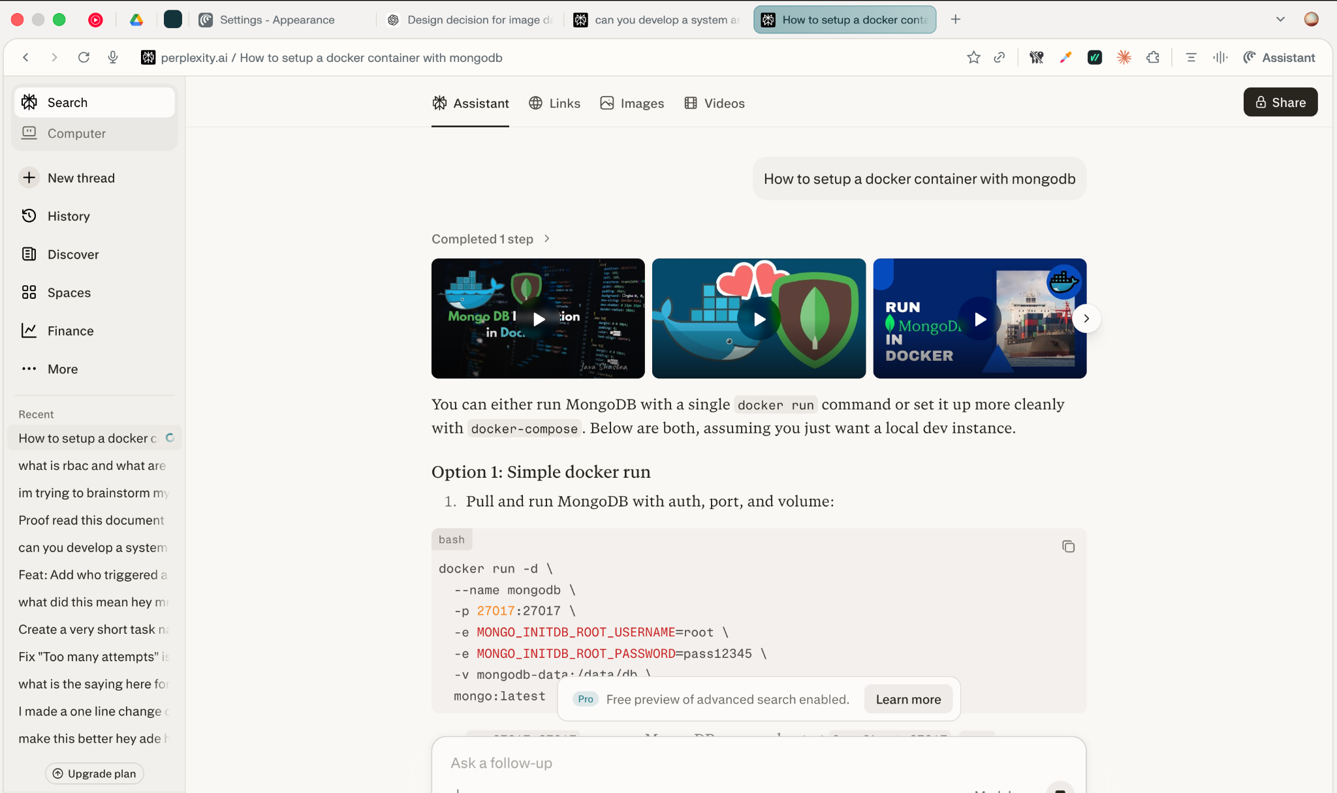
Appendix B: Docker installation (Use of Generative AI)
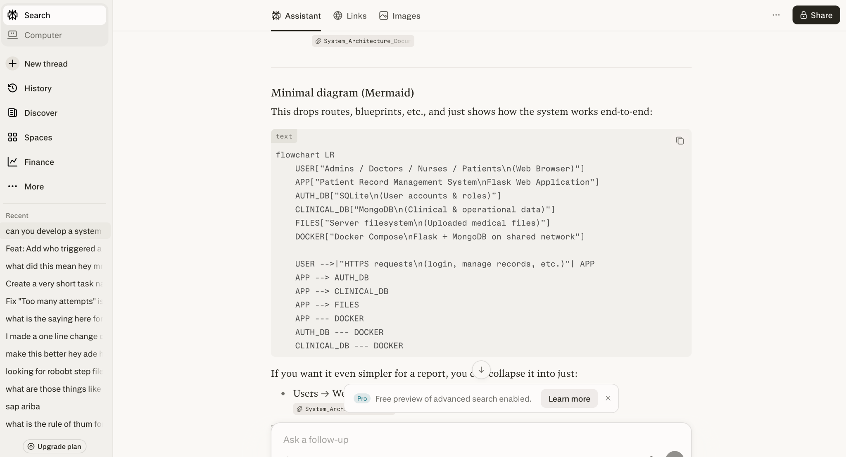
Appendix C: System Architecture (Use of Generative AI)

Appendix D: RBAC Flow (Use of Generative AI)
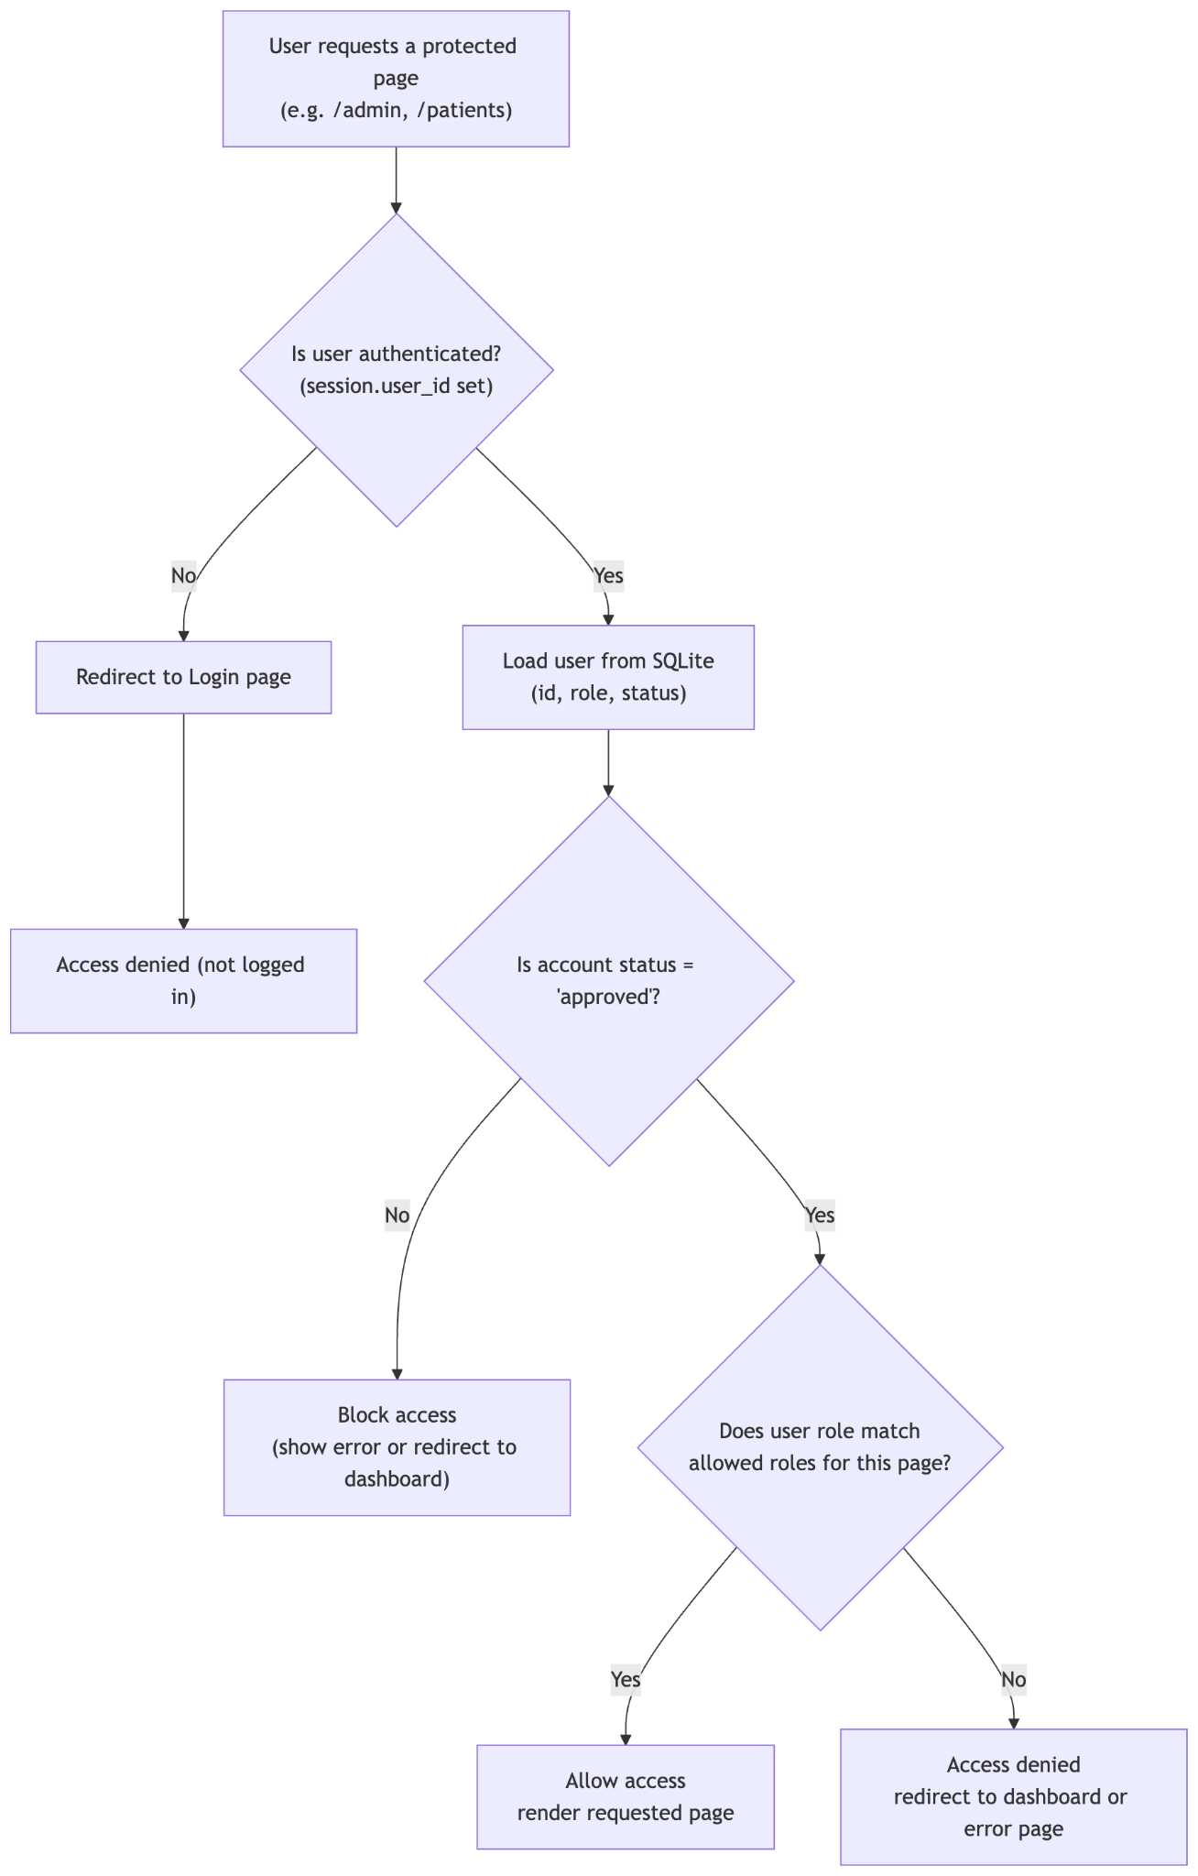

Appendix E: What is RBAC? (Use of Generative AI)

