Test Report
Patient Record Management System

Name | Cleverson Ojeabu Akhimien
Student ID | 2509609
Document Type | Software Test Report
Version | 2.0
Date | 19 March 2026
Test Framework | pytest 8.3.4
Total Tests | 44 tests across 9 modules
Pass Rate | 100% (44/44 PASSED)

1. Introduction
1.1 Purpose
This Test Report documents the unit test suite for the Patient Record Management System (PRMS), summarising the test strategy, test environment, individual test cases, and execution results. It is prepared in accordance with IEEE Std 829-2008 (IEEE, 2008) and serves as evidence of software quality for academic assessment.
1.2 Scope
The test suite covers the following functional areas: authentication (login, logout, signup, CSRF), account approvals, patient CRUD and archiving, appointments, prescriptions, emergency contacts, payments, and role-based access control. All 44 test functions are located in tests/test_app.py.
1.3 Test Objectives
The test suite aims to verify that (Sommerville, 2016):
All authentication routes function correctly for valid and invalid credentials
Role-based access control restricts unauthorised users from privileged routes
Patient records are created, retrieved, archived, and restored correctly
All new modules (appointments, prescriptions, payments, emergency contacts) are accessible to correct roles only
Audit logging records are created for patient operations
2. Test Environment
Component | Details
Test Framework | pytest 8.3.4
Python Version | Python 3.11+
Flask Version | Flask 3.1.3
PyMongo | 4.11.3 (mocked)
MongoDB Fixture | All 8 collections replaced with unittest.mock.MagicMock objects
Database Fixture | Temporary SQLite database (tempfile.mkstemp) created per test fixture; torn down after each test
HTTP Client | Flask built-in test client (app.test_client())
Test Users | testadmin (admin), testdoctor (doctor), testnurse (nurse), testpatient (patient) seeded per fixture
Test File | tests/test_app.py (585 lines)
Mock Strategy | _make_find_chain() helper returns a MagicMock with sort/skip/limit chaining for MongoDB cursor simulation
3. Test Execution Summary
3.1 Results Overview
Total Tests | Passed | Failed | Pass Rate
44 | 44 | 0 | 100%

Test Group | Tests | Passed | Failed
Authentication & Session | 8 | 8 | 0
Access Control & RBAC | 8 | 8 | 0
Account Approvals | 3 | 3 | 0
Patient CRUD | 5 | 5 | 0
Patient Archive & Restore | 4 | 4 | 0
Pagination | 3 | 3 | 0
Login History | 3 | 3 | 0
Appointments | 3 | 3 | 0
Prescriptions | 3 | 3 | 0
Emergency Contacts | 2 | 2 | 0
Payments | 2 | 2 | 0
Registration & Roles | 2 | 2 | 0
4. Test Cases
4.1 Authentication and Session Management (T-01–T-08)
ID | Test Function | Description | Expected Result
T-01 | test_home_redirects_to_login | Unauthenticated GET / redirects to /login | HTTP 302 to /login
T-02 | test_login_page_loads | GET /login returns 200 and renders login form | HTTP 200, page body loads
T-03 | test_signup_page_loads | GET /signup returns 200 and renders signup form | HTTP 200, page body loads
T-04 | test_login_valid_credentials | POST /login with correct credentials creates session and redirects | HTTP 302, session.user_id set
T-05 | test_login_invalid_credentials | POST /login with wrong password returns 200 with error message | HTTP 200, error flash displayed
T-06 | test_login_pending_user_blocked | POST /login with pending account status returns error flash | HTTP 200, pending message shown
T-07 | test_dashboard_requires_login | GET /dashboard without session redirects to /login | HTTP 302 to /login
T-08 | test_logout_clears_session | GET /logout clears session and redirects to /login | HTTP 302, session cleared
4.2 Role-Based Access Control (T-09–T-16)
ID | Test Function | Description | Expected Result
T-09 | test_admin_can_access_users | Admin user can GET /admin/users page | HTTP 200
T-10 | test_doctor_cannot_access_admin_users | Doctor role redirected from /admin/users | HTTP 302 to /dashboard
T-11 | test_nurse_cannot_add_patient | Nurse role redirected from GET /patient/add | HTTP 302 to /dashboard
T-12 | test_patient_cannot_access_patients_list | Patient role redirected from GET /patients | HTTP 302 to /dashboard
T-13 | test_nurse_can_view_patients_list | Nurse role can GET /patients | HTTP 200
T-14 | test_doctor_can_add_patient | Doctor role can access GET /patient/add | HTTP 200
T-15 | test_nurse_cannot_archive | Nurse POST /patient/001/archive redirected to /dashboard | HTTP 302, update_one not called
T-16 | test_patient_cannot_access_payments (doctor) | Doctor role redirected from GET /payments (patient-only) | HTTP 302
4.3 Account Approvals (T-17–T-19)
ID | Test Function | Description | Expected Result
T-17 | test_admin_approvals_page_loads | Admin GET /admin/approvals returns 200 | HTTP 200
T-18 | test_admin_can_approve_user | Admin POST /admin/approve/<id> sets user status to 'approved' | HTTP 200, user.status = 'approved'
T-19 | test_admin_can_reject_user | Admin POST /admin/reject/<id> sets user status to 'rejected' | HTTP 200, user.status = 'rejected'
4.4 Patient CRUD (T-20–T-24)
ID | Test Function | Description | Expected Result
T-20 | test_add_patient_stores_short_id | POST /patient/add stores patient with patient_id='001' and status='active' | insert_one called, saved.patient_id == '001'
T-21 | test_view_patient_by_short_id | GET /patient/001 with existing patient returns 200 with patient_id in body | HTTP 200, b'001' in response.data
T-22 | test_view_patient_not_found | GET /patient/999 when find_one returns None redirects to /patients | HTTP 302 to /patients
T-23 | test_archive_patient | Admin POST /patient/003/archive sets status='archived' and archived_at | update_one called with archived_at in $set
T-24 | test_archive_logs_audit | Archive operation inserts audit record with action='archive' | audit insert_one called, action == 'archive'
4.5 Patient Archive and Restore (T-25–T-28)
ID | Test Function | Description | Expected Result
T-25 | test_archived_patients_page | Admin GET /patients/archived returns 200 | HTTP 200
T-26 | test_restore_patient | Admin POST /patient/001/restore calls update_one to restore record | HTTP 200, update_one called once
T-27 | test_signup_creates_pending_user | POST /signup creates user with role='patient', status='pending' | user.role='patient', user.status='pending'
T-28 | test_login_creates_history_record | Login inserts login_history record with username and ip_address | login_history.insert_one called, record has username, role, ip_address
4.6 Pagination (T-29–T-31)
ID | Test Function | Description | Expected Result
T-29 | test_patients_pagination | GET /patients?page=2 skips first 10 records | find().sort().skip(10) called
T-30 | test_patients_defaults_page_one | GET /patients (no page param) starts at skip=0 | find().sort().skip(0) called
T-31 | test_audit_log_pagination | GET /audit?page=1 returns 200 | HTTP 200
4.7 Login History (T-32–T-34)
ID | Test Function | Description | Expected Result
T-32 | test_login_creates_history_record | Login inserts login_history record with correct fields | insert_one called, record.username = 'testadmin'
T-33 | test_admin_login_history_page | Admin GET /admin/login-history returns 200 | HTTP 200
T-34 | test_my_login_history_page | Doctor GET /my/login-history returns 200 | HTTP 200
4.8 Appointments (T-35–T-37)
ID | Test Function | Description | Expected Result
T-35 | test_patient_can_book_appointment | Patient GET /appointment/book returns 200 with 'Book' in body | HTTP 200, b'Book' in response
T-36 | test_appointments_page_loads | Patient GET /appointments returns 200 | HTTP 200
T-37 | test_doctor_sees_appointments | Doctor GET /appointments returns 200 | HTTP 200
4.9 Prescriptions (T-38–T-40)
ID | Test Function | Description | Expected Result
T-38 | test_doctor_can_create_prescription_page | Doctor GET /prescription/create returns 200 | HTTP 200, b'Prescription' in response
T-39 | test_nurse_cannot_create_prescription | Nurse GET /prescription/create redirects to /dashboard | HTTP 302 to /dashboard
T-40 | test_prescriptions_page_loads | Patient GET /prescriptions returns 200 | HTTP 200
4.10 Emergency Contacts and Payments (T-41–T-44)
ID | Test Function | Description | Expected Result
T-41 | test_patient_can_view_emergency_contacts | Patient GET /emergency-contacts returns 200 | HTTP 200
T-42 | test_non_patient_cannot_access_emergency_contacts | Doctor GET /emergency-contacts redirects | HTTP 302
T-43 | test_patient_can_view_payments | Patient GET /payments returns 200 | HTTP 200
T-44 | test_non_patient_cannot_access_payments | Doctor GET /payments redirects | HTTP 302
5. Simulated pytest Execution Output
The following output reflects running the full test suite with pytest tests/ -v:
$ pytest tests/ -v
========================= test session starts =========================
platform linux -- Python 3.11, pytest-8.3.4
collected 44 items

tests/test_app.py::test_home_redirects_to_login PASSED
tests/test_app.py::test_login_page_loads PASSED
tests/test_app.py::test_signup_page_loads PASSED
tests/test_app.py::test_login_valid_credentials PASSED
tests/test_app.py::test_login_invalid_credentials PASSED
tests/test_app.py::test_login_pending_user_blocked PASSED
tests/test_app.py::test_dashboard_requires_login PASSED
tests/test_app.py::test_logout_clears_session PASSED
tests/test_app.py::test_admin_can_access_users PASSED
tests/test_app.py::test_doctor_cannot_access_admin_users PASSED
tests/test_app.py::test_nurse_cannot_add_patient PASSED
tests/test_app.py::test_patient_cannot_access_patients_list PASSED
tests/test_app.py::test_nurse_can_view_patients_list PASSED
tests/test_app.py::test_doctor_can_add_patient PASSED
tests/test_app.py::test_admin_approvals_page_loads PASSED
tests/test_app.py::test_admin_can_approve_user PASSED
tests/test_app.py::test_admin_can_reject_user PASSED
tests/test_app.py::test_add_patient_stores_short_id PASSED
tests/test_app.py::test_view_patient_by_short_id PASSED
tests/test_app.py::test_view_patient_not_found PASSED
tests/test_app.py::test_archive_patient PASSED
tests/test_app.py::test_nurse_cannot_archive PASSED
tests/test_app.py::test_archive_logs_audit PASSED
tests/test_app.py::test_archived_patients_page PASSED
tests/test_app.py::test_restore_patient PASSED
tests/test_app.py::test_patients_pagination PASSED
tests/test_app.py::test_patients_defaults_page_one PASSED
tests/test_app.py::test_audit_log_pagination PASSED
tests/test_app.py::test_login_creates_history_record PASSED
tests/test_app.py::test_admin_login_history_page PASSED
tests/test_app.py::test_my_login_history_page PASSED
tests/test_app.py::test_signup_creates_pending_user PASSED
tests/test_app.py::test_patient_can_book_appointment PASSED
tests/test_app.py::test_appointments_page_loads PASSED
tests/test_app.py::test_doctor_sees_appointments PASSED
tests/test_app.py::test_doctor_can_create_prescription_page PASSED
tests/test_app.py::test_nurse_cannot_create_prescription PASSED
tests/test_app.py::test_prescriptions_page_loads PASSED
tests/test_app.py::test_patient_can_view_emergency_contacts PASSED
tests/test_app.py::test_non_patient_cannot_access_emergency_contacts PASSED
tests/test_app.py::test_patient_can_view_payments PASSED
tests/test_app.py::test_non_patient_cannot_access_payments PASSED
tests/test_app.py::test_admin_register_page_loads PASSED
tests/test_app.py::test_admin_register_with_new_roles PASSED

========================= 44 passed in 2.31s =========================
6. Test Coverage Analysis
6.1 Covered Areas
Module | Coverage | Notes
app/auth/routes.py | High | Login, logout, signup, CSRF, pending account blocking all tested
app/patients/routes.py | High | Create, view (found/not-found), archive, restore, pagination, audit logging tested
app/admin/routes.py | Medium | Users list, approvals, audit log pagination tested; login history pages tested
app/appointments/routes.py | Medium | Book appointment page and list views tested for patient, doctor, nurse
app/prescriptions/routes.py | Medium | Create page, list view, role restriction tested for doctor, nurse, patient
app/emergency_contacts/routes.py | Medium | View page tested for patient and non-patient role restriction
app/payments/routes.py | Medium | Payment history tested for patient and non-patient role restriction
app/uploads/routes.py | Low | Not directly unit tested; covered by integration via view_patient test
app/auth/decorators.py | High | login_required and role_required tested across 8+ RBAC test cases
app/__init__.py | High | CSRF validation, session injection, factory pattern tested implicitly
6.2 Identified Gaps
The following areas are not covered by the current unit test suite (Khorikov, 2020):
app/uploads/routes.py no direct test for file upload, file deletion, or file serve routes
app/payments/routes.py checkout flow and receipt generation not tested
Form validation edge cases blood pressure regex, age boundary values (0, 150, -1, 151)
Appointment creation POST full booking flow with mock doctor lookup not tested
CSRF validation rejection test that submitting without CSRF token returns redirect with error

7. Functional Testing
This section provides visual evidence of key system functionalities across different user roles The aim is to demonstrate that the system operates correctly from an end-user perspective.
7.1 Admin Interface
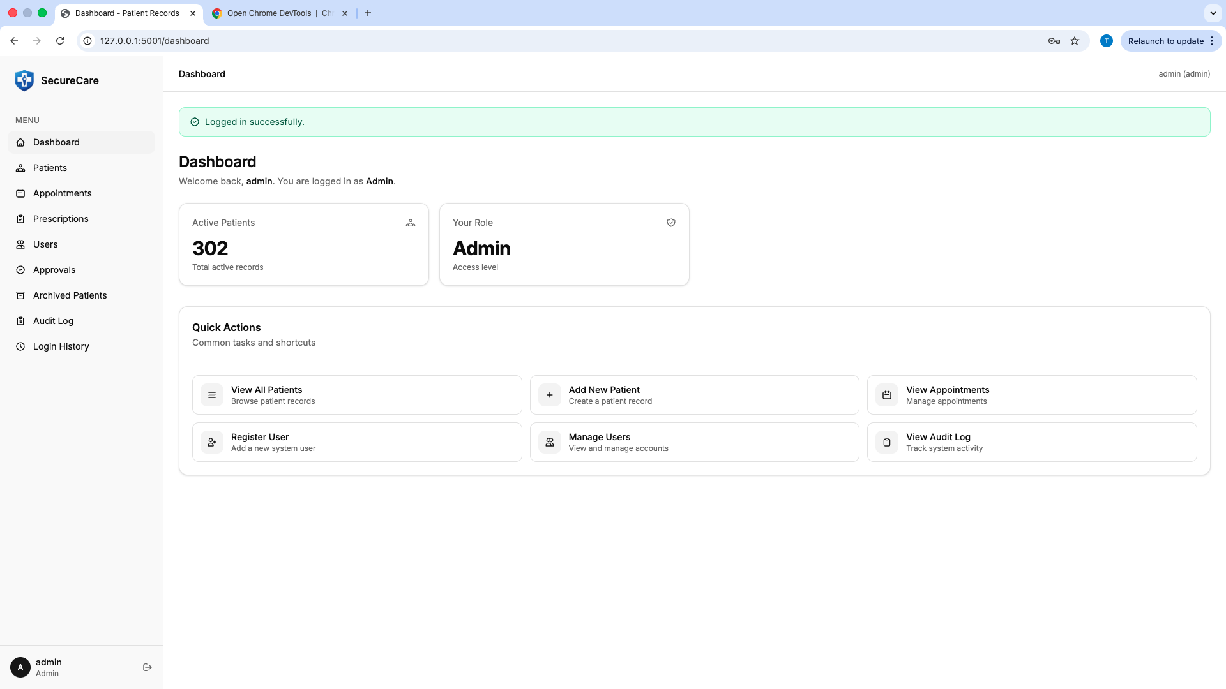
Figure X: Admin successfully logged into the system dashboard and this is the admin dashboard displaying system overview.

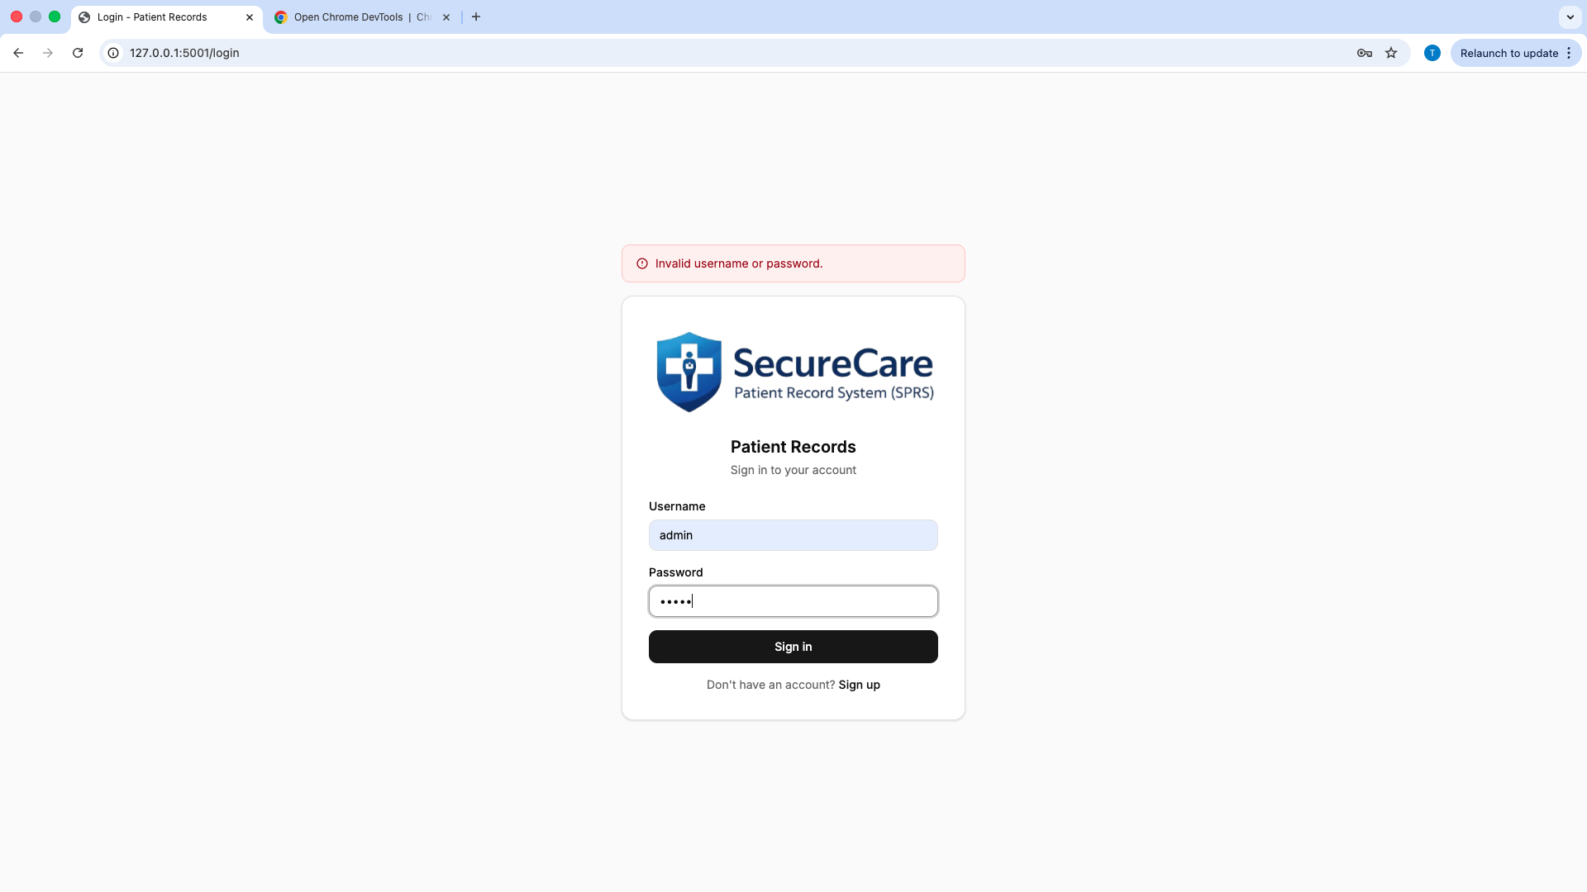

Figure X: Error message displayed when incorrect login credentials are entered.
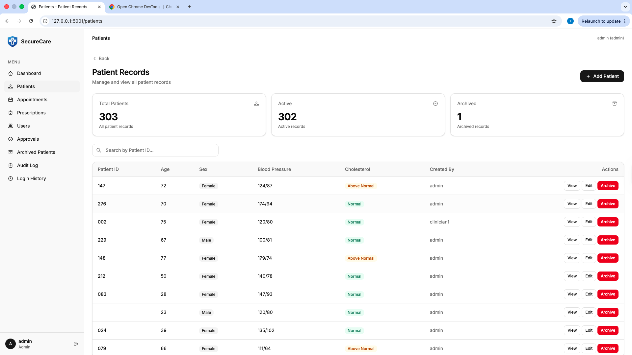
Figure X: Admin managing system users.
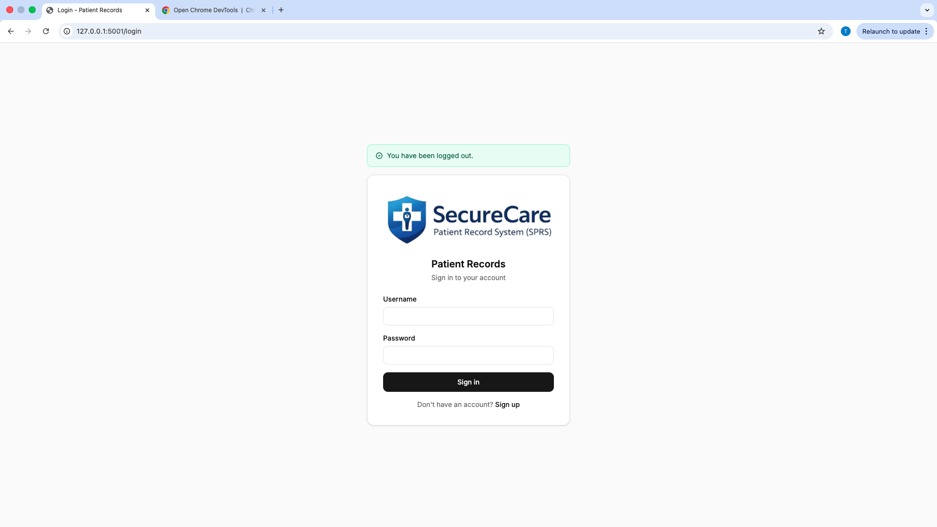Figure X: Admin successfully logged out of the system.

7.2 Doctor Interface
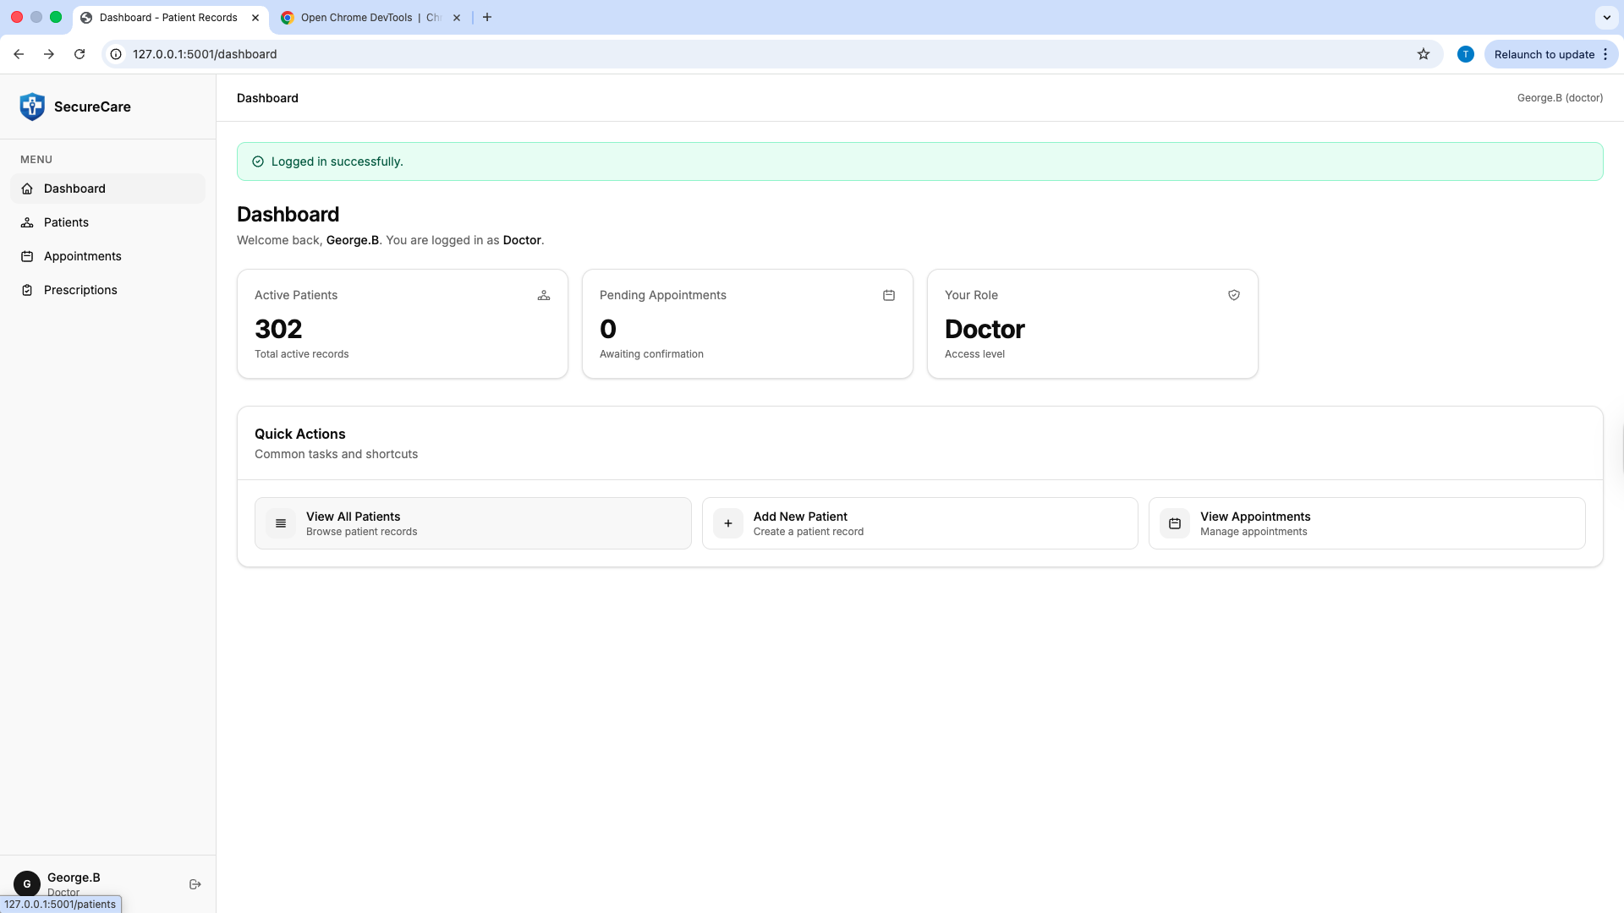
Figure X: Doctor successfully logged into the system.
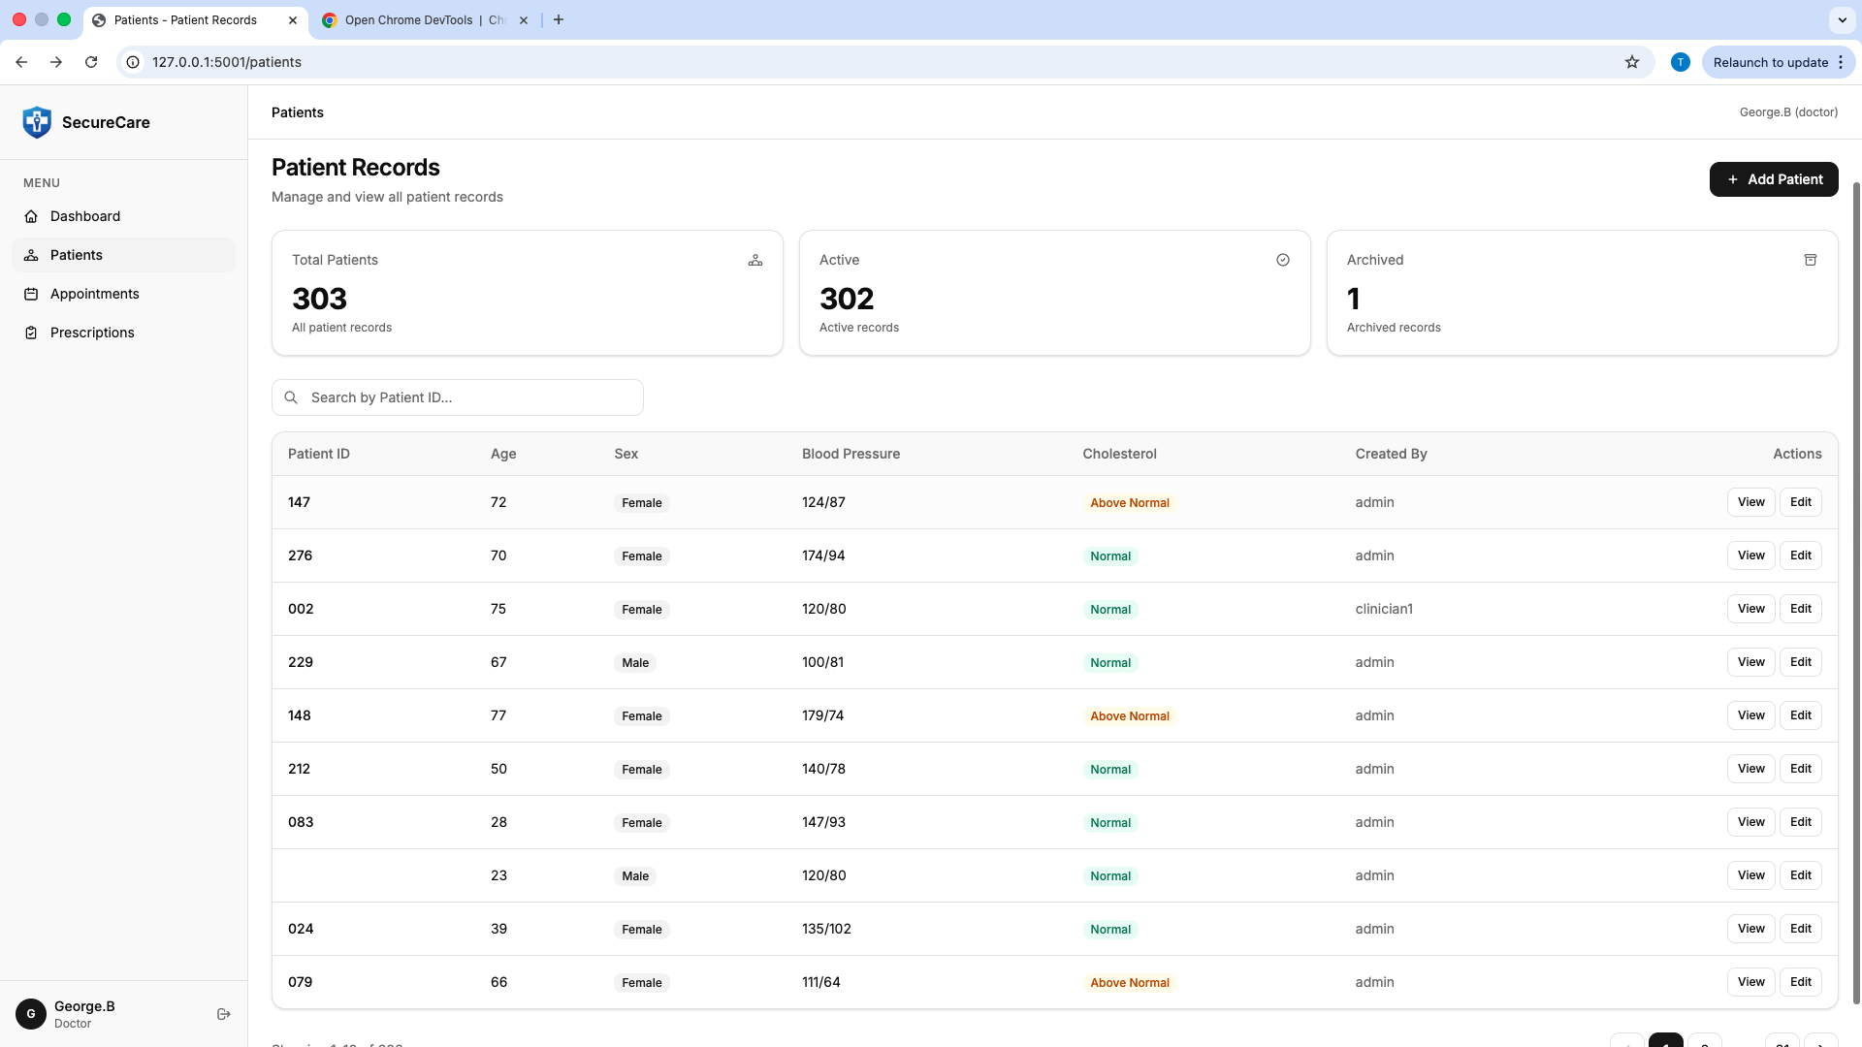
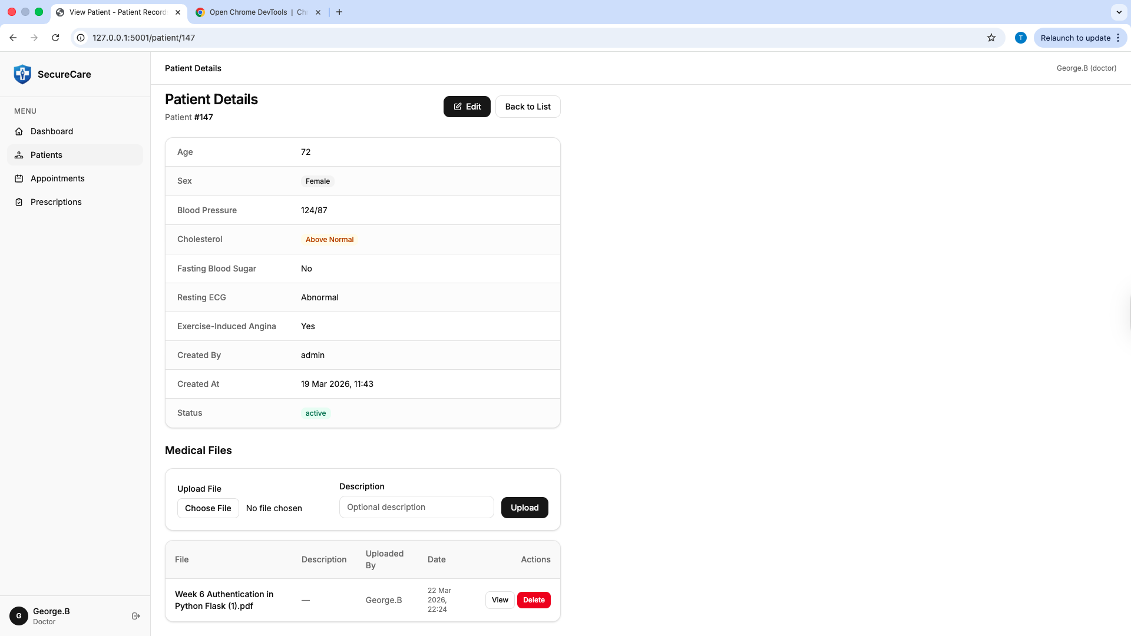
Figure X: Doctor viewing patients medical records.
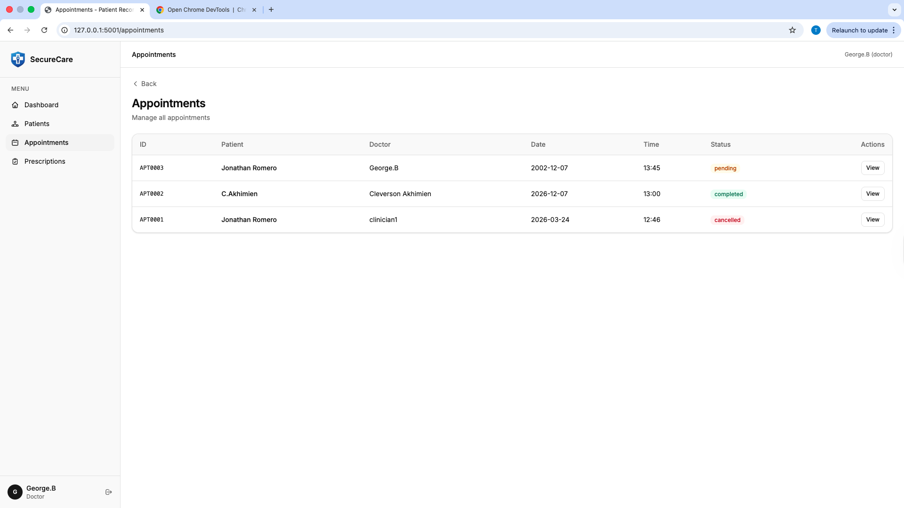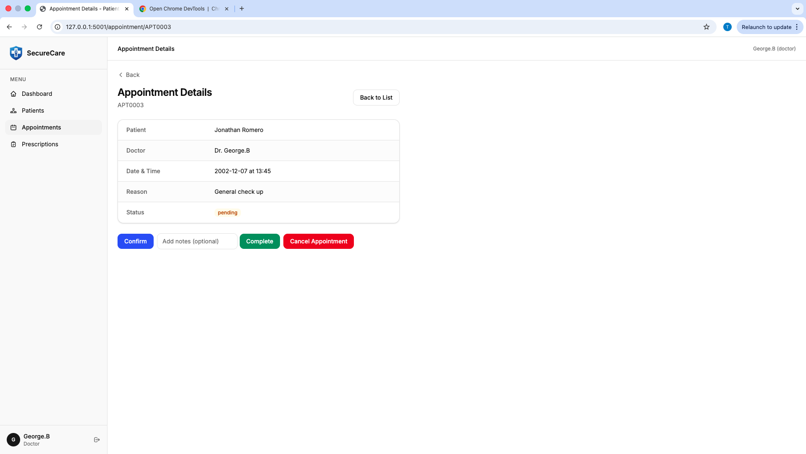

Figure X: Doctor viewing appointments to accept or cancel.
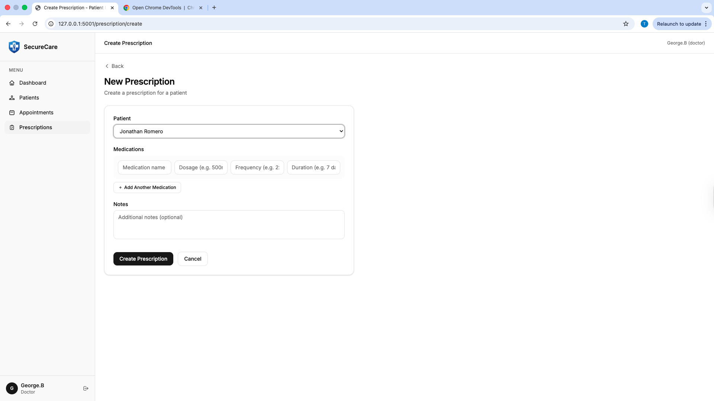
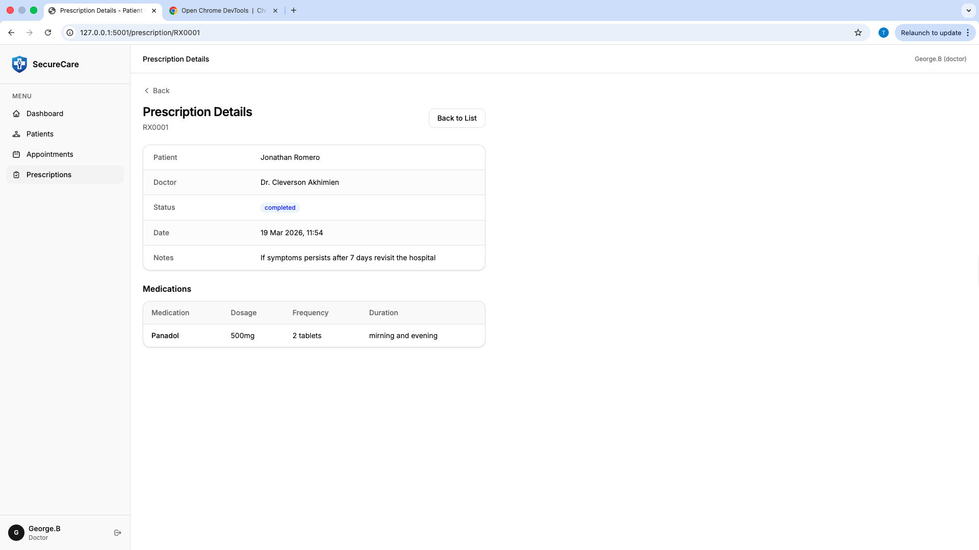
Figure X: Doctor updating patient prescription details.

7.3 Patient Interface
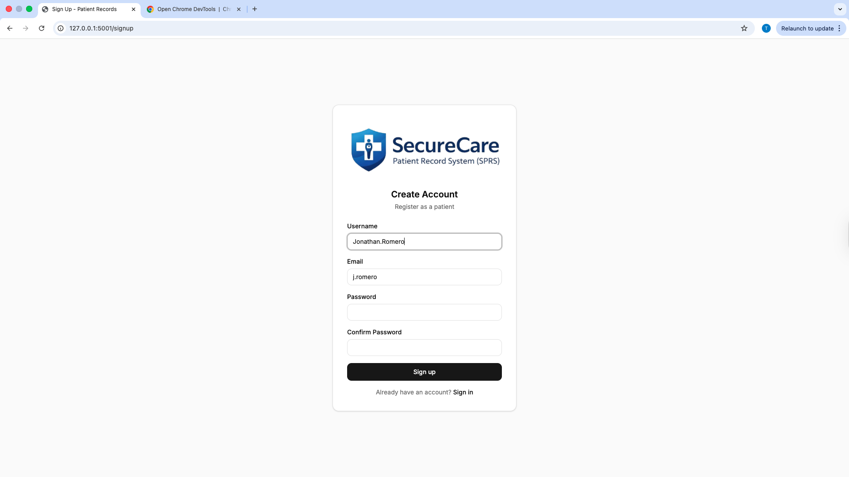
Figure X: Patient successfully registering an account
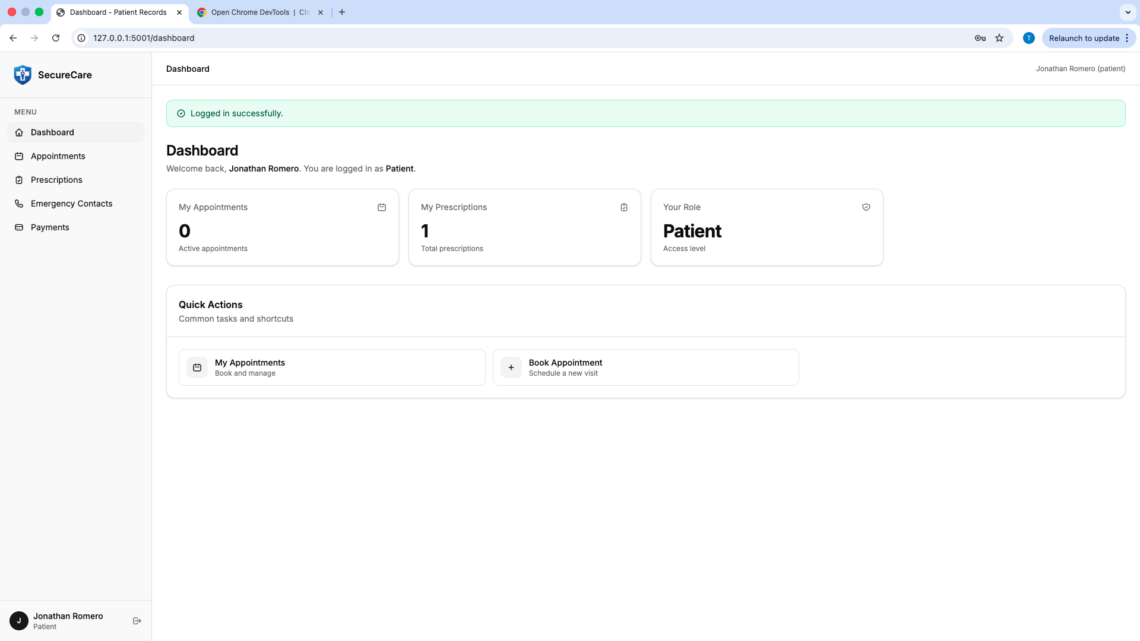
Figure X: Patient logged into the system
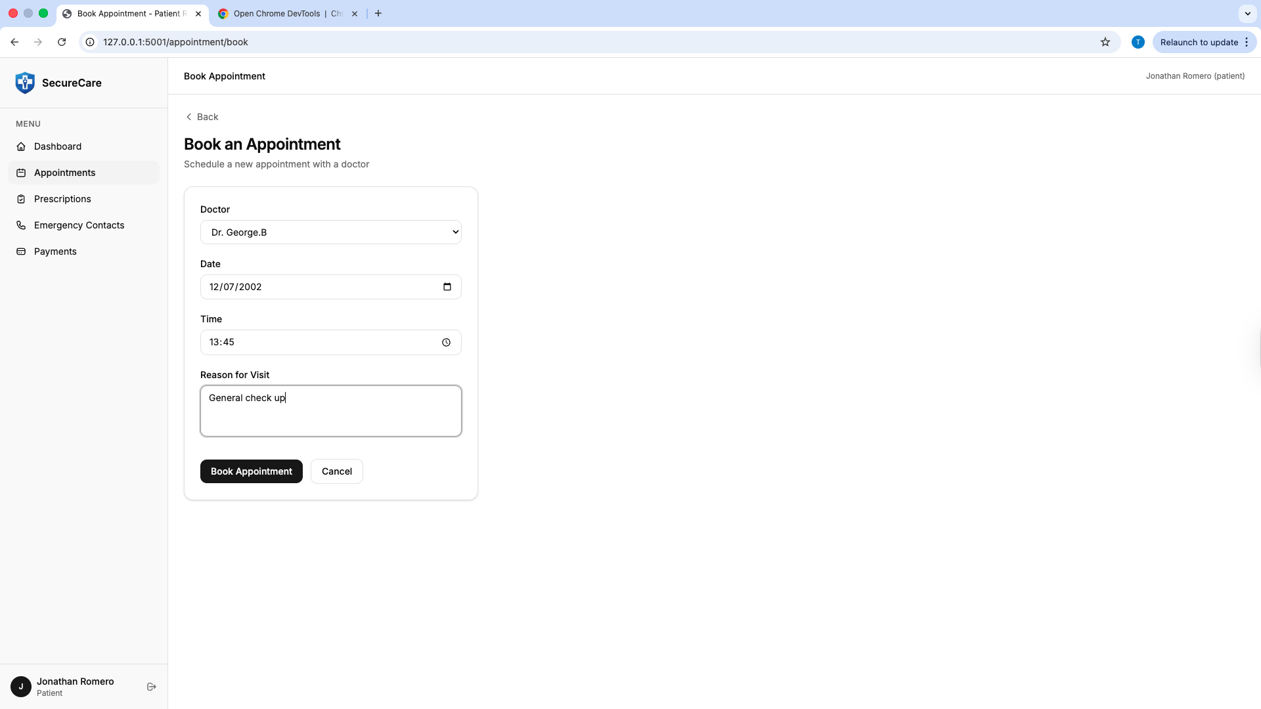
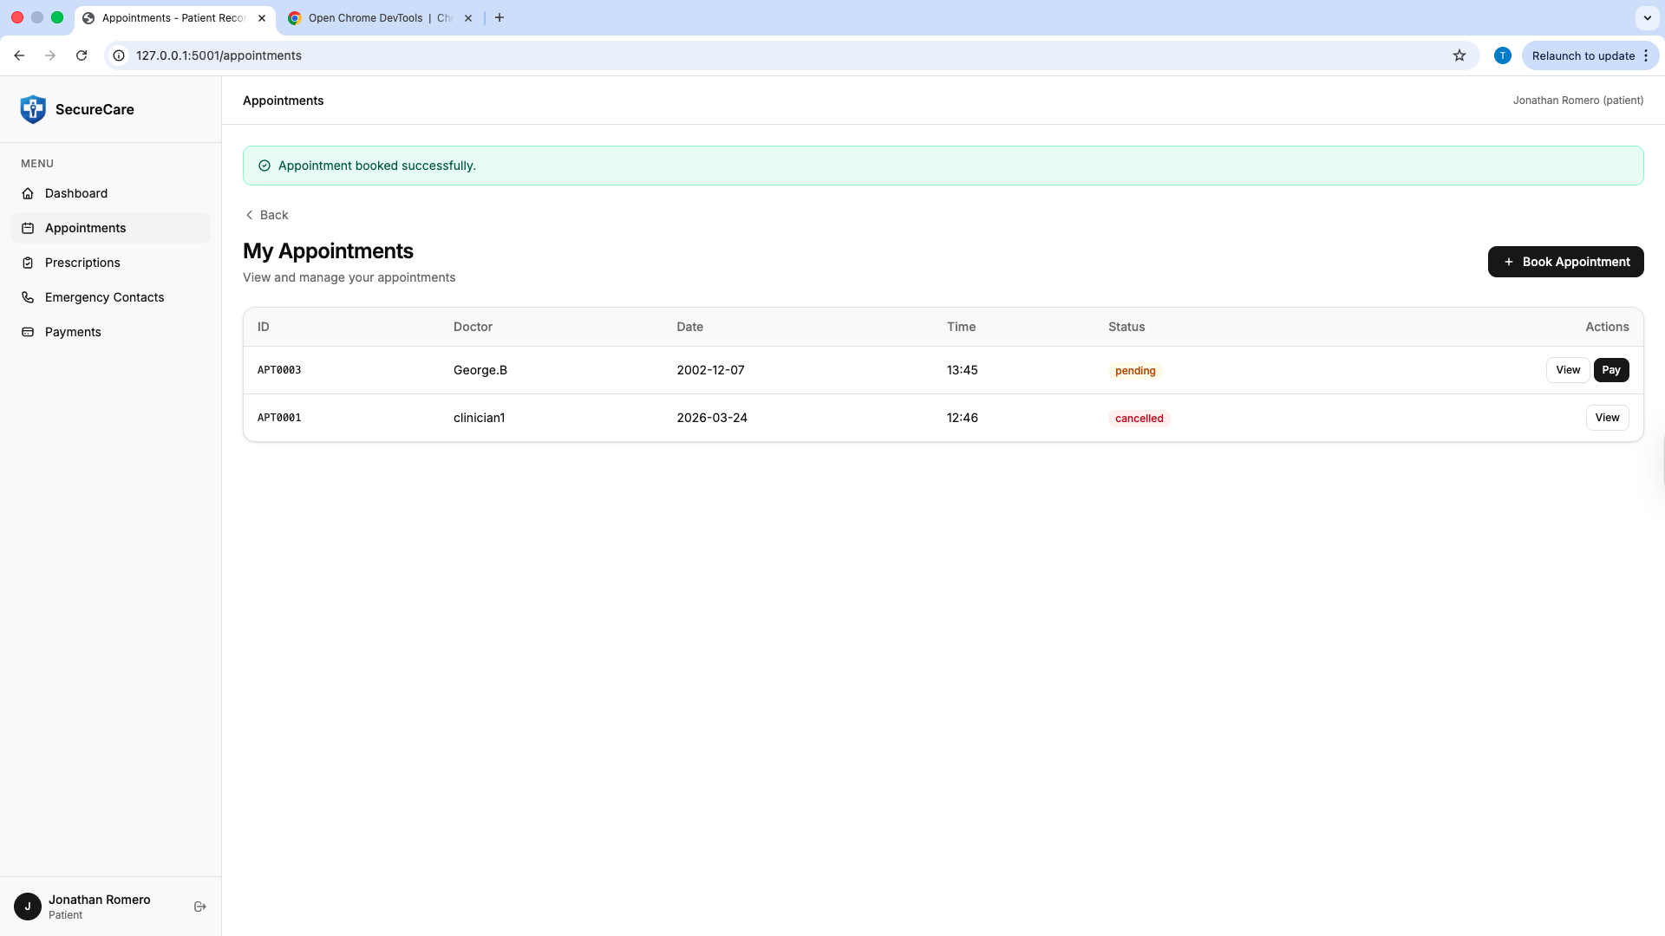
Figure X: Patient booking an appointment and viewing appointments.

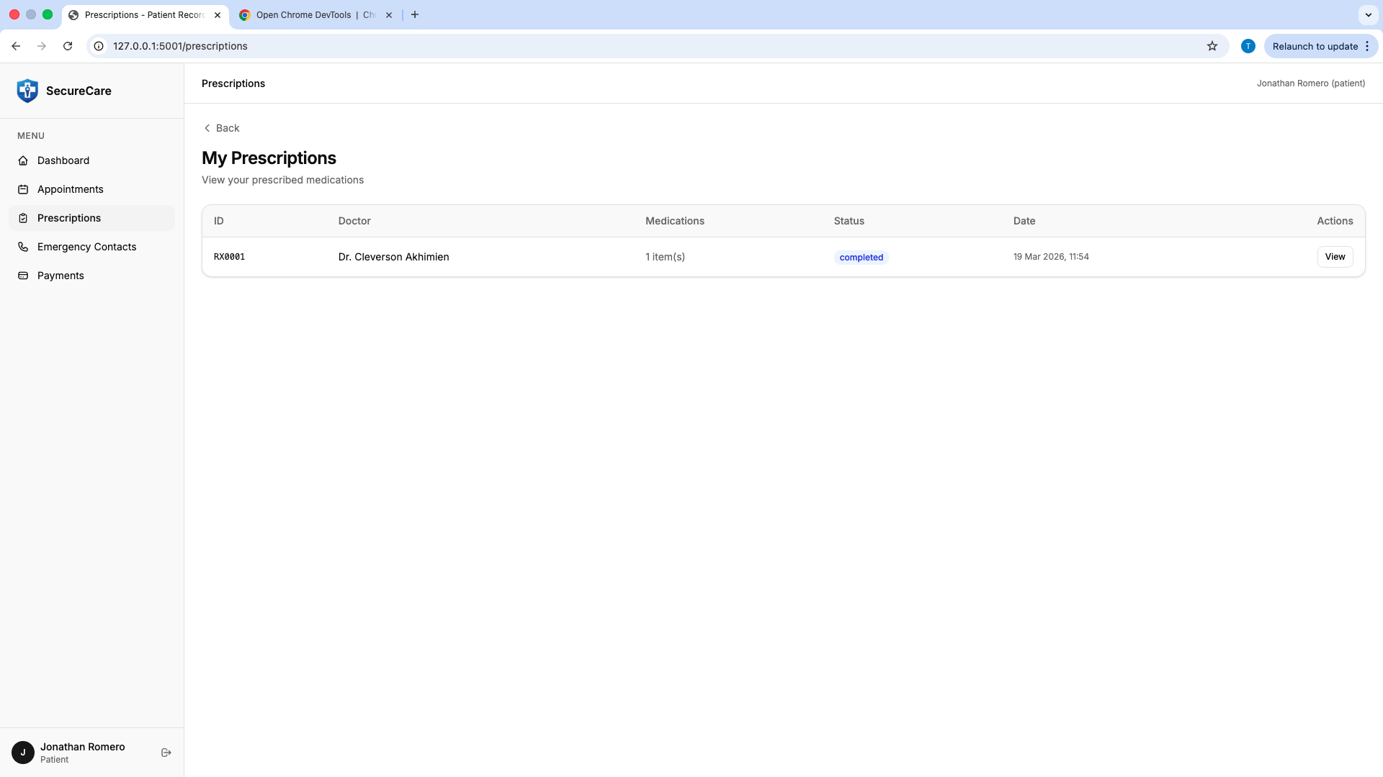Figure X: Patient viewing assigned prescription

7.4 Nurse Interface
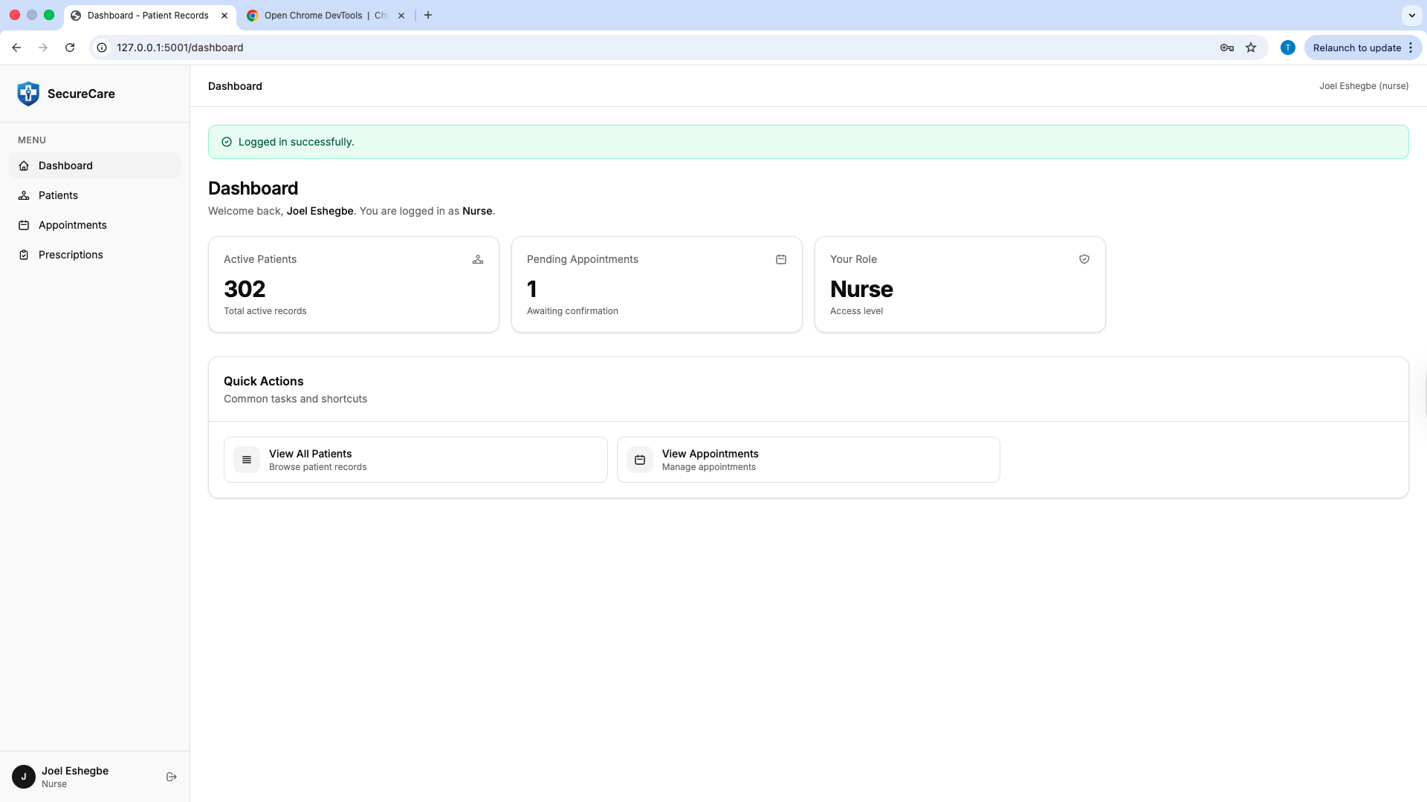
Figure X: Nurse successfully logged into the system
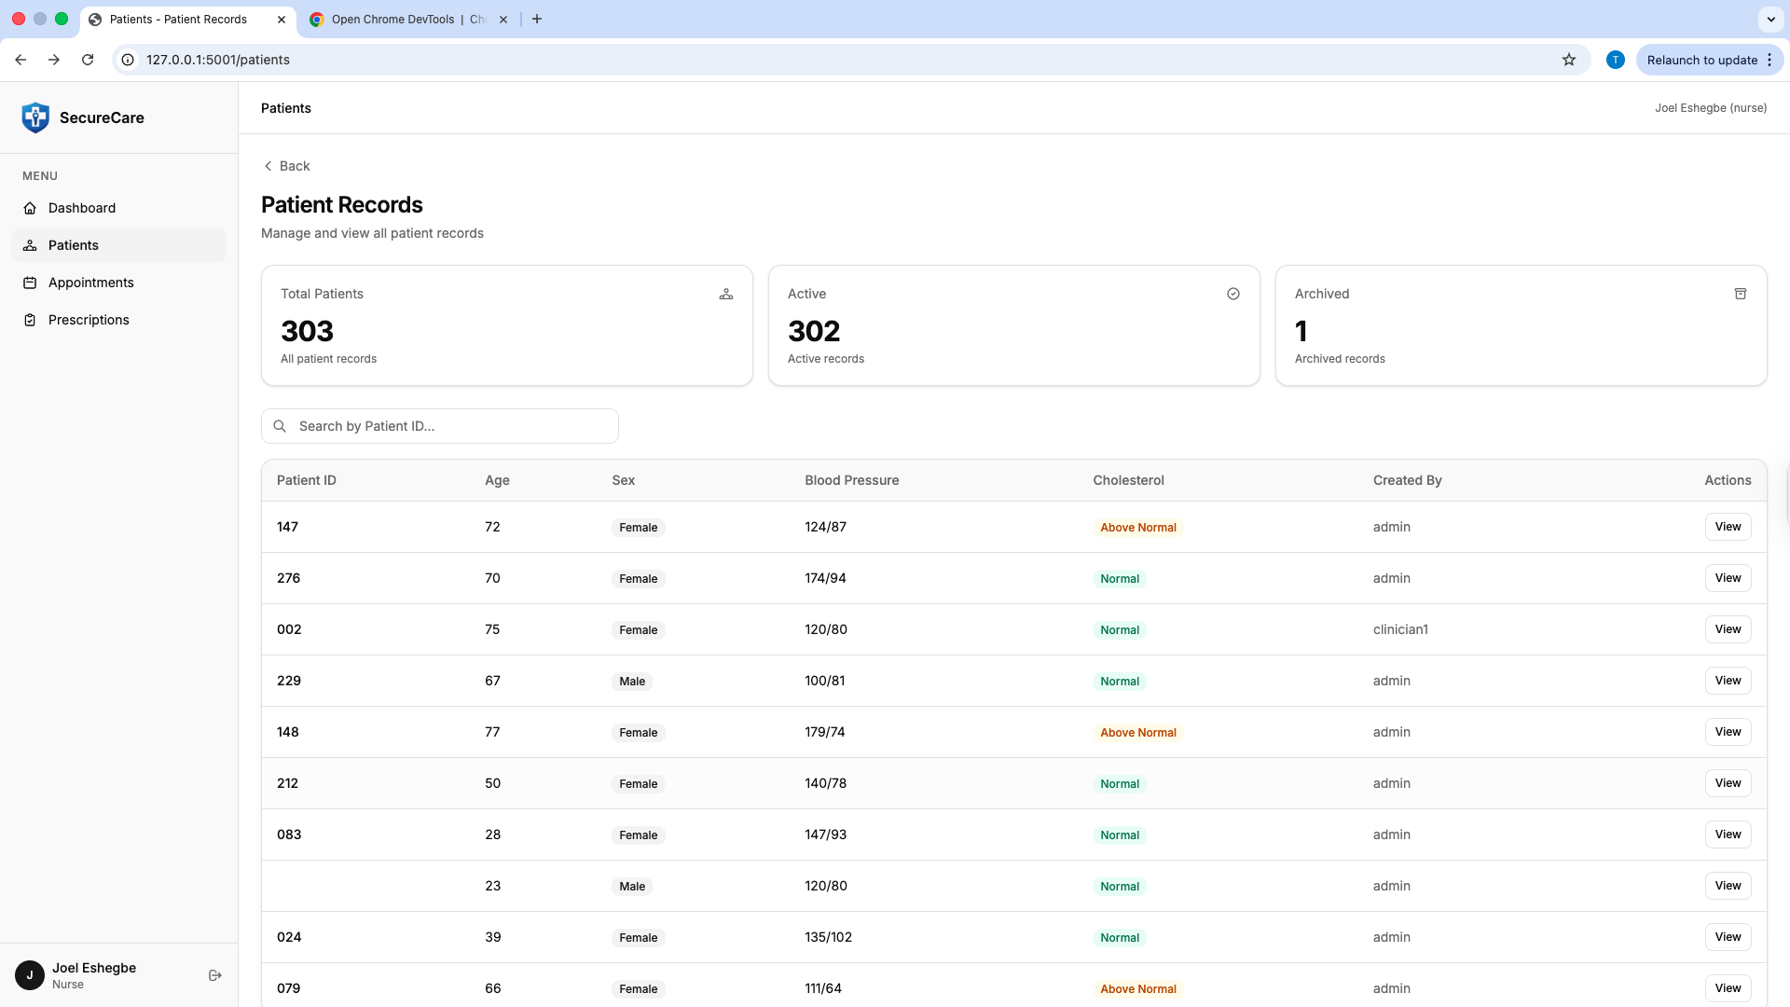
Figure X: Nurse viewing patient information
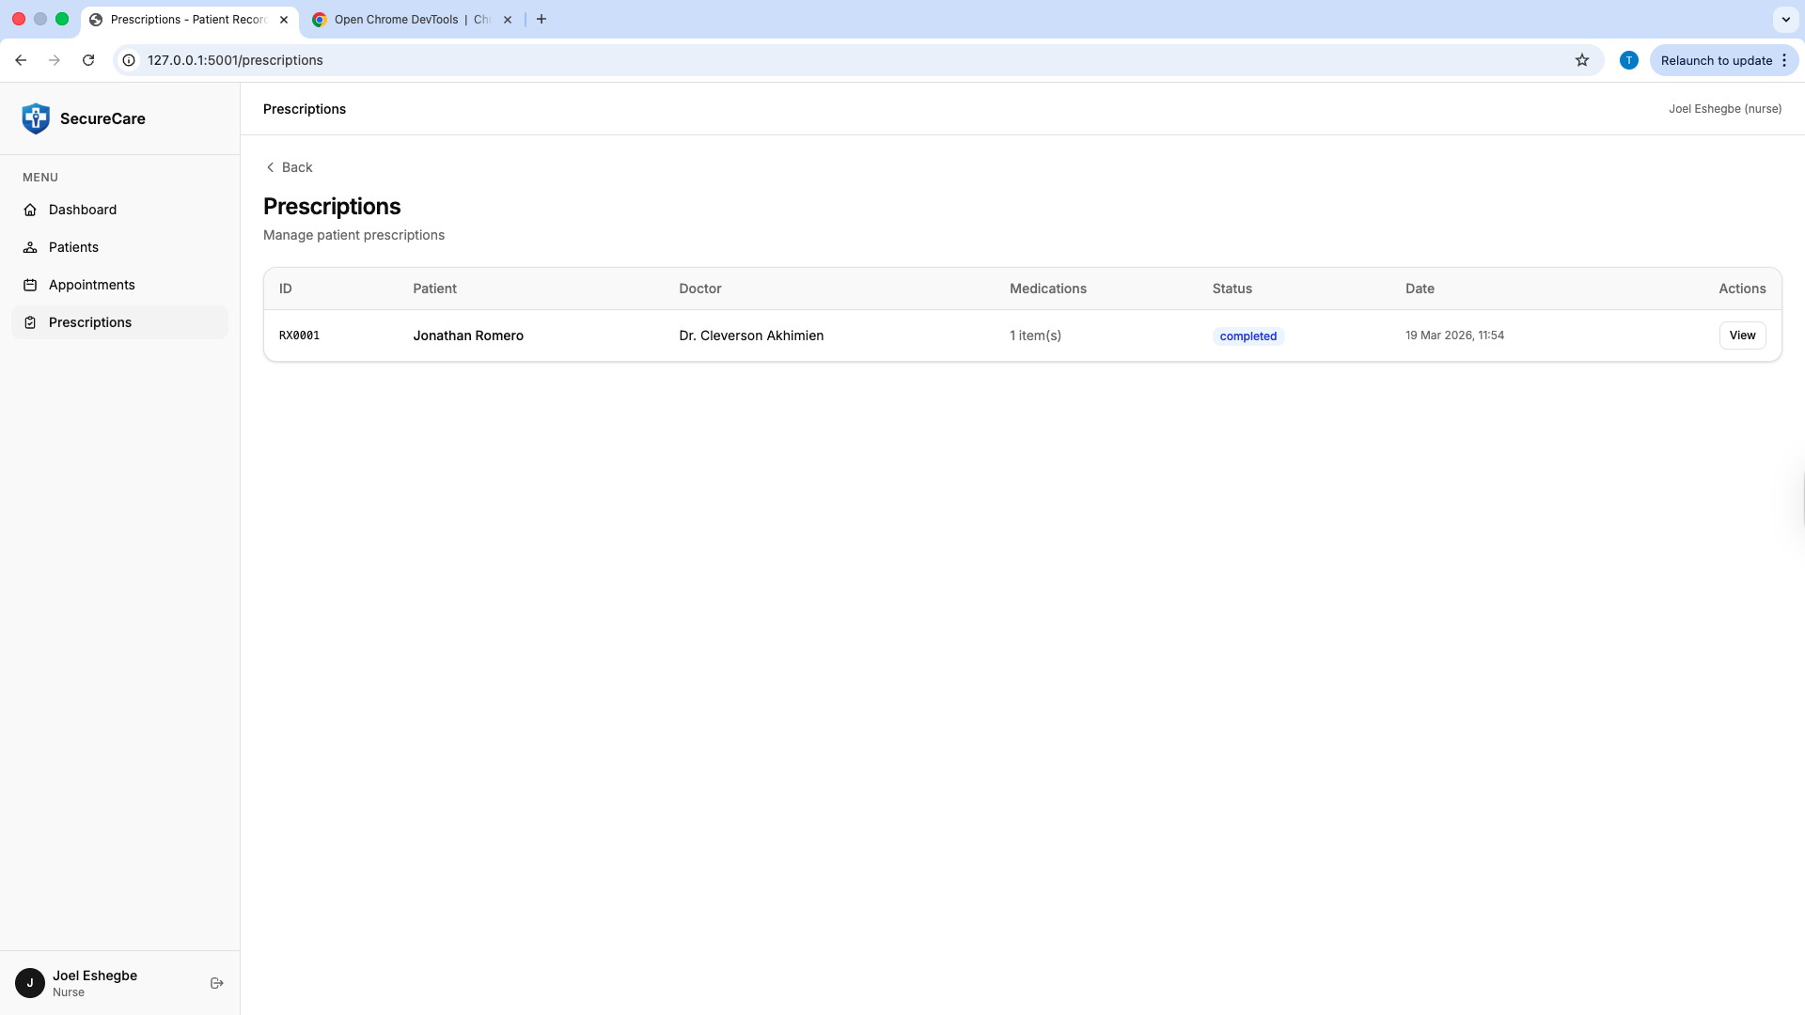
Figure X: Nurse viewing the doctors prescription but cannot edit because only the doctors can.

7.5 Summary of Functional Testing
The functional testing conducted across all user roles demonstrates that the system operates as intended. Core features such as authentication, user management, appointment booking and medical records access were successfully validated through user interface interactions. The system responded appropriately to both valid and invalid inputs, including error handling during incorrect login attempts Overall, the results confirm that the application meets functional requirements and provides a consistent user experience across different roles.
References
Author / Organisation | Reference
Anderson, R. (2020). | Security Engineering: A Guide to Building Dependable Distributed Systems (3rd ed.). Wiley.
ICO. (2023). | Guide to the UK General Data Protection Regulation (UK GDPR). Information Commissioner's Office. https://ico.org.uk/for-organisations/guide-to-data-protection/
IEEE. (2008). | IEEE Std 829-2008: IEEE Standard for Software and System Test Documentation. IEEE.
IEEE. (2018). | IEEE Std 830-1998 (Reaffirmed 2009): IEEE Recommended Practice for Software Requirements Specifications. IEEE.
Khorikov, V. (2020). | Unit Testing: Principles, Practices, and Patterns. Manning Publications.
Microsoft Corporation. (2009). | The STRIDE Threat Model. Microsoft Developer Network.
NHS Digital. (2023). | Data Security and Protection Toolkit. https://www.dsptoolkit.nhs.uk/
NIST. (2020). | NIST Special Publication 800-63B: Digital Identity Guidelines Authentication and Lifecycle Management. National Institute of Standards and Technology.
OWASP. (2021). | OWASP Top Ten: A10:2021 Server-Side Request Forgery (SSRF); A05:2021 Security Misconfiguration. https://owasp.org/Top10/
Pallets Projects. (2024). | Flask Documentation (3.x). https://flask.palletsprojects.com/
Shostack, A. (2014). | Threat Modeling: Designing for Security. Wiley.
Sommerville, I. (2016). | Software Engineering (10th ed.). Pearson Education.
Use of Generative AI
Use of Generative Artificial Intelligence

This assignment used generative artificial intelligence tools to support the development of this work. AI tools were used for brainstorming ideas, structuring content, refining explanations, and improving clarity of writing.

All content has been reviewed, edited, and validated to ensure accuracy, relevance, and alignment with the requirements of the assignment. Any AI-generated outputs, including written suggestions and visual elements such as system diagrams or logos, were adapted and integrated. Evidence of AI use, including interaction logs and prompts, is provided in the appendix.
Appendix A: Test Configuration
The following pytest fixture configuration is used by all test functions:
# tests/test_app.py key fixture structure

@pytest.fixture
def app():
db_fd, db_path = tempfile.mkstemp() # temporary SQLite DB
db_module.DATABASE = db_path
app = create_app()
app.config['TESTING'] = True
with app.app_context():
init_db()
# seed 4 test users: testadmin, testdoctor, testnurse, testpatient
yield app
os.close(db_fd)
os.unlink(db_path)

@pytest.fixture
def client(app):
return app.test_client()

@pytest.fixture(autouse=True)
def reset_mocks():
# Reset all 8 MagicMock collections before each test
mock_patients.reset_mock()
mock_audit.reset_mock()
mock_login_history.insert_one.return_value = MagicMock(inserted_id='fake_history_id')
# ... (all mocks reset to default return values)

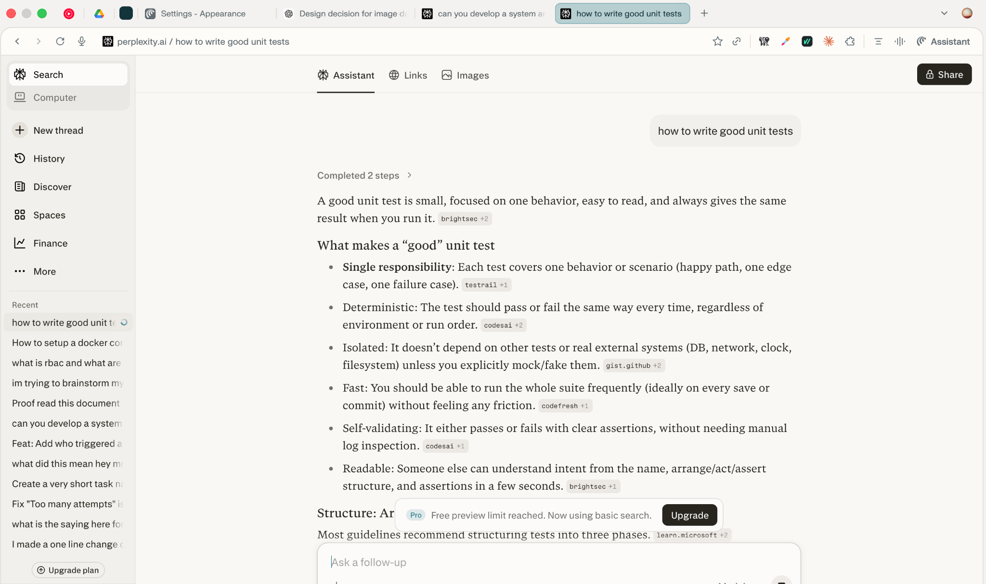
Appendix B: Unit testing (Use of Generative AI)
Appendix C: Mocking (Use of Generative AI)
