1. Which of the following statements is TRUE
a. Elastic deformation result in movement of dislocations on the microstructural level
b. Plastic deformations result in reversible changes in the interatomic distances
c. If the stress values are proportional to strain, the modulus of elasticity is stress-dependent
d. On the microscopic level plastic deformations correspond to irreversible displacements of atms.

2. A 6400 N force is applied to a 5mm diameter nickel wire having a yield strength of 250MPa and a tensile strength of 310MPa. What will happen to the wire?
a. The wire will deform plastically and uniformely
b. The wire will fracture
c. The wire will experience necking
d. The wire will recover its original length when unloaded

3. Which strengthening mechanism in metallic materials is based on significant increase in number of dislocations:
a. Solid solutions hardening
b. Strain hardening
c. Precipitation hardening
d. Grain refining

4. With an increase in the temperature the electrical conductivity of metals:
a. Decreases due to higher scattering of electrons
b. Increases due to higher number of electrons
c. Increases due to higher number of lattice imperfections
d. Decreases due to lower thermal vibrations of atoms

5. Extrinsic semiconductor behaves as an intrinsic one only:
a. If it is a p type
b. At very high temperature
c. If it is an n type
d. At very low temperatures

6. Microstructure of steel with 0.5 wt% C below 727ºC consists of:
a. Pearlite matrix with proeutectoid austenite
b. Pearlite matrix with proeutectoid ferrite
c. Austenite matrix with proeutectoid ferrite
d. Austenite matrix with proeutectoid cementite

7. From the Pb-Sn phase diagram, indicate which alloys will go through the eutectic transformation:
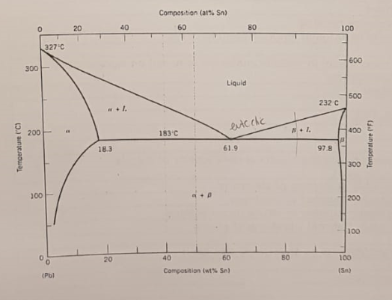

a. All the compositions of alloys from 18.3 wt% Sn to 97.8 wt% Sn
b. Alloys with composition lower than the solubility limit of Sn in the α phase
c. All the compositions of alloys from 18.3 wt% Sn to eutectic composition
d. Only the alloy with composition 61.9 wt% Sn

8. Determine the modulus of elasticity of some hypothetical alloy if it has a diameter of 8.0 mm, Poisson’s ratio 0.35 and a tensile force of 1122 N produces an elastic reduction in diameter of 2.5*10-4mm
a. 160 GPa
b. 190 GPa
c. 220 GPa
d. 250 GPa

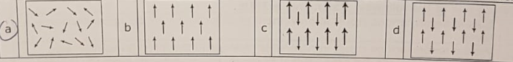
9. Which picture describes paramagnetic material before application of an external field?

10. The linear coefficient of thermal expansion:
a. is high when atomic bonding is strong
b. is not affected by allotropic changes
c. is low when material shows a deep bonding energy
d. of iron is higher than that of lead; due to higher melting temperature
PROBLEM
Using the following Ni-Nb phase diagram answer the questions:
a) Determine all the invariant reactions, writing the type of reaction, temperature they occur and composition (in at% of Nb) of all phases involved in the reaction
b) For an alloy with 30 at% of Nb at a temperature of 1175-ΔTºC indicate the microconstituents present and their quantities.
c) Sketch the microstructure of an alloy with 45 at% of Nb at temperature of 1175+ΔT and 1175-ΔT
d) Indicate which intermetallic compounds have incongruent melting. What is the maximum solubility of Nb in Nickel and at what temperatures is it observed?
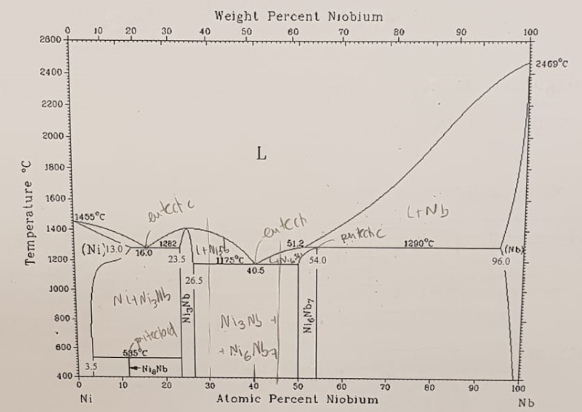

1. Which of the following statements is TRUE
a. Elastic deformation result in movement of dislocations on the microstructural level
b. Plastic deformations result in reversible changes in the interatomic distances
c. If the stress values are proportional to strain, the modulus of elasticity is stress-dependent
d. On the microscopic level plastic deformations correspond to irreversible displacements of atms.

2. A 6400 N force is applied to a 5mm diameter nickel wire having a yield strength of 250MPa and a tensile strength of 310MPa. What will happen to the wire?
a. The wire will deform plastically and uniformely
b. The wire will fracture
c. The wire will experience necking
d. The wire will recover its original length when unloaded

3. Which strengthening mechanism in metallic materials is based on significant increase in number of dislocations:
a. Solid solutions hardening
b. Strain hardening
c. Precipitation hardening
d. Grain refining

4. With an increase in the temperature the electrical conductivity of metals:
a. Decreases due to higher scattering of electrons
b. Increases due to higher number of electrons
c. Increases due to higher number of lattice imperfections
d. Decreases due to lower thermal vibrations of atoms

5. Extrinsic semiconductor behaves as an intrinsic one only:
a. If it is a p type
b. At very high temperature
c. If it is an n type
d. At very low temperatures

6. Microstructure of steel with 0.5 wt% C below 727ºC consists of:
a. Pearlite matrix with proeutectoid austenite
b. Pearlite matrix with proeutectoid ferrite
c. Austenite matrix with proeutectoid ferrite
d. Austenite matrix with proeutectoid cementite

7. From the Pb-Sn phase diagram, indicate which alloys will go through the eutectic transformation:

a. All the compositions of alloys from 18.3 wt% Sn to 97.8 wt% Sn
b. Alloys with composition lower than the solubility limit of Sn in the α phase
c. All the compositions of alloys from 18.3 wt% Sn to eutectic composition
d. Only the alloy with composition 61.9 wt% Sn

8. Determine the modulus of elasticity of some hypothetical alloy if it has a diameter of 8.0 mm, Poisson’s ratio 0.35 and a tensile force of 1122 N produces an elastic reduction in diameter of 2.5*10-4mm
a. 160 GPa
b. 190 GPa
c. 220 GPa
d. 250 GPa

9. Which picture describes paramagnetic material before application of an external field?

10. The linear coefficient of thermal expansion:
a. is high when atomic bonding is strong
b. is not affected by allotropic changes
c. is low when material shows a deep bonding energy
d. of iron is higher than that of lead; due to higher melting temperature
PROBLEM
Using the following Ni-Nb phase diagram answer the questions:
a) Determine all the invariant reactions, writing the type of reaction, temperature they occur and composition (in at% of Nb) of all phases involved in the reaction
b) For an alloy with 30 at% of Nb at a temperature of 1175-ΔTºC indicate the microconstituents present and their quantities.
c) Sketch the microstructure of an alloy with 45 at% of Nb at temperature of 1175+ΔT and 1175-ΔT
d) Indicate which intermetallic compounds have incongruent melting. What is the maximum solubility of Nb in Nickel and at what temperatures is it observed?

