PROBLEM 1
SOLUTION:
1.1 The homogeneous equation, x² y⁰⁰_{h} − 2 x y⁰_{h} + 2 y_{h} = 0, is of the Cauchy-Euler type. We try a solution of the form x^{k}, and obtain (k(k − 1) − 2k + 2)x^{k} = 0. The roots of the polyomial k² − 3k + 2 are 1 and 2, therefore the general solution of the homogeneous problem is y_{h}(x) = c₁x + c₂x².
1.2 As we have two linearly independent solutions of the homogeneous problem, we can find a particular integral of the nonhomogeneous problem by the method of variation of constants. We will give all the steps in detail, though the direct use of the formulas involving the Wronskian is also possible. We write y_{p}(x) = u₁(x)x + u₂(x)x², whose first derivative is y⁰_{p}(x) = u₁(x) + u⁰₁(x)x + u₂(x)2x + u⁰₂(x)x². As usual, we impose the condition that u⁰₁(x)x + u⁰₂(x)x² = 0, so y⁰_{p}(x) = u₁(x) + u₂(x)2x. The second derivative is thus y⁰⁰_{p}(x) = u⁰₁(x) + u⁰₂(x)2x + u₂(x)2. By substituting these derivatives into the nonhomogeneous equation, we find
x²(u⁰₁(x) + u⁰₂(x)2x + u₂(x)2) − 2 x (u₁(x) + u₂(x)2x) + 2 (u₁(x)x + u₂(x)x²) = x log x. If we rearrange the terms in the equation
u₁(x)(−2 x + 2 x) + u₂(x)(2x² − 4x² + 2x²) + u⁰₁(x)x² + u⁰₂(x)2x³ = x log x,
the first two terms vanish, and we have one equation involving u⁰₁(x) and u⁰₂(x), which we need to solve, together with the condition we imposed above on these same derivatives. The resulting system of ^{equation is(}u⁰₁(x)x + u⁰₂(x)x² = 0,
u⁰₁(x)x² + u⁰₂(x)2x³ = x log x.
From the first equation, we have u⁰₁(x) = −u⁰₂(x)x, which we can put into the second to obtain −u⁰₂(x)x³ + u⁰₂(x)2x³ = x log x, thus u⁰₂(x) = log x/x², and so u⁰₁(x) = − log x/x. Integration by parts of these equations yields u₁(x) = −¹₂log² x + C and u₂(x) = −1/x − log x/x + D. As we are looking for a particular solution we can set the constants C and D to zero. The particular solution is thus
y_{p(x) = −}log² x ₂x +

₋¹_{x−}log x x

x² ₌ ₋x log² x
₂− x log x − x.
We add the particular solution of the nonhomogeneous problem to the general solution of the homoge neous problem in order to find the general solution of the nonhomogeneous problem
_{y(x) = −}¹₂x log² x − x log x + (c₁ − 1)x + c₂x².
1.3 From y(1) = c₁ −1 +c₂ = 0 we obtain c₁ +c₂ = 1, which we can use to leave the solution with just one parameter: y(x) = −¹₂x log² x − x log x + (1 − c₂ − 1)x + c₂x² = −¹₂x log² x − x log x + c₂(x² − x). From the other condition, we get y(2) = − log²2 − 2 log 2 + 2c₂ = − log 2(2 + log 2); hence, c₂ = 0. The solution of the boundary value problem is thus
_{y(x) = −}¹₂x log² x − x log x.
PROBLEM 2
SOLUTION:
2.1 x⁰ = 0 = y^{0if and only if} αx + y = 0
−x + αy + (α² + 1)x³ = 0
In other words,
x = 0, or x = ±1 and y = −αx.
Then, the critical points are (0, 0), (1, −α) and (−1, α). Moreover, the Jacobian matrix will be
DF(x, y) =
α 1 −1 + 3(α² + 1)x² α

.
Particularising for the different critical points, first for (0, 0), it follows

.
Thus, λ ∈ σ(A₁) if and only if
A₁ = DF(0, 0) =
α 1 −1 α
(α − λ)² + 1 = 0 ⇒ λ = α ± i.
• If α > 0, Re(σ(A₁)) > 0 and (0, 0) is an unstable spiral. • If α < 0, Re(σ(A₁)) < 0 and (0, 0) is an stable spiral. • If α = 0, (0, 0) is a centre.
For (1, −α), it follows
A₂ = DF(1, −α) =
Thus, λ ∈ σ(A₂) if and only if
α 1 3α² + 2 α

.
(α − λ)² − (3α² _{+ 2) = 0 ⇒ λ = α ±}^{p}3α² + 2.
Then (1, −α) is a saddle point. Since DF(1, −α) = DF(−1, α), (−1, α) is also a saddle point
2.2 If α = 0 the system becomes x⁰ = y = f(x, y)
y⁰ = −x + x³ = g(x, y)
^{and since}∂f(x, y)
_{∂y = 1 = −}∂g(x, y)
_{∂x} ,
the system is conservative. As discussed in the previous item, the critical points are (0, 0), (1, 0) and (−1, 0), with (0, 0) as a centre and (1, 0), (−1, 0) two saddle points.
2.3 Integrating the system we obtain
y²
₂₊x²₂₋x⁴₄= c,
as the family of all the trajectories, where V (x) = ^{x2}₂ −^{x4}₄is the potential associated with the system.
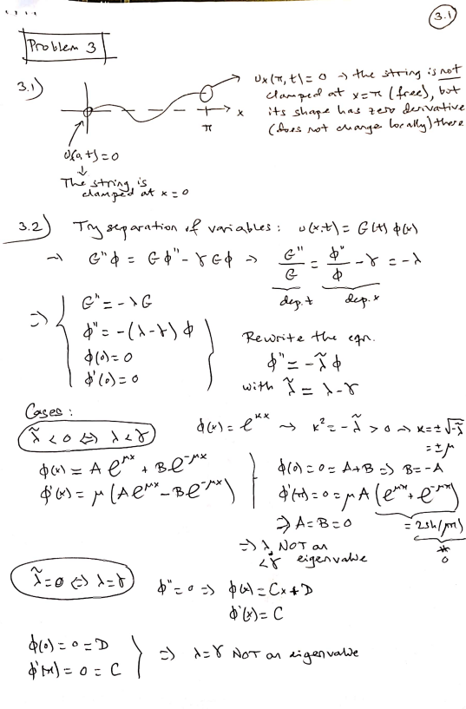
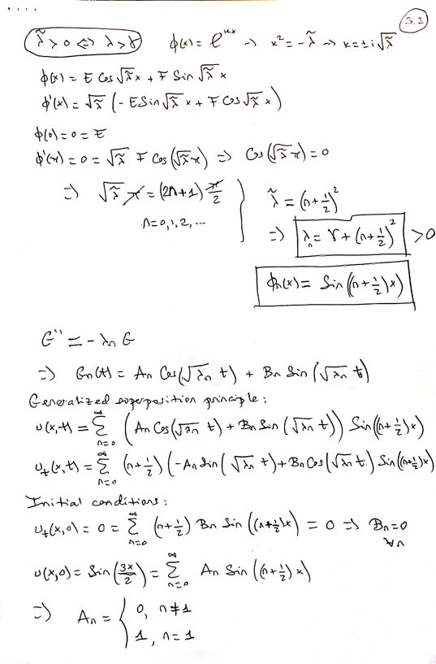Scanned by CamScanner
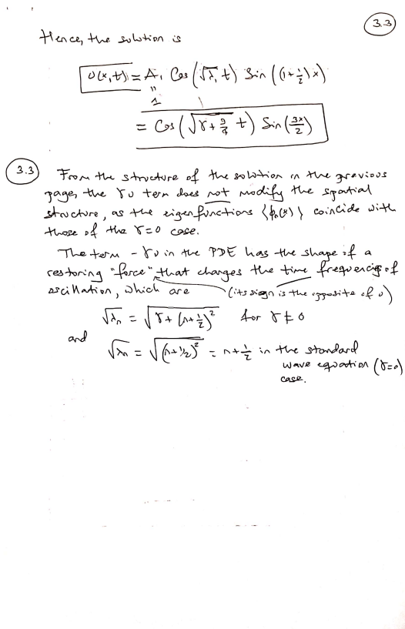Scanned by CamScanner
PROBLEM 4
SOLUTION:
4.1 First we solve the steady-state equation associated with the heat equation ∂²u
∂x²= 6x − 12x²,
under the time-independent boundary conditions
u(0) = 2, u(1) = 3.
The solution of this stationary problem is given by
u_{s}(x) = 2 + x + x³ − x⁴.
4.2 To solve the complete problem we construct a solution of the form u(x, t) = w(x, t) + u_{s}(x).
Since the function u_{s}(x) just depends on x we find that
_{∂t −}∂²w
∂w
∂x²− u⁰⁰_{s}(x) = 12x² − 6x.
Also, by construction
w(0, t) = 0 and w(1, t) = 0. _{∂t =}^{∂u}_{∂t and} ∂²w
∂w
and, hence,
∂x²₌∂²u
∂x²− 6x + 12x²,
_{∂t =}∂²w
∂w
∂x².
Finally, using the previous item we arrive at the initial condition
w(x, 0) = u(x, 0) − u_{s}(x) = f(x) − (2 + x + x³ − x⁴).
Doing so we reduce the non-homogeneous problem to homogeneous problem with homogeneous boundary conditions

_{∂t} =^{∂2}w
∂w
∂x² with x ∈ (0, 1) and t > 0,
w(0, t) = 0 and w(1, t) = 0 t > 0, 
w(x, 0) = f(x) − (2 + x + x³ − x⁴) = g(x) with t > 0,
The general solution for this homogenous heat equation is given by
_{w(x, t) =} X∞
n=1
with (after applying the Fourier series) Z ₁
A_{n}e^{−n2}π^{2t}sin(nπx),
g(x) sin(nπx)dx, ∀n ∈ N.
4.3 When t → ∞ we find that
u(x, t) → u_{s}(x),
A_{n} = 2
0
since the function w(x, t) has a negative exponential function.

