
LAB ASSIGNMENT-2
Submitted by:
Abhinav Khandelwal
1024150194
2O23
1.Create a structure in C++ containing the details of Students as details below and a main function to execute the structure.
Data Members (properties):
Name
Roll No
Degree
Hostel
Current CGPA
Member Functions (behavior):
addDetails()
updateDetails()
updateCGPA()
updateHostel()
displayDetails()
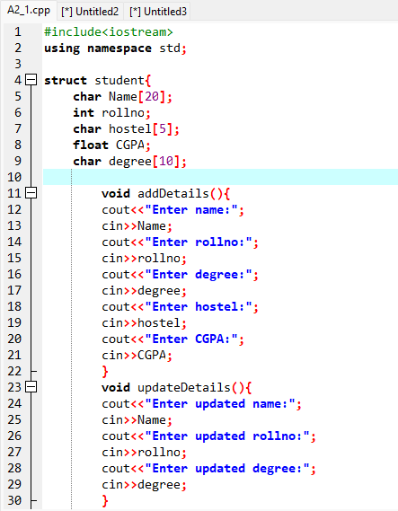
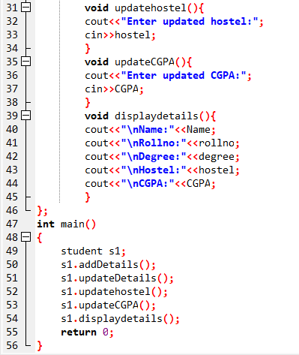
OUTPUT:
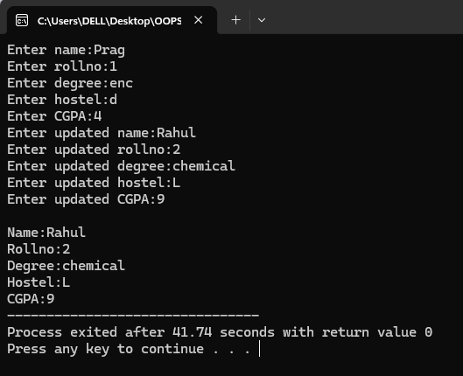
2.Differentiate between private and public access / scope.
Perform Question No. 1 using class instead of structure, having the data members private and some member functions in private scope and some in public scope
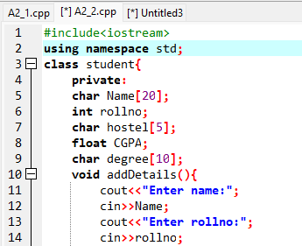

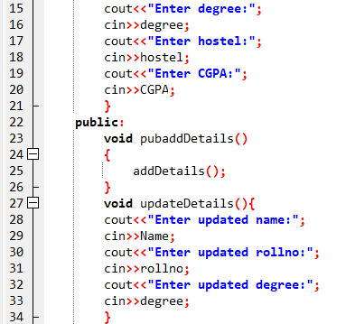
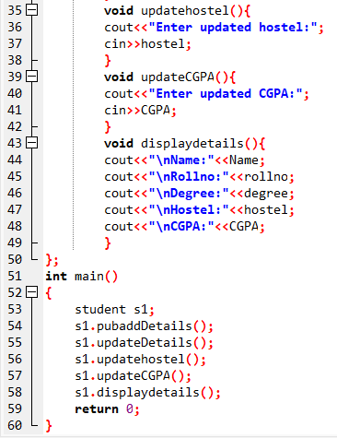
OUTPUT:
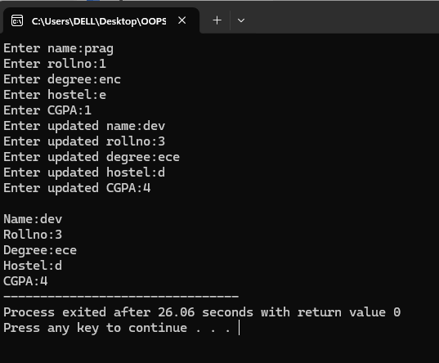
3.Create a code snippet that illustrates the following:
Calling of private member functions inside public member function.
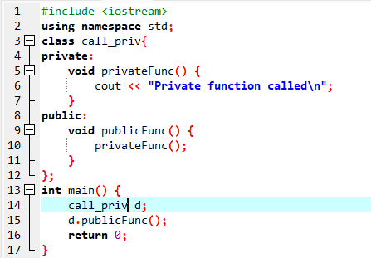
OUTPUT:
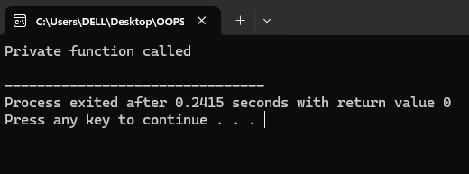
4.Define a class Rectangle with variables width and height of integer type along with the following:
(a) void getdata() to initialize object values
(b) void calculateArea() to calculate and display the area
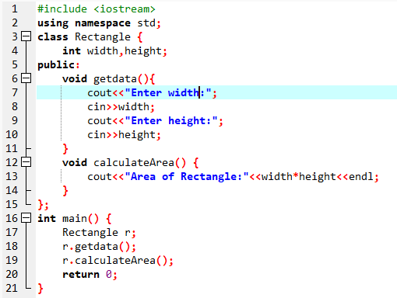
OUTPUT:
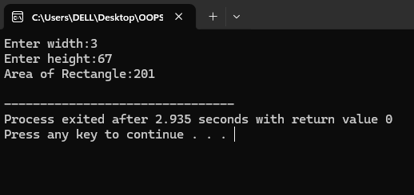
5.Define a class Complex with variables real and imaginary along with the following:
(a) void setComplex(float, float) to initialize object values
(b) void displayComplex() to show the complex number
(c) Pass andS and return objects to calculate sum of two complex numbers. Display the sum.
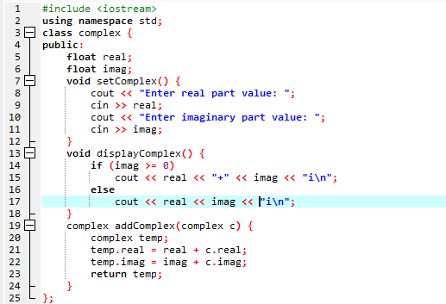

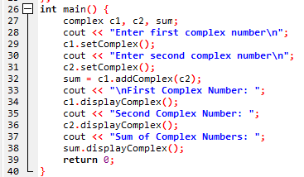
OUTPUT:
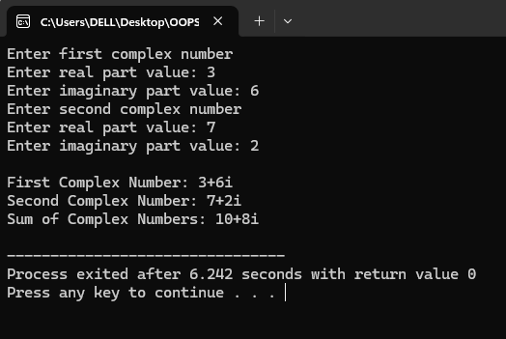

6.Implement scope resolution operator :: for the following uses:
(a) Class functions defined outside the class
(b) Access a global variable with the same name as a local variable
(c) Access static variables
(d) Use inbuilt libraries (cin, cout) with scope resolution operator
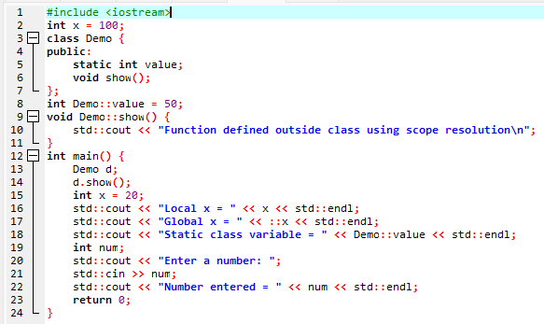
OUTPUT:
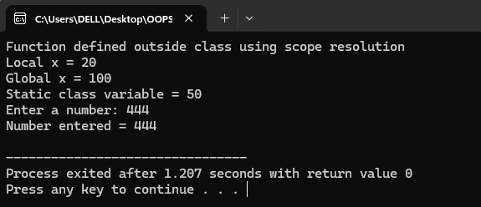
7.Implement namespace in a program to illustrate the use of same name variables and functions in different sections/libraries of the code.
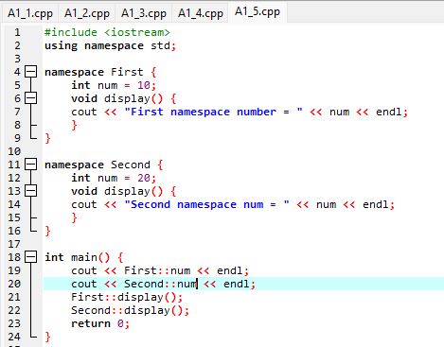
OUTPUT:
