Task-1
Routed Corporate Web Portal
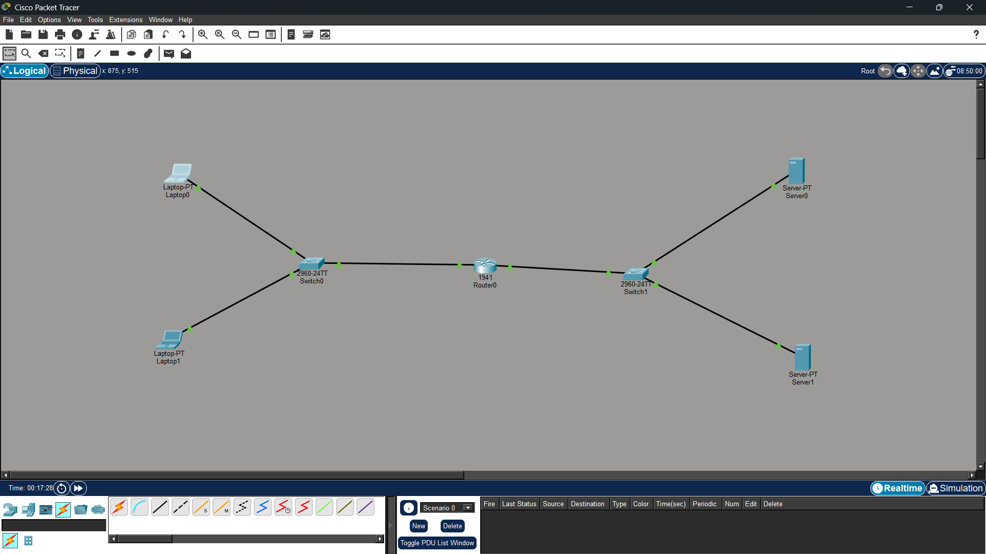

- Test PC-A → Gateway
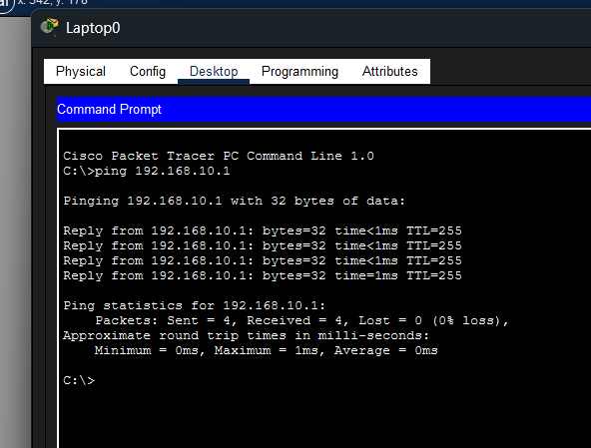
2. Test PC-A → DNS Server
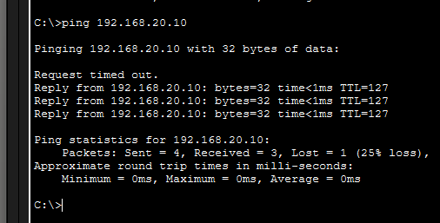
3. Test PC-A → WEB Server
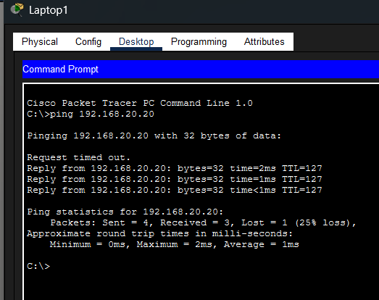
Test Website Using Domain Name:
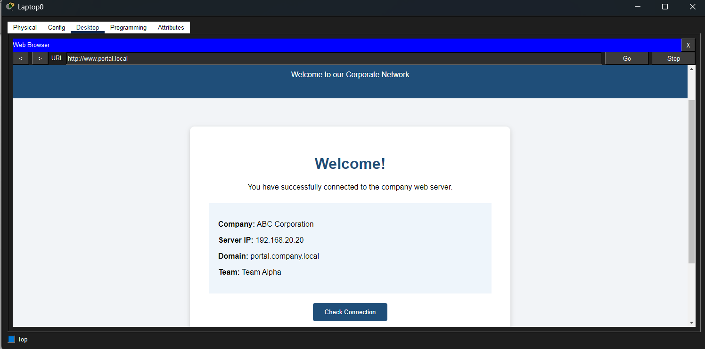

Tested from 2nd laptop for fetching website from server :
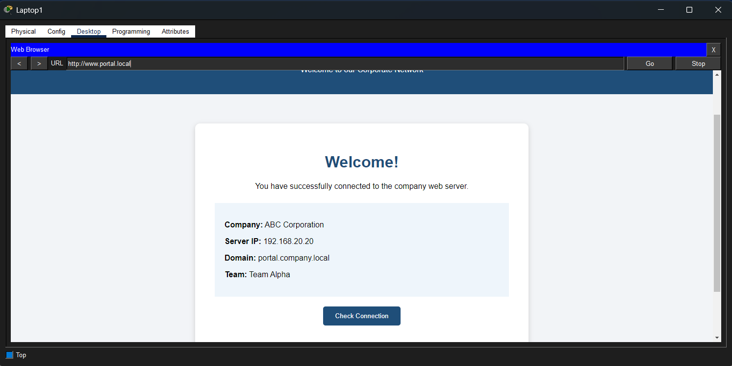
Tested completely from laptop 1 to server which stores the web browser with simulation using ARP , DNS , TCP, HTTP.
