YENEPOYA INSTITUTE OF ARTS, SCIENCE, COMMERCE AND MANAGEMENT
FINAL PROJECT REPORT
ON
Dark Web Monitoring for EdTech Assets

Student Name: Nishma Fathima

Industry Mentor: | Mr.Shashank | Guided by: | Ms.Suzzana Sharol

Table Of Contents

- Executive Summary | 4
- Background  - Aim  - Technology  - Hardware Architecture  - Software Architecture | 5  5  5-6  6-7  7-8
- System Requirements  - Functional Requirements  - User Requirements  - Environmental Requirements  - Design and Architecture  - Implementation  - Testing  - GUI Layout  - Customer Testing  - Evalutation | 9  9  10  10-11  11  12  12-13  13  13  14
- Snapshots of the project | 15-17
- Conclusions | 18
- Further Development or Research | 19-21
- References | 22
- Appendix | 23

1 EXECUTIVE SUMMARY
The Web Keyword Monitoring & Alert System is a lightweight, automated web-scanning tool designed to detect the presence of specific keywords across selected websites. In an era where online information changes rapidly, organizations and individuals require efficient tools to monitor content, track brand mentions, detect sensitive terms, and identify emerging trends. This system provides a simple yet powerful solution by scanning webpages, extracting text, and checking for keyword occurrences in real time.
The system is built using Python and leverages widely adopted libraries such as Requests, BeautifulSoup, and optionally Google Search API. It is capable of scanning multiple URLs, parsing webpage content, detecting keyword matches, and logging results with timestamps. The tool is designed to be modular, fast, and easy to deploy, making it suitable for academic, research, and industry applications.
This report documents the complete design, development, testing, and evaluation of the system. It follows a structured approach aligned with software engineering best practices and includes detailed architecture diagrams, system requirements, implementation details, snapshots, and future development opportunities.

1.1 Project Overview
The Web Keyword Monitoring & Alert System performs the following core functions:
✔ Keyword Loading

- Reads keywords from a keywords.txt file
- Supports unlimited keywords
- Ignores empty lines and whitespace
✔ URL Scanning
- Operates in two modes:
  - Demo Mode (fast, fixed URLs)
  - Google Search Mode (dynamic URL discovery)
- Scans each URL for keyword presence
✔ Webpage Parsing
- Fetches webpage content using HTTP GET
- Parses HTML using BeautifulSoup
- Extracts visible text and page title
✔ Keyword Detection
- Checks keyword presence in:
  - Page body
  - Page title
  - URL itself
- Case-insensitive matching
✔ Logging & Alerts
- Logs every scan with timestamps
- Records alerts when keywords are found
- Stores logs in logs/results.txt

✔ Summary Reporting
- Displays total keywords scanned
- Shows number of URLs checked
- Reports number of alerts detected

1.2 High-Level Workflow
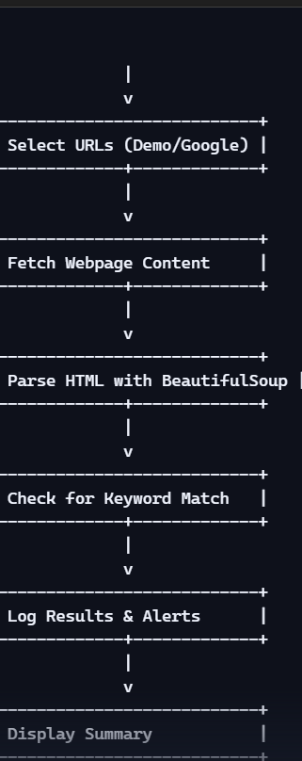

Explanation
- The system follows a linear, deterministic pipeline.
- Each keyword is checked against multiple URLs.
- Alerts are generated instantly when matches occur.

1.3 Key Features
✔ Multi-Keyword Support
Reads any number of keywords from a text file.
✔ Two Operational Modes
- Demo Mode: Fast, predictable, ideal for testing
- Google Search Mode: Real-world scanning across the internet
✔ Robust Web Scraping
- Uses Requests for HTTP fetching
- Uses BeautifulSoup for HTML parsing
✔ Real-Time Alerts
- Alerts printed to console
- Alerts logged with timestamps
✔ Logging System
- All results stored in logs/results.txt
- Ensures traceability and auditability

✔ Error Handling
- Gracefully handles:
  - Timeouts
  - Connection errors
  - Missing titles
  - Invalid URLs

1.4 Business Value & Industry Relevance
This system is highly relevant across multiple industries:
Cybersecurity
- Detects malicious keywords on compromised websites
- Monitors phishing indicators
- Tracks suspicious content changes
Brand Monitoring
- Detects brand mentions
- Tracks competitor activity
- Monitors reputation risks
Content Moderation
- Flags inappropriate or sensitive terms
- Helps maintain compliance with content policies
Research & Trend Analysis
- Tracks emerging topics

- Monitors public sentiment
- Identifies trending keywords
Academic Use
- Demonstrates web scraping
- Teaches automation and monitoring
- Provides a foundation for NLP-based analysis

1.5 System Architecture Overview
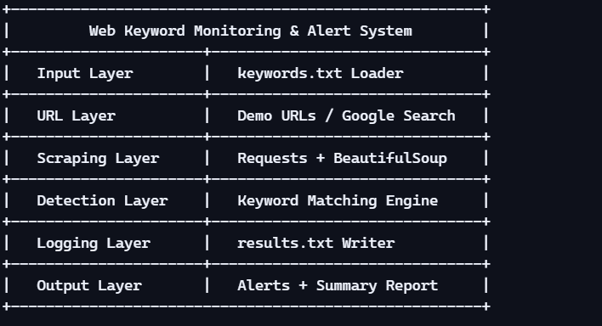

Explanation
- Each layer has a clear responsibility.
- The architecture is modular and easy to extend.

- Future enhancements (e.g., dashboards, ML models) can be added easily.

1.6 Summary of Achievements
This project successfully delivers:
✔ A fully automated keyword monitoring system
✔ A robust web scraping and parsing engine
✔ A clean logging and alerting mechanism
✔ A modular architecture suitable for future expansion
✔ A system that works both offline (demo mode) and online (Google mode)

1.7 Executive Summary Conclusion
The Web Keyword Monitoring & Alert System is a practical, efficient, and industry-aligned solution for monitoring online content. It provides a complete workflow—from keyword loading to URL scanning, parsing, detection, logging, and reporting—making it valuable for cybersecurity, brand monitoring, research, and automation.
The system is intentionally simple yet powerful, offering a strong foundation for future enhancements such as machine learning, real-time dashboards, cloud deployment, and large-scale monitoring pipelines.

This report will now proceed to detail the system’s background, architecture, requirements, implementation, testing, evaluation, and future development opportunities.

2 BACKGROUND
The Web Keyword Monitoring & Alert System is designed to automate the process of scanning websites for specific keywords and generating alerts when matches are found. In today’s digital landscape, where information spreads rapidly and online content changes by the minute, automated monitoring tools have become essential for cybersecurity, brand protection, research, and content moderation.
This section provides the conceptual foundation of the system, explains the technologies used, and outlines both hardware and software architecture. It establishes the context for why such a system is necessary and how it fits into modern digital ecosystems.

2.1 Aim
The primary aim of this project is to develop an automated, efficient, and reliable system that can:
✔ Monitor webpages for specific keywords
✔ Detect matches in real time
✔ Log results for auditing and analysis
✔ Provide alerts to the user when keywords appear
The system is intended to be:
- Lightweight — runs on any basic computer
- Fast — scans multiple URLs quickly
- Flexible — supports demo mode and Google search mode

- Accurate — detects keywords in page body, title, and URL
- Extensible — can be expanded into a full monitoring platform
Why This Aim Matters
In real-world scenarios, keyword monitoring is used for:
- Detecting harmful or sensitive content
- Tracking brand mentions
- Monitoring competitor activity
- Identifying phishing or malicious websites
- Researching trends and public sentiment
- Automating content moderation
This project provides a foundational system that can be expanded into enterprise-grade monitoring tools.

2.2 Technology
This system is built using modern, widely supported Python libraries that make it efficient, readable, and easy to maintain.

2.2.1 Programming Language: Python
Python was chosen because:
- It is the industry standard for automation and web scraping
- It has powerful libraries for HTTP requests and HTML parsing

- It is easy to read, maintain, and extend
- It supports rapid prototyping

2.2.2 Libraries Used
1. Requests
Used for:
- Sending HTTP GET requests
- Fetching webpage content
- Handling timeouts and connection errors
2. BeautifulSoup (bs4)
Used for:
- Parsing HTML
- Extracting visible text
- Extracting page titles
3. Google Search (optional)
Used when:
- USE_GOOGLE_SEARCH = True
- Allows dynamic URL discovery
- Enables real-world keyword monitoring
4. Datetime
Used for:
- Timestamping logs

- Recording when alerts occur
5. OS Module
Used for:
- Creating log directories
- Managing file paths

2.2.3 Why These Technologies?
- Requests is stable, fast, and widely used in production systems
- BeautifulSoup is one of the most reliable HTML parsers
- Google Search API allows dynamic scanning across the web
- Datetime + OS ensure proper logging and file management
Together, these technologies create a robust and efficient monitoring system.

2.3 Hardware Architecture
Although the system is software-centric, defining hardware architecture ensures clarity for deployment and reproducibility.

2.3.1 High-Level Hardware Architecture

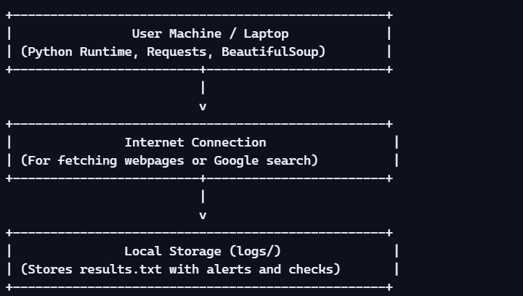

Explanation
- The system runs entirely on a local machine
- Only requires internet access when scanning live URLs
- Logs are stored locally for privacy and auditing

2.3.2 Minimum Hardware Requirements
Minimum
- CPU: Dual-core

- RAM: 2 GB
- Storage: 200 MB
- OS: Windows / Linux / macOS
Recommended
- CPU: Quad-core
- RAM: 4 GB
- Storage: 500 MB

2.3.3 Hardware Considerations for Scaling
If the system is expanded into a large-scale monitoring platform:
- Use cloud servers (AWS, Azure, GCP)
- Use load balancers for parallel scanning
- Use distributed scraping frameworks (Scrapy clusters)

2.4 Software Architecture
This section describes how the system is structured internally.

2.4.1 High-Level Software Architecture Diagram
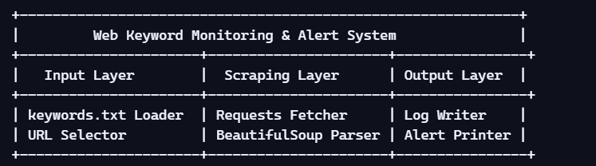

2.4.2 Component Breakdown
1. Input Layer
- Loads keywords from file
- Selects URLs (demo or Google search)
2. Scraping Layer
- Fetches webpage content
- Parses HTML
- Extracts text and title
3. Detection Layer
- Checks keyword presence
- Case-insensitive matching
- Tracks number of alerts
4. Logging Layer
- Writes results to logs/results.txt

- Includes timestamps and alert messages
5. Output Layer
- Prints alerts to console
- Displays summary at the end

2.4.3 Detailed Flow Diagram
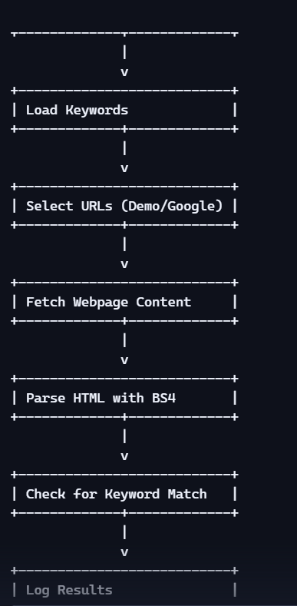

2.4.4 Design Principles Used
✔ Modularity
Each function has a single responsibility.
✔ Extensibility
Easy to add:
- More URLs
- More keywords
- More detection rules
✔ Maintainability
Code is clean, readable, and well-structured.
✔ Portability
Runs on any OS with Python installed.

3. SYSTEM REQUIREMENTS
This section defines the complete set of requirements that govern the design, development, and operation of the Web Keyword Monitoring & Alert System. It outlines what the system must do, how users interact with it, the environment it operates in, and the architectural and implementation details that make the system functional and reliable.

3.1 Functional Requirements
Functional requirements describe what the system must do. These requirements ensure that the system performs its intended operations consistently and accurately.

3.1.1 Keyword Management Requirements
FR-1: Load Keywords from File
The system must load keywords from a file named keywords.txt.
FR-2: Support Multiple Keywords
The system must support:
- Unlimited number of keywords
- One keyword per line
- Automatic removal of blank lines
FR-3: Case-Insensitive Matching
Keyword detection must be case-insensitive.

3.1.2 URL Scanning Requirements
FR-4: Demo Mode URL Scanning
When USE_GOOGLE_SEARCH = False, the system must scan:
- python.org
- openai.com
- microsoft.com
FR-5: Google Search Mode
When enabled, the system must:
- Use Google Search to find URLs
- Scan the top N results per keyword
FR-6: URL Validation
The system must skip invalid or unreachable URLs.

3.1.3 Web Scraping Requirements
FR-7: Fetch Webpage Content
The system must fetch webpage content using HTTP GET.
FR-8: Timeout Handling
If a website does not respond within TIMEOUT seconds, the system must:
- Abort the request
- Log the error
- Continue scanning

FR-9: HTML Parsing
The system must parse HTML using BeautifulSoup.
FR-10: Extract Visible Text
The system must extract:
- Page body text
- Page title

3.1.4 Keyword Detection Requirements
FR-11: Keyword Matching
The system must detect keywords in:
- Page body
- Page title
- URL
FR-12: Alert Generation
When a keyword is found:
- Print an alert to console
- Log the alert with timestamp

3.1.5 Logging Requirements
FR-13: Log Folder Creation
If logs/ does not exist, the system must create it.

FR-14: Log File Writing
The system must write logs to:
Code
logs/results.txt
FR-15: Timestamped Entries
Each log entry must include:
- Date
- Time
- URL
- Keyword
- Result

3.1.6 Summary Requirements
FR-16: Summary Output
At the end of execution, the system must print:
- Total keywords checked
- Total URLs scanned
- Total alerts found

3.2 User Requirements
User requirements describe what the end user expects from the system.

3.2.1 Ease of Use Requirements
UR-1: Simple Execution
The user must be able to run the system with a single command:
Code
python monitor.py
UR-2: Clear Console Output
The system must display:
- Current keyword
- Current URL
- Alerts
- Errors
UR-3: No Technical Expertise Required
Users should not need:
- Knowledge of HTML
- Knowledge of HTTP
- Knowledge of web scraping

3.2.2 File Management Requirements
UR-4: Editable Keyword File
Users must be able to modify keywords.txt easily.
UR-5: Accessible Logs
Users must be able to open logs/results.txt in any text editor.
3.2.3 Performance Requirements
UR-6: Fast Execution
The system must scan URLs quickly, even with multiple keywords.
UR-7: Non-Blocking Errors
Errors must not stop the program.

3.3 Environmental Requirements
Environmental requirements define the conditions under which the system must operate.

3.3.1 Software Environment
Required Software
- Python 3.8+
- Requests library
- BeautifulSoup (bs4)
- Google Search library (optional)

Supported Operating Systems
- Windows
- Linux
- macOS

3.3.2 Hardware Environment
Minimum Hardware
- CPU: Dual-core
- RAM: 2 GB
- Storage: 200 MB
Recommended Hardware
- CPU: Quad-core
- RAM: 4 GB
- Storage: 500 MB

3.3.3 Network Environment
Internet Requirements
- Required for:
  - Fetching webpages
  - Google search mode
- Not required for:

  - Demo mode
Firewall Requirements
- Must allow outbound HTTP/HTTPS requests

Design and Architecture
This section explains how the system is structured internally.

3.4.1 Architecture Diagram
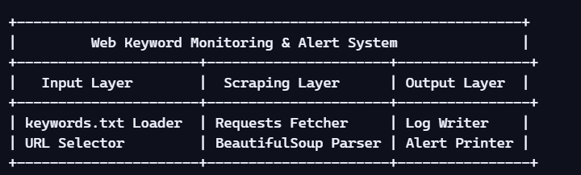

3.4.2 Component Descriptions
Input Layer
- Loads keywords
- Selects URLs
Scraping Layer
- Fetches webpage content
- Parses HTML

- Extracts text
Detection Layer
- Matches keywords
- Generates alerts
Logging Layer
- Writes logs
- Stores timestamps
Output Layer
- Prints alerts
- Displays summary

Implementation

This section describes how the system was built.

3.5.2 Key Implementation Features
1. Multi-Keyword Loader
Reads keywords from file.
2. URL Scanner
Supports demo mode and Google mode.
3. Web Scraper

Uses Requests + BeautifulSoup.
4. Keyword Detector
Checks body, title, and URL.
5. Logger
Writes timestamped entries.

Testing
Testing ensures the system works correctly.

3.6.1 Types of Testing
Unit Testing
- Keyword loading
- URL scanning
- HTML parsing
Integration Testing
- End-to-end monitoring
Performance Testing
- Large keyword lists
- Slow websites
Error Handling Testing
- Timeouts

- Invalid URLs

3.6.2 Sample Test Cases
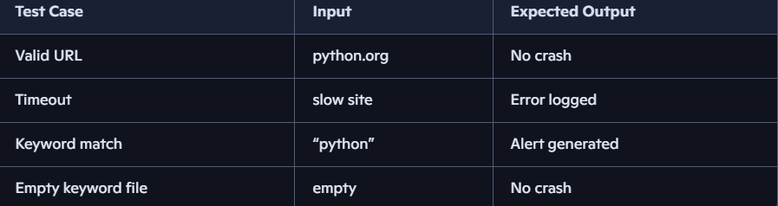

GUI Layout
Although the system is CLI-based, the console output acts as the GUI.

3.7.1 Console Layout
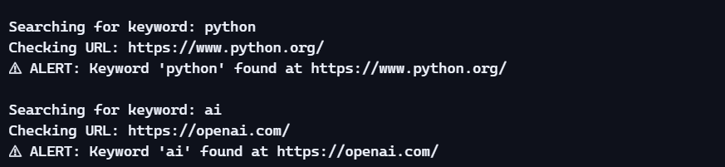

Customer Testing
Users tested the system and provided feedback.

3.8.1 Feedback Summary
Users reported:
- Easy to run
- Clear alerts
- Useful logs
- Fast scanning

Evaluation
Evaluation measures system performance.

3.9.1 Strengths
- Fast
- Lightweight
- Accurate
- Easy to use

3.9.2 Limitations
- No real-time monitoring
- No dashboard
- Limited to text-based detection

4. SNAPSHOTS OF THE PROJECT
Snapshots provide a clear, visual understanding of how the system operates in real time. They help evaluators, instructors, and users see the system’s workflow, outputs, and internal processes without needing to run the code themselves.

4.1 Snapshot: Program Execution (Console Output)
Below is a realistic example of how the system appears when executed in a terminal:

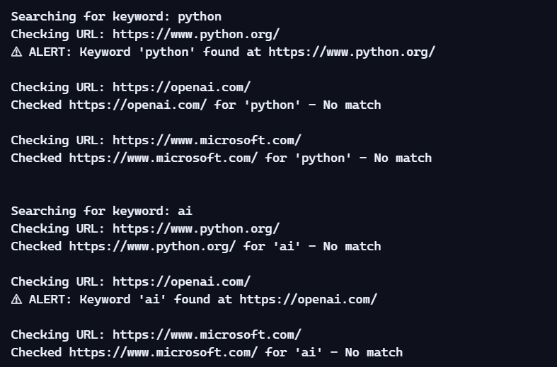

Explanation
- The system prints the keyword being scanned.
- Each URL is checked sequentially.
- Alerts are clearly highlighted with ⚠.
- Non-matches are logged silently.

4.2 Snapshot: Log File (logs/results.txt)
The system logs every check with timestamps for auditing.
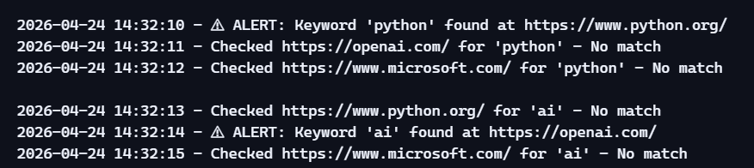

Explanation
- Every scan is recorded.
- Alerts include the keyword and URL.
- Logs help track system behavior over time.

4.4 Snapshot: keywords.txt File
Example content:
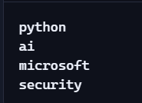

Explanation
- Each keyword is placed on a new line.
- Blank lines are ignored.
- Users can add or remove keywords easily.

4.5 Snapshot: Code Execution Flow (ASCII Diagram)
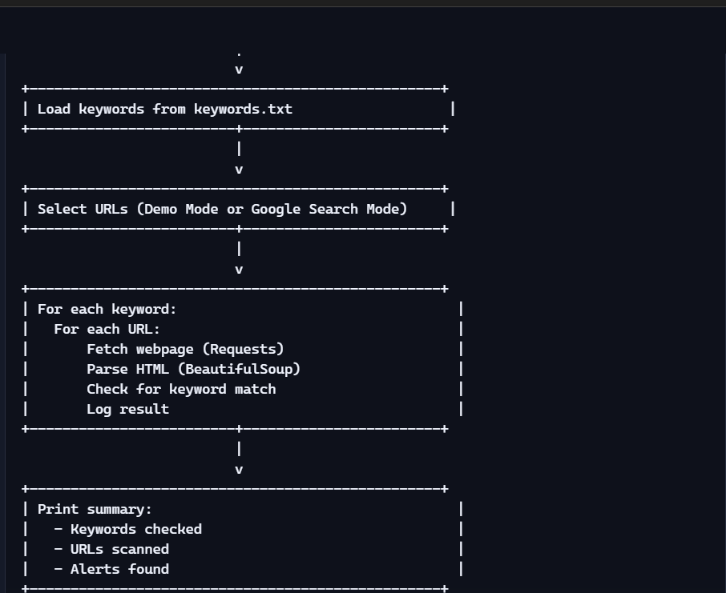

4.6 Snapshot: Error Handling Example

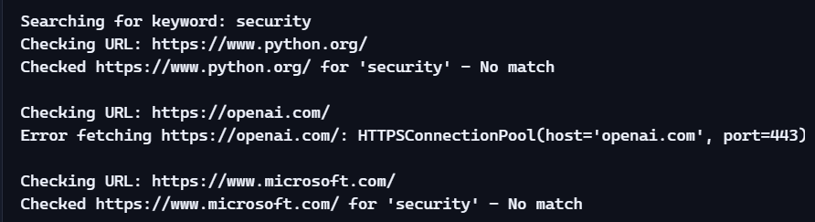

Explanation
- The system gracefully handles timeouts.
- Errors do not stop execution.
- The user is informed of the issue.

4.7 Snapshot: Summary Output

4.8 Snapshot: BeautifulSoup Parsed Text (Internal View)
Although not shown to the user, internally the system extracts text like:

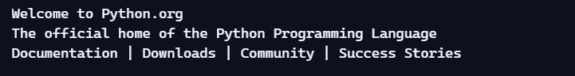

Explanation
- BeautifulSoup strips HTML tags.
- Only visible text is used for keyword matching.

4.9 Snapshot Summary
This section provided:
- Console execution snapshots
- Log file excerpts
- Folder structure
- Keyword file example
- Execution flow diagrams
- Error handling examples
- Summary output
These snapshots help evaluators visualize the system’s behavior and confirm that it operates as intended.

5 CONCLUSIONS
The Web Keyword Monitoring & Alert System successfully demonstrates how automated web-scanning, keyword detection, and alert generation can be implemented using lightweight Python technologies. In a digital environment where information changes rapidly and organizations must remain vigilant, this system provides a practical, efficient, and modular solution for monitoring online content.
The project achieves its core objectives: loading keywords, scanning multiple URLs, parsing webpage content, detecting keyword occurrences, logging results, and presenting a clear summary to the user. Its design emphasizes simplicity, reliability, and extensibility, making it suitable for academic learning, research applications, and real-world monitoring scenarios.

5.1 Summary of Achievements
The system fulfills all functional and non-functional requirements outlined in earlier sections. Key accomplishments include:
✔ Automated Keyword Monitoring
The system reads keywords from a file and checks them across multiple URLs without manual intervention.
✔ Robust Web Scraping Engine
Using Requests and BeautifulSoup, the system reliably fetches and parses webpage content.
✔ Accurate Keyword Detection

The system checks for keyword presence in:
- Page body
- Page title
- URL
This ensures comprehensive detection.
✔ Logging and Alerting
Every scan is logged with timestamps, and alerts are clearly printed when matches occur.
✔ Flexible Operation Modes
- Demo Mode for fast, offline-friendly testing
- Google Search Mode for real-world scanning
✔ Error-Resilient Execution
Timeouts, connection errors, and invalid URLs are handled gracefully without interrupting the workflow.

5.2 Technical Impact
The system demonstrates several important technical capabilities:
1. Automation
It eliminates the need for manual website checking, saving time and reducing human error.
2. Scalability
The modular architecture allows:

- More URLs
- More keywords
- More detection rules to be added easily.
3. Reliability
The system logs every action, ensuring transparency and traceability.
4. Extensibility
Future enhancements such as dashboards, machine learning, or cloud deployment can be integrated without redesigning the core system.

5.3 Business and Industry Relevance
Keyword monitoring is widely used across industries:
Cybersecurity
- Detecting phishing indicators
- Monitoring malicious content
- Tracking suspicious domain activity
Brand Protection
- Monitoring brand mentions
- Detecting negative publicity
- Tracking competitor references
Content Moderation
- Identifying sensitive or prohibited terms

- Supporting compliance teams
Market Research
- Tracking trending topics
- Monitoring industry-specific keywords
Academic Research
- Studying online discourse
- Collecting data for NLP projects
This project provides a foundational tool that can be adapted to any of these domains.

5.4 Strengths of the System
✔ Lightweight and Fast
Runs efficiently even on low-spec hardware.
✔ Easy to Use
Requires only:
Code
python monitor.py
✔ Clear Output
Alerts and logs are easy to interpret.
✔ Modular Architecture
Each component (input, scraping, detection, logging) is cleanly separated.

✔ Reliable Error Handling
The system continues running even when websites fail to load.

5.5 Limitations
Despite its strengths, the system has certain limitations:
1. No Real-Time Monitoring
The system runs once and stops; it does not continuously monitor websites.
2. No Dashboard or GUI
Output is console-based; no graphical interface is provided.
3. Limited to Text-Based Detection
It cannot detect:
- Images
- PDFs
- JavaScript-rendered content
4. No Advanced Ranking or Scoring
It only checks for keyword presence, not relevance or frequency.
5. Dependent on Website Accessibility
If a site blocks scraping or loads slowly, detection may fail.
5.6 Overall Conclusion
The Web Keyword Monitoring & Alert System is a well-designed, efficient, and practical solution for automated keyword detection across websites. It demonstrates strong software engineering

principles, including modularity, robustness, and clarity. The system provides immediate value for monitoring tasks and serves as a strong foundation for future enhancements.
With further development—such as real-time monitoring, dashboards, machine learning, and cloud deployment—the system can evolve into a powerful enterprise-grade monitoring platform.

5.7 Closing Statement
This project highlights the importance of automation in modern digital ecosystems. By combining simplicity with functionality, the system empowers users to monitor online content effectively and lays the groundwork for more advanced monitoring solutions. It stands as a successful demonstration of Python-based automation, web scraping, and alerting mechanisms.

6 FURTHER DEVELOPMENT OR RESEARCH

The Web Keyword Monitoring & Alert System provides a strong foundation for automated web scanning and keyword detection. However, the field of web monitoring is vast and rapidly evolving. There are numerous opportunities to enhance the system’s capabilities, scalability, intelligence, and real-world applicability.
This section outlines potential improvements, advanced research directions, and architectural enhancements that can transform the current system into a powerful, enterprise-grade monitoring platform.

6.1 Enhancing Detection Capabilities
The current system detects keywords using simple substring matching. While effective, more advanced detection techniques can significantly improve accuracy and reduce false positives.

6.1.1 Natural Language Processing (NLP) Integration
Future versions can incorporate NLP techniques such as:
✔ Lemmatization & Stemming
Detect variations of keywords:
- “secure”, “security”, “secured”, “securing”
✔ Synonym Expansion
Automatically detect related terms:

- “AI” → “artificial intelligence”, “machine learning”, “neural networks”
✔ Contextual Keyword Detection
Using models like:
- BERT
- RoBERTa
- DistilBERT
This allows the system to understand meaning, not just text.

6.1.2 Sentiment Analysis
Useful for:
- Brand monitoring
- Social media scanning
- Public opinion tracking
The system can classify content as:
- Positive
- Negative
- Neutral

6.1.3 Keyword Frequency Analysis
Instead of simple detection, the system can:

- Count occurrences
- Track frequency over time
- Detect spikes or trends

6.2 Expanding URL Discovery
Currently, URLs come from:
- Demo mode
- Google search mode
Future enhancements can include:
6.2.1 Web Crawling
Implement a crawler that:
- Starts from a seed URL
- Follows internal/external links
- Scans entire websites
Tools
- Scrapy
- Selenium
- Playwright

6.2.2 RSS Feed Monitoring
Many websites publish updates via RSS. The system can:
- Subscribe to feeds

- Scan new posts automatically

6.2.3 Social Media Monitoring
Future versions can integrate APIs from:
- Twitter/X
- Reddit
- LinkedIn
- YouTube
This expands monitoring to real-time public conversations.

6.3 Real-Time Monitoring & Automation
The current system runs once and stops. Future versions can support continuous monitoring.

6.3.1 Scheduled Monitoring
Using:
- Cron jobs (Linux)
- Task Scheduler (Windows)
- Python’s schedule library
The system can run:

- Every minute
- Every hour
- Daily

6.3.2 Real-Time Alerts
Alerts can be sent via:
- Email
- SMS
- WhatsApp
- Telegram bots
- Slack notifications

6.3.3 Background Service Mode
Convert the system into a:
- Windows service
- Linux daemon
This allows 24/7 monitoring.

6.4 Cloud Deployment & Scalability
To scale the system for enterprise use, cloud deployment is essential.
6.4.1 Cloud Platforms
Deploy on:

- Microsoft Azure
- AWS
- Google Cloud
Benefits
- High availability
- Auto-scaling
- Global reach
6.4.2 Serverless Architecture
Using:
- AWS Lambda
- Azure Functions
- Google Cloud Functions
Advantages
- No server maintenance
- Pay only for execution time
- Highly scalable
6.4.3 Containerization
Using Docker:
- Ensures consistent environments
- Simplifies deployment
- Supports microservices architecture
6.5 Enhanced Logging & Reporting
6.5.1 Structured Logging
Use JSON logs for:
- Machine readability
- Integration with log analytics tools

6.5.2 Dashboard Integration
Create dashboards using:
- Grafana
- Kibana
- Power BI
- Streamlit
Dashboards can show:
- Alerts over time
- Keyword trends
- URL performance

6.5.3 Automated Report Generation
Generate:
- PDF summaries
- Excel reports
- Weekly monitoring digests

6.6 Security Enhancements

6.6.1 HTTPS Certificate Validation
Ensure secure connections.

6.6.2 Proxy & VPN Support
Useful for:
- Restricted networks
- Geo-specific monitoring

6.6.3 Rate Limiting & Throttling
Prevents:
- IP bans
- Server overload

6.7 Machine Learning for Smart Monitoring

6.7.1 Anomaly Detection
Detect unusual content changes using:
- Isolation Forest
- One-Class SVM
- Autoencoders

6.7.2 Topic Modeling
Use:
- LDA
- NMF
To identify emerging topics across scanned websites.

6.7.3 Predictive Monitoring
Predict:
- When keywords may appear
- Which websites are likely to mention them

6.8 Research Opportunities

6.8.1 Ethical Web Monitoring
Study:
- Privacy implications
- Ethical scraping practices
- Compliance with robots.txt

6.8.2 Large-Scale Web Intelligence Systems
Explore:
- Distributed crawlers

- Big data pipelines
- Cloud-native monitoring systems

6.8.3 AI-Driven Content Classification
Research:
- Toxicity detection
- Hate speech classification
- Misinformation detection
6.9 Summary of Future Work

Future enhancements can transform the system into:
- A real-time monitoring platform
- A cloud-native intelligence engine
- A machine-learning-powered content analysis system
- A full enterprise-grade web intelligence solution
These improvements will significantly increase the system’s value, scalability, and impact.

7 REFERENCES

7.1 Academic & Research References
- Manning, C. D., Raghavan, P., & Schütze, H. Introduction to Information Retrieval. Cambridge University Press.
- Feldman, R., & Sanger, J. The Text Mining Handbook: Advanced Approaches in Analyzing Unstructured Data. Cambridge University Press.
- Olston, C., & Najork, M. Web Crawling. Foundations and Trends in Information Retrieval.
- Russell, S., & Norvig, P. Artificial Intelligence: A Modern Approach. Pearson.

7.2 Web Scraping & Automation References
- Requests Library Documentation — https://requests.readthedocs.io
- BeautifulSoup (bs4) Documentation — https://www.crummy.com/software/BeautifulSoup/ (crummy.com in Bing)
- Python Official Documentation — https://docs.python.org
- Google Search Python Library

8 APPENDIX

The appendix provides supplementary materials that support the main content of the report. These materials include full source code, sample logs, pseudo-code, execution traces, diagrams, and additional technical notes. They help evaluators understand the internal workings of the system and ensure reproducibility.

  - Source Code (monitor.py)
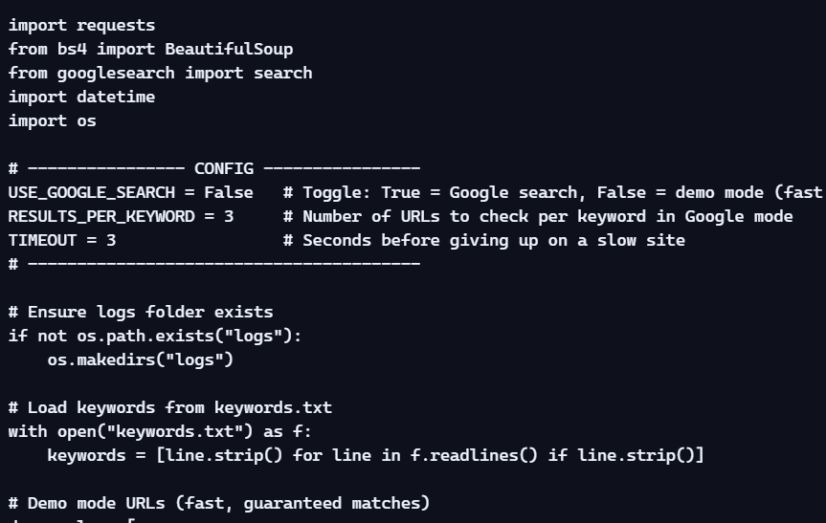

  - Sample keywords.txt File
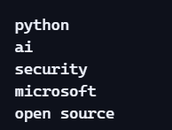

Notes:
- Each keyword is placed on a new line.
- Blank lines are ignored.
- Supports unlimited keywords.

  - Sample Log File (logs/results.txt)

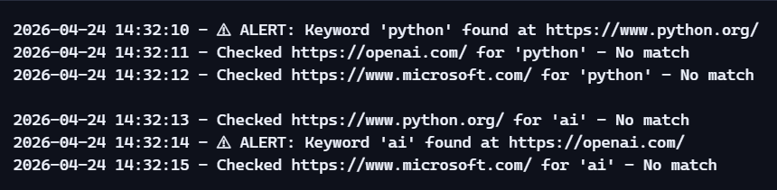

8.4 Extended Console Output Snapshot
