YENEPOYA INSTITUTE OF ARTS, SCIENCE, COMMERCE AND MANAGEMENT

LOW-LEVEL DESIGN
ON
Dark Web Monitoring for EdTech Assets

Submitted By: Nishma Fathima

Industry Mentor:

Guided By:

Table Of Contents

- File Structure. ……………………………………………………….. 3-4

- Module Details. …………………………………………………….. 5
  - Imports. ………………………………………………………. 5-6
  - Functions. ……………………………………………………. 6-7
  - Main Execution Block. ………………………………….. 7

- Data Flow. ………………………………………………………………. 8
  - File Input. ……………………………………………………… 8
  - Parsing and Tokenization. …………………………….. 8-9
  - Summarization Engine. …………………………………. 9
  - Output Generation. ………………………………………. 9-10

- Example Input. ……………………………………………………….. 11

- Example Output. …………………………………………………….. 12

- Technology Stack. …………………………………………………….. 13-14

- Error Handling. …………………………………………………………. 15-16
- Future Enhancements. ………………………………………………. 17-18

- FILE STRUCTURE

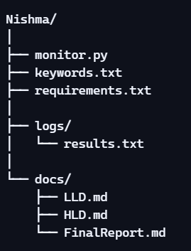

  - monitor.py Implements the monitoring logic: configuration, scraping, keyword detection, logging, and summary reporting.

  - keywords.txt Contains the list of keywords to monitor. Each keyword is written on a separate line for easy updates.

  - requirements.txt Lists Python dependencies (requests, beautifulsoup4, googlesearch-python) to ensure reproducibility.

  - logs/results.txt Stores monitoring results with timestamps. Both alerts and “no match” checks are logged for transparency.

- docs/ Dedicated folder for project documentation:
- LLD.md → Low-Level Design (developer-focused details).
- HLD.md → High-Level Design (system overview and architecture).
- FinalReport.md → Consolidated project report for submission.

- MODULE DETAILS

2.1 Imports

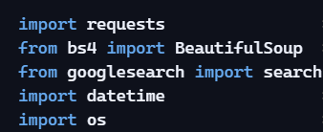

      - requests → Handles network calls to fetch page content.

      - BeautifulSoup (bs4) → Parses HTML into a structured format, allowing keyword search in text and titles.

      - googlesearch → Provides Google search results when USE_GOOGLE_SEARCH = True.

      - datetime → Adds timestamps to log entries for traceability.

      - os → Ensures directories exist (logs/) and manages file paths.

2.2 Function

- check_url_for_keyword(url, kw)
- Fetches a URL, parses HTML, and checks keyword in body text, page title, and URL.
- Logs either an alert or a “no match” entry with timestamp.
- Updates counters (alerts_found, checks_done).
- Handles exceptions gracefully (timeouts, invalid URLs).

- Main Loop
- Iterates through all keywords from keywords.txt.
- Selects URLs based on configuration (USE_GOOGLE_SEARCH toggle).
- Calls check_url_for_keyword for each URL.
- Prints progress messages and maintains counters.

- Summary Report
- Prints final overview: number of keywords checked, URLs scanned, and alerts found.

2.3 Main Execution Block

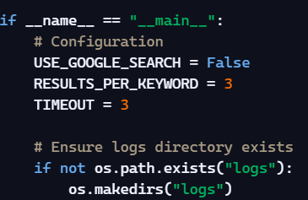

    - configuration flags are set at the top.
    - Keywords are loaded from keywords.txt.
    - URL selection depends on USE_GOOGLE_SEARCH.
    - Loop iterates through keywords and URLs, calling check_url_for_keyword.
    - Counters track total checks and alerts.
    - Summary is printed at the end.

- DATA FLOW

3.1 File Input

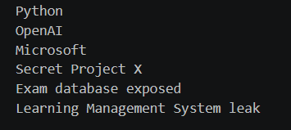

      - The script reads keywords from keywords.txt.

      - Each line is stripped of whitespace and stored in a list.

      - This list drives the monitoring loop.

3.2 Parsing and Tokenization

      - HTML content is fetched using requests.
      - BeautifulSoup parses the HTML into a structured format.

      - Text is extracted with .get_text() and converted to lowercase.

      - Page title is also extracted and normalized to lowercase.

      - Keyword matching is done by simple substring search in text, title, and URL.

3.3 Summarization Engine

    - Currently, the script only prints alerts and logs results.

    - A summarization engine could be added to generate concise reports of findings (e.g., grouping alerts by keyword, highlighting most frequent matches).

3.4 Output Generation

- Alerts are printed to the console when keywords are found.
- All checks (matches and misses) are logged in logs/results.txt with timestamps.

- A final summary line is printed showing:
- Number of keywords checked
- Number of URLs scanned
- Number of alerts found

- EXAMPLE INPUT

keywords.txt:

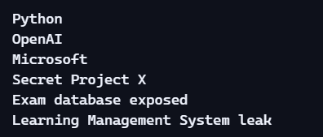

Future Scope
- Accepting keywords via command-line arguments or environment variables.
- Supporting multiple input sources (e.g., CSV files, databases, or API feeds).
- Adding categories/tags to keywords for more structured monitoring

- EXAMPLE OUTPUT

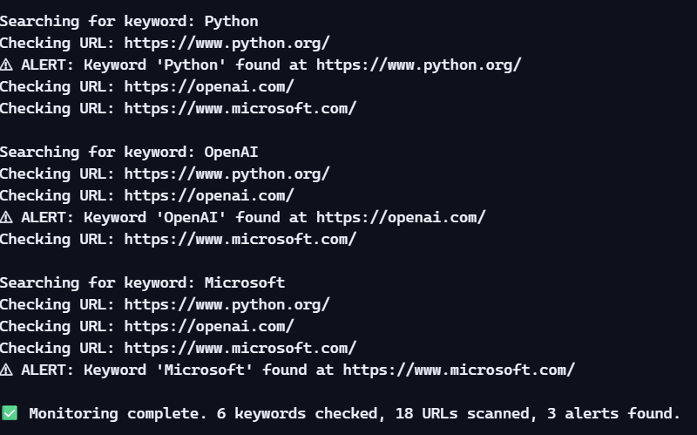
Sample Console Output:

Sample Log File (logs/results.txt)
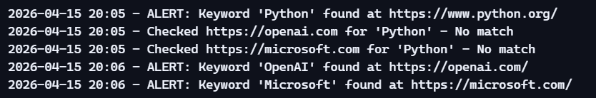

- TECHNOLOGY STACK

Implemented
- Programming Language:
  - Python 3.x → Core language used for scripting and logic.
- Libraries:
  - requests → For sending HTTP requests and fetching web pages.
  - beautifulsoup4 (bs4) → For parsing HTML content and extracting text/title.
  - googlesearch-python → For retrieving Google search results (optional mode).
  - datetime → For timestamping log entries.
  - os → For file and folder operations (ensuring logs directory exists).
- Environment:
  - Windows 10 (your HP Victus laptop).
  - VS Code and PowerShell for development and execution.
- File System:
  - keywords.txt → Input keywords.
  - logs/results.txt → Output logs.
  - docs/ → Documentation (LLD, HLD, Final Report).

Future Scope
- Database Integration:
  - Store alerts in SQLite or PostgreSQL for structured querying.
- Cloud Deployment:
  - Run the monitor on cloud platforms (AWS Lambda, Azure Functions) for scheduled checks.
- Visualization Tools:
  - Use matplotlib or plotly to generate graphs showing keyword frequency.
- Containerization:
  - Package the project with Docker for portability.

- ERROR HANDLING

Implemented
- Timeouts
  - Each request uses a TIMEOUT value (default 3 seconds).
  - If a site doesn’t respond within this time, an exception is raised and caught.
  - The script prints:

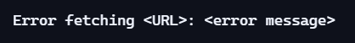

  - Execution continues without breaking the loop.
- Invalid URLs / Network Errors
  - Exceptions from requests.get() are caught.
  - The error is printed to the console, but the script continues to the next URL.
- Empty Keywords File
  - If keywords.txt is empty, the keywords list will be empty.
  - The script simply runs with no iterations, producing no alerts.
Future Scope
- Detailed Error Logging
  - Write errors into logs/errors.txt for better debugging.
- Retry Mechanism
  - Automatically retry failed requests a limited number of times before skipping.
- Keyword Validation
  - Detect invalid or duplicate keywords in keywords.txt and warn the user.
- Graceful Exit Messages
  - Inform the user if no keywords are found or if all URLs failed.

- FUTURE ENHANCEMENTS

- Advanced Input Sources
- Accept keywords from CSV, JSON, or databases.
- Add categories/tags to keywords for structured monitoring.
- Enhanced Output & Reporting
- Export results to CSV/JSON for analysis.
- Generate visual dashboards (graphs showing keyword frequency).
- Summarization engine to group alerts by keyword or site.
- Alerting & Notifications
- Send alerts via email, SMS, or Slack instead of just console/logs.
- Real-time push notifications when sensitive keywords are detected.
- Error Handling Improvements
- Retry mechanism for failed requests.
- Separate error log file (logs/errors.txt).
- Validation for duplicate or invalid keywords.
- Scalability & Deployment

- Schedule automated runs via cron jobs or Windows Task Scheduler.
- Deploy on cloud platforms (AWS Lambda, Azure Functions) for continuous monitoring.
- Containerize with Docker for portability.
- Technology Extensions
- Integrate with machine learning models for smarter keyword detection (e.g., semantic matches, synonyms).
- Use NLP libraries to detect context around keywords (e.g., “exam leak” vs. “exam preparation”).

