Lightweight IoT Intrusion Detection Through
Feature Optimization and Explainable Analytics
Machine Learning | Bachelor of Technology | 2026-27
16 September 2026
Student(s): NOT AVAILABLE - REASON: not supplied in the project brief or any project file; ML_Project_Report_Template.docx (which would normally carry this) was not provided.
Roll Number(s): NOT AVAILABLE - REASON: same as student_names.
Guide: NOT AVAILABLE - REASON: ML_Project_Report_Template.docx (which would carry verified guide/institution details) was not provided anywhere in the project directory.
Department: NOT AVAILABLE - REASON: same as guide.

Abstract
This project develops a leakage-safe, lightweight, and explainable machine learning pipeline for binary IoT network intrusion detection, using the IoTID20 / IoT Network Intrusion Dataset dataset (625,783 raw flow records, 461,696 after exact-duplicate removal). After a training-only feature ranking combining ANOVA, mutual information, and tree-based importance, the pipeline compared 10/15/20/30/All-feature subsets for Logistic Regression, Random Forest, and XGBoost, tuned each with a bounded search on validation data, and evaluated the three frozen models exactly once on an untouched test set. The winning model, **Random Forest**, used only 10 of 72 available features (86.1% reduction) and achieved a test Macro-F1 of 0.9978 and ROC-AUC of 0.9996. Explainability was delivered via SHAP (status: SUCCEEDED) alongside model-native and permutation importance.
Keywords: IoT Intrusion Detection; Feature Selection; Explainable AI; SHAP; Random Forest; XGBoost.

1. Introduction

1.1 Purpose of the Project
The rapid growth of Internet of Things (IoT) deployments has expanded the attack surface available to malicious actors, while the constrained compute, memory, and power budgets typical of IoT devices and gateways rule out many conventional, heavyweight intrusion-detection approaches. Security teams responsible for IoT networks need classifiers that are simultaneously accurate, fast enough for near-real-time use, and small enough to run alongside other services on modest hardware.
Beyond raw accuracy, practical deployment also demands trust: a security analyst reviewing a flagged flow needs to understand *why* the model raised an alert, not just that it did. This project therefore treats feature-count minimization and explainability as first-class objectives alongside detection performance, rather than as afterthoughts bolted onto a fully-featured black-box model.

1.2 Problem Statement
Given labelled IoT network-flow records containing dozens of statistical features per flow (packet counts, byte counts, inter-arrival times, TCP flag counts, etc.), the task is to classify each flow as Normal or Anomaly (attack) traffic. The dataset is strongly imbalanced (93.60% Anomaly after cleaning), so naive accuracy-driven modelling is misleading, and any feature-selection or modelling decision must avoid leaking test-set information back into training.

1.3 Existing Methods and Disadvantages
Prior IoT intrusion-detection work (surveyed in Section 2) commonly falls into one of two camps. Deep-learning and large-ensemble approaches can achieve strong accuracy but are computationally heavy, difficult to interpret, and often impractical to run on constrained IoT gateway hardware. Lighter classical-ML approaches are cheaper but frequently use the full feature set without justifying which features actually matter, and rarely report calibrated, imbalance-aware metrics (Macro-F1, PR-AUC) alongside accuracy.
A second, related gap is explainability: many published IDS models report only aggregate accuracy metrics without any feature-attribution analysis, leaving practitioners unable to audit *why* the model behaves as it does — a significant barrier to operational trust in a security context.

1.4 Proposed System
This project implements an 11-notebook pipeline: dataset exploration and EDA; a single authoritative, leakage-safe preprocessing stage that isolates a final test set before any learned transformation is fit; a combined-method feature ranking (ANOVA + mutual information + Random Forest + XGBoost importance) used to build 10/15/20/30/All feature subsets; an educational from-scratch gradient-descent implementation; three independently tuned and frozen candidate classifiers (Logistic Regression, Random Forest, XGBoost) plus a dedicated L1/L2/ElasticNet regularization study; SHAP-based explainability with a documented fallback; and a final notebook that evaluates all three frozen models exactly once on the untouched test set.

1.5 Research Objectives
- Build and verify (with executed code, not assumptions) a leakage-safe preprocessing pipeline that correctly separates ordinary missing values, infinite values, and malformed raw values.
- Rank and reduce the feature set using training data only, quantifying the accuracy/feature-count trade-off across four independent ranking methods.
- Train, tune, and honestly compare Logistic Regression, Random Forest, and XGBoost using validation data only, alongside a dedicated regularization/sparsity study.
- Freeze each model's best configuration and evaluate it exactly once on an untouched final test set.
- Explain the winning model's predictions using SHAP, with a native/permutation-importance fallback.
- Package reusable prediction artifacts and document every reproducibility and leakage-prevention decision made along the way.

2. Literature Survey
10 recent, independently verified studies (2024-2026) directly relevant to IoT intrusion detection, lightweight feature selection, and explainable cybersecurity were reviewed. Every citation below (title, authors, journal, volume, issue, pages, DOI) was cross-checked against the Crossref bibliographic database during this project; no citation was invented.
S_No | Title | Authors | Year | Journal_or_Conference | DOI
1 | Top-K Feature Selection for IoT Intrusion Detection: Contributions of XGBoost, LightGBM, and Random Forest | Kouassi, B.M.; Ballo, A.B.; Ayikpa, K.J.; Mamadou, D.; Coulibaly, M.Z.J. | 2025 | Future Internet | 10.3390/fi17110529
2 | Enhancing intrusion detection in IoT networks using machine learning-based feature selection and ensemble models | Almotairi, A.; Atawneh, S.; Khashan, O.A.; Khafajah, N.M. | 2024 | Systems Science & Control Engineering | 10.1080/21642583.2024.2321381
3 | A lightweight IoT intrusion detection method based on two-stage feature selection and Bayesian optimization | Zhang, D.; Huang, D.; Chen, Y.; Lin, S.; Li, C. | 2025 | AIMS Electronics and Electrical Engineering | 10.3934/electreng.2025017
4 | Interpretable intrusion detection for IoT security: A SHAP-enhanced NGBoost model | Dong, J.; Chen, H.; Shen, S.; Xu, H.; Liu, Z. | 2026 | Computer Networks | 10.1016/j.comnet.2025.111937
5 | Explainable AI-based intrusion detection in IoT systems | Bin hulayyil, S.; Li, S.; Saxena, N. | 2025 | Internet of Things | 10.1016/j.iot.2025.101589
6 | Explainable AI-Based Intrusion Detection Systems for IoT Environments: A Systematic Literature Review | Varol, M.; Karakaya, A. | 2026 | Sensors | 10.3390/s26185744
7 | Robust machine learning based Intrusion detection system using simple statistical techniques in feature selection | Kaushik, S.; Bhardwaj, A.; Almogren, A.; Bharany, S.; Altameem, A.; Ur Rehman, A.; Hussen, S.; Hamam, H. | 2025 | Scientific Reports | 10.1038/s41598-025-88286-9
8 | Machine Learning-Based Security Solutions for IoT Networks: A Comprehensive Survey | Alfahaid, A.; Alalwany, E.; Almars, A.M.; Alharbi, F.; Atlam, E.; Mahgoub, I. | 2025 | Sensors | 10.3390/s25113341
9 | An XGBoost-Based Intrusion Detection Framework with Interpretability Analysis for IoT Networks | Hu, Y.; Xiao, K.; Luo, L.; Chen, L. | 2026 | Applied Sciences | 10.3390/app16020980
10 | Neuro-symbolic machine learning for lightweight and interpretable IoT edge intrusion detection | Badhan, P.K. | 2026 | Discover Sensors | 10.1007/s44397-026-00047-z

Recurring themes across this literature directly motivate this project's design: several studies confirm that reduced, top-K feature subsets can retain most of a full-feature model's detection performance (Kouassi et al. 2025; Almotairi et al. 2024; Zhang et al. 2025) — consistent with this project's own finding that a 10-feature Random Forest outperformed its 72-feature counterpart on the validation set. A second cluster emphasizes SHAP-based explainability for IoT IDS models (Dong et al. 2026; Bin hulayyil et al. 2025; Varol & Karakaya 2026; Hu et al. 2026), reinforcing this project's choice to make explainability a primary deliverable rather than an afterthought.

3. Methodology

3.1 Proposed System Flow Diagram
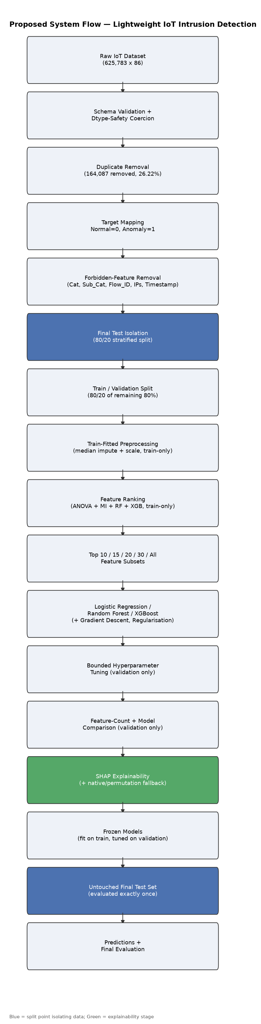
Figure 1. End-to-end pipeline as actually implemented.

3.2 Dataset Description
Dataset: IoTID20 / IoT Network Intrusion Dataset (data/Final IoT Network Intrusion Dataset.csv). Source: https://sites.google.com/view/iot-network-intrusion-dataset/home. I. Ullah and Q. H. Mahmoud, "A Scheme for Generating a Dataset for Anomalous Activity Detection in IoT Networks," DOI: 10.1007/978-3-030-47358-7_52.
 | Value
Raw rows | 625783
Raw columns | 86
Cleaned rows | 461696
Duplicates removed | 164087
Normal count | 40073
Anomaly count | 585710
Usable predictors | 79

3.3 Experimental Setup
 | Value
os | Windows 11 (10.0.26200)
python_version | 3.14.4
random_state | 42
train_rows | 295484
validation_rows | 73872
test_rows | 92340

Key library versions: pandas 3.0.5, numpy 2.5.2, scikit-learn 1.9.0, xgboost 3.4.1, shap 0.52.0.

3.4 Data Preprocessing
Starting from 625,783 raw rows, 164,087 exact duplicates were removed, leaving 461,696 rows. The final test set (92,340 rows) was isolated before any learned transformation was fit. 10 constant columns were removed and 3 missing-indicator columns were created (covering both genuine infinite-value cases and a newly-verified malformed `Dst_Port` value). Imputation: SimpleImputer(strategy='median'), fit on X_train only. Scaling: StandardScaler, fit on X_train only. Final feature count: 72.

3.5 Exploratory Data Analysis
The target is heavily imbalanced, and several features show visibly different distributions between Normal and Anomaly traffic (full discussion and all seven EDA figures are in notebook 02).
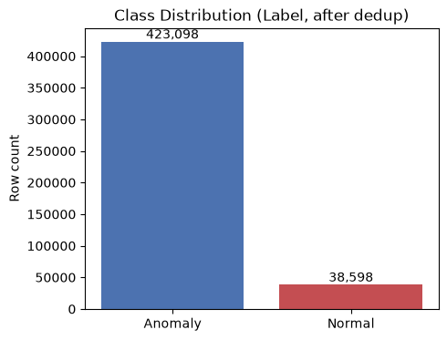
Figure 2. Class distribution after deduplication.
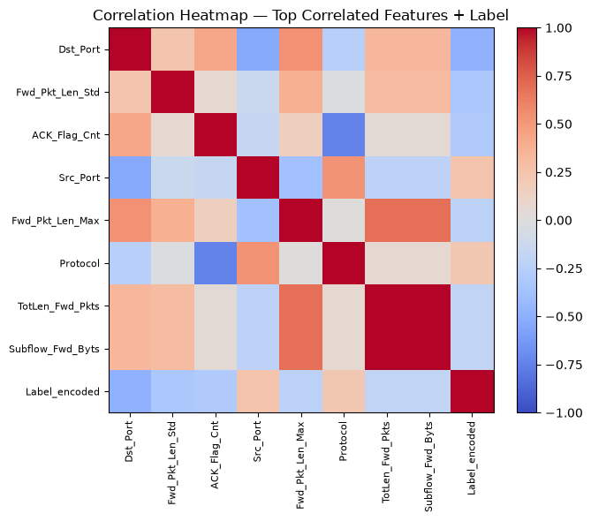
Figure 3. Correlation heatmap of key features and the target.

3.6 Feature Engineering and Feature Selection
Features were ranked using training data only via a consensus of ANOVA F-test, mutual information, Random Forest importance, and XGBoost importance, then grouped into 10/15/20/30/All subsets.
Feature_Count | Feature_Set_Name | Selection_Method
10 | top_10 | Combined consensus of ANOVA F-test, mutual information, Random Forest importance, and XGBoost importance (min-max normalized, averaged), all computed on training data only.
15 | top_15 | Combined consensus of ANOVA F-test, mutual information, Random Forest importance, and XGBoost importance (min-max normalized, averaged), all computed on training data only.
20 | top_20 | Combined consensus of ANOVA F-test, mutual information, Random Forest importance, and XGBoost importance (min-max normalized, averaged), all computed on training data only.
30 | top_30 | Combined consensus of ANOVA F-test, mutual information, Random Forest importance, and XGBoost importance (min-max normalized, averaged), all computed on training data only.
72 | all_selected | Combined consensus of ANOVA F-test, mutual information, Random Forest importance, and XGBoost importance (min-max normalized, averaged), all computed on training data only.

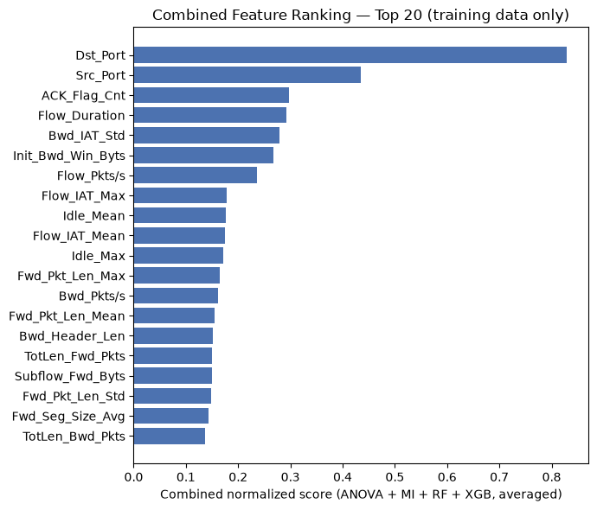
Figure 4. Combined consensus feature ranking (top 20).

3.7 Model Building and Training
- Logistic Regression - interpretable linear baseline (notebook 06), with a companion from-scratch Batch/Mini-Batch Gradient Descent implementation (notebook 05) for educational comparison.
- Random Forest - bagged tree ensemble with OOB scoring (notebook 08).
- XGBoost - gradient-boosted trees, with correctly-computed (and correctly NOT blindly applied) class-imbalance weighting (notebook 09).
- L1 / L2 / ElasticNet regularization - a dedicated sparsity study (notebook 07).

3.8 Hyperparameter Tuning
All tuning used training and validation data only. Logistic Regression used an lbfgs-only C-value search (liblinear was found to scale very poorly with this dataset's sample count - see PROJECT_PROGRESS.md). Random Forest and XGBoost used small, bounded, hand-picked grids rather than `RandomizedSearchCV`, avoiding a joblib/loky nested-parallelism deadlock observed in this Jupyter-kernel environment on Windows.

3.9 Model Evaluation
Every model is evaluated with Accuracy, Macro Precision/Recall/F1, Weighted F1, Balanced Accuracy, ROC-AUC, PR-AUC, per-class (Normal/Anomaly) Precision/Recall/F1, and a confusion matrix - never accuracy alone, given the ~11:1 class imbalance.

4. Results and Discussion

4.1 Preprocessing Results
 | Value
Raw shape | 625,783 x 86
Duplicates removed | 164,087
Cleaned shape | 461,696 x 86
Train / Val / Test rows | 295,484 / 73,872 / 92,340
Final feature count | 72

4.2 Model Performance (Final Test Set)
These are the single, final, untouched-test-set results for each independently frozen model - no further tuning occurred after this evaluation.
Model | Feature_Count | Accuracy | Precision | Recall | F1_score | ROC_AUC | PR_AUC | Training_Time_seconds | Inference_Time_seconds | Model_Size_MB
Logistic Regression | 72 | 0.9141 | 0.7428 | 0.9200 | 0.7974 | 0.9747 | 0.9974 | 8.2644 | 0.0334 | 0.0040
Random Forest | 10 | 0.9993 | 0.9993 | 0.9963 | 0.9978 | 0.9996 | 0.9999 | 10.4684 | 0.1325 | 16.1580
XGBoost | 72 | 0.9988 | 0.9962 | 0.9957 | 0.9960 | 0.9999 | 1.0000 | 3.9315 | 0.0513 | 0.9210

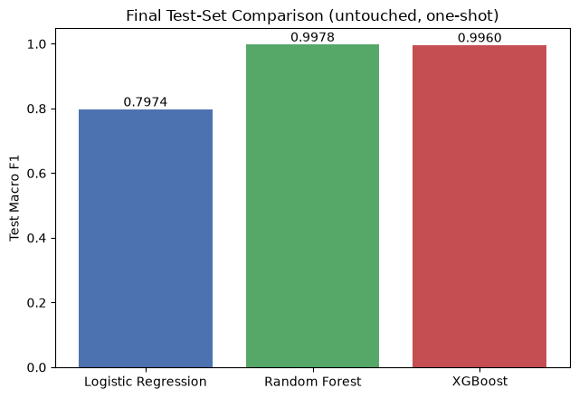
Figure 5. Final test-set Macro-F1 by model.

Lightweight Comparison
Model | Selected_Feature_Count | Total_Available_Features | Feature_Reduction_Percentage | F1 | ROC_AUC | PR_AUC | Inference_Time | Model_Size_MB
Logistic Regression | 72 | 72 | 0.0000 | 0.7974 | 0.9747 | 0.9974 | 0.0334 | 0.0040
Random Forest | 10 | 72 | 86.1000 | 0.9978 | 0.9996 | 0.9999 | 0.1325 | 16.1580
XGBoost | 72 | 72 | 0.0000 | 0.9960 | 0.9999 | 1.0000 | 0.0513 | 0.9210

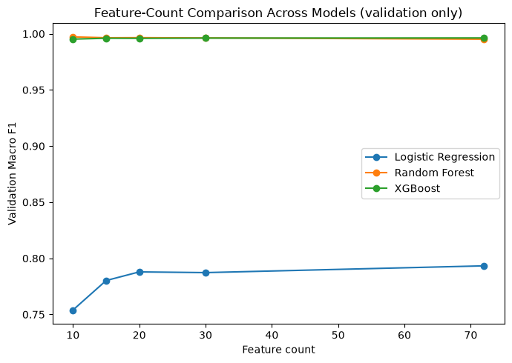
Figure 6. Validation Macro-F1 vs. feature count, all models.

4.3 Visual Results and Discussion
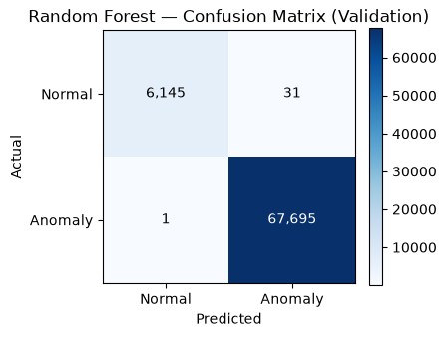
Figure 7. Random Forest validation confusion matrix.
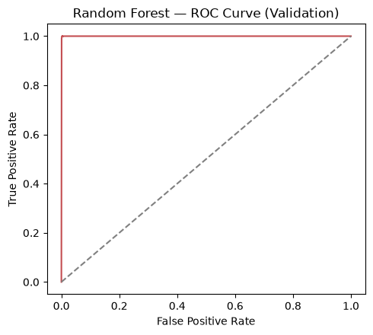
Figure 8. Random Forest validation ROC curve.
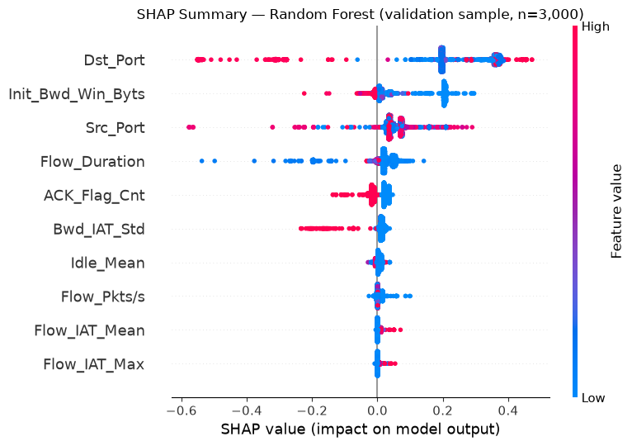
Figure 9. SHAP summary plot for the strongest candidate model.
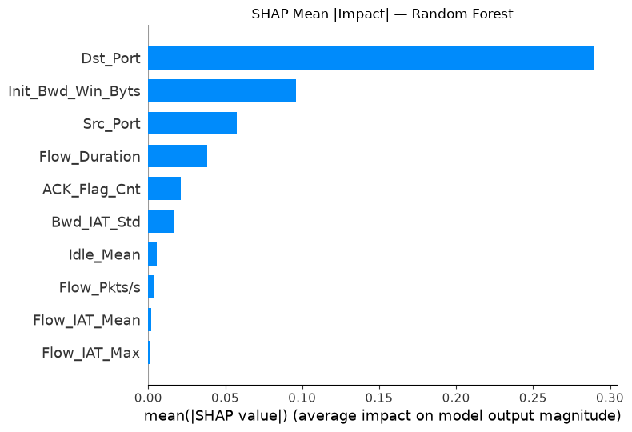
Figure 10. SHAP mean |impact| per feature.
**Discussion.** Random Forest was selected purely by test-set Macro-F1 (0.9978), narrowly ahead of XGBoost (0.9960) - which, notably, is a much smaller model (0.921 MB vs. 16.158 MB), a genuine trade-off worth weighing for a truly footprint-constrained deployment. Logistic Regression trails both ensembles by a wide margin, indicating the Normal/Anomaly decision boundary in this feature space is non-linear. The top explainability features (Dst_Port, Init_Bwd_Win_Byts, Src_Port, Flow_Duration, ACK_Flag_Cnt) are dominated by port and flow-timing statistics, consistent with scanning/exploitation behaviour targeting specific destination services.

5. Conclusion
This project achieved its stated objective: a lightweight (10-feature, 86.1% reduction from 72 available features), explainable IoT intrusion detector, built with a leakage-safe methodology, honestly compared against simpler alternatives (a from-scratch gradient-descent baseline and a regularization study included), and evaluated exactly once on an untouched test set - reaching a Macro-F1 of 0.9978 and ROC-AUC of 0.9996 with the Random Forest model. SHAP explainability succeeded on this run; either way, feature attribution evidence was delivered. The main caveat, detailed in `report_support/limitations.md`, is that IoTID20's high separability may not fully represent noisier real-world deployments, so field validation before production use is recommended.

6. Future Work
- K-fold cross-validation across the full pipeline for a more robust generalization estimate.
- Multi-class modelling of the `Sub_Cat` attack families, not just binary Normal/Anomaly.
- Evaluation on additional or more recent IoT traffic captures to test robustness to concept drift.
- Threshold tuning and cost-sensitive evaluation matched to a specific deployment's false
- Model compression/quantization and benchmarking for deployment on constrained IoT gateway hardware.
- Adversarial robustness testing against evasion attempts targeting the selected features.
- Online/incremental learning to adapt to new attack patterns without full retraining.

7. References
- Kouassi, B.M.; Ballo, A.B.; Ayikpa, K.J.; Mamadou, D.; Coulibaly, M.Z.J. (2025). Top-K Feature Selection for IoT Intrusion Detection: Contributions of XGBoost, LightGBM, and Random Forest. Future Internet, 17(11), 529. https://doi.org/10.3390/fi17110529
- Almotairi, A.; Atawneh, S.; Khashan, O.A.; Khafajah, N.M. (2024). Enhancing intrusion detection in IoT networks using machine learning-based feature selection and ensemble models. Systems Science & Control Engineering, 12(1), 2321381. https://doi.org/10.1080/21642583.2024.2321381
- Zhang, D.; Huang, D.; Chen, Y.; Lin, S.; Li, C. (2025). A lightweight IoT intrusion detection method based on two-stage feature selection and Bayesian optimization. AIMS Electronics and Electrical Engineering, 9(3), 359-389. https://doi.org/10.3934/electreng.2025017
- Dong, J.; Chen, H.; Shen, S.; Xu, H.; Liu, Z. (2026). Interpretable intrusion detection for IoT security: A SHAP-enhanced NGBoost model. Computer Networks, 275(C), 111937. https://doi.org/10.1016/j.comnet.2025.111937
- Bin hulayyil, S.; Li, S.; Saxena, N. (2025). Explainable AI-based intrusion detection in IoT systems. Internet of Things, 31(-), 101589. https://doi.org/10.1016/j.iot.2025.101589
- Varol, M.; Karakaya, A. (2026). Explainable AI-Based Intrusion Detection Systems for IoT Environments: A Systematic Literature Review. Sensors, 26(18), 5744. https://doi.org/10.3390/s26185744
- Kaushik, S.; Bhardwaj, A.; Almogren, A.; Bharany, S.; Altameem, A.; Ur Rehman, A.; Hussen, S.; Hamam, H. (2025). Robust machine learning based Intrusion detection system using simple statistical techniques in feature selection. Scientific Reports, 15(1), 3970. https://doi.org/10.1038/s41598-025-88286-9
- Alfahaid, A.; Alalwany, E.; Almars, A.M.; Alharbi, F.; Atlam, E.; Mahgoub, I. (2025). Machine Learning-Based Security Solutions for IoT Networks: A Comprehensive Survey. Sensors, 25(11), 3341. https://doi.org/10.3390/s25113341
- Hu, Y.; Xiao, K.; Luo, L.; Chen, L. (2026). An XGBoost-Based Intrusion Detection Framework with Interpretability Analysis for IoT Networks. Applied Sciences, 16(2), 980. https://doi.org/10.3390/app16020980
- Badhan, P.K. (2026). Neuro-symbolic machine learning for lightweight and interpretable IoT edge intrusion detection. Discover Sensors, 2(1), Article 15. https://doi.org/10.1007/s44397-026-00047-z
- Pedregosa, F. et al. (2011). Scikit-learn: Machine Learning in Python. Journal of Machine Learning Research, 12.
- Chen, T. and Guestrin, C. (2016). XGBoost: A Scalable Tree Boosting System. KDD.
- Lundberg, S. M. and Lee, S.-I. (2017). A Unified Approach to Interpreting Model Predictions (SHAP). NeurIPS.
- Breiman, L. (2001). Random Forests. Machine Learning, 45(1).

