DATABASE SYSTEM ENGINEERING AND DISTRIBUTED BACKEND DEVELOPMENT
WEEK-3 PRACTICAL
Flexible Data and the Aggregation Pipeline using MongoDB Atlas
Item | Details
Platform | MongoDB Atlas, Data Explorer (web browser)
Cluster / Project | DatabaseProject / Project 0
Database | bookflow
Collection | book_metadata
Scenario | BookFlow library: store reviews and format-specific specs for books

1. Aim
To create a flexible MongoDB collection that stores book metadata, embedded reviews, referenced member information and different technical specifications for each book, and then to analyse it using comparison queries, regular expressions, the aggregation pipeline, a text index and explain().

2. Procedure Followed in MongoDB Atlas
- Signed in to MongoDB Atlas and opened the project cluster (DatabaseProject).
- Database > Clusters > Browse Collections, then opened the bookflow database.
- Created the collection book_metadata.
- Added Data > Insert Document, and inserted the five book documents one by one.
- Ran the filters in the Documents tab, the pipeline in the Aggregations tab, created the text index in the Indexes tab, and used Explain for the query plan.

3. Create the Collection
Input
Database : bookflow
Collection : book_metadata

Output
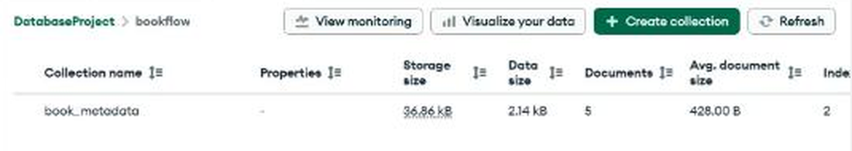
Figure 1: bookflow database now contains book_metadata (5 documents).

4. Document Modelling
Embedded pattern. Reviews are stored as an array inside each book document, so a book and all its reviews are read together in one query.
Referenced pattern. member_id links the book and each review to a member record kept in the SQL system, so member details are not duplicated.
Flexible (polymorphic) schema. Digital books carry format and file_size; the physical book (Clean Code) carries dimensions instead. MongoDB does not require every document to have the same fields.

5. Insert Documents
Add Data > Insert Document was used for each of the following five documents.
Input

Document 1: The Martian
{
"book_id": 101,
"title": "The Martian",
"author": "Andy Weir",
"published_year": 2021,
"category": "Science Fiction",
"format": "Digital PDF",
"file_size": "2.5 MB",
"member_id": 101,
"reviews": [
{
"member_id": 101,
"rating": 5,
"comments": "Excellent science fiction story"
},
{
"member_id": 102,
"rating": 4,
"comments": "Very interesting and informative"
},
{
"member_id": 103,
"rating": 5,
"comments": "Excellent space adventure"
}
]
}

Document 2: Dune
{
"book_id": 102,
"title": "Dune",
"author": "Frank Herbert",
"published_year": 2022,
"category": "Science Fiction",
"format": "Digital EPUB",
"file_size": "3.1 MB",
"member_id": 102,
"reviews": [
{
"member_id": 101,
"rating": 5,
"comments": "Amazing world building"
},
{
"member_id": 104,
"rating": 4,
"comments": "Classic science fiction novel"
},
{
"member_id": 105,
"rating": 5,
"comments": "Excellent characters and story"
}
]
}

Document 3: Clean Code
{
"book_id": 103,
"title": "Clean Code",
"author": "Robert C. Martin",
"published_year": 2019,
"category": "Programming",
"format": "Physical",
"dimensions": {
"height": "23 cm",
"width": "18 cm",
"weight": "700 g"
},
"member_id": 103,
"reviews": [
{
"member_id": 101,
"rating": 5,
"comments": "Excellent programming reference"
},
{
"member_id": 106,
"rating": 4,
"comments": "Very useful coding practices"
}
]
}

Document 4: Artificial Intelligence Basics
{
"book_id": 104,
"title": "Artificial Intelligence Basics",
"author": "John Smith",
"published_year": 2023,
"category": "Artificial Intelligence",
"format": "Digital PDF",
"file_size": "4.2 MB",
"member_id": 104,
"reviews": [
{
"member_id": 102,
"rating": 4,
"comments": "Good introduction to artificial intelligence"
},
{
"member_id": 105,
"rating": 5,
"comments": "Excellent machine learning explanation"
},
{
"member_id": 106,
"rating": 4,
"comments": "Useful for beginners"
}
]
}

Document 5: Data Structures
{
"book_id": 105,
"title": "Data Structures",
"author": "Mark Allen",
"published_year": 2024,
"category": "Computer Science",
"format": "Digital PDF",
"file_size": "5.0 MB",
"member_id": 105,
"reviews": [
{
"member_id": 101,
"rating": 5,
"comments": "Excellent data structures book"
},
{
"member_id": 107,
"rating": 3,
"comments": "Good but needs more examples"
}
]
}

Output: verification (5 documents)
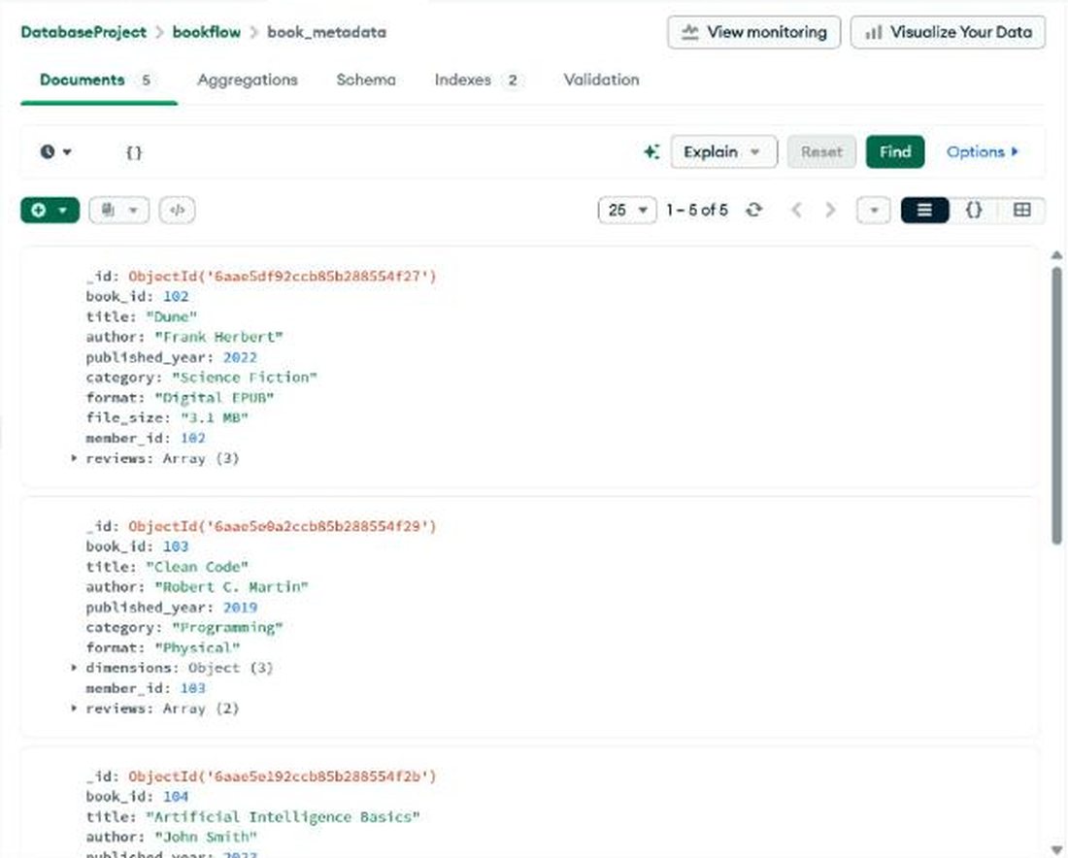
Figure 2: book_metadata documents (1 - 5 of 5), first part.
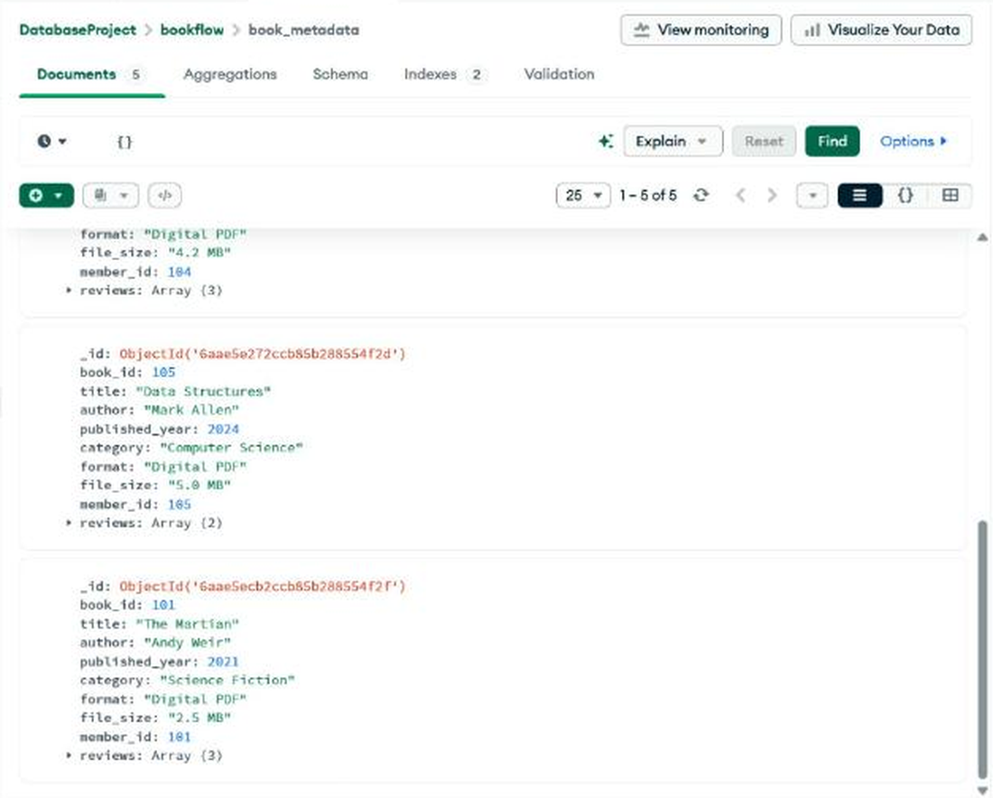
Figure 3: book_metadata documents, last part (reviews are shown collapsed as Array).

6. Queries

Query 1: Comparison operator $gt (rating greater than 4)
Input (Filter)
{
"reviews.rating": {
"$gt": 4
}
}

Expected
The Martian, Dune, Clean Code, Artificial Intelligence Basics, Data Structures. Each has at least one review with rating 5.
Output
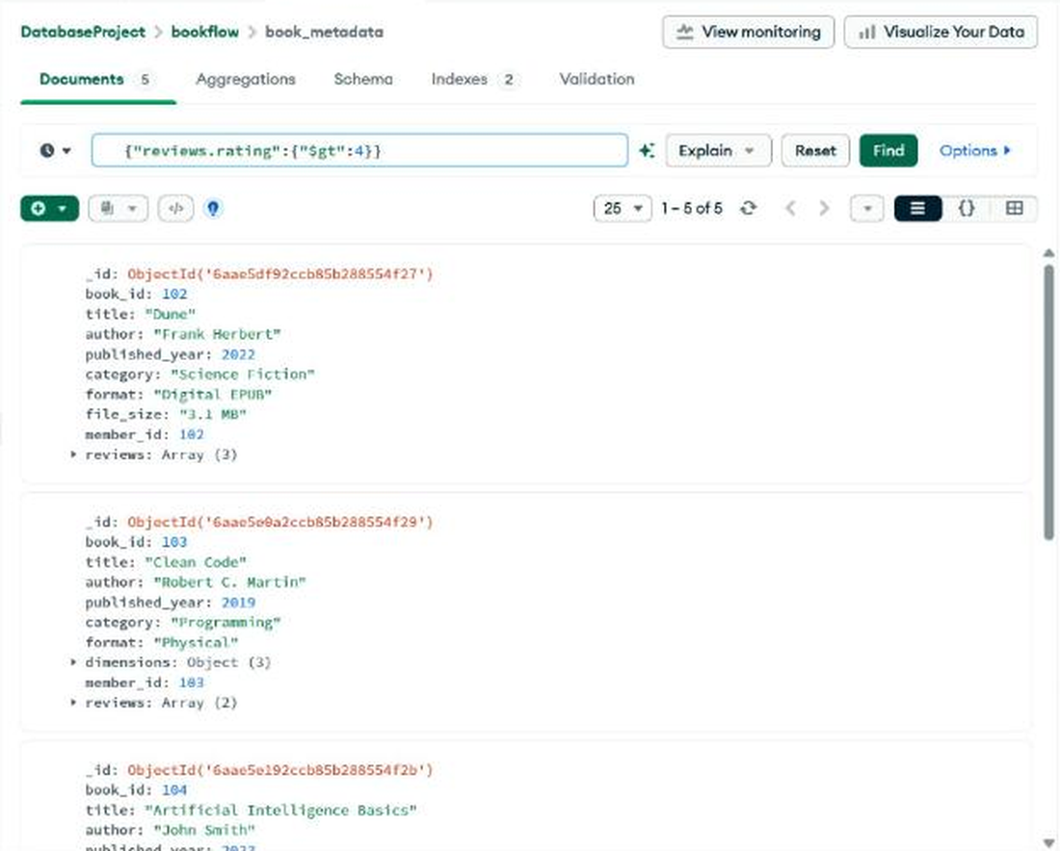
Figure 4: $gt query returned 5 of 5 documents (top).
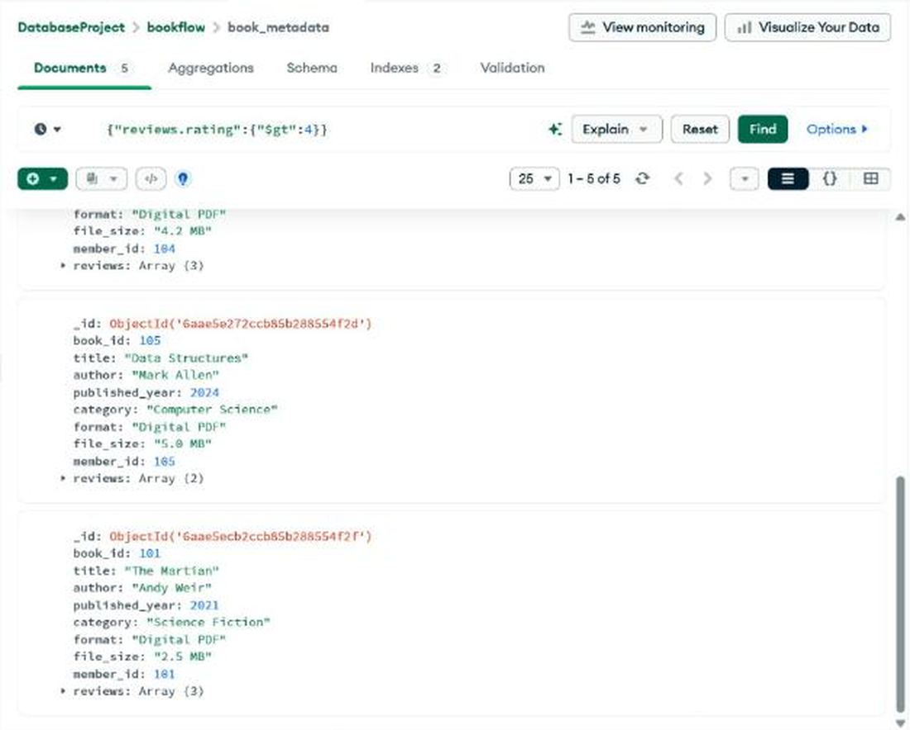
Figure 5: $gt query result (bottom).

Query 2: $in (ratings 4 or 5)
Input (Filter)
{
"reviews.rating": {
"$in": [
4,
5
]
}
}

Expected
All five books, since every book has a review rated 4 or 5.
Output
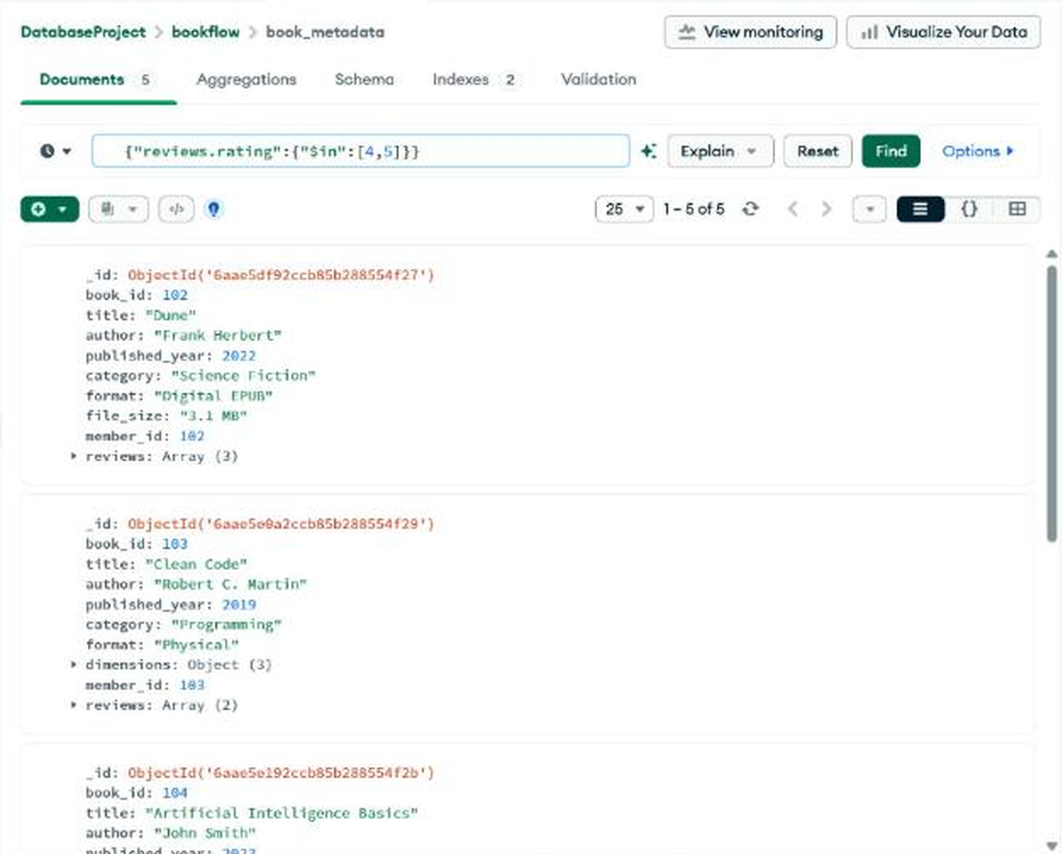
Figure 6: $in query returned 5 of 5 documents (top).
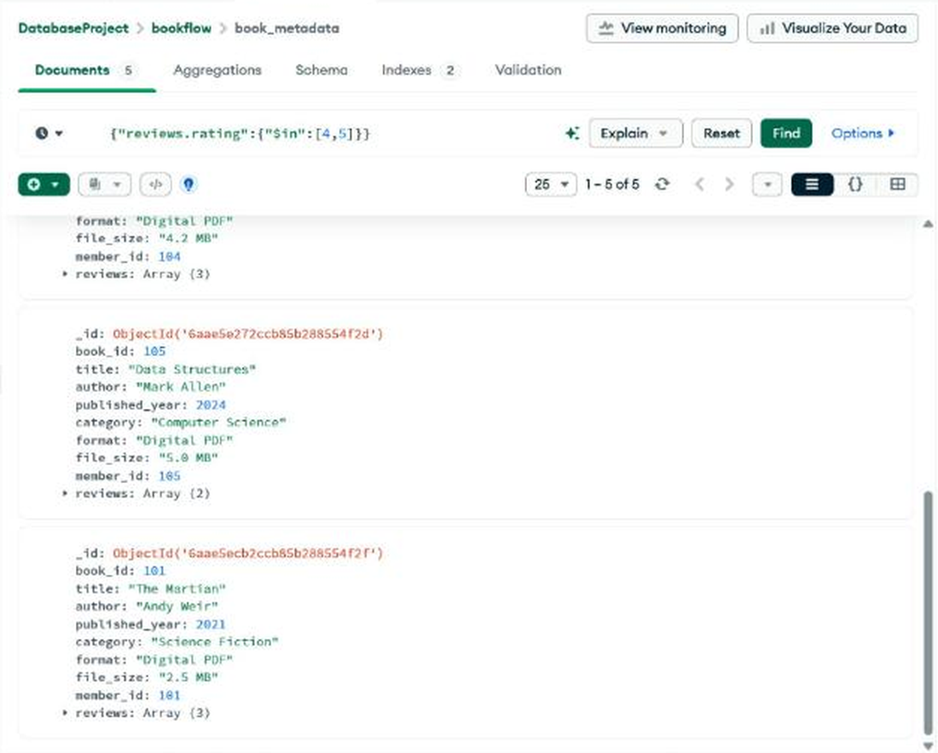
Figure 7: $in query result (bottom).

Query 3: Regex (format contains "Digital")
Input (Filter)
{
"format": {
"$regex": "Digital",
"$options": "i"
}
}

Expected
The Martian, Dune, Artificial Intelligence Basics, Data Structures. Clean Code is not returned because its format is "Physical".
Output
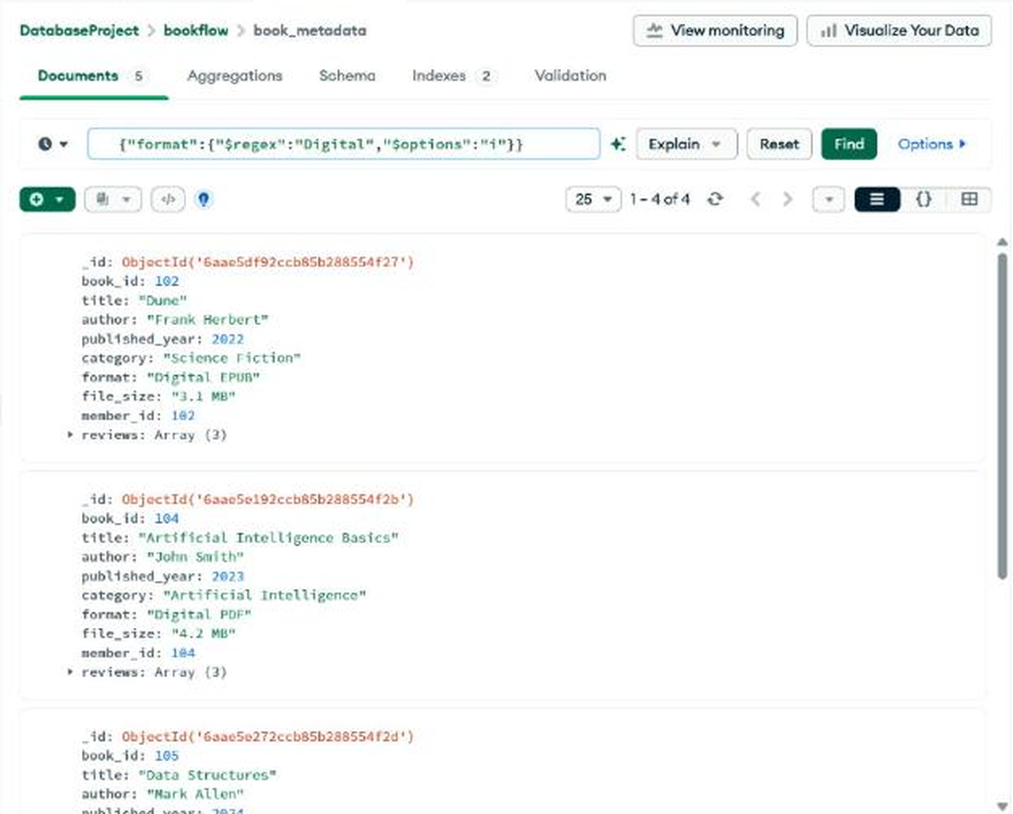
Figure 8: Regex query returned 4 of 4 documents (top).
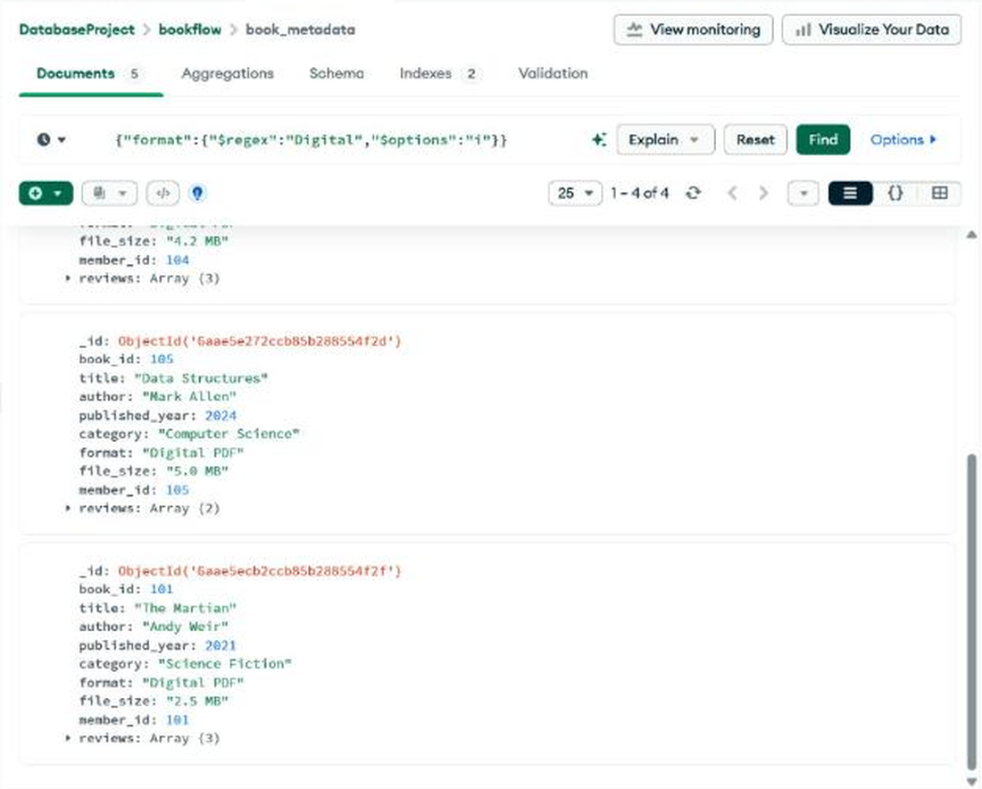
Figure 9: Regex query result (bottom).

Query 4: Books published after 2020
Input (Filter)
{
"published_year": {
"$gt": 2020
}
}

Expected
The Martian (2021), Dune (2022), Artificial Intelligence Basics (2023), Data Structures (2024).
Output
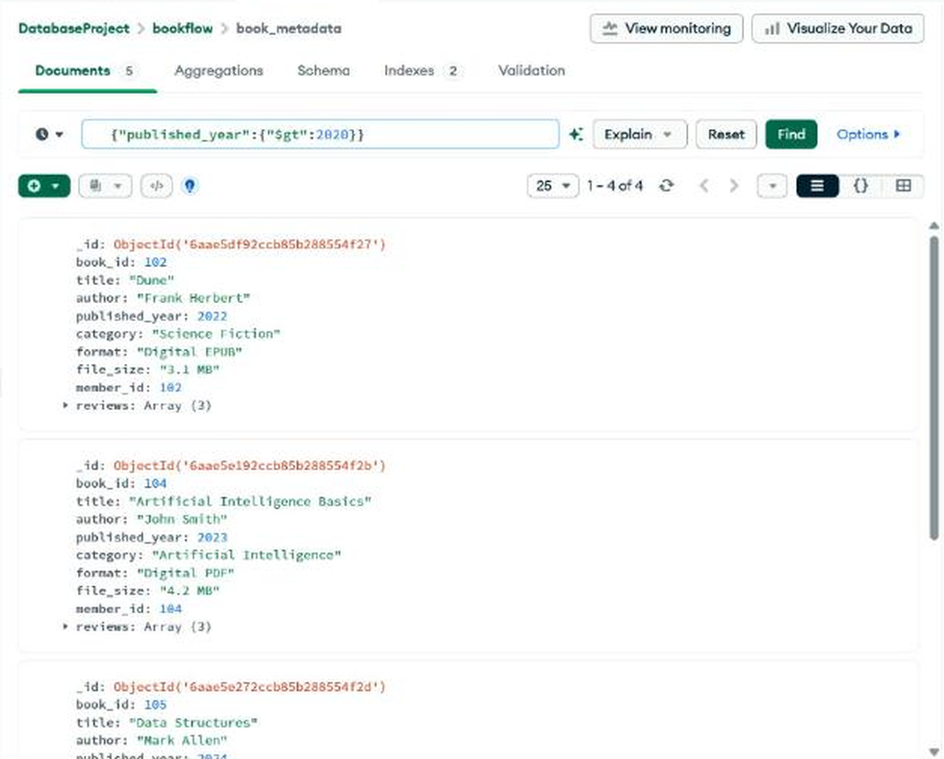
Figure 10: published_year > 2020 returned 4 of 4 documents (top).
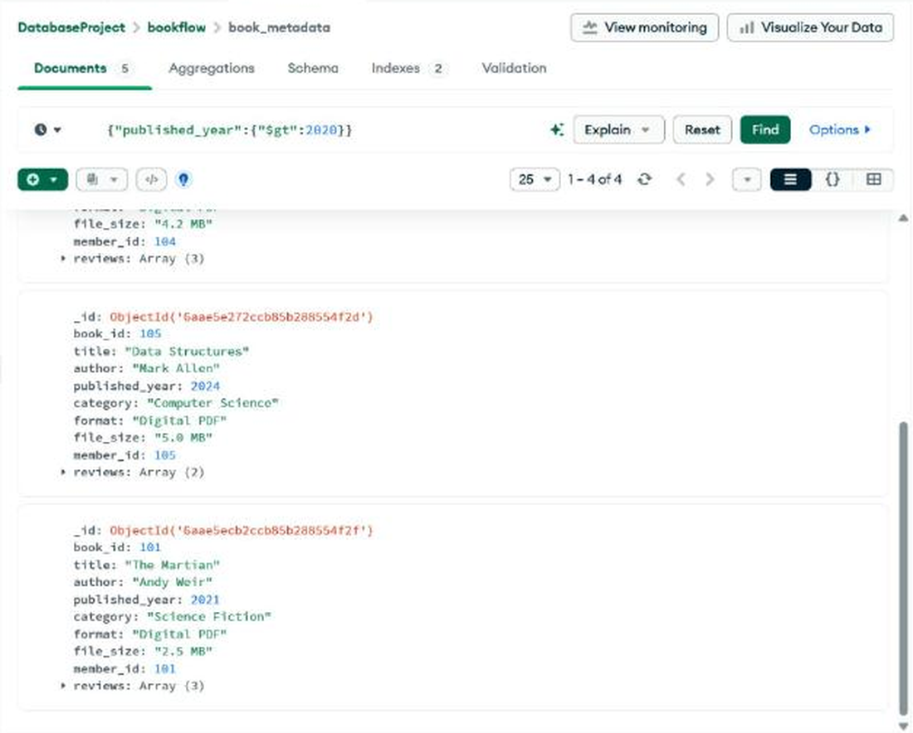
Figure 11: published_year > 2020 result (bottom).

7. Aggregation Pipeline: Top Rated Books
Stages used: $match (published after 2020), $unwind (one document per review), $group (average rating per title) and $sort (highest first).
Input (Aggregations tab)
[
{
"$match": {
"published_year": {
"$gt": 2020
}
}
},
{
"$unwind": "$reviews"
},
{
"$group": {
"_id": "$title",
"average_rating": {
"$avg": "$reviews.rating"
},
"total_reviews": {
"$sum": 1
}
}
},
{
"$sort": {
"average_rating": -1
}
}
]

Expected and observed
Book title | Average rating | Total reviews
Dune | 4.67 | 3
The Martian | 4.67 | 3
Artificial Intelligence Basics | 4.33 | 3
Data Structures | 4.00 | 2

Output
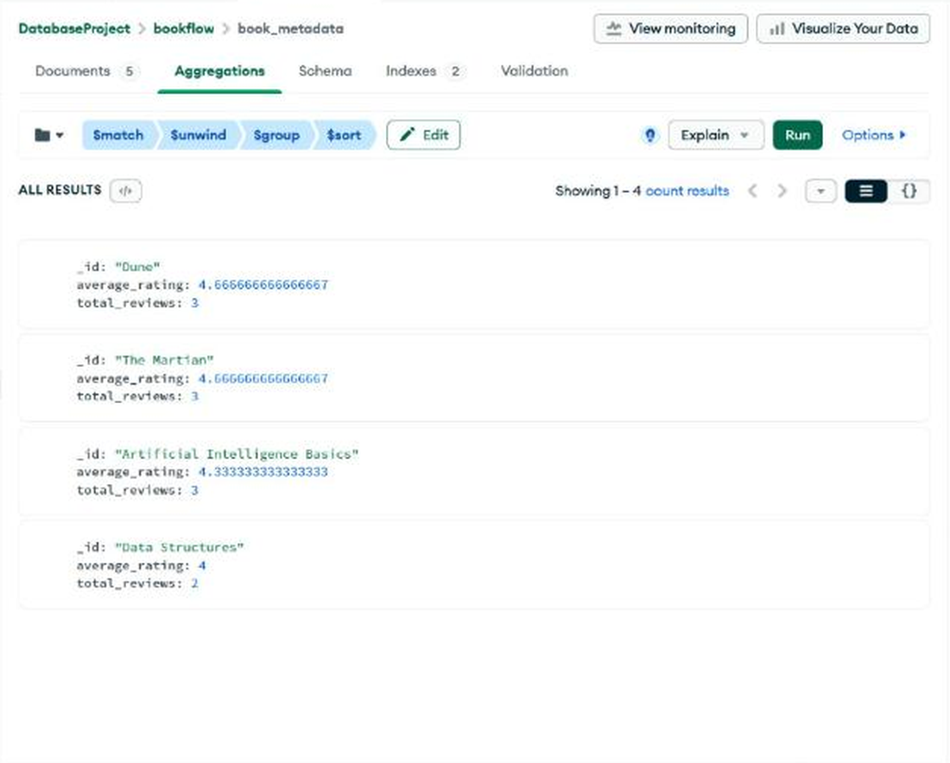
Figure 12: Top Rated aggregation result (4 documents).

8. Text Index on reviews.comments
Input
db.book_metadata.createIndex({
"reviews.comments": "text"
})

Output
The Indexes tab lists the text index reviews.comments_text (type TEXT, status READY) alongside the default _id index.
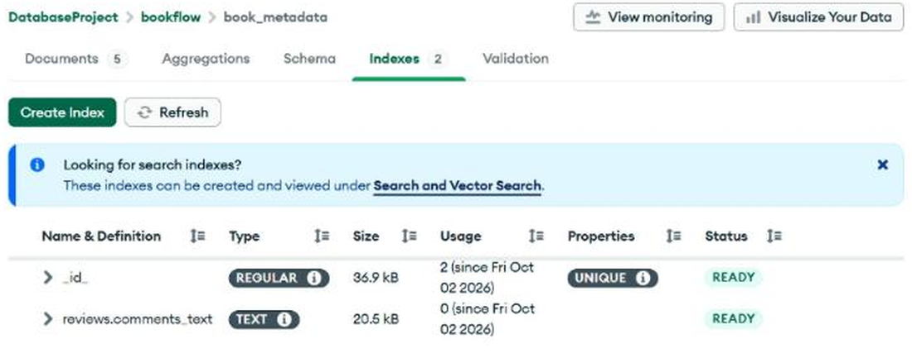
Figure 13: Indexes tab showing reviews.comments_text (TEXT).

9. Text Search

Search 1: keyword "excellent"
Input (Filter)
{
"$text": {
"$search": "excellent"
}
}

Output
All five books are returned, as each has a review comment containing "excellent".
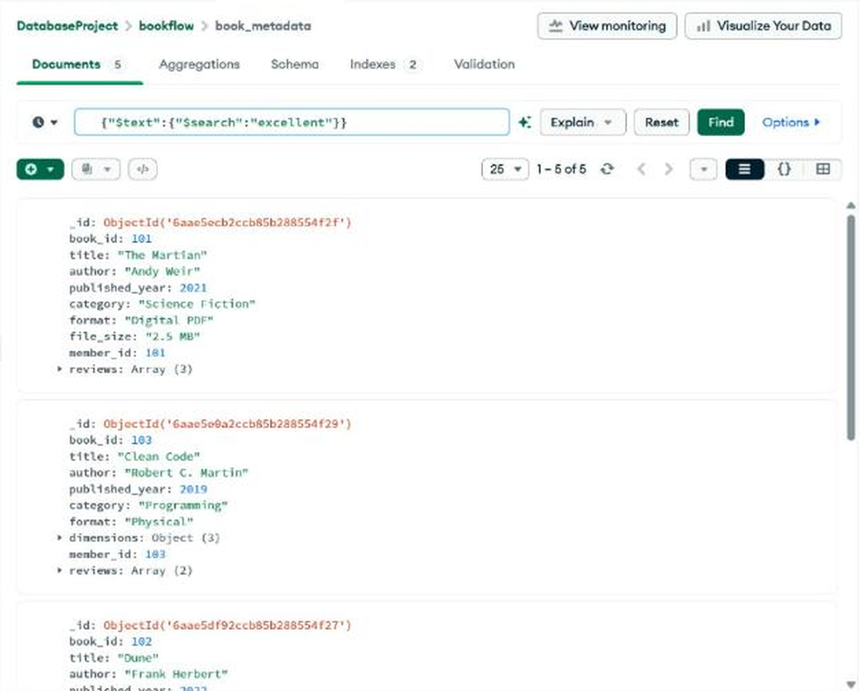
Figure 14: $text search for "excellent": 5 documents (top).
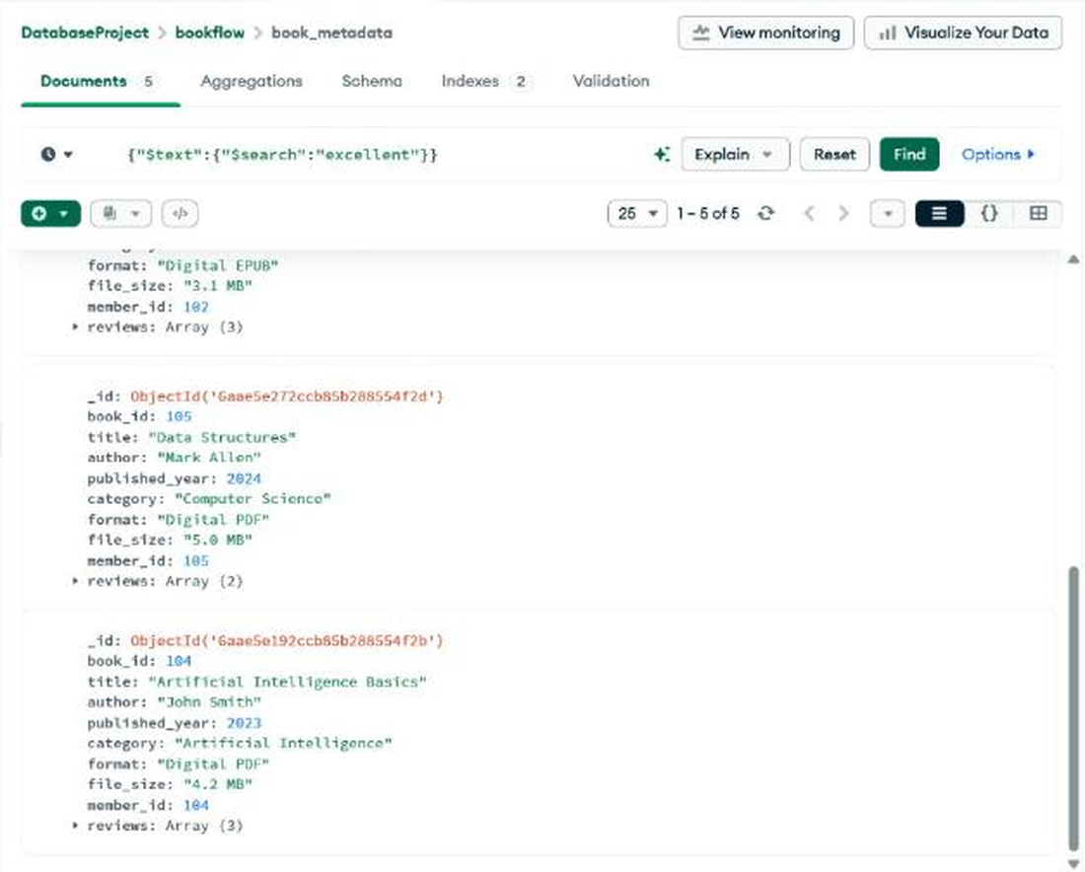
Figure 15: $text search for "excellent" (bottom).

Search 2: phrase "science fiction"
Input (Filter)
{
"$text": {
"$search": "\"science fiction\""
}
}

Output
Two books are returned: The Martian ("Excellent science fiction story") and Dune ("Classic science fiction novel").
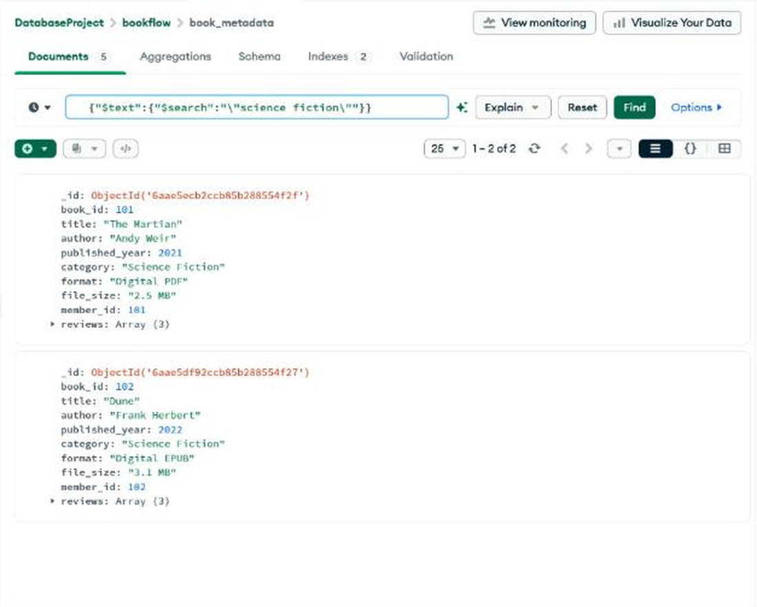
Figure 16: Phrase search for "science fiction": 2 documents.

10. Query Plan using explain()
Input
db.book_metadata.find(
{ $text: { $search: "excellent" } }
).explain("executionStats")

In Atlas this was run with the Explain button next to the filter (Visual tree view).
Output
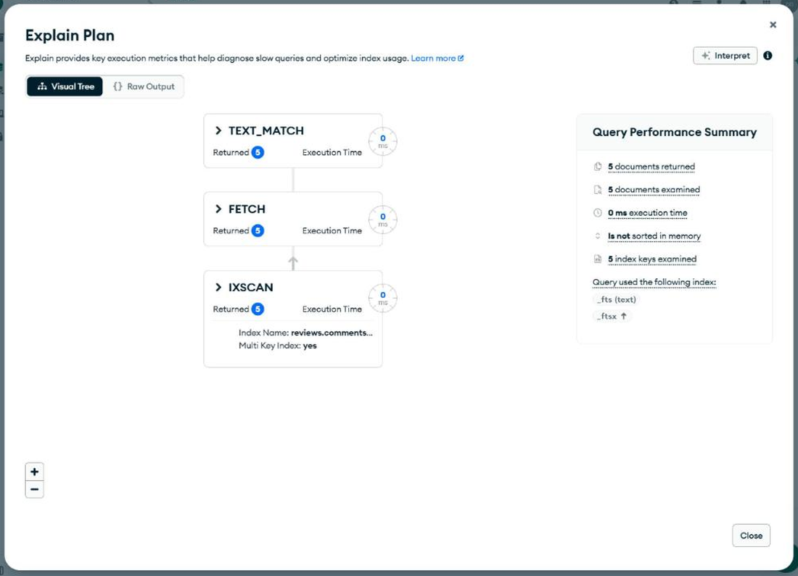
Figure 17: Explain plan: TEXT_MATCH > FETCH > IXSCAN on reviews.comments_text.
Observation. The plan uses IXSCAN on the text index (multikey: yes), so MongoDB did not perform a collection scan (COLLSCAN). 5 index keys were examined, 5 documents were examined and 5 were returned, in 0 ms.

11. Result
The book_metadata collection was created in MongoDB Atlas with flexible book metadata, embedded reviews and referenced member identifiers. Comparison, $in, regex and date-range queries returned the expected documents. The $match, $unwind, $group and $sort pipeline produced the Top Rated Books report (Dune and The Martian 4.67, Artificial Intelligence Basics 4.33, Data Structures 4.00). A text index on reviews.comments was created and used for keyword and phrase searches, and explain() confirmed that the text search uses an index scan (IXSCAN) instead of a collection scan.

