DATABASE SYSTEM ENGINEERING AND DISTRIBUTED BACKEND DEVELOPMENT
SKILL SESSION 4 AND 5
Bank Transaction Management using MongoDB Atlas Data Explorer
Item | Details
Platform | MongoDB Atlas, Data Explorer (web browser)
Cluster / Project | DatabaseProject / Project 0
Database | bankdb
Collections | customers (8 documents), transactions (15 documents)
Link between collections | customer_id (JOIN is done with $lookup)

1. Aim
To create a bank database in MongoDB Atlas, store customer and transaction information in separate collections, run queries similar to SQL JOINs, and execute complex transaction-analysis queries.

2. SQL to MongoDB Mapping
SQL concept | MongoDB equivalent
Table | Collection
SELECT / WHERE | find() with a filter
> / IN / AND | $gt / $in / multiple fields in one filter
GROUP BY / ORDER BY | $group / $sort
JOIN | $lookup (followed by $unwind)
SUM / AVG / COUNT | $sum / $avg / $sum: 1

3. Create the Database and Collections
Input
Create Database -> Database name: bankdb, Collection name: customers
+ Create Collection -> transactions

Output
bankdb contains the two collections, with 8 and 15 documents after the data was inserted.
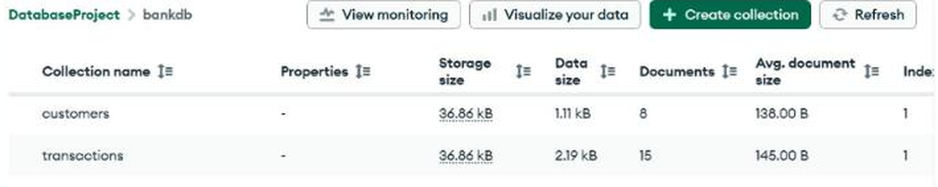
Figure 1: bankdb collections: customers (8) and transactions (15).

4. Insert Data
Each row below was inserted as one document using Add Data > Insert Document. A sample document from each collection is shown first.
Input: sample customer document
{
"customer_id": 101,
"name": "Ravi Kumar",
"city": "Hyderabad",
"account_type": "Savings",
"balance": 85000,
"status": "Active"
}

Input: sample transaction document
{
"transaction_id": 1001,
"customer_id": 101,
"type": "Deposit",
"amount": 25000,
"mode": "UPI",
"date": "2026-08-01",
"status": "Success"
}

customers collection (8 documents)
customer_id | name | city | account_type | balance | status
101 | Ravi Kumar | Hyderabad | Savings | 85000 | Active
102 | Priya Sharma | Vijayawada | Current | 125000 | Active
103 | Arjun Reddy | Hyderabad | Savings | 45000 | Active
104 | Sneha Rao | Warangal | Savings | 210000 | Active
105 | Kiran Kumar | Guntur | Current | 65000 | Inactive
106 | Anjali Singh | Hyderabad | Savings | 175000 | Active
107 | Rahul Verma | Bengaluru | Current | 95000 | Active
108 | Meena Devi | Chennai | Savings | 320000 | Active

transactions collection (15 documents)
Every transaction has status "Success".
transaction_id | customer_id | type | amount | mode | date
1001 | 101 | Deposit | 25000 | UPI | 2026-08-01
1002 | 101 | Withdrawal | 10000 | ATM | 2026-08-02
1003 | 102 | Deposit | 50000 | NEFT | 2026-08-02
1004 | 102 | Withdrawal | 15000 | ATM | 2026-08-03
1005 | 103 | Deposit | 30000 | UPI | 2026-08-03
1006 | 103 | Withdrawal | 5000 | ATM | 2026-08-04
1007 | 104 | Deposit | 100000 | NEFT | 2026-08-04
1008 | 104 | Withdrawal | 25000 | ATM | 2026-08-05
1009 | 105 | Deposit | 15000 | UPI | 2026-08-05
1010 | 106 | Deposit | 75000 | NEFT | 2026-08-06
1011 | 106 | Withdrawal | 20000 | ATM | 2026-08-06
1012 | 107 | Deposit | 40000 | IMPS | 2026-08-07
1013 | 107 | Withdrawal | 12000 | ATM | 2026-08-07
1014 | 108 | Deposit | 150000 | NEFT | 2026-08-08
1015 | 108 | Withdrawal | 30000 | ATM | 2026-08-08

5. Queries and Outputs
Queries 1 to 5, 10 and 11 are run on customers (Documents tab, Filter box, Find). Queries 6 to 9 are run on transactions. Queries 12 to 20 are aggregation pipelines (Aggregations tab, Run). For each query the input is shown first, then the expected result from the lab manual, then the screenshot of the output from Atlas.

Query 1: Display all customers
Collection: customers (Documents tab)
Input (Filter)
{}

Expected
8 customer documents.
Observed
8 documents returned (1 - 8 of 8).
Output
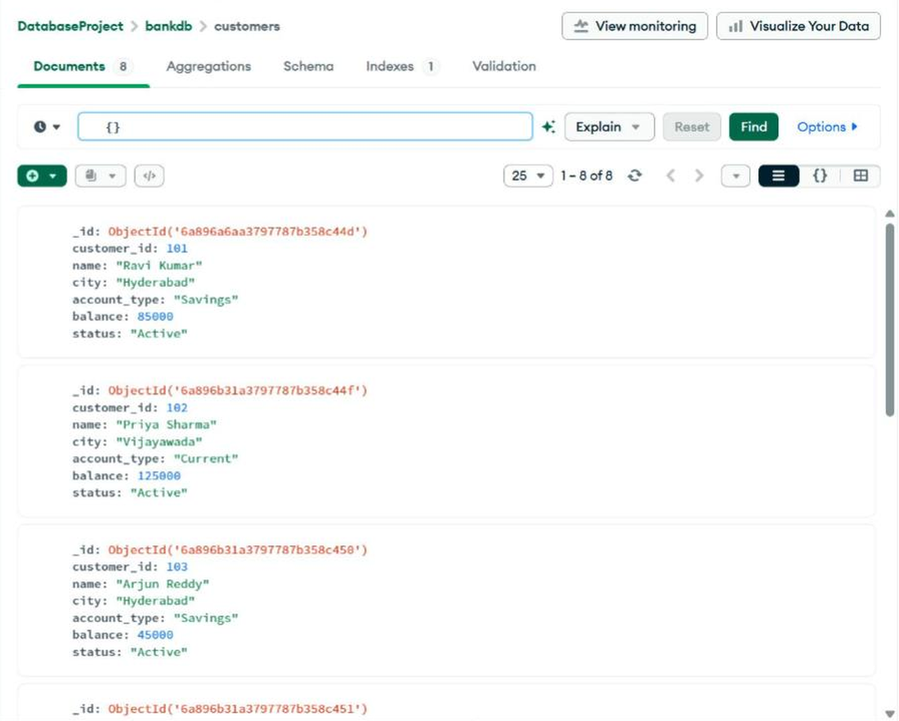
Figure Q1-1: Output of Query 1 (top of the results).
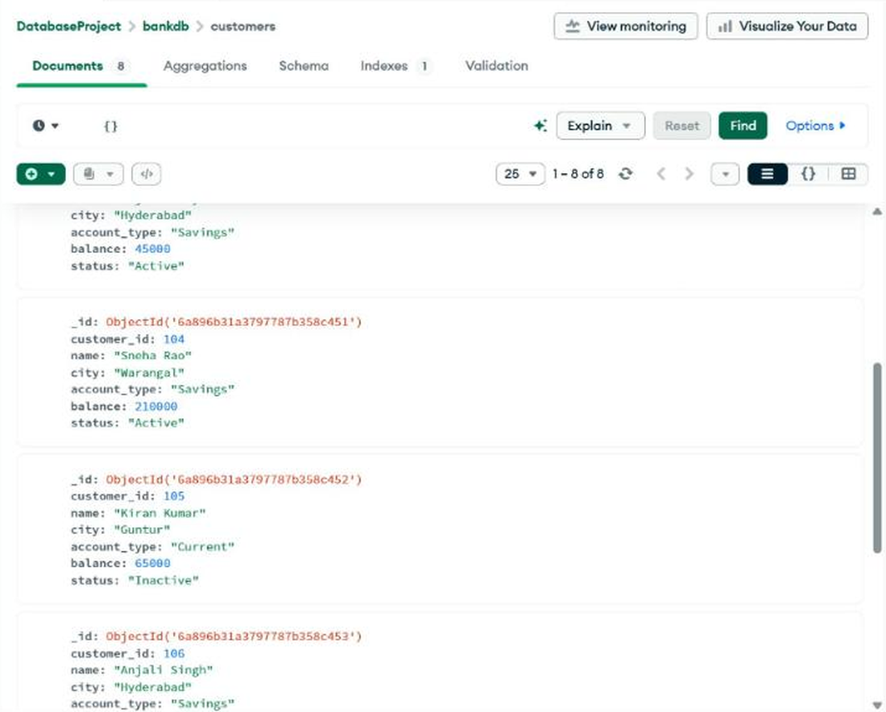
Figure Q1-2: Output of Query 1 (middle of the results).
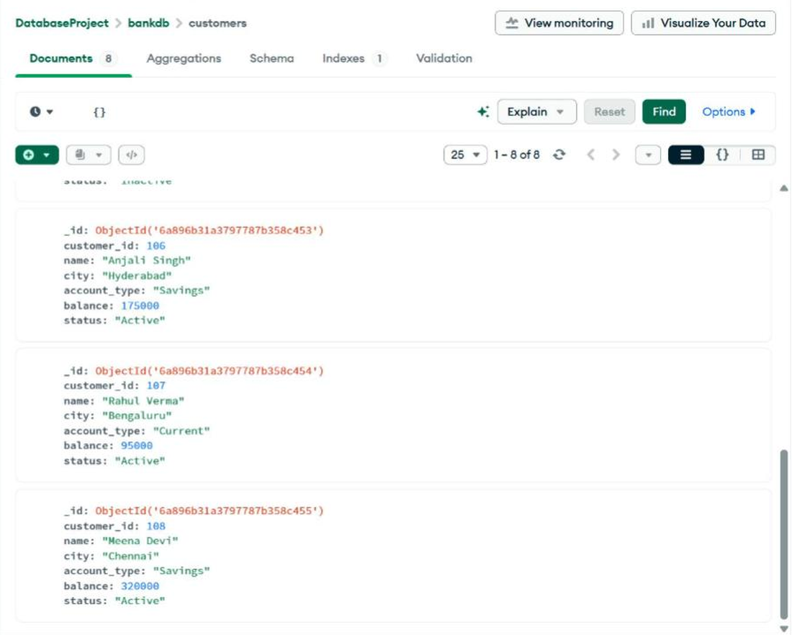
Figure Q1-3: Output of Query 1 (bottom of the results).

Query 2: Find active customers
Collection: customers (Documents tab)
Input (Filter)
{
"status": "Active"
}

Expected
Ravi Kumar, Priya Sharma, Arjun Reddy, Sneha Rao, Anjali Singh, Rahul Verma, Meena Devi.
Observed
7 documents returned, exactly the customers above. Kiran Kumar is excluded because the status is Inactive.
Output
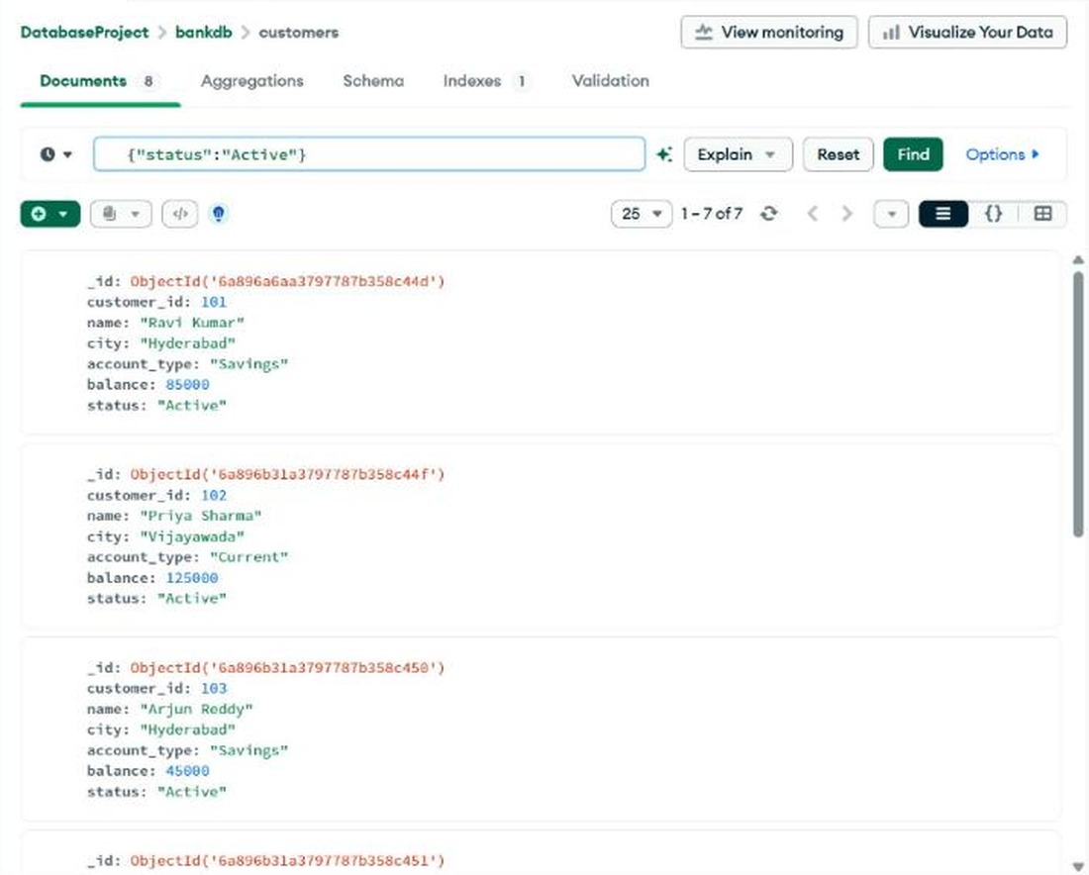
Figure Q2-1: Output of Query 2 (top of the results).
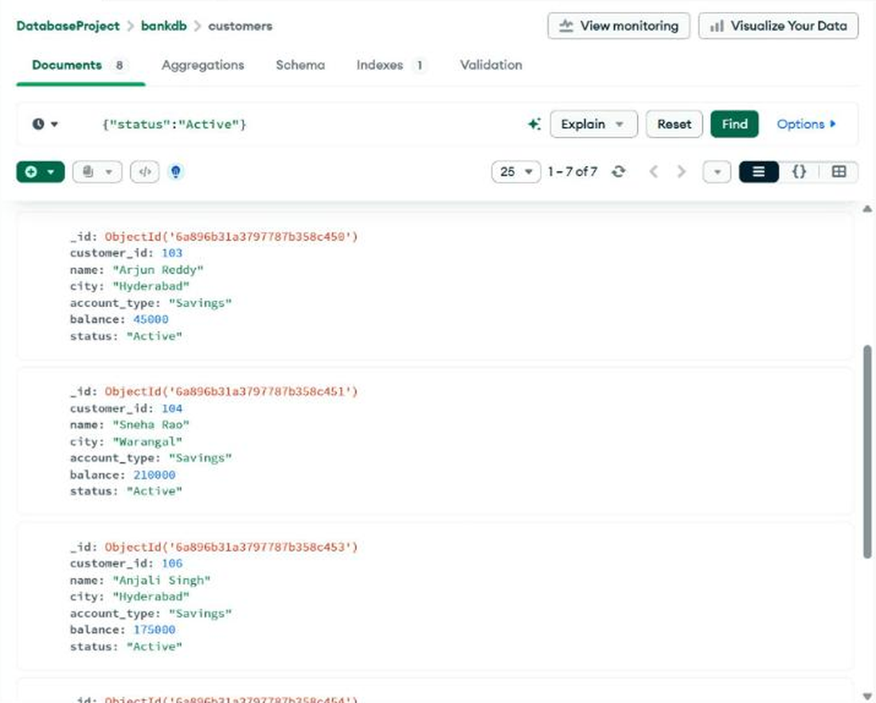
Figure Q2-2: Output of Query 2 (middle of the results).
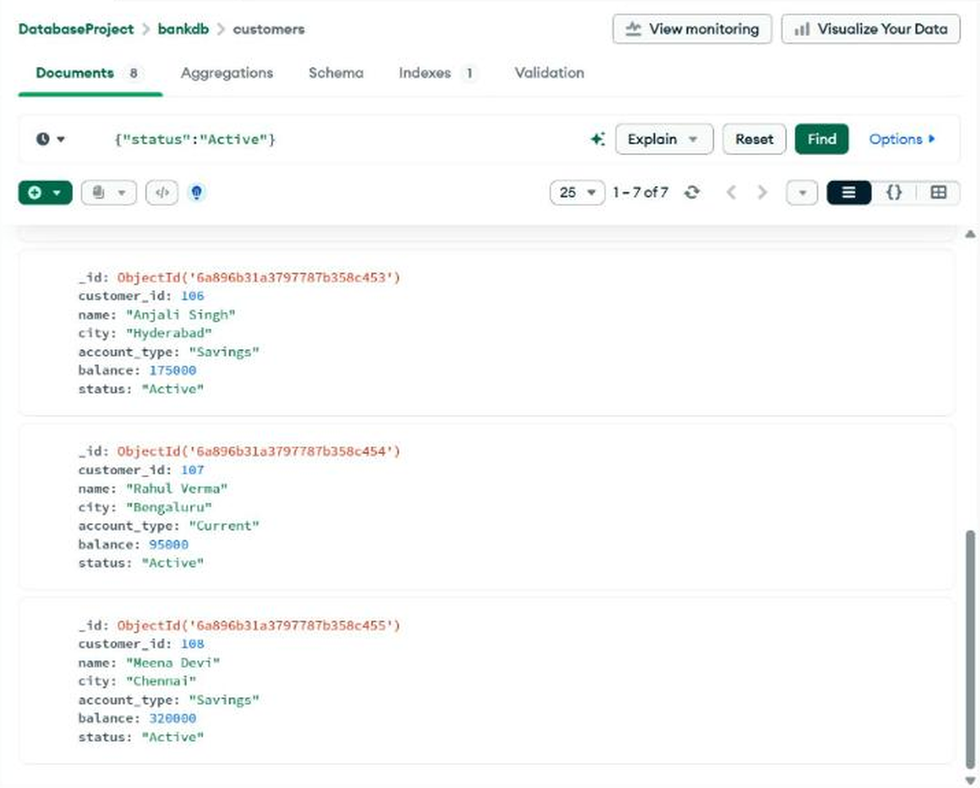
Figure Q2-3: Output of Query 2 (bottom of the results).

Query 3: Customers with balance greater than 100000
Collection: customers (Documents tab)
Input (Filter)
{
"balance": {
"$gt": 100000
}
}

Expected
Priya Sharma, Sneha Rao, Anjali Singh, Meena Devi.
Observed
4 documents returned, matching the expected list.
Output
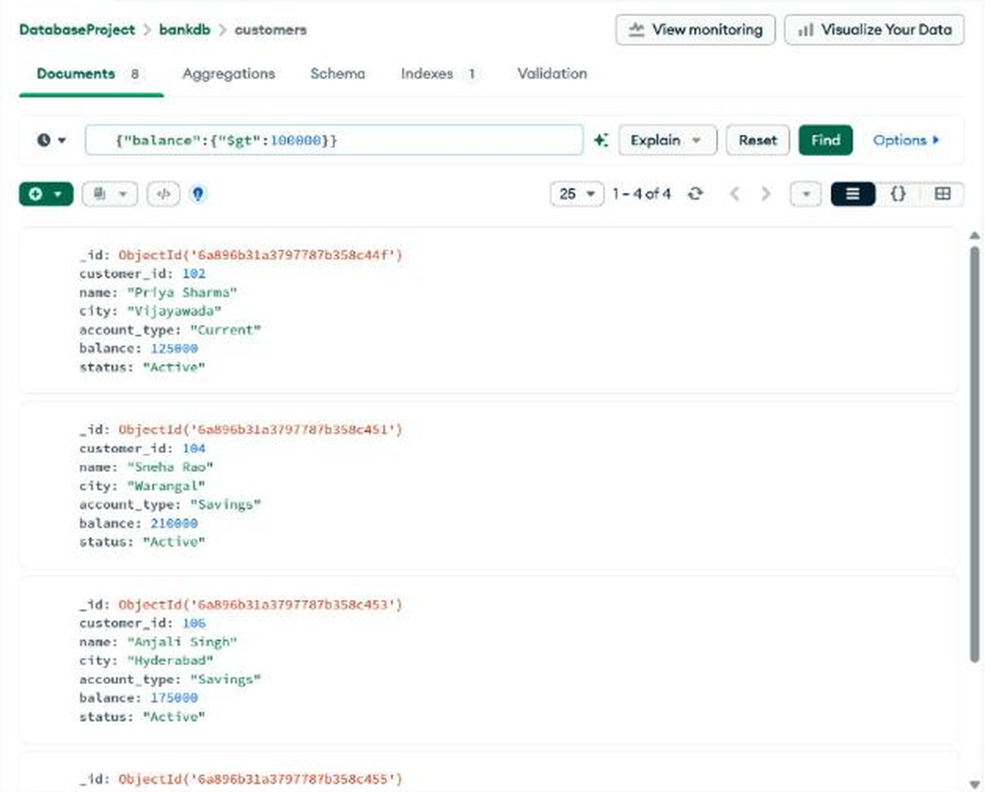
Figure Q3-1: Output of Query 3 (top of the results).
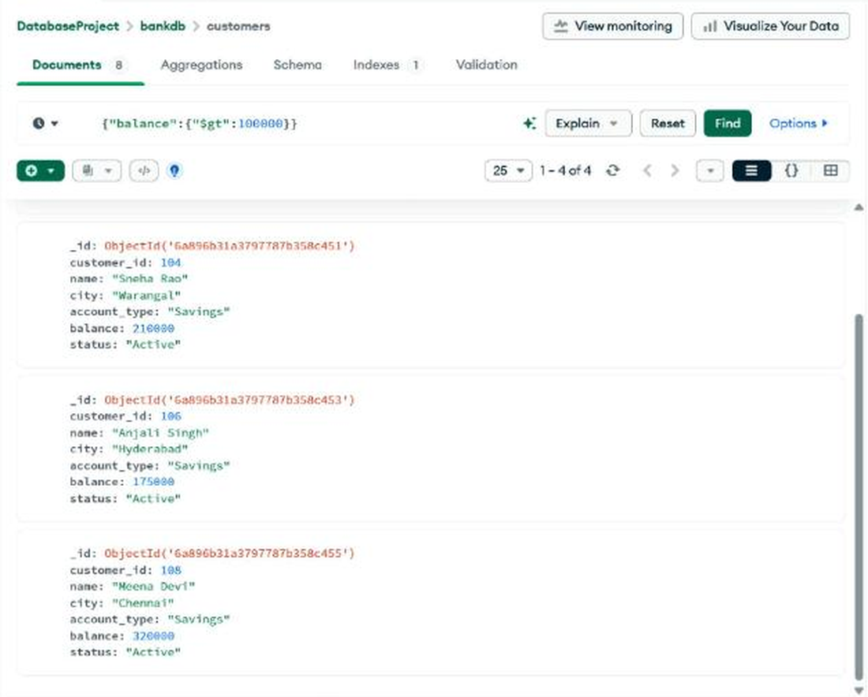
Figure Q3-2: Output of Query 3 (bottom of the results).

Query 4: Hyderabad customers
Collection: customers (Documents tab)
Input (Filter)
{
"city": "Hyderabad"
}

Expected
Ravi Kumar, Arjun Reddy, Anjali Singh.
Observed
3 documents returned, matching the expected list.
Output
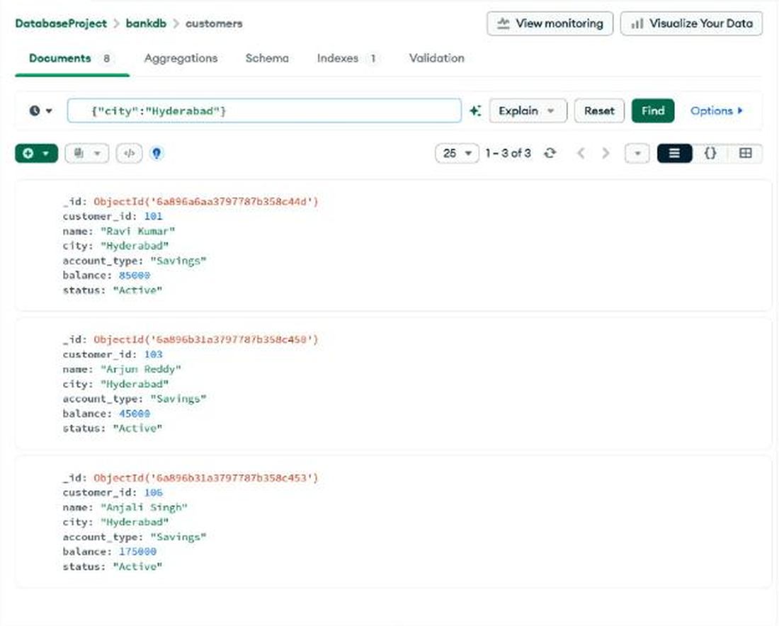
Figure Q4: Output of Query 4.

Query 5: Savings account customers
Collection: customers (Documents tab)
Input (Filter)
{
"account_type": "Savings"
}

Expected
Ravi Kumar, Arjun Reddy, Sneha Rao, Anjali Singh, Meena Devi.
Observed
5 documents returned, matching the expected list.
Output
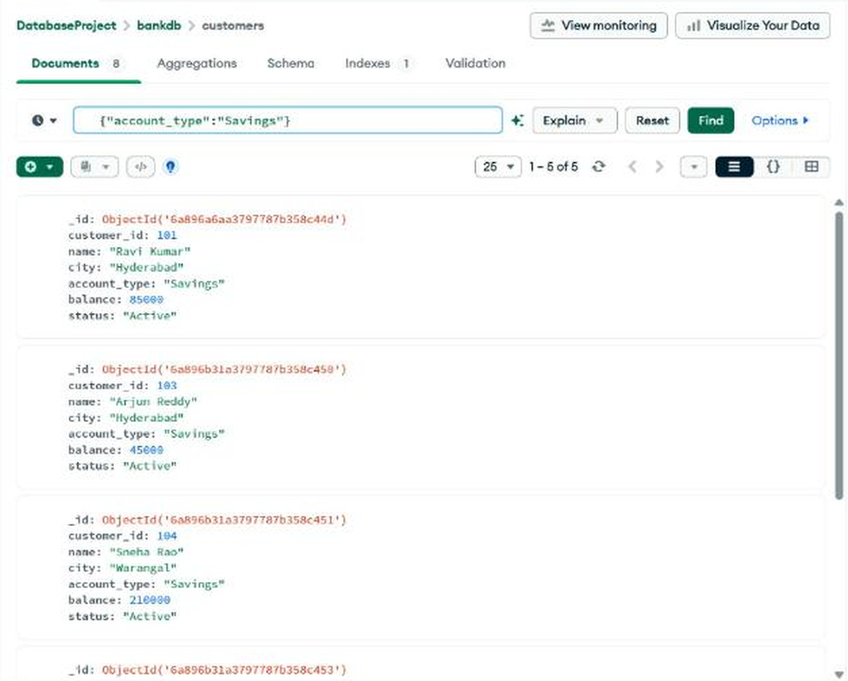
Figure Q5-1: Output of Query 5 (top of the results).
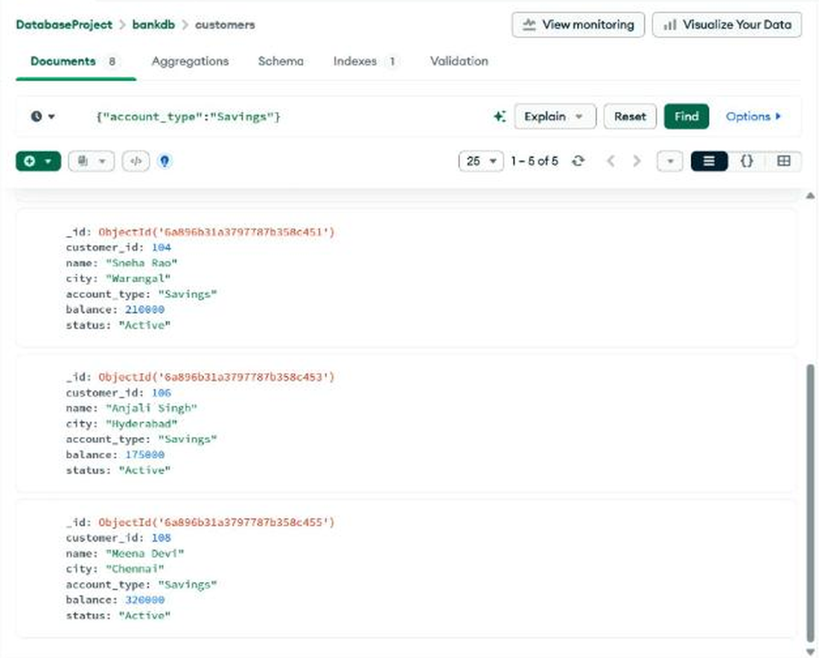
Figure Q5-2: Output of Query 5 (bottom of the results).

Query 6: Transactions greater than 20000
Collection: transactions (Documents tab)
Input (Filter)
{
"amount": {
"$gt": 20000
}
}

Expected
Manual lists 1001, 1003, 1005, 1007, 1008, 1010, 1012, 1014.
Observed
9 documents returned: 1001, 1003, 1005, 1007, 1008, 1010, 1012, 1014 and 1015.
Note: Transaction 1015 (Withdrawal, amount 30000) is also greater than 20000, so Atlas correctly returns it. It is missing from the expected list in the lab manual.
Output
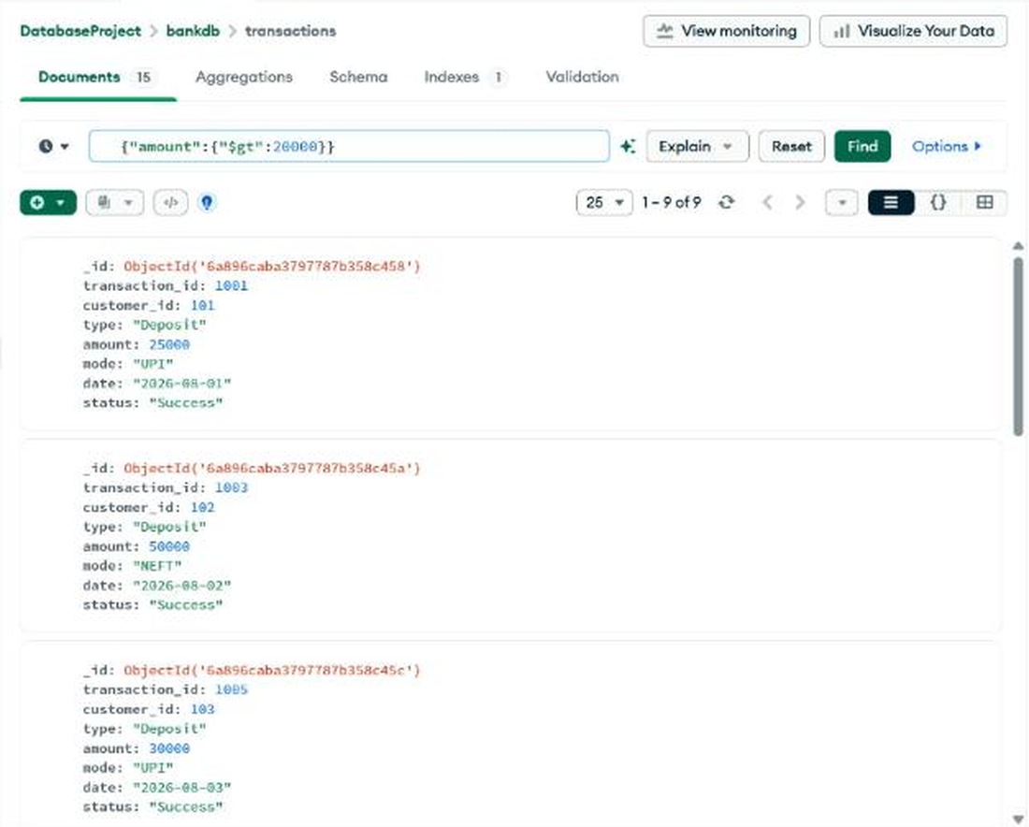
Figure Q6-1: Output of Query 6 (top of the results).
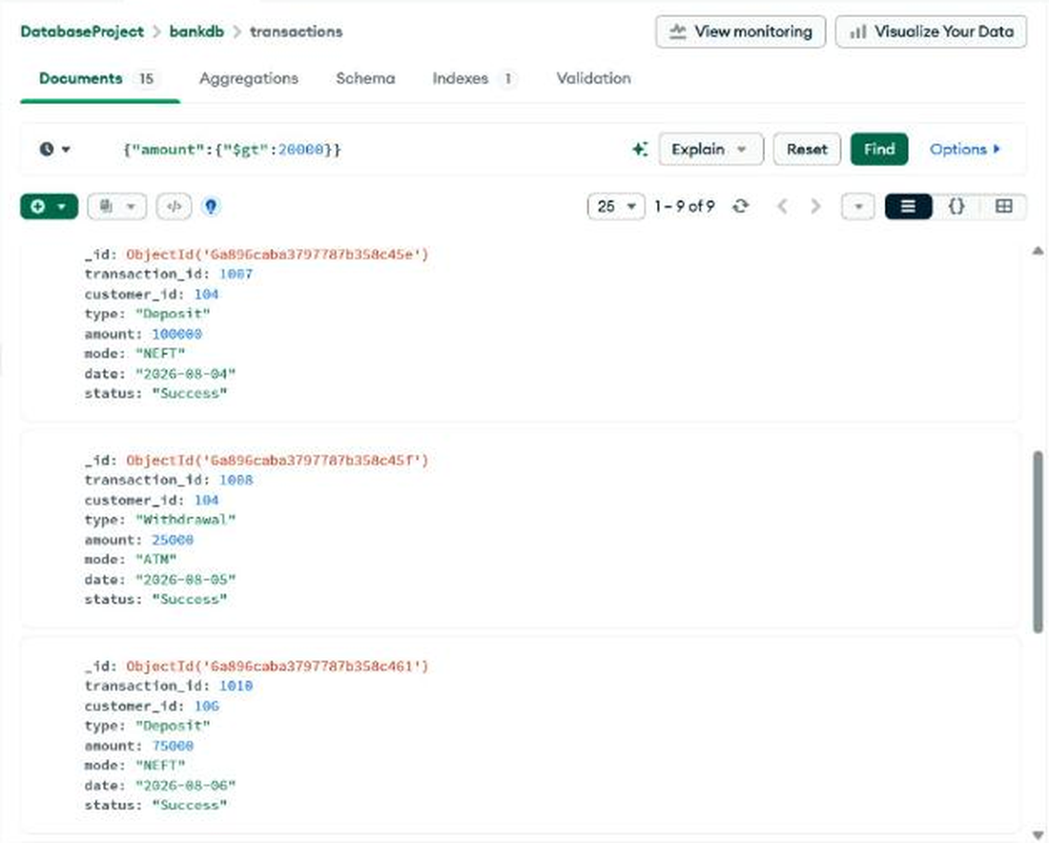
Figure Q6-2: Output of Query 6 (middle of the results).
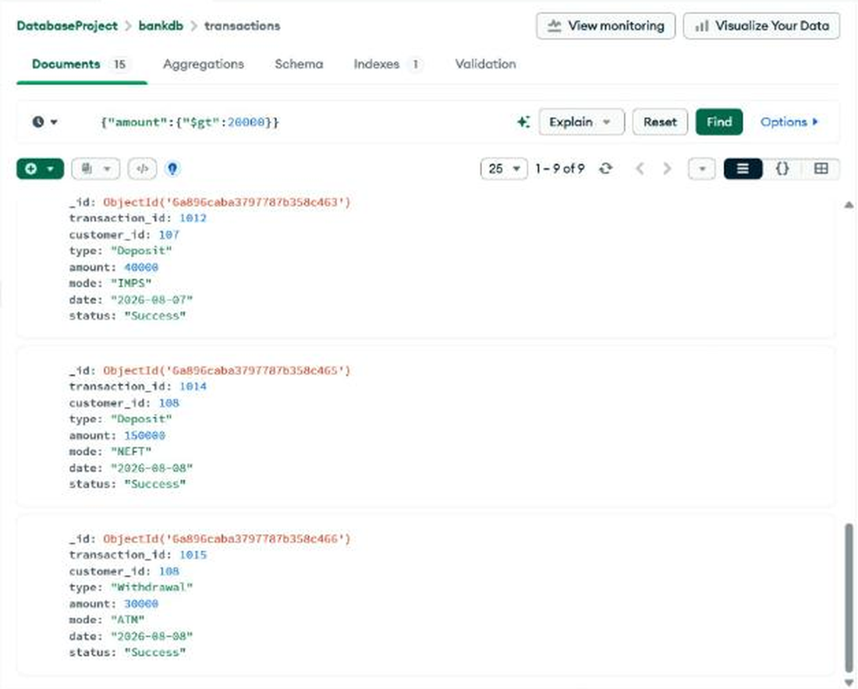
Figure Q6-3: Output of Query 6 (bottom of the results).

Query 7: Deposits
Collection: transactions (Documents tab)
Input (Filter)
{
"type": "Deposit"
}

Expected
1001, 1003, 1005, 1007, 1009, 1010, 1012, 1014.
Observed
8 documents returned, matching the expected list.
Output
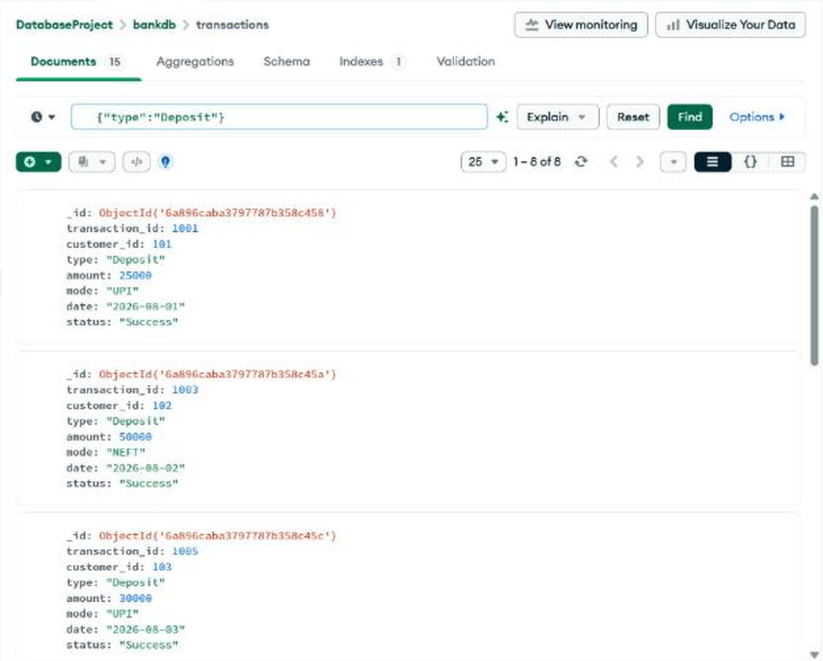
Figure Q7-1: Output of Query 7 (top of the results).
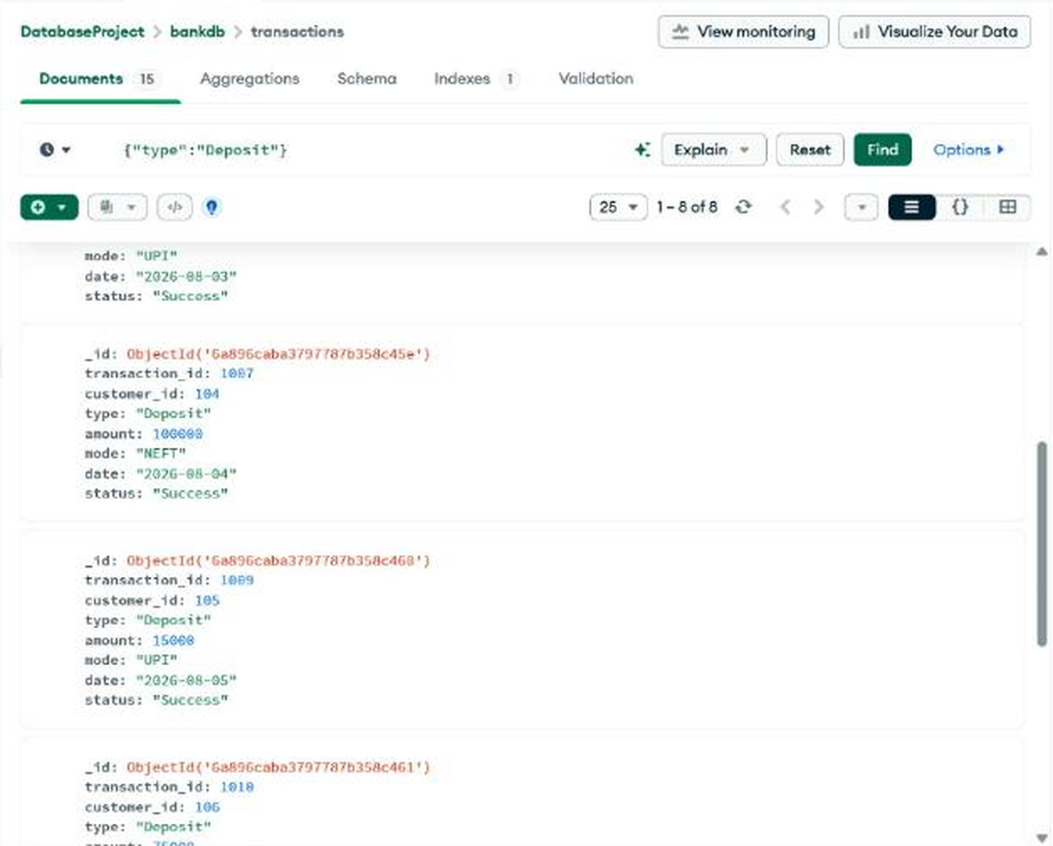
Figure Q7-2: Output of Query 7 (middle of the results).
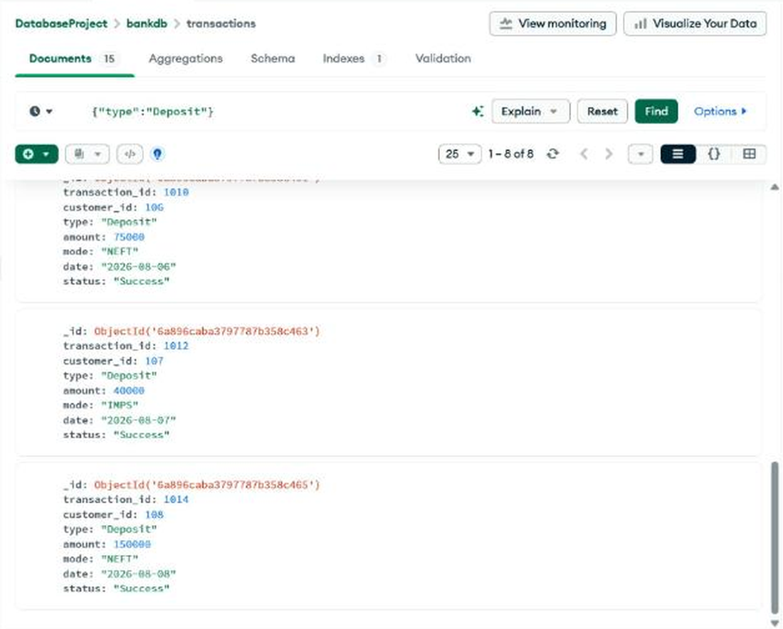
Figure Q7-3: Output of Query 7 (bottom of the results).

Query 8: ATM transactions
Collection: transactions (Documents tab)
Input (Filter)
{
"mode": "ATM"
}

Expected
1002, 1004, 1006, 1008, 1011, 1013, 1015.
Observed
7 documents returned, matching the expected list.
Output
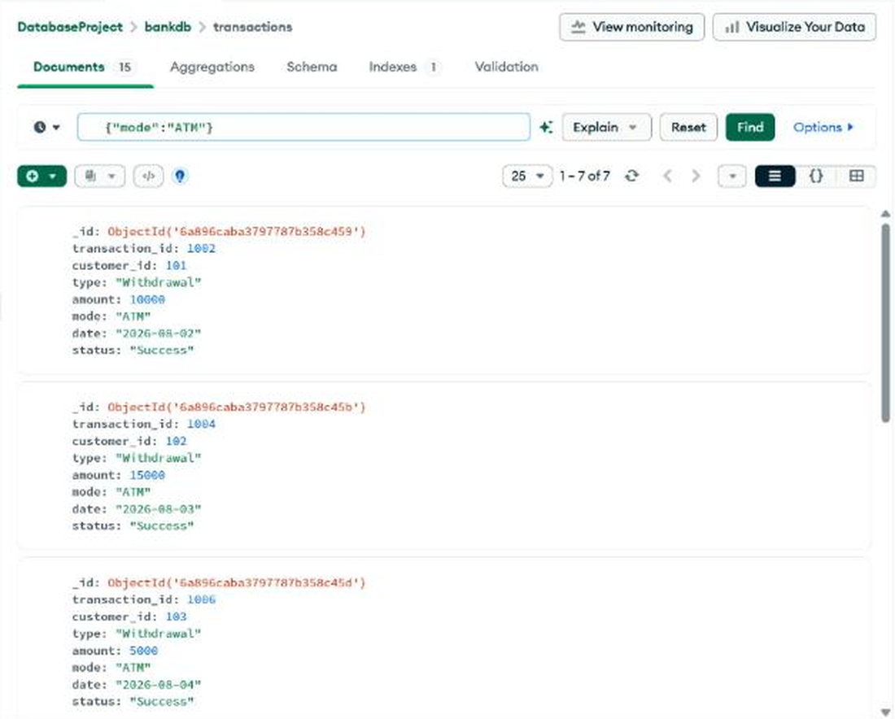
Figure Q8-1: Output of Query 8 (top of the results).
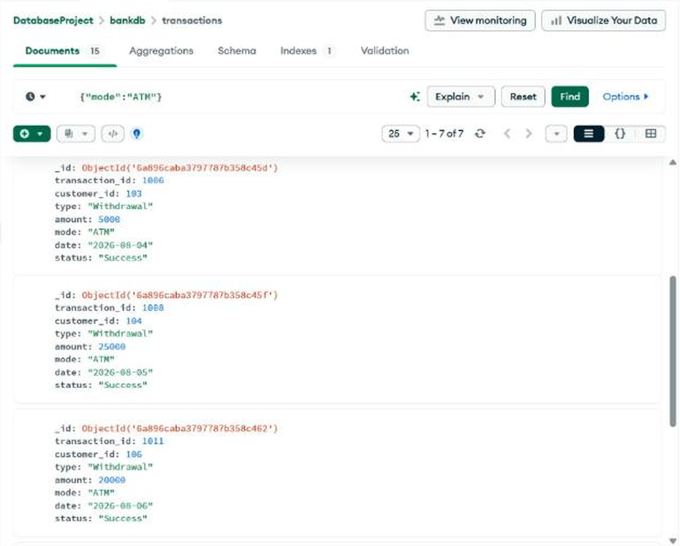
Figure Q8-2: Output of Query 8 (middle of the results).
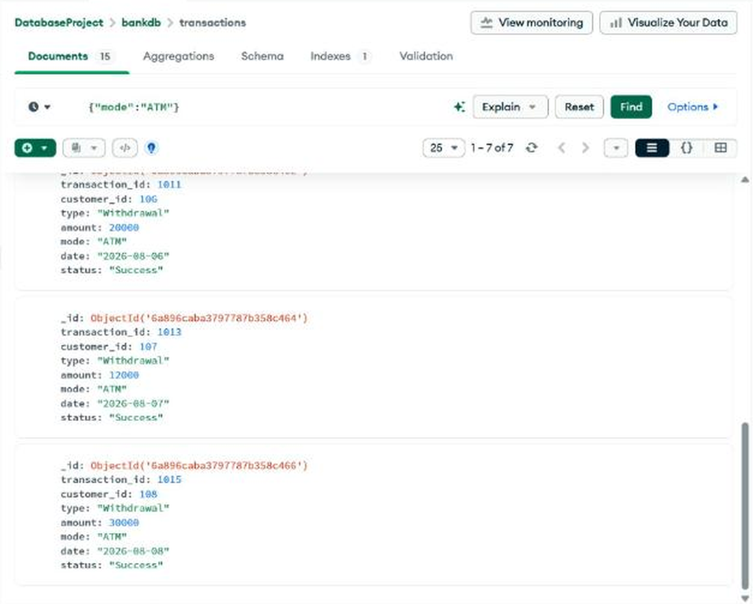
Figure Q8-3: Output of Query 8 (bottom of the results).

Query 9: Deposits greater than 50000
Collection: transactions (Documents tab)
Input (Filter)
{
"type": "Deposit",
"amount": {
"$gt": 50000
}
}

Expected
1007, 1010, 1014.
Observed
3 documents returned, matching the expected list.
Output
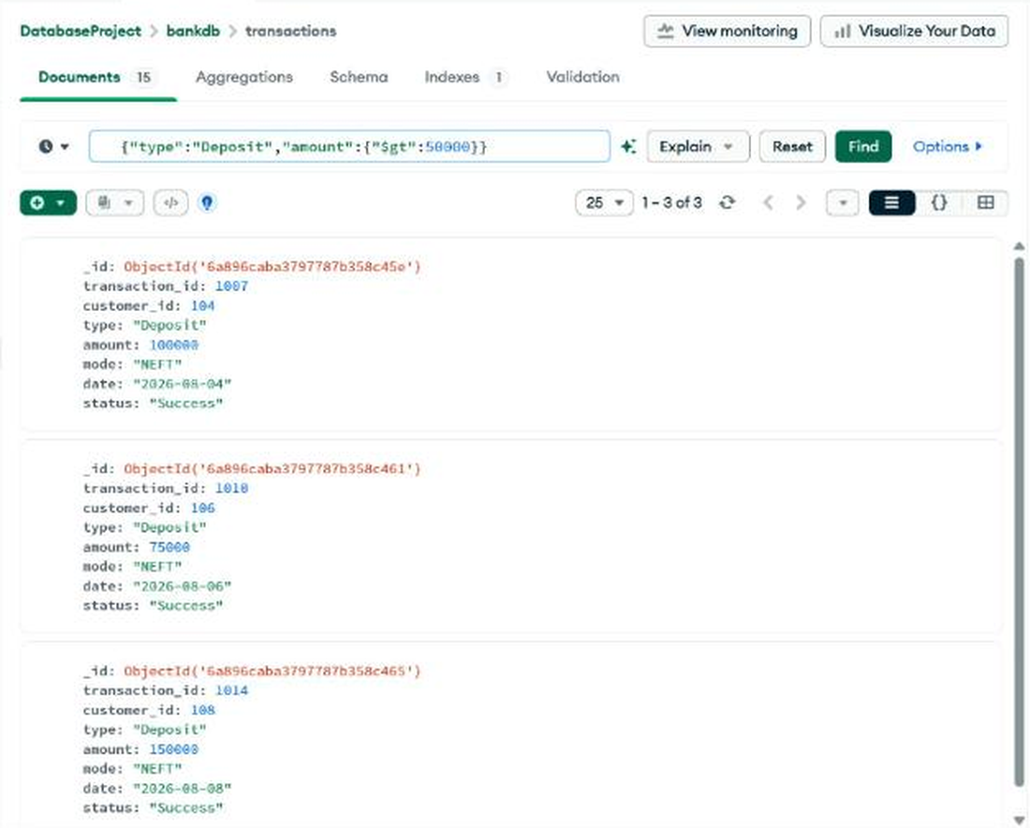
Figure Q9: Output of Query 9.

Query 10: Hyderabad customers with high balance
Collection: customers (Documents tab)
Input (Filter)
{
"city": "Hyderabad",
"balance": {
"$gt": 100000
}
}

Expected
Anjali Singh.
Observed
1 document returned: Anjali Singh (balance 175000).
Output
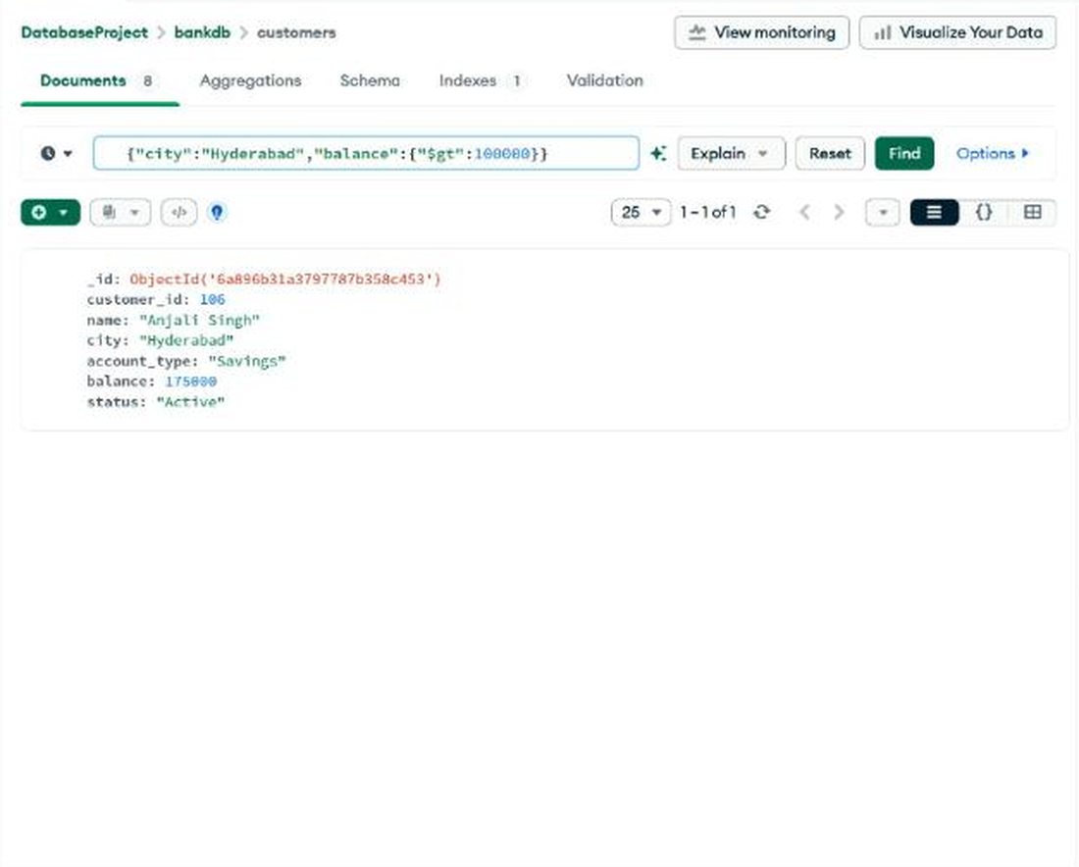
Figure Q10: Output of Query 10.

Query 11: Customers in multiple cities
Collection: customers (Documents tab)
Input (Filter)
{
"city": {
"$in": [
"Hyderabad",
"Vijayawada",
"Warangal"
]
}
}

Expected
Ravi Kumar, Priya Sharma, Arjun Reddy, Sneha Rao, Anjali Singh.
Observed
5 documents returned, matching the expected list.
Output
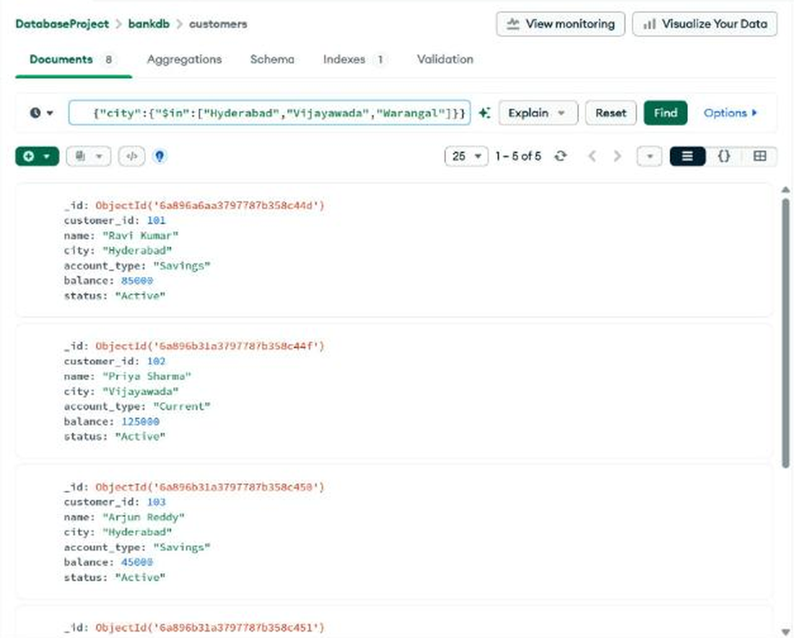
Figure Q11-1: Output of Query 11 (top of the results).
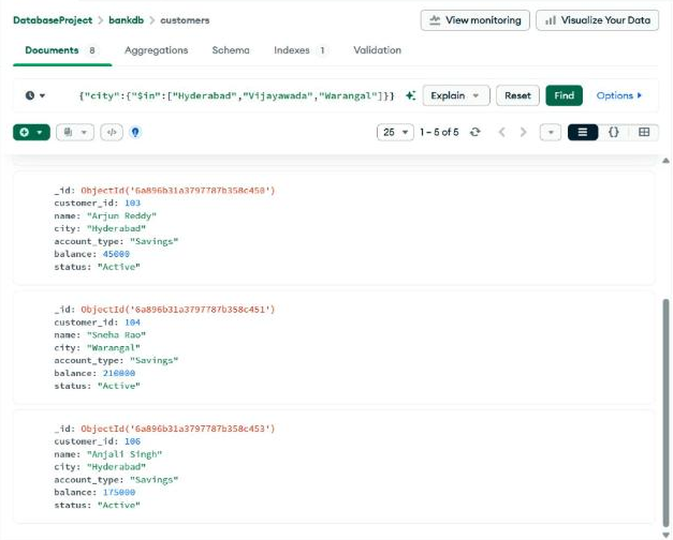
Figure Q11-2: Output of Query 11 (bottom of the results).

Query 12: Sort customers by balance (descending)
Collection: customers (Aggregations tab)
Input (Pipeline)
[
{
"$sort": {
"balance": -1
}
}
]

Expected
Meena Devi 320000, Sneha Rao 210000, Anjali Singh 175000, Priya Sharma 125000, Rahul Verma 95000, Ravi Kumar 85000, Kiran Kumar 65000, Arjun Reddy 45000.
Observed
8 documents returned in exactly this order.
Output
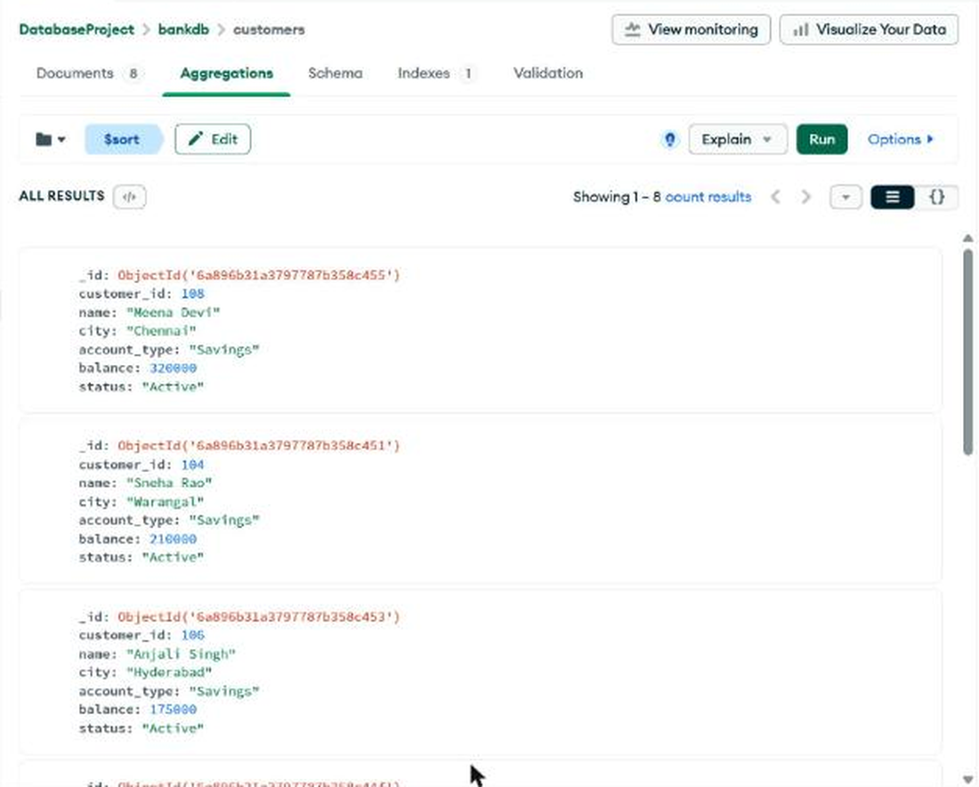
Figure Q12-1: Output of Query 12 (top of the results).
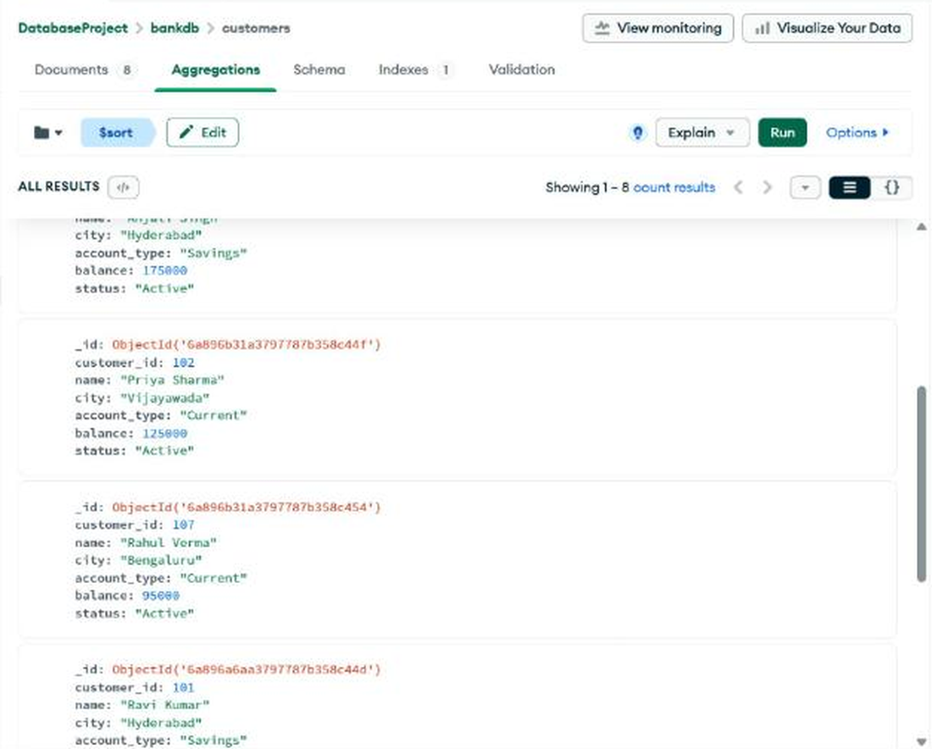
Figure Q12-2: Output of Query 12 (middle of the results).
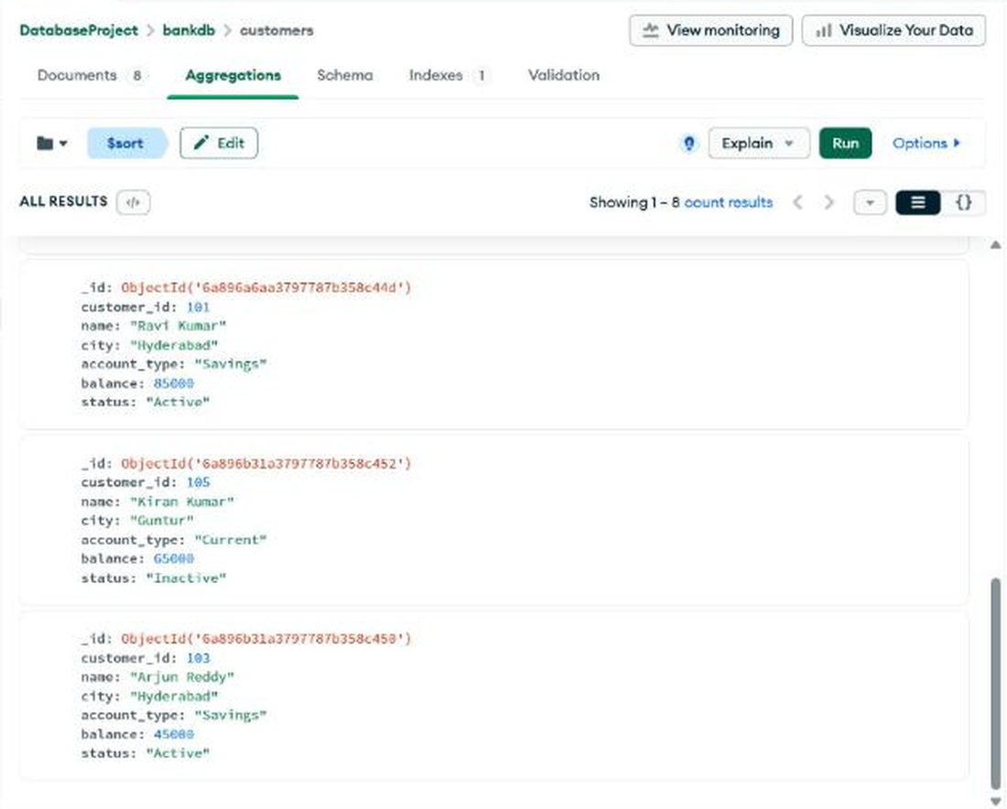
Figure Q12-3: Output of Query 12 (bottom of the results).

Query 13: Total transaction amount
Collection: transactions (Aggregations tab)
Input (Pipeline)
[
{
"$group": {
"_id": null,
"total_amount": {
"$sum": "$amount"
}
}
}
]

Expected
Manual states total_amount = 632000.
Observed
total_amount = 602000.
Note: The 15 transactions add up to 602000 (Deposits 485000 + Withdrawals 117000), so the 632000 in the manual does not match its own data. Atlas computes the correct value from the stored documents.
Output
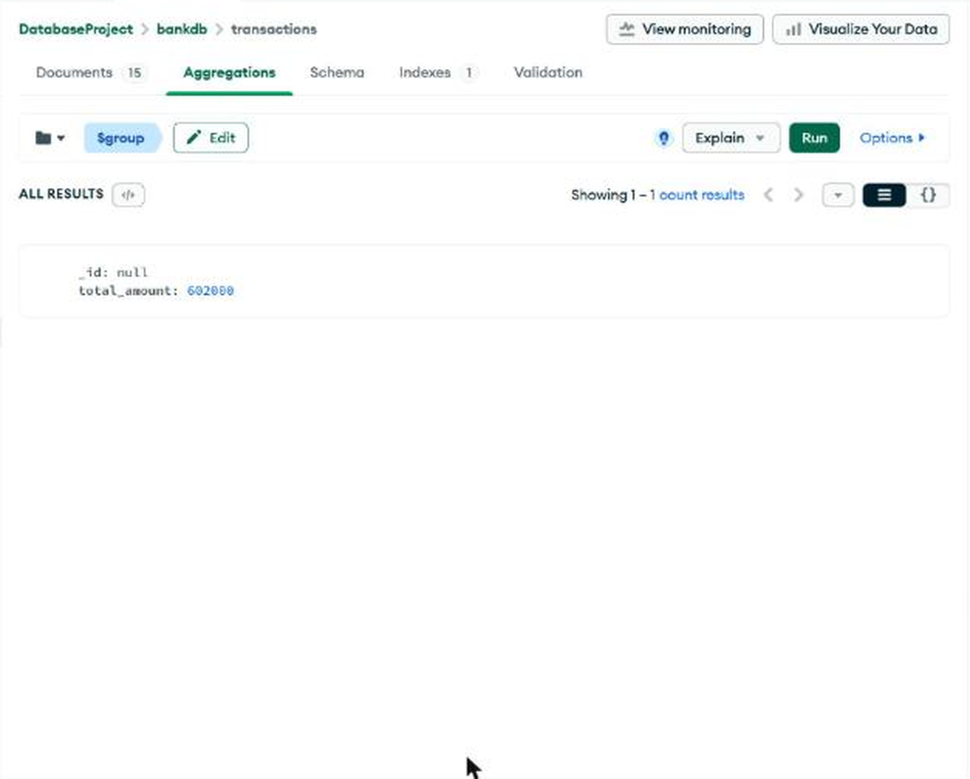
Figure Q13: Output of Query 13.

Query 14: Average transaction amount
Collection: transactions (Aggregations tab)
Input (Pipeline)
[
{
"$group": {
"_id": null,
"average_amount": {
"$avg": "$amount"
}
}
}
]

Expected
Manual states average_amount = 42133.33.
Observed
average_amount = 40133.33 (602000 / 15).
Note: Because the manual total is off by 30000, its average (632000 / 15 = 42133.33) is also off by 2000. The value from the data is 40133.33.
Output
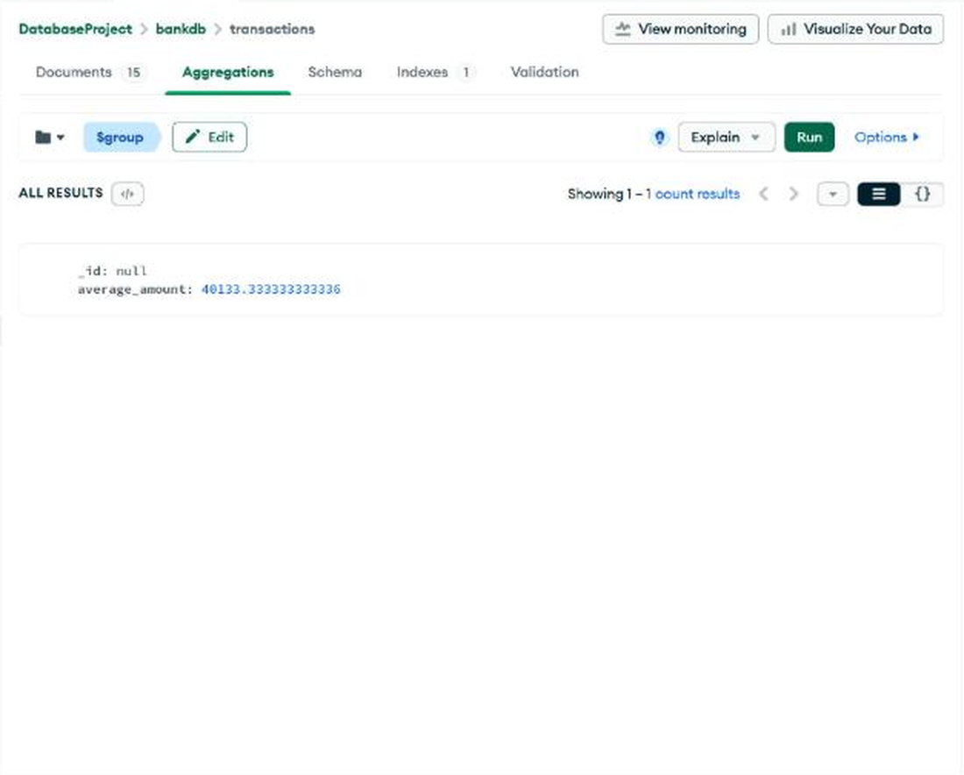
Figure Q14: Output of Query 14.

Query 15: Total transaction amount by type
Collection: transactions (Aggregations tab)
Input (Pipeline)
[
{
"$group": {
"_id": "$type",
"total_amount": {
"$sum": "$amount"
}
}
}
]

Expected
Manual states Deposit 485000 and Withdrawal 147000.
Observed
Deposit = 485000, Withdrawal = 117000.
Note: Deposit matches the manual. The seven withdrawals (10000 + 15000 + 5000 + 25000 + 20000 + 12000 + 30000) add up to 117000, not 147000.
Output
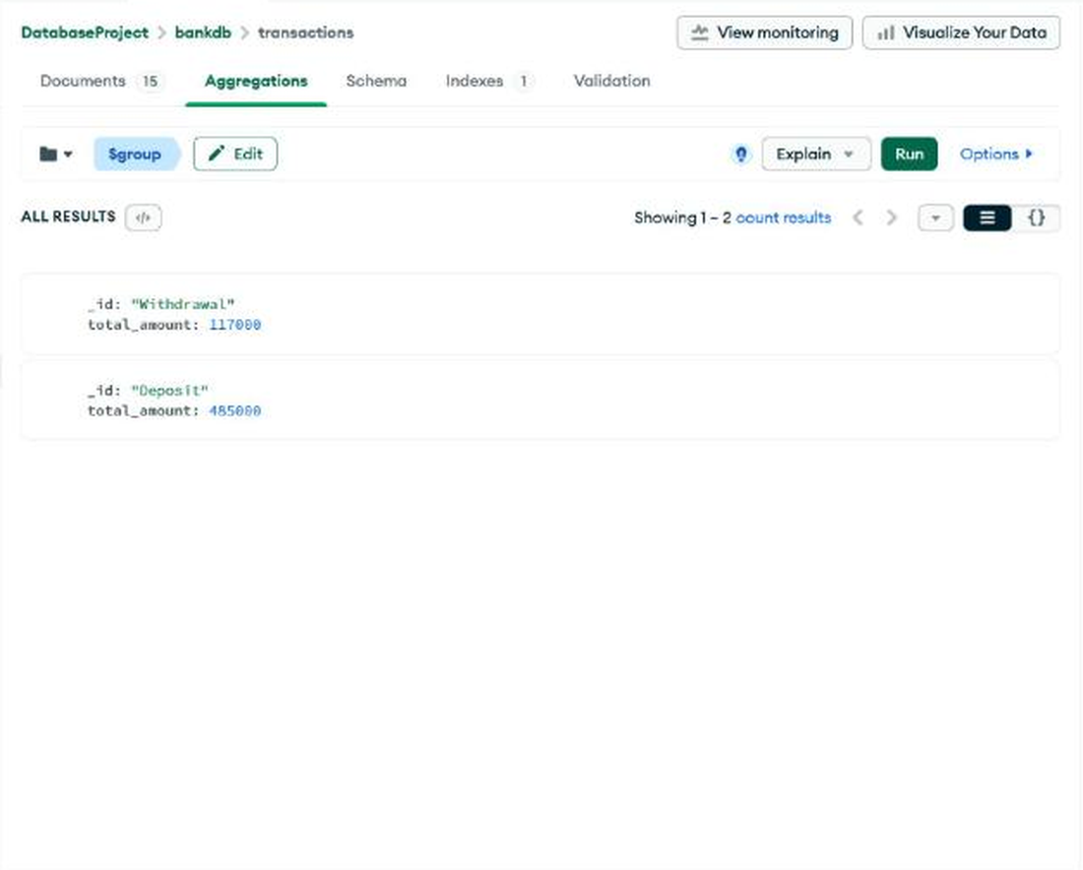
Figure Q15: Output of Query 15.

Query 16: Number of transactions per customer
Collection: transactions (Aggregations tab)
Input (Pipeline)
[
{
"$group": {
"_id": "$customer_id",
"transaction_count": {
"$sum": 1
}
}
},
{
"$sort": {
"transaction_count": -1
}
}
]

Expected
2 transactions each for customers 101, 102, 103, 104, 106, 107, 108 and 1 for customer 105.
Observed
8 groups returned: seven customers with 2 transactions, customer 105 last with 1. Matches the expected output.
Output
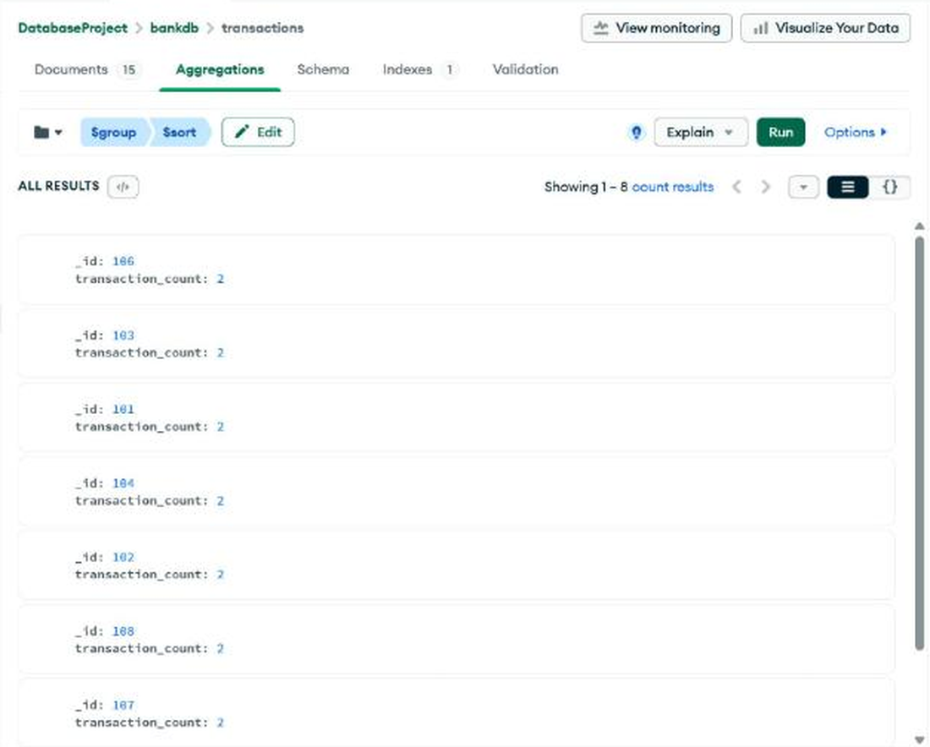
Figure Q16-1: Output of Query 16 (top of the results).
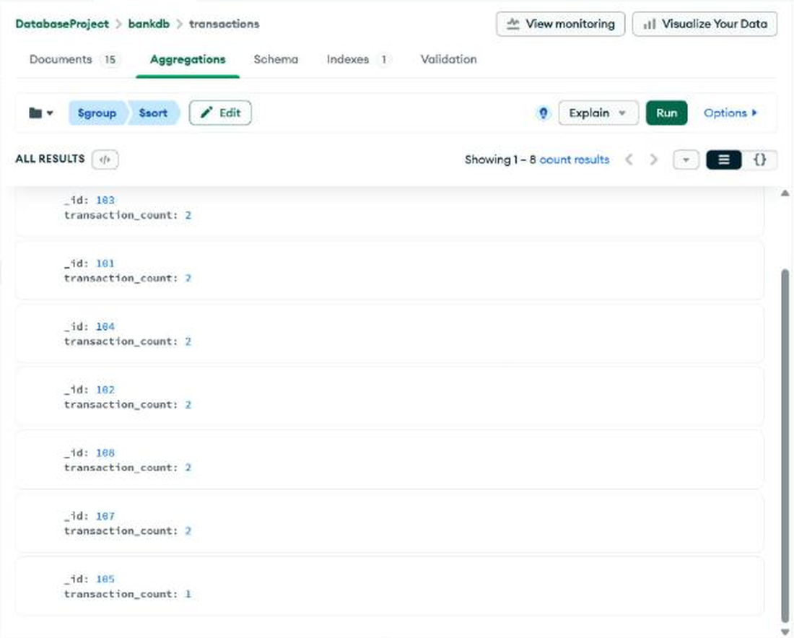
Figure Q16-2: Output of Query 16 (bottom of the results).

Query 17: Customer + transaction join using $lookup
Collection: transactions (Aggregations tab)
Input (Pipeline)
[
{
"$lookup": {
"from": "customers",
"localField": "customer_id",
"foreignField": "customer_id",
"as": "customer_details"
}
},
{
"$unwind": "$customer_details"
}
]

Expected
Each transaction with its customer_details, e.g. transaction 1001, Ravi Kumar, 25000, Deposit.
Observed
15 documents returned; each carries a customer_details object (7 fields). The first document is transaction 1001 (customer 101, Deposit, 25000).
Output
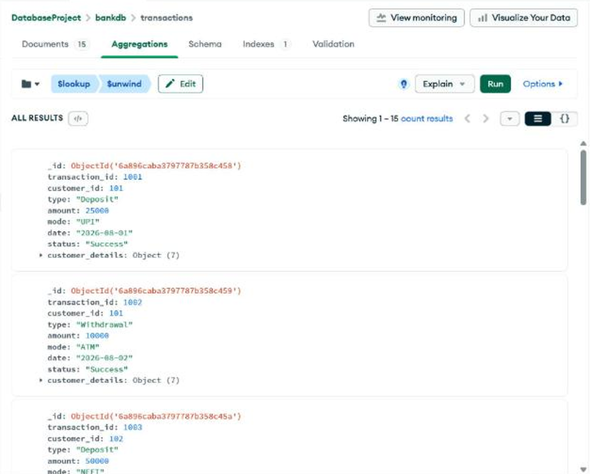
Figure Q17-1: Output of Query 17 (top of the results).
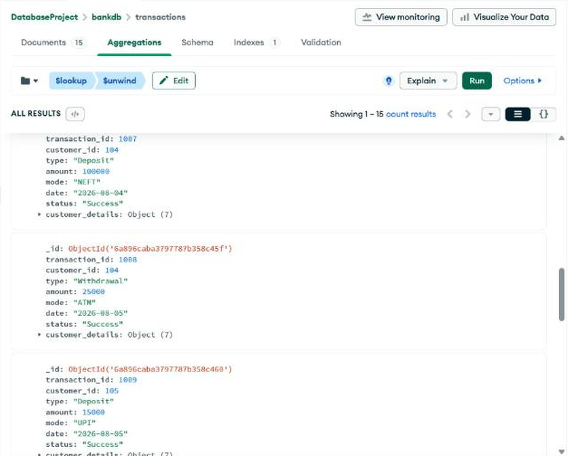
Figure Q17-2: Output of Query 17 (middle of the results).
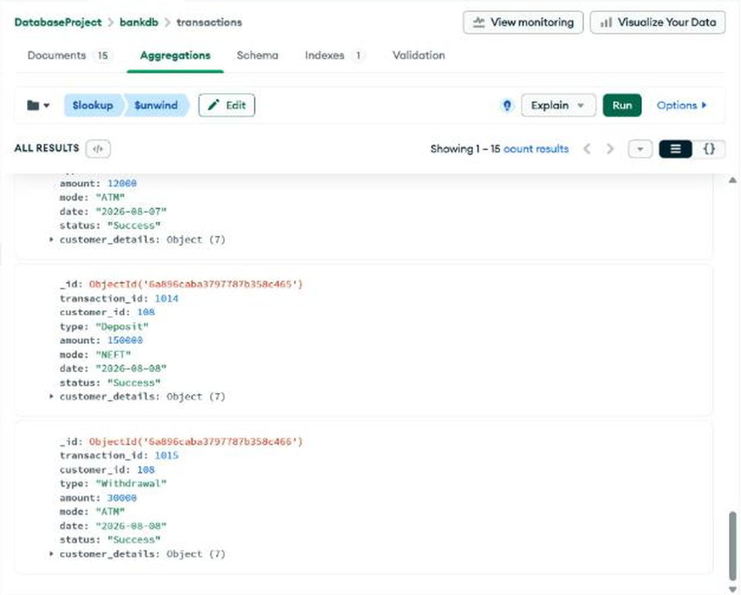
Figure Q17-3: Output of Query 17 (bottom of the results).

Query 18: Customer name and transaction amount using $lookup, $unwind and $project
Collection: transactions (Aggregations tab)
Input (Pipeline)
[
{
"$lookup": {
"from": "customers",
"localField": "customer_id",
"foreignField": "customer_id",
"as": "customer"
}
},
{
"$unwind": "$customer"
},
{
"$project": {
"_id": 0,
"transaction_id": 1,
"customer_name": "$customer.name",
"city": "$customer.city",
"type": 1,
"amount": 1,
"mode": 1
}
}
]

Expected
{ transaction_id: 1001, customer_name: "Ravi Kumar", city: "Hyderabad", type: "Deposit", amount: 25000, mode: "UPI" } and so on.
Observed
15 documents returned in the projected shape; the first is exactly the expected document for transaction 1001.
Output
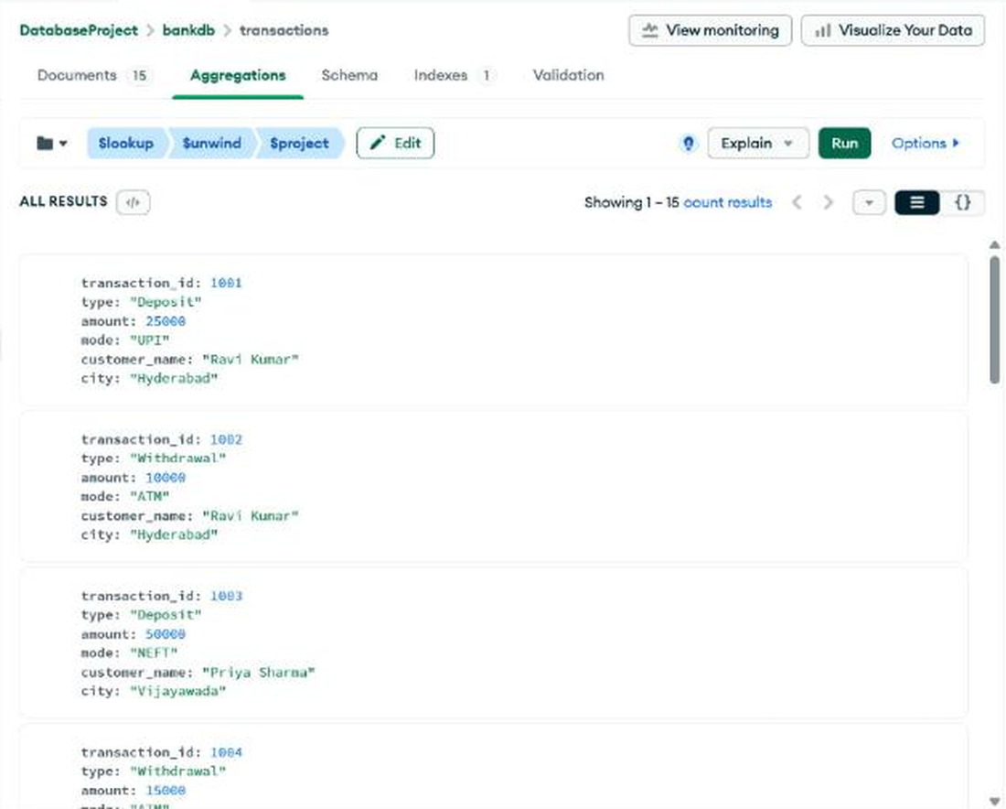
Figure Q18-1: Output of Query 18 (top of the results).
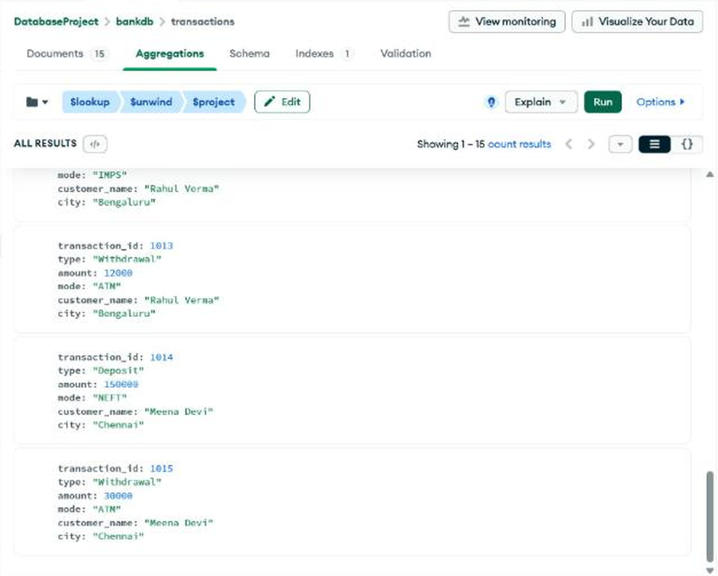
Figure Q18-2: Output of Query 18 (bottom of the results).

Query 19: Total transaction amount for each customer
Collection: transactions (Aggregations tab)
Input (Pipeline)
[
{
"$group": {
"_id": "$customer_id",
"total_transaction": {
"$sum": "$amount"
}
}
},
{
"$lookup": {
"from": "customers",
"localField": "_id",
"foreignField": "customer_id",
"as": "customer"
}
},
{
"$unwind": "$customer"
},
{
"$project": {
"_id": 0,
"customer_id": "$_id",
"customer_name": "$customer.name",
"total_transaction": 1
}
},
{
"$sort": {
"total_transaction": -1
}
}
]

Expected
Top results: Meena Devi 180000, Sneha Rao 125000, Anjali Singh 95000, Priya Sharma 65000.
Observed
8 documents returned. Top four match the expected values; the rest are Rahul Verma 52000, Arjun Reddy 35000, Ravi Kumar 35000 and Kiran Kumar 15000.
Output
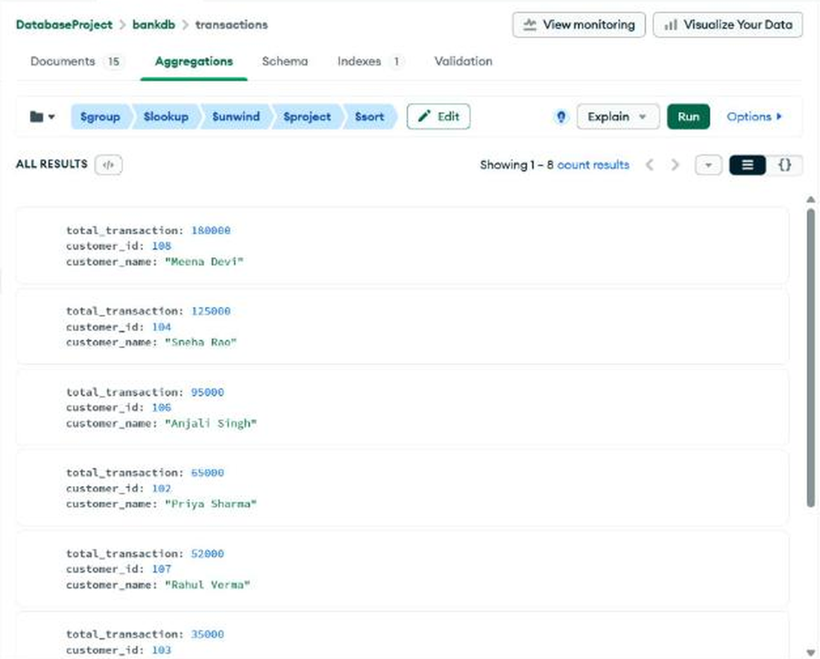
Figure Q19-1: Output of Query 19 (top of the results).
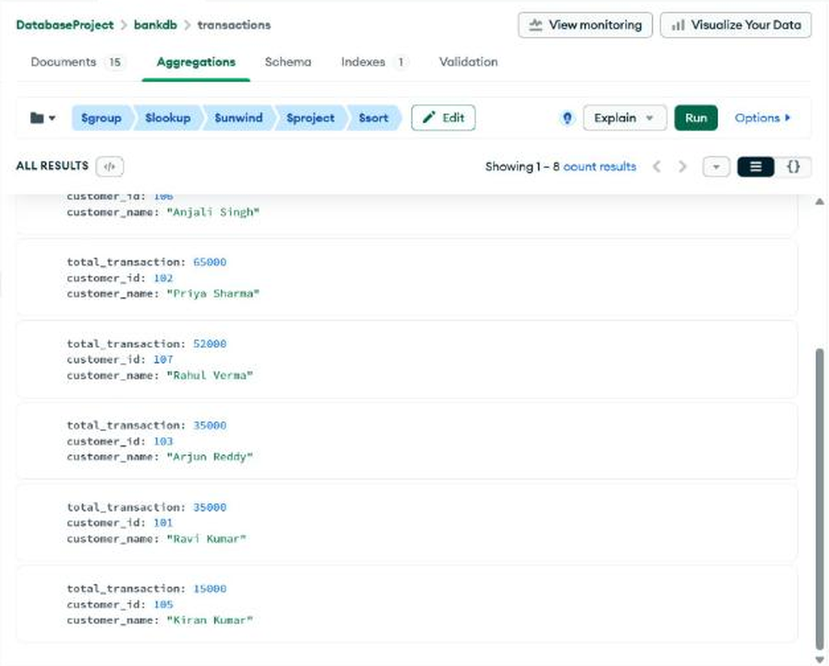
Figure Q19-2: Output of Query 19 (bottom of the results).

Query 20: Complex bank transaction report
Collection: customers (Aggregations tab)
Input (Pipeline)
[
{
"$match": {
"status": "Active",
"balance": {
"$gt": 80000
}
}
},
{
"$lookup": {
"from": "transactions",
"localField": "customer_id",
"foreignField": "customer_id",
"as": "transactions"
}
},
{
"$unwind": "$transactions"
},
{
"$group": {
"_id": "$customer_id",
"customer_name": {
"$first": "$name"
},
"city": {
"$first": "$city"
},
"balance": {
"$first": "$balance"
},
"total_transactions": {
"$sum": "$transactions.amount"
},
"transaction_count": {
"$sum": 1
}
}
},
{
"$sort": {
"total_transactions": -1
}
}
]

Expected
Report with customer ID, name, city, account balance, total transaction amount and transaction count for active customers with balance above 80000.
Observed
6 customers returned, highest total first (table below).
_id | customer_name | city | balance | total_transactions | transaction_count
108 | Meena Devi | Chennai | 320000 | 180000 | 2
104 | Sneha Rao | Warangal | 210000 | 125000 | 2
106 | Anjali Singh | Hyderabad | 175000 | 95000 | 2
102 | Priya Sharma | Vijayawada | 125000 | 65000 | 2
107 | Rahul Verma | Bengaluru | 95000 | 52000 | 2
101 | Ravi Kumar | Hyderabad | 85000 | 35000 | 2

Output
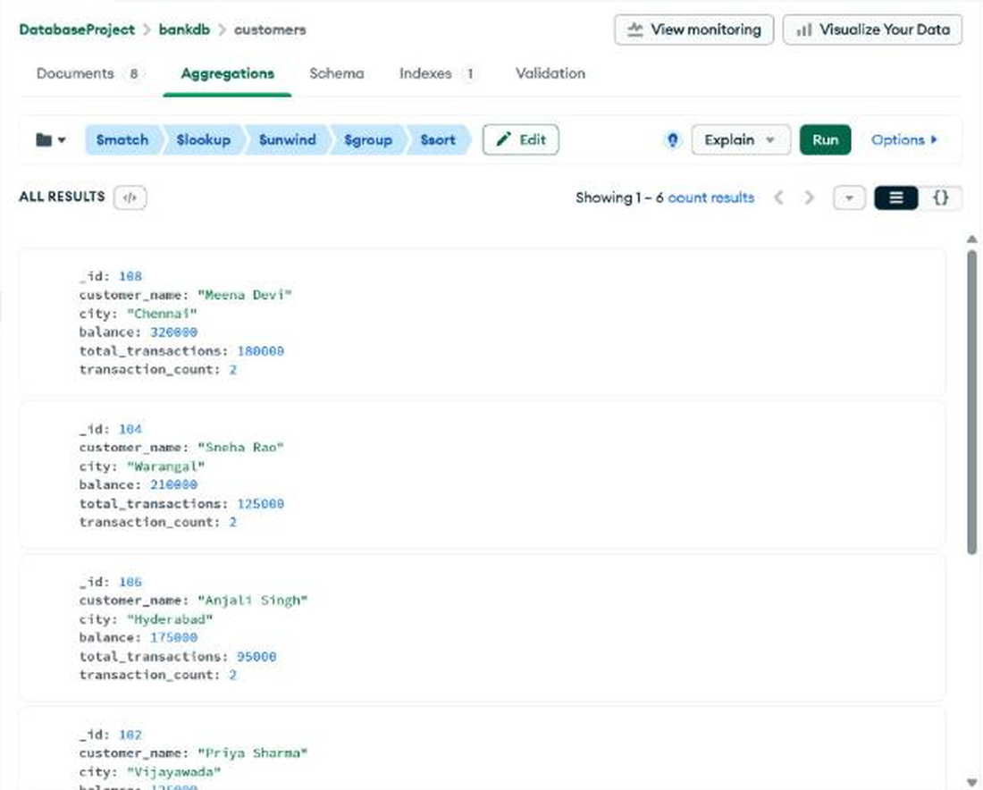
Figure Q20-1: Output of Query 20 (top of the results).
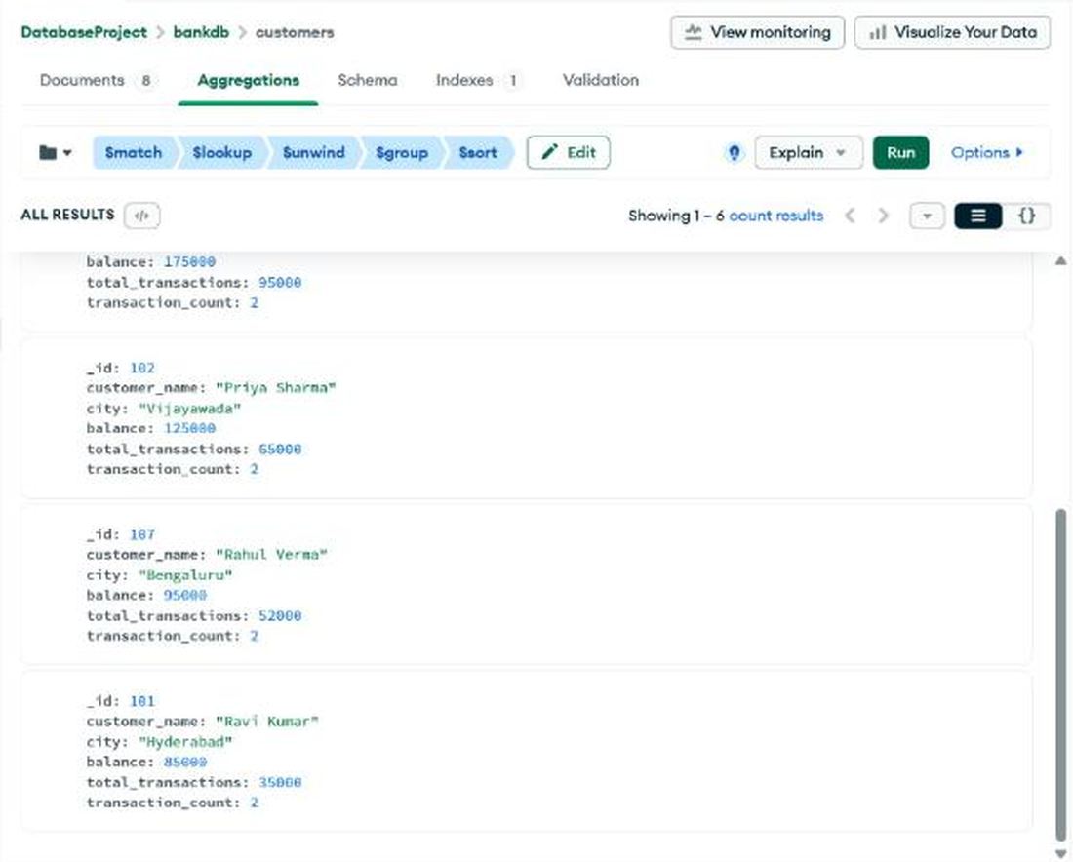
Figure Q20-2: Output of Query 20 (bottom of the results).

6. Summary of Results
Query | Description | Result in Atlas | Matches manual
1 | All customers | 8 documents | Yes
2 | Active customers | 7 documents | Yes
3 | Balance > 100000 | 4 documents | Yes
4 | City = Hyderabad | 3 documents | Yes
5 | Savings accounts | 5 documents | Yes
6 | Transactions > 20000 | 9 documents (adds 1015) | No: manual omits 1015
7 | Deposits | 8 documents | Yes
8 | ATM transactions | 7 documents | Yes
9 | Deposits > 50000 | 1007, 1010, 1014 | Yes
10 | Hyderabad with balance > 100000 | Anjali Singh | Yes
11 | City in Hyderabad, Vijayawada, Warangal | 5 documents | Yes
12 | Sort by balance descending | Meena Devi first, Arjun Reddy last | Yes
13 | Total amount | 602000 | No: manual says 632000
14 | Average amount | 40133.33 | No: manual says 42133.33
15 | Total by type | Deposit 485000, Withdrawal 117000 | Deposit yes; Withdrawal: manual says 147000
16 | Transactions per customer | 2 each, 105 has 1 | Yes
17 | $lookup + $unwind | 15 joined documents | Yes
18 | $lookup + $unwind + $project | 15 projected documents | Yes
19 | Total per customer | Meena 180000 ... Kiran 15000 | Yes
20 | Active customers, balance > 80000, report | 6 customers, Meena Devi first | Yes

7. Result
The Bank Transaction Management system was implemented in MongoDB Atlas Data Explorer with two collections, customers and transactions, linked by customer_id. Twenty queries were executed covering selection, comparison operators, $in, multiple conditions, sorting, SUM, AVG, COUNT, GROUP BY, JOIN-like operations with $lookup, $unwind, $project and a complex transaction report. Results were verified against the lab manual; the only differences (Queries 6, 13, 14 and 15) come from arithmetic errors in the manual’s expected values, not from the database.

