
K L (Deemed to be) University
Department of Computer Science and Engineering

PROJECT REPORT
PROPERTY FINDER
A Java Swing Desktop Application for Searching Indian Real-Estate Records Using Manually Implemented String-Search Algorithms and Adaptive Algorithm Selection

A Project Report submitted in the partial fulfillment of the requirements for the award of the degree of
BACHELOR OF TECHNOLOGY
in
COMPUTER SCIENCE AND ENGINEERING
by
Dhruva Datta Vishnubhotla | 2520039620
A Vishal Goud | 2520030521
A Samarth | 2520030478
Under the guidance of
Dr. S. Vinay Kumar
Associate Professor
Department of Computer Science and Engineering
Data Structures and Algorithms Project | Academic Year 2026-27


Declaration
We, the undersigned students of the Department of Computer Science and Engineering, K L (Deemed to be) University, hereby declare that the project report entitled "PROPERTY FINDER" is a record of bona fide work carried out by us during the academic year 2026-27, in partial fulfillment of the requirements for the award of the degree of Bachelor of Technology in Computer Science and Engineering.
The work was carried out by the following team members:
1. Dhruva Datta Vishnubhotla | 2520039620
2. A Vishal Goud | 2520030521
3. A Samarth | 2520030478

We further declare that the report is based on our own project work, that the design, implementation and observations described in it are those of the project, and that, to the best of our knowledge, it has not been copied from any other report nor submitted to any other university or institution for the award of any degree or diploma. Wherever the work of others has been used, it has been acknowledged in the references.
Signatures of the students
________________________  Dhruva Datta Vishnubhotla | ________________________  A Vishal Goud | ________________________  A Samarth
Certificate
This is to certify that the mini project based report entitled "PROPERTY FINDER" is a bonafide work done and submitted by
Dhruva Datta Vishnubhotla | 2520039620
A Vishal Goud | 2520030521
A Samarth | 2520030478

in partial fulfillment of the requirements for the award of the degree of Bachelor of Technology in Computer Science and Engineering at K L (Deemed to be) University during the academic year 2026-27.
The work has been carried out under our supervision, and to the best of our knowledge the report has not been submitted elsewhere for the award of any degree or diploma.
________________________  Signature of the Guide  (Dr. S. Vinay Kumar)  Associate Professor | ________________________  Signature of the HOD  (Dr. P. Venkateshwara Rao)  Associate Professor and HOD
Department of Computer Science and Engineering, K L (Deemed to be) University
Acknowledgement
We express our sincere gratitude to our guide, Dr. S. Vinay Kumar, Associate Professor, Department of Computer Science and Engineering, for his continuous guidance, technical suggestions and encouragement throughout the development of this project.
We also thank Dr. P. Venkateshwara Rao, Associate Professor and HOD, Department of Computer Science and Engineering, for providing the academic environment and support required to complete this work.
We are grateful to all the teaching and non-teaching staff of the Department of Computer Science and Engineering, K L (Deemed to be) University, for their help and support.
Finally, we thank our teammates, classmates and family members for their cooperation and encouragement. The project gave us practical experience in algorithm design, Java programming, GUI development and dataset integration.
Dhruva Datta Vishnubhotla – 2520039620
A Vishal Goud – 2520030521
A Samarth – 2520030478
Abstract
Property Finder is a Java Swing desktop application developed as a Data Structures and Algorithms course project for searching Indian real-estate records by locality, city and state. The system demonstrates how different string-search and indexing algorithms suit different kinds of query: a single exact location, a misspelt location, a list of several locations, and repeated searches over the same data.
The project integrates heterogeneous property datasets into a unified model and offers both manual algorithm selection and an Auto mode. Auto mode is a deterministic, rule-based Adaptive Algorithm Selection Engine — not artificial intelligence or machine learning. It routes comma-separated queries to Aho-Corasick, repeated queries to a cached suffix array, single terms with exact matches to KMP, and single terms without exact matches to a Levenshtein fuzzy fallback. KMP, Z Algorithm, Rabin-Karp, Levenshtein, Aho-Corasick and Suffix Array search are all implemented manually, and KMP, Z Algorithm and Rabin-Karp can be compared on identical input with algorithm-only timing and a result-equality check.
The project documentation reports 38 GUI-loadable dataset files containing 321,470 property records. The application includes dataset-specific loaders, a UnifiedProperty model with source provenance, error isolation for missing files and malformed rows, background processing with SwingWorker, an optional parallel layer for large exact searches over all sources, an Algorithms Used dialog, rupee price formatting and the original Phase 1 command-line interface. Beyond location search, the final application adds Damerau–Levenshtein and weighted edit-distance fuzzy options, an optional randomised-hash variant of Rabin–Karp, and two graph-algorithm tools: Dinic's maximum flow for buyer-to-property allocation and a vertex-cover 2-approximation for selecting representative area spellings.
Keywords: Property Finder, Data Structures and Algorithms, String Matching, KMP, Z Algorithm, Rabin-Karp, Levenshtein Distance, Aho-Corasick, Suffix Array, Adaptive Algorithm Selection, Java Swing, SwingWorker
Table of Contents
Declaration i
Certificate ii
Acknowledgement iii
Abstract iv
Table of Contents v
List of Figures vii
List of Tables viii
Chapter 1: Introduction 1
1.1 Overview 1
1.2 Problem Statement 1
1.3 Scope of the Project 2
1.4 Objectives of the Project 2
1.5 Importance of the Project 2
1.6 Target Users / Audience 3
1.7 Project Team and Guide 3
1.8 Organisation of the Report 3
Chapter 2: Background and Related Algorithms 5
2.1 String Searching Fundamentals 5
2.2 Knuth–Morris–Pratt (KMP) 5
2.3 Z Algorithm 6
2.4 Rabin–Karp 6
2.5 Levenshtein Distance 7
2.6 Aho–Corasick 7
2.7 Suffix Array 8
2.8 Graph Algorithm Extensions 9
2.9 Comparison of the Algorithms 9
2.10 Why Adaptive Algorithm Selection 10
2.11 Supporting Technologies and Concepts 10
Chapter 3: System Requirements 11
3.1 Functional Requirements 11
3.2 Non-Functional Requirements 11
3.3 Software, Hardware and Dataset Requirements 12
3.4 Dataset Requirements 12
Chapter 4: System Design 13
4.1 High-Level Architecture 13
4.2 Layer and Module Description 14
4.3 Data Model and Dataset Organisation 14
4.4 Dataset Integration Design 15
4.5 Adaptive Routing Design 15
4.6 Concurrency Design 17
4.7 User Interface Design 19
4.8 Key Design Decisions 19
Chapter 5: Implementation 21
5.1 Module-wise Implementation 21
5.2 Algorithm Implementation 21
5.3 Query Parsing and Routing 24
5.4 Dataset Loading and Unification 25
5.5 GUI and Background Processing 25
5.6 Parallel Dataset Search 25
5.7 Algorithm Comparison Mode 25
5.8 Price Formatting and Utilities 25
5.9 Build, Run and Command-Line Interface 26
5.10 Pseudocode 26
Chapter 6: Results and Testing 28
6.1 Functional Results 28
6.2 Dataset Results 28
6.3 Algorithm Results and Testing 29
6.4 Correctness Check Through Compare Mode 30
6.5 Timing and Performance Notes 31
6.6 GUI Result 31
6.7 Screenshots of Execution 33
Chapter 7: Challenges and Limitations 40
7.1 Issues Faced During Development 40
7.2 Solutions Applied 40
7.3 Limitations of the System 40
Chapter 8: Conclusion and Future Work 42
8.1 Conclusion 42
8.2 Objectives Achieved 42
8.3 Future Work 43
8.4 Skills Learned During Development 43
References 44
List of Figures
Figure 2.1: Kinds of location query handled by Property Finder and the algorithms used 5
Figure 2.2: Illustrative Aho–Corasick automaton for the patterns he, she, his and hers (dashed arrows are failure links; not project data) 8
Figure 4.1: Layered system architecture of Property Finder 13
Figure 4.2: Dataset integration pipeline 15
Figure 4.3: Decision flow of the Adaptive Algorithm Selection Engine 16
Figure 4.4: Search workflow across the EDT, SwingWorker and service layer 17
Figure 4.5: Chunked parallel search with ordered merge 18
Figure 4.6: Workflow of the Compare Exact Algorithms mode 18
Figure 6.1: Reported property rows by dataset or group (from Table 6.2) 29
Figure 6.2: Development-stage Property Finder Java Swing main window 32
Figure 6.3: Final main window with the algorithm selector open 33
Figure 6.4: Dataset selector listing All Sources, up and the state/UT datasets 33
Figure 6.5: Exact search for Gachibowli in Auto mode — KMP selected, parallel search on 16 chunks (TC01, TC05) 34
Figure 6.6: Fuzzy search for Gachibowlii in Auto mode — Levenshtein fallback, closest match at edit distance 1 (TC02) 34
Figure 6.7: Multi-pattern search for Kokapet, Gachibowli, Tellapur in Auto mode — Aho–Corasick selected (TC03) 35
Figure 6.8: Repeated query in Auto mode — Suffix Array Search with the cached index (TC04) 35
Figure 6.9: Compare Exact Algorithms — KMP, Z Algorithm and Rabin–Karp give identical results (TC06) 36
Figure 6.10: Property Details dialog for a selected result (TC09, TC10) 36
Figure 6.11: Algorithms Used dialog (1 of 6) — exact search: KMP, Z Algorithm, Rabin–Karp 37
Figure 6.12: Algorithms Used dialog (2 of 6) — fuzzy search: Levenshtein, Damerau–Levenshtein, Weighted Edit Distance 37
Figure 6.13: Algorithms Used dialog (3 of 6) — multi-pattern and indexed search: Aho–Corasick, Suffix Array, Kasai LCP 38
Figure 6.14: Algorithms Used dialog (4 of 6) — performance extensions and the Adaptive Algorithm Selection Engine 38
Figure 6.15: Algorithms Used dialog (5 of 6) — graph algorithm extensions: Max Flow (Dinic) and Vertex Cover 39
Figure 6.16: Algorithms Used dialog (6 of 6) — Adaptive Router auto-routing rules 39
List of Tables
Table 1.1: Scope of the project 2
Table 1.2: Target users of the project 3
Table 1.3: Project team and guide 3
Table 1.4: Organisation of the report 3
Table 2.1: Illustrative LPS array for the pattern ABABAC (not project data) 6
Table 2.2: Illustrative Z array for the string aabxaab (not project data) 6
Table 2.3: Illustrative edit-distance table for "cat" and "cut" (distance = 1; not project data) 7
Table 2.4: Illustrative suffix array and LCP array for the text banana (not project data) 8
Table 2.5: Comparison of the algorithms used in Property Finder 9
Table 3.1: Functional requirements 11
Table 3.2: Non-functional requirements 11
Table 3.3: Software, hardware and dataset requirements 12
Table 4.1: Layers, main classes and responsibilities 14
Table 4.2: Fields of the UnifiedProperty model 14
Table 4.3: Adaptive routing rules 16
Table 4.4: Key design decisions and their rationale 19
Table 5.1: Modules, classes and responsibilities 21
Table 5.2: Algorithm catalogue as shown by the Algorithms Used dialog 21
Table 6.1: Features delivered 28
Table 6.2: Reported dataset inventory 29
Table 6.3: Test cases, expected results and observed results 30
Table 6.4: Search times shown in the screenshots (single runs, dataset All Sources (38)) 31
Table 7.1: Issues faced during development 40
Table 7.2: Solutions applied 40
Table 8.1: Objectives and their achievement 42
Table 8.2: Future work (not implemented) 43

Chapter 1: Introduction

1.1 Overview
Searching for property is, above all, a search by location. A buyer or renter usually begins with a locality, a city or a state, and a property-search system must turn that short piece of text into a list of matching records quickly and correctly. When the records number in the hundreds of thousands and come from different sources, the choice of search technique and the structure of the software around it become real engineering questions.
Property Finder is a Java Swing desktop application that searches Indian real-estate datasets by locality, city and state, and that is built to demonstrate the practical use of Data Structures and Algorithms (DSA). The project began as a terminal-based Knuth–Morris–Pratt (KMP) pattern-search exercise and was progressively expanded into a multi-dataset desktop system with exact, fuzzy, multi-pattern and indexed search modes. The original command-line interface (CLI) is retained as a simple demonstration and debugging tool, while the graphical interface provides the richer, day-to-day way of using the system.
The central idea of the project is that no single algorithm is ideal for every kind of query. A single exact location can be handled efficiently by KMP; a misspelt location needs an approximate method such as Levenshtein distance; a comma-separated list of locations fits Aho-Corasick; and repeated searches can benefit from a cached suffix array. Property Finder therefore includes an Adaptive Algorithm Selection Engine (“Auto” mode) that uses transparent, rule-based decisions to pick an appropriate algorithm. Auto mode is explicitly not an artificial-intelligence or machine-learning model: every decision follows explicit rules that can be inspected and explained.
Beyond location search, the final application adds two graph-algorithm extensions: a Property Allocation tool that uses Dinic's maximum-flow algorithm to match buyers to eligible, in-budget properties, and a Representative Areas tool that uses a vertex-cover 2-approximation to select a limited set of representative area spellings from likely-duplicate location strings. The fuzzy-search family also includes Damerau–Levenshtein and weighted edit-distance variants.

1.2 Problem Statement
A property-search application must cope with a large number of heterogeneous records, inconsistent source formats and different search intentions. Using only one string-search method makes the application hard to extend and weakens the academic demonstration of DSA concepts. In addition, a desktop application that processes hundreds of thousands of records must not freeze while it works.
The project therefore addresses the problem of designing a location-search system that can:
- unify multiple datasets with different schemas into one common property model;
- apply manually implemented search algorithms correctly;
- choose an appropriate technique for the query situation instead of forcing one method on every query;
- compare the exact algorithms fairly on identical input; and
- keep the user interface responsive on a corpus of hundreds of thousands of records.

1.3 Scope of the Project
Table 1.1: Scope of the project
In scope | Out of scope
Location search by locality, city or state | Price prediction or property valuation
Exact, fuzzy, multi-pattern and indexed search | Investment or financial recommendations
Manual algorithm selection and deterministic Auto routing | Machine-learning classification or learned routing
Search across individual datasets or All Sources | Live web scraping or real-time listing feeds
Algorithm comparison, timing and correctness checks | Multi-user server deployment
Property details and rupee price formatting | Free-text semantic search over full descriptions
Fuzzy variants: Damerau–Levenshtein and weighted edit distance | —
Graph extensions: buyer-to-property allocation (max flow) and representative areas (vertex cover) | —

1.4 Objectives of the Project
1. Develop a professional, resizable Java Swing desktop application for property searching.
2. Implement KMP, Z Algorithm, Rabin-Karp, Levenshtein, Aho-Corasick and Suffix Array search manually, together with Damerau–Levenshtein and weighted edit-distance fuzzy variants.
3. Provide deterministic Auto routing while retaining manual algorithm override.
4. Support exact, fuzzy, multi-pattern and repeated-query scenarios.
5. Compare KMP, Z Algorithm and Rabin-Karp on identical input with algorithm-only timing.
6. Integrate multiple heterogeneous real-estate datasets into one UnifiedProperty representation.
7. Use SwingWorker and optional parallel execution to keep the GUI responsive on large searches.
8. Retain the Phase 1 CLI as a simple demonstration and debugging tool.
9. Provide graph-algorithm extensions: Dinic's maximum flow for buyer-to-property allocation and a vertex-cover 2-approximation for representative area spellings.

1.5 Importance of the Project
- Algorithms in a real application. The algorithms are not isolated exercises; each solves a different, realistic shape of location query inside one working system.
- Explainable decision-making. Because Auto routing is rule-based, every choice can be justified in a viva, which makes the project a strong academic demonstration.
- Data-integration experience. Real datasets differ in schema, delimiters and quality; the project shows how loaders, a common model and source provenance deal with this.
- Responsive desktop design. Using background workers and an optional parallel layer demonstrates how long-running work is kept off the Swing event-dispatch thread.
- Honest evaluation. Algorithm results are cross-checked rather than assumed, and timing is interpreted with caution (Section 6.5).

1.6 Target Users / Audience
Table 1.2: Target users of the project
User group | How they use or benefit from the project
DSA students | A runnable reference showing KMP, Z, Rabin-Karp, Levenshtein, Aho-Corasick and suffix arrays working on real data.
Faculty and evaluators | A project in which each algorithm, routing rule and design decision can be located, explained and checked.
Property seekers (demonstration use) | A desktop tool for searching property records by locality, city or state across individual datasets or all sources.
Future project teams | A layered code base to which testing, filtering, benchmarking and other extensions can be added (Section 8.2).

1.7 Project Team and Guide
Table 1.3: Project team and guide
No. | Name | Registration number
1 | Dhruva Datta Vishnubhotla | 2520039620
2 | A Vishal Goud | 2520030521
3 | A Samarth | 2520030478
Guide | Dr. S. Vinay Kumar, Associate Professor | Department of Computer Science and Engineering

1.8 Organisation of the Report
Table 1.4: Organisation of the report
Chapter | Content
1 Introduction | Overview, problem statement, scope, objectives, importance and team.
2 Background and Related Algorithms | The string-matching and graph algorithms with worked examples, their comparison, and the supporting technologies.
3 System Requirements | Functional and non-functional requirements; software, hardware and dataset requirements.
4 System Design | Layered architecture, data model, dataset integration, adaptive routing and concurrency design.
5 Implementation | Modules, algorithm implementation, GUI and background processing, parallel search, build and run, pseudocode.
6 Results and Testing | Features delivered, dataset inventory, test cases, the Compare mode, GUI results and screenshots.
7 Challenges and Limitations | Issues faced, solutions applied and the limitations of the system.
8 Conclusion and Future Work | Conclusion, objectives achieved, future work and skills learned.
References | Algorithm papers, textbooks and Java documentation.

Chapter 2: Background and Related Algorithms
This chapter explains the string-matching, indexing and graph techniques on which Property Finder is built. Each algorithm is described, shown on a small worked example, and tied to the way the project uses it. The worked examples use short generic strings chosen for clarity; they are illustrations of the algorithms and are not data from the project.

2.1 String Searching Fundamentals
In string searching, the text is the string being searched (length n) and the pattern is the string being looked for (length m). In Property Finder the text is the searchable location information of a property record — its locality, city and state — and the pattern is the location typed by the user; matching is case-insensitive. Four kinds of search appear in this project (Figure 2.1):
- Exact, single pattern — find every occurrence of one pattern (KMP, Z Algorithm, Rabin-Karp).
- Approximate — find strings that are close to the pattern, allowing for spelling mistakes (Levenshtein distance).
- Exact, multiple patterns — find several patterns in one pass over the text (Aho-Corasick).
- Indexed — preprocess the text once so that repeated exact queries are answered quickly (suffix array).
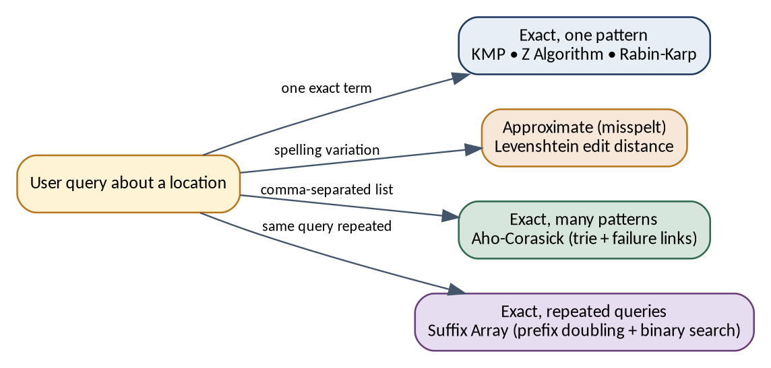
Figure 2.1: Kinds of location query handled by Property Finder and the algorithms used

2.2 Knuth–Morris–Pratt (KMP)
A naive search restarts the comparison from the next text position after every mismatch, which can repeat work. KMP avoids this by preprocessing the pattern into an LPS array (longest proper prefix that is also a suffix). After a mismatch, the LPS value tells how many characters of the pattern are already known to match, so the pattern shifts forward without moving the text pointer backwards. Preprocessing takes O(m) and the scan takes O(n), giving O(n + m) overall with O(m) extra space.
Table 2.1: Illustrative LPS array for the pattern ABABAC (not project data)
Index | 0 | 1 | 2 | 3 | 4 | 5
Pattern | A | B | A | B | A | C
LPS value | 0 | 0 | 1 | 2 | 3 | 0

For example, at index 4 the prefix ABABA has the longest proper prefix-suffix ABA, of length 3. If a mismatch occurs after matching ABABA, KMP continues by comparing the next text character with pattern position 3 instead of starting again. In Property Finder, KMP is the default exact algorithm for a single location term (rule R3, Section 4.5).

2.3 Z Algorithm
The Z Algorithm computes, for every position i of a string, the length Z[i] of the longest substring starting at i that matches a prefix of the string. It keeps the rightmost Z-box — the interval of the rightmost match found so far — and reuses it to avoid re-comparing characters, which makes the whole computation linear. To search, the pattern and text are joined with a separator that occurs in neither (pattern + separator + text), and every position whose Z value equals the pattern length marks an occurrence. The time is O(n + m).
Table 2.2: Illustrative Z array for the string aabxaab (not project data)
Index | 0 | 1 | 2 | 3 | 4 | 5 | 6
String | a | a | b | x | a | a | b
Z value | 7 | 1 | 0 | 0 | 3 | 1 | 0

Here Z[4] = 3 because the substring starting at index 4 (aab) equals the prefix aab. By convention Z[0] is set to the string length. Property Finder implements the separator as an integer sentinel value of -1: the pattern and text are converted to integer arrays, and -1 can never equal any Java char value, so a separator character inside real data cannot corrupt the boundary between pattern and text (Section 7.2).

2.4 Rabin–Karp
Rabin–Karp compares hash values instead of characters. The hash of the pattern is computed once; then a window of m characters slides across the text and its hash is updated in constant time by removing the contribution of the outgoing character and adding the incoming one (a rolling hash). Only when a window's hash equals the pattern's hash are the characters compared. Because different strings can share a hash (a collision), every hash hit must be verified character by character; Property Finder verifies every candidate so that collisions can never produce a false match. The expected time is O(n + m) and the worst case, when many collisions occur, is O(nm). The application also provides an optional randomised variant in which the modulus is chosen at random from a curated set of primes on every search call, which reduces the chance of an adversarial worst-case collision pattern; its average complexity is the same.
h(next) = ( d * ( h(window) - text[i] * d^(m-1) ) + text[i+m] ) mod q
d = alphabet base, q = modulus, m = pattern length, i = window start

2.5 Levenshtein Distance
The Levenshtein distance between two strings is the minimum number of single-character insertions, deletions and substitutions needed to turn one into the other. It is computed by dynamic programming (the Wagner–Fischer recurrence): with D[i][j] the distance between the first i characters of A and the first j characters of B,
D[i][0] = i , D[0][j] = j
D[i][j] = min( D[i-1][j] + 1 , // deletion
D[i][j-1] + 1 , // insertion
D[i-1][j-1] + cost ) // cost = 0 if A[i] = B[j], else 1

Table 2.3: Illustrative edit-distance table for "cat" and "cut" (distance = 1; not project data)
A \ B | "" | c | u | t
"" | 0 | 1 | 2 | 3
c | 1 | 0 | 1 | 2
a | 2 | 1 | 1 | 2
t | 3 | 2 | 2 | 1

The bottom-right cell is the distance: turning cat into cut needs one substitution. A misspelt locality such as Gachibowlii differs from Gachibowli by a single inserted letter and therefore has distance 1. Only the previous row of the table is needed to compute the next one, so a two-row table reduces memory compared with a full matrix. The cost is O(nm) per pair of strings. Standard Levenshtein counts an adjacent transposition as two edits, which is noted as a limitation (Section 7.3). In Property Finder, Levenshtein is the fuzzy fallback when a single term has no exact match, using a bounded tolerance.
Variants. The algorithm selector of the final application (Figure 6.3) also lists Damerau–Levenshtein Fuzzy Search and Weighted Edit Distance Fuzzy Search. According to the Algorithms Used dialog (Figure 6.12), the Damerau–Levenshtein option uses Lowrance–Wagner dynamic programming and treats a swapped pair of adjacent letters as a single edit, so a transposition costs one edit instead of two. The weighted option uses Wagner–Fischer dynamic programming with a character-pair-dependent substitution cost, so that adjacent-key and vowel typos score as closer matches than arbitrary substitutions. Both have O(nm) complexity.

2.6 Aho–Corasick
To search for several patterns, running a single-pattern algorithm once per pattern repeats the pass over the text. Aho–Corasick builds a trie (prefix tree) of all patterns and adds failure links: for each trie node, the failure link points to the node for the longest proper suffix of that node's string that is also a prefix of some pattern. The links are built by a breadth-first traversal. During the scan the automaton moves along trie edges, follows failure links on a mismatch, and reports every pattern that ends at the current node — all in a single pass. The time is O(n + M + z), where n is the text length, M the total length of all patterns and z the number of matches reported.
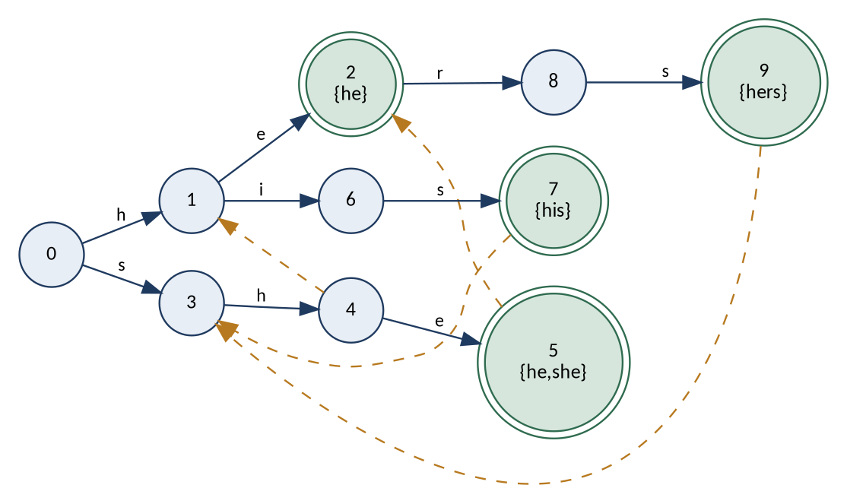
Figure 2.2: Illustrative Aho–Corasick automaton for the patterns he, she, his and hers (dashed arrows are failure links; not project data)
In the figure, the node for she (5) has a failure link to the node for he (2), so after matching she the automaton reports both she and he. Property Finder uses Aho–Corasick whenever the query is a comma-separated list of locations (rule R1).

2.7 Suffix Array
A suffix array lists the starting positions of all suffixes of a string in sorted order. Because the suffixes are sorted, any substring query can be answered with binary search, in O(m log n) time, after the index has been built once. The array can be built by prefix doubling: suffixes are first ranked by their first character, then by their first two, four, eight characters and so on, with each round sorted by counting sort, for a total build time of O(n log n). The LCP array (longest common prefix of neighbouring suffixes) can be computed in linear time by Kasai's algorithm and supports faster queries.
Table 2.4: Illustrative suffix array and LCP array for the text banana (not project data)
Rank | SA (start position) | Suffix | LCP with previous
0 | 5 | a | -
1 | 3 | ana | 1
2 | 1 | anana | 3
3 | 0 | banana | 0
4 | 4 | na | 0
5 | 2 | nana | 2

A query such as ana is found by binary search over the sorted suffixes: it is a prefix of the suffixes at ranks 1 and 2 (ana and anana), so the text contains it at positions 3 and 1. Property Finder builds its suffix array over distinct searchable location strings, builds it lazily the first time it is needed, and caches it for the current dataset selection, so a repeated query can reuse it (rule R2). In the run shown in Figure 6.8, the cached index covered 4,771 unique location strings that together cover all 321,470 properties. Kasai's LCP construction is listed in the application as a support algorithm rather than a search mode.

2.8 Graph Algorithm Extensions
Besides string search, the final application contains two tools built on graph algorithms (Figure 6.15). Their general theory is summarised here; their project-specific purpose is taken from the Algorithms Used dialog.
Maximum flow and Dinic's algorithm
A flow network is a directed graph with a source, a sink and a capacity on every edge; a maximum flow is the largest amount that can be sent from source to sink without exceeding any capacity. Dinic's algorithm repeats two steps. First a breadth-first search (BFS) builds a level graph that assigns each vertex its distance from the source; then a depth-first search (DFS) finds a blocking flow that uses only edges going from one level to the next. Keeping a per-vertex edge pointer lets the DFS skip edges that are already exhausted instead of re-scanning them. The running time is O(V²E) in general and O(E√V) on unit-capacity networks.
Property Finder uses it for buyer-to-property allocation: a bipartite network source → buyers → properties → sink in which the maximum flow equals the largest number of buyers that can each be matched to an eligible, in-budget property with no property double-booked. The implementation classes are algo.DinicMaxFlow and service.PropertyAllocationService.
Vertex cover and its 2-approximation
A vertex cover of a graph is a set of vertices that touches every edge. Finding a minimum vertex cover is NP-hard, but a simple greedy edge-picking algorithm gives a cover at most twice the optimal size: repeatedly pick an edge that is not yet covered, add both of its endpoints to the cover, and discard every edge touching them. The picked edges share no vertex, and any cover — including the optimal one — must contain at least one endpoint of each of them, so the result is at most twice the optimum. After the graph is built, the running time is O(V + E).
Property Finder uses it to choose representative area spellings. The graph has one vertex per distinct location string, and an edge joins two strings whose Damerau–Levenshtein distance is small, which flags likely duplicates such as “Gachibowli” and “Gachibowlii”. The graph is built with bucketed distance comparisons, and the cover then yields a limited set of representative spellings. The implementation classes are algo.VertexCoverApprox and service.RepresentativeAreaService.

2.9 Comparison of the Algorithms
Table 2.5: Comparison of the algorithms used in Property Finder
Algorithm | Match type | Core structure | Complexity | Role in Property Finder
KMP | Exact, one pattern | LPS array | O(n+m) overall | Default single exact location search
Z Algorithm | Exact, one pattern | Z array + Z-box | O(n+m) | Exact search; cross-check in Compare mode
Rabin-Karp | Exact, one pattern | Rolling hash | O(n+m) average; O(nm) worst | Hash-based exact search; cross-check
Levenshtein | Approximate | Two-row DP | O(nm) per pair | Misspelt locations (fuzzy fallback)
Aho-Corasick | Exact, many patterns | Trie + failure links | O(n+M+z) | Comma-separated locations
Suffix Array | Exact, indexed | Prefix doubling + binary search | Build O(n log n) | Repeated queries on the same dataset selection
Damerau-Levenshtein | Approximate | DP with transposition | O(nm) | Fuzzy option: swapped letters cost one edit
Weighted edit distance | Approximate | DP with pair-dependent cost | O(nm) | Fuzzy option: adjacent-key and vowel typos score closer
Dinic max flow | Graph | BFS level graph + DFS blocking flow | O(V²E); O(E√V) unit capacity | Property Allocation tool
Vertex cover (2-approx.) | Graph | Greedy edge picking | O(V+E) after graph build | Representative Areas tool

2.10 Why Adaptive Algorithm Selection
Table 2.5 shows that each algorithm is best for a different problem shape: there is no algorithm that is the right answer to every query. Rather than leaving the choice entirely to the user, Property Finder offers an Auto mode that selects an algorithm from the shape of the query using four rules (R1–R4) plus an additional parallel-execution rule (R5), described in Section 4.5. The decision system is deterministic: the same query in the same session state always produces the same decision. Manual selection remains available for every algorithm.

2.11 Supporting Technologies and Concepts
- Java Swing and Nimbus. Swing is Java's desktop GUI toolkit; the application uses the Nimbus look and feel, with a safe fallback if Nimbus is unavailable. Results are shown in a JTable.
- Event-dispatch thread (EDT). All Swing components must be updated on the EDT, so long-running work must be kept off it or the window freezes.
- SwingWorker. A Swing utility that runs a task on a background thread and delivers the result back on the EDT; Property Finder uses it for dataset loading and searching.
- Thread-pool parallelism. A large list can be divided into contiguous chunks that are searched by worker threads and merged in original order; this is used for qualifying exact searches over All Sources.
- CSV/TSV-like dataset parsing. The datasets are plain-text files whose schemas and delimiters differ, so dataset-specific loaders convert rows to a common model.
- Timing with System.nanoTime(). Algorithm timing is measured around the algorithm work only, not around dataset loading or GUI rendering; a warm-up reduces just-in-time (JIT) compilation bias in Compare mode.

Chapter 3: System Requirements

3.1 Functional Requirements
Table 3.1: Functional requirements
ID | Requirement
FR-01 | Load the GUI datasets and isolate failures so one missing file does not disable unrelated sources.
FR-02 | Allow the user to select one dataset or All Sources.
FR-03 | Accept a single location or a comma-separated list of locations.
FR-04 | Perform case-insensitive location matching over locality, city and state.
FR-05 | Support Auto, KMP, Z, Rabin-Karp, Levenshtein, Aho-Corasick, Suffix Array and Compare Exact Algorithms; the final algorithm selector also offers Damerau–Levenshtein and Weighted Edit Distance fuzzy-search options.
FR-06 | Display the Auto-selected algorithm, reason, technique and complexity.
FR-07 | Display results in a JTable and open a detailed property dialog.
FR-08 | Format prices in rupees, including Lakh, Crore and monthly-rent forms.
FR-09 | Use background processing so loading/searching does not freeze the GUI.
FR-10 | Provide an Algorithms Used dialog showing algorithm categories and implementation status.
FR-11 | Retain the terminal CLI for demonstration and debugging.
FR-12 | Provide a Property Allocation tool that allocates buyers to eligible, in-budget properties using maximum flow.
FR-13 | Provide a Representative Areas tool that selects representative area spellings using a vertex-cover approximation.

3.2 Non-Functional Requirements
Table 3.2: Non-functional requirements
Requirement | Project implementation
Usability | Nimbus Swing interface, resizable window, dataset/algorithm controls and details dialog.
Responsiveness | SwingWorker for long-running loading and search tasks.
Correctness | KMP, Z and Rabin-Karp cross-checked in Compare Exact Algorithms mode.
Maintainability | Search, service, loader, model, GUI and utility responsibilities separated.
Determinism | Auto routing is rule-based, reproducible and not machine learning.
Robustness | Malformed rows are skipped/countable; missing files affect only their own dataset.
Transparency | Every Auto decision can expose algorithm, reason, technique and complexity.

3.3 Software, Hardware and Dataset Requirements
Table 3.3: Software, hardware and dataset requirements
Component | Requirement / use
Programming language | Java
GUI framework | Java Swing
Look and feel | Nimbus, with safe fallback
Concurrency | SwingWorker and thread-pool based parallel search
Input data | Plain-text CSV/TSV-like datasets
Build / run | run.ps1; compiled classes are written to out/
CLI | java -cp out cli.PatternSearchDemo
Processing | A multi-core CPU benefits the optional Parallel Dataset Search; the application also works without it
Memory | Enough memory to hold the loaded property records of the selected datasets

The exact Java version, operating-system version and hardware specification of the development machines were not recorded in the project documentation and are therefore not stated here.

3.4 Dataset Requirements
According to the project documentation, the GUI uses 38 loadable files containing 321,470 property records in total: the pan-India source up.txt, 36 state and union-territory files, and Indian_House_Rent_Unassigned.txt. Several older sources (Delhi, Hyderabad and rent data) were merged into the state files; the Source field preserves where each record originally came from. Rent records whose city is blank or unreadable (655 rows) are kept in Indian_House_Rent_Unassigned.txt rather than being assigned to a guessed state. The full inventory is given in Table 6.2.

Chapter 4: System Design

4.1 High-Level Architecture
Property Finder follows a layered architecture (Figure 4.1). The presentation layer handles user interaction; the service layer coordinates routing, repository access and search execution; the algorithm layer contains the actual DSA implementations; the data-access layer converts heterogeneous rows into UnifiedProperty objects; and the storage layer contains the property datasets. Each layer uses only the layer below it, and the algorithm classes do not depend on Swing, which allows them to be tested independently of the user interface.
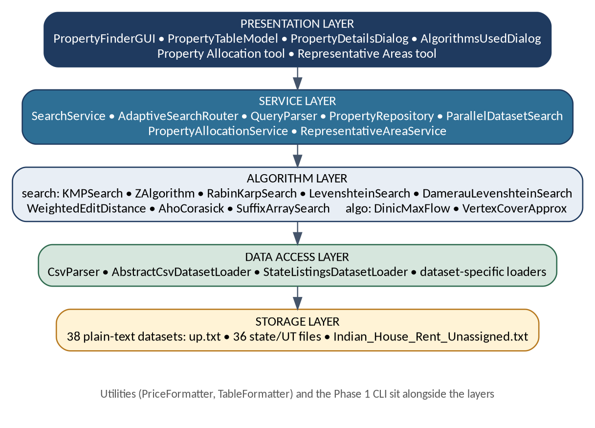
Figure 4.1: Layered system architecture of Property Finder

4.2 Layer and Module Description
Table 4.1: Layers, main classes and responsibilities
Layer | Main classes / files | Responsibility
Presentation | PropertyFinderGUI, PropertyTableModel, PropertyDetailsDialog, AlgorithmsUsedDialog | Input controls, JTable results, details and algorithm information.
Service | SearchService, AdaptiveSearchRouter, QueryParser, PropertyRepository, ParallelDatasetSearch, PropertyAllocationService, RepresentativeAreaService | Coordinates data, routing, execution and result objects.
Algorithm | KMPSearch, ZAlgorithm, RabinKarpSearch, LevenshteinSearch, DamerauLevenshteinSearch, WeightedEditDistance, AhoCorasick, SuffixArraySearch, DinicMaxFlow, VertexCoverApprox | Implements exact, fuzzy, multi-pattern, indexed and graph algorithms.
Data access | CsvParser, AbstractCsvDatasetLoader, StateListingsDatasetLoader and specialised loaders | Reads source files and maps them to UnifiedProperty.
Storage | up.txt, state/UT datasets and unassigned rent data | Persistent project datasets used by the GUI.

Two further groups sit alongside the layers: the utilities (PriceFormatter for rupee formatting and TableFormatter for CLI table output) and the tools/CLI (MergeIntoStateFiles for regenerating merged datasets, and PatternSearchDemo, the Phase 1 command-line interface).

4.3 Data Model and Dataset Organisation
UnifiedProperty is the main cross-dataset representation. It stores source provenance together with the common fields of a property: title, locality, city, state, type/configuration, area, price or rent, furnishing, bathroom information, listing type and description. Source-specific rows are first represented as PropertyRecord objects and then mapped into UnifiedProperty. Preserving the Source field is important because several older sources were merged into state files; the user can still identify where a result originally came from.
Table 4.2: Fields of the UnifiedProperty model
Field | Description
Source | Original dataset/source name retained after merging.
Property | Property title or source-derived name.
Location | Locality or area component.
City / State | Geographic fields used for location searching.
Type / Config | Property type and BHK/configuration where available.
Area | Reported property area.
Price / Rent | Source value formatted by PriceFormatter.
Furnishing | Furnishing status if present.
Bathrooms / Tenant | Additional source fields where available.
Listing Type | Sale or rent classification.
Description | Optional trailing source description.

4.4 Dataset Integration Design
The datasets come from different sources and use different schemas and delimiters. Figure 4.2 shows how they are integrated. CsvParser handles the low-level parsing of delimited text; AbstractCsvDatasetLoader provides the common loading behaviour; StateListingsDatasetLoader reads the state and union-territory files; and specialised loaders handle the pan-India (up), Hyderabad, Delhi and rent sources. Every loader produces UnifiedProperty objects, which PropertyRepository holds by dataset and which SearchService then searches.
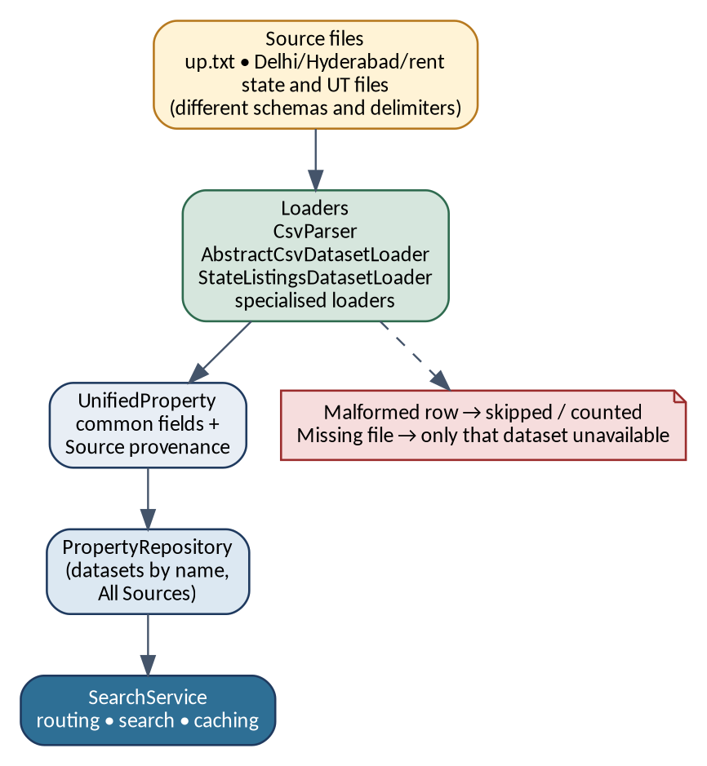
Figure 4.2: Dataset integration pipeline
Integration is designed to be fault-tolerant: a malformed row is skipped and can be counted without terminating the whole load, and a missing file makes only its own dataset unavailable. The MergeIntoStateFiles tool regenerates the merged state files, and rent rows whose city is blank or unreadable are kept in Indian_House_Rent_Unassigned.txt instead of being assigned to a guessed state.

4.5 Adaptive Routing Design
Auto mode is implemented as a deterministic decision system, not as a learned model. The AdaptiveSearchRouter examines the query and the session state and returns a RouterDecision containing the chosen algorithm, the reason, the technique and its complexity, all of which the GUI can display. Figure 4.3 shows the decision flow and Table 4.3 lists the rules.
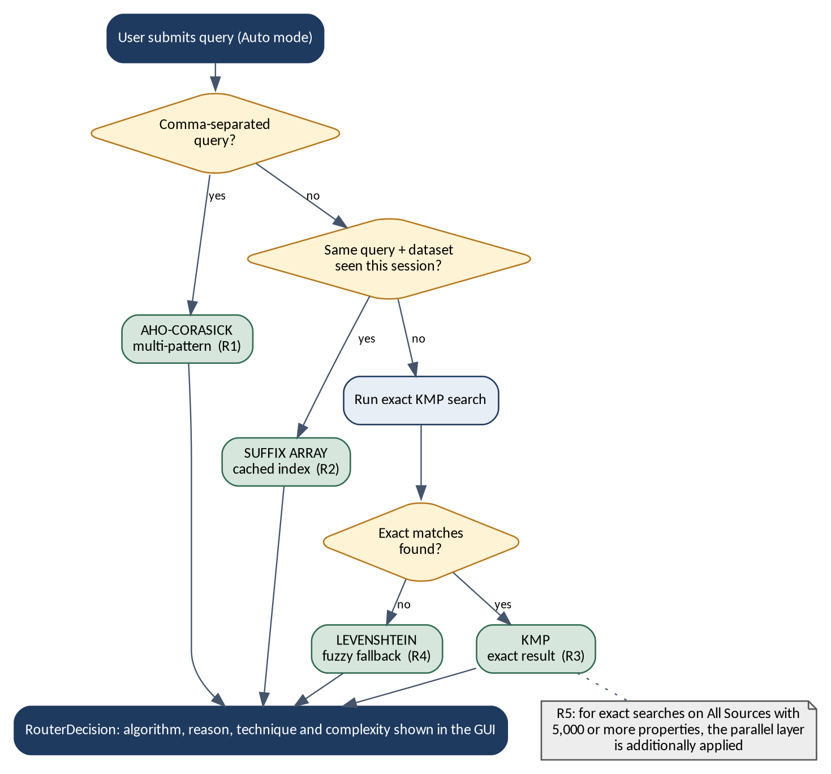
Figure 4.3: Decision flow of the Adaptive Algorithm Selection Engine
Table 4.3: Adaptive routing rules
Rule | Condition | Selection | Reason
R1 | Comma-separated query | Aho-Corasick | Search several patterns in one corpus pass.
R2 | Same query + same dataset seen in current session | Suffix Array | Reuse cached index for repeated queries.
R3 | Single term with exact matches | KMP | Predictable linear-time exact search.
R4 | Single term with zero exact matches | Levenshtein fallback | Handle likely spelling variation.
R5 | Large All Sources exact workload | Parallel layer additionally applied | Use multiple workers without changing match semantics.

The rules are evaluated in order. A comma-separated query is treated as a multi-pattern request (R1). Otherwise the router builds a key from the dataset selection and the lower-cased query; if the key has been searched earlier in the session, the cached suffix-array index is used (R2). For a first-time single term, an exact KMP search is run; if it finds matches, KMP is the result (R3), and if it finds none, Levenshtein is used as a fuzzy fallback (R4). R5 does not choose a different algorithm: it adds the parallel execution layer to qualifying exact searches over All Sources (Section 4.6). Compare Exact Algorithms is always a manual selection and is never chosen by Auto.

4.6 Concurrency Design
Keeping the GUI responsive
The Swing event-dispatch thread (EDT) is kept free of long-running work. As Figure 4.4 shows, the EDT collects the user's choices; a SwingWorker performs parsing, routing and searching on a background thread; and the structured result is returned to the EDT, which updates the table, the statistics and the decision information. Dataset loading uses the same mechanism.
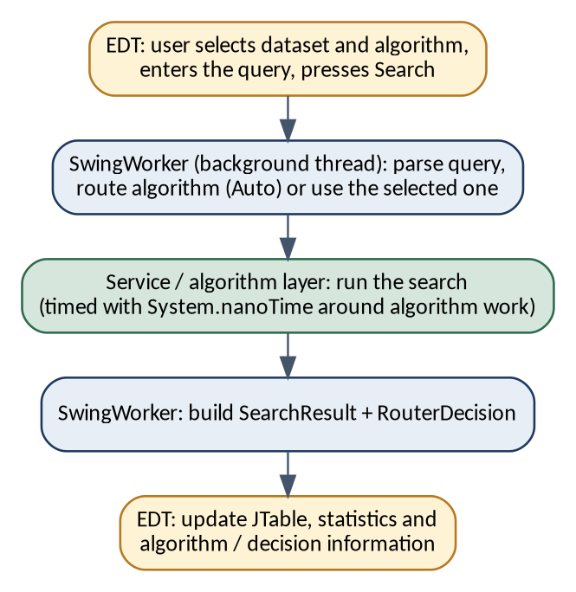
Figure 4.4: Search workflow across the EDT, SwingWorker and service layer
Chunked parallel search with ordered merge
For qualifying exact searches over All Sources — according to the project design, workloads of 5,000 or more properties — the property list is split into contiguous chunks, each chunk is searched by a worker thread, and the partial results are merged in the original order (Figure 4.5). Because the chunks are contiguous and merged in order, the parallel search returns the same matches in the same order as a sequential search; parallelism changes the speed, not the semantics.
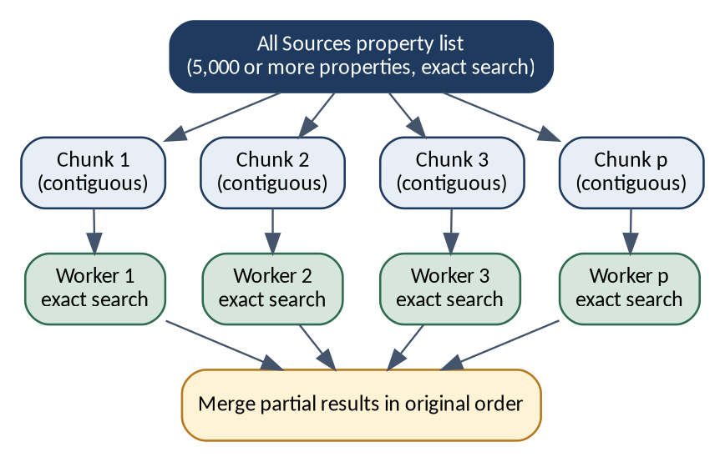
Figure 4.5: Chunked parallel search with ordered merge
Compare Exact Algorithms
Compare mode runs KMP, Z Algorithm and Rabin-Karp sequentially on identical normalised input (Figure 4.6). An untimed warm-up reduces first-run JIT bias, each algorithm is timed with System.nanoTime() around the algorithm work only, and the three independent results are compared. Their property sets and occurrence counts should agree, which makes this mode a built-in correctness check as well as a timing display.
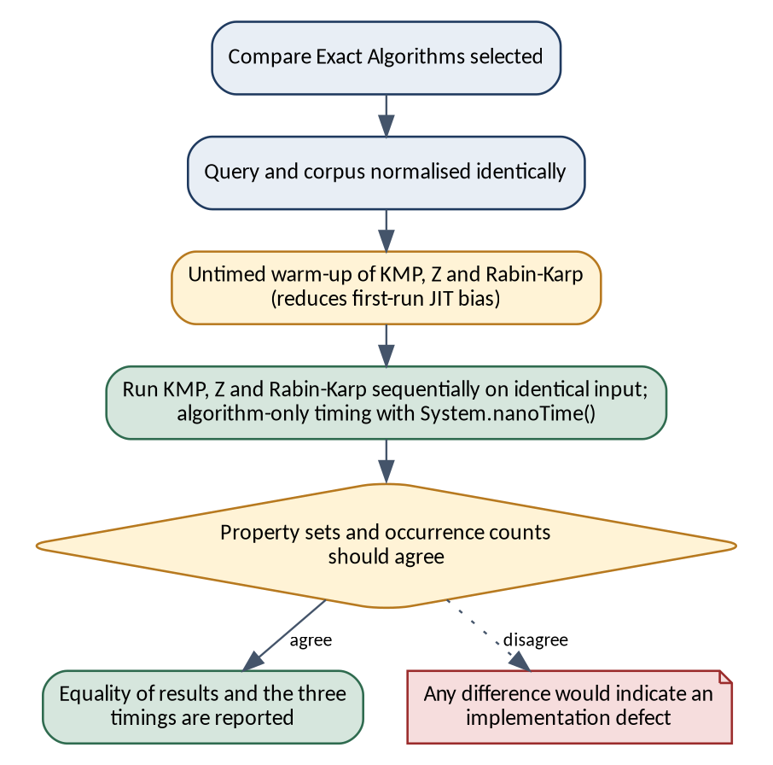
Figure 4.6: Workflow of the Compare Exact Algorithms mode

4.7 User Interface Design
The main window is a resizable Swing window using the Nimbus look and feel. PropertyFinderGUI contains the search field, the Search and Clear actions, the algorithm and dataset selectors, an algorithm status area, search statistics, the result table, the View Details action and access to the Algorithms Used dialog. PropertyTableModel maps UnifiedProperty records to the columns of the JTable; PropertyDetailsDialog shows the additional source fields of a selected result (also opened by double-clicking a row); and AlgorithmsUsedDialog lists the algorithm categories — search algorithms, support algorithms and performance extensions — with their implementation status. In the final design this dialog replaced the separate “How It Works” control of the earlier development-stage window, keeping the main interface cleaner (see Figures 6.2 and 6.3). The final window also has Property Allocation and Representative Areas buttons beside Algorithms Used (Figure 6.3); they give access to the max-flow allocation tool and the vertex-cover representative-areas tool (Section 5.2).

4.8 Key Design Decisions
Table 4.4: Key design decisions and their rationale
Decision | Rationale
Algorithm classes independent of Swing | Allows the algorithms to be tested and reasoned about independently of the GUI.
Rule-based Auto routing | Reproducible, inspectable and explainable in a viva; explicitly not machine learning.
Manual override retained | The user can always choose any implemented algorithm, which supports demonstration and comparison.
UnifiedProperty with Source provenance | One model for all datasets while still showing where each result originally came from.
Per-dataset fault isolation | A missing file or malformed row must not disable unrelated sources.
Integer sentinel -1 in the Z Algorithm | A separator character inside real data could corrupt boundary matching; -1 can never equal a Java char.
Verification of every Rabin-Karp hash hit | Hash collisions must not produce false matches.
Two-row dynamic programming for Levenshtein | Reduces memory compared with a full matrix.
Lazy, cached suffix-array index | The index is built only when needed and reused for the current dataset selection.
Contiguous chunks merged in original order | Parallel search returns the same result order as sequential search.
Timing around algorithm work only | Excludes dataset loading and GUI rendering from the measured time.
Unassigned rent file | Rows with unreadable cities are not assigned to a guessed state.
Optional randomised modulus for Rabin-Karp | Reduces the chance of an adversarial worst-case collision pattern; average complexity is unchanged.
Graph algorithms in a separate package | Dinic max flow and vertex cover live in the algo package, with service classes (PropertyAllocationService, RepresentativeAreaService) between them and the GUI.

Chapter 5: Implementation

5.1 Module-wise Implementation
The code base is organised into packages (modules) with separate responsibilities, summarised in Table 5.1.
Table 5.1: Modules, classes and responsibilities
Module | Classes | Responsibility
search | KMPSearch, ZAlgorithm, RabinKarpSearch, LevenshteinSearch, DamerauLevenshteinSearch, WeightedEditDistance, AhoCorasick, SuffixArraySearch | Core DSA implementations and fuzzy variants.
algo | DinicMaxFlow, VertexCoverApprox | Graph algorithm extensions.
model | PropertyRecord, UnifiedProperty | Source-specific and unified property representations.
loader | CsvParser, AbstractCsvDatasetLoader and dataset-specific loaders | Read, parse and transform heterogeneous text/CSV data.
service | PropertyRepository, SearchService, AdaptiveSearchRouter, QueryParser, PropertyAllocationService, RepresentativeAreaService | Coordinate datasets, search, routing, index caching and the two graph tools.
performance | ParallelDatasetSearch | Execute qualifying exact searches across chunks concurrently.
gui | PropertyFinderGUI, PropertyTableModel, PropertyDetailsDialog, AlgorithmsUsedDialog | Desktop presentation layer.
utils | PriceFormatter, TableFormatter | Rupee formatting and CLI table output.
tools / cli | MergeIntoStateFiles, PatternSearchDemo | Dataset merge regeneration and the Phase 1 CLI.

5.2 Algorithm Implementation
The core algorithms are implemented manually in the search module and the graph algorithms in the algo module; Table 5.2 is the algorithm catalogue shown by the Algorithms Used dialog (Figures 6.11–6.16). The outline pseudocode below describes each algorithm as it is implemented in the project, following the implementation notes in the project documentation; the notes also explain what is distinctive about each implementation.
Table 5.2: Algorithm catalogue as shown by the Algorithms Used dialog
Algorithm | Category | Technique | Complexity | Java class | Status
KMP | Exact | LPS array (prefix function) | O(n + m) | search.KMPSearch | Implemented; used by Auto; comparison
Z Algorithm | Exact | Z array + Z-box [L, R] | O(n + m) | search.ZAlgorithm | Implemented; comparison
Rabin–Karp | Exact | Rolling hash + character verification | O(n + m) avg; O(nm) worst | search.RabinKarpSearch | Implemented; comparison
Levenshtein | Fuzzy | Wagner–Fischer DP | O(n · m) | search.LevenshteinSearch | Implemented; used by Auto
Damerau–Levenshtein | Fuzzy | Lowrance–Wagner DP (edit distance + transposition) | O(n · m) | search.DamerauLevenshteinSearch | Implemented; comparison algorithm
Weighted Edit Distance | Fuzzy | Wagner–Fischer DP, character-pair-dependent substitution cost | O(n · m) | search.WeightedEditDistance | Implemented; comparison algorithm
Aho–Corasick | Multi-pattern | Trie + failure links (automaton) | O(n + m + z) | search.AhoCorasick | Implemented; used by Auto
Suffix Array | Indexed | Radix-sort prefix doubling + Kasai LCP | O(n log n) build; O(m log n) per query | search.SuffixArraySearch | Implemented; used by Auto
Kasai LCP Array | Support | Rank array + previous-match-length reuse | O(n) | search.SuffixArraySearch#kasaiLcp | Support algorithm
Parallel Dataset Search | Performance | Fixed thread pool, equal contiguous chunks, ordered merge | O(n / p + m) per thread | service.ParallelDatasetSearch | Performance layer
Randomized Hashing | Performance extension | Modulus chosen at random from a curated prime set on every search call | O(n + m) average | search.RabinKarpSearch#searchRandomized | Implemented (optional extension)
Adaptive Algorithm Selection Engine | Router | Rule-based dispatch on query shape and first-attempt outcome | Cost of the selected algorithm | service.AdaptiveSearchRouter | Implemented
Max Flow (Dinic) | Graph | BFS level graph + DFS blocking flow, per-vertex edge pointers | O(V²E) general; O(E√V) unit capacity | algo.DinicMaxFlow / service.PropertyAllocationService | Implemented (Property Allocation tool)
Vertex Cover (2-approximation) | Graph | Greedy edge picking over a graph of location strings | O(V + E) after O(n log n)-scale bucketed comparisons | algo.VertexCoverApprox / service.RepresentativeAreaService | Implemented (Representative Areas tool)

KMP — KMPSearch
KMP builds an LPS array and scans the location text without moving the text pointer backwards.
ALGORITHM KMPSearch(text, pattern)
lps <- BuildLPS(pattern) // O(m)
i <- 0 ; j <- 0
WHILE i < length(text)
IF text[i] = pattern[j] THEN i <- i+1 ; j <- j+1
IF j = length(pattern) THEN record match at i-j ; j <- lps[j-1]
ELSE IF i < length(text) AND text[i] != pattern[j] THEN
IF j != 0 THEN j <- lps[j-1] ELSE i <- i+1

Z Algorithm — ZAlgorithm
The Z Algorithm works on an integer representation of the pattern and text joined by a sentinel value of -1, which cannot collide with any Java char value.
ALGORITHM ZSearch(text, pattern)
s <- codes(pattern) + [-1] + codes(text) // -1 never equals a char code
Z <- ComputeZ(s) // O(|s|) using the rightmost Z-box
FOR each position k after the sentinel
IF Z[k] = length(pattern) THEN record match at k - length(pattern) - 1

Rabin-Karp — RabinKarpSearch
Rabin-Karp maintains a rolling hash and verifies every candidate hash match character by character.
ALGORITHM RabinKarpSearch(text, pattern)
hp <- hash(pattern) ; hw <- hash(text[0 .. m-1])
FOR i <- 0 TO n-m
IF hw = hp AND text[i .. i+m-1] equals pattern // verify every hash hit
THEN record match at i
IF i < n-m THEN hw <- roll(hw, text[i], text[i+m])

Levenshtein — LevenshteinSearch
Levenshtein search uses the Wagner–Fischer recurrence with a two-row table, reducing memory compared with a full matrix. Matching is bounded by a tolerance, so heavily misspelt names may not be returned.
ALGORITHM Distance(a, b)
prev <- [0 .. length(b)]
FOR i <- 1 TO length(a)
cur[0] <- i
FOR j <- 1 TO length(b)
cost <- (a[i] != b[j]) ? 1 : 0
cur[j] <- MIN(prev[j]+1, cur[j-1]+1, prev[j-1]+cost)
prev <- cur
RETURN prev[length(b)] // accept if the distance is within the tolerance

Aho-Corasick — AhoCorasick
Aho-Corasick builds a trie for all query patterns and constructs failure links using breadth-first search, so several locations are matched in one pass.
ALGORITHM AhoCorasickSearch(text, patterns)
trie <- build trie of all patterns ; mark the end node of each pattern
BFS from the root: failure[child] <- longest proper suffix of the child
that is also a prefix in the trie
state <- root
FOR each character c of text
WHILE state has no edge c AND state != root DO state <- failure[state]
IF state has edge c THEN state <- child(state, c)
report every pattern that ends at state (also via failure links)

Suffix array — SuffixArraySearch
SuffixArraySearch builds an index over distinct searchable location strings, constructs the suffix array by prefix doubling with counting sort, and uses Kasai LCP support. The index is built lazily and cached for the current dataset selection. A query is answered by binary search; matching location strings are mapped back to property records, and properties are returned in dataset order (Pseudocode 5.3).
Damerau–Levenshtein and weighted edit distance — DamerauLevenshteinSearch, WeightedEditDistance
Both fuzzy variants extend the two-row Wagner–Fischer idea. The Damerau–Levenshtein option adds a transposition operation using Lowrance–Wagner dynamic programming, so a swapped pair of adjacent letters costs one edit. The weighted option makes the substitution cost depend on the pair of characters, so that adjacent-key and vowel typos are scored as closer matches than arbitrary substitutions.
ALGORITHM WeightedDistance(a, b)
fill the DP table as in the Levenshtein recurrence, but
substitution cost <- cost(a[i], b[j]) // lower for adjacent-key and
// vowel pairs than for other pairs
ALGORITHM DamerauDistance(a, b)
fill the DP table as in the Levenshtein recurrence, and also
IF a[i-1..i] is a swapped pair of b[j-1..j] THEN
allow the transposition as a single edit

Randomised hashing — RabinKarpSearch#searchRandomized
The optional randomised variant of Rabin–Karp chooses the modulus at random from a curated set of primes on every search call, which reduces the chance of an adversarial worst-case collision pattern. Every hash hit is still verified character by character, and the average complexity stays O(n + m).
Max flow — DinicMaxFlow and PropertyAllocationService
The Property Allocation tool models buyers and properties as a bipartite unit-capacity network (source → buyers → properties → sink). DinicMaxFlow computes the maximum flow with a BFS level graph, a DFS blocking flow and per-vertex edge pointers; the flow value is the largest number of buyers that can be matched to an eligible, in-budget property with no property double-booked.
ALGORITHM Dinic(s, t)
flow <- 0
WHILE BFS from s builds a level graph in which t is reachable
set every vertex edge pointer to 0
REPEAT f <- DFS(s, t, infinity) ; flow <- flow + f UNTIL f = 0
RETURN flow
ALGORITHM DFS(v, t, pushed)
IF v = t THEN RETURN pushed
WHILE pointer[v] < number of edges of v
e <- edge at pointer[v]
IF e has residual capacity AND level[e.to] = level[v] + 1 THEN
d <- DFS(e.to, t, MIN(pushed, residual of e))
IF d > 0 THEN update residual capacities ; RETURN d
pointer[v] <- pointer[v] + 1
RETURN 0

Vertex cover — VertexCoverApprox and RepresentativeAreaService
The Representative Areas tool builds a graph whose vertices are distinct location strings and whose edges join strings within a small Damerau–Levenshtein distance (found with bucketed comparisons). VertexCoverApprox then applies greedy edge picking, which yields a cover at most twice the optimal size, and the cover supplies the limited set of representative spellings.
ALGORITHM VertexCover2Approx(G)
cover <- empty set
WHILE G has an edge (u, v) with neither endpoint in cover
add u and v to cover
RETURN cover // size is at most 2 x optimal

5.3 Query Parsing and Routing
QueryParser splits the input into one or more patterns: a comma-separated query yields several patterns, which is the condition for Aho-Corasick. Matching is case-insensitive, so queries and location text are normalised to the same case before searching. AdaptiveSearchRouter implements rules R1–R4 of Table 4.3 and returns a RouterDecision; the router uses a key made of the dataset selection and the lower-cased query to recognise a repeated search within the current session. This repeated-query state, and the suffix-array indexes, are session-scoped: they are rebuilt after the application is restarted.

5.4 Dataset Loading and Unification
Loading is performed by CsvParser, AbstractCsvDatasetLoader, StateListingsDatasetLoader and the specialised loaders for the pan-India, Hyderabad, Delhi and rent sources. Each loader maps its source-specific columns into UnifiedProperty and records the source name in the Source field. A malformed row is skipped and can be counted, and a missing file disables only its own dataset, so the remaining datasets stay usable. PropertyRepository then makes the datasets available individually or as All Sources.

5.5 GUI and Background Processing
Dataset loading and substantial searches run in SwingWorker background tasks. This keeps the window responsive and ensures that table updates are performed on the event-dispatch thread. When a search completes, the GUI shows the results in the JTable, the search statistics, and — in Auto mode — the algorithm chosen together with the reason, technique and complexity. Search timing uses System.nanoTime() around the algorithm work, not around dataset loading or GUI rendering.

5.6 Parallel Dataset Search
ParallelDatasetSearch (module performance) implements the design of Section 4.6. For qualifying exact searches over All Sources, it divides the property list into contiguous chunks, runs the exact search on each chunk with a pool of worker threads, and merges the partial results in the original order. The speed-up obtained depends on the CPU core count, the JVM state, the dataset size and the query distribution; no universal speed-up is claimed (Section 6.5).

5.7 Algorithm Comparison Mode
In Compare Exact Algorithms mode the application warms up KMP, Z Algorithm and Rabin-Karp without timing, runs all three sequentially on identical normalised input, compares the results and records System.nanoTime() timings. Three independent implementations agreeing on the same input is strong evidence that each is correct. Timing is shown for observation, but it should not be read as proof that one algorithm is universally better than another.

5.8 Price Formatting and Utilities
PriceFormatter converts stored price or rent values into readable rupee forms. The documented examples are ₹32,500/month for a monthly rent, ₹63 L for a price in lakhs and ₹1.85 Cr for a price in crores. In the screenshots of the final application (Figures 6.5–6.7 and 6.10), rents appear as, for example, ₹120,000/month and sale prices as full rupee amounts with digit grouping, such as ₹15,000,000; the Lakh and Crore forms do not appear in the captured screens. TableFormatter produces the table output of the CLI.

5.9 Build, Run and Command-Line Interface
The project is built and run with the run.ps1 PowerShell script, which writes the compiled classes to the out/ directory. The Phase 1 command-line interface is retained for demonstration and debugging and is started with:
java -cp out cli.PatternSearchDemo

5.10 Pseudocode
The following pseudocode, taken from the project documentation, describes the main workflows.
Pseudocode 5.1 — Main search workflow
BEGIN
read dataset selection
read query
parse query into one or more patterns
IF algorithm mode = Auto THEN
decision <- AdaptiveSearchRouter.choose(query, dataset, session state)
selectedAlgorithm <- decision.algorithm
ELSE
selectedAlgorithm <- user-selected algorithm
END IF
IF selectedAlgorithm = Compare Exact Algorithms THEN
warm up KMP, Z and Rabin-Karp
run all three sequentially on identical input
compare results and record nanoTime timings
ELSE IF large All Sources exact search qualifies THEN
split properties into contiguous chunks
search chunks using worker threads
merge results in original order
ELSE
run selected algorithm through SearchService
END IF
construct SearchResult
update GUI table
display algorithm/decision information
END

Pseudocode 5.2 — Adaptive Auto router
BEGIN
patterns <- parse query
IF multiple comma-separated patterns THEN RETURN AHO_CORASICK
key <- dataset selection + lower-case query
IF key searched previously in current session THEN RETURN SUFFIX_ARRAY
exactResults <- KMP(query)
IF exactResults are not empty THEN RETURN KMP
ELSE RETURN LEVENSHTEIN
END

Pseudocode 5.3 — Suffix array search
BEGIN
IF suffix index for current dataset does not exist THEN
collect distinct searchable location strings
build suffix array using prefix doubling and counting sort
build rank/LCP support
cache index
END IF
binary-search suffix array for query prefix
map matching location strings back to property records
return properties in dataset order
END

Chapter 6: Results and Testing

6.1 Functional Results
The finished application provides a working Java Swing GUI with dataset selection, manual algorithm selection, Auto routing, exact, fuzzy and multi-pattern location searches, indexed repeated search, algorithm comparison, property details, algorithm information, price formatting, background processing, and two graph-algorithm tools. The original terminal CLI remains available. The features and their status are given in Table 6.1.
Table 6.1: Features delivered
Feature | Result
Desktop GUI | Implemented with Java Swing and Nimbus look and feel (Figure 6.3).
Exact search | KMP, Z Algorithm and Rabin-Karp implemented; an optional randomised-modulus variant of Rabin-Karp is also implemented.
Fuzzy search | Levenshtein, Damerau–Levenshtein and Weighted Edit Distance fuzzy-search options implemented (Figures 6.3 and 6.12).
Multi-pattern search | Aho-Corasick implemented for comma-separated patterns (Figure 6.7).
Indexed search | Suffix Array search with Kasai LCP and a cached index implemented (Figure 6.8).
Algorithm comparison | KMP / Z / Rabin-Karp run on identical input with result-equality check (Figure 6.9).
Background processing | SwingWorker used for loading and searching.
Parallel layer | ParallelDatasetSearch implemented for qualifying large All Sources exact searches; Figure 6.5 shows it enabled with 16 chunks on 16 threads.
Property details | Detailed result dialog implemented (Figure 6.10).
Algorithms Used | Dialog lists exact, fuzzy, multi-pattern, indexed, performance, router and graph-algorithm categories with purpose, technique, complexity, Java class and status, followed by the Auto routing rules (Figures 6.11–6.16).
Property Allocation | Tool based on Dinic's maximum-flow algorithm: maximises how many buyers can be matched to an eligible, in-budget property with no property double-booked (Figure 6.15).
Representative Areas | Tool based on a vertex-cover 2-approximation: selects a limited set of representative area spellings by flagging likely-duplicate location strings (Figure 6.15).

6.2 Dataset Results
Table 6.2 gives the dataset inventory reported in the project documentation: 38 GUI-loadable files and 321,470 property records. The row counts have been carried into this report unchanged; they sum to the stated total. The status line of the final application confirms the totals: it reads “38 of 38 datasets loaded. 321470 properties available. Ready.” (Figures 6.3 and 6.4).
Table 6.2: Reported dataset inventory
Dataset / group | Reported rows | Notes
up.txt | 269,418 | Pan-India property source.
Indian_House_Rent_Unassigned.txt | 655 | Rent rows with blank/unreadable city.
Delhi.txt | 6,698 | State file including integrated legacy Delhi/rent rows.
Telangana.txt | 2,084 | State file including Hyderabad/rent rows.
Tamil_Nadu.txt | 1,938 | State file including rent rows.
Karnataka.txt | 1,932 | State file including rent rows.
Maharashtra.txt | 2,000 | State file including rent rows.
West_Bengal.txt | 1,615 | State file including rent rows.
Other 30 state/UT files | 35,130 | 1,171 rows each in the reported dataset inventory.
Total | 321,470 | 38 GUI-loadable files.

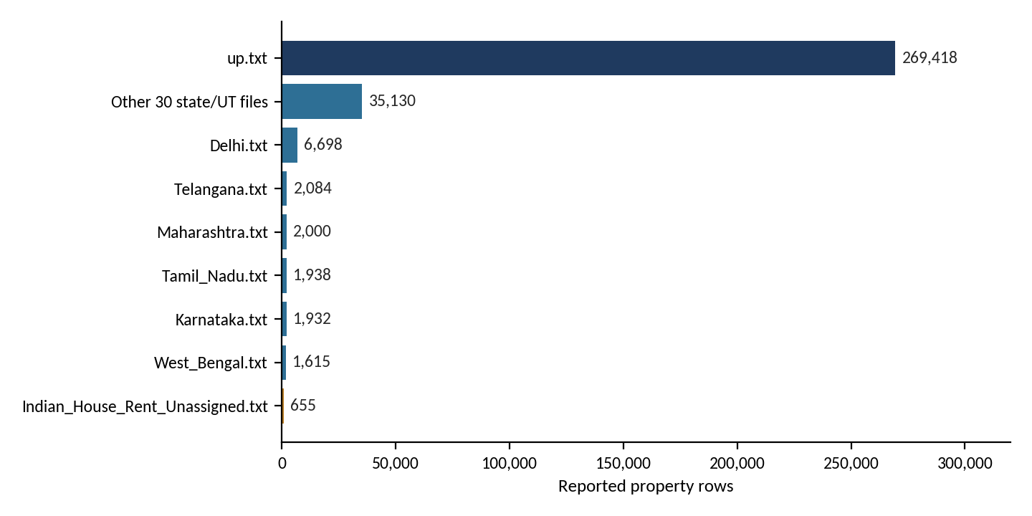
Figure 6.1: Reported property rows by dataset or group (from Table 6.2)
The inventory is dominated by up.txt, which holds 269,418 of the 321,470 records (about 83.8 %). This is why large searches over All Sources are the case where the application keeps work off the event-dispatch thread and, for exact algorithms, may apply the parallel layer.

6.3 Algorithm Results and Testing
Table 6.3 lists the test cases defined in the project documentation, the behaviour expected from each, and what the screenshots of the final application show (Section 6.7). TC01 to TC06, TC09 and TC10 are evidenced by screenshots. For TC07 and TC08 no screenshot was captured, so no result is stated for them; they describe the behaviour of the loaders as designed (Section 4.4).
Table 6.3: Test cases, expected results and observed results
ID | Input / condition | Expected result | Observed in the final application
TC01 | Exact locality such as Gachibowli | Matching records returned; Auto can select KMP. | Auto selected KMP (single exact location query; LPS array; O(n + m)). 41 matching properties, 41 occurrences, 195.698 ms, All Sources (38). Figure 6.5.
TC02 | Misspelt locality such as Gachibowlii | Levenshtein fallback can return a nearby valid locality. | Auto selected Levenshtein Fuzzy Search (no exact match for “Gachibowlii”); closest match “gachibowli”, edit distance 1; 41 matching properties, 112.646 ms. Figure 6.6.
TC03 | Kokapet, Gachibowli, Tellapur | Auto selects Aho-Corasick for multiple patterns. | Auto selected Aho–Corasick (multiple locations detected (3); trie + failure links; O(n + m + z)); 68 matching properties, 66.739 ms. Figure 6.7.
TC04 | Repeat same query and dataset in one session | Auto can use cached Suffix Array search. | Auto selected Suffix Array Search (repeated query detected; cached suffix-array index reused; radix-sort prefix doubling + Kasai LCP). 41 matching properties, 0.081 ms; indexed corpus of 4771 unique location strings covering 321470 properties. Figure 6.8.
TC05 | All Sources, large exact workload | Parallel execution can be applied. | Parallel Dataset Search enabled for All Sources: 16 chunks on 16 threads, visible in the TC01 run. Figure 6.5.
TC06 | Compare Exact Algorithms | KMP, Z and Rabin-Karp run on identical input and report equality. | KMP 81.291 ms, Z Algorithm 142.816 ms, Rabin–Karp 179.952 ms (404.059 ms for all three); 41 matching properties and 41 occurrences for each; “Results identical: YES”. Figure 6.9.
TC07 | One missing dataset file | Only that dataset becomes unavailable. | No screenshot captured; behaviour as designed (Section 4.4).
TC08 | Malformed row | Row is skipped/counted without terminating the full load. | No screenshot captured; behaviour as designed (Section 4.4).
TC09 | Open a result | PropertyDetailsDialog shows source-specific details. | The Property Details dialog showed the source file (hyderabad_recent_properties.txt), property title, locality, city, state, type, configuration, purpose, area, price/rent and furnishing, and a description with bathrooms, status and facing. Figure 6.10.
TC10 | Rent/sale values | PriceFormatter shows rupee/Lakh/Crore/month formats. | Rents appear as ₹…/month (for example ₹100,000/month in Figure 6.10) and sale prices as full rupee amounts (for example ₹15,000,000; Figures 6.5–6.7). Lakh and Crore forms did not appear in the captured screens.

6.4 Correctness Check Through Compare Mode
The Compare Exact Algorithms mode is an important built-in correctness check, because three independent exact-search implementations are executed on the same normalised input. Their property sets and occurrence counts should agree. In Figure 6.9, KMP, Z Algorithm and Rabin-Karp — which use a prefix table, a Z array and a rolling hash respectively — each found 41 matching properties and 41 occurrences for Gachibowli, and the application reported “Results identical: YES”. Three independent methods agreeing makes an implementation defect in any one of them very unlikely to go unnoticed. The other algorithms solve different problems and are therefore checked through the test cases of Table 6.3. The fuzzy run of Figure 6.6 is consistent with the exact run of Figure 6.5: the misspelt query returned the same 41 matching properties, with the closest match reported at edit distance 1.

6.5 Timing and Performance Notes
Search time is measured with System.nanoTime() around algorithm work only, so dataset loading and GUI rendering are not included, and the GUI displays it in the Search Time statistic. Compare mode performs an untimed warm-up first to reduce just-in-time-compilation bias. Table 6.4 lists the times shown in the screenshots. For the exact search, the application reported Parallel Dataset Search enabled with 16 chunks on 16 threads; the processor model and memory of the machine were not recorded.
Table 6.4: Search times shown in the screenshots (single runs, dataset All Sources (38))
Query / mode | Algorithm | Matching properties | Search time | Note
Gachibowli (Auto) | KMP | 41 | 195.698 ms | Parallel: 16 chunks on 16 threads
Gachibowlii (Auto) | Levenshtein Fuzzy Search | 41 | 112.646 ms | Fuzzy fallback
Kokapet, Gachibowli, Tellapur (Auto) | Aho–Corasick | 68 | 66.739 ms | Three patterns
Gachibowli, repeated (Auto) | Suffix Array Search | 41 | 0.081 ms | Cached index reused
Gachibowli (Compare mode) | KMP | 41 | 81.291 ms | 404.059 ms for all three
Gachibowli (Compare mode) | Z Algorithm | 41 | 142.816 ms | Identical results: YES
Gachibowli (Compare mode) | Rabin–Karp | 41 | 179.952 ms | Identical results: YES

These are single observations and are not a benchmark. The same query with KMP took 195.698 ms in the Auto run and 81.291 ms in Compare mode, which shows how much a single measurement can vary between runs, so the values are indicative only and must not be used to rank the algorithms. JIT compilation and thread scheduling can distort short measurements, and parallel speed-ups depend on the CPU core count, the JVM state, the dataset size and the query distribution. The very small suffix-array time reflects reuse of an index that was already built; it is not comparable with the scan-based searches. A reproducible benchmark mode is listed as future work (Section 8.3).

6.6 GUI Result
Figure 6.2 is a screenshot of the main window taken during development. Its algorithm list contains only KMP, Z Algorithm and Compare KMP vs Z, its status line reports 4 datasets with 279,314 properties, and it still has the separate “How It Works” button.
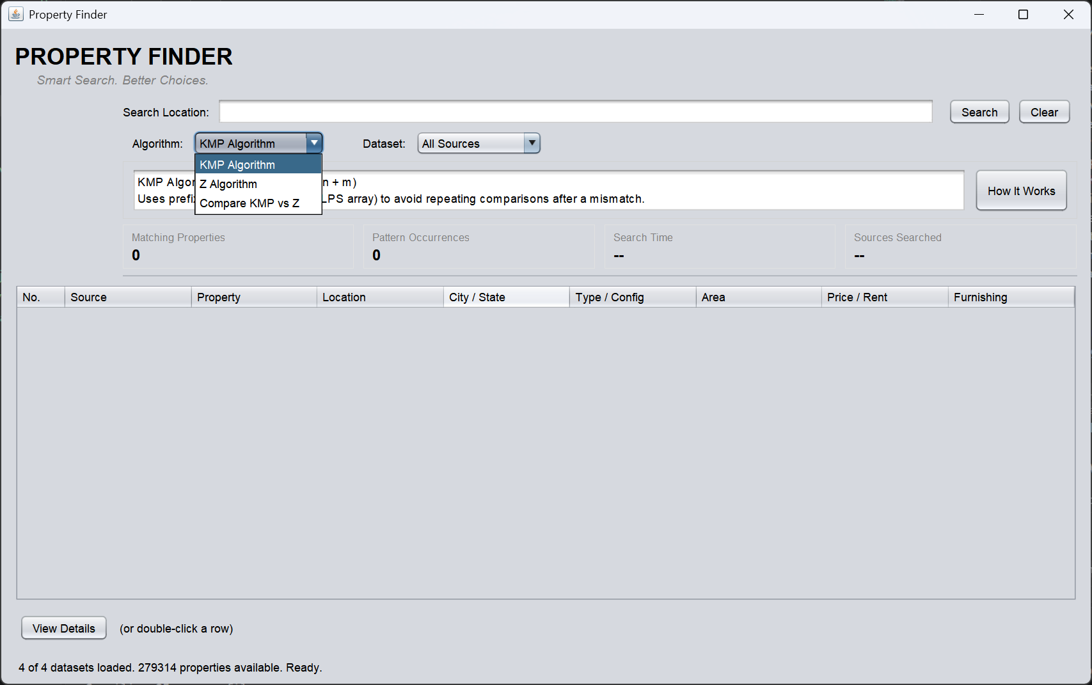
Figure 6.2: Development-stage Property Finder Java Swing main window
The final window is shown in Figure 6.3. It reports 38 of 38 datasets loaded with 321,470 properties. Its algorithm selector lists Auto — Smart Selection, KMP, Z Algorithm, Rabin–Karp, Levenshtein Fuzzy Search, Damerau–Levenshtein Fuzzy Search, Weighted Edit Distance Fuzzy Search and Aho–Corasick, followed by further entries (Suffix Array Search and Compare Exact Algorithms, which appear in the later screenshots). The “How It Works” button has been replaced by Algorithms Used, Property Allocation and Representative Areas buttons. The information area describes Auto mode as deterministic rule-based dispatch, “not AI/ML”; after a search it shows the selected algorithm, the reason, the technique, the complexity and extra details such as the closest fuzzy match, the patterns searched, the indexed corpus or the parallel chunk and thread counts (Figures 6.5–6.8). The Source column keeps the provenance of every result.
The Algorithms Used dialog (Figures 6.11–6.16) is organised into Exact Search, Fuzzy Search, Multi-Pattern Search, Indexed Search, Performance Extensions, Smart Search Router and Graph Algorithm Extensions. For each algorithm it gives the purpose, technique, complexity, Java class and status (Table 5.2), and it ends with the Auto routing rules, which match rules R1–R5 of Table 4.3. It also states that Compare Exact Algorithms is always a manual selection.
The two graph-algorithm tools are described in the dialog. Property Allocation uses Dinic's maximum-flow algorithm (algo.DinicMaxFlow, service.PropertyAllocationService) to model buyer-to-property allocation: it maximises how many buyers can be matched to an eligible, in-budget property with no property double-booked, using a BFS level graph and a DFS blocking flow with per-vertex edge pointers on a bipartite source → buyers → properties → sink network. Representative Areas uses a greedy 2-approximation of vertex cover (algo.VertexCoverApprox, service.RepresentativeAreaService) over a graph of location strings connected by a small Damerau–Levenshtein distance, to select a limited set of representative area spellings by flagging likely-duplicate strings such as “Gachibowli” and “Gachibowlii”.

6.7 Screenshots of Execution
Figures 6.3 to 6.16 are screenshots of the final application captured by the team. Figures 6.11 to 6.16 show the Algorithms Used dialog, scrolled from top to bottom.
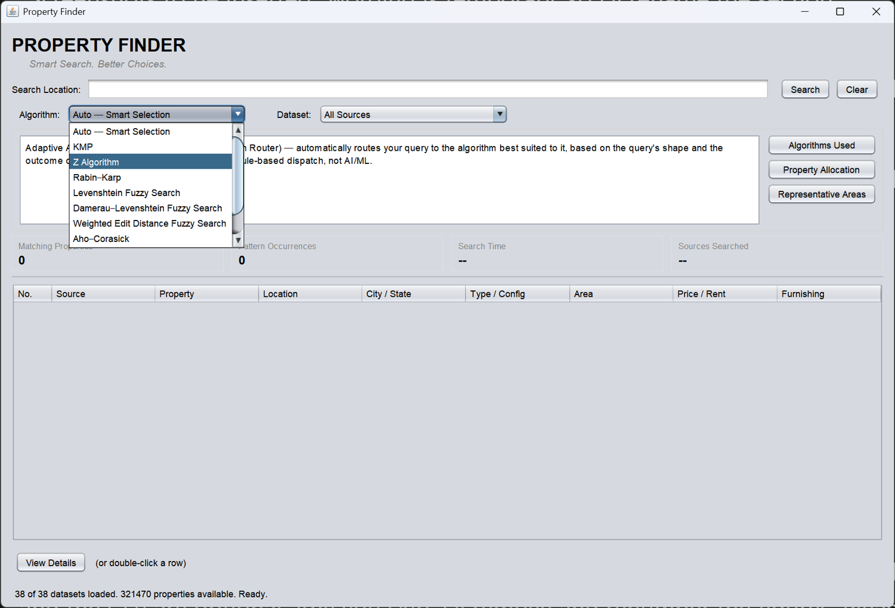
Figure 6.3: Final main window with the algorithm selector open
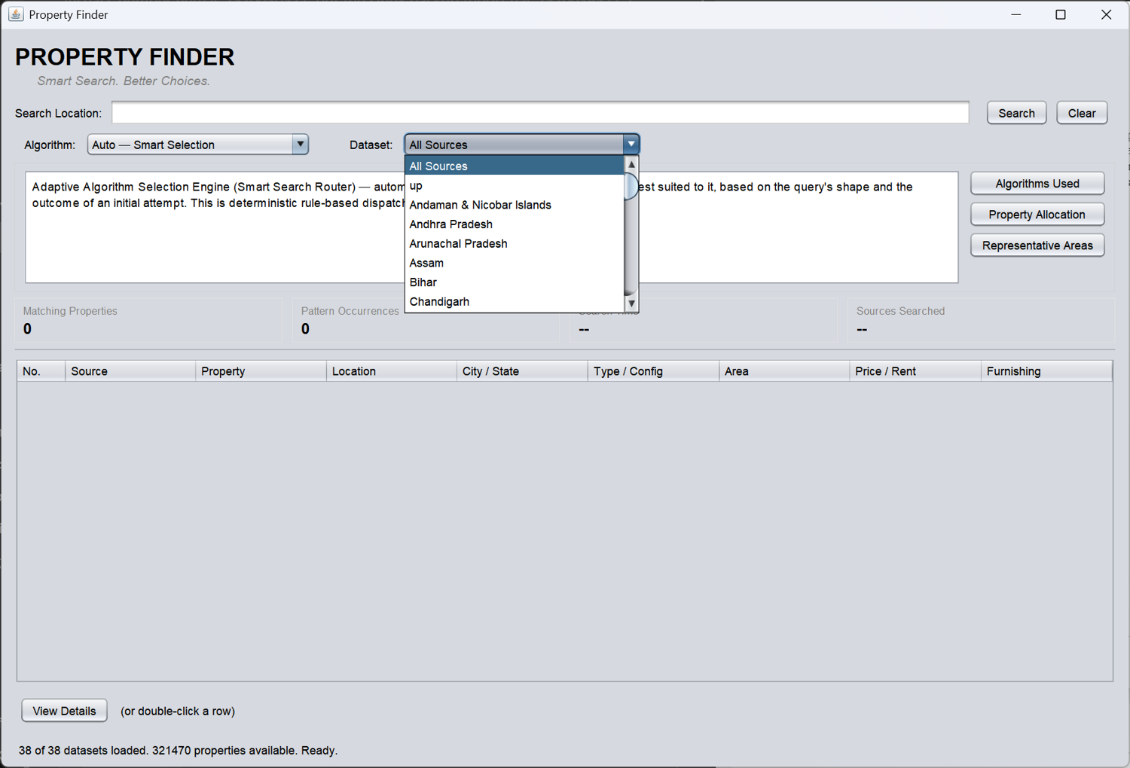
Figure 6.4: Dataset selector listing All Sources, up and the state/UT datasets
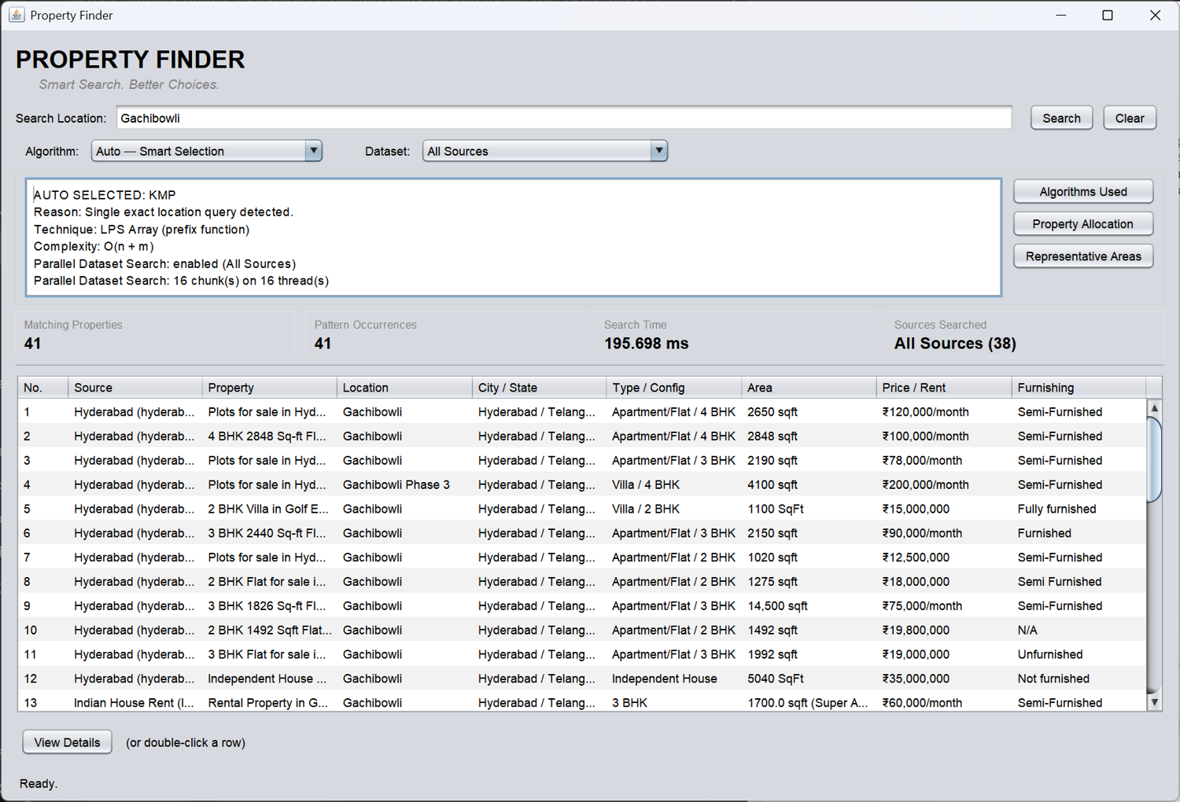
Figure 6.5: Exact search for Gachibowli in Auto mode — KMP selected, parallel search on 16 chunks (TC01, TC05)
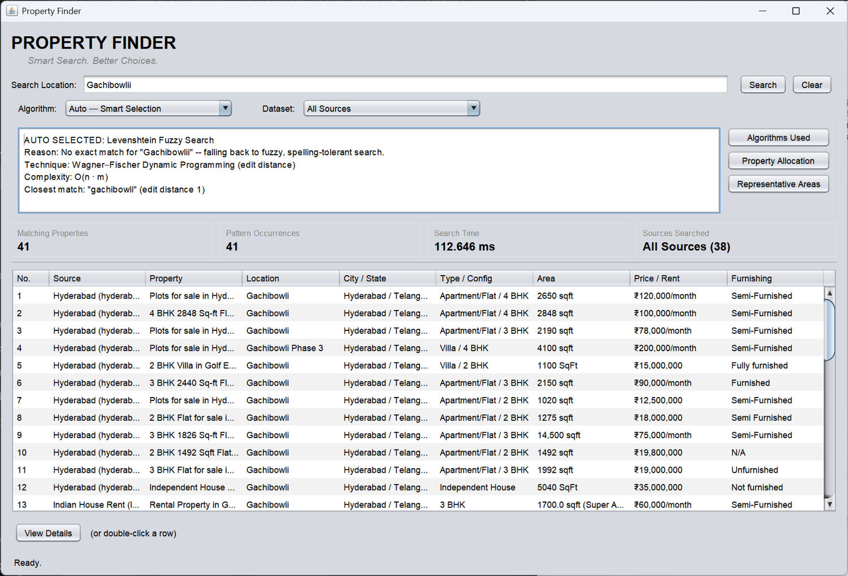
Figure 6.6: Fuzzy search for Gachibowlii in Auto mode — Levenshtein fallback, closest match at edit distance 1 (TC02)
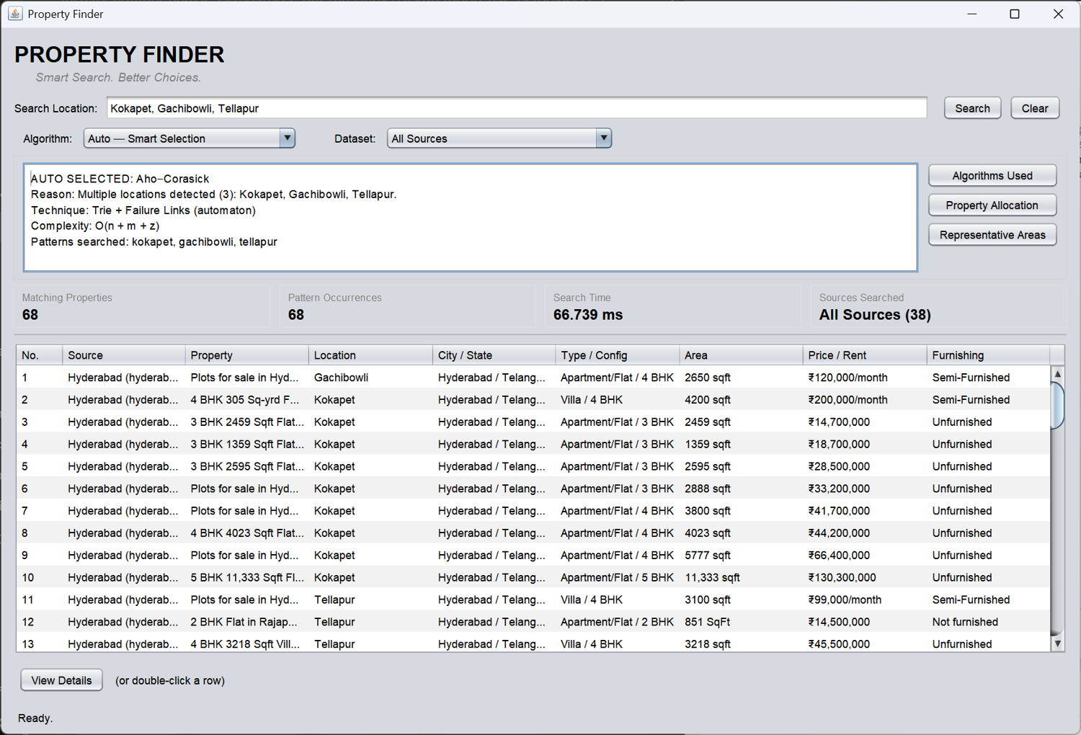
Figure 6.7: Multi-pattern search for Kokapet, Gachibowli, Tellapur in Auto mode — Aho–Corasick selected (TC03)
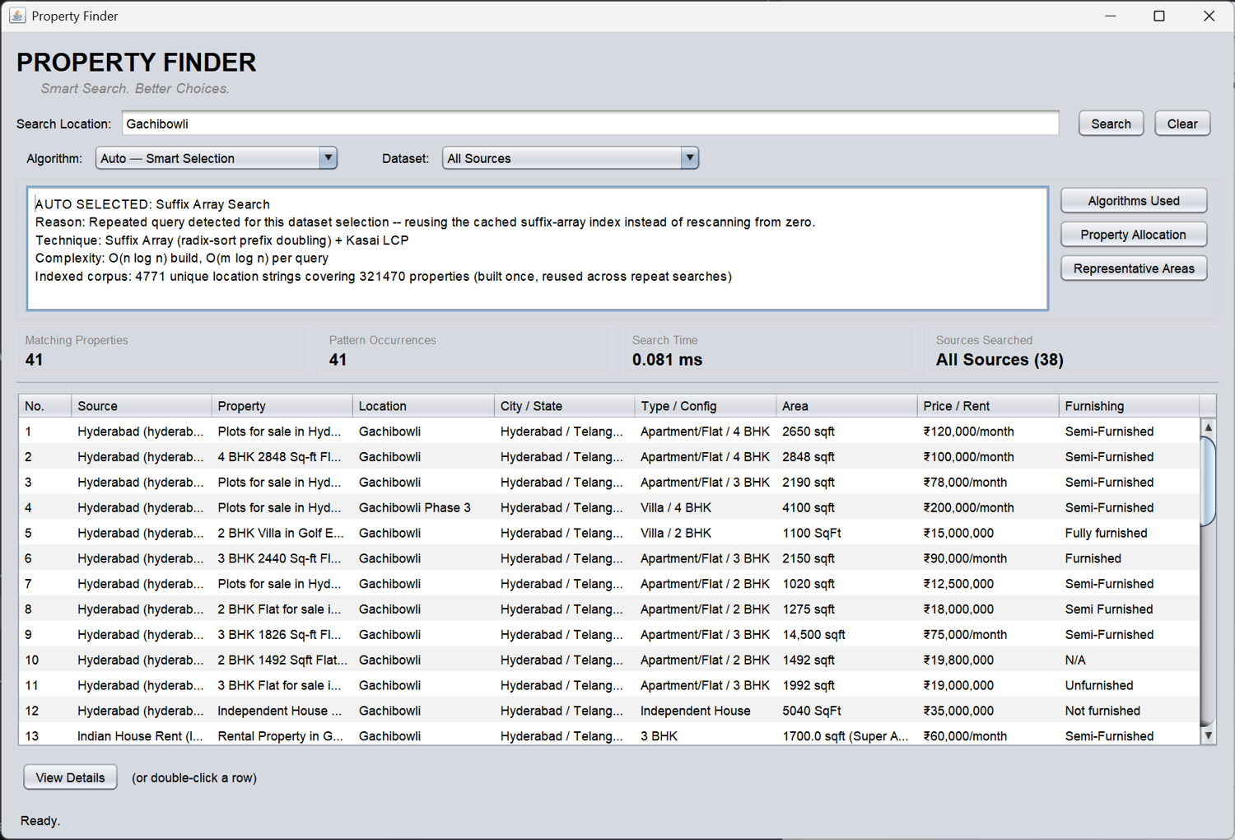
Figure 6.8: Repeated query in Auto mode — Suffix Array Search with the cached index (TC04)
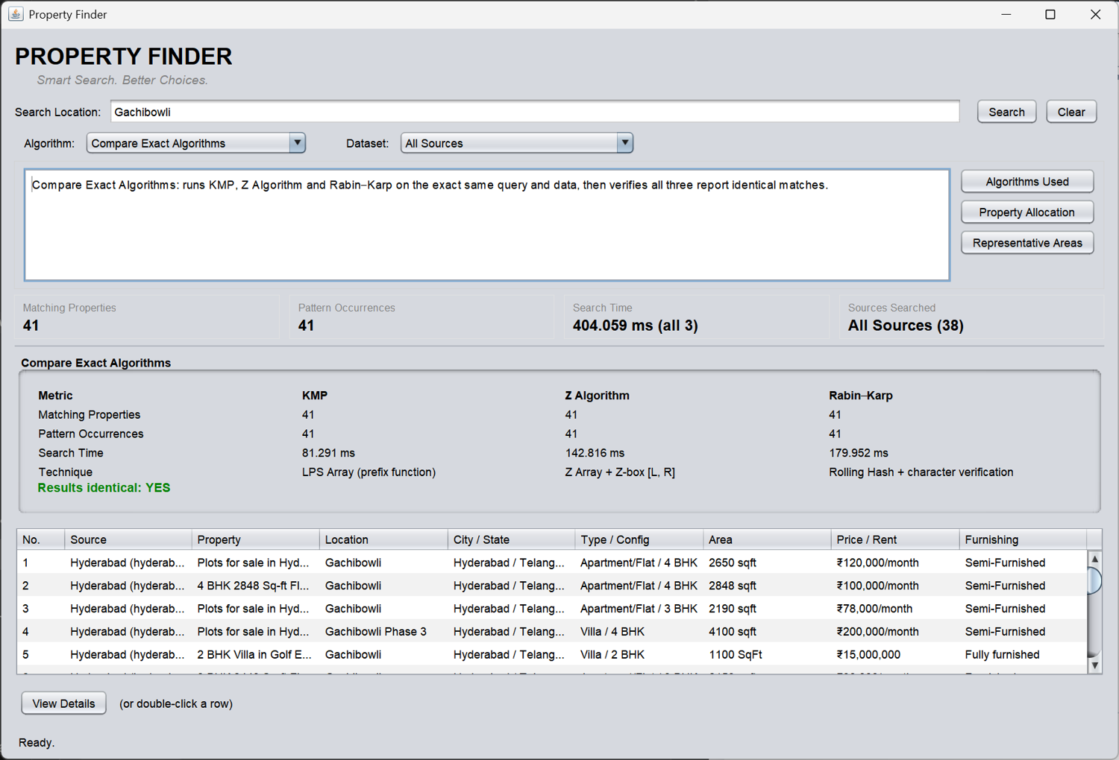
Figure 6.9: Compare Exact Algorithms — KMP, Z Algorithm and Rabin–Karp give identical results (TC06)
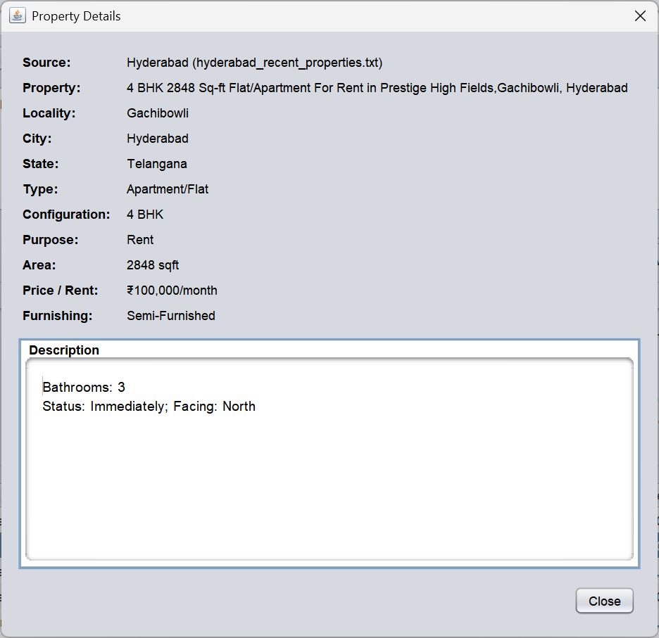
Figure 6.10: Property Details dialog for a selected result (TC09, TC10)
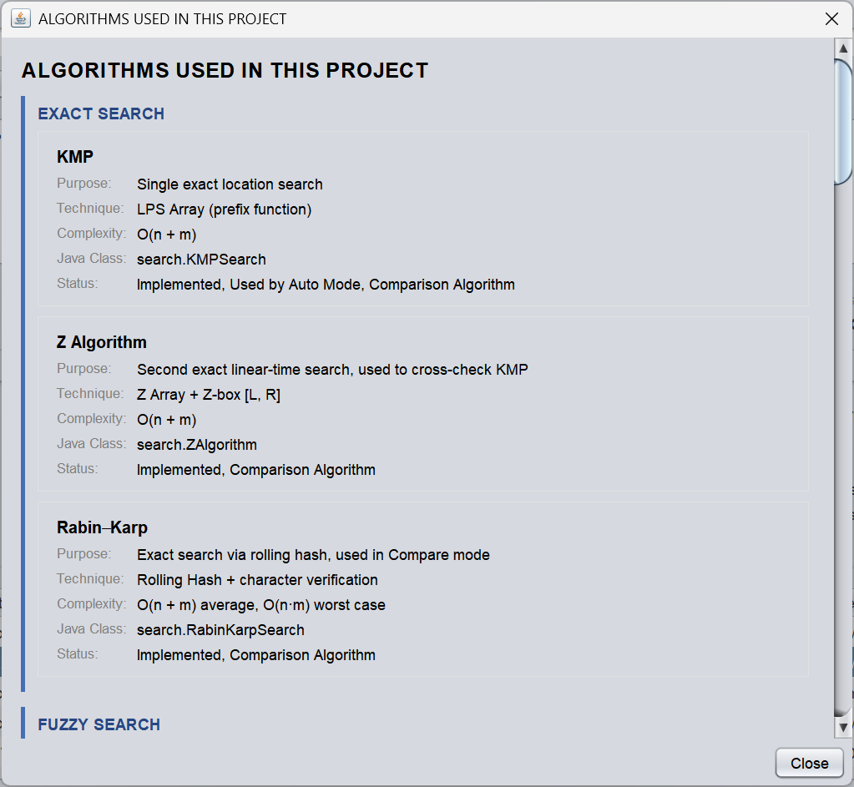
Figure 6.11: Algorithms Used dialog (1 of 6) — exact search: KMP, Z Algorithm, Rabin–Karp
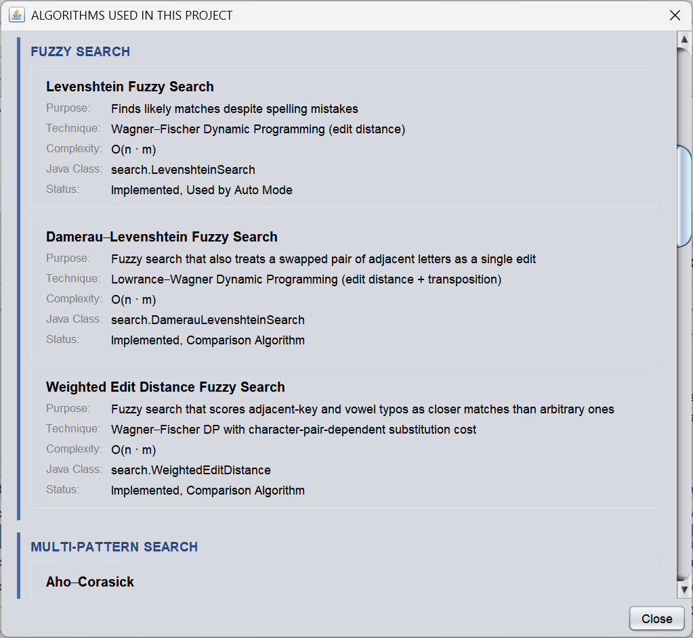
Figure 6.12: Algorithms Used dialog (2 of 6) — fuzzy search: Levenshtein, Damerau–Levenshtein, Weighted Edit Distance
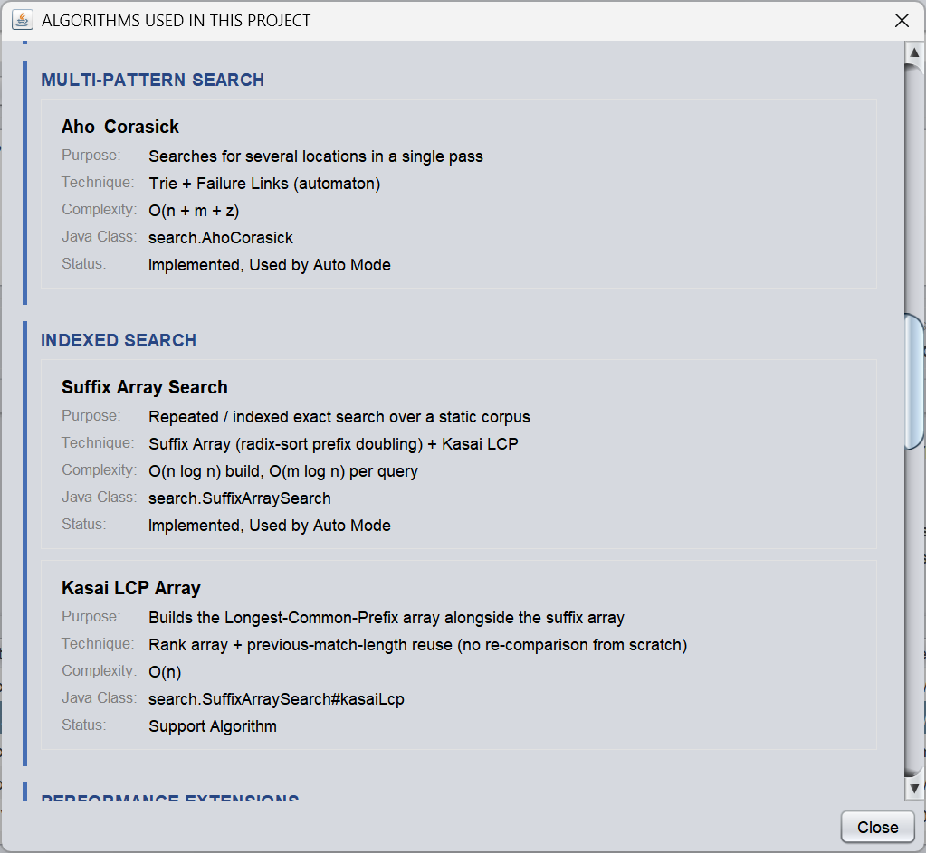
Figure 6.13: Algorithms Used dialog (3 of 6) — multi-pattern and indexed search: Aho–Corasick, Suffix Array, Kasai LCP
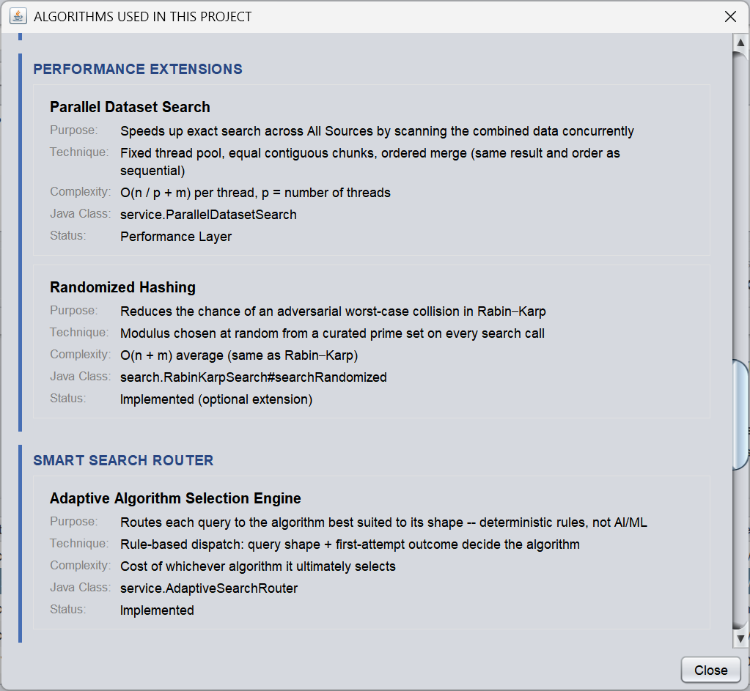
Figure 6.14: Algorithms Used dialog (4 of 6) — performance extensions and the Adaptive Algorithm Selection Engine
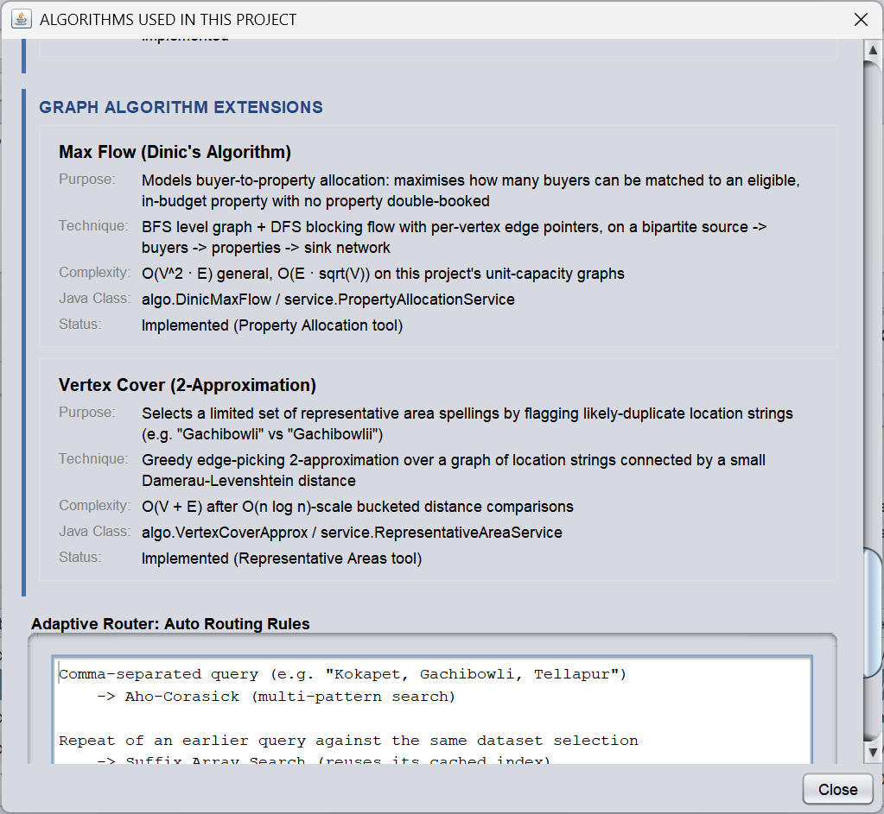
Figure 6.15: Algorithms Used dialog (5 of 6) — graph algorithm extensions: Max Flow (Dinic) and Vertex Cover
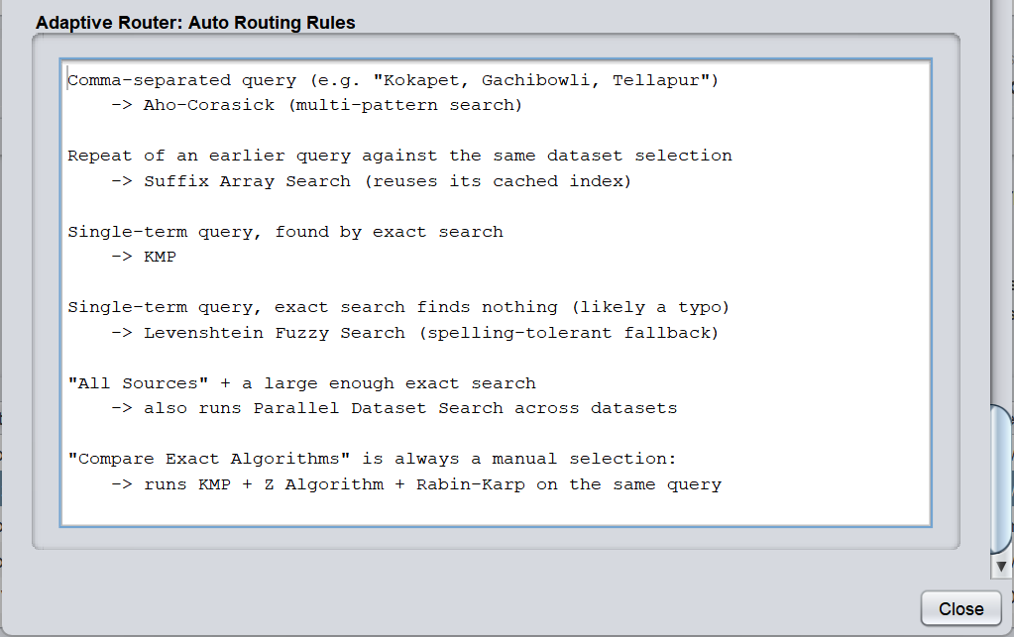
Figure 6.16: Algorithms Used dialog (6 of 6) — Adaptive Router auto-routing rules

Chapter 7: Challenges and Limitations

7.1 Issues Faced During Development
Table 7.1: Issues faced during development
Issue | Why it matters
Heterogeneous source formats | Delhi, Hyderabad, rent, pan-India and state files use different schemas and delimiters.
Large dataset volume | Hundreds of thousands of records can make start-up and search operations noticeable.
Algorithm selection | Exact, fuzzy, multi-pattern and indexed searches solve different problem shapes.
Unsafe separators | A character delimiter inside real data could corrupt Z-algorithm boundary matching.
GUI responsiveness | Large searches must not block Swing's event-dispatch thread.
Imperfect data | Missing values, malformed rows, noisy text and unreadable cities occur in source files.
Fair timing | JIT compilation and thread scheduling can distort small benchmark measurements.

7.2 Solutions Applied
Table 7.2: Solutions applied
Solution | Application
Dataset adapters and UnifiedProperty | Dedicated loaders map source-specific rows into one common model while retaining Source provenance.
SwingWorker | Background loading/searching prevents the main Swing UI from freezing.
AdaptiveSearchRouter | Transparent rules choose KMP, Aho-Corasick, Suffix Array or fuzzy fallback according to query context.
Integer sentinel -1 | Used in the Z Algorithm so the separator cannot equal a Java char.
ParallelDatasetSearch | Large exact All Sources workloads can be divided into contiguous chunks and merged in order.
Robust loader behaviour | Malformed rows are skipped/countable; a missing file disables only that dataset.
Compare-mode warm-up | An untimed warm-up helps reduce first-run JIT bias before measured exact-algorithm comparisons.

7.3 Limitations of the System
- Fuzzy matching uses bounded Levenshtein tolerance, so heavily misspelt names may not be returned.
- Standard Levenshtein treats adjacent transpositions as two edits rather than one; the Damerau–Levenshtein option offered in the algorithm selector counts them as one.
- Repeated-query state and suffix-array indexes are session-scoped and are rebuilt after application restart.
- Search is intentionally limited to locality, city and state rather than semantic search over complete descriptions.
- Parallel speed-ups depend on CPU core count, JVM state, dataset size and query distribution; they are not universal benchmarks.
- The application is a local desktop system rather than a multi-user web or server application.
- Automated unit/integration coverage can be expanded further, even though the exact algorithms are cross-checked in Compare mode.

Chapter 8: Conclusion and Future Work

8.1 Conclusion
Property Finder demonstrates how core Data Structures and Algorithms concepts can be integrated into a complete desktop application. It combines Java Swing, heterogeneous dataset loading, a unified property model, manually implemented string-search algorithms, deterministic adaptive routing, suffix-array indexing, algorithm comparison, optional parallel execution and two graph-algorithm extensions (max-flow property allocation and vertex-cover representative areas). The project shows that algorithm selection should follow the shape of the problem rather than forcing a single method onto every search.
A major strength of the design is transparency. Auto mode is not described as artificial intelligence; every routing decision follows explicit rules that can be inspected and explained during a viva. The project therefore remains a strong academic DSA demonstration while also providing practical search behaviour and a professional user interface.

8.2 Objectives Achieved
The status below is as recorded in the project documentation; the evidence column points to the sections of this report that describe each item.
Table 8.1: Objectives and their achievement
No. | Objective | Status | Evidence
1 | Professional, resizable Java Swing desktop application | Implemented | Sections 4.7, 6.1, 6.6
2 | Manual implementation of KMP, Z, Rabin-Karp, Levenshtein, Aho-Corasick and Suffix Array (plus fuzzy variants) | Implemented | Sections 2.2–2.7, 5.2; Table 5.2
3 | Deterministic Auto routing with manual override | Implemented | Sections 4.5, 5.3
4 | Exact, fuzzy, multi-pattern and repeated-query scenarios | Implemented | Table 6.1, Table 6.3
5 | Comparison of KMP, Z and Rabin-Karp with algorithm-only timing | Implemented | Sections 4.6, 5.7, 6.4
6 | Integration of heterogeneous datasets into UnifiedProperty | Implemented | Sections 4.3, 4.4, 5.4, 6.2
7 | SwingWorker and optional parallel execution for responsiveness | Implemented | Sections 4.6, 5.5, 5.6
8 | Phase 1 CLI retained as a demonstration tool | Implemented | Section 5.9
9 | Graph-algorithm extensions: Dinic max flow and vertex-cover approximation | Implemented | Sections 2.8, 5.2; Figures 6.15–6.16

8.3 Future Work
The items below are FUTURE WORK. None of them is part of the current implementation.
Table 8.2: Future work (not implemented)
Area | Proposed extension
Automated testing | Add unit and integration tests for each search algorithm, loader and routing rule.
Benchmarking | Add a reproducible benchmark mode that records query size, dataset size, JVM state and hardware.
Fuzzy search | Make the fuzzy-match tolerance configurable by the user.
Indexing | Improve suffix-array memory efficiency and expose index-build statistics.
Persistence | Persist safe index caches across restarts when source datasets have not changed.
Filtering | Add price/rent range, furnishing, type and area filters while keeping location search algorithmic.
Visualisation | Add charts for KMP, Z and Rabin-Karp comparison results.
Accessibility | Improve keyboard navigation, focus indicators and screen-reader friendliness.

8.4 Skills Learned During Development
- Manual implementation and comparison of multiple string-search algorithms.
- Designing deterministic algorithm-selection rules and separating them from GUI code.
- Using Java Swing, JTable, dialogs, layout management and SwingWorker.
- Parsing heterogeneous CSV/TSV-like datasets and preserving source provenance.
- Designing service, model, loader, search and utility layers for maintainability.
- Using suffix-array indexing, dynamic programming, tries, rolling hashes and prefix tables.
- Applying graph algorithms: Dinic's maximum flow and a vertex-cover 2-approximation.
- Applying Git/GitHub workflows for project versioning and repository updates.
- Testing correctness, interpreting performance measurements and documenting limitations honestly.

References
[1] D. E. Knuth, J. H. Morris Jr. and V. R. Pratt, “Fast Pattern Matching in Strings,” SIAM Journal on Computing, vol. 6, no. 2, pp. 323–350, 1977.
[2] R. M. Karp and M. O. Rabin, “Efficient Randomized Pattern-Matching Algorithms,” IBM Journal of Research and Development, vol. 31, no. 2, pp. 249–260, 1987.
[3] V. I. Levenshtein, “Binary Codes Capable of Correcting Deletions, Insertions and Reversals,” Soviet Physics Doklady, vol. 10, no. 8, pp. 707–710, 1966.
[4] R. A. Wagner and M. J. Fischer, “The String-to-String Correction Problem,” Journal of the ACM, vol. 21, no. 1, pp. 168–173, 1974.
[5] A. V. Aho and M. J. Corasick, “Efficient String Matching: An Aid to Bibliographic Search,” Communications of the ACM, vol. 18, no. 6, pp. 333–340, 1975.
[6] U. Manber and G. Myers, “Suffix Arrays: A New Method for On-Line String Searches,” SIAM Journal on Computing, vol. 22, no. 5, pp. 935–948, 1993.
[7] T. Kasai, G. Lee, H. Arimura, S. Arikawa and K. Park, “Linear-Time Longest-Common-Prefix Computation in Suffix Arrays and Its Applications,” Proc. CPM 2001, LNCS 2089, pp. 181–192.
[8] D. Gusfield, Algorithms on Strings, Trees, and Sequences, Cambridge University Press, 1997.
[9] T. H. Cormen, C. E. Leiserson, R. L. Rivest and C. Stein, Introduction to Algorithms, 4th ed., MIT Press, 2022.
[10] R. Sedgewick and K. Wayne, Algorithms, 4th ed., Addison-Wesley, 2011.
[11] Oracle, “Java Platform SE API Documentation: javax.swing.SwingWorker.”
[12] Oracle, “The Java Tutorials: Concurrency in Swing.” https://docs.oracle.com/javase/tutorial/uiswing/concurrency/

