Ten Years of Prohibition: Did Addiction Leave, or Just Change Its Route?
Divyanshu · October 2026

A Question from the Streets of Patna
Bihar's liquor ban has completed ten years, but the law is as weak on the ground as it is strict on paper. This question did not come from a report. It came from the streets of Patna.
Recently I walked around Patna Junction and the city's roads, sometimes on foot, sometimes by vehicle. One thing is visible to every passer-by: addiction exists at every age. Children who should have been in school, who should not even have known what intoxication is, appear to be in its grip. From small children to eighty-year-old men.
The most shocking part is the age. Veteran journalists and elders say that even when liquor was sold legally, people drank, but usually after passing Class 10 or 12. Today, even a child in Class 7 or 8 is no stranger to that taste.
So the question is simple: did prohibition achieve the purpose for which it was brought in?

The Promise of 2016: Peace at Home, or Electoral Arithmetic?
Since 5 April 2016, making, selling, transporting and drinking liquor have all been completely banned in Bihar. Behind it was a movement of village women, for whom liquor meant an empty kitchen, shrinking income and beatings. According to Outlook, more than half the state's population was then in multidimensional poverty, so every rupee spent on liquor was directly linked to hunger.
Then Chief Minister Nitish Kumar said in 2022 that this was not his personal wish but a response to the cries of women (Gulf News/AP). The argument remained the same after the government changed. Samrat Choudhary, who took office in April 2026 as Bihar's first BJP Chief Minister, said in September 2026 that the ban will continue because half the population supports it and women back it strongly (ANI).
Women's support has been a major and legitimate reason for this policy. But the final measure of any policy's success should be its social outcomes, not merely its political support. The question is whether prohibition, instead of fixing the root of the problem, has become just a political symbol. The real test is how much safer homes have become in ten years.

To Be Honest: Some Things Did Change
To stay fair in this debate, it must be admitted that some effects of prohibition show up in the data.
- Drinking fell: According to NFHS, about 3 in 10 men drank in 2015-16; by 2019-21 this fell to roughly 1 in 6 (Outlook).
- Claimed fall in domestic violence: A 2024 study in The Lancet Regional Health – Southeast Asia, comparing Bihar with neighbouring states, estimated that the ban prevented about 2.1 million cases of intimate partner violence and 2.4 million cases of regular drinking (Lancet).
- Level of violence: The share of women facing violence from their husbands fell from 43% to 40%, and then to 36.1% in 2023-24 (Outlook).
- Public support: In the state government's own 2022 survey, 80% of people supported the ban.
So in homes where husbands drank occasionally, there was relief. This is true, and denying it would be dishonest. But the full picture of ten years is far more complicated.

A Ban on Paper, Home Delivery on the Ground
The government's own figures show that liquor never left Bihar. The tally from April 2016 to March 2026 (ETV Bharat, IANS):
Ten-year tally (2016–2026) | Figure
Cases registered | 11.38 lakh
People arrested | 17.18 lakh
Liquor seized | 4.83 crore litres
Vehicles seized | Over 1.67 lakh

The government presents these numbers as proof of strict enforcement. But think about it: if the ban really worked, why would lakhs of litres be seized every month? In 2025 alone there were 1.25 lakh arrests, more than in 2024. Seizures are rising, which means supply is rising too.
The number of drinkers is climbing again as well. In NFHS-6, 16.5% of men above 15 said they drink, up from 15.4% in the previous survey. Patna is among the districts with the highest drinking. In a small Patna University study, about 64% of people in Kankarbagh and Pataliputra admitted drinking despite the ban (Outlook).

Whose Pocket Does the Money Go To?
The courts too have raised serious questions about what is visible on the streets. In 2024, while hearing a case, Justice Purnendu Singh of the Patna High Court observed in his order that the law had become a means of big earnings for officials of the police, excise, tax and transport departments, and pointed to collusion between police and smugglers (Scroll, The Week/PTI). The court also raised the question of whether the law hits the poor and small-time accused harder, while action rarely reaches the big networks.
These observations and the steadily rising seizures seriously raise the question of how deep the collusion runs between smugglers and a corrupt system in the illegal liquor trade. Money that once went into the state treasury as tax now largely circulates in the illegal market. And the drinker now pays far more for liquor than before.

Spurious Liquor: The Bitterest Price of the Ban
A law meant to save lives is, in its shadow, seeing poisonous liquor take lives. According to official records, about 300 people have died from spurious liquor since 2016 (Outlook). The real number is feared to be much higher.
- December 2022, Saran (Mashrakh): The state admitted 40 deaths, while the National Human Rights Commission's inquiry put the figure above 70 (Onmanorama).
- October 2024, Siwan-Saran-Gopalganj: The administration admitted 37 deaths, but villagers said 67 died; several people lost their eyesight (ETV Bharat).
- April 2026, East Champaran: At least 10 deaths; in August 2026, four young men died suspiciously in Patna district, where a liquor bottle was found (Outlook).
The saddest part is that victims, out of fear, do not seek treatment in time, because reaching a hospital becomes a confession of breaking the law. In 2024, villagers said several bodies were hurriedly cremated out of fear of the police.
This is where my question lies. When demand does not end completely, it moves into the illegal market, where there is no quality check and no accountability. That is where the risk of poisonous liquor multiplies. So a ban alone is not enough; without treatment, rehabilitation and honest enforcement, this law may increase risk instead of saving lives.

Dry Drugs: A Closed Door, an Open Window
Alongside the curbs on liquor, concern has also grown in Bihar about the availability and use of other drugs. Among the children and teenagers seen intoxicated on Patna's streets, one hears more about “dry drugs” than liquor: ganja, smack, brown sugar, cough syrup, whitener and injections. In the market they are given innocent names like snacks, so no one suspects.
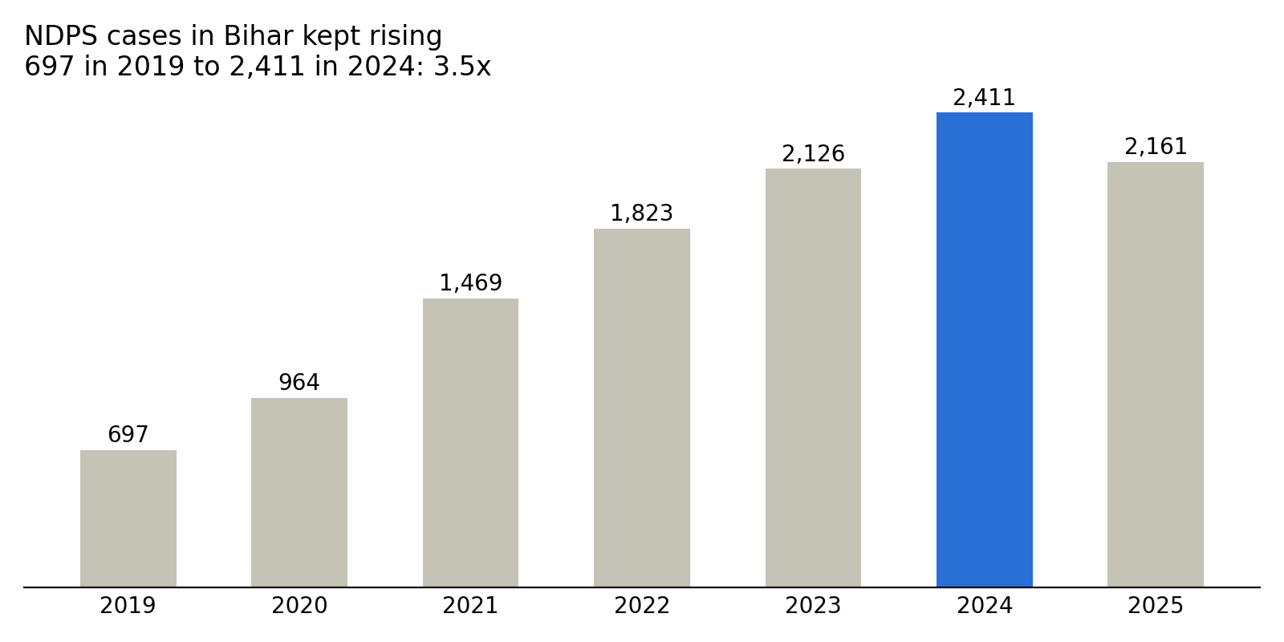
The 2025 figure is from the Chief Minister's statement in the Assembly; the rest are official figures. Source: ETV Bharat, June 2026.
The concern began appearing in the first year of the ban. A 2017 pilot study by doctors found that more than 25% of habitual drinkers had shifted to alternatives like toddy, ganja and charas (Jindal Policy Lab). Today, workers at de-addiction centres say they see more smack and brown sugar patients than alcohol patients (ETV Bharat). Better policing may also explain part of the rise in cases, so calling prohibition the sole cause would be hasty; but the trend cannot be ignored either.
- Before 2016, Bihar had 13-14 de-addiction centres; today it has about 200, with over 20 in Patna alone.
- People aged 12 to 75 are admitted to these centres.
- About a quarter of all narcotic injections seized across India were caught in Bihar alone.
- Among the state's 11,836 HIV patients, infection came from sharing needles.
Another possible concern is that the ban created a “forbidden fruit” curiosity. For someone who had seen liquor in the open market, it was no mystery. But for the generation that grew up after the ban, “what is that thing like” can become a thrill. This is my assumption, and testing it needs a separate study. But this much is clear: the mothers who hoped their children would stay away from addiction have not yet seen that hope fulfilled.

The Emptying Treasury of a Poor State
Bihar gave up a large share of its income, but the liquor money did not disappear; it just went into other pockets. In 2015-16 the state earned ₹3,142 crore from excise duty; the next year it was about ₹30 crore (Outlook). In the three years before the ban, excise made up over 14% of the state's own tax revenue (ThePrint/HT).
Meanwhile, the neighbours earned more. Between 2015-16 and 2017-18, Jharkhand's excise revenue rose from ₹912 crore to ₹1,600 crore, and West Bengal's from ₹4,014 crore to ₹5,781 crore (Jindal Policy Lab). The annual growth in excise earnings of Uttar Pradesh, Jharkhand and Bengal in 2017-19 was the fastest since 2001-02. Nepal's open border is a separate factor. The data suggests that part of Bihar's demand, by crossing borders or through smuggling, is filling those states' treasuries.
In August 2026, an NCAER study estimated that restoring excise duty could raise Bihar's own revenue by 14-15%, meaning thousands of crores of rupees every year (Outlook). The government's answer is that the social benefit outweighs this loss, and it is also true that the state's overall fiscal health has improved during this period. But in a state where schools, hospitals and jobs are the biggest shortages, leaving this money behind and handing it to smugglers does not seem wise to me.

Ten Years Later: What Did Women Get?
Prohibition's biggest promise was to women, and that is what remains most unfulfilled. Many of the women who backed this law to keep their husbands away from liquor still have husbands who drink, only now it is costly smuggled liquor or deadly spurious liquor. More household money goes out than before, and the fights are the same.
The data says the same. Among women facing violence from their husbands, the share whose husbands were often drunk was 83.1% in 2015-16 and 83.3% in 2019-21, meaning no change (Outlook). According to the NCAER study, recorded crimes against women did not fall after 2016; they rose. And the children who were to be saved from addiction are now in the grip of dry drugs.
So who benefited from this system? Illegal liquor networks, elements that exploit weak enforcement, and the economies of some neighbouring states. An independent review of both the policy's social benefits and its current cost is still pending. Governments changed, reports came out, courts raised objections, yet no such review has come forward.

The Way Forward
- An honest review: An independent audit of ten years, covering both new patterns of addiction and revenue.
- Target syndicates, not the poor: Focus on supply networks and the corrupt elements protecting them, instead of the labourer who drinks.
- Treat addiction as a health issue: Awareness in schools, de-addiction centres with doctors in every district, and fearless treatment for victims of spurious liquor.
- Open debate on alternatives: A model of regulated sale, strict licensing, and spending part of that revenue on education and de-addiction.

The Other Side
The arguments of the ban's supporters deserve a hearing too. They say the cure for weak enforcement is stronger enforcement, not repeal; studies like the Lancet one show a fall in domestic violence; and in government surveys most women still want it to continue. Some activists believe the intent was right, but instead of empowering village women's groups, all trust was placed in the police. This debate is open, and it should stay open. But if, after ten years, a Class 7 child is still seen intoxicated on a Patna street, the question should be asked not of the law, but of its results.

Sources
- Outlook: Bihar Prohibition, Legally Dry But Not Alcohol-Free (September 2026)
- Outlook: Bihar's Liquor Ban Has A Revenue Problem (August 2026)
- ETV Bharat: Liquor Ban To Dry Drugs (June 2026)
- ETV Bharat: A Decade Of Prohibition (April 2026)
- The Lancet Regional Health – Southeast Asia (2024)
- Scroll: Patna High Court observation (2024)
- ANI: Chief Minister Samrat Choudhary's statement (September 2026)
- ThePrint: Bihar's loss may be neighbours' gain
- Jindal Policy Research Lab: Sipping on Change
- ETV Bharat: Siwan-Saran hooch tragedy (2024)

