Level 5 Extended Diploma in Computing

Advanced Programming
Tasks 1 to 4

By
Surafel Biruk Abay

Registration No.
std3168

Submitted To
Ravushnar

Submission Date
28 September 2026

Table of contents
Task 1 Object oriented programming and SOLID 2
1 1 The five SOLID principles 2
1 2 Evaluating design and pattern compliance 3
1 3 Four pillars with executable examples 3
1 4 Rental application and evaluation 4
Task 2 DevSecOps and continuous delivery 6
2 1 Shift left and shared responsibility 6
2 2 Problems addressed during development 6
2 3 Security stages and configuration 7
2 4 Implemented Jenkins pipeline 8
Task 3 Large dataset application 9
3 1 Client requirements and scope 9
3 2 Dataset and quality rules 9
3 3 Architecture and implementation 10
3 4 SOLID and clean coding in the solution 11
3 5 Results and limitations 11
Task 4 Automated testing and evaluation 12
4 1 Test specification and implementation 12
4 2 Recorded results 12
4 3 Jenkins failure and successful correction 13
4 4 Benefits and limits of automation 15
References 16

Task 1 Object oriented programming and SOLID
This guide supports new ModernDayTech developers who know basic programming but are learning how to organise larger applications. Object-oriented programming groups state and behaviour into objects. SOLID provides five design principles for managing dependencies and change. The examples progress from individual concepts to a vehicle rental workflow. The complete executable files are in task1/ in the accompanying repository.

1 1 The five SOLID principles
Single responsibility means one coherent reason for a class to change. A rental receipt can change when its format changes, while a payment processor changes when payment behaviour changes. ReceiptService and PaymentProcessor therefore remain separate. Like specialists in a workshop, each has a defined job; a class need not have only one method to satisfy this principle.
Open/closed design allows an established abstraction to accept new behaviour through extensions. ElectricVan adds its own pricing method without adding another vehicle-specific branch inside RentalSystem. This resembles fitting another device to a standard socket. It does not mean existing code must never be changed: a new shared requirement can legitimately change the interface.
Liskov substitution requires a subtype to preserve the behaviour callers are promised. Every Vehicle accepts the same valid day range and returns a non-negative Decimal price. A subclass that rejects an otherwise valid duration, returns a different kind of result or silently changes the meaning of days would break that contract. Matching method names alone is insufficient.
Interface segregation keeps clients independent of operations they do not need. Insurable is separate from Vehicle, so Motorcycle is not forced to provide an irrelevant insurance method. The business rule here is that cars and trucks receive insurance charges; it is a rule of this demonstration, not a claim about real insurance requirements.
Dependency inversion makes the rental coordinator depend on PaymentProcessor rather than a particular card implementation. CardPaymentProcessor and CashPaymentProcessor are supplied when the system is constructed. A test can supply a processor that declines payment. This both allows replacement and tests the coordinator without contacting an external payment provider.

1 2 Evaluating design and pattern compliance
A review should ask what changes each class is responsible for, where concrete dependencies are constructed, and whether all subtypes preserve the same input and result contracts. Class or dependency diagrams can reveal cycles and unnecessary coupling. A small change exercise, such as adding ElectricVan, tests whether the intended extension point actually prevents changes to the coordinator.
Automated tests examine behaviour that a diagram cannot establish. Parameterised rental tests pass each vehicle subtype through the same workflow and assert independently calculated prices. A declining payment test verifies that no confirmation or receipt follows failure. Static analysis and code metrics can highlight complexity or risky constructs, but a low warning count does not prove SOLID compliance. Pair review and refactoring are still needed to judge whether an abstraction is useful.
The interchangeable payment processors use the Strategy pattern: the rental workflow delegates payment behaviour to a supplied strategy. This is a concrete pattern relationship. The code does not claim that every class implements a named pattern, or that inheritance is always preferable to composition.

1 3 Four pillars with executable examples
Encapsulation combines state with controlled operations. BankAccount exposes a read-only balance and validates deposits and withdrawals; an overdraft leaves its balance unchanged. Double-underscore names reduce accidental access through name mangling, but Python does not make them a security boundary (Python Software Foundation, n.d.). In task1/four_pillars_demo.py:
account = BankAccount("Sura", 100)
account.deposit(50)
account.withdraw(30)
print(account.balance) # 120
Abstraction defines the operations callers need while leaving implementation details to concrete classes. Shape specifies area and perimeter; it cannot be instantiated until its abstract methods are implemented. Rectangle and Circle provide different calculations behind that interface (Python Software Foundation, n.d.). The following is an excerpt from the supplied file:
class Shape(ABC):
@abstractmethod
def area(self) -> float:
...
@abstractmethod
def perimeter(self) -> float:
...
Inheritance lets a specialised class reuse and extend a parent. Dog inherits Animal.eat and overrides make_sound; it also adds fetch. The relationship is that a Dog is an Animal. The example below produces the inherited eating message and the specialised barking message:
dog = Dog("Rex")
print(dog.eat())
print(dog.make_sound())
Polymorphism means the same operation dispatches to the object supplied. total_area does not branch on Circle or Rectangle. It invokes area on each shape, so the rectangle contributes 20 and the circle approximately 28.27:
def total_area(shapes: list) -> float:
return sum(shape.area() for shape in shapes)
print(f"{total_area([Rectangle(4, 5), Circle(3)]):.2f}")
# 48.27

1 4 Rental application and evaluation
The rental application combines vehicle pricing, optional insurance, payment, notification and receipt generation in one workflow. Vehicle encapsulates mileage behind add_mileage, declares abstract pricing operations, and supplies a base for four concrete types. RentalSystem invokes those operations polymorphically. Separate services and an injected payment abstraction demonstrate single responsibility and dependency inversion; the extra vehicle type and focused Insurable interface also illustrate open/closed design and interface segregation.
Vehicle | Three day calculation | Expected AED
Car | 120 × 3 + 5 × 3 | 375.00
Motorcycle | 60 × 3 × 0.8 | 144.00
Truck | 200 × 3 + 3 × 2 × 3 + 15 × 3 | 663.00
Electric van | 140 × 3 × 0.9 | 378.00

Rental days must be integers from 1 to 365. Rates and capacity must be positive and finite, and mileage increments must be non-negative integers. Money uses Decimal and two-decimal rounding. A failed payment now raises an error before confirmation or receipt. The supplied 22 Task 1 tests cover prices, invalid values, controlled state, abstract classes, polymorphism and this failure path.
This is a composed in-memory application rather than a complete booking service. Payments are explicitly simulated; vehicle availability, persistent agreements and refunds are outside its scope. The design reduces coupling but introduces more classes than a one-off calculation needs. Its value is clearest when adding pricing types or replacing payment behaviour, which are the changes demonstrated here.

Task 2 DevSecOps and continuous delivery

2 1 Shift left and shared responsibility
DevOps brings development and operations together to deliver and run software through repeatable processes. DevSecOps integrates security responsibilities throughout that work. A DevOps pipeline can already contain security checks; the distinction is the deliberate treatment of security as a shared, continuing requirement rather than a final approval owned by a separate team.
Shift left means applying suitable checks earlier in the lifecycle. Requirements identify sensitive data and likely misuse; design reviews examine boundaries; dependency and source checks run when code changes. Finding a vulnerable package before it is included in a release avoids propagating it into later environments. This resembles checking an electrical design before walls are finished: later inspection is still necessary, but correcting the design first limits rework. No fixed percentage saving is claimed.
The NIST Secure Software Development Framework recommends integrating secure development practices into the software lifecycle, including preventing vulnerabilities and responding to remaining weaknesses (NIST, 2022). Early checks do not replace runtime testing, monitoring or incident response. The demonstrated pipeline therefore checks both source/dependencies and a running local service.

2 2 Problems addressed during development
Problem | Applied response and remaining limit
Security work arrives late | Functional, dependency and static checks precede runtime verification and delivery. Humans still review requirements and design.
Vulnerable third-party packages | SCA audits every pinned runtime dependency; a known vulnerability blocks the build. Unknown vulnerabilities remain possible.
Different installations behave differently | Hash-locked dependencies and a versioned Jenkinsfile support repeatable setup. Java, ZAP and agent configuration must also be maintained.
Changes are accepted without evidence | JUnit results, scan reports and source hashes are retained against a build. A failing test prevents delivery.
Security ownership is unclear | Developers fix defects, reviewers assess exceptions, and operations maintain the execution environment. This is the proposed team workflow, not a claim of an observed organisational rollout.

A team using this process should review findings rather than suppressing them to make a build green. A fix is checked by rerunning the relevant tests and then the required pipeline. Low severity findings remain visible for review; scanner errors are failures because incomplete analysis cannot establish that a gate passed.

2 3 Security stages and configuration
Stage and tool | Configuration | Gate
SCA pip-audit | Exact versions from requirements.lock; all 14 runtime packages must appear in the audit. | Any known vulnerability, missing package or tool error blocks.
SAST Bandit | Scan src and task1, nine Python files; ignore inline nosec suppression and verify file coverage. | Medium/high findings, parse errors or incomplete coverage block.
DAST ZAP 2.17.0 | Loopback service; imported OpenAPI and successful route examples; six active rules, LOW strength, MEDIUM threshold, plus passive scanning. | Medium/high alerts, unfinished scan or missing required routes block.

SCA answers whether a selected component version has a known advisory. SAST looks for risky source patterns without exercising the service. DAST sends requests to the running application and observes responses. Their coverage is complementary: none proves the calculation correct, and no one scanner establishes complete security. Exact expected-value tests therefore run alongside them (PyPA, n.d.; Bandit, n.d.; ZAP, n.d.).
The six enabled ZAP rule IDs are 6, 7, 40012, 40018, 90019 and 90020, targeting traversal, remote inclusion, reflected scripting, SQL injection, server-side code injection and command injection. The scan is restricted to its own local service at port 18785 in Jenkins. Completion must reach 100 percent and the passive queue must finish. There are no authenticated application roles, so role-based authorisation testing is not demonstrated.

2 4 Implemented Jenkins pipeline
The repository Jenkinsfile runs on the transport-windows agent. Its stages are Checkout, Locked dependencies, Functional SCA and SAST, Live checks and DAST, and Deliver verified source. A fresh checkout prevents stale results. Jenkins polls source control every two minutes, installs hash-locked packages, executes the checks and archives JUnit and scan results. The delivery stage verifies source hashes before producing the ZIP (Jenkins, n.d.).
The final successful build is 5, testing commit de1387aa1bb7. It passed 59 tests and completed the security gates. Earlier build 2 deliberately doubled pickup counts, failed three assertions and skipped delivery. The successful and failed runs are analysed in Task 4. This implements continuous integration and delivery to an archived artifact; it does not claim production deployment or operational monitoring.
Tasks 2, 3 and 4 use the same transport project, so the designed security process, implemented application and recorded tests refer to the same system. Task 1 supplies the separate rental example for the requested OOP concepts.

Task 3 Large dataset application

3 1 Client requirements and scope
The chosen ModernDayTech client is a fleet planning team that needs to compare recorded taxi activity across zones and times. The application processes the complete January 2025 NYC yellow-taxi file, ranks pickup zones, filters dates and optional hour/zone values, and exports the selected result. This is a defined educational client scenario, not a claim that the application was commissioned or deployed by a real transport operator.
Requirement | Acceptance evidence
Process the complete monthly file | Provenance and hashes identify 3,475,226 source rows; the importer records accepted and excluded totals.
Explain data quality decisions | Each row has one classification; fixture counts and aggregate totals reconcile.
Return correct filtered rankings | Date/hour/zone tests use known expected counts; ties are ordered by zone ID and result limit is 1 to 100.
Export consistent results | CSV and JSON agree; separate tests check unsafe spreadsheet and HTML labels.
Provide responsive local access | Twenty sequential full-month requests must each complete within 2 seconds.
Validate input and preserve data | Invalid filters are rejected; failed imports do not publish a database or overwrite an existing destination.

Recorded pickups reflect existing supply and customer activity. They do not measure unmet demand, future trips, profitability or the number of vehicles that should be allocated. The browser supports dates and result limit; hour and zone filters are available through the API. The service is read-only and intended for local use.

3 2 Dataset and quality rules
The official NYC Taxi and Limousine Commission publishes monthly Parquet trip files and a taxi-zone lookup. The selected January 2025 file is 59,158,238 bytes. The application uses pickup/drop-off times, pickup zone and distance; readable location names come from the lookup. Source URLs, download date and SHA-256 hashes are retained in data/sources.json (NYC TLC, n.d.).
Classification is ordered: exclude missing or out-of-month pickup times, unknown zones, invalid durations, then invalid distances. Duration must be greater than zero and at most 180 minutes; distance must be finite, greater than zero and at most 200 miles. The first applicable reason is recorded to prevent double-counting. These are analytical choices that can exclude genuine unusual journeys. Repeated observations remain counted because the selected fields do not establish unique trip identity.
Outcome | Rows
Accepted | 3,373,177
Invalid distance | 89,138
Invalid duration | 3,368
Unknown zone | 9,521
Outside month or missing pickup | 22
Total | 3,475,226

The rules reject 102,049 rows, about 2.94 percent. This could affect rankings unevenly between zones; no sensitivity study is claimed. Timestamps are grouped as supplied without conversion to the analyst’s timezone. Different months, especially daylight-saving transitions, require checking the source’s timestamp interpretation.

3 3 Architecture and implementation
The flow is Parquet and lookup input, validation and classification, date-hour-zone aggregation, a DuckDB database, a service layer, then browser/API responses. DuckDB performs the grouping directly over Parquet rather than constructing millions of Python objects. The prepared database contains 92,875 aggregate groups, reducing work for interactive queries (DuckDB, n.d.).
ingest.py checks required columns and unique lookup IDs, builds within a transaction, reconciles totals and publishes a temporary database only after successful completion. It refuses to overwrite an existing destination. The configured 512 MB limit applies to DuckDB, not to the entire process’s measured peak memory.
DemandFilter is immutable and validates dates, zone, hour and limit. DuckDBReader uses read-only connections, disabled external file access and static SQL with separate parameter values. DemandService enforces loaded date coverage and shares one result path between JSON and CSV. The HTTP layer validates types, escapes HTML labels, neutralises formula-like CSV text and applies security headers.

3 4 SOLID and clean coding in the solution
Single responsibility separates import, storage reads, service rules and HTTP presentation. Dependency inversion is concrete: DemandService accepts a DemandReader protocol instead of constructing DuckDB itself, and create_app accepts the service. Tests supply an in-memory reader to challenge export and presentation behaviour. The narrow summary/demand protocol also avoids forcing the service to depend on import or administration methods.
Another reader can satisfy that interface without changing the service, illustrating open/closed design at this boundary. Substitution still requires the same coverage metadata, fields and filtering behaviour. The supplied tests demonstrate the exercised replacements, not every possible adapter. Named modules, immutable filters, explicit errors and deterministic ordering make the implementation easier to review.
The reader abstraction supports focused tests at the cost of extra classes. A new field or study month still requires coordinated changes. Distributed infrastructure is not justified by the measured local workload.

3 5 Results and limitations
Midtown Center ranks first with 166,493 accepted pickups, followed by Upper East Side South with 161,372 and Upper East Side North with 153,131. The recorded import processing interval was 1.374 seconds, excluding download and startup. In final build 5, 20 sequential HTTP queries had median 109.198 ms and maximum 149.303 ms, below the 2,000 ms acceptance bound.
The aggregate database enables local use; a fetch script and hashes support rebuilding. Results establish performance for this month and sequential workload. Concurrent capacity and unmet demand remain untested. Further analysis should compare months and test sensitivity to cleaning thresholds.

Task 4 Automated testing and evaluation

4 1 Test specification and implementation
The test specification combines independently known small fixtures with the complete real dataset. The 12-row transport fixture has four accepted rows and eight rejected rows, with exact outcomes: two invalid pickup/date values, one unknown zone, two invalid durations and three invalid distances. Accepted rows form three aggregate groups. This supplies an independent numerical oracle rather than checking only that two outputs agree.
Test group | Specified behaviour | Evidence
Classification and queries | Exact counts, repeated observations, day/hour/zone selection and month-end inclusion. | test_analysis.py
HTTP and presentation | 422 for invalid filters; matching export; escaped labels; security headers; rejected write method. | test_api.py
Boundary and empty data | Direct domain bounds, exactly 180 minutes and 200 miles accepted, all-invalid input yields no aggregate rows. | test_boundaries.py
OOP and rental regression | Four prices, invalid inputs, state protection, abstract classes, substitution and payment rejection. | test_task1.py
Live and security checks | Nine HTTP cases; 20 timed queries; required SCA, SAST and DAST gates. | scripts/verify.py

pytest fixtures build isolated temporary inputs and databases, so tests do not depend on the raw download or mutate the submitted database. The transport suite contains 37 cases; the rental and pillar suite adds 22, giving 59. Existing-database preservation and invalid-schema tests check failure handling. Dependency injection enables focused CSV and HTML safety checks (pytest, n.d.).

4 2 Recorded results
Check | Final observed result
Functional tests | 59 passed and 0 failed
Live HTTP checks | 9 of 9 passed
SCA | 14 runtime packages audited; 0 known vulnerabilities
SAST | 9 application/example files scanned; 0 findings
DAST | 100 percent complete; 0 alerts; 0 blocking findings
Performance | 20 requests; median 109.198 ms; maximum 149.303 ms

JUnit XML preserves the individual test results. JSON and HTML reports preserve security and live checks, and the release manifest records the tested commit, database hash and artifact checksum. The audit wrapper uses an in-memory HTTP cache to avoid a Windows cache-permission problem; vulnerability queries and gate decisions are unchanged. One test-client deprecation warning remains and should be checked during the next dependency update.
The scans had no findings within the configured scope. This is not proof of absence of vulnerabilities. Static patterns, advisory databases and selected dynamic payloads cover different risks and have blind spots. The single-user local service does not supply evidence about authentication roles or concurrent production use.

4 3 Jenkins failure and successful correction
Build | Observed outcome | Interpretation
2 | 34 passed, 3 failed; release skipped | Controlled regression doubled pickup totals.
3 | 37 passed; all original gates passed | Corrected transport source completed the pipeline.
4 | Dependency setup failed; later stages skipped | Environment network restriction; no test success was claimed.
5 | 59 passed; all final gates passed | Combined submission includes the corrected Task 1 code and expanded checks.

The controlled defect replaced SUM(d.pickups) with SUM(d.pickups * 2). A filter expectation of two became four, and the month-end expectation of one became two. Three tests failed and Jenkins skipped later stages, including delivery. This also reveals why comparing CSV with JSON is insufficient alone: both could repeat the same wrong calculation. Independently calculated fixture values detected the defect.
The correct sum was restored. Final build 5 verifies the combined submission at de1387aa1bb7 and delivers a source ZIP only after the required gates pass. Build 4 was a separate setup failure: the restricted environment could not reach the dependency index. The agent was restarted with the required network access and the same checks were rerun. The evidence distinguishes this environmental failure from the deliberate application regression.
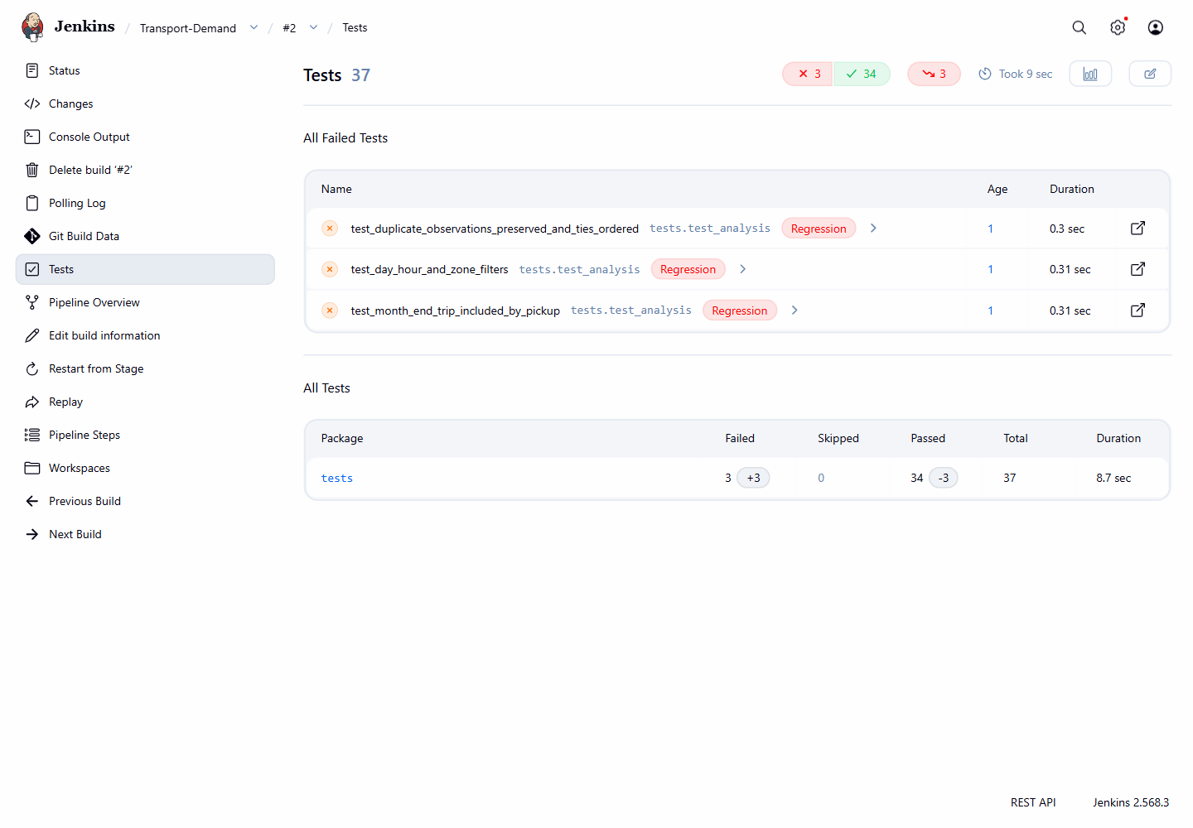
Figure 1 Jenkins build 2 records three failed count tests. This was an intentional fault-injection exercise; the faulty calculation is absent from the submitted code.
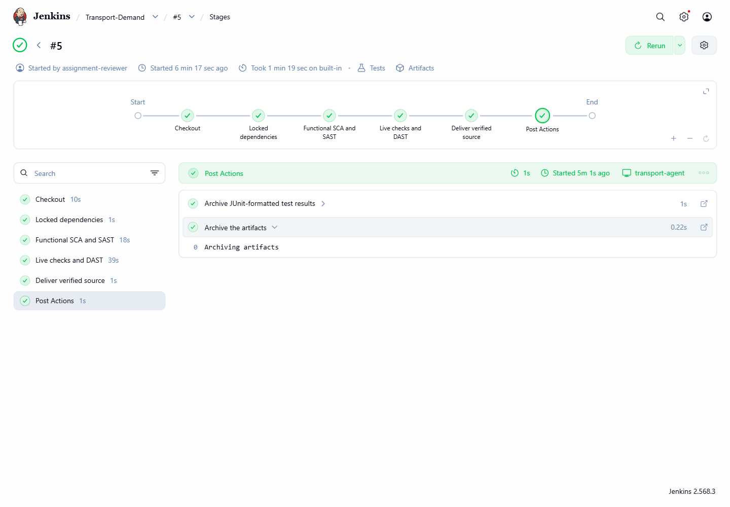
Figure 2 Jenkins build 5 records successful verification and delivery of the final combined source. The console and machine-readable reports are retained with the source evidence.

4 4 Benefits and limits of automation
Build 2 shows automation catching a counting error that manual review of millions of records could miss. Jenkins retains the assertion and revision for repeatable correction checks. Early failures also avoid unnecessary runtime scanning.
Automated reconciliation accounts for every source row, while small fixtures challenge query behaviour. Scanner errors and failed tests consistently block delivery. This reduces dependence on manual checklists, although test maintenance takes time and incorrect expectations can still approve faulty software.
Human review must challenge cleaning thresholds, judge usability and assess whether pickups answer the client’s question. Exploratory checks complement automation by revealing requirements absent from scripted tests.

References
ATHE (2024) Unit 9 Advanced Programming Assignment v1.0 and Level 5 Computing New Specification. Supplied assignment brief and unit specification.
Bandit (n.d.) Bandit documentation. https://bandit.readthedocs.io/en/latest/
DuckDB (n.d.) Reading and Writing Parquet Files. https://duckdb.org/docs/current/data/parquet/overview
Jenkins (n.d.) Using a Jenkinsfile. https://www.jenkins.io/doc/book/pipeline/jenkinsfile/
NIST (2022) Secure Software Development Framework Version 1.1. SP 800-218. https://csrc.nist.gov/pubs/sp/800/218/final
NYC Taxi and Limousine Commission (n.d.) TLC Trip Record Data. https://www.nyc.gov/site/tlc/about/tlc-trip-record-data.page
PyPA (n.d.) pip-audit. https://github.com/pypa/pip-audit
pytest (n.d.) How to use fixtures. https://docs.pytest.org/en/stable/how-to/fixtures.html
Python Software Foundation (n.d.) Classes and Abstract Base Classes. https://docs.python.org/3/tutorial/classes.html and https://docs.python.org/3/library/abc.html
ZAP (n.d.) ZAP API Scan. https://www.zaproxy.org/docs/docker/api-scan/
Web references accessed 28 September 2026.
Source code and selected verification evidence: https://github.com/25458346/advanced-programming-assignment

