Desk research survey on other air fryer sites.
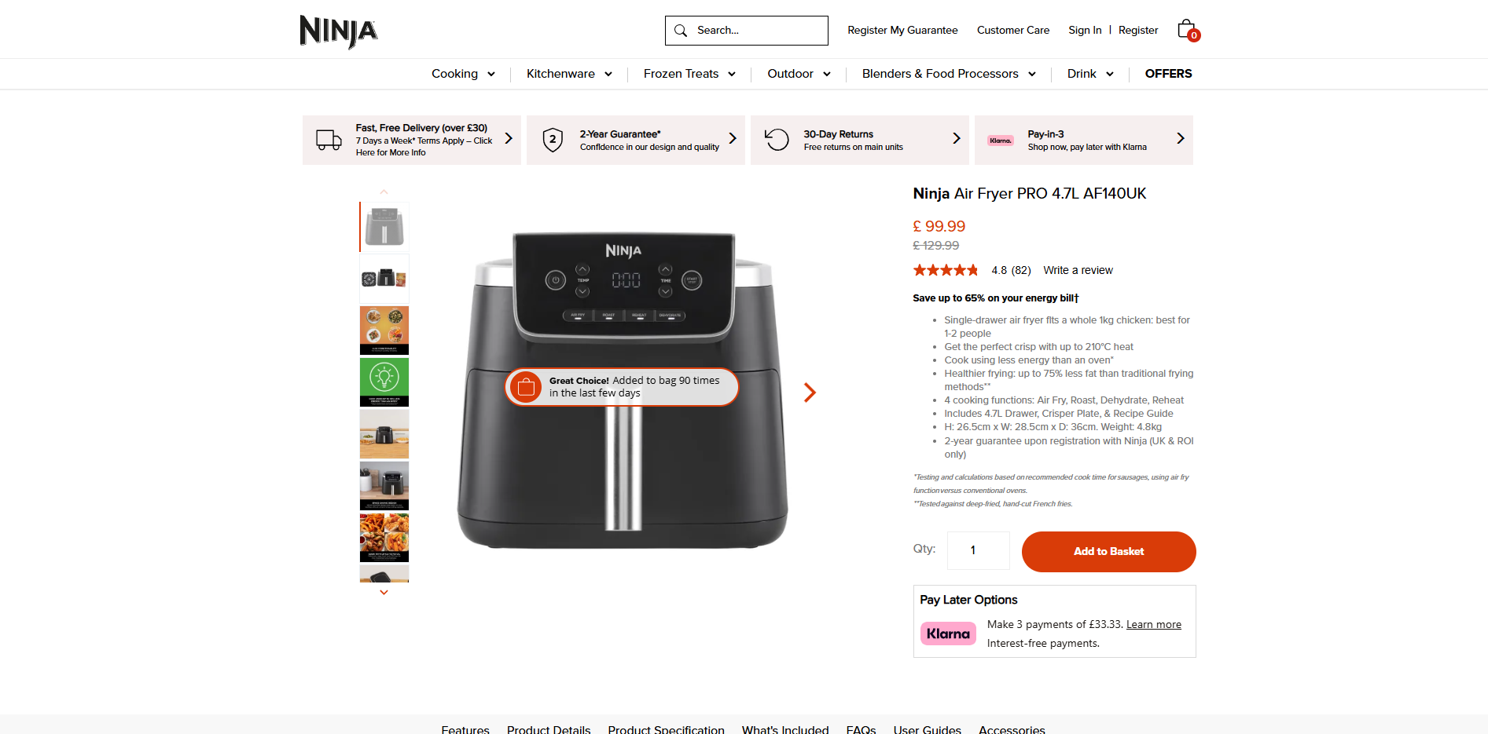

Ninja:
Basic white bg black text. Orange accents. Images in a slideshow that advance when arrows clicked. Image on left text on right. Stars are cut off slightly.
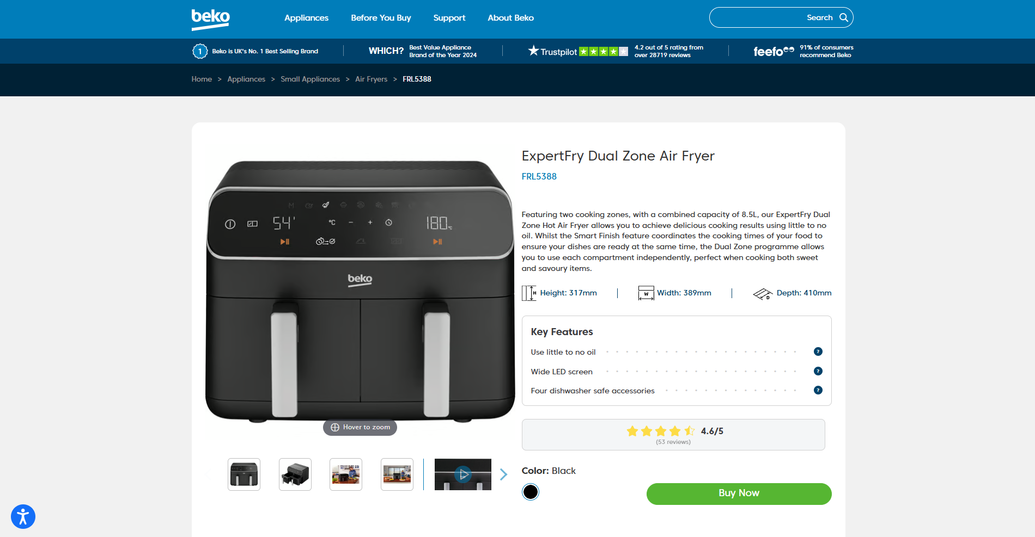
Beko:
Very similar structure to the Ninja, different colour scheme.
Includes same information but the structure is slightly easier to read.
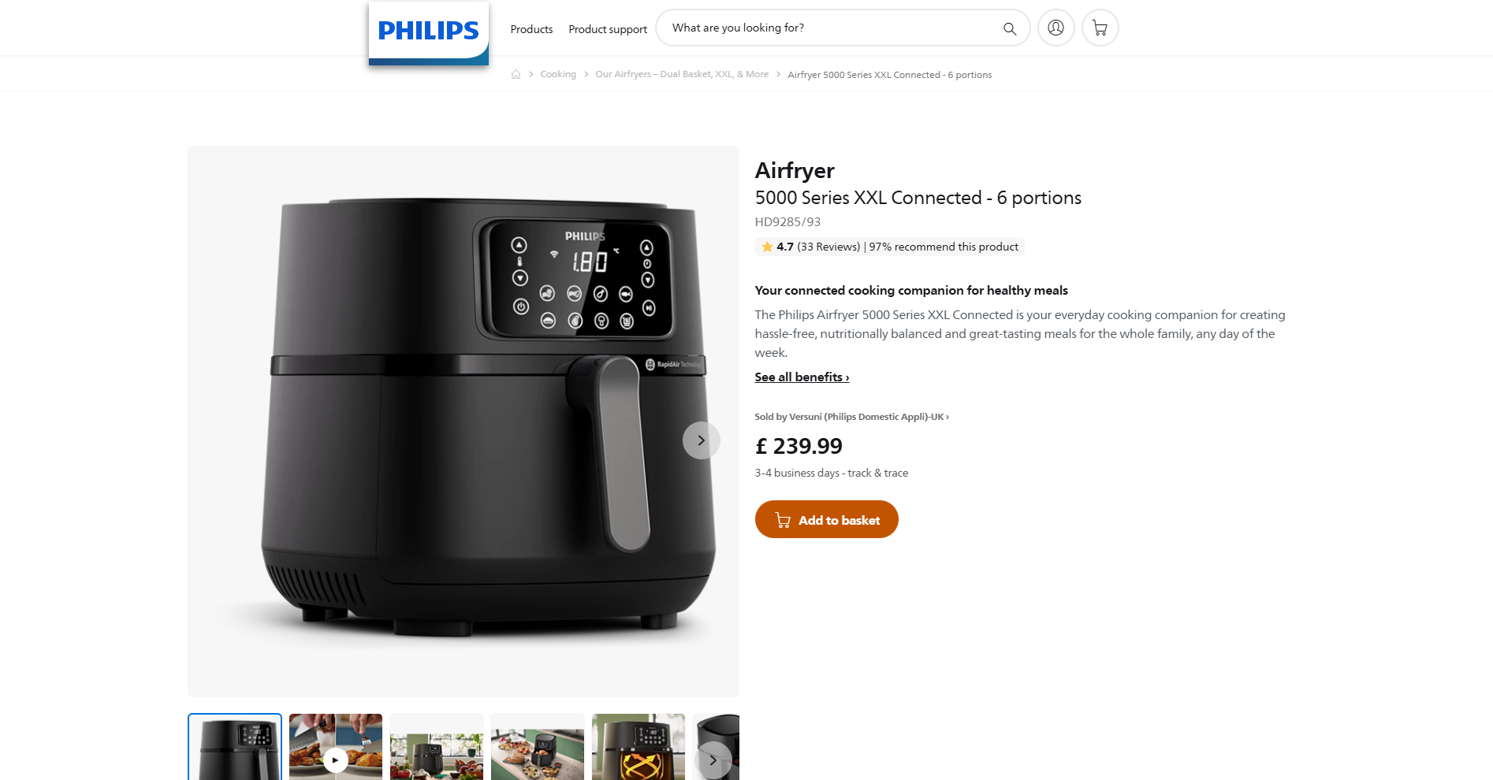
Philips:
Same structure yet again. Less information at a glance though it is mainly further down on this one.
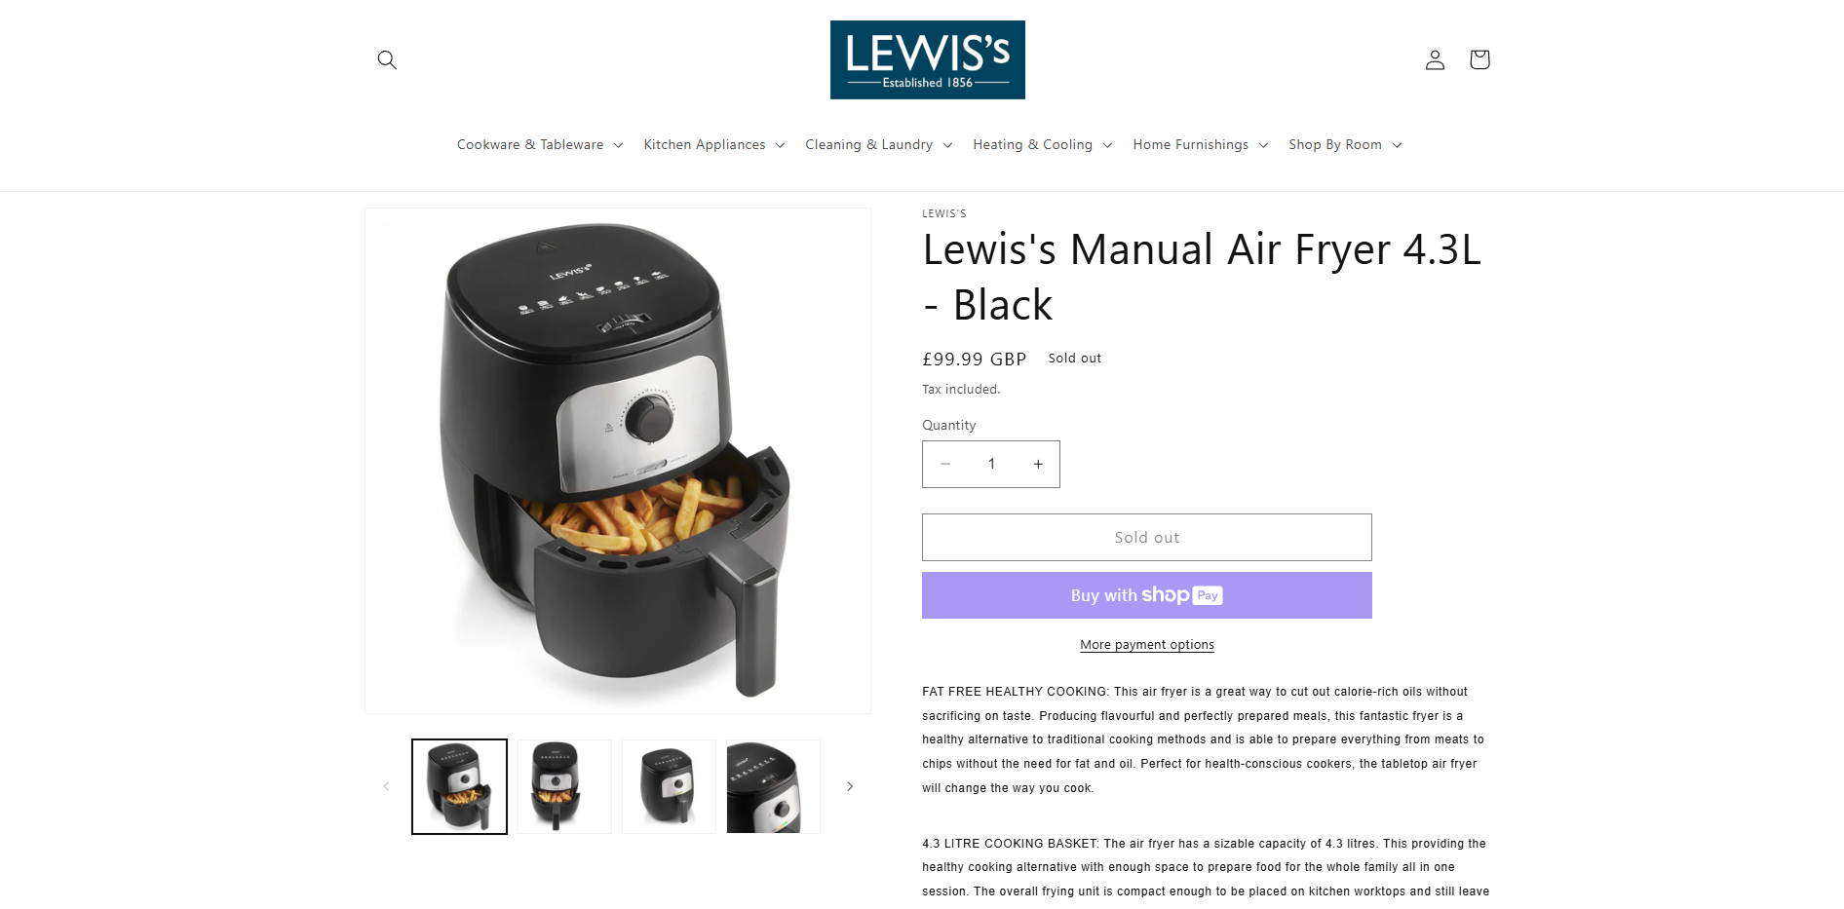
Lewis’s (same brand as my one)
Same structure, but the buy button and price are above the text rather than below.

