NO.137
CERTIFICATE OF DE-INSTALLATION
VEHICLE TRACKING SYSTEM
We hereby declare vehicle tracking system device has been de-installed
HESBON OMURWA
NIRVANA AFRICA LIMITED
Customer Name Destination

KCW 433T
LDA-5131530
Engine number Vehicle Reg no

- 354778343674084
- 355229560408136
COMBO
Security office model Ei number

GP1-1131807

Chassis number

117/12/2025

Date 17-Dec-25

Color
SILVER

PAUL KARANJA
Signatory Name
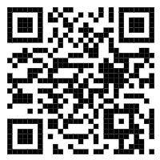

Failure due to accidents or damages to either vehicle or the units is not covered by the warranty. The warranty is limited to the replacement of faulty parts and components and the repair of the unit. The warranty becomes null and void if the unit has been tampered with, repaired or damaged by unauthorized person.

