FRS 303: CRIME SCENE INVESTIGATION
WEEK 6 SECURING, PROTECTING, AND RECORDING THE CRIME SCENE: Crime scene documentation - Forensic photography, sketching, and field notes. OOI
WEEK 7 PHYSICAL EVIDENCES IN CRIME INVESTIGATION: Definition, importance, and types of physical evidences. OOI
WEEK 8 HANDLING OF PHYSICAL EVIDENCE: Collection and preservation of physical evidence, maintaining chain of custody; and forwarding to the forensic laboratory in crimes like murder, theft, extortion, explosion etc. OOI
WEEK 9-10 CRIME SCENE SURVEY: Preliminary survey, Investigation and sketching of indoor scenes of crime using triangulation method and baseline method. OOI

LECTURE NOTES
WEEK 6
SECURING, PROTECTING, AND RECORDING THE CRIME SCENE
Crime scene management
Crime scene management can be defined as the actions taken to ensure that all the available forensic evidence is recovered from a crime scene. This may range from basic preservation and protection measures taken by the first officer attending and advice to the victim at a minor scene to the necessary cordoning guards, and protective measures such as tents at a major scene. The purpose in all cases is to control, preserve, record, and recover all evidence in a logical sequence that ensures, wherever possible, non-compromise of no other evidence type. Crime scene management requires the development of skills because it is an extremely significant task component of criminal investigation. Consequently, evidence that originates at the crime scene will provide a picture of events for the court to consider in the course of its deliberations. Different task processes and protocols are involved in crime scene management and these are:
Securing and Protecting the Crime Scene
This entails maintaining the integrity of the crime scene and it involves the performance of different tasks by the investigator that will ensure the identification, collection, preservation, and protection of evidence in such a way that it will be acceptable in the court. The different tasks to be performed in this regard include:
Locking down the crime scene
On arrival at the crime scene, the investigator has to establish if the criminal event has become an inactive event or it is still an active event. In the case of the latter, a tactical investigative response mode is employed. This entails protecting the life and safety of people as first priority while not neglecting evidence if it can be protected in view of the prevailing circumstances. On determining that the criminal event is an inactive one or has transited from an active to an inactive event, the immediate requirement is to take control of and lock down the crime scene. This involves stopping all ongoing activities inside the crime scene and making everyone within the scene (first responders, and witnesses, victim(s) or the arrested suspect as the case may be) to leave to a location some distance away. Next is to place a physical barrier, usually police tape, around the outside edges of the crime scene i.e. establish a crime scene perimeter in order to define the crime scene. No unauthorized person is henceforth allowed to cross the perimeter. Typically, there will only be one controlled access point to the crime scene known as the path of contamination, through which authorized personnel can re-enter the crime scene to conduct their investigative duties. The last step in locking down the crime scene is to establish a security system that will ensure that no unauthorized person(s) enters the crime scene and causes contamination i.e. a crime scene security officer is assigned to regulate the coming and going of persons from that crime scene.
Recording the crime scene – Crime scene documentation
This is the documentation of the crime scene and it involves videotaping, photographing, sketching, and field notes.
Videotaping
This is the first step in documenting a crime scene if a video camera is available. It has the advantage of providing a perspective on the crime scene layout which cannot be easily captured in photographs or depicted in sketches. It is more real and can readily be related to by people because it is a more natural viewing medium. Moreover, it demonstrates the structure of the crime scene, and how the evidence relates to the crime. Videotaping should be carried out with a video camera that has a fully charged battery, possesses time and date display and possibly a title generator. The camera range should be cleared of all personnel and recording should be done in absolute silence by all present. Once recording by the video camera begins, it should not be stopped until taping is completed. The secret to good videotaping is slow camera movement. Once taping is completed, the tape should be transferred to a high quality master tape which should be stored in a safe place. Copies can then be made from the master tape as the need arises.
Forensic photography
This is also referred to as crime scene photography. It is an activity that documents the initial appearance of the crime scene and physical evidence in order to provide a permanent record for the courts. The purpose of forensic photography is to document what is there and where it is in relationship to the scene, whether it is obviously connected to the crime scene or not. For example, in a particular crime scene, the photograph of a can of beer in the fridge at a homicide scene in a home matched the receipt of 6-pack of beer purchased by victim who does not drink. CCTV camera at point of purchase showed victim with a hitch-hiker. Good photography created the link!
Forensic photography thus provides a true and accurate record of the crime scene and physical evidence present by recording the original scene and related areas. It is extremely important to crime scene investigation because it establishes what the crime scene looked like at the time of the investigator’s arrival. Each photograph must therefore be taken in such a way as to capture its story. Forensic photography is most useful in that it supplies significant bits and pieces with exact measurement of the site and evidence where the crime has occurred.
Sketching
Crime scene sketches are one of the foundations of crime scene investigation and they are viable tools of scene documentation. A crime sketch refers to a handmade pictorial representation of conditions at a crime scene. It depicts the overall layout of a location and the relationship of evidentiary items to the surroundings e.g. it can show the path a suspect or victim took and the distances involved. A crime scene sketch therefore serves as a graphic document to show the layout, orientation and the interrelationships of the scene and evidence. The aim of an investigative sketch is to provide a correct record that shows the scene as it was found and that can be examined at a later date. It doesn’t require artistic ability but it must be accurate enough to show facts. It is supplementary to the investigator’s field notes. Its primary purpose is to support the final report as well as allowing viewers to quickly understand the scene set up. However, the sketch is not meant to replace photographs but rather to supplement the work. Other uses of a sketch include:
- Accurately portrays the physical facts and relates to the sequence of events at the scene
- Records the precise location and relationships of objects and evidence at the scene
- Refreshes the memory of the investigator
- Eliminates confusing and unnecessary details
- Assists later understanding of the crime scene(s)
- Assists in the questioning of suspects or witnesses
- Assists in correlating the testimony of witnesses etc.
There are two basic forms of crime scene sketches:
- A rough or preliminary sketch i.e. a draft and
- A finished sketch.
However, there are four main types of sketches which are:
- Floor plan or overview sketch i.e. looking straight down or bird’s eye view. It is the most common type of sketch and consists of items on the horizontal plane

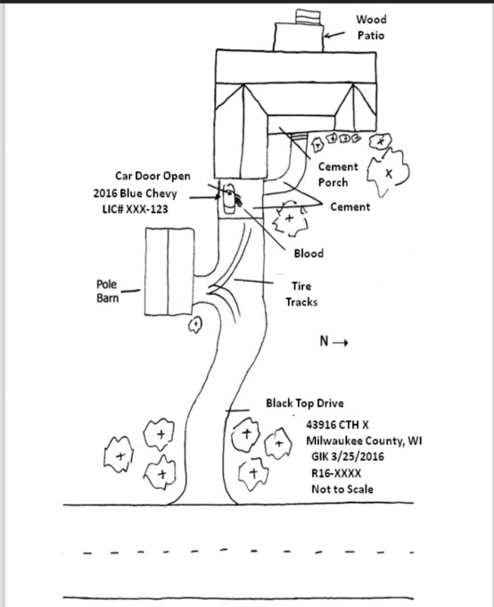
Fig. 1: Overview sketch of an exterior crime scene.
- Elevation drawing sketch i.e. straight ahead. It portrays a vertical plane rather than a horizontal plane e.g. blood stain patterns on a vertical surface such as walls or cabinetry and bullet holes through windows.

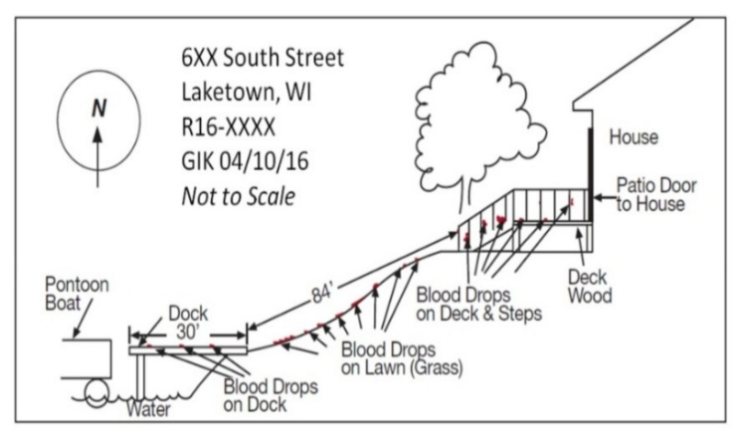
Fig. 2: Elevation sketch illustrating a blood trail
- Exploded view or cross-projection sketch i.e. a combination of the first two types. It is similar to a floor plan except the walls have been laid out flat and objects on them have been shown in their relative positions.
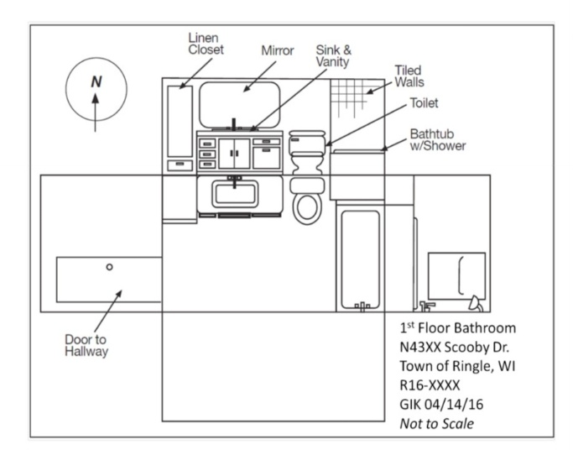
Fig. 3: Exploded view sketch of a bathroom
- Perspective sketch i.e. drawing depicting the scene or item of interest in three dimensions. It is the most difficult sketch to create and thus requires some artistic skill.
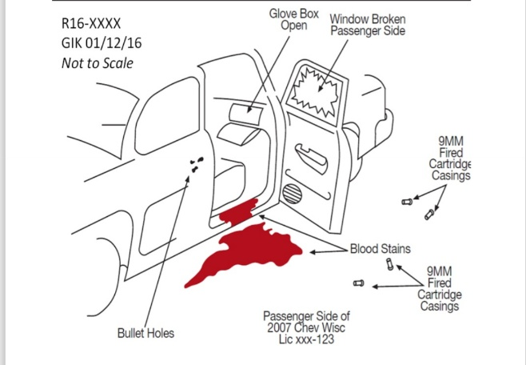
Fig. 4:Perspective sketch of the passenger side of a vehicle
Each type of sketch has its own limitations and they are used when needs be depending on the scene under investigation.
Field notes
Note taking is the documentation of personal perception and recollection of the event by the investigator at a crime scene. More than any other, the most important document for an investigator for a crime scene is note taking. It is his personal reference for recording the investigation, an overview of things seen or heard, and actions taken accurately and specifically documented. Acceptable parameters for a notebook used in crime scene management include:
- It must be a book with cover page, showing the name of the investigator, date the book started and date ended
- It must be a sequentially numbered and bound book such that pages cannot be removed unnoticed
- Each item in the book must start with a time, date, and case reference
- Blank pages must not be left in the book but if present, must be crossed with a single diagonal line so also errors
Initially overlooked but recalled facts are not inserted but rather written on a new page with current time and date but with reference to the previous recording. The content of the note is as follows:
- A big picture of general perspective at the onset of investigation
- Dates, times, description of persons, places, vehicles
- Identity of persons encountered
- All statements made by witnesses
- Record statement made by a suspect or prospective suspect verbatim
Although it may not be feasible to make notes on arrival at the crime scene in all cases, notes are made as soon as practical. The chronology of dates in the note demonstrates the investigator’s mental map of the facts that led to forming reasonable grounds for arrest and charges.

WEEK 7
PHYSICAL EVIDENCES IN CRIME INVESTIGATION
Evidence is something that tends to establish or disprove a fact, and it includes documents, testimony and other objects. It is divided into two general types which are:
- Testimonial evidence which also is called direct evidence or prima facie and it is a statement made under oath.
- Physical evidence which is also called real evidence and it is any object or material (tangible, large or small) relevant in a crime.
Definition of physical evidence
Physical evidence can be defined as a tangible object which can tie the defendant, the witness or the victim to the crime scene i.e. an evidence that can be seen, held, or observed in a crime scene. This could range from being microscopic in nature (may go unnoticed by an ordinary human) to something that is macroscopic to a level that someone may perceive it is normal and hence insignificant i.e. can be as large as a building, fleeting as odour or temperature, small as a hair or even sub-microscopic like DNA evidence. Physical evidence is generally much more reliable than testimonial evidence and when collected without errors, collected by experts without any mismanagement, and preserved properly, it is completely irrefutable. Common types of physical evidence include drugs or toxic substances, paints, Gunshot residue (GSR), firearms and ammunition, impressions (shoe prints, bite marks etc.), fibres, soils, glass, body fluids, blood, fingerprints, pollen, bones, tool marks, wood material, tissues, hairs, serial numbers, explosive residues, alcohols (especially ethanol), rubber material, resins, plastics etc.
Importance of physical evidence
Edmund Locard was the first to emphasize the importance of contact or trace forensic evidence, that investigators extract as physical evidence, and he formulated the theory called ‘exchange principle’. Physical evidence, whether individual evidence (which is the best) i.e. anything that can be related to a unique, single, specific source e.g. fingerprints, handwriting, DNA patterns, and sometimes physical matches such as a piece of broken glass that fits exactly to another, like a jigsaw puzzle or class evidence (most common) i.e. has a characteristics common to a group of similar objects e.g. blue jeans (though we can go to some length towards individualization by classifying by maker, model, size, colour shade, and surface treatment, but there are still thousands of other pairs that are just the same except for tears, stains, or even creases that individualize them). Apart from proving that a crime has been committed e.g. gasoline found at the scene of a fire accident, physical evidence plays very important roles in criminal investigation such as:
- Plays a key role in linking the suspect and the victim to every alternative or to the crime scene e.g. a broken piece of headlight glass found in the cuff of a suspect’s pants could place him at the scene of a hit-and-run accident.
- Physical evidence helps the examiner or investigator to reconstruct or recreate the crime scene and infer the sequence of events that might have taken place e.g. blood spatter pattern may show where the suspect and victim were located relative to each other, and may indicate what happened and in what order.
- Being objective in nature, physical evidence can be used as a solid and reliable fact to prove or disprove witness testimony or that of any other individuals involved e.g. a forensic scientist can test a bloodstain that a suspect claims is his own and not the victim’s.
- Physical evidence is also referred to as “silent witness” because it is one of the crucial ways to determine or prove the involvement or identity of someone in a certain activity that took place at the crime scene e.g. fingerprints or handwriting or DNA might prove that a certain person was present at a crime scene.
- Physical evidence can help infer information related to the method the defendant used to harm the plaintiff, the trajectory of the weapon used, and even an estimated intent in case it is a question of plain murder or self-defence.
Types of physical evidence
The main types of physical evidence are:
- Trace evidence – these are materials left behind when two objects or people interact, may be microscopic or macroscopic e.g. fibres, hair, soil, wood, Gunshot residue (GSR), pollen etc.
- Biological evidence – these consists of bodily fluids and tissues e.g. blood, skin, saliva, hair, semen, and urine.
- Comparative evidence – these are evidential marks that are analysed and compared to other evidence markings to determine their origin e.g. fire arms, tool mark, footwear mark, tire imprint and impression analysis.
- Conditional evidence – this is an evidence that is dependent on certain conditions being met to establish a connection or support a conclusion e.g. witness testimony, DNA evidence, circumstantial evidence.
- Latent fingerprints – these are fingerprints that are not apparent to the eye but can be made sufficiently visible, as by dusting or fuming, for use in identification i.e. traces of sweat, oil, or other natural secretions.

WEEK 8
HANDLING OF PHYSICAL EVIDENCE
Collection and preservation of physical evidence
Most physical evidence is perishable to some extent and they can be deliberately or naturally destroyed or contaminated. Hence physical evidence should be identified and secured as soon as possible. The Federal Bureau of Investigation (FBI) recommended the following five steps for collecting and preserving evidence:
- Obtaining it legally
- Describing the evidence in detailed notes
- Identifying it accurately and positively
- Packing it properly for identification, storage, or shipment to the laboratory
- Establishing and maintaining the chain of custody
Once the crime scene has been thoroughly documented and the locations of the evidence noted, then the evidence collection process commences. The process usually begins with the collection of the most fragile or most easily lost. Special consideration is given to any evidence or object that needs to be moved. Collection then continues along crime scene trail or in some logical manner viz-a-viz trace (hairs, fibres) → biological fluids → tool marks → visible fingerprints or foot wear patterns → latent patterns. Photographs should also continue to be taken if the investigator is revealing layers of evidence not previously documented because they were hidden from sight. For proper preservation, different evidence type usually requires different containers. While most evidence will be collected in paper containers e.g. packets, envelopes and bags and liquid items will be collected in non-breakable leak-proof containers, moist or wet evidence e.g. blood, plants etc. on the other hand will be collected in plastic containers but once in a secure location, whether they are in plastic or paper, they must be removed and allowed to completely air dry, then re-packaged in a new dry paper container. Evidence storage interval between collection and preservation before being forwarded to the laboratory for analysis is usually two hours or less. In general, physical evidence must be handled in such a way that the collection and preservation process does not give any room for damage, contamination, or even loss from the point of collection to presentation in court.

Maintaining chain of custody
Chain of custody can be defined as a process that tracks the movement of evidence through its collection, safeguarding, and analysis life cycle by sequentially documenting each person who handled the evidence, the date or time it was collected or transferred and the purpose for the transfer. The chain of custody, otherwise known as the chain of evidence, is what confers authenticity (proof of integrity), on the evidence before the court of law and it is therefore a very crucial process of evidence documentation. i.e. it is what attests that it is the same evidence seized at the crime scene – it was at all times in the custody of a person designated to handle it and for which it was never unaccounted for. Thus, for an evidence to be relevant in the court, the continuity of its possession or custody, and its movement and location from the point of discovery and recovery (at the crime scene or from a person) to its transport to the laboratory for examination and until the time it is allowed and admitted in the court, must be documented on a paper trail! A record of the chain of custody is therefore very crucial in forensic science, particularly in crime scene investigation for it not only guarantees that evidence was handled only by approved personnel and was not accessible for tampering before analysis, it also prevents police officers and other laboratory or law officials involved from tainting the evidence or misplacing it as it would eventually be traceable back to them, and they would be held responsible for same.
The investigator or the person responsible for collecting evidence must complete the labels of appropriately packaged sample container or bags as well as the chain of custody forms to enable tracking of the sample. A separate chain of custody form must accompany different evidence bags and the information on the form must include:
- Unique identifier
- Name and signature of the sample collector
- Official address and contact number
- Name of the recipient
- Laboratory’s address
- Details of each sample
- Signature of everyone involved in the chain of possession with date and time
- Date and method of delivery
- Authorization for analysis of the sample
- Any other information about the sample
Each time the charge of the evidence is changed, an entry of signature, date, and time is necessary for the chain of custody form.
Forwarding to the forensic laboratory in crimes like murder, theft, extortion, explosion etc.
Physical evidence can be classified into two categories which are:
- Trace evidence – which are small, often microscopic evidence left at the crime scene e.g. paint, hair, fiber etc.
- Objective evidence – these are larger items which may have been used in the commission of a crime e.g. weapons, tools, clothing etc.
Different types of evidence can be associated with different types of crimes and there may not be a strict dichotomy from one crime to the other. Some trace evidences such as fingerprints, fibers, hair, wood, soil, GSR etc., biological evidence e.g. blood, saliva, hair etc. as well as firearms e.g. GSR, bullets etc. could be associated with murder, theft, extortion, explosion etc. however, some evidence types may be unique to some crimes e.g. semen or vaginal fluid in homicides, handwriting in extortion, fragments or parts of a bomb in an explosion etc. Appropriate packaging materials are used for different types of physical evidence for onward transmission to the forensic laboratory e.g. trace is placed in paper or plastic bags (depending on porosity i.e. porous ones are placed in non-porous bags and vice versa) to prevent contamination by moisture or other substances, materials requiring residue testing (e.g. swabs) are packaged in nylon zip-lock or heat sealed bags, non-corrosive plastics or glass containers, fragment or parts of bomb are packaged in tight cotton from all sides in a plastic container with a transparent lid, dried clothing or cloth containing dried blood stains are packaged in paper bag or polythene bag, materials not requiring residue testing are packaged in polythene zip-lock bag, soil, loose materials are placed in interlocking type polythene bag or plastic container, liquid samples are packaged in glass containers or non-corrosive plastic containers etc. For evidence that have to be shipped to the forensic laboratory, bubble wrap or foam is used to protect them while in transit and a reliable and secure method must be chosen for transportation. Packaging and forwarding of physical evidence in forensic science is a crucial step in ensuring the evidence is preserved in its original state, and is not contaminated during the transportation.

WEEK 9-10
CRIME SCENE SURVEY
Crime scene survey involves the examination of the crime scene in such a way as to gather as much information as possible about the scene. This is to enhance crime scene investigation which is aimed at helping to establish what happened (crime scene reconstruction) and to identify the responsible person. The process of crime scene survey begins with walking along the “trail” of the crime i.e. the area which all apparent actions associated with the crime took place, as marked by the presence of physical evidence. This includes point of entry, location of the crime, areas that may have been cleared up by the suspect, and the point of exit. This walking along the “trail” is otherwise known as preliminary survey or “walk-through”
Preliminary survey
This is an initial survey of the crime scene to prioritize evidence collection. It is also known as primary survey or “walk-through”. It is usually done by the lead investigator to identify potentially valuable evidence, take notes and capture initial photographs of the scene and the evidence. The aim is to note the location of potential evidence and mentally outline how the scene will be examined. If a potential evidence is in danger of being destroyed, then it should be taken care of before the “walk-through” commences i.e. the evidence should be preserved or documented and collected as quickly as possible first. The first place the investigator should examine is the ground on which he is about to tread and any evidence observed there should have a marker placed on it as a warning to others to keep off and not step on such.
The “walk-through” begins as close to the point of entry as possible. A good technique employed for the “walk-through”, especially indoors on hard floors, is that of side lighting (or oblique lighting). It entails darkening the room (taking care to dust a light switch which a suspect may have used first for fingerprints before touching it) and using a good flashlight with a strong concentrated beam to sweep over the floor surface and fanned back and forth to bring any evidence (e.g. trace evidence, shoeprints) into view. During the “walk-through”, the investigator must ensure that his hands are occupied by either carrying notebooks, flashlight, pens, etc. or by keeping them in his pockets. Areas over his head should also not be left out e.g. ceiling, tree branches etc. as they may yield valuable evidence as blood spatters and bullet holes. On the conclusion of the “walk-through”, the next step is to document the crime scene i.e. videotaping, forensic photography, sketching, and note taking.
Sketching of indoor and outdoor crime scenes
There are different types of crime scenes which are outdoor, indoor, and conveyance. Outdoor crime scenes are the most difficult to investigate because of potential contamination of and subsequent destruction of evidence due to exposure to elements such as rain, wind, or heat as well as animal activity. Evidence at indoor crime scenes are generally less susceptible to loss, contamination or deleterious change. Conveyance crime scenes involve something that serves as a means of transportation e.g. vehicle burglary, carjacking, homicide, sexual battery (a less serious offense but used interchangeably with rape in some states in the US while in others, the former does not involve penetration though it is a crime that is sexual in nature e.g. touching private parts or even forcing a kiss) and like indoor crime scenes, evidence are also less susceptible to damage.
However, for indoor and outdoor crime scenes, apart from preliminary pictorial sketches, an investigative sketch must contain measurements for all evidence locations and other pertinent objects (e.g. furniture) in the crime scene. Three basic methods are employed for taking such measurements i.e. recording the location of evidence and they are:
- Triangulation method – This is a highly accurate method for indoor scenes or where fixed points are readily available. It is also useful for plotting irregularly shaped areas or multiple items of evidence. It uses two or more reference points to establish the position of an object. By drawing a line that connects the two reference points and extending a line from each of the reference point to the object being measure, a triangle is formed i.e. measuring each object to two fixed locations of the crime scene and the distance between those fixed locations to form a triangle of known measurements e.g. in an indoor crime scene or a vehicle collision scene.

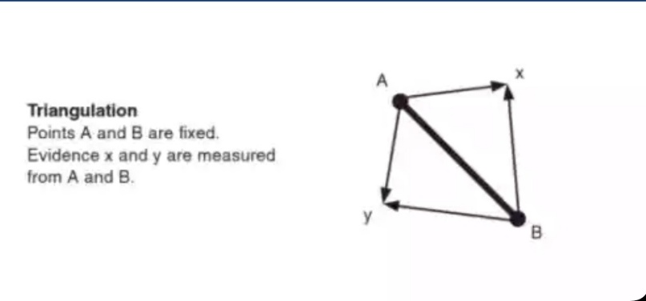

- Baseline method – This is one of the most common or basic methods but it is the least accurate. This is mainly used for outdoor crime scenes or where a clear, straight reference line can be established. It is simple and quick to use, as well as being effective for outdoor scenes or large areas with few points. It entails often establishing a baseline along a curb or side walk in order to simplify the measurement process. Measurements are then made from a point on the tape to an object in the crime scene.

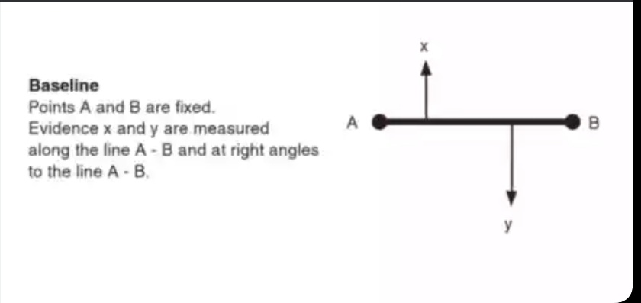
- Polar coordinate method – This is commonly used in outdoor scenes where establishing a straight baseline is difficult or impractical. It uses a fixed point and measures the distance and angle from this point to the evidence. It is employed for measuring the locations of evidence concealed in settings such as wells, pits, cisterns, sinkholes, cave shafts or other confined subterranean spaces, thus it is useful for large or irregularly shaped crime scenes. It is also very effective when evidence is scattered over a wide area. It entails mapping, remotely, from ground surface, using polar coordinates. Three-dimensional diagrams can then be generated from the map obtained.

