**Rock paper scissors** (also known by other orderings of the three items, with "rock" sometimes being called "stone"  is a [hand game](https://en.wikipedia.org/wiki/Hand_game) usually played between two people, in which each player simultaneously forms one of three shapes with an outstretched hand. These shapes are "rock" (a closed fist), "paper" (a flat hand), and "scissors" (a fist with the index finger and middle finger extended, forming a V). "Scissors" is identical to the two-fingered [V sign](https://en.wikipedia.org/wiki/V_sign) (also indicating "victory" or "peace") except that it is pointed horizontally instead of being held upright in the air.

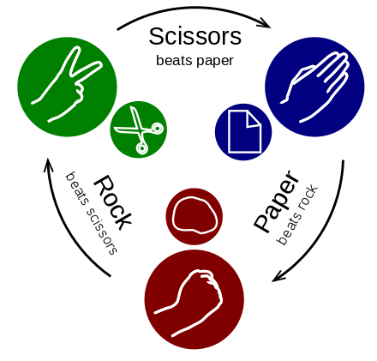

Here we implement game with Computer Vs Player

To re-create this using c-programming the requirements are as follows

HIGH LEVEL REQUIREMENTS

|  |  |  |
| --- | --- | --- |
| No. | Requirements | category |
| 1 | C-program | Technical Requirements |
| 2 | Operating system | platform |
| 3 |  |  |

LOW LEVEL REQUIREMENTS

A C-program to implement the game flow

A [simultaneous](https://en.wikipedia.org/wiki/Simultaneous_game), [zero-sum game](https://en.wikipedia.org/wiki/Zero-sum_game), it has only two possible outcomes: a draw, or a win for one player and a loss for the other. A player who decides to play rock will beat another player who has chosen scissors ("rock crushes scissors" or sometimes "blunts scissors”, but will lose to one who has played paper ("paper covers rock"); a play of paper will lose to a play of scissors ("scissors cuts paper"). If both players choose the same shape, the game is tied.

|  |  |
| --- | --- |
| **Genre(s)** | Hand Game |
| **Players** | Player vs computer |
| **Setup time** | None |
| **Playing time** | Instant |
| **Random chance** | Depending on the instantaneous situations |
| **Skill(s) required** | Psychology |