UML DIAGRAMS

1. STRUCTURAL DIAGRAMS

Class digram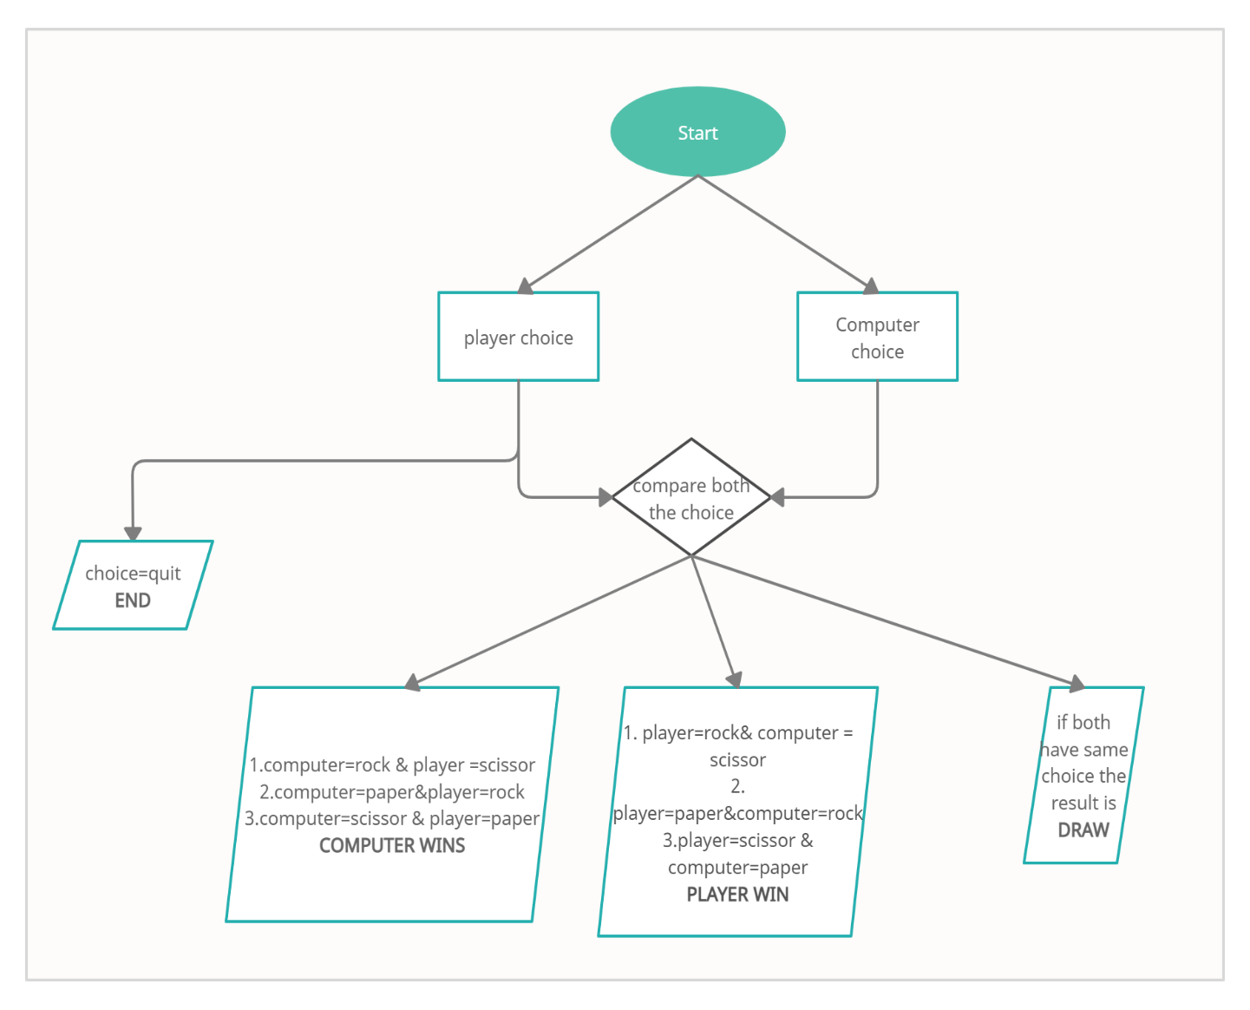

Object diagram also known as the instance diagram which represents the instance at certain point

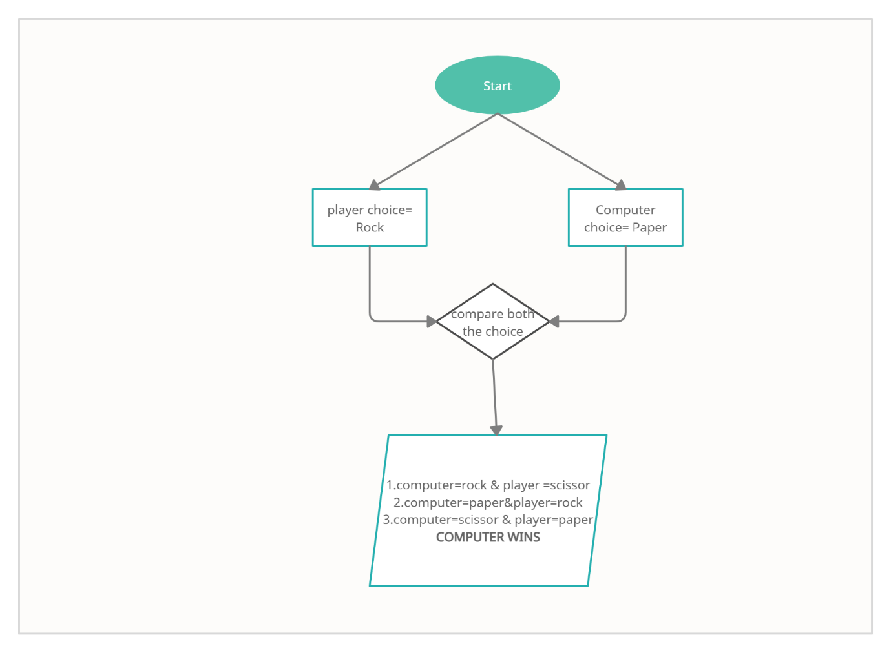

1. BEHAVOIRAL DIAGRAM

Activity diagram

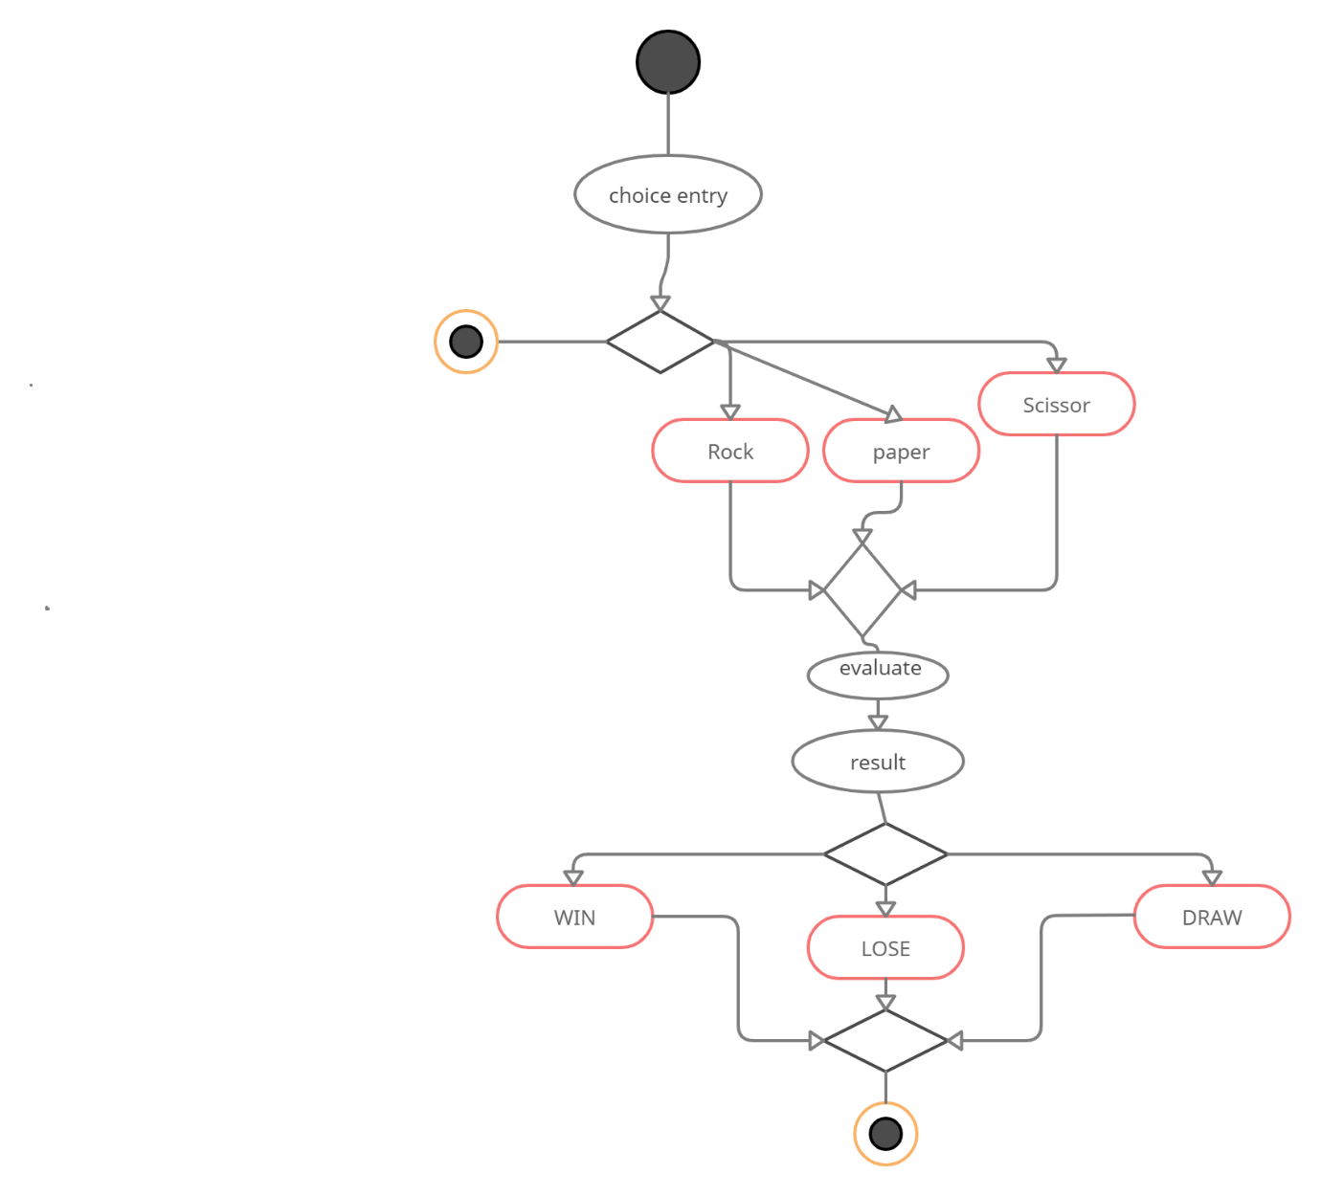

User flow diagram

