High-EQ Reply Assistant: A Generative AI Approach to Complex Social Context Response Generation
1.Analysis of the Problem and the Topic
In contemporary digital communication, individuals are frequently thrust into high-pressure social scenarios that demand an acute sense of emotional intelligence. Whether it involves tactfully declining an unreasonable workplace request, navigating interpersonal friction, or addressing awkward inquiries, the margin for error is notoriously thin. These situations require a delicate equilibrium: a response must be polite yet firm, displaying empathy while asserting clear boundaries. However, the psychological friction involved, compounded by the expectation of instant replies, often induces a state of "social aphasia." This phenomenon routinely results in poorly formulated messages that inadvertently escalate conflicts rather than resolving them.
Interestingly, while the current market is saturated with entertainment-oriented AI applications—such as text-based RPGs or virtual companions that merely satisfy "nice-to-have" desires—there remains a glaring void for functional tools designed to address genuine conversational crises. Our project targets this universal "painkiller" need. The core challenge we address is the linguistic and emotional paralysis people experience when provoked, a difficulty further exacerbated by the "high-context" nature of Chinese social dynamics where implicit meanings often outweigh explicit statements.
To bridge this gap, we conceptualized the "High-EQ Reply Assistant," an AI-driven social survival agent. Situated at the intersection of computational linguistics and social psychology, this research explores how large language models (LLMs) can be rigorously engineered. Rather than producing generic text, the objective is to generate responses that are contextually nuanced, strictly boundary-aware, and aligned with customized stylistic personas—namely Witty, Diplomatic, Direct, and Empathetic—thereby effectively equipping users to untangle complex communication dilemmas.
2.Why Generative AI is the Right Tool for the Task
The inherent complexity of human social interaction renders traditional programming methodologies largely obsolete for this domain. Social exchanges are infinitely variable and culturally situated, meaning that attempting to hard-code a rule-based conversational agent using conventional "if-then" decision trees is an exercise in futility. Generative AI, notably advanced Large Language Models, stands as the only viable technical solution primarily due to its intrinsic capacity for unstructured contextual understanding. These models excel at inferring the latent emotional undertones, implied relational power dynamics, and actual intent concealed within a given conversational prompt.
Furthermore, state-of-the-art LLMs demonstrate a rudimentary architectural capacity for "Theory of Mind"—the psychological ability to anticipate how a specific cognitive or emotional stance might be received by a counterpart. By leveraging this capability, our system instructs the model to actively simulate the recipient's perspective. It effectively performs an internalized "Multi-Agent Simulation" or sandbox negotiation, evaluating potential conversational fallout before finalizing the output.
Perhaps most crucially, the specific requirements of our task hinge on stylistic multiplicity. Users require varied tonal options to match their specific real-world context. Generative AI possesses a unique aptitude for zero-shot stylistic transfer. Through precisely targeted prompt engineering, these models can dynamically recalibrate their vocabulary, syntactic structure, and empathic tone to embody a desired persona, circumventing the need for thousands of manually labeled, style-specific datasets.
3.Approach and Methods Implemented
Moving beyond the rudimentary creation of an LLM API wrapper, our developmental approach is rooted in rigorous engineering designed to quantify and control the inherently subjective metric of "High EQ."
3.1 System Architecture
We initiated this by constructing a lightweight Web Application utilizing a custom HTML/Vanilla JS frontend and a robust FastAPI backend, securely hosted on the Railway deployment platform. This architecture aggregates multiple state-of-the-art models—including GPT, DeepSeek, Gemini, and Qwen—via the HKBU GenAI API. This infrastructure effectively establishes an "LLM EQ Arena," an environment allowing us to continuously cross-validate how differing neural architectures compute identical high-pressure Chinese social schemas.
3.2 Context-Aware Prompt Architecture (Intervention)
The cornerstone of our intervention relies on a Context-Aware Prompt Architecture. Recognizing that a zero-shot generic prompt inevitably yields socially obtuse and robotic output, we enforced a structured "System 2 Thinking" protocol upon the LLMs. The model must first execute an intent analysis to detect any passive-aggressive or adversarial elements in the sender's text. Following this, it applies strict behavioral constraints to suppress the AI's natural predisposition toward excessive compliance and unwarranted apologies. Finally, it bifurcates its generative process to yield exactly four tonal variations—Witty, Diplomatic, Direct, and Empathetic—ensuring the user retains sovereign decision-making power over the final interaction.
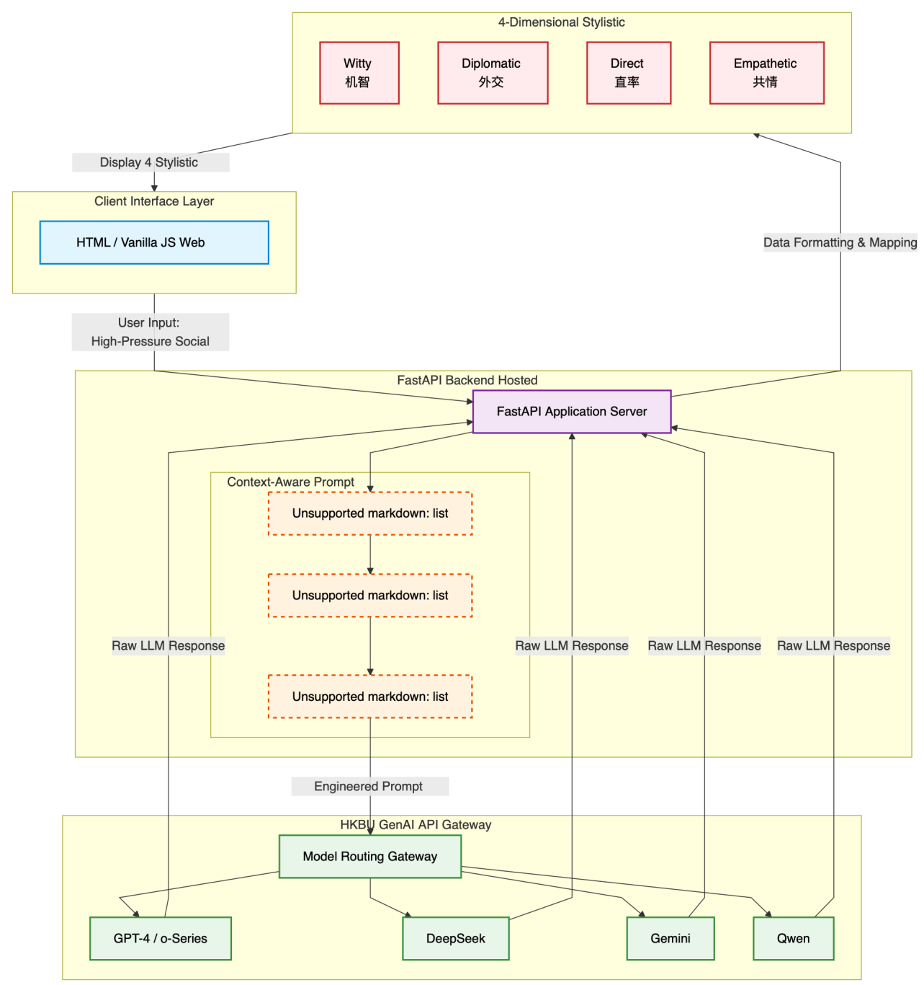
3.3 The EQ Evaluation Matrix
To grant this system academic validity, it was imperative to dismantle the abstract notion of "High EQ" into a measurable rubric. We formulated a quantitative four-dimensional EQ Evaluation Matrix. This benchmark assesses:
- Empathy & Politeness: Does the generated response demonstrate sufficient empathy to validate counterparty feelings while maintaining dignity?
- Boundary Management: Does the response successfully defend user interests without over-conceding?
- Clarity & Effectiveness: Is the core message efficiently communicated?
- Context Appropriateness: Does the formulation fundamentally respect the situational appropriateness of prevailing power dynamics (e.g., adjusting deference based on peer versus superior interactions)?
4. Results and Conclusion
To empirically validate our architectural design, we executed a Human-in-the-loop Baseline Comparison via blind user surveys, functioning as an Ablation Study. We contrasted the unconstrained outputs of a zero-shot LLM (the Baseline) against the refined outputs generated via our Context-Aware Prompt Architecture.
4.1 Results Assessment
The analytical data, as visually corroborated by the survey comparison charts, exposed a profound contrast across three distinct developmental phases. Initially, the Baseline model frequently synthesized responses that users condemned as highly artificial and "robotic." Notably, these early iterations consistently failed the Context Appropriateness parameters because the native models exhibited a strong compliance bias—they sought to instantly resolve conflict by automatically apologizing or sacrificing the user's operational boundaries. Conversely, an engaging contradiction emerged during our second phase: early, unoptimized attempts at injecting personality caused the prompt to swing entirely to the opposing extreme, producing variations that bordered on aggressive sarcasm. This rendered the tool largely unusable for formal or workplace scenarios.

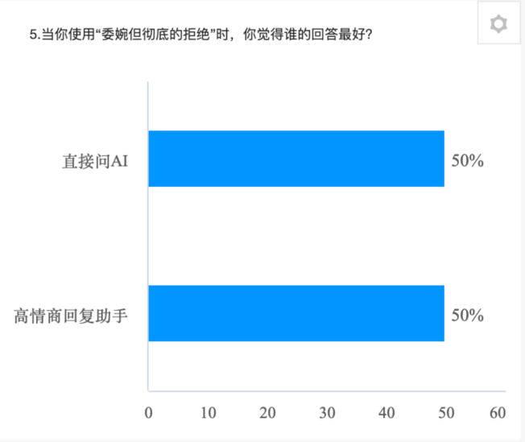
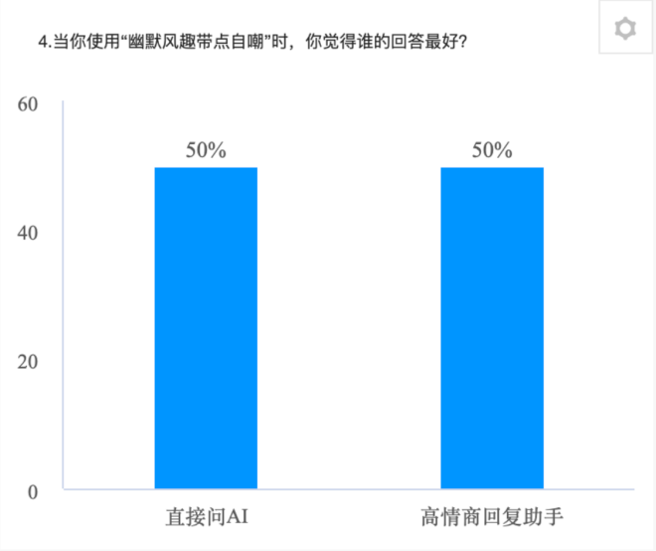
It was only upon deploying our final, meticulously calibrated prompt framework that we observed a stabilization. The optimized architecture successfully suppressed the mechanical tone while reigning in the passive-aggression, striking a functional balance between human decency and steadfast boundary protection. According to the subsequent blind testing data (detailed in the survey comparison graphs), the vast majority of users preferred the fine-tuned system's output over the native LLM during high-stress simulation scenarios. Moreover, the visualization of these comparative metrics illustrated a substantial aggregate increase in user satisfaction specifically within the volatile realms of Boundary Management and Context Appropriateness, definitively proving the efficacy of our intervention.
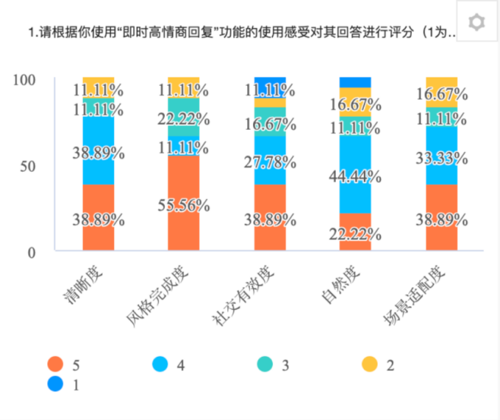
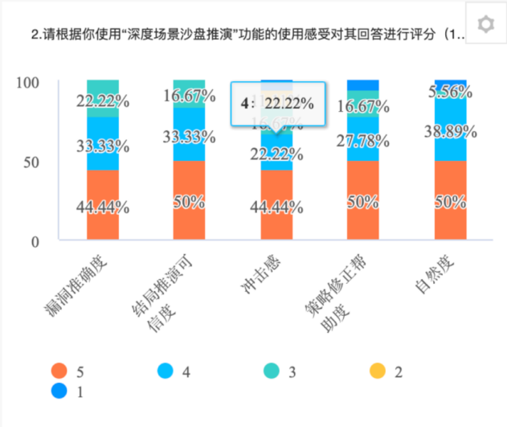

4.2 Conclusion
In final analysis, this project convincingly demonstrates that Generative AI can be elevated from the realm of general-purpose chatbots to operate as a highly specialized, surgically precise social survival mechanism. By codifying an inclusive EQ Evaluation Matrix and imposing rigorous Prompt Engineering structures, our methodology successfully neutralized the intrinsic compliance bias typically observed in commercial LLMs. The evolution of the "High-EQ Reply Assistant" serves as compelling evidence that, governed by appropriate algorithmic restraints, these models can adeptly navigate the high-context, emotionally charged labyrinths of human interaction. This paradigm not only offers immediate practical utility but also illuminates significant future pathways for both commercial communication tools and AI-assisted psychological empowerment.

Workload Distribution
LI JIHANG: Core Technical Development (Backend programming, HKBU API integration, multi-model version mapping, and core system architecture setup). (25%)
LI DISAI: Product Management and Prompt Engineering (System requirement coordination, prompt design and ablation tuning, context-aware logic construction, report writing). (25%)
GUO ZILIANG: Research & Data Analytics (Designed user surveys, conducted the blind tests, data compilation, evaluation matrix framing, and presentation script writing). (25%)
LI ZINING: UI/UX Design & Visualization (Web interface styling, visual data mapping for the EQ matrix radar charts, and slide beautification). (25%)

