TestPilot AI
An AI-powered platform that tests any web app from just a public URL. It chooses the right tests and generates safe synthetic data automatically.
- Live demo: https://testpilot-ai-8136.ai.studio
- Source code: https://github.com/258x5a4201-max/TestPilot-AI
- Built with: Google AI Studio, Gemini API, React, TypeScript

1. The problem
Good software testing needs many specialists and many tools: one for functional tests, one for APIs, one for load, one for security, one for accessibility. Small teams and startups cannot afford this. Writing test scripts by hand is slow and fragile, and most bugs hide in unusual inputs that people forget to try.

2. Our solution
TestPilot AI combines these into one application that needs only a URL. The AI explores the app, maps it, decides which kinds of testing fit, generates privacy-safe test data, runs the tests, and reports what is broken and how to fix it.

How it works (6 steps)
Step | What happens
1. Submit Target | The user enters the app’s public URL, with optional test login, OpenAPI/Swagger URL and test depth.
2. Verify Ownership | The user proves they own the site (DNS TXT record or a file at /.well-known/). This unlocks risky tests (rate limiting, security). Safe, read-only tests need no verification.
3. AI Discovery | The platform explores the app and builds an interactive App Map of pages, forms, inputs, APIs and auth flows, each with a risk score.
4. Test Strategy | Gemini selects the suitable testing types for each part of the app and explains why. The user sees a Selected vs Skipped table.
5. Synthetic Data | The AI generates safe fake data for every field (valid, boundary, malicious, unicode) and writes Given/When/Then test cases and Playwright scripts.
6. Execution and Reports | Tests run with live progress. The report shows a health score, severity ranking, screenshots, reproduction steps and AI fixes.

3. Feature list
Status key: Built = working in the app. Demo mode = works on sample data. Roadmap = planned.

Core platform
Feature | Status
6-step guided wizard (submit, verify, discover, strategy, data, report) | Built
Interactive App Map with risk scores (page, form, input, API, auth) | Built
AI test strategy selection with reasoning | Built
Synthetic data generator per field (valid, boundary, malicious, unicode) | Built
Given/When/Then test cases and Playwright test suites | Built
100% PII-free test data guarantee | Built
Role-based access: Admin, Tester, Viewer | Built
Slack webhook alerts (with test ping) | Built
Comparison page vs Qodo, Playwright, Postman, k6/JMeter, OWASP ZAP, Applitools | Built

Testing coverage
Capability | Status
Functional and form validation tests | Demo mode
Accessibility (WCAG 2.2 AA with axe-core) | Demo mode
Rate limiting and 429 burst detection | Demo mode
Security checks (XSS, SQLi patterns, headers, cookies, CORS) | Demo mode
API testing from OpenAPI or captured traffic | Demo mode
Self-healing selectors | Demo mode
Load, stress and spike testing | Roadmap
Cross-browser and visual regression | Roadmap

Productivity features
Feature | Status
Fix with AI (root cause, code fix, confidence score) | Built
Run comparison (fixed, new failure, still failing) | Built
CI/CD integration (GitHub Actions snippet, quality gate, README badge) | Built

4. Architecture
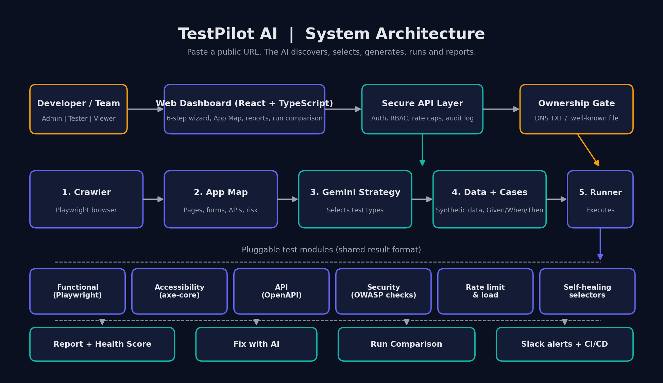
Architecture diagram
Design idea: one shared core (crawler, data generator, Gemini layer, runner, reporting) with each testing type as a small plugin that returns results in the same format. Adding a new test type means adding one plugin, not building a new tool.

5. Installation guide

Prerequisites
- Node.js 18 or newer and npm
- A Gemini API key from Google AI Studio (https://aistudio.google.com/apikey)
- Git

Steps
# 1. Clone the repository
git clone https://github.com/258x5a4201-max/TestPilot-AI.git
cd TestPilot-AI
# 2. Install dependencies
npm install
# 3. Add your API key (never commit this file)
cp .env.example .env.local
# open .env.local and set:
# GEMINI_API_KEY=your_key_here
# 4. Run locally
npm run dev
# open the URL printed in the terminal (usually http://localhost:3000 or http://localhost:5173)
# 5. Build for production (optional)
npm run build
Folder names, ports and script names depend on how Google AI Studio exported your project. If a command differs, check the scripts section of package.json.

Deployment
The project is deployed from Google AI Studio to Google Cloud Run. Add GEMINI_API_KEY as an environment variable or secret in the deploy settings. Do not put it in the code. The static frontend can also be deployed to Vercel or Netlify from the GitHub repository.

Quick try
- Open the live URL.
- Enter https://www.saucedemo.com as the target.
- Optional test login: standard_user / secret_sauce. Leave the OpenAPI field blank.
- Walk through the six steps and review the App Map, test strategy, synthetic data and report.

6. Business use case
Who needs it
- Startups and small dev teams with no dedicated QA staff
- Agencies that deliver many client websites and need fast, repeatable testing
- Students and freelancers who need professional-grade checks without setup
- Product teams that want a quality gate in CI/CD
Value
- Cuts manual QA effort: no test scripts to write, no tools to configure.
- Finds more bugs earlier: edge cases (boundary, malicious, unicode) are tested automatically.
- One report instead of five tools: functional, API, security, rate limit and accessibility together.
- Compliance help: accessibility (WCAG 2.2 AA) and common OWASP-style checks.
- Faster fixes: AI explains the root cause and suggests the code change.
Business model ideas
- Free tier: limited runs and safe, read-only tests
- Team plan: more runs, scheduled testing, CI/CD, Slack alerts, run history
- Enterprise: SSO, private deployment, custom compliance packs, usage quotas

7. Security and ethics
- Ownership verification before any intrusive test (rate limiting, security fuzzing).
- Safe by design: hard caps on requests per second and test duration, plus a kill switch.
- SSRF protection: private and internal addresses (localhost, 192.168.x.x) are blocked.
- Privacy: all generated data is synthetic and PII-free. Test credentials are stored encrypted and masked in the UI.
- Access control: Admin, Tester and Viewer roles, with an audit log.
- Use only on applications you own or have written permission to test.

8. Future roadmap
Phase | Plan
Now | Complete live crawl and Playwright execution on verified domains; connect the real DNS/file ownership check
Next | Load and stress testing with k6; visual regression; cross-browser and mobile viewports
Later | Auto-created Jira and GitHub issues; scheduled nightly runs; AI exploratory agent; learning from past bugs on the same app
Long term | Compliance packs (OWASP Top 10, GDPR, PCI-DSS); team workspaces and billing; IDE and pull-request integrations

9. Known limitations
- Automated accessibility tools find only part of all accessibility issues. Human review is still needed.
- AI-generated expected results and code fixes are suggestions and must be reviewed by a developer.
- Features marked Demo mode run on sample data until the backend execution engine is connected.

10. Team
TECH TRINITY: CH TEJA SAI VIGHNESH, CH RAMGOPAL, B RAHITHYA, E SWATHI REDDY

License
MIT

