**Button Sensor is ON and Heater is ON , LED is ON**

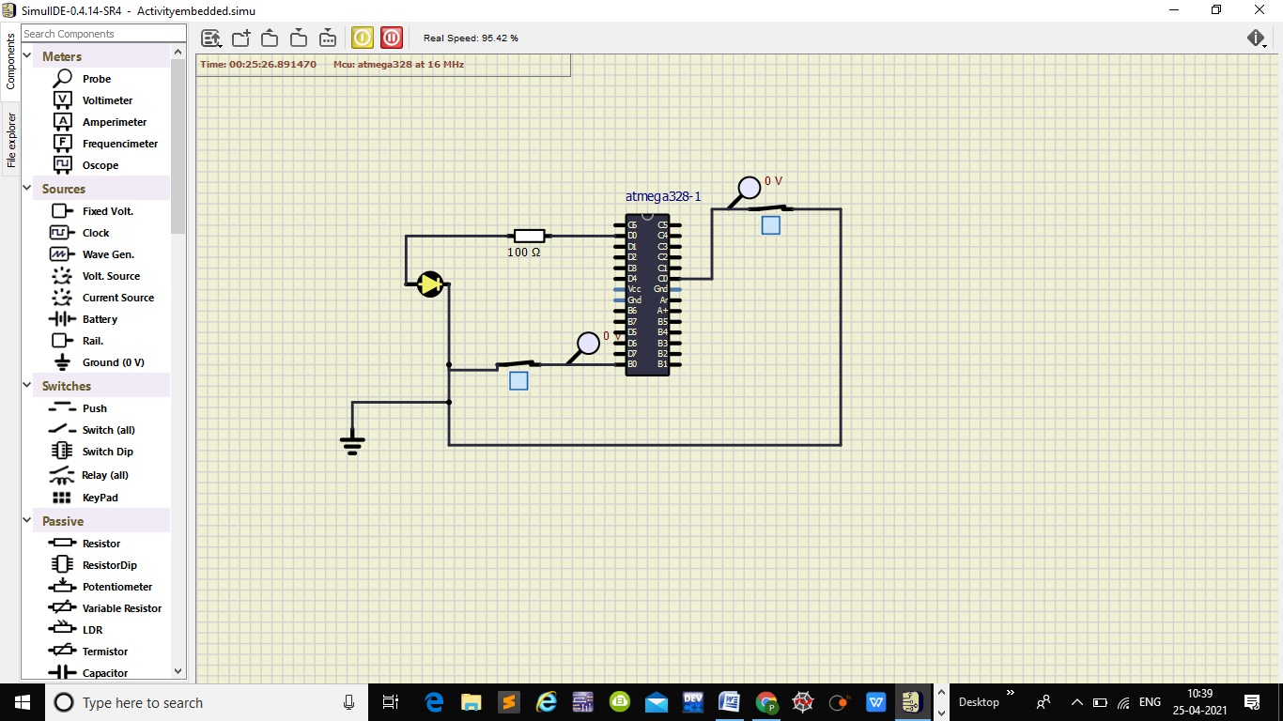

## Button Sensor is ON and Heater is OFF ,LED is OFF

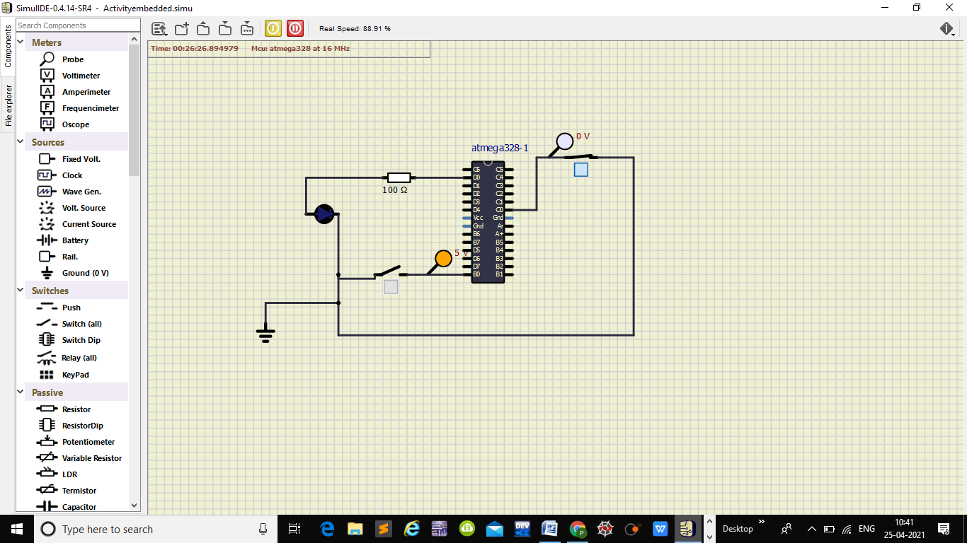

## Button Sensor is OFF and Heater is ON ,LED is OFF

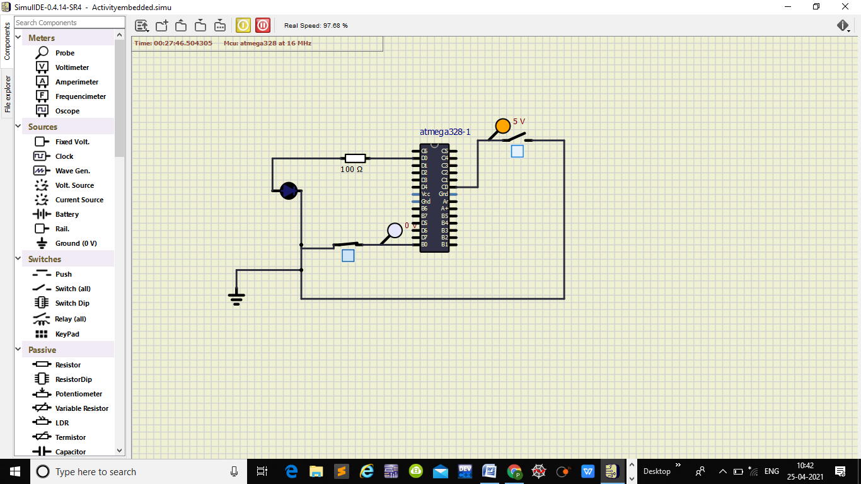

## Button Sensor is OFF and Heater is OFF ,LED is OFF

