SIMPLE CHAT APPLICATION
A SIMPLE CHAT APPLICATION USING C SOCKET PROGRAMMING

REQUIREMENTS:
1. Hardware Requirements
1.Computer / Laptop
2.Keyboard and Mouse
3.Minimum 4 GB RAM
2. Software Requiremets
1.Compiler : GCC / Turbo C / IDE
2.Operating system : Windows / Linux
3.Programming Language : C/C++
4.Database (optional) : MySQL / File System
INTRODUCTION
A Simple Chat Application is a network-based communication program that allows two users to exchange messages in real time through a client-server architecture. This project is developed using the C programming language and socket programming concepts. The server waits for client connections, while the client connects to the server and sends messages through sockets.
ALGORITHMS
SERVER :
1.Start the server program and initialize variables.
2.Create a socket using the socket() function.
3.Set the IP address and port number for the server.
4.Bind the socket with the server address using bind().
5.Listen for client connection requests using listen().
6.Accept the client connection using accept().
7.Display a message that the client is connected.
8.Receive the message from the client using read().
9.Send a reply message to the client using send().
10.Close the socket and stop the program after communication ends.

CLIENT :
1.Start the client program and initialize variables.
2.Create a socket using the socket() function.
3.Enter the server IP address and port number.
4.Connect to the server using connect().
5.Display a successful connection message.
6.Enter the message from the keyboard.
7.Send the message to the server using send().
8.Receive the reply from the server using read().
9.Display the server reply on the screen.
10.Close the socket and stop the program after communication ends.
FLOWCHART
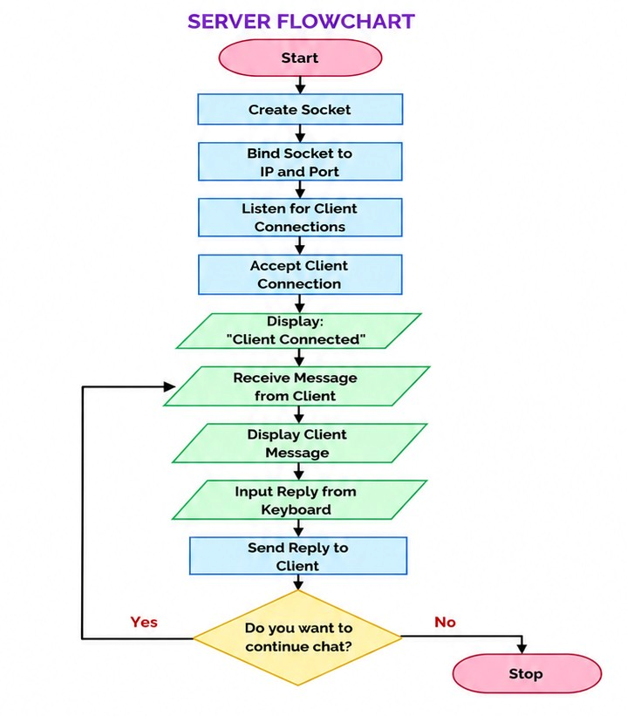
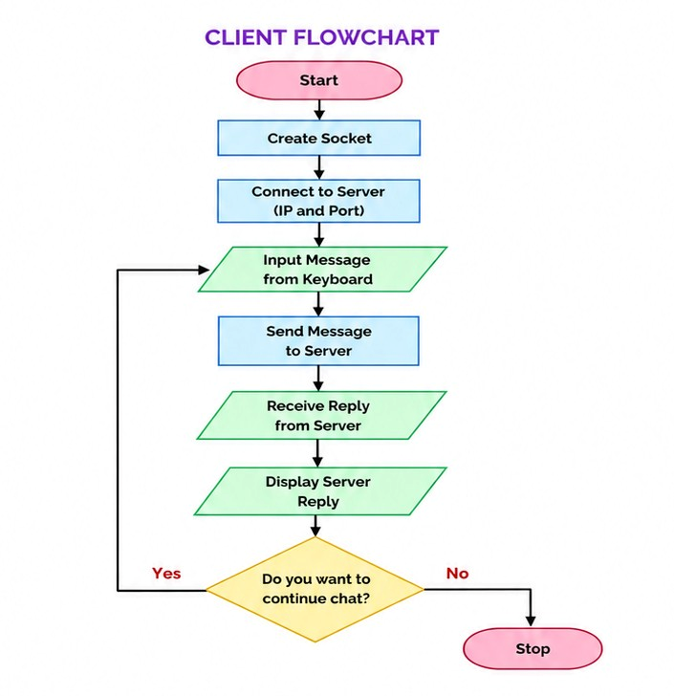MODULE WISE LOGIC
Server Module Logic :
M1 →Create socket for server communication
M2 →Bind server with IP address and port number
M3 →Listen and accept client connection
M4 →Receive and send messages between client

Client Module Logic :
M1 →Create socket for client communication
M2 →Connect client to server using IP and port
M3 →Send messages from client to server
M4 →Receive and display server replies

FORMULAS
- TCP Communication :
Server + Client + Socket Connection = Chat Communication
- Socket Creation:
Plain text
socket(AF_INET, SOCK_STREAM, 0)
- Server Connection Formula:
Plain text
bind() + listen() + accept()
- Client Connection Formula:
Plain text
connect(Server IP, Port Number)
- Data Transfer Formula:
Plain text
send() ↔ read()

MODULES INTEGRATION (FULL PROGRAM)
SERVER CODE :
#include <stdio.h>
#include <stdlib.h>
#include <string.h>
#include <unistd.h>
#include <arpa/inet.h>
#define PORT 8080
int main() {
int server_fd, new_socket;
struct sockaddr_in address;
int addrlen = sizeof(address);
char buffer[1024] = {0};
char message[1024];
// Create socket
server_fd = socket(AF_INET, SOCK_STREAM, 0);
if (server_fd == 0) {
perror("Socket failed");
exit(EXIT_FAILURE);
}
// Define server address
address.sin_family = AF_INET;
address.sin_addr.s_addr = INADDR_ANY;
address.sin_port = htons(PORT);
// Bind socket
bind(server_fd, (struct sockaddr *)&address, sizeof(address));
// Listen for connections
listen(server_fd, 3);
printf("Waiting for client...\n");
// Accept client connection
new_socket = accept(server_fd,
(struct sockaddr *)&address,
(socklen_t*)&addrlen);
printf("Client connected!\n");
while (1) {
memset(buffer, 0, sizeof(buffer));
// Read message from client
read(new_socket, buffer, sizeof(buffer));
printf("Client: %s\n", buffer);
// Send reply
printf("Server: ");
fgets(message, sizeof(message), stdin);
send(new_socket, message, strlen(message), 0);
}
close(new_socket);
close(server_fd);
return 0;
}
CLIENT CODE :
#include <stdio.h>
#include <stdlib.h>
#include <string.h>
#include <unistd.h>
#include <arpa/inet.h>
#define PORT 8080
int main() {
int sock = 0;
struct sockaddr_in serv_addr;
char buffer[1024] = {0};
char message[1024];
// Create socket
sock = socket(AF_INET, SOCK_STREAM, 0);
if (sock < 0) {
printf("Socket creation error\n");
return -1;
}
serv_addr.sin_family = AF_INET;
serv_addr.sin_port = htons(PORT);
// Convert IP address
inet_pton(AF_INET, "127.0.0.1", &serv_addr.sin_addr);
// Connect to server
connect(sock,
(struct sockaddr *)&serv_addr,
sizeof(serv_addr));
printf("Connected to server!\n");
while (1) {
// Send message
printf("Client: ");
fgets(message, sizeof(message), stdin);
send(sock, message, strlen(message), 0);
// Receive reply
memset(buffer, 0, sizeof(buffer));

read(sock, buffer, sizeof(buffer));
printf("Server: %s\n", buffer);
}
close(sock);
return 0;
}

SAMPLE OUTPUT :

Server terminal :
Waiting for client...
Client connected!
Client: Hello
Server: Hi

Client terminal :
Connected to server!
Client: Hello
Server: Hi

RESULT :

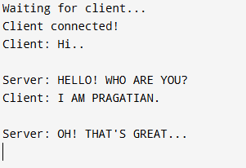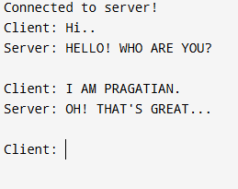

CONCLUSION :
The Simple Chat Application demonstrates communication between client and server using socket programming in C.
It helps in understanding important networking concepts such as socket creation, connection establishment, and message transfer.

