

Concurrent Mix calculator
REQUIREMENTS
Hardware Requirements Software Requirements

Storage: Minimum 4GB RAM
Windows 7/8/10/11
Processor: Intel Core i3
Linux
Input Devices: Keyboard, Mouse
Mac Os
Personal Computers MS Word

Introduction
◆ In civil engineering and construction materials testing, achieving the correct aggregate gradation is essential
for producing high-quality concrete, asphalt, and pavement layers. A well-graded aggregate mix improves
strength, durability, workability, and overall performance of the final construction material. However,
aggregates used on site often come from different sources and have varying gradation characteristics. To
obtain a desired final gradation, these different aggregates must be blended in suitable proportions. This
process is known as concurrent mixing.
◆ A Concurrent Mix Calculator is a computational tool designed to simplify and accurately determine the
combined gradation when two or more aggregates are mixed together. Instead of manually performing
repeated calculations for each sieve size and proportion, the calculator automates the process, ensuring fast,
error-free, and reliable results. By applying weighted average calculations across all sieve sizes, the system
generates the final percentage passing or retained for each sieve, enabling engineers to validate whether the
mix meets specific standards such as MORTH, ASTM, or project-based requirements.

◆ | Algorithm  ALGORITHM: Concurrent Mix Calculator and Beam Load Calculator
◆ ==============================================================
PART A: CONCRETE MIX DESIGN CALCULATOR
◆ 1. INPUT MODULE
Input Parameters:
◆ Grade of concrete (M15, M20, M25, M30, M35, M40, etc.)
◆ Type of cement (OPC 33, 43, 53)
◆ Maximum aggregate size (10mm, 20mm, 40mm)
◆ Degree of workability (slump value)
◆ Exposure conditions (mild, moderate, severe)
◆ Quality of materials (aggregates, water)
◆ 2. TARGET STRENGTH CALCULATION
Process:
a. Obtain characteristic strength (fck) from grade
Example: M25 → fck = 25 N/mm²
◆ b. Calculate target mean strength (fm):
fm = fck + 1.65 × s
where s = standard deviation (depends on quality control)
◆ Good control: s = 4 N/mm²
◆ Fair control: s = 5 N/mm²
◆ Output: Target mean strength

◆ 3. WATER-CEMENT RATIO SELECTION
Process:
a. Calculate W/C ratio from target strength:
W/C ≈ 0.5 (for approximate calculation)
◆ Or use empirical formula:
fck = (fm × Ce × Wa) / (Ce + k × Wa)
where Ce = cement content, Wa = water content, k = constant
◆ b. Check durability requirements:
◆ Mild exposure: max W/C = 0.55
◆ Moderate exposure: max W/C = 0.50
◆ Severe exposure: max W/C = 0.45
◆ c. Select minimum of strength and durability W/C ratio
◆ Output: Final W/C ratio
◆ 4. WATER CONTENT DETERMINATION
Process:
a. Select water content based on:
◆ Maximum aggregate size
◆ Slump value required
◆ b. Use standard tables (IS 10262):
For 20mm aggregate:
◆ 25–50mm slump: 186 liters
◆ 50–100mm slump: 205 liters
◆ Output: Water content per m³
◆ 5. CEMENT CONTENT CALCULATION
Process:
a. Calculate cement (C) from W/C ratio:
C = Water content / (W/C ratio)
◆ b. Check minimum cement content (durability):
◆ Mild exposure: min 300 kg/m³

◆ Moderate exposure: min 320 kg/m³
◆ Severe exposure: min 340 kg/m³
◆ c. Use maximum of calculated and minimum values
◆ Output: Cement content (kg/m³)
◆ 6. AGGREGATE PROPORTIONING
Process:
a. Calculate total aggregate = 1 m³ − (Cement vol + Water vol)
◆ b. Determine fine aggregate (FA) to coarse aggregate (CA) ratio:
◆ Use grading zone and workability tables
◆ Typical ratio: 1:2 (FA:CA)
◆ c. Calculate individual quantities:
FA = Total aggregate × FA ratio / (FA + CA ratio)
CA = Total aggregate × CA ratio / (FA + CA ratio)
◆ Output: Fine aggregate and coarse aggregate quantities
◆ 7. MIX ADJUSTMENT FOR ADMIXTURES
Process:
a. If using admixtures (plasticizers, superplasticizers):
◆ Reduce water content by 5–30%
◆ Maintain W/C ratio
◆ Adjust cement accordingly
◆ Output: Adjusted mix proportions
◆ 8. FINAL MIX PROPORTIONS
Output Format:
◆ Cement : Fine Aggregate : Coarse Aggregate (by weight)
◆ Example: 1 : 1.5 : 3
◆ Quantities per m³:
◆ Cement: XXX kg
◆ Fine Aggregate: XXX kg
◆ Coarse Aggregate: XXX kg
◆ Water: XXX liters

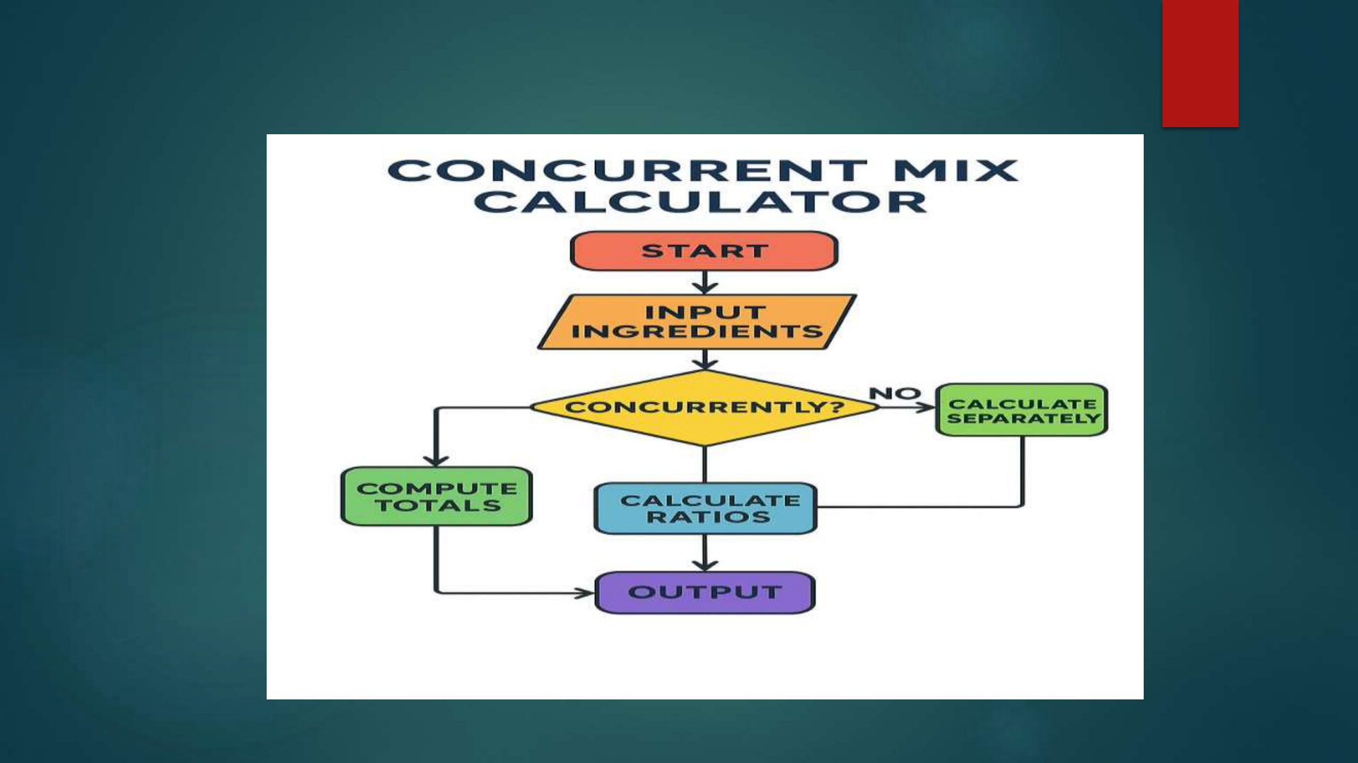

Flowchart

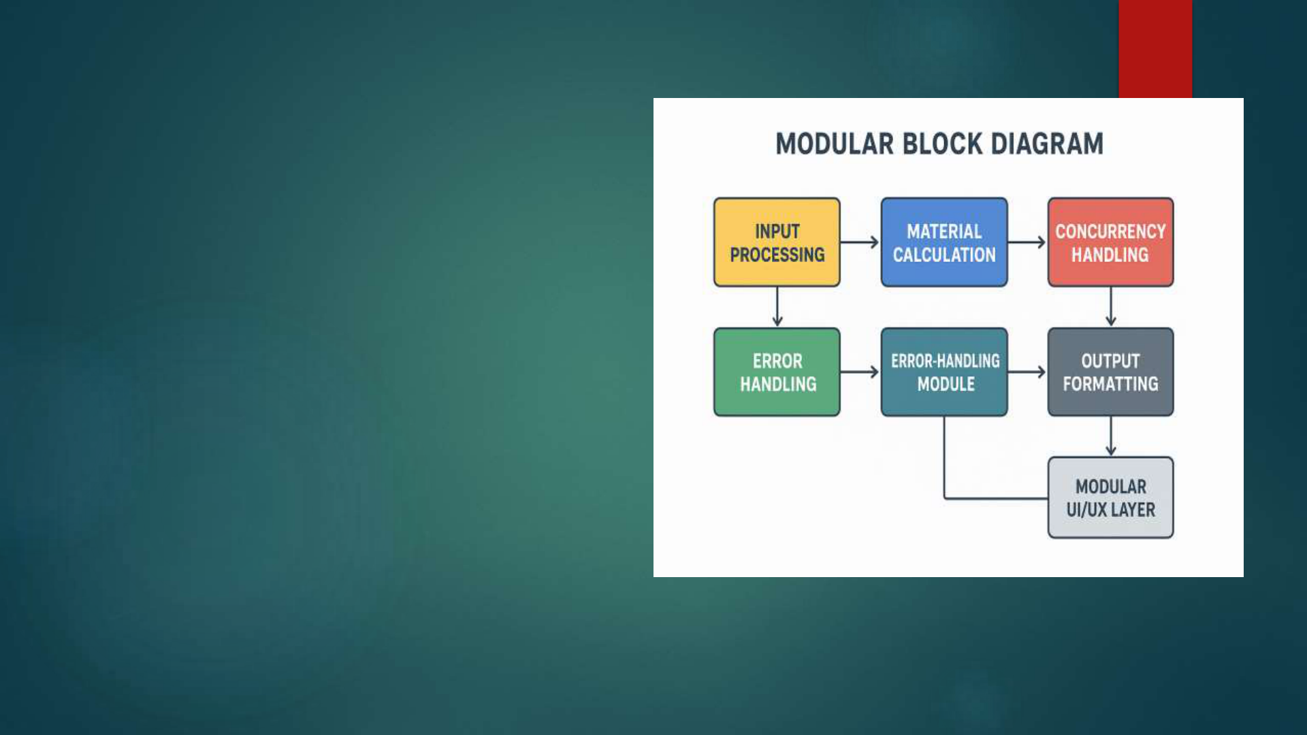

Modular Design
The system is divided into smaller, self
contain units that can function
independently
Since modules are isolated, you can
update or fix one module without
effecting the entire system
Modules can be reused in different
projects or systems, reducing
development time and cost
New features or components can be
added easily by plugging in new modules
without designing the whole system
Different team members can work on
separate modules simultaneously,
increasing efficiency and reducing
dependencies

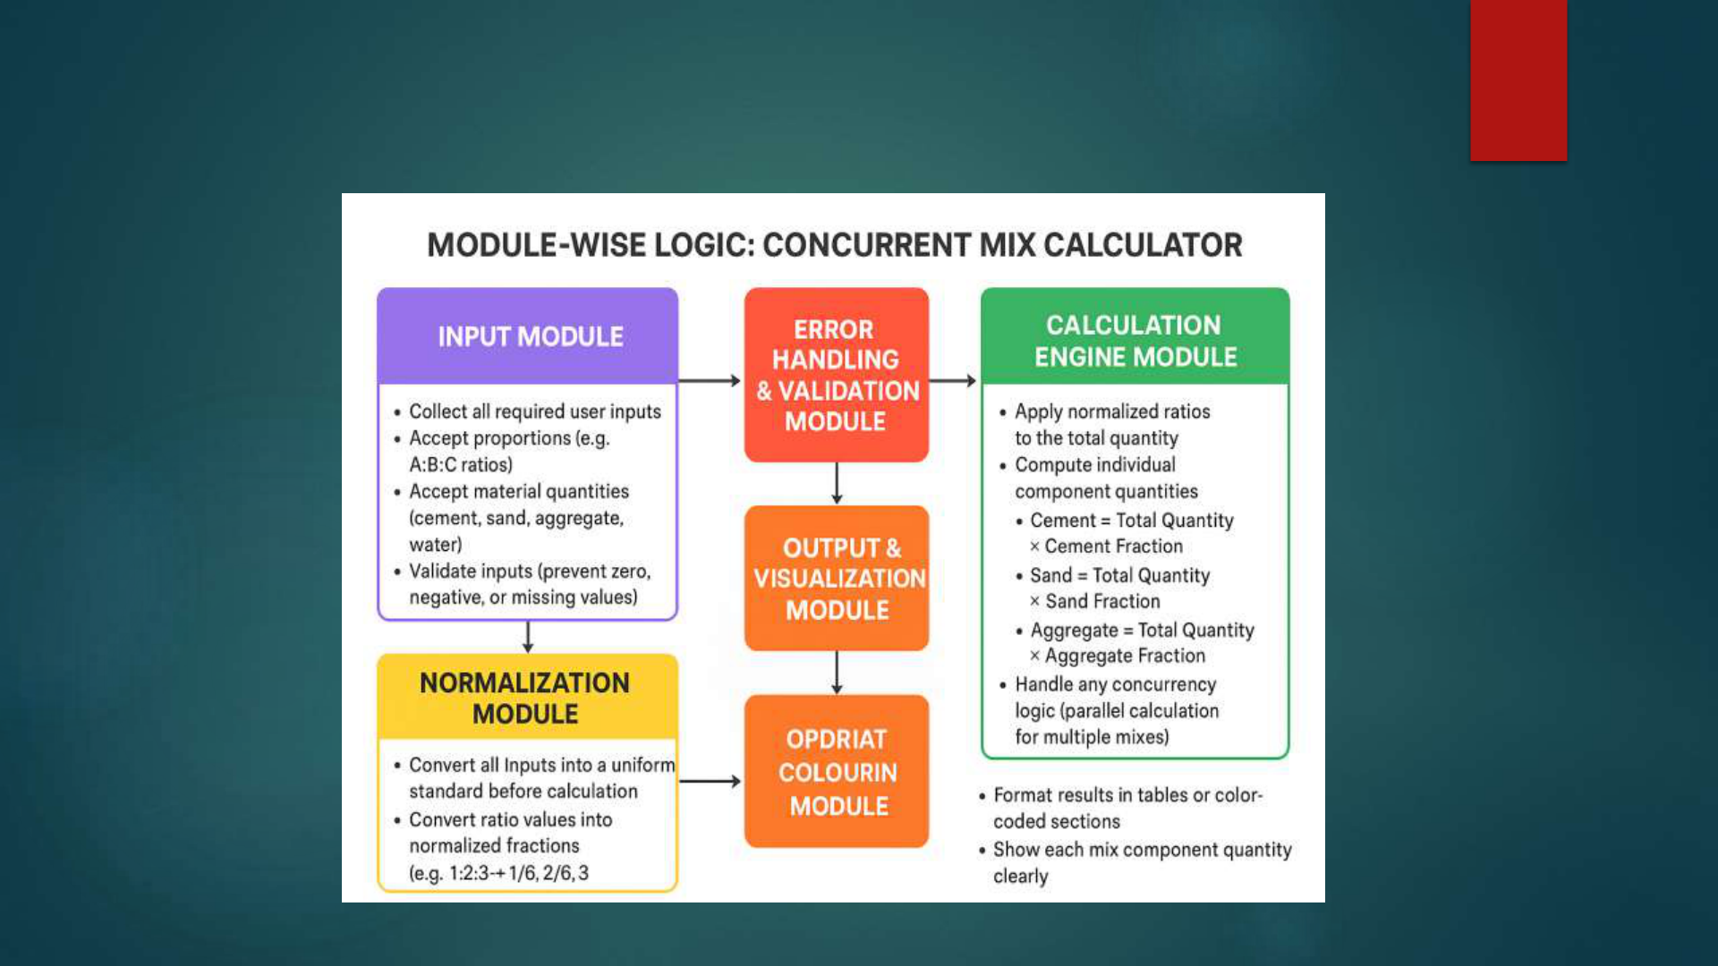

Module Wise Logic

Module Wise Program
#include<stdio.h>
Int main () {
float c, s, a, w, total;
float cement, sand, aggregate, water;
float sum;
// Input
printf("Enter cement ratio: ");
scanf("%f", &c);
printf("Enter sand ratio: ");
scanf("%f", &s);
printf("Enter aggregate ratio: ");
scanf("%f", &a);

printf("Enter water ratio: ");
scanf("%f", &w);
printf("Enter total quantity (m³): ");
scanf("%f", &total);
// Calculation
sum = c + s + a + w;
cement = (c / sum) * total;
sand = (s / sum) * total;
aggregate = (a / sum) * total;
water = (w / sum) * total;

// Output
printf("\n--- RESULTS ---\n");
printf("Cement: %.2f units\n", cement);
printf("Sand: %.2f units\n", sand);
printf("Aggregate: %.2f units\n", aggregate);
printf("Water: %.2f units\n", water);
return 0;

Sample Output
Enter cement ratio: 1
Enter sand ratio: 2
Enter aggregate ratio: 3
Enter water ratio: 0.5
Enter total quantity (m³): 10
// RESULTS
Cement: 1.18 units
Sand: 2.35 units
Aggregate: 3.53 units
Water: 0.59 units

Thank
You

BEAM LOAD CALCULATOR
REQUIREMENTS
HARDWARE REQUIREMENTS SOFTWARE
REQUIREMENTS * Any computer or
laptop * Windows 7/8/10/11
* Minimum 2 GB RAM *
Linux
* Keyboard for input * Mac Os
* Personal computers * MS Word

INTRODUCTION :
A Beam Load Calculator is a program that
calculates how forces act on a beam when loads are
applied .
This helps students understand basic structural
analysis concepts such as :
Reactions at supports
Shear
force

Bending moment
The project teaches input handling , modular
programming , and applying formulas in code .
ALGORITHM
Step - by - step algorithm
1. Start
2 . Display menu of load types
3 . Get beam length from user
4 . Ask user to select load type :

o 1–Point Load
o 2 –Uniformly Distributed Load ( UDL )
5 . If Point Load :
o Get magnitude of load
o Get position of load
o Calculate reactions
o Calculate maximum bending moment
6 . If UDL :
o Get intensity ( load per meter )
o Calculate reactions

o Calculate maximum bending moment
7 . Display results
8 . End
FLOWCHART Start___ calculateon of Sn(Eqs. 3 or 8)
|
Calculation of Lp assuming Sa=Sn (Eq. 2)
|
Calculation of Pdy (Eq. 1) ___ Calculation of Vcd (Eq. 7)

|
Vcd< Pdy
Scr= Sn Scr= 2/3 Sn
Calculation of Lp (Eq. 2)
|
Lp< La
Total loss of FRP yielding of longitudinal reinforcement in
Laminate’s efficiency substrate concret at the shear flexure
Zone
| |
Pdy = Puc calculation of Pdy (Eq. 1)
|
Pdy = Pdy | ___ | Pdy < Vcd
Pdy = Vcd
MODULAR DESIGN +
- - - - - - - - - - - - - - - - - - - - - - - - - +
| MAIN
MODULE |
+
- - - - - - - - - - - - - - - - - - - - - - - - - - - - +
|

+
- - - - - - - - - - - - - - - - - - - - - - - - - - - - +
| INPUT
MODULE |
+
- - - - - - - - - - - - - - - - - - - - - - - - - - - - - - - +
|
+
- - - - - - - - - - - - - - - - - - - - - - - - - - - - - - - +
|
VALIDATION MODULE |
+
- - - - - - - - - - - - - - - - - - - - - - - - - - - - - +
|
+- - - - - - - - - - - - - - - - - - - - - - - - - - - - - - - +
|
CALCULATION MODULE |
+
- - - - - - - - - - - - - - - - - - - - - - - - - - - - - - - +
|
+
- - - - - - - - - - - - - - - - - - - - - - - - - - - - - - +
|
OUTPUT MODULE |
+
- - - - - - - - - - - - - - - - - - - - - - - - - - - - - - +

MODULE WISE LOGIC

MODULE WISE PROGRAM
#include <stdio.h>
Int input data(float *P ,float *W ,int *type) {
Printf(“Beam Load Calculator\n”);
Printf(“1. Point Load at Center\n”);
Printf(“2. UDL (Uniformly Distributed Load)\n”);
Printf(“Enter Load Type:”);
Scanf(“% d”,type);
Printf(“Enter Length of Beam (in meters):”);
scanf(“% f” ,L);
If(*type==1) {

Printf(“Enter Point Load (in KN):”);
Scanf(“% f” ,P);
} else {
printf(“Enter UDL Load (KN/m):”);
scanf(“% f” ,W) ;
}
}
Float calculate shear force(float L, float P, float W, int
type) {
If(type==1) {
Return P/2;

} else {
Return (W*L)/2;
}
}
Float calculate bending moment (float L, float P, float W,
int type) {
If(type==1) {
Return(P*L)/4;
} else {
Return (L*P)/8;
}

}
// OUTPUT
Int display results(float SF , float BM) {
Printf(“\n- - - - - Results - - - -\n”);
printf(“Shear force = % .2f kN\n”,SF);
printf(“Bending moment =% .2f Kn- m\n”,BM);
printf(“- - - - - - - - - - - - - - - - -\n”);
}
// SAMPLE OUTPUT
Point Load at Center
UDL (Uniformly Distributed Load)

Enter Length of Beam (in meters): 4
Enter Load Type : 1
Enter Point Load (in kN): 18
// RESULTS
Shear Force = 9.00 kN
Bending Moment = 18.00 Kn - m

THANK YOU

