PROJECT TITLE -

- STUDENT HEALTH TRACKER

LANGUAGE - C

INTRODUCTION:

Health indicators help students understand their fitness level.
This program takes basic inputs such as waist, hip, height, and weight, and calculates:
· WHR (Waist-to-Hip Ratio) →indicates fat distribution
• BMI (Body Mass Index) → indicates whether a person is underweight, normal, or overweight The program is menu-driven and divided into modules for clarity.

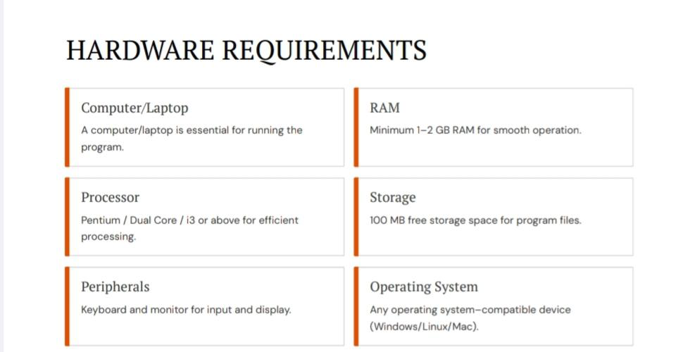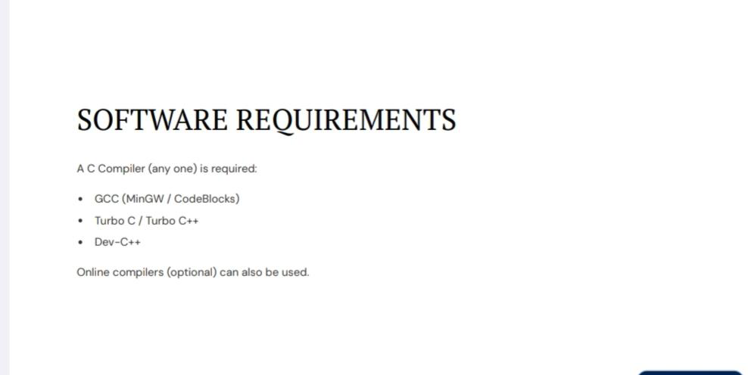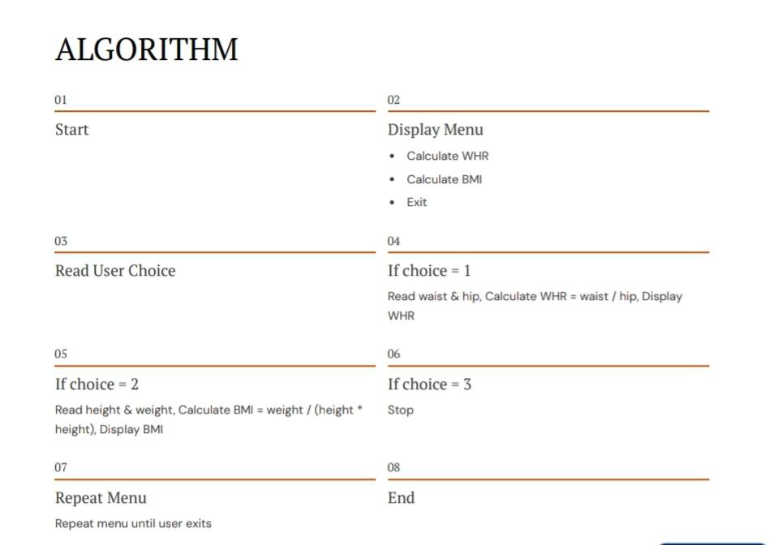
⭐ FLOWCHART
┌────────────────────┐
│ START │
└───────┬────────────┘
│
▼
┌────────────────────┐
│ Display Menu: │
│ 1. WHR │
│ 2. BMI │
│ 3. Exit │
└─────────┬──────────┘
│
▼
┌────────────────────┐
│ Read Choice │
└─────────┬──────────┘
┌───────┼────────────────────────┐
▼ ▼ ▼
(choice=1) (choice=2) (choice=3?)
│ │ │
│ │ └──► YES ──► STOP
│ │
│ └─────► Read Weight, Height
│ BMI = W / H²
│ Display BMI
│
└─────────────► Read Waist, Hip
WHR = Waist / Hip
Display WHR

▼
┌────────────────────┐
│ Go to Menu │
└─────────┬──────────┘
│
▼
(Repeat)

—

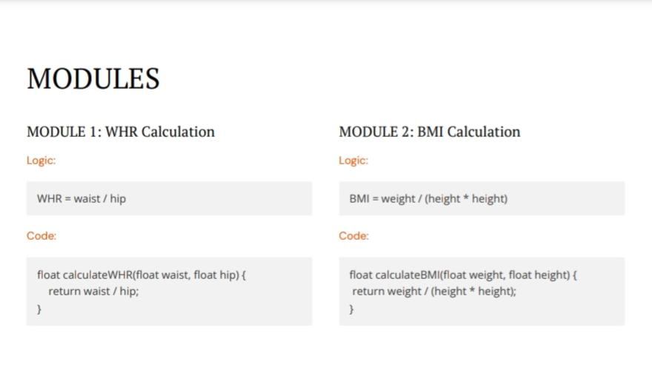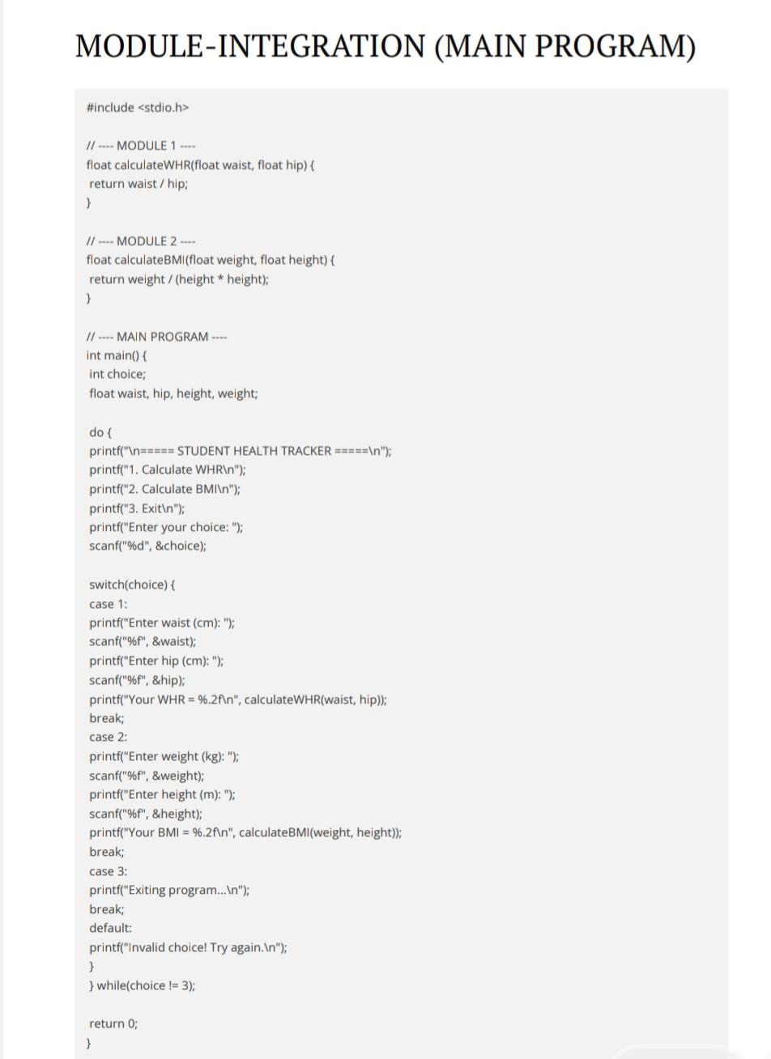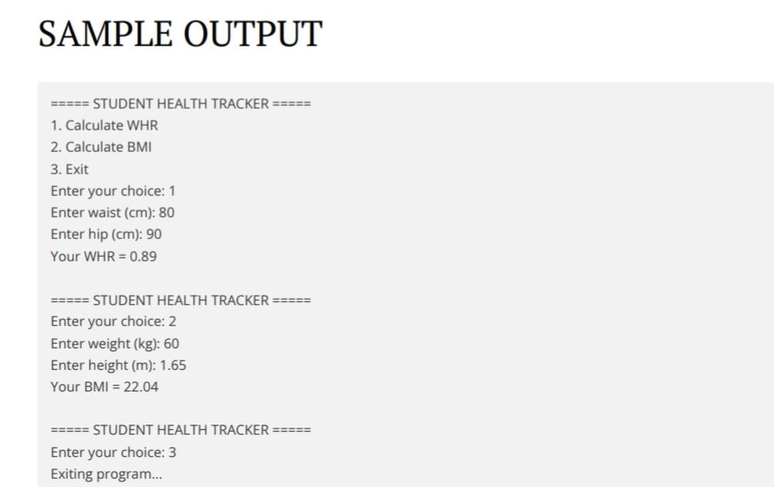

Project Acknowledgements
Thank You!
We extend our sincere gratitude to everyone who supported us throughout this project. Your encouragement
and contributions were invaluable.
This project was a collaborative effort, bringing together diverse skills and perspectives to achieve a common goal. We are proud of the work accomplished and believe this Student Health Tracker will be a valuable tool.



