Documentation
•Abstract :
- Inventory management is essential for smooth business operations
- This project implements an Inventory Management System using C
- It allows adding, viewing, updating, and selling products
- Designed mainly for small shops and beginners in programming
- Demonstrates practical use of structures, arrays, and loops

•Introduction:
- Inventory refers to the goods available in a shop for sale
- Manual inventory handling is time-consuming and error-prone
- This system automates inventory tracking
- Helps shop owners know stock availability at any time
- Improves accuracy and efficiency in managing products

• Software Requirements:
- Operating System: Windows / Linux
- Programming Language: C
- Compiler: GCC / Turbo C / Dev-C++
- Code Editor: VS Code / Code::Blocks / Dev-C++

•Hardware Requirements:
- Processor: Any basic processor
- RAM: Minimum 2 GB
- Hard Disk: 100 MB free space
- Input Devices: Keyboard
- Output Devices: Monitor

- Code:

#include <stdio.h>
#include <string.h>

Struct product {
Int id;
Char name[30];
Int quantity;
Float price;
};

Int main() {
Struct product p[50];
Int n = 0, choice, I, id, qty;
Float total = 0;
Do {
Printf(“\n\n--- Inventory Management System ---\n”);
Printf(“1. Add Product\n”);
Printf(“2. View Products\n”);
Printf(“3. Update Stock\n”);
Printf(“4. Sell Product\n”);
Printf(“5. Low Stock Alert\n”);
Printf(“6. Exit\n”);
Printf(“Enter your choice: “);
Scanf(“%d”, &choice);

Switch (choice) {

Case 1:
Printf(“Enter Product ID: “);
Scanf(“%d”, &p[n].id);
Printf(“Enter Product Name: “);
Scanf(“%s”, p[n].name);
Printf(“Enter Quantity: “);
Scanf(“%d”, &p[n].quantity);
Printf(“Enter Price: “);
Scanf(“%f”, &p[n].price);
N++;
Printf(“Product Added Successfully!\n”);
Break;

Case 2:
Printf(“\nID\tName\tQuantity\tPrice\n”);
For (I = 0; I < n; i++) {
Printf(“%d\t%s\t%d\t\t%.2f\n”,
P[i].id, p[i].name, p[i].quantity, p[i].price);
}
Break;

Case 3:
Printf(“Enter Product ID to update stock: “);
Scanf(“%d”, &id);
For (I = 0; I < n; i++) {
If (p[i].id == id) {
Printf(“Enter new quantity: “);
Scanf(“%d”, &p[i].quantity);
Printf(“Stock Updated Successfully!\n”);
}
}
Break;

Case 4:
Printf(“Enter Product ID to sell: “);
Scanf(“%d”, &id);
Printf(“Enter quantity to sell: “);
Scanf(“%d”, &qty);
For (I = 0; I < n; i++) {
If (p[i].id == id && p[i].quantity >= qty) {
P[i].quantity -= qty;
Total = qty * p[i].price;
Printf(“Bill Amount: %.2f\n”, total);
}
}
Break;

Case 5:
Printf(“\nLow Stock Products (Qty < 5):\n”);
For (I = 0; I < n; i++) {
If (p[i].quantity < 5) {
Printf(“%s (Qty: %d)\n”, p[i].name, p[i].quantity);
}
}
Break;

Case 6:
Printf(“Exiting Program…\n”);
Break;

Default:
Printf(“Invalid Choice!\n”);
}

} while (choice != 6);

Return 0;
}

- Key Concepts Used:
- Structures – to store product details
- Arrays – to store multiple products
- Loops – do-while, for
- Switch-case – menu-driven operations

- Functions Performed:
- Add new product
- View all products
- Update stock
- Sell products
- Calculate total bill
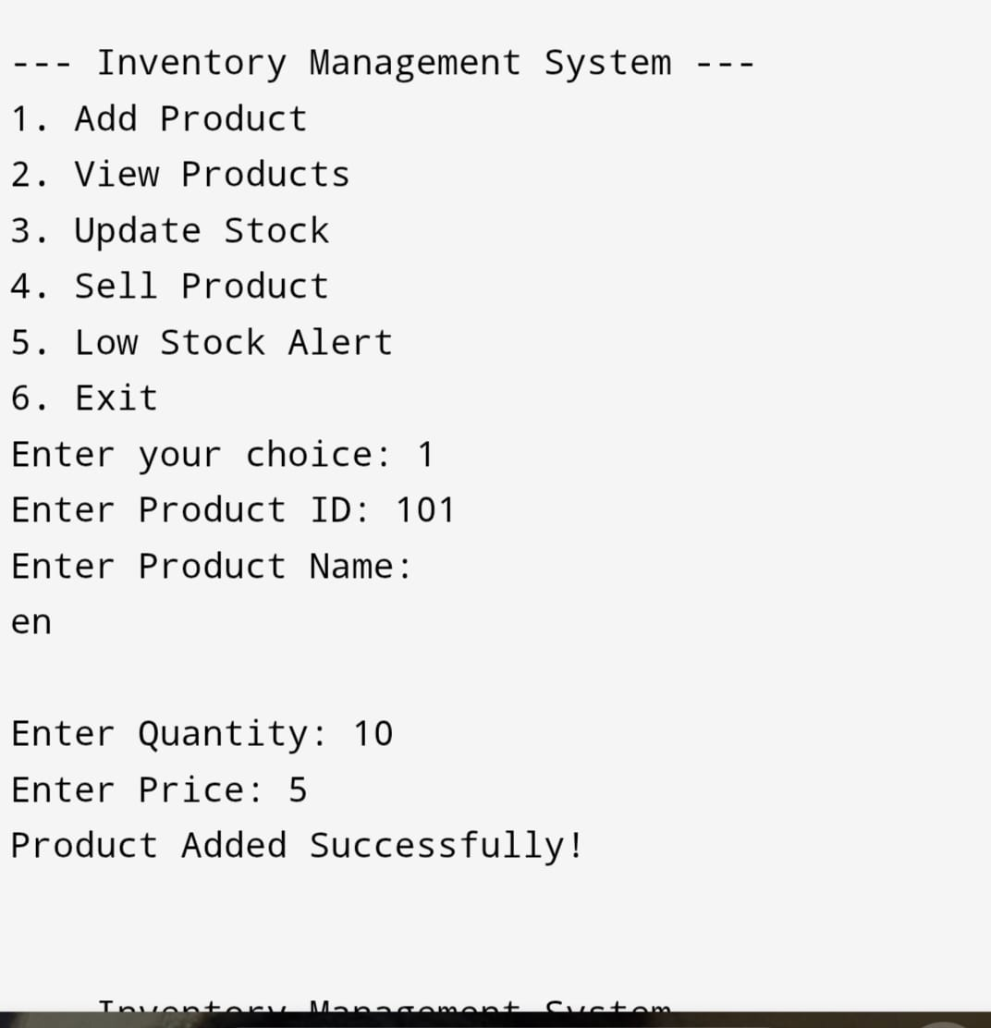
•Result:

•Conclusion:
•The inventory management is simple and effective
- Helps understand core C programming concepts
- Useful for small shops and students
- Can be further enhanced with file handling and database support
- Serves as a good foundation for real-world applications

