DOCUMENTATION :

1.Abstract :
he Student Attendance Manager is a digital system designed to simplify and automate the process of recording, managing, and monitoring student attendance in educational institutions. The project aims to reduce manual effort, minimize errors, and improve efficiency compared to traditional paper-based attendance methods. The system allows teachers to mark attendance electronically, store records securely, and generate attendance reports for individual students or entire classes. It also enables easy tracking of attendance trends over time, helping institutions identify irregular attendance patterns. By providing a reliable and user-friendly platform, the Student Attendance Manager enhances accuracy, saves time, and supports better academic administration and decision-making.

2.Introduction:
Attendance management is a critical administrative function in educational institutions, as it reflects student participation and plays a significant role in academic evaluation and discipline. Traditional attendance systems, which rely on manual entry using registers or spreadsheets, are time-consuming, prone to errors, and inefficient for long-term data management and analysis. With the increasing number of students and courses, these conventional methods have become inadequate for modern academic environments. Overall, the Student Attendance Manager represents a practical step toward the digital transformation of educational administration.
3.Software requirements :
• Operating System: Windows 10 / Windows 11
• Programming Language: Java / Python
• Front-End: HTML, CSS, JavaScript
• Back-End: Java (JSP/Servlets) or Python (Django/Flask)
• Database: MySQL / SQLite

4.Hardware requirements :
• Processor: Intel Core i3 or higher
• RAM: Minimum 4 GB (8 GB recommended)
• Hard Disk: Minimum 250 GB
• Keyboard & Mouse: Standard input devices

5.Code :
#include <stdio.h>
#include <stdlib.h>

struct student
{
int roll;
char name[30];
int attendance; // 1 = Present, 0 = Absent
};

void addStudent()
{
struct student s;
FILE *fp = fopen("attendance.dat", "ab");

printf("\nEnter Roll Number: ");
scanf("%d", &s.roll);
printf("Enter Name: ");
scanf("%s", s.name);

s.attendance = 0; // default absent
fwrite(&s, sizeof(s), 1, fp);
fclose(fp);

printf("\nStudent Added Successfully!\n");
}

void markAttendance()
{
struct student s;
int roll, found = 0;
FILE *fp = fopen("attendance.dat", "rb+");

printf("\nEnter Roll Number to mark attendance: ");
scanf("%d", &roll);

while (fread(&s, sizeof(s), 1, fp))
{
if (s.roll == roll)
{
printf("Student Name: %s\n", s.name);
printf("Enter 1 for Present, 0 for Absent: ");
scanf("%d", &s.attendance);

fseek(fp, -sizeof(s), SEEK_CUR);
fwrite(&s, sizeof(s), 1, fp);
found = 1;
break;
}
}

fclose(fp);

if (found)
printf("\nAttendance Marked Successfully!\n");
else
printf("\nStudent Not Found!\n");
}

void viewAttendance()
{
struct student s;
FILE *fp = fopen("attendance.dat", "rb");

printf("\n--- Attendance List ---\n");
printf("Roll\tName\t\tStatus\n");

while (fread(&s, sizeof(s), 1, fp))
{
printf("%d\t%s\t\t%s\n", s.roll, s.name,
s.attendance ? "Present" : "Absent");
}

fclose(fp);
}

int main()
{
int choice;

do
{
printf("\n===== STUDENT ATTENDANCE MANAGER =====");
printf("\n1. Add Student");
printf("\n2. Mark Attendance");
printf("\n3. View Attendance");
printf("\n4. Exit");
printf("\nEnter your choice: ");
scanf("%d", &choice);

switch (choice)
{
case 1:
addStudent();
break;
case 2:
markAttendance();
break;
case 3:
viewAttendance();
break;
case 4:
printf("\nExiting Program...\n");
break;
default:
printf("\nInvalid Choice!\n");
}
} while (choice != 4);

return 0;
}

6.Result :

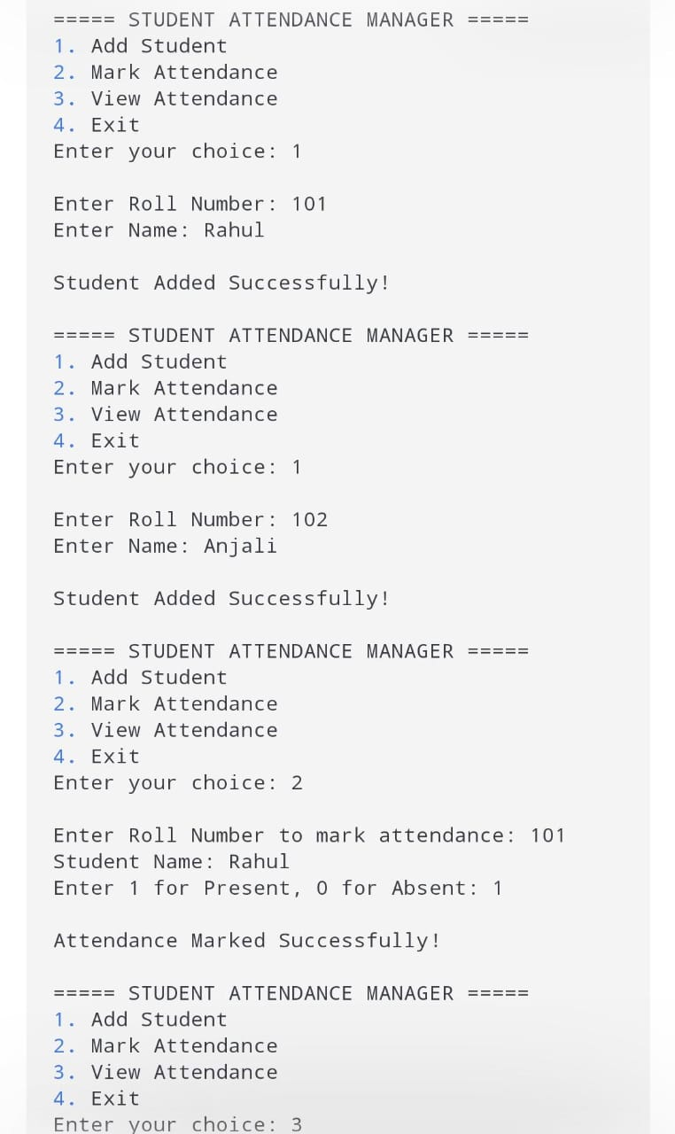
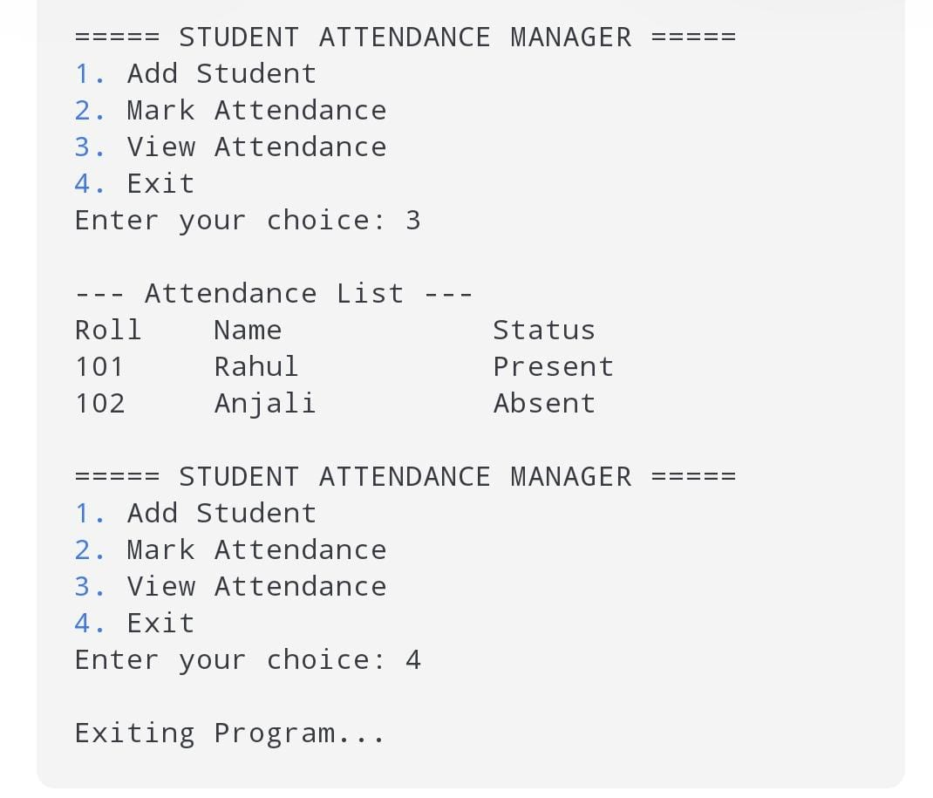

7.conclusion :

The Student Attendance Manager successfully provides an efficient and reliable solution for managing student attendance in educational institutions. By replacing manual attendance methods with a digital system, the project reduces human errors, saves time, and improves the overall accuracy of attendance records. The system enables faculty to record attendance easily, maintain structured data, and generate reports whenever required.

